

DEPARTMENT OF COMPUTER SCIENCE AND ENGINEERING

23CSE304 Embedded Systems Laboratory

Activity Sheet #7

Activity Name: PWM Module Interfacing

Name of Student: | Chetan Kumar G
Registration No.: | CH.SC.U4CSE24109
Activity Date: | 02|10|2026
Submission Date: | 02|10|2026

Assessment Rubrics:

Component | Maximum Marks | Marks Allotted
Program | 3
Output | 4
Viva | 2
Timely Submission | 1
Total | 10

Faculty In-charge

Write an embedded C program for ARM architecture to drive PWM module. Debug and verify the program using IDE on a development computer system.

PROGRAM:

#include <LPC21xx.H>

int main(void)
{
PINSEL0 = (1 << 1); // Select PWM1 on P0.0

PWMPR = 0; // Prescaler

PWMMR0 = 1000; // PWM period

PWMMCR = (1 << 1); // Reset PWMTC on PWMMR0 match

PWMMR1 = 500; // 50% duty cycle

PWMLER = (1 << 0) | (1 << 1); // Load MR0 and MR1

PWMPCR = (1 << 9); // Enable PWM1 output

PWMTCR = (1 << 1); // Reset PWM TC and PR

PWMTCR = (1 << 0) | (1 << 3); // Enable counter and PWM mode

while(1);
}

OUTPUT WINDOW:

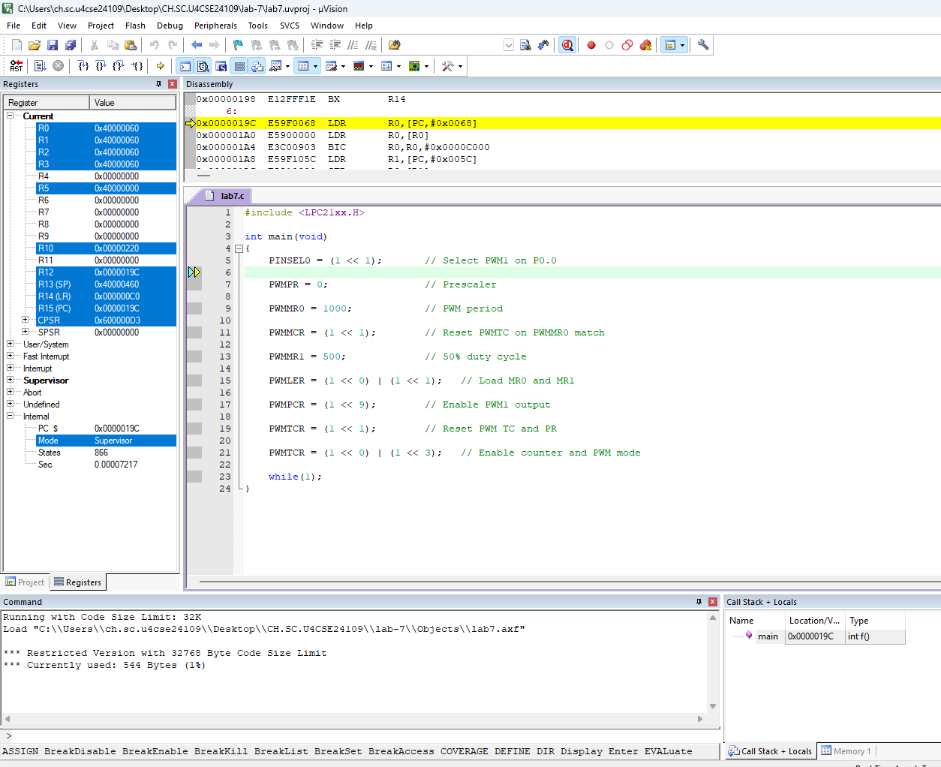

OUTPUT:
