

DEPARTMENT OF COMPUTER SCIENCE AND ENGINEERING

23CSE304 Embedded Systems Laboratory

Activity Sheet #8

Activity Name: Real-Time Clock Interfacing

Name of Student: | Chetan Kumar G
Registration No.: | CH.SC.U4CSE24109
Activity Date: | 02|10|2026
Submission Date: | 02|10|2026

Assessment Rubrics:

Component | Maximum Marks | Marks Allotted
Program | 3
Output | 4
Viva | 2
Timely Submission | 1
Total | 10

Faculty In-charge

Write an embedded C program for ARM architecture to interface Real-Time Clock. Debug and verify the program using IDE on a development computer system.

PROGRAM:
#include <LPC21xx.H>

#define RS (1<<24)
#define EN (1<<25)

#define LCD_DATA_MASK 0x00FF0000

void delay(unsigned int t)
{
unsigned int i, j;

for(i = 0; i < t; i++)
for(j = 0; j < 1000; j++);
}

void lcd_cmd(unsigned char cmd)
{
IOCLR0 = LCD_DATA_MASK;
IOSET0 = ((unsigned long)cmd << 16);

IOCLR1 = RS;
IOSET1 = EN;
delay(1);
IOCLR1 = EN;

delay(2);
}

void lcd_data(unsigned char data)
{
IOCLR0 = LCD_DATA_MASK;
IOSET0 = ((unsigned long)data << 16);

IOSET1 = RS;
IOSET1 = EN;
delay(1);
IOCLR1 = EN;

delay(2);
}

void lcd_string(char *str)
{
while(*str)
{
lcd_data(*str++);
}
}

void lcd_init(void)
{
IODIR0 |= LCD_DATA_MASK;
IODIR1 |= RS | EN;

delay(20);

lcd_cmd(0x38); // 8-bit, 2-line
lcd_cmd(0x0C); // Display ON, cursor OFF
lcd_cmd(0x06); // Increment cursor
lcd_cmd(0x01); // Clear display

delay(5);
}

void lcd_num(unsigned int num)
{
lcd_data((num / 10) + '0');
lcd_data((num % 10) + '0');
}

void rtc_init(void)
{
CCR = 0x02; // Reset RTC

SEC = 0;
MIN = 30;
HOUR = 10;

DOM = 1;
DOW = 4;
DOY = 1;
MONTH = 10;
YEAR = 2026;

CCR = 0x01; // Enable RTC
}

int main(void)
{
lcd_init();
rtc_init();

while(1)
{
lcd_cmd(0x80);
lcd_string("TIME: ");

lcd_num(HOUR);
lcd_data(':');

lcd_num(MIN);
lcd_data(':');

lcd_num(SEC);

lcd_cmd(0xC0);
lcd_string("DATE: ");

lcd_num(DOM);
lcd_data('/');

lcd_num(MONTH);
lcd_data('/');

lcd_num(YEAR / 100);
lcd_num(YEAR % 100);

delay(500);
}
}

OUTPUT WINDOW:

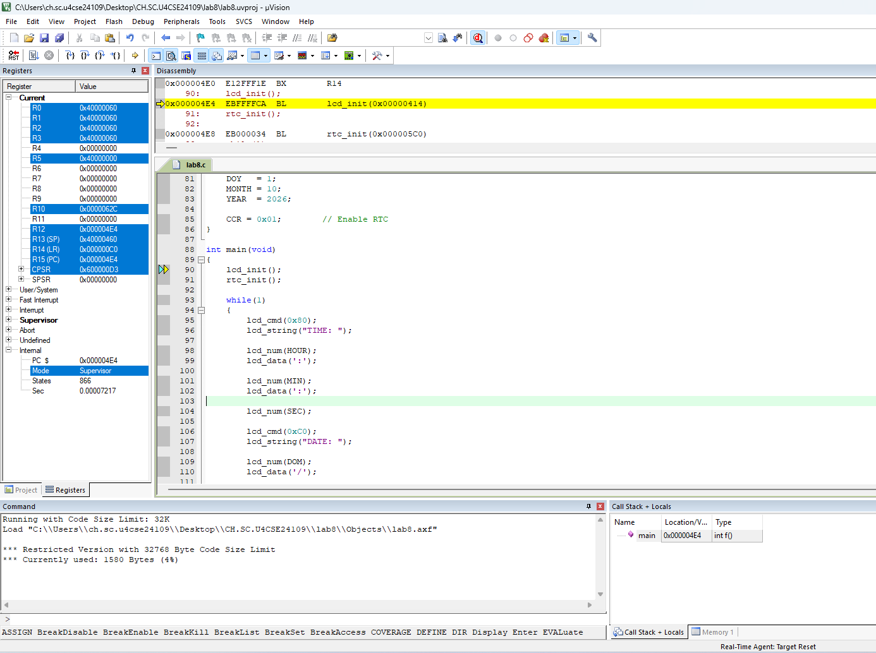

OUTPUT:

