

DEPARTMENT OF COMPUTER SCIENCE AND ENGINEERING

23CSE304 Embedded Systems Laboratory

Activity Sheet #6

Activity Name: ADC Module Interfacing

Name of Student: | Chetan Kumar G
Registration No.: | CH.SC.U4CSE24109
Activity Date: | 02|10|2026
Submission Date: | 02|10|2026

Assessment Rubrics:

Component | Maximum Marks | Marks Allotted
Program | 3
Output | 4
Viva | 2
Timely Submission | 1
Total | 10

Faculty In-charge

Write an embedded C program for ARM architecture to drive ADC module. Debug and verify the program using IDE on a development computer system.

PROGRAM:
#include <LPC21xx.H>

/* LCD control pins */
#define RS (1 << 0) // P0.0
#define RW (1 << 1) // P0.1
#define EN (1 << 2) // P0.2

/* ADC registers */
#define AD0CR (*((volatile unsigned long *)0xE0034000))
#define AD0GDR (*((volatile unsigned long *)0xE0034004))

void delay(unsigned int t)
{
unsigned int i;
for(i = 0; i < t; i++);
}

/* Send command to LCD */
void lcd_cmd(unsigned char cmd)
{
IO1PIN = (IO1PIN & 0x00FFFFFF) | ((unsigned long)cmd << 24);

IO0CLR = RS;
IO0CLR = RW;
IO0SET = EN;

delay(1000);

IO0CLR = EN;

delay(5000);
}

/* Send data to LCD */
void lcd_data(unsigned char data)
{
IO1PIN = (IO1PIN & 0x00FFFFFF) | ((unsigned long)data << 24);

IO0SET = RS;
IO0CLR = RW;
IO0SET = EN;

delay(1000);

IO0CLR = EN;

delay(5000);
}

/* LCD initialization */
void lcd_init(void)
{
lcd_cmd(0x38); // 8-bit, 2-line, 5x7
lcd_cmd(0x0C); // Display ON, cursor OFF
lcd_cmd(0x01); // Clear display
lcd_cmd(0x06); // Increment cursor
delay(10000);
}

/* Display string */
void lcd_string(char *str)
{
while(*str)
{
lcd_data(*str);
str++;
}
}

/* Display integer */
void lcd_number(unsigned int num)
{
char buffer[6];
int i = 0;

if(num == 0)
{
lcd_data('0');
return;
}

while(num > 0)
{
buffer[i] = (num % 10) + '0';
num = num / 10;
i++;
}

while(i > 0)
{
i--;
lcd_data(buffer[i]);
}
}

/* ADC read function */
unsigned int ADC_Read(void)
{
unsigned int value;

/*
Select AD0.0
CLKDIV = 4
ADC enabled
*/
AD0CR = (1 << 0) | (4 << 8) | (1 << 21);

/* Start conversion */
AD0CR |= (1 << 24);

/* Wait until conversion completes */
while((AD0GDR & (1UL << 31)) == 0);

/* Extract 10-bit result */
value = (AD0GDR >> 6) & 0x3FF;

/* Stop conversion */
AD0CR &= ~(7 << 24);

return value;
}

int main(void)
{
unsigned int adc_value;

/* P0.27 = AD0.0
Bits 22:23 of PINSEL1 = 01
*/
PINSEL1 &= ~(3UL << 22);
PINSEL1 |= (1UL << 22);

/* LCD control pins P0.0, P0.1, P0.2 as output */
IO0DIR |= RS | RW | EN;

/* LCD data pins P1.24 - P1.31 as output */
IO1DIR |= 0xFF000000;

/* Initialize LCD */
lcd_init();

/* Display heading */
lcd_cmd(0x80);
lcd_string("ADC VALUE:");

while(1)
{
/* Read ADC */
adc_value = ADC_Read();

/* Move to second line */
lcd_cmd(0xC0);

/* Display ADC value */
lcd_number(adc_value);

/* Clear remaining characters */
lcd_string(" ");

delay(50000);
}
}
OUTPUT WINDOW:
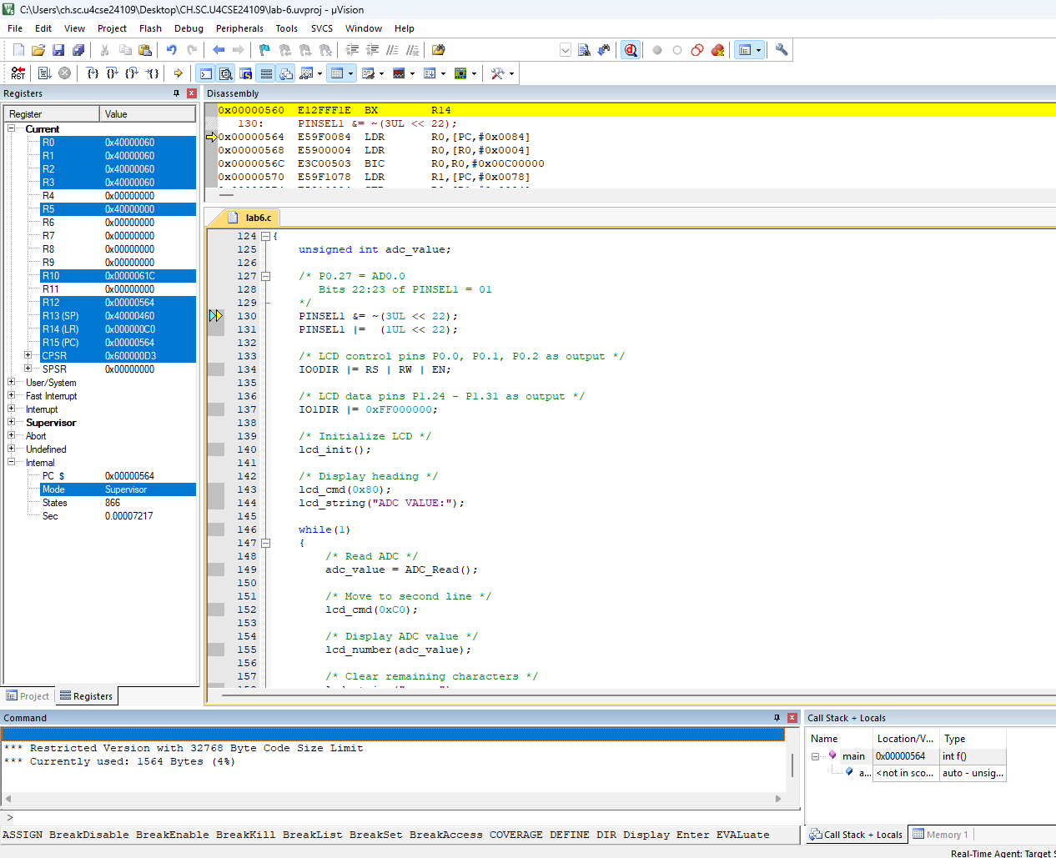

OUTPUT:

