

DEPARTMENT OF COMPUTER SCIENCE AND ENGINEERING

23CSE304 Embedded Systems Laboratory

Activity Sheet #9

Activity Name: Timer Programming

Name of Student: | Chetan Kumar G
Registration No.: | CH.SC.U4CSE24109
Activity Date: | 02|10|2026
Submission Date: | 02|10|2026

Assessment Rubrics:

Component | Maximum Marks | Marks Allotted
Program | 3
Output | 4
Viva | 2
Timely Submission | 1
Total | 10

Faculty In-charge

Write an embedded C program for ARM architecture to drive Timer module. Debug and verify the program using IDE on a development computer system.

PROGRAM:

#include <LPC21xx.H>

#define LED 0x00000001 // P0.0

int main(void)
{
PINSEL0 = 0x00000000;
IO0DIR = LED;

T0TCR = 0x02; // Reset Timer0
T0PR = 0; // Prescaler = 0
T0MR0 = 50000; // Match value (controls toggle speed)
T0MCR = 0x03; // Interrupt flag + reset TC on MR0 match
T0TCR = 0x01; // Enable Timer0

while(1)
{
while(!(T0IR & 0x01));
T0IR = 0x01;
IO0PIN ^= LED;
}
}

OUTPUT WINDOW:

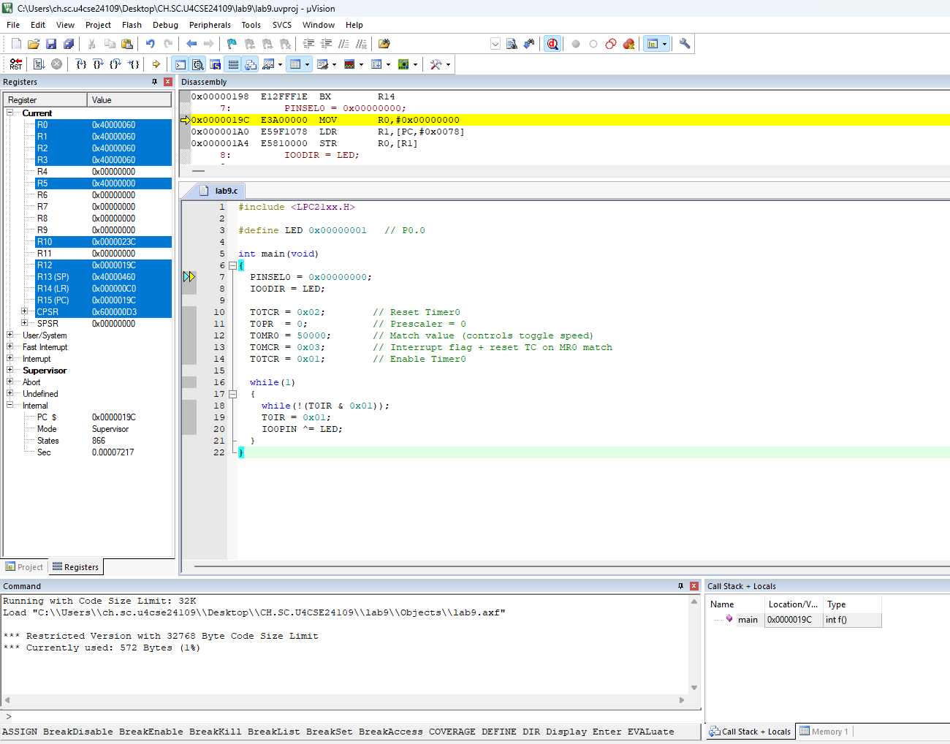

OUTPUT:
