

**SUB: Software Engineering**

**Branch: COMPS B**

|  |  |
| --- | --- |
| **Name :** | **Chetan Deepak Patil** |
| **UID :** | **2023301012** |
| **Expt no :** | **02** |
| **Aim :** | **Use Case Diagram for Online Booking System** |

Table 1: List of Actors

|  |  |
| --- | --- |
| **Actor** | **Description** |
| Customer | The Customer is the individual who uses the food delivery system to order meals from various restaurants. They are the primary end-user and their  experience with the system is crucial for its success. |
| Restaurant | The Restaurant is a business entity that participates in the food delivery  system by offering food items to customers. They are essential for providing the menu options and preparing the ordered food. |
| Admin | The Admin is responsible for overseeing and managing the food delivery system's operations. They ensure that the system runs smoothly, handle user  issues, and manage system-wide settings. |
| Service Provider | The entity offering services available for booking, such as hotels, events, etc. |
| Payment Gateway | A secure platform that processes customer payments through various methods, ensuring transaction safety. |

Table 2: List of Use-Cases

|  |  |  |
| --- | --- | --- |
| **#** | **Use Case** | **Description** |
| UC1 | Browse Restaurants | Customers search for and view a list of available restaurants based on their location or preferences. They can filter and sort options to find suitable dining  choices. |
| UC2 | Browse Menu | Customers view detailed menus of selected restaurants, including item descriptions, prices, and images. This  helps them make informed decisions about what to order. |
| UC3 | Manage Menu | Restaurants add, update, or remove menu items on the platform, including adjusting prices and descriptions. This ensures that the menu reflects the current offerings  and availability. |
| UC4 | Manage Orders | Restaurants receive, review, and process incoming orders from customers. They ensure that all orders are prepared accurately and in a timely manner. |
| UC5 | Update Order Status | Restaurants update the progress of each order, such as “Being Prepared,” “Ready for Delivery,” or “Completed.” This provides customers with real-time  information about their orders. |
| UC6 | Track Order | Customers monitor the status and location of their orders from preparation to delivery. This feature  provides estimated delivery times and updates on the order's journey. |
| UC7 | Make Payment | Customers complete their transactions by paying for their orders using available payment methods, such as credit/debit cards or digital wallets. Secure payment  processing ensures a smooth checkout experience. |
| UC8 | Rate and Review | After receiving their orders, customers can rate their  experience and leave reviews for both the restaurant and delivery service. Feedback helps maintain quality and  improve services. |
| UC9 | Contact Support | Users can reach out to customer support for assistance with issues related to orders, payments, or account  management. Support is available to resolve problems and answer queries. |
| UC10 | Manage Accounts | Users (customers and restaurants) can update personal or business account information, including contact  details, payment methods, and account settings. This ensures that account data is accurate and current. |

Use Case Scenarios:

Table 3: UC1 – Browse Restaurants

|  |  |  |  |  |
| --- | --- | --- | --- | --- |
| Use Case: | UC1. Browse Restaurants | | | |
| Goal: | Enable customers to find and view a list of restaurants based on location, cuisine, or other criteria. | | | |
| Actors: | Customer | | | |
| Pre-condition: | The customer is logged into the system and has access to the restaurant listing. | | | |
| Post-condition: | The customer views a list of restaurants and can select one to browse its menu | | | |
| Mainline Scenario: |  | **Actor Actions** | **System Actions** |  |
| 1. The customer logs into the system. | 1. The system authenticates the customer and provides access. |  |
| 2. The customer enters search criteria (e.g., location, cuisine). | 2. The system processes the  search criteria and retrieves relevant restaurants. |  |
| 3. The customer views the list of restaurants. | 3. The system displays the list of restaurants matching the criteria. |  |
| 4. The customer selects a restaurant to view its menu. | 4. The system retrieves and displays the selected restaurant's menu. |  |
| Alternate Flows: | If no restaurants match the criteria, the system displays a “No results found”  message. | | | |

Table 4: UC2 – Browse Menu

Table 5: UC3 – Make Payment  
  
Use Case: UC3. Make Payment  
Goal: Facilitate secure payment for appointments or reservations using various payment methods.  
Actors: Customer, Payment Gateway  
Pre-condition: The customer has finalized their booking or reservation and is ready to complete the payment.  
Post-condition: Payment is processed successfully, and the transaction is recorded.  
  
Mainline Scenario:  
1. Actor Actions: The customer proceeds to the payment page.  
 System Actions: The system presents the payment options and order summary.  
2. Actor Actions: The customer selects a payment method and enters payment details.  
 System Actions: The system processes the payment securely.  
3. Actor Actions: The customer confirms the payment.  
 System Actions: The system confirms the payment and updates the booking or reservation status.  
4. Actor Actions: The customer receives a confirmation of successful payment.  
 System Actions: The system sends a confirmation receipt to the customer.  
  
Alternate Flows:  
- If payment fails, the system prompts the customer to re-enter payment details or choose an alternative payment method.

|  |  |  |  |  |
| --- | --- | --- | --- | --- |
| Use Case: | UC2. Browse Menu | | | |
| Goal: | Allow customers to view the detailed menu of a selected restaurant, including item descriptions and prices. | | | |
| Actors: | Customer | | | |
| Pre-condition: | The customer has selected a restaurant from the restaurant list. | | | |
| Post-condition: | he customer can view and explore the restaurant's menu items. | | | |
| Mainline Scenario: |  | **Actor Actions** | **System Actions** |  |
| 1. The customer selects a restaurant from the list. | 1. The system retrieves the restaurant's menu information. |  |
| 2. The customer views the menu items, prices, and descriptions. | 2. The system displays the menu details for the selected restaurant. |  |
| Alternate Flows: | If the menu fails to load, the system displays an error message and prompts  the customer to retry. | | | |

Table 5: UC3 – Manage Menu

|  |  |
| --- | --- |
| Use Case: | UC3. Manage Menu |
| Goal: | Allow restaurants to update their menu items, including adding, modifying, or removing dishes. |
| Actors: | Restaurant |
| Pre-condition: | The restaurant is logged in and has access to the menu management interface. |
| Post-condition: | The restaurant's menu is updated with the new or modified items. |
| Mainline Scenario: | **Actor Actions System Actions**   1. The restaurant logs into 1. The system authenticates the the system. restaurant and provides access. 2. The restaurant accesses the menu 2. The system displays the menu management interface. management tools. 3. The restaurant adds, updates, or 3. The system processes the changes removes menu items. and updates the menu. 4. The system confirms that the menu 4. The system confirms and displays has been updated successfully. the updated menu to customers. |
| Alternate Flows: | If the system encounters an error while saving changes, it displays an error message and prompts the restaurant to correct the issue. |

Table 6: UC4 – Manage Orders

|  |  |
| --- | --- |
| Use Case: | UC4. Manage Orders |
| Goal: | Enable restaurants to receive, review, and process incoming customer orders. |
| Actors: | Restaurant |
| Pre-condition: | The restaurant has received new orders from customers. |
| Post-condition: | Orders are processed and prepared as specified by the customers. |
| Mainline Scenario: | **Actor Actions System Actions**   1. The restaurant receives a new 1. The system sends an order order notification. notification to the restaurant. 2. The restaurant reviews the 2. The system displays the order details to order details. the restaurant. 3. The restaurant prepares the order 3. The system updates the order according to the specifications. status to "Being Prepared." 4. The restaurant updates the 4. The system reflects the updated status to order status. the customer. |
| Alternate Flows: | If there is an issue with an order (e.g., missing item), the restaurant contacts the customer for clarification. |

Table 7: UC5 – Update Order Status

|  |  |
| --- | --- |
| Use Case: | UC5. Update Order Status |
| Goal: | Allow restaurants to update the status of orders as they are processed, from preparation to delivery. |
| Actors: | Restaurant |
| Pre-condition: | The restaurant is handling an active order that needs status updates. |
| Post-condition: | The order status is updated and visible to the customer. |
| Mainline Scenario: | **Actor Actions System Actions**   1. The restaurant updates the status of 1. The system processes the an order. status update. 2. The restaurant marks the order as 2. The system updates the “Ready for Delivery” or order status and notifies the   “Completed.” customer.   1. The restaurant confirms the status 3. The system displays the update. updated status to the customer. |
| Alternate Flows: | If there is a delay in updating the status, the system provides an estimated time and updates the customer when available. |

Table 8: UC6 – Track Order

|  |  |
| --- | --- |
| Use Case: | UC6. Track Order |
| Goal: | Enable customers to monitor the real-time status and location of their order from preparation to delivery. |
| Actors: | Customer |
| Pre-condition: | The customer has placed an order and is awaiting delivery. |
| Post-condition: | The customer has up-to-date information on their order’s status and location. |
| Mainline Scenario: | **Actor Actions System Actions**   1. The customer accesses the order 1. The system retrieves the current order tracking feature. status and location. 2. The customer views the 2. The system displays real-time order’s status and location. updates on the order’s status and location. 3. The customer monitors the 3. The system provides updated estimated delivery time. estimates for delivery time. |
| Alternate Flows: | If tracking information is unavailable, the system informs the customer and provides an alternative contact option. |

Table 9: UC7 – Make Payment

|  |  |
| --- | --- |
| Use Case: | UC7. Make Payment |
| Goal: | Facilitate secure payment for the customer’s order using various payment methods. |
| Actors: | Customer |
| Pre-condition: | The customer has finalized their order and is ready to complete the payment. |
| Post-condition: | Payment is processed successfully, and the transaction is recorded. |
| Mainline Scenario: | **Actor Actions System Actions**   1. The customer proceeds to 1. The system presents the payment the checkout page. options and order summary. 2. The customer selects a 2. The system processes the payment payment method and enters payment securely.   details.   1. The customer confirms 3. The system confirms the payment the payment. and updates the order status. 2. The customer receives a 4. The system sends a confirmation confirmation of successful payment. receipt to the customer. |
| Alternate Flows: | If payment fails, the system prompts the customer to re-enter payment details or choose an alternative payment method. |

Table 10: UC8 – Rate and Review

|  |  |
| --- | --- |
| Use Case: | UC8. Rate and Review |
| Goal: | Allow customers to provide feedback and rate their experience with the restaurant and delivery service. |
| Actors: | Customer |
| Pre-condition: | The customer has received their order and is ready to leave feedback. |
| Post-condition: | The restaurant and delivery service receive the customer’s rating and review. |
| Mainline Scenario: | **Actor Actions System Actions**   1. The customer 1. The system retrieves the review submission navigates to the review interface.   section.   1. The customer selects a   rating and writes a 2. The system processes the review submission. review.   1. The customer submits 3. The system updates the restaurant’s and   the review. delivery service’s review scores and displays a  confirmation message. |
| Alternate Flows: | If the review submission fails, the system notifies the customer and allows them to retry. |

Table 11: UC9 – Contact Support

|  |  |
| --- | --- |
| Use Case: | UC9. Contact Support |
| Goal: | Provide a means for users to get assistance with issues related to their orders, payments, or accounts. |
| Actors: | Customer, Restaurant |
| Pre-condition: | The user has an issue or question requiring support. |
| Post-condition: | The user’s issue is addressed or a response is provided by the support team. |
| Mainline Scenario: | **Actor Actions System Actions**   1. The user accesses the support 1. The system provides options for contact feature. contacting support. 2. The user describes the issue 2. The system logs the support request and submits the support request. and forwards it to the support team. 3. The user receives a response 3. The system updates the user with a from the support team. resolution or further instructions. |
| Alternate Flows: | If support is unavailable, the system informs the user and provides alternative contact methods or times. |

Table 12: UC10 – Manage Accounts

|  |  |
| --- | --- |
| Use Case: | UC10. Manage Accounts |
| Goal: | Allow users to update their personal or business account information, including contact details and payment methods. |
| Actors: | Customer, Restaurant |
| Pre-condition: | The user is logged into their account and has access to account settings. |
| Post-condition: | The user's account information is updated and saved. |
| Mainline Scenario: | **Actor Actions System Actions**   1. The user logs into 1. The system authenticates the user their account. and provides access to account settings. 2. The user navigates to the account 2. The system displays the account management section. settings options. 3. The user updates personal or business 3. The system saves the updated information. information. 4. The system confirms that the account 4. The system displays a information has been updated successfully. confirmation message. |
| Alternate Flows: | If there is an error while saving changes, the system alerts the user and prompts them to correct the issue. |

Use Case Diagram :-

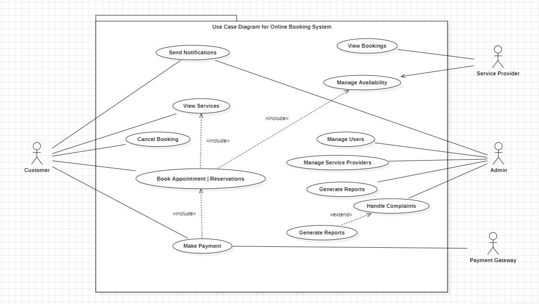

Level 1

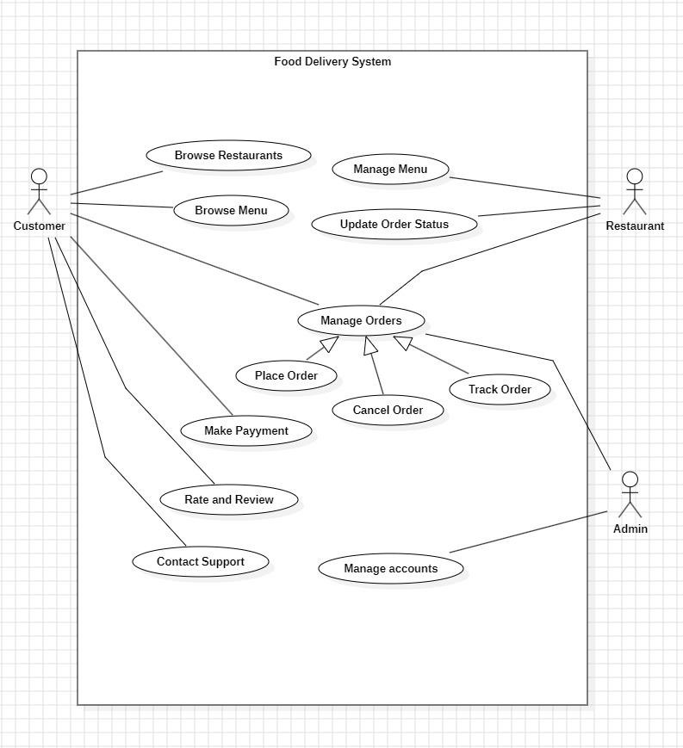

Level 2

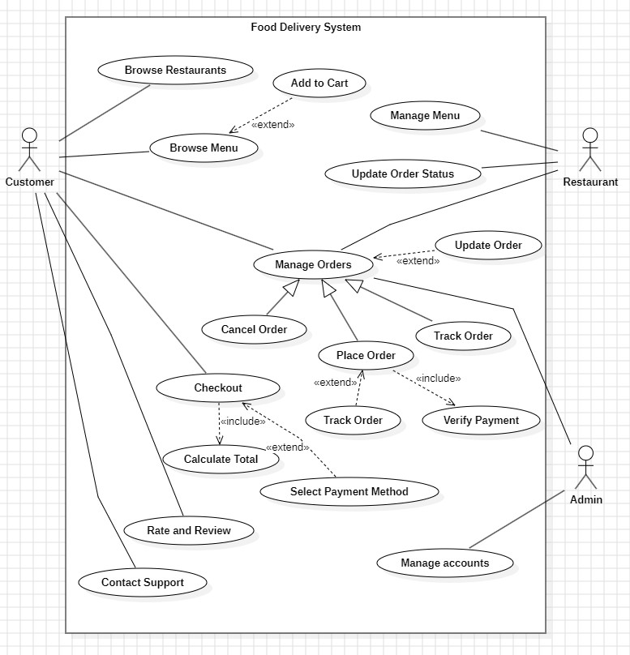

Conclusion ;-

From the above experiment, we have learned how to implement a Use case diagram based on Use case scenarios.