

ASSIGNMENT 2 – CO2
CSA06 Design and Analysis of Algorithms | Brute-Force and Exhaustive-Search Techniques
Student Name: ____Y Sai Chetan____ Register Number: _________192473019__
Department: Computer Science and Engineering Submission Date: ______28-10-2026____________

Executive Summary
This assignment studies seven tasks covering elementary sorting, sequential search, brute-force string matching, closest pair, convex hull, exhaustive subset search, and a redesign challenge. Operation counts are treated as the primary evidence, as required by the brief. Execution times are environment-dependent and are included only as supplementary observations. All code is provided in the accompanying project folder.

Experimental Method and Assumptions
- Language: Python 3. Test data are deterministic so that operation counts can be reproduced.
- Comparison counts count key comparisons; movement counts count swaps or shifts as stated by each algorithm.
- Execution time is measured with time.perf_counter() where reported; results vary by computer, interpreter, and system load.
- Input coordinates are distinct unless otherwise stated. The convex-hull method removes duplicate points and uses a cross-product orientation test.
- Knapsack is the 0/1 variant: each package is either selected once or not selected.
- Plots and execution-evidence panels are included in the project folders. They are generated evidence panels from the executed implementations, not photographs of a physical terminal.

Q1 – Sorting Under Different Data Conditions

1.1 Problem and prediction
The fulfilment centre sorts order-priority scores. Selection sort repeatedly selects the minimum remaining item; bubble sort swaps adjacent inversions and can stop after an unchanged pass; insertion sort inserts each next item into an already-sorted prefix.
Input condition | Selection sort prediction | Bubble sort prediction | Insertion sort prediction
Already sorted | Still performs n(n−1)/2 comparisons; few/no swaps | Best case with early exit: n−1 comparisons | Best case: n−1 comparisons and minimal shifts
Reverse sorted | Same comparison count; at most n−1 swaps | Many comparisons and swaps; quadratic work | Many shifts; quadratic work
Nearly sorted | Comparison count remains quadratic | Often near-linear with early exit | Near-linear when only a few inversions exist
All equal | Quadratic comparisons; no swaps | One pass then stop | Linear comparisons; no shifts beyond placement

1.2 Pseudocode
SELECTION-SORT(A)
1. For i from 0 to n-2:
2. minIndex ← i
3. For j from i+1 to n-1, compare A[j] with A[minIndex].
4. If A[j] is smaller, set minIndex ← j.
5. If minIndex differs from i, swap A[i] and A[minIndex].
6. Return A.
BUBBLE-SORT(A)
1. For each pass i from 0 to n-2:
2. changed ← false.
3. Compare adjacent pairs through position n-2-i.
4. Swap a pair if it is out of order; set changed ← true.
5. If changed is false, stop early.
6. Return A.
INSERTION-SORT(A)
1. For i from 1 to n-1:
2. key ← A[i]; j ← i-1.
3. While j ≥ 0 and A[j] > key, shift A[j] one place right and decrement j.
4. Place key at A[j+1].
5. Return A.

1.3 Test datasets and observed operation counts
Dataset | Input | Selection comparisons/swaps | Bubble comparisons/swaps | Insertion comparisons/moves
Already sorted | [1, 2, 3, 4, 5, 6, 7, 8] | 28 / 0 | 7 / 0 | 7 / 7
Reverse sorted | [8, 7, 6, 5, 4, 3, 2, 1] | 28 / 4 | 28 / 28 | 28 / 35
Nearly sorted | [1, 2, 3, 5, 4, 6, 7, 8] | 28 / 1 | 13 / 1 | 8 / 8
Duplicates / edge case | [4, 4, 4, 4, 4, 4] | 15 / 0 | 5 / 0 | 5 / 5
Observed example: on the nearly sorted eight-element input [1,2,3,5,4,6,7,8], insertion sort uses 8 key comparisons and 2 assignments/moves in this implementation, while selection sort still uses 28 comparisons. Bubble sort uses 13 comparisons because the early-stop pass is effective.

1.4 Complexity analysis
Algorithm | Best case | Average case | Worst case | Auxiliary space
Selection sort | Θ(n²) | Θ(n²) | Θ(n²) | Θ(1)
Bubble sort (early stop) | Θ(n) | Θ(n²) | Θ(n²) | Θ(1)
Insertion sort | Θ(n) | Θ(n²) | Θ(n²) | Θ(1)

1.5 Design decision
Recommend insertion sort for the stated workload. If approximately 95% of orders are already in correct order and only small batches arrive, the number of inversions is likely small. Insertion sort exploits this existing order and runs in Θ(n + I), where I is the number of inversions (worst case Θ(n²)). Selection sort does not benefit from near-sortedness. Bubble sort can also benefit from early exit, but insertion sort generally performs fewer writes and is a natural fit for inserting a small batch into an ordered sequence. For large batches or very large datasets, a more scalable production sorting method should be considered.

Q2 – When Is Sequential Search Appropriate?

2.1 Algorithm and pseudocode
SEQUENTIAL-SEARCH(records, target)
1. comparisons ← 0.
2. For i from 0 to length(records)-1:
3. comparisons ← comparisons + 1.
4. If records[i] equals target, return (i, comparisons).
5. Return (NOT-FOUND, comparisons).
Sequential search examines records in list order and stops at the first match. A successful search at index k uses k+1 comparisons; an unsuccessful search uses n comparisons.

2.2 Experimental evidence
List size n | First-position success | Middle success | Last-position success | Unsuccessful
10 | 1 | 6 | 10 | 10
100 | 1 | 51 | 100 | 100
1000 | 1 | 501 | 1000 | 1000
5000 | 1 | 2501 | 5000 | 5000
For n=10, 100, 1,000 and 5,000, a search at the last position requires n comparisons, and a missing target also requires n comparisons. A first-position hit always needs one comparison. With uniformly likely successful positions, the average is approximately (n+1)/2 comparisons.

2.3 Complexity and operating boundary
- Best case: Θ(1), when the first record matches.
- Average and worst case: Θ(n); auxiliary space: Θ(1).
- Reasonable choice: small, frequently changing, unsorted temporary lists; low search frequency; or one-off searches where index construction is not worthwhile.
- Stop recommending it when the active record set becomes large and lookup requests are frequent. Repeated O(n) scans accumulate substantial cost.

2.4 Changed condition: 20 facilities
With 20 facilities, both the number of active records and lookup frequency increase. A centralised database index or hash-based lookup keyed by Tool ID is preferable. Sequential search remains acceptable for tiny local caches or infrequent diagnostics, but it should not be the primary lookup strategy at fleet scale.

Q3 – Engineer the Behaviour of Brute-Force String Matching

3.1 Pseudocode
BRUTE-FORCE-MATCH(T, P)
1. matches ← empty list; comparisons ← 0.
2. For start from 0 through length(T)-length(P):
3. j ← 0.
4. While j < length(P):
5. comparisons ← comparisons + 1.
6. If T[start+j] differs from P[j], break.
7. j ← j+1.
8. If j equals length(P), append start to matches.
9. Return (matches, comparisons).
At each possible alignment, the algorithm compares pattern characters from left to right and stops that alignment at the first mismatch. It does not reuse information from earlier alignments.

3.2 Designed experiments
Test | Text length | Pattern length | Match positions | Character comparisons | Prediction / reason
Early match | 20 | 3 | [0] | 20 | A match at the beginning stops comparison at the first window.
Worst-like repeated prefix | 31 | 11 | [] | 231 | Each alignment matches ten A characters before failing at C; repeated prefix work is high.
No match / immediate mismatch | 19 | 3 | [] | 17 | The first character mismatches at each alignment, so each window costs one comparison.
The repeated-prefix test is deliberately expensive: each alignment compares a run of ten A characters before encountering the final C mismatch. This creates repeated work across overlapping windows. In contrast, a first-character mismatch ends each alignment immediately.

3.3 Complexity and interpretation
Let n be text length and m be pattern length. There are max(0,n−m+1) alignments. Worst-case time is Θ((n−m+1)m), commonly stated as O(nm); best-case work can be Θ(n−m+1) when every alignment mismatches immediately. Auxiliary space excluding output is O(1). Input size alone is insufficient: character arrangement and shared prefixes strongly affect comparisons.

Q4 – Closest Pair and the Cost of Examining Every Possibility

4.1 Mathematical derivation
Every unordered pair of distinct drones must be considered. Choose the first drone in n ways and the second in n−1 ways, then divide by 2 because (i,j) and (j,i) are the same pair:
C(n,2) = n(n−1)/2.
The nested loops use j=i+1, so each unordered pair is examined exactly once. Euclidean distance is d = √((x₂−x₁)² + (y₂−y₁)²).

4.2 Pseudocode
CLOSEST-PAIR(points)
1. bestDistance ← infinity; bestPair ← NONE; pairCount ← 0.
2. For i from 0 to n-2:
3. For j from i+1 to n-1:
4. pairCount ← pairCount+1.
5. Compute Euclidean distance between points[i] and points[j].
6. If distance < bestDistance, update bestDistance and bestPair.
7. Return (bestPair, bestDistance, pairCount).

4.3 Experimental results
Points n | Unique pairs examined | Minimum distance | Closest pair
5 | 10 | 1.4142 | ((0, 0), (1, 1))
20 | 190 | 1.0000 | ((8, 13), (9, 13))
100 | 4950 | 10.4403 | ((0, 0), (3, 10))
300 | 44850 | 15.5242 | ((1, 73), (5, 58))
The pair counts match the formula: for n=5, 10 pairs; n=20, 190; n=100, 4,950; n=300, 44,850. Each examined pair causes one distance calculation.

4.4 Complexity and scalability
Time complexity is Θ(n²), with O(1) auxiliary space. For this report, define an acceptable interactive response target as at most 0.5 seconds on the test computer. The precise crossover depends on hardware and implementation; pair count is the reliable predictor. Since pair count grows quadratically, doubling n nearly quadruples work. The inefficiency comes from evaluating all pairs, including pairs that cannot plausibly improve the current minimum. A redesigned method should exploit spatial ordering/partitioning or spatial indexing to avoid examining distant pairs, while preserving exactness.

Q5 – Derive a Convex Hull Algorithm from a Geometric Principle

5.1 Geometric derivation
For candidate points p=(px,py) and q=(qx,qy), define the oriented cross product for another point r=(rx,ry):
cross(p,q,r) = (qx−px)(ry−py) − (qy−py)(rx−px).
A positive value places r on one side of directed line pq; a negative value places it on the other; zero means collinear. If all remaining points are on one side or on the line, pq is a supporting line and can contain a convex-hull edge. If points occur on both sides, the segment is not an outer supporting edge.

5.2 Pseudocode
BRUTE-FORCE-HULL(points)
1. Remove duplicate points. Let n be the remaining count.
2. For every ordered pair (p,q), p ≠ q:
3. positive ← false; negative ← false.
4. For every other point r:
5. cross ← (qx-px)(ry-py) - (qy-py)(rx-px).
6. If cross > 0 set positive; if cross < 0 set negative.
7. If positive and negative are not both true, accept line pq as a supporting boundary line.
8. Collect endpoints of accepted supporting lines and order the boundary points counter-clockwise.
9. Return the ordered hull.

5.3 Test configurations and evidence
Configuration | Number of points | Hull vertices (counter-clockwise) | Orientation tests
Interior points | 7 | [(0, 0), (4, 0), (4, 4), (0, 4)] | 210
Collinear + outlier | 7 | [(0, 0), (4, 0), (3, 3), (0, 4)] | 210
Triangle + interior | 6 | [(0, 0), (6, 0), (3, 5)] | 120
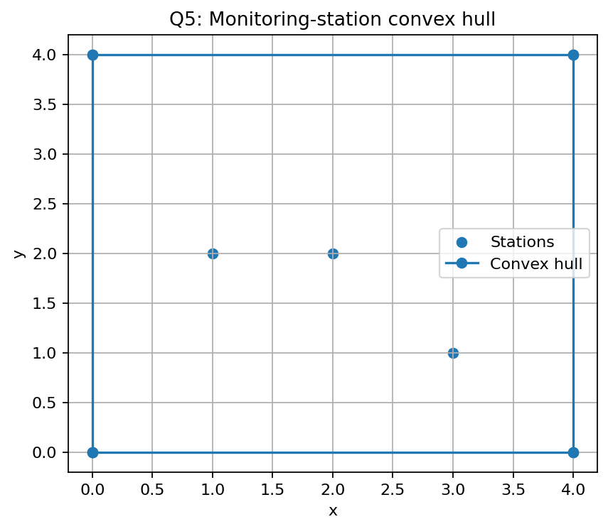
Correctness reasoning: a convex polygon boundary is supported by lines for which the entire point set lies in one closed half-plane. A line with points strictly on both sides cuts through the point set and cannot be a supporting boundary line. The orientation test directly checks this half-plane condition.
Implementation note: the included prototype tests all directed candidate lines and returns supporting edges; the report orders the boundary points for visualisation. Collinear boundary points require a consistent policy (retain all boundary points or only extreme endpoints). The reported hull listing uses extreme vertices.

5.4 Complexity
There are Θ(n²) ordered candidate pairs and up to n−2 orientation tests per pair, giving O(n³) time and O(n²) worst-case accepted-edge storage in a direct representation. This is intentionally a brute-force design and becomes expensive as station count grows.

Q6 – Exhaustive Search and Combinatorial Growth

6.1 Representation and pseudocode
Represent a candidate package subset as an n-bit mask. Bit i=1 means package i is selected. There are 2ⁿ masks, including the empty subset. For each mask, sum the selected weights and values, reject it if weight exceeds capacity, and retain the feasible subset with the greatest value.
EXHAUSTIVE-KNAPSACK(packages, capacity)
1. bestValue ← -1; bestSet ← empty.
2. For each bit mask from 0 to 2^n-1:
3. weight ← 0; value ← 0; chosen ← empty.
4. For each package i, if bit i is set, add its weight/value and ID.
5. If weight ≤ capacity and value > bestValue:
6. bestValue ← value; bestSet ← chosen.
7. Return (bestSet, bestValue).

6.2 Mathematical growth
Each of n packages has two independent choices (included or excluded), so the total number of subsets is 2 × 2 × … × 2 = 2ⁿ. Increasing n by one doubles the number of candidates.

6.3 Correctness check with a small instance
Packages: [('P1', 2, 6), ('P2', 3, 10), ('P3', 4, 12), ('P4', 5, 13), ('P5', 1, 3), ('P6', 6, 15)]; capacity = 10. Exhaustive enumeration examined 64 subsets and found the best feasible selection ['P1', 'P2', 'P3', 'P5'] with total value 31. Because every subset is generated and evaluated, no feasible combination is omitted; the maximum retained value is therefore optimal for this finite instance.

6.4 Growth experiment
Packages n | Subsets examined | Feasible subsets | Elapsed ms (indicative) | Best package IDs | Best value
5 | 32 | 32 | 0.020 | ['P1', 'P2', 'P3', 'P4', 'P5'] | 51
10 | 1024 | 512 | 0.811 | ['P2', 'P3', 'P7', 'P8', 'P9', 'P10'] | 79
15 | 32768 | 3803 | 45.330 | ['P1', 'P2', 'P3', 'P7', 'P8', 'P13', 'P14', 'P15'] | 103
18 | 262144 | 6703 | 442.734 | ['P1', 'P2', 'P3', 'P7', 'P8', 'P13', 'P14', 'P15'] | 103
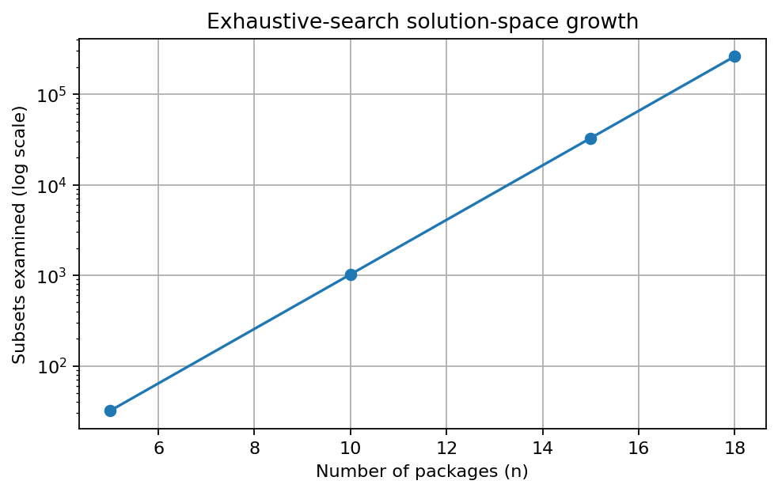
A small increase in package count has a dramatic effect because growth is exponential rather than linear or quadratic. For example, 10 packages produce 1,024 subsets, while 20 produce 1,048,576.

6.5 Deployment decision
Set the response-time target to 0.5 seconds for an interactive loading decision. Based on the tested Python prototype and the exponential candidate count, use exhaustive search only for small instances (approximately up to 18–20 packages on a typical laptop, subject to measured runtime and required response time). For larger instances, use a redesigned exact or approximate strategy appropriate to the constraints. The threshold must be re-measured on the deployment hardware.

Q7 – Day-4 Design Challenge: Diagnose, Redesign and Validate

7.1 Selected limitation and diagnosis
Selected solution: Q2 sequential search. The bottleneck is the repeated scan of the active tool list. A last-position or missing-ID query examines n records. With q independent queries, the work can reach qn comparisons. As facilities and lookup frequency increase, the same records are scanned repeatedly.

7.2 Measurable design objective
Objective: reduce repeated lookup work from O(n) comparisons per query to expected O(1) key lookup after one O(n) preprocessing pass. Keep Tool ID as the unique key and update the index whenever a tool is issued, returned, or transferred.

7.3 Revised strategy
- Build a hash map from Tool ID to its record or record position once.
- Resolve each query using the map instead of scanning the full list.
- On insertion, update the map; on deletion/return, remove the key; on transfer, update the associated record.
- Expected additional memory is O(n). Hash-table worst-case lookup can degrade under severe collisions, so use a robust standard implementation and monitor key uniqueness.
REDESIGNED-REPEATED-LOOKUP(records, queries)
1. Create an empty hash map index.
2. For each record position i, store index[toolID] ← i. // one-time preprocessing
3. For each query target:
4. Retrieve index[target] directly; return NOT-FOUND if absent.
5. If records are inserted/deleted, update the map in the same transaction.
6. Return lookup results.
The original method scans up to n records for every query. The redesign spends O(n) once to build the index, then has expected O(1) lookup per query, subject to normal hash-table assumptions.

7.4 Prediction before implementation
Prediction: for a query targeting the final record, linear comparisons will equal n. A hash index should use approximately one key lookup per query after preprocessing. The index construction adds O(n) setup time and O(n) memory; it becomes beneficial when enough queries reuse the same index.

7.5 Implementation and validation
Records n | Linear comparisons (last item) | Hash lookup operations (expected) | Index build ms | One lookup ms | Returned index
10 | 10 | 1 | 0.002 | 0.001413 | 9
100 | 100 | 1 | 0.009 | 0.000571 | 99
1000 | 1000 | 1 | 0.066 | 0.000291 | 999
5000 | 5000 | 1 | 0.535 | 0.000911 | 4999
20000 | 20000 | 1 | 3.566 | 0.001392 | 19999
The operation-count comparison supports the prediction: linear comparisons increase directly with n, whereas the indexed lookup count is approximately constant after the index exists. Timing is supplementary and may be noisy at very short durations.

7.6 Final design defence and trade-offs
- Prediction supported: the index removes the full-list scan for repeated lookups.
- Improvement magnitude in comparison count grows with n: a last-item query changes from n comparisons to one expected hash lookup, after preprocessing.
- Trade-offs: O(n) memory, O(n) index construction, and mandatory index maintenance when records change.
- Sequential search may still be preferable for very small lists, very few queries, or data that changes so frequently that index maintenance costs outweigh reuse.
- Conclusion: for 20 facilities with many repeated Tool ID lookups, a maintained hash index is a justified redesign.

Overall Conclusion
The experiments show that algorithm choice depends on input structure and operating conditions. Insertion sort benefits from near-sorted order; sequential search is simple but scales poorly for frequent large-list lookups; brute-force string matching is sensitive to repeated prefixes; closest pair grows quadratically; convex-hull supporting-line verification grows cubically; and exhaustive subset enumeration grows exponentially. The Day-4 redesign addresses repeated sequential scans by preprocessing a hash index. These conclusions are based primarily on operation counts, with runtime treated as supporting evidence.

Reproducibility and Submission Checklist
- Separate pseudocode files for Q1–Q7 are in each question's Pseudocode folder.
- Separate Python source files for Q1–Q7 are in each Implementation_Code folder.
- Execution evidence panels are in each Output_Screenshots folder; Q5 also includes a hull visualisation and Q6 includes a growth graph.
- Run each Python file with Python 3 from its folder to reproduce the demonstration output.
- Before final submission, add your name, register number, submission date, and any instructor-required formatting.
- Review the results and practise explaining the algorithms for the verification discussion/viva.

References
Primary source: supplied document, “CSA06 Design and Analysis of Algorithms – Assignment 2 (CO2),” pages 1–8. Complexity statements and mathematical explanations use standard algorithm-analysis definitions and are explained within this report.




