JOIN Queries

1.Displaying the valid products who qty is between greater than 0 and less than 3.

select user_no,prod_id,services.ser_no FROM product

NATURAL JOIN services where (services.qty>0 and services.qty<3);

Front end execution:

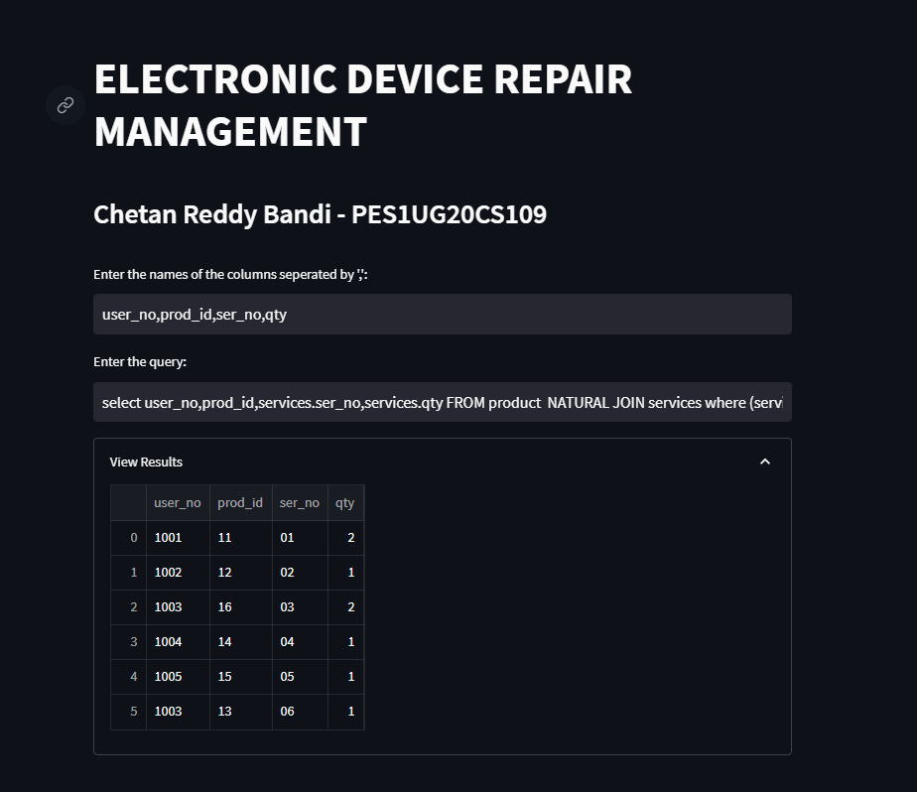

Backend execution:

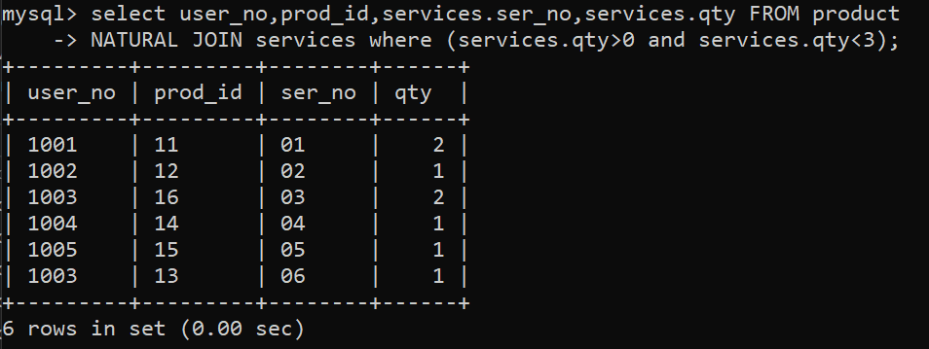

2. **Displaying user details who have product name as laptop.**

**Query:**

select user_no,fname ,lname , sex , phone_no , dob, age ,email,product.prod_id,product.name

FROM user_details NATURAL JOIN product where product.name="Laptop";

**Result:**

**Front end**

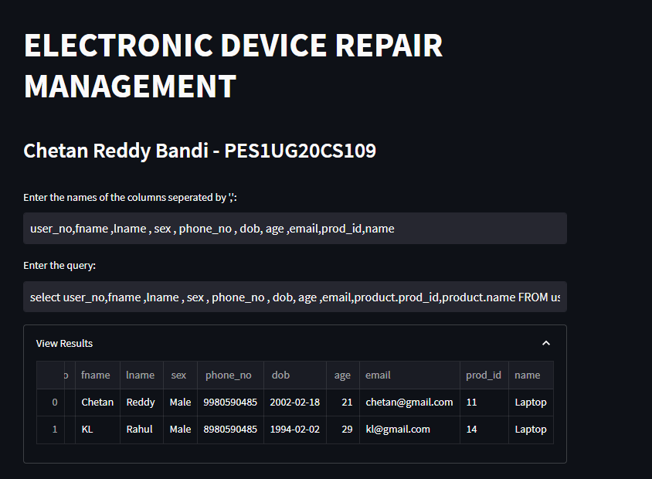

Backend:

