Procedure: update age of the user

--used to update the age of the users.

DELIMITER $$

CREATE procedure age_updation_f(

IN u_no varchar(30),IN DB date, OUT msg varchar(30))

BEGIN

DECLARE age int;

IF DB>sysdate() THEN

    set msg= 'Invalid DOB';

ELSE

update user_details

set Age=(datediff(sysdate(),DB))/365

where user_no= u_no;

update user_details

set dob=DB

where user_no=u_no;

set msg='Age updated Successfully';

END IF;

END;$$

DELIMITER ;

CALL age_updation_f('1001','2002-02-18',@A);

SELECT @A;

select * from user_details where user_no='1001';

s

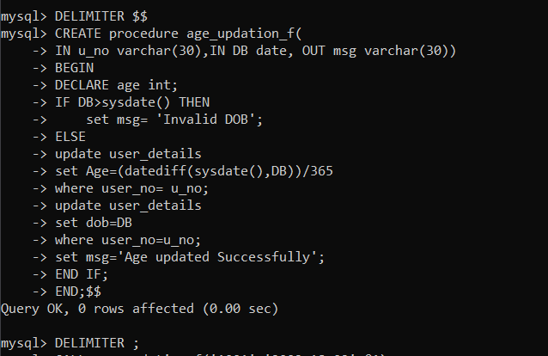

Before update:

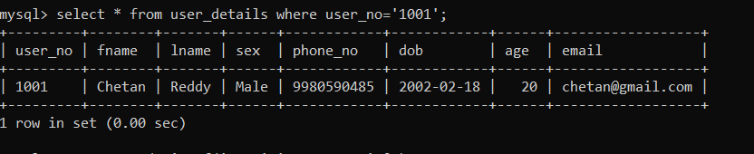

After update:

