|  |  |
| --- | --- |
| A picture of a winding road and trees  Agile Group Project  Google Map Service | Team  Chetan Sharma, Karanbir Singh and Harmanjit Singh |

Contents

Introduction 2

Project Members 2

Time Schedule 2

Agile Methodology 3

Pages and Mock-ups 3

Home Page 3

Base Map Page 4

Distance Calculator Page 4

Live Location Page 5

Testing 5

Conclusion and Future Work 5

# Introduction

The main aim of this project is the design of an agile / scrum mobile application named Google Map Service. We have created an application for finding live locations, maps, and directions. In this application GooglePlay Services. Maps library is used to find the locations as per the user’s choice.

# Project Members

To increase the effectiveness of the application, five team members are participating in a different role that is given in the below table:

|  |  |
| --- | --- |
| Name of Team Member | Role |
| Karanbir Singh | Team Leader , Application Tester |
| Chetan Sharma | Front and Back End Developer |
| Harmanjit Singh | Web Designer |
|  |  |

# Time Schedule

|  |  |  |  |  |  |  |  |  |  |  |  |  |  |  |  |
| --- | --- | --- | --- | --- | --- | --- | --- | --- | --- | --- | --- | --- | --- | --- | --- |
| **Stages** | **Activities** | **Duration**  **Week1-2** | | | | **Duration**  **Week-2-3** | | | | | **Duration**  **Week-3-4** | | | | |
| Project Planning | Research |  |  |  |  |  |  |  |  |  |  |  |  |  |  |
| Start of Meeting |  |  |  |  |  |  |  |  |  |  |  |  |  |  |
| Project Proposal and documentation |  |  |  |  |  |  |  |  |  |  |  |  |  |  |
| Project Execution | Application Design |  |  |  |  |  |  |  |  |  |  |  |  |  |  |
| UI Design |  |  |  |  |  |  |  |  |  |  |  |  |  |  |
| coding |  |  |  |  |  |  |  |  |  |  |  |  |  |  |
| Testing |  |  |  |  |  |  |  |  |  |  |  |  |  |  |
| Final | Documentation and Report |  |  |  |  |  |  |  |  |  |  |  |  |  |  |

# Agile Methodology

The Agile methodology is used in this project as an alternative to traditional approaches. This strategic approach is highly effective and pragmatic and addresses technology's changing needs.

Our group used the agile / scrum method in this project. The team members originally identify and follow all requirements. The team then decided to implement the GoogleMap Service special feature to satisfy users ' needs.

There have been many changes to make this software more user-friendly. The app is available for customers after all updates have been created.

# Pages and Mock-ups

## Home Page

This is the main page of the application. On this page there are four buttons map, locate me, distance calculator, and quit. With the help of this page, the user can select the option as per their choice.

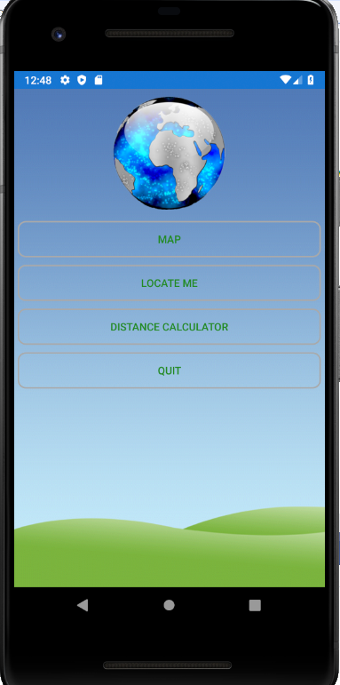

# Base Map Page

With the help of this page users can find a base map which is any particular location on a map. For example, the user decided to open the New Zealand map and on the map of NZ one can easily locate Auckland.

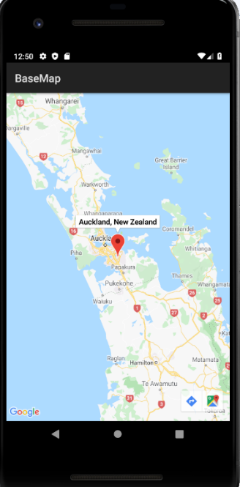

# Distance Calculator Page

With the help of this page, the user can calculate the distance between two cities. For example, in the given screenshot the distance between Auckland and Wellington is shown as 493KM.

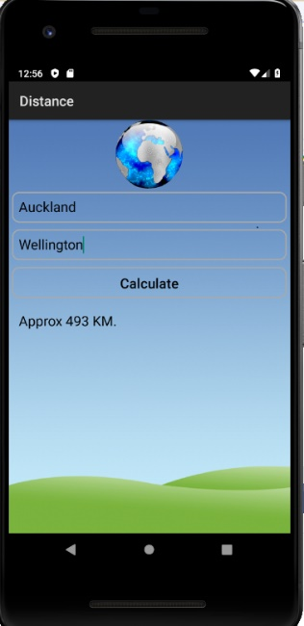

# Live Location Page

With the help of this page or feature, one can send their live location to their friend or family. With the help of this page, the user can send the latitude and longitude information and can share it

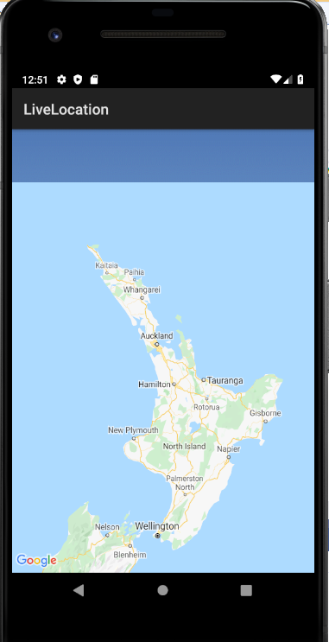

# Testing

Due to the limited time available, we just conducted the usability testing of the project which can be found at [Usability Testing.xls](Usability%20Testing.xls)

# Conclusion and Future Work

In brief, this project is based on the agile scrum method used by the IT group to create the so-called Google Map Service Android app. Because of the limited time, we only build a small framework. However, this application can be further improved, by adding a back button. The live location services sometimes don’t work, which can be improved.