**Dev Environment Setup**

1. **Download the Visual Studio Code**[**https://code.visualstudio.com/download**](https://code.visualstudio.com/download)
2. **Download the Python latest version**[**https://www.python.org/downloads/**](https://www.python.org/downloads/)while installtion select “Add Python to environment variable”  
   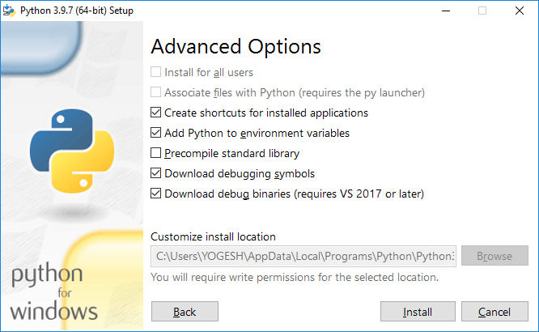
3. **Install Python Extension in Visual Studio Code  
   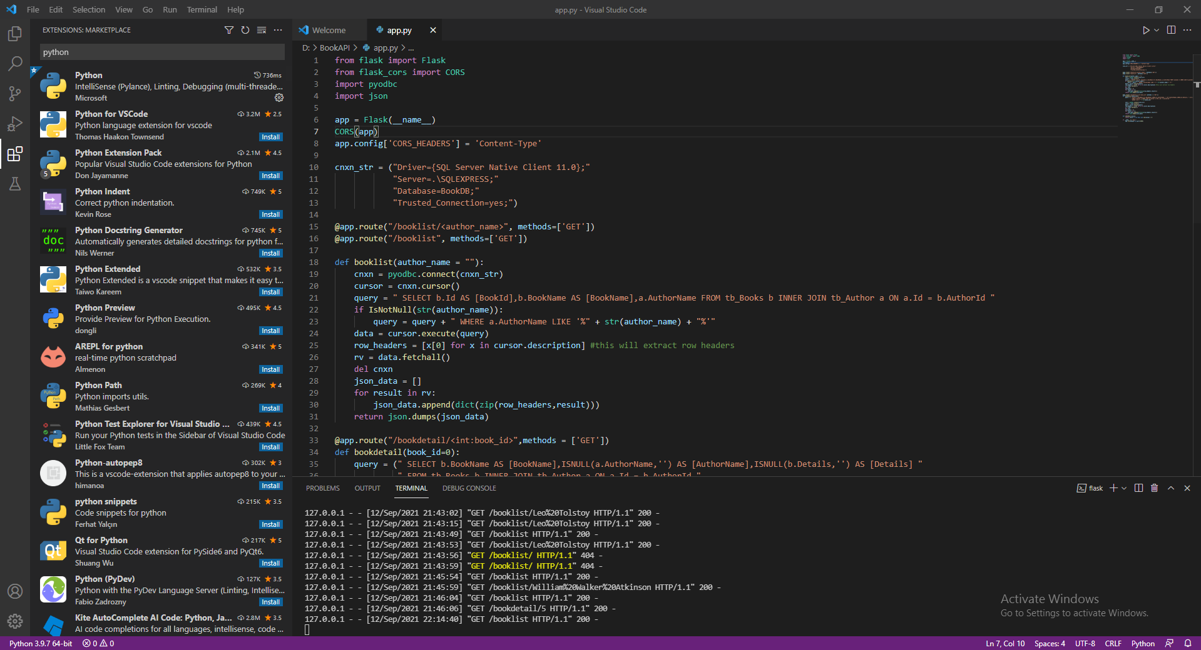**
4. **Execute the following command in the terminal of Visual Studio Code**pip install Flask  
   pip install flask-cors
5. **Install the SQL Server 2008 R2**
6. **Open file “app.py” in Visual Studio Code**
7. **Change the connection string**
8. **And Run API by using the following command in ternimal**

flask run

1. **Open HTML file in Visual Studio Code and change the API url in the following files**1. BookList.html

2. BookDetail.html

1. **Run the BookList.html file**