Detection Of Number Plates using Image Processing Techniques and EasyOCR.

I. Introduction
License plate recognition using image processing technology has been attracting attention in recent years due to its wide range of applications in various fields such as traffic enforcement, law enforcement, parking management, and vehicle tracking.
However, advances in image processing and computer vision technology have made automatic license plate recognition systems a reliable and efficient solution.
These systems use advanced algorithms and techniques to extract and recognize license plate information from image or video streams.
In the localization step, the system identifies and isolates the region of interest containing the license plate within the image or video frame.
Once the license plate area is successfully identified, the detection step begins.
License plate recognition using EasyOCR.
We’ll talk about different stages included in this project.

A. Image Acquisition :
First, the Image is Acquired using traditional image input methods. Here, we use Python opencv for each stage of the project.


Figure1: Input Image

B. Conversion of Image To grayscale :
For further Pre-Processing image needs to be converted to grayscale, converting an image to grayscale is a common

preprocessing step that simplifies the image and reduces its complexity by removing color information. Grayscale images
are represented using only shades of gray, ranging from black to white, without any color variations.

C. Removal Of Noise :
Noise removal is an important pre-processing step,
It enables us to remove the unwanted random variations and un-even distributions in the image, This will allow the program to apply later pre-processing steps with greater accuracy.

D. Edge Detection :
Edge detection is a fundamental process in image processing that aims to identify and highlight the boundaries or transitions between different objects or regions in an image. The edges represent significant changes in intensity, color, or texture, and they provide valuable information about the structure and content of the image. Edge detection plays a vital role in various image processing tasks and applications, including image segmentation, object recognition, feature extraction, and image understanding.

E. Finding Contours :
In image processing, a contour is a curved line that represents the boundary of an object or region in an image. Contours are used to detect, analyze and represent the shape and structure of objects or regions of interest in an image.
Here are some important properties and uses of contours in image processing.

F. Use EasyOCR to read the text :
Using a pre-trained image-to-text model EasyOCR,
We detect the output number plate cropped image through the EasyOCR interface which gives us the output of the detected text.

II. CONVERSION OF IMAGE TO GRAYSCALE
In image processing, converting an image to grayscale is a common preprocessing step to simplify the image and reduce complexity by removing color information. A grayscale image is rendered with only shades of gray from black to white, with no color variations.

There are several reasons why grayscale conversion is used in image processing.

1. Simplification of image data:
Grayscale images reduce data complexity by removing color information. Each pixel in a grayscale image is represented by a single intensity value, typically ranging from 0 (black) to 255 (white). This simplification makes it easier to perform various image processing operations such as filtering, edge detection, and segmentation.

2. Reduced dimensions:
Color images typically have three color channels (red, green, and blue), so they have three times the amount of data compared to grayscale images. Converting an image to grayscale reduces the dimensionality of the data and increases the computational efficiency of processing and analysis.

3. Focus on structural information:
For many image processing tasks such as edge detection and feature extraction, structural information and patterns in images are more important than color information. Grayscale images accentuate intensity variations, allowing the algorithm to focus on structural details rather than being overwhelmed by color variations.

4. Compatibility and Efficiency:
Grayscale images require less memory and computing resources than color images. This makes grayscale images more suitable for applications with limited memory and processing power. Additionally, grayscale images often assume a single-channel input, making them compatible with a wide variety of image processing algorithms and techniques.

5. Recognition and Interpretation:
Human vision is more sensitive to variations in brightness and contrast than to variations in color. Grayscale images can effectively represent the luminance information of an image, facilitating the interpretation and analysis of visual content.

It is important to note that converting an image to grayscale is not always necessary or desirable. Following is converted image :

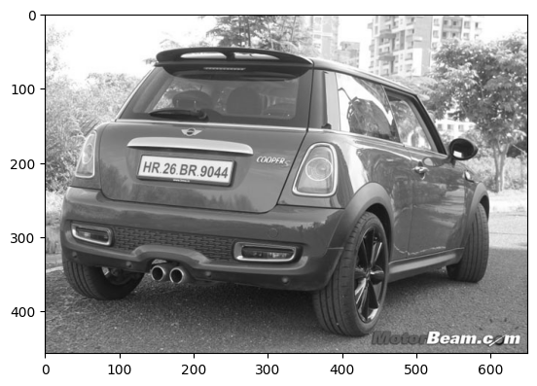
Image Converted to Grayscale.

We have used in-built open cv library to convert the image to grayscale:

gray = cv2.cvtColor(img, cv2.COLOR_BGR2GRAY)

III. REMOVAL OF NOISE
Noise can come from a variety of sources, including electronic sensors, transmission interference, environmental factors, and imperfections in the recording or acquisition process. These sources can introduce random variations and errors into the signal, affecting the quality, clarity and accuracy of the processed information.

Different types of noise can affect the signal and image in different ways. The most common types of noise are:

1. Gaussian noise:
Also called white noise, the values ​​are randomly distributed according to a Gaussian or normal distribution. Gaussian noise is characterized by equal power at all frequencies and a mean value of zero.
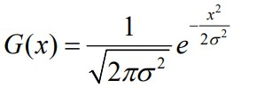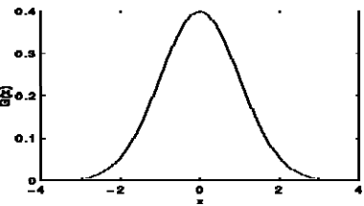

PDF of Gaussian Noise Graph of Gaussian Noise

2. Salt & Pepper Sound:
This type of noise appears as random black-and-white pixels in the image. Often caused by bad pixels or transmission errors, the image can be severely distorted.

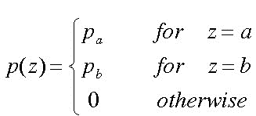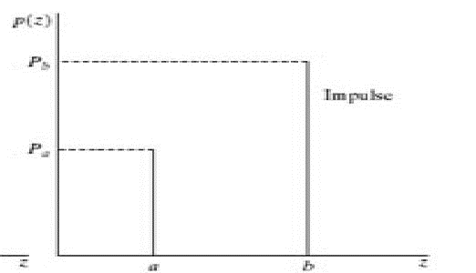

PDF* of salt and pepper Noise Graph of salt and pepper Noise

3. Gamma noise:
The gamma distribution is a continuous probability distribution commonly used to model the latency of a certain number of events occurring in a Poisson process.

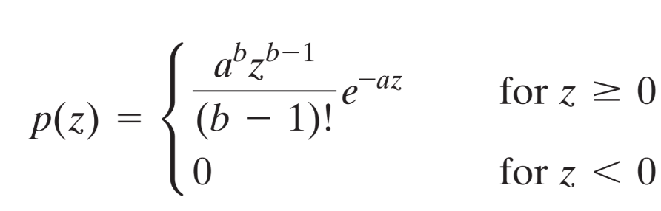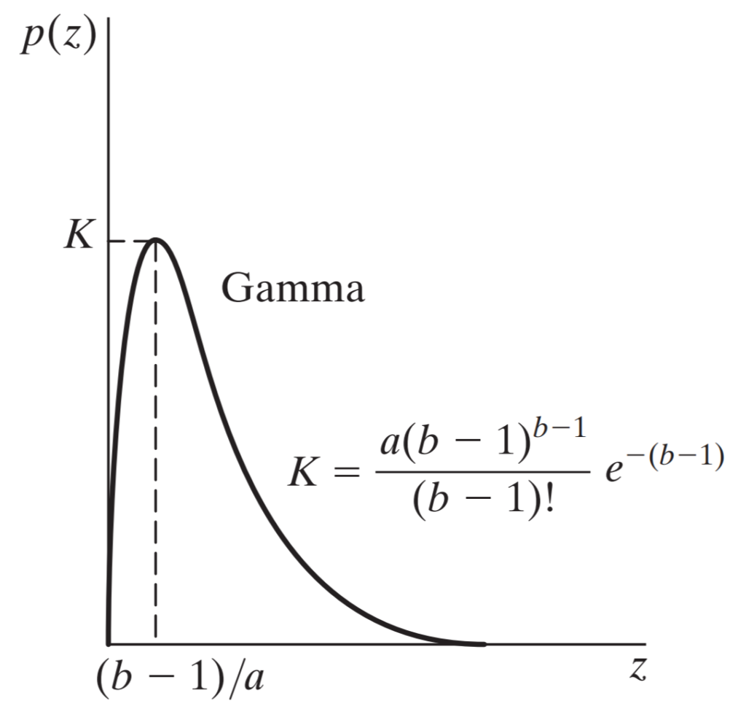

PDF of uniform Noise Graph of uniform Noise

4. Rayleigh noise:
Rayleigh noise is primarily caused by multipath propagation.
Multipath propagation occurs when radio waves travel multiple paths and encounter reflections, refractions, and scattering from various objects such as buildings, trees, and other obstacles in the propagation environment.

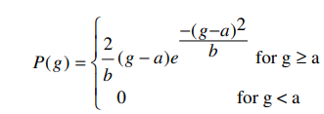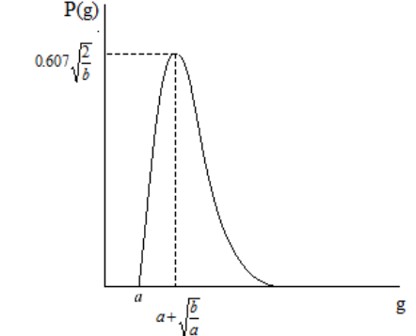

pdf of Rayleigh Noise Graph of Rayleigh Noise

We have used Opencv’s in-built noise removal method called “BILATERAL_FILTER” .
Noise Removed.

bfilter = cv2.bilateralFilter(gray, 11, 17, 17) #Noise reduction

IV. EDGE DETECTION
Here are some of the main reasons why edge detection is important in image processing.

1. Object boundaries:
Edges correspond to the boundaries of objects or regions in the image. By detecting and extracting these boundaries, edge detection helps separate different objects and regions, enabling further analysis and processing of specific regions of interest.

2. Shape and structure analysis:
Edges provide important cues about the shape and structure of objects in an image. Analysis and characterization of these edges is useful for object detection, shape matching, and geometric measurement.

3. Feature extraction:
Edges often capture salient features of images such as corners, transitions, and texture changes. Extraction of these features by edge detection is important for various tasks such as image matching, object tracking, and image registration.

4. Segmentation:
Edge detection is an important step in image segmentation, the purpose is to divide the image into meaningful regions or objects. Identifying edges makes it easy to separate different objects or regions based on their boundaries. 5. Compression and encoding:
Edges contain important visual information and their preservation is very important in image compression and encoding schemes. By accurately detecting and encoding edges, you can achieve higher compression ratios while maintaining good visual quality.

6. Image Enhancement:
Edges can be enhanced or enhanced to improve the overall visual quality of the image. Emphasizing edges can make an image look sharper, sharper, and more visually appealing.

Edge detection algorithms and techniques differ in their approach and complexity. Commonly used edge detection methods include gradient-based approaches such as Sobel, Prewitt, and Roberts operators, and more advanced approaches such as the Canny edge detector, which combines multiple steps to provide robust and accurate edge detection. includes a method.

Overall, edge detection plays an important role in image processing by providing important information about object boundaries, shape, structure, and features. This enables a wide range of applications and facilitates further analysis and understanding of image content.

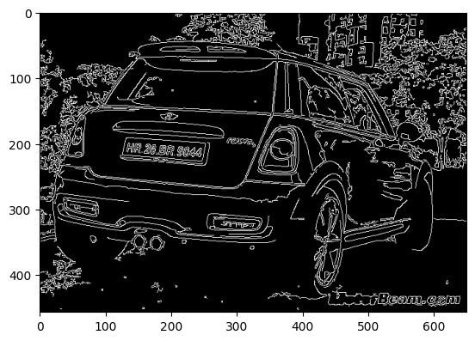
Edges Detected

For the Purpose of Edge Detection, we used Canny Edge Detection.

edged = cv2.Canny(bfilter, 30, 200) #Edge detection

Process
The process of the Canny edge detection algorithm can be broken down into five different steps:

- Apply a Gaussian filter to smooth the image in order to remove the noise
- Find the intensity gradients of the image
- Apply gradient magnitude thresholding or lower bound cut-off suppression to get rid of spurious response to edge detection
- Apply a double threshold to determine potential edges
- Track edge by hysteresis: Finalize the detection of edges by suppressing all the other edges that are weak and not connected to strong edges.

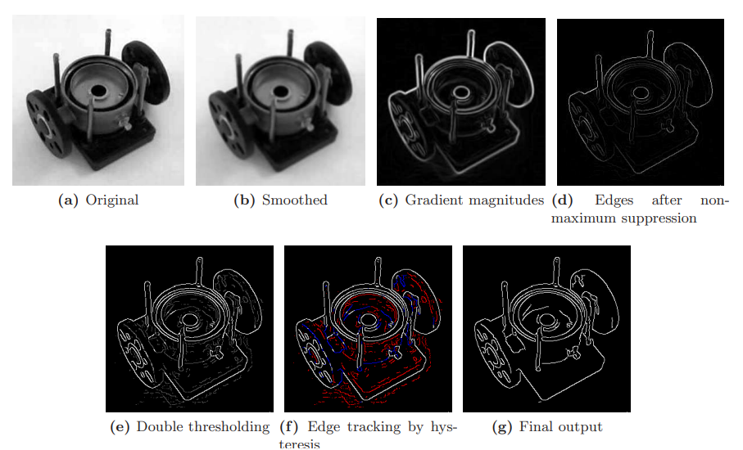
Figure2:Stages of Canny Filter

V. FIND CONTOURS AND APPLYING A MASK
In image processing, a contour is the outline or boundary of an object or region within a digital image.
A contour is represented as a series of connected points or coordinates that form a curve that encloses an object or area of ​​interest.
Image processing uses contour detection algorithms to extract and display contours from the input image.
The most popular contour detection algorithm is the Canny edge detector mentioned in a previous answer.
Canny Edge Detector detects edges in an image and can process these edges further to extract contours.
These models use an energy function that compensates for contour smoothness and attractiveness to image edges, allowing them to fit complex object shapes.
A contour matching algorithm allows you to compare and recognize objects based on their shape.
In this case, the interior of the contour represents a specific object or region of interest.

1: Contour display:
Contours can be represented in different ways, depending on the application and the specific algorithm used.
OpenCV, a popular computer vision library, represents contours as a set of points or a hierarchy of contours.

2: Contour hierarchy:
Many images may have multiple objects or regions, and the contours can be interrelated.
A contour hierarchy represents these relationships and helps you analyze and organize your contours.

3: Contour features:
Various geometric and statistical properties can be calculated from contours to describe objects and regions.

4: Contour filtering and selection:
Contour filtering applies criteria to select or reject contours based on certain properties.


Figure3: Contours Detection

keypoints = cv2.findContours(edged.copy(), cv2.RETR_TREE, cv2.CHAIN_APPROX_SIMPLE)
contours = imutils.grab_contours(keypoints)
contours = sorted(contours, key=cv2.contourArea, reverse=True)[:10]
Contour Detection Code using OpenCV

In our input image we programmed the algorithm to detect only contours which has 4 sides.

The contours which consist of 4 sides are most probably our number plates because all the number plates are of rectangle shape.

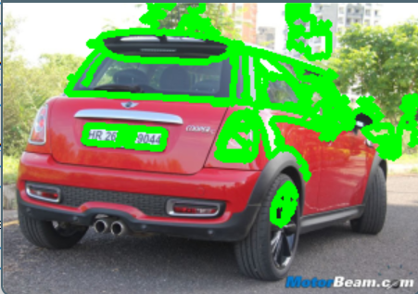

Contour Detected

After contour detection, we stored all the contours in a BTREE.

Then we Sorted the Contours. Sorting the contours gave us the most important contour values.

We retained only top 30 contours.
For the purpose of extracting the cropped image of our number plate, we have to use some sort of Mask.

MASKING :

Masking in image processing is the technique of selectively applying or removing certain parts of an image based on a binary mask.
A mask is a binary image that acts as a stencil or template, specifying which pixels or regions of the original image to keep, change, or discard.
The masking process involves combining the original image with the mask using bitwise operations such as bitwise AND, bitwise OR, or bitwise XOR.
A mask specifies which pixels to keep (if the mask is white) or discard (if the mask is black) to allow selective editing or analysis of specific regions.
A binary mask (usually a grayscale or color image) is created and each pixel is assigned a value of either 0 (black) or non-zero (white).
White areas in the mask indicate regions or pixels of interest that are retained or modified, and black areas represent portions that are discarded or unchanged.
The mask is combined with the original image using bitwise operations.

Bitwise XOR: Combines the original image and mask, discarding pixels common to both.

Bitwise NOT: Inverts the mask and swaps black and white areas.
After applying the mask to the original image, you can perform various operations on the resulting masked image.

mask = np.zeros(gray.shape, np.uint8)
new_image = cv2.drawContours(mask, [location], 0,255, -1)
new_image = cv2.bitwise_and(img, img, mask=mask)
Code of Masking in OpenCV

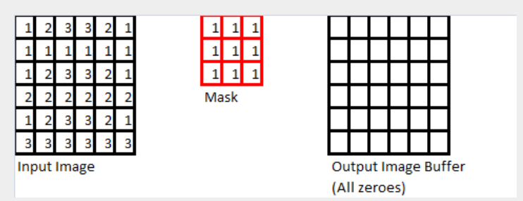
Figure4: Manually Masking on a 6*6 image

In our input image we applied mask and we get the following output:
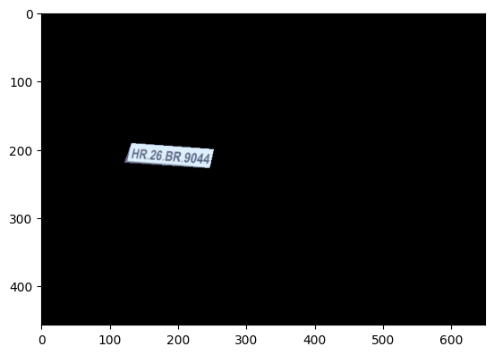
Output after applying mask

As we can see the after we applied contour detection, we get the top contour as the number plate.

The contour detection gave us the (x,y) coordinates of image start.

And it also gave us the height and width values.

Using these values we can then Appy mask and get the cropped image as shown above.

The Output is still not pre-processed. So we take the outputed image and pass it through pre-processing steps.

After Applying the Pre-processing we get the cropped image of our number plate.

The output is given as:

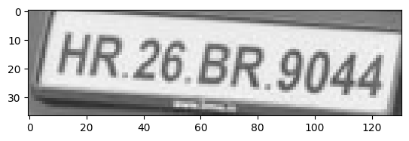
Output Image of Number plate after Pre-Processing

VI. USING EASY OCR TO DETECT THE TEXT FROM THE IMAGE
Optical Character Reader (OCR), also known as optical character recognition, is a technology that converts printed or handwritten text into machine-readable text.
OCR software or systems use image processing techniques and pattern recognition algorithms to recognize and extract characters from scanned documents, images, or other sources.
Image Acquisition:
A source document containing text is scanned or captured with an optical scanner or digital camera.
Pretreatment:
Captured images are pre-processed to improve text quality and readability.
Techniques such as edge detection, connected component analysis, or text recognition algorithms are used to locate text regions.
Character splitting:
The text area is further processed to segment individual characters.
Character recognition:
Once the characters are segmented, the OCR system uses pattern recognition algorithms to recognize and classify each character.
The final output of an OCR system is the converted text, which can be used for various purposes such as text searching, data extraction, indexing, or further processing.
OCR technology has a wide range of applications, including document digitization, automatic data entry, document indexing, text-to-speech conversion, and machine translation.
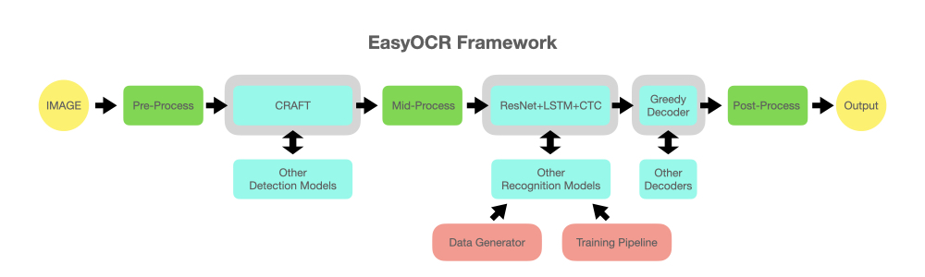
Figure5: EasyOCR Framework
Now, using the generated image of the cropped number plate through Optical Character Reader Here, We are using EasyOCR which is a pre-trained software used to detect the text from the input image.
For this Purpose, We performed pre-processing steps on the image .
The output wee get after applying the code with input image of cropped Number plate is:
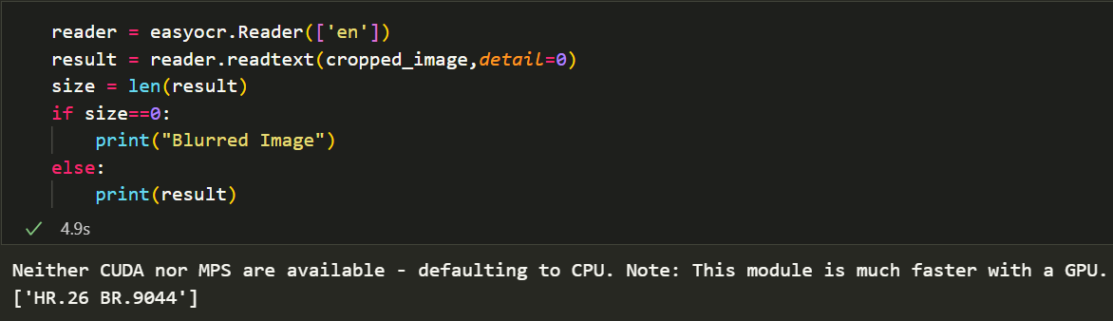 Output after applying code.
We can see that the output we get after applying the code is the number plate.
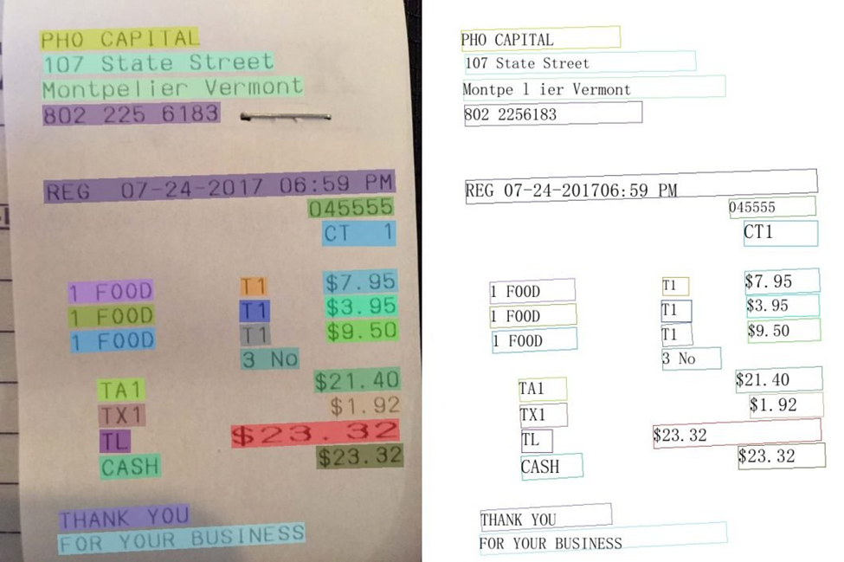
Figure7: Example Easy OCR detecting text from image
Reference

Figure1 : https://gomechanic.in/blog/number-plates-in-india/
Figure2 : https://medium.com/@ssatyajitmaitra/what-canny edge-detection-algorithm-is-all-about-103d94553d21
Figure3 : https://learnopencv.com/contour-detection-using-opencv-python-c/
Figure4 : https://www.giassa.net/?page_id=588
Figure5 : https://www.analyticsvidhya.com/blog/2021/06/text-detection-from-images-using-easyocr-hands-on-guide/
Figure6 : https://www.analyticsvidhya.com/blog/2021/06/text-detection-from-images-using-easyocr-hands-on-guide/

