Hiring Process Analytics

**Introduction-**

Hiring process is the fundamental and the most important function of a company. Here, the MNCs get to know about the major underlying trends about the hiring process. Trends such as- number of rejections, number of interviews, types of jobs, vacancies etc. are important for a company to analyze before hiring freshers or any other individual. Thus, making an opportunity for a Data Analyst job here too!  
  
Being a Data Analyst, your job is to go through these trends and draw insights out of it for hiring department to work upon.  
  
You are working for a MNC such as Google as a lead Data Analyst and the company has provided with the data records of their previous hirings and have asked you to answer certain questions making sense out of that data.

**Approach-**

I Exported all the datasets into excel sheet to start analyzing data I used pivot tables,pivot charts and formulae to get the useful data.

**Hiring:** Process of intaking of people into an organization for different kinds of positions.  
**Your task:** How many males and females are Hired ?

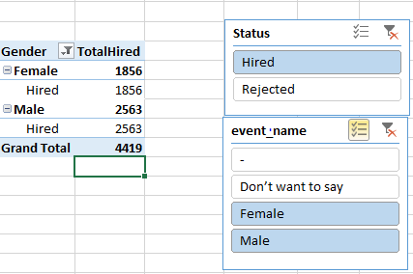

I used pivot table with count function to get the output and applied slicer so that I can get only the hired male and female data.

**Average Salary:** Adding all the salaries for a select group of employees and then dividing the sum by the number of employees in the group.

**Your task:** What is the average salary offered in this company ?



I used formula “=average(HiringData[offeredSalary]) “

**Class Intervals:** The class interval is the difference between the upper class limit and the lower class limit.  
**Your task:**Draw the class intervals for salary in the company ?

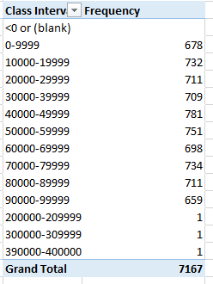

In this also is used pivot table then group the offered salary in between 0-400000 range in between gab 10000 and for frequency count function.

**Charts and Plots:**This is one of the most important part of analysis to visualize the data.  
**Your task:**Draw Pie Chart / Bar Graph ( or any other graph ) to show proportion of people working different department ?

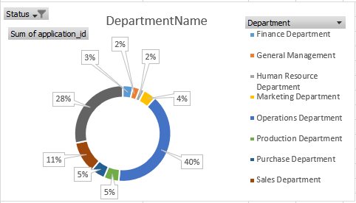

I used Pivot Chart to show this pie diagram I used label options to show the department proportions in percentage.

**Charts:**Use different charts and graphs to perform the task representing the data.  
**Your task:**Represent different post tiers using chart/graph?

