Graphics and Visualization

Chetan

10/11/2021

#For Accessing all the inbuilt datasets in the R.

# ls(package:datasets)

#For Loading datasets

# data("name of the dataset")

#For Accessing the Attributes in the datasets in the R.

# attributes("name of the dataset")

#For Accessing the Attiributes of the perticular columns of dataset in the R.

# attributes("name of the dataset$perticular col name")

#Line Chart.

x=c(14,22,8,19,42)  
y=c(12,23,45,23,23)  
plot(y,type="o",col="red",xlab="Months",ylab="rain Fall",main="Rain Fall Chart")

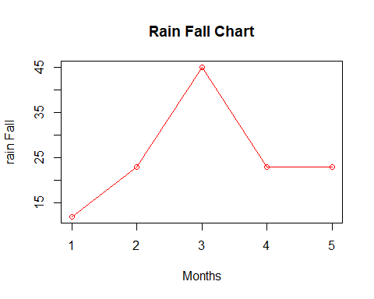

#Multiple Line Chart

x=c(14,22,8,19,42)  
y=c(12,23,45,23,23)  
plot(y,type="o",col="red",xlab = "Months",ylab="rain Fall",main="Rain Fall chart")  
lines(x,type="o",col="blue")

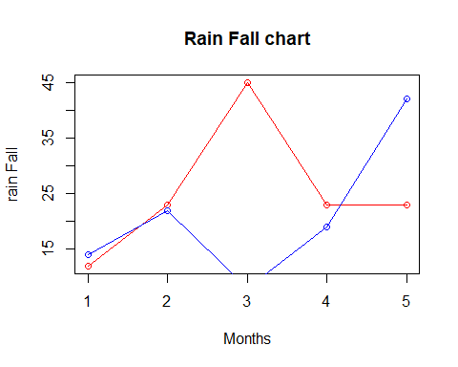 #Barplot

x=c(122,345,567,987,234,546,677,980,334,147,890,444)  
m=month.name  
barplot(x,names.arg = m,col=7,xlab ="Months",ylab="Revenue",main="Revenue Vs Months")

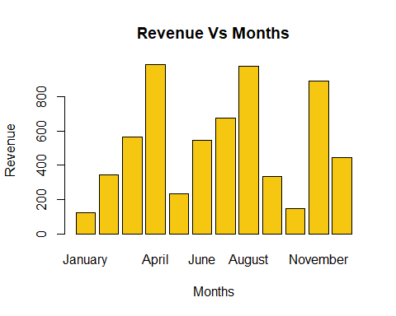 #Multiple Barplot

color=c("red","yellow","blue")  
States=c("Maharastra","Rajasthan","kerala")  
years=c(month.name[1:5])  
high_temp=matrix(c(35,40,31,43,51,39,48,52,42,45,48,39,34,39,37),nrow=3)  
b=barplot(high_temp,names.arg=years,xlab="years",ylab="max temeparature",main="Max temp of the states 2015-2021",col=color)  
legend("topright",States,cex=0.5,fill = color)

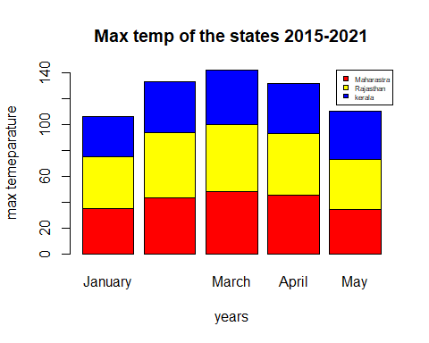 #Histogram

data("airquality")  
# attributes(airquality)  
hist(airquality$Temp,xlab="Temperature",ylab="frequency count",col=6,main="Histogram of temperature in airqulality dataset",probability = TRUE)  
# to draw the density line we have to add probability= TRUE in hist() function.  
lines(density(airquality$Temp))

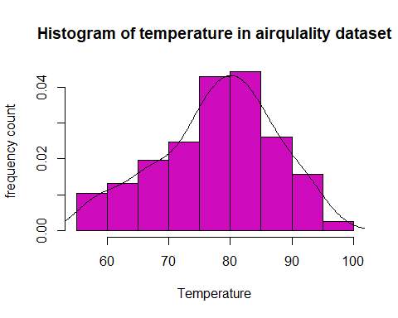 #using breaks command.

#without breaks  
hist(cars$dist)

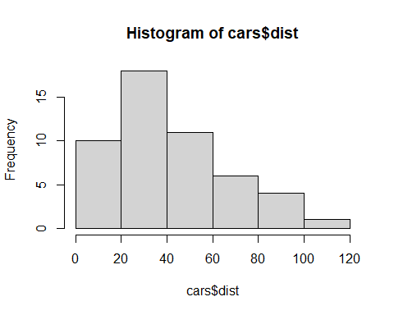

# with breaks command  
data("cars")  
brk=seq(0,120,5)  
hist(cars$dist,main="Distance",breaks = brk,probability = TRUE)  
  
lines(density(cars$dist))

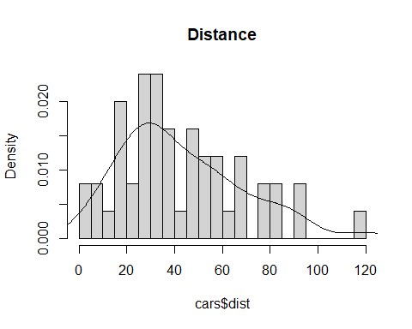 #Scatter Plot.

x=seq(1,50,5)  
y=seq(2,51,5)  
par(mfrow=c(2,2))  
plot(x,y,type="o")  
plot(x,y,type="l")  
plot(x,y,type="b")  
plot(x,y,type="c")

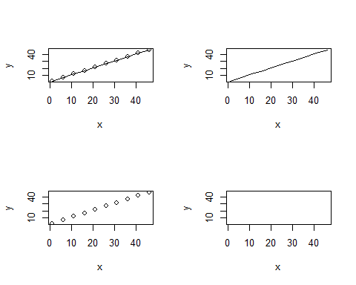

data("airquality")  
par(mfrow=c(2,2))  
plot(airquality$Temp,airquality$Ozone,col="red")  
plot(airquality$Temp,airquality$Ozone,col="blue",type="b")  
plot(airquality$Temp,airquality$Ozone,col="yellow",type="c")  
plot(airquality$Temp,airquality$Ozone,col="black",type="l")

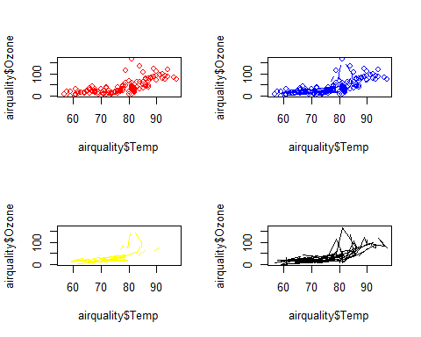 #Dotplot/Dotchart

# a dot chart or dot plot is same as the scatter plot. the main difference is that the dot plot in R displays the index(each category) in vertical axis and the corresponding value in the horizontal axis.

data("cars")  
plot(cars$dist,cars$speed,main="Distance Vs Speed" )

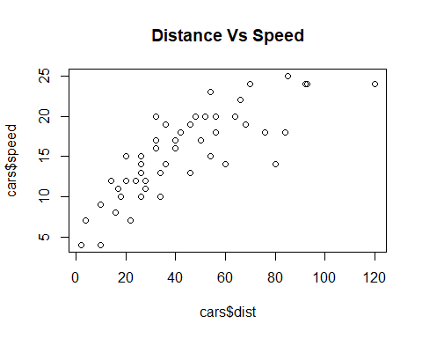

#Boxplot

data("sleep")  
# sleep$extra~sleep$group :y axis on x axis  
boxplot(sleep$extra~sleep$group,xlab="group no.",ylab="Extra sleeping hours",main="boxplot comparing Numetical data with categorical data")

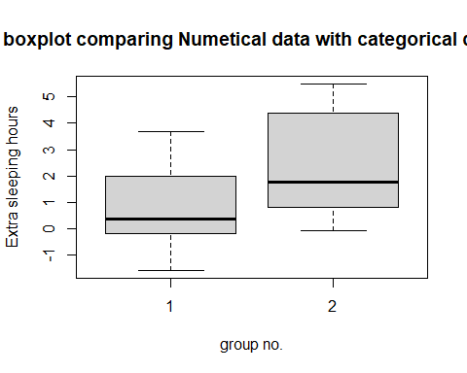 #Pie Chart.

States_label=c("Maharastra","Kerala","Tamilnadu","Bihar","jharkhand","Lakshdweep")  
literacy=c(82,94,80,61,66,91)  
label=round(c(100*literacy/sum(literacy),1))  
pie(literacy,labels =paste0(label,"%"),main="Pie Chart Of the no of college of States",col=rainbow(length(literacy)))  
legend("topright",States_label,fill=rainbow(length(literacy)))

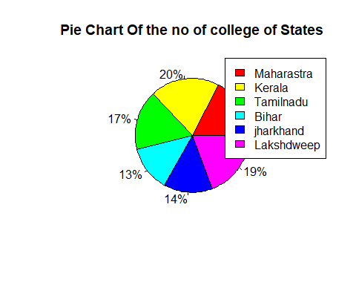 #labeling count with percentages.

States_label=c("Maharastra","Kerala","Tamilnadu","Bihar","jharkhand","Lakshdweep")  
literacy=c(82,94,80,61,66,91)  
label=round(c(100*literacy/sum(literacy),1))  
pie(literacy,labels =paste(literacy,"=",label,"%"),main="Pie Chart Of the no of college of States",col=rainbow(length(literacy)))  
legend("topright",States_label,fill=rainbow(length(literacy)))

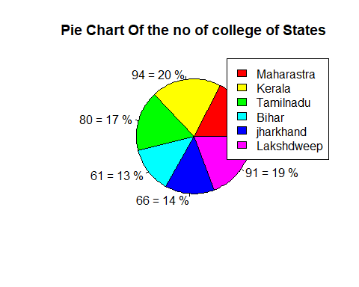 #Pie chart with categorical data.

gender=factor(c(rep("Male",10), rep("Female",20)))  
pie(table(gender),main = "Male and Female ",col =c(5,7))  
legend("topright",c("Male","Famale"),fill = c(5,7))

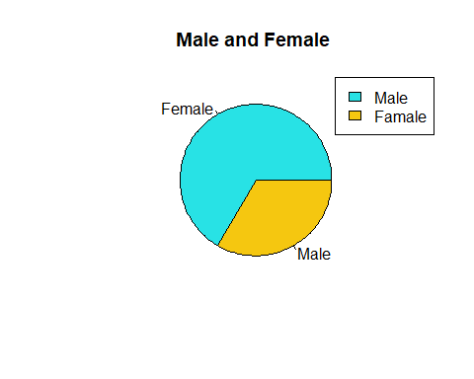 #Pairs Plot.

data("airquality")  
pairs(airquality)

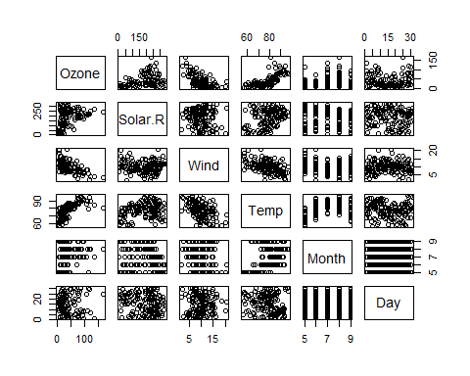 #Stem-Leaf Plot:

# A Stem and Leaf Diagram, also called Stem and Leaf plot in R, is a   
# special table where each numeric value split into a stem (First digit(s) ) and a leaf (last   
# Digit). Stem and Leaf plot is a technique of displaying the frequencies with which some   
# classes of values may occur.  
data("iris")  
stem(iris$Petal.Length)

##   
## The decimal point is at the |  
##   
## 1 | 012233333334444444444444  
## 1 | 55555555555556666666777799  
## 2 |   
## 2 |   
## 3 | 033  
## 3 | 55678999  
## 4 | 000001112222334444  
## 4 | 5555555566677777888899999  
## 5 | 000011111111223344  
## 5 | 55566666677788899  
## 6 | 0011134  
## 6 | 6779

#3D -Plots

library(plotrix)  
countries=c("United States","China","Japan","Germany","U.k","France","India","Italy")  
gdp=c(20.49,13.4,4.97,4,2.83,2.78,2.72,2.070)  
pie3D(gdp,labels=countries,main="GDP of top coounties",col=c(2:9))  
legend("topleft",countries,fill = c(2:9),cex = 0.6)

