**Design Development and Evaluation of Electronic Broom for Household Cleaning**

*Akash Shekhavat, Madhuri Shelke, Chetan Shinde, Shripad Bhatlawande, Swati Shilaskar  
 Dept. of Electronics and Telecommunication Engineering  
 Vishwakarma Institute of Technology  
 Pune, India*

*{akash.shekhavat20, madhuri.shelke20, chetan.shinde20, shripad.bhatlawande, swati.shilaskar}@vit.edu*

***Abstract: Cleanliness is a very vital aspect of our life, of which household cleaning plays an important role. With the increasing demand for automated cleaning solutions, electronic bots have become an attractive option for many households. These bots are designed to navigate and clean various surfaces, minimizing the need for human intervention. However, traditional electronic bots have limitations, such as inaccurate dust detection and obstacles avoidance. To address these limitations, the proposed model demonstrates the development of an electronic bot that can be controlled manually as well as automatically through the use of an android application. It has been integrated with computer vision for dust prediction using Gray Level Co-occurrence Matrix (GLCM) algorithm and an ultrasonic sensor for obstacle avoidance. The bot uses a combination of suction and mopping mechanisms to clean surfaces. The proposed bot aims to improve the efficiency and convenience of household cleaning while reducing the physical effort required from the user, and ensuring that the cleaning is optimized based on the amount of dust present on the floor.***

***Keywords: Autonomous, Electronic bot, GLCM, Manual Control, Mopping, Vacuuming***

I. INTRODUCTION

In the race of developing and getting better every day, humans engage themselves in different tasks. For their hectic daily lives, they want to get rid of the small household chores, especially floor cleaning. Floor cleaning, though it is simple, many do not prefer to do this; they hire workers for this work. People carry out the task of cleaning their homes on a regular basis. Every day, people have to do the repetitive task of household cleaning instead of having no time for it [1].

To solve this problem people, find an innovative solution i.e., cleaning robots. Robots for cleaning purposes have been getting attention amongst various industries all over the world. The household or office floor cleaning robots being the most widespread. Hence there is a need to develop a cleaning robot with a reasonable price that is affordable for common people, which could assist them in performing repetitive every-day tasks. Currently available vacuum cleaner systems have limited suction power, lacking in dust detection capability. Also, they are costly and complex in structure. To solve this problem, many robots were designed and developed. Mostly vacuum cleaner and mopper found to be two separate modules commercially. Their fusion in the form of advance floor cleaning robot can also be seen, but in costlier form [2].

In the proposed model, a smart manually as well automatically operated compact floor cleaning bot has been developed with the enhancement of functions like mopping, floor cleaning and dust detecting. The bot is equipped with an ultrasonic sensor to detect and navigate obstacles, a camera for dust detection and prediction integrated with raspberry pi. In manual mode bot can be operated using an android application. The Automatic mode enables the bot to operate autonomously with the help of obstacle detection and adjusting its cleaning mechanism according to the detected dust predictions. The objective is to evaluate the performance of the developed electronic bot and its ability to accurately predict dust and avoid obstacles. Through this study, the main aim is to provide a cost efficient and improved solution for automated household cleaning that can operate effectively and efficiently in real-world environments.

II. LITERATURE REVIEW

Cleaning and mopping are a very tedious task for members of the family who are working professionals. It becomes very difficult for them to manage their time for cleaning work along with their office work. A lot of labour and time are required for cleaning homes. So, to tackle this, many manual and autonomously operated floor cleaning robots and machines are available in the market. The architecture, shape, size, and functionalities of the cleaning robot depend upon the work it is going to accompany. The autonomous cleaning robots are more technologically advanced than one that is manually operated. The most common functionalities are dusting and mopping. Path planning and obstacle avoidance are the major challenges faced while developing a cleaning robot. People make different attempts to develop self-made room-cleaning robots. Paper discusses the development of such a robot. The components they used are like HC-05 Bluetooth module, the Arduino microcontroller, ultrasonic sensors, the L293D motor drive, and lead acid batteries to power the entire model. Ultrasonic sensors look for obstacles and, if found, take a turn; if not found, they move forward, and the cleaning is done in a perpendicular path. This robot operates in both automatic and manual modes. It provides both cleaning and mopping mechanisms and is low-cost. It can work for almost 35 minutes once charged, but the power consumption is higher [1].

Cleaning of walls and glass is a difficult task therefore an automatic wall and floor cleaning robot has been developed using Arduino Mega, IR sensor, HC 05 Bluetooth, L298 motor driver, vacuum pump, electric ducted fan and BSC(Bluetooth serial controller) android app. Advantage is that it can be used to clean the floor as well as glass walls, so edges are cleaned properly. Limitation is that it cannot be controlled from long distance and a plain glass surface is required for cleaning [3]. Also, street dusting is a very tedious task. Street Dust causes hazard to health. A brush and shovel is used by a sweeper to collect garbage on the roads and footpaths, which is a long time consuming method.  To make it simple, an Arduino based solar energy street cleaning machine is designed with a dust collecting bin. It is eco-friendly, lightweight and easy to use. Also the machine speed is controllable and can be varied [4]. Multi-story buildings require cleaning the staircase is a repetitive, hectic, and time-consuming task that calls for in-depth labour. This paper has discussed the manufacturing of cleaning robots with the help of vision-based mechanisms in order to perceive the measurements on the way to correct its motion and the clearance distance. The disadvantage here is that there is a greater requirement for power [5].

Current robots (round or D-configuration) are not able to reach corners, convex spaces, or concave regions within the cleaning surroundings; therefore, a robot with a backstepping layout used for motion control has been made. The design assures asymptotic path tracking. A PID controller is used to correct the wheel orientation after every configuration exchange. The robot can be changed into three different configurations and has better area coverage for cleaning; it also has a complex structure [6]. A robot whose motion can be controlled via voice instructions has been developed. The major use of such robots can be found in floor cleaning. User interaction will become easier with such a developed system. This has been done using the LabVIEW graphical programming language and a speech recognition algorithm. The algorithm is modified to use the warping time method algorithm using an embedded device, the RIO. Feature extraction has been done while keeping the critical frequency bandwidth, which is interpreted using different artificial models with accurate filters; this frequency is called the Mel Frequency Cepstral Coefficient (MFCC’s). The accuracy after attempting 160 voice commands in different pronunciations is about 91.48%. The my RIO device with this algorithm needs to be tested for computational complexity, which results in this voice command recognition algorithm not being sufficient [7].

The paper [8] discussed the need for automated cleaning robots to tackle our hectic lifestyles. The hardware components included ultrasonic sensors, LDR, video processing, an Arduino microcontroller, a motor driver, Bluetooth (HC05), and dc motors. The robot performs its task in three steps. The first step is to detect the garbage or trash, the second is to locate the robot near that garbage, and the third is to collect the garbage. The manufacturing price of this robot is quite high. Omni-wheel floor cleaning robots are also a popular category of cleaning machines available on the market. The main advantage of such robots is that they can move in all directions. The author of the paper discusses developing an intelligent floor cleaning robot. He also talked about its features, like navigation and cleaning and polishing floors automatically. In only three easy steps—analysis, design architecture, implementation, and testing—the author achieved his objective. The Omni wheel that makes up the robot is coupled to a floor-polishing and vacuuming motor. The robot was built with hardware parts including a wheel motor, hoover cleaner, polishing motor, Arduino microcontroller circuit, motor driver, and Bluetooth receiver [9].

Totally autonomous robots can be a mess sometimes. They are intelligent enough to map our inner home environment, but sometimes we need hard cleaning or event-specific cleaning. So, in such a situation, we need a robot that can run Hybrid mode (manual and autonomous). In Paper [10], the author discusses the idea of developing a cleaning robot that can run in two modes: manual and automatic. They shares the features of the robot, like how it can detect obstacles and change its path and has a mopping facility for wet cleaning. Hardware components RF module, AT89S52 microcontroller, 4 gear DC motors, motor driver circuit, 12V DC supply, RF module, and LCD screen were being used in the project. The main disadvantage of this robot is that it does not have a proper navigation system for cleaning. The robot also doesn't have depth sensors for edge detection. The authors have discussed the development of a room-cleaning robot that can clean autonomously. The robot proposed in this paper has some features like floor mapping, dry cleaning, and wet cleaning. I has dust disposal mechanism and several other features, like obstacle avoidance and edge detection. The author has made use of the Raspberry Pi to control all sensors. Robots autonomously reach the charging station as soon as less charging is detected. The robot will follow a spiral pattern for area coverage [11].

III. METHODOLOGY

The paper presents a comprehensive methodology for the design, development, and evaluation of the automatic cleaning bot, including details on the design, modelling, hardware and software part. The methodology involves six sections: design and fabrication of the bot, component selection on the basis of required specification, integration with computer vision and the steps involved in data gathering and pre-processing steps, extracting features using GLCM algorithm, followed by evaluation and testing of the model. It also presents the results of the evaluation and user study, that show the effectiveness and usability of bot.

*A. Design and fabrication of cleaning bot*

The design of the cleaning bot was created using Computer-Aided Design (CAD) and SolidWorks software as shown in Fig.1. The various parts of the bot, including the vacuum mechanism shown in Fig. 2, mop mechanism, and battery compartment were modelled in 3D using the software. The cleaning bot has been designed with two circular plates, which make up the top and bottom parts of the bot. The components such as the battery, motors, motor drivers, vacuum and mopping mechanism were situated between these two plates. The vacuum mechanism consists of a high-RPM motor that generates suction to pull dust from the floor and it has direct contact with the surface of the floor. The mop mechanism has been designed to activate only when dust is detected, as determined by the dust detection system. The cleaning bot is powered by a rechargeable battery, which is housed in a compartment in between the two circular plates.

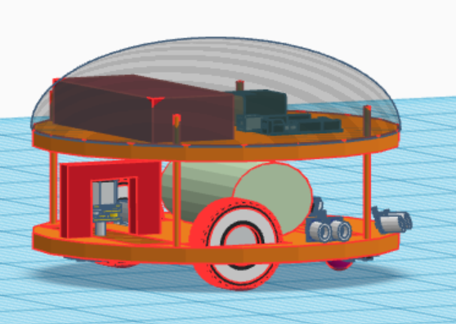

Fig. 1: CAD model of the bot

The process of modelling involved creating a detailed digital representation of each part, including its dimensions, shape, and orientation. The software allowed for precise measurements and adjustments to be made, ensuring that each part fit together correctly. Once the CAD models were complete, they were used to create physical prototypes using a 3D printer. The printing process involved layer-by-layer deposition of plastic material until the entire part was created. This allowed for quick and efficient production of the various parts, as well as the ability to adjust the design as needed.

Table 1: Component Specifications

|  |  |
| --- | --- |
| **Components** | **Specifications** |
| Base and top acrylic plate diameter | 30 cm |
| Acrylic plates thickness | 0.6 cm |
| Bot total height | 22 cm |
| Wheel diameter | 6 cm |
| Mopper diameter | 8 cm |

After the printing process was complete, various parts were assembled to create the final cleaning bot. The components were carefully aligned in place to ensure that the bot operated efficiently and effectively. The design details for the bot is shown in Table 1. Acrylic material has been used to provide robustness to the bot.

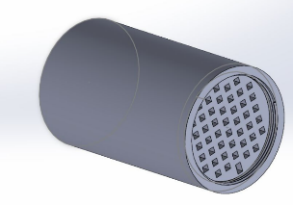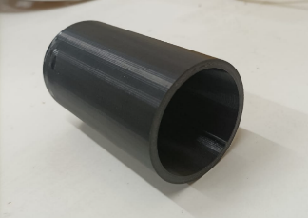

Fig. 2: CAD model and 3d printed dust collector.

The CAD modelling process played a crucial role in the design and fabrication of the cleaning bot. As it gives the sense of position of each component it is easier to fabricate with precision. The two circular plates, along with the various components situated between them, allowed for optimal placement and operation of the vacuum and mop mechanisms. The battery, motors, and motor drivers were also easily accessible and could be replaced or repaired as needed.

*B. Components Selection and Connection*

Electronic components are being selected based on specific requirements. Raspberry Pi, L293D motor driver, ultrasonic sensor, DC gear motors for wheels and mopper, high rpm dc motor for vacuum cleaner, switch, relay and 2 lithium polymer (LiPo) batteries are being used the specifications for the same has been given in table 2 and table 3. The Raspberry Pi served as the control unit for the electronic bot. It was connected to the L293D motor driver, which controlled the speed and direction of the DC motors. Ultrasonic sensor detects obstacles in the path of the bot, and it was connected to the Raspberry Pi as well.

Table 2: DC Motors Specifications

|  |  |  |  |
| --- | --- | --- | --- |
| **Components** | **Current Rating (load current)** | **Voltage rating** | **RPM** |
| Wheel dc motor | 300 mA | 3V-12V | 100 |
| Mopper motor | 100 mA | 3V-12V | 60 |
| Vacuum motor | 750 mA | 5V-12V | 9800 |

Table 3: Battery Specifications

|  |  |  |
| --- | --- | --- |
| **Battery name** | **Voltage**  **rating** | **Current**  **Ratings**  **(mAh)** |
| Lithium  polymer | 7.4 V | 4200 |
| Lithium  polymer | 11.1 V | 2200 |

As soon as the cleaning bot is turned on, each of the wheels of the robotic bot will start simultaneously, the robot will move in the forward direction, and the suction and mopping mechanisms will be turned on. During the motion of the bot, the cleaning module can perform two activities simultaneously. The connections are shown in Fig.3.

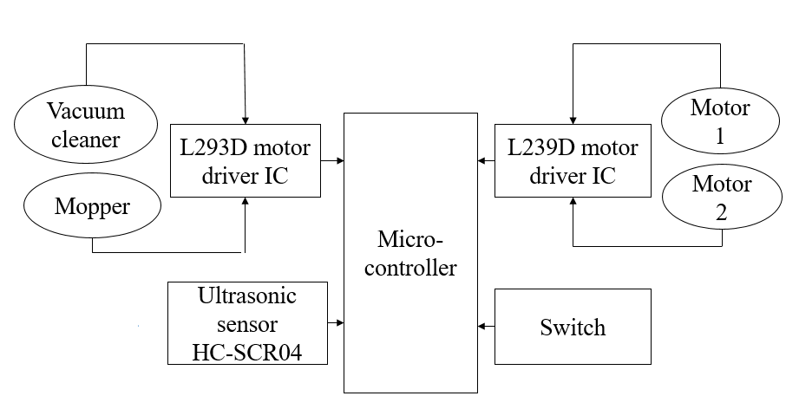

Fig.3: Interfacing of sensors and motor with Microcontroller

Fig. 4 shows the prototype for the cleaning module after the complete assemblance of the components. The vacuum cleaner suction part is placed at the front part with the dust collector at the top, while the mopping brushes are placed at the backside, so the combined work of vacuuming of dust and mopping of floor is done. A caster wheel is placed at the front side for the smooth motion of the bot on the floor.

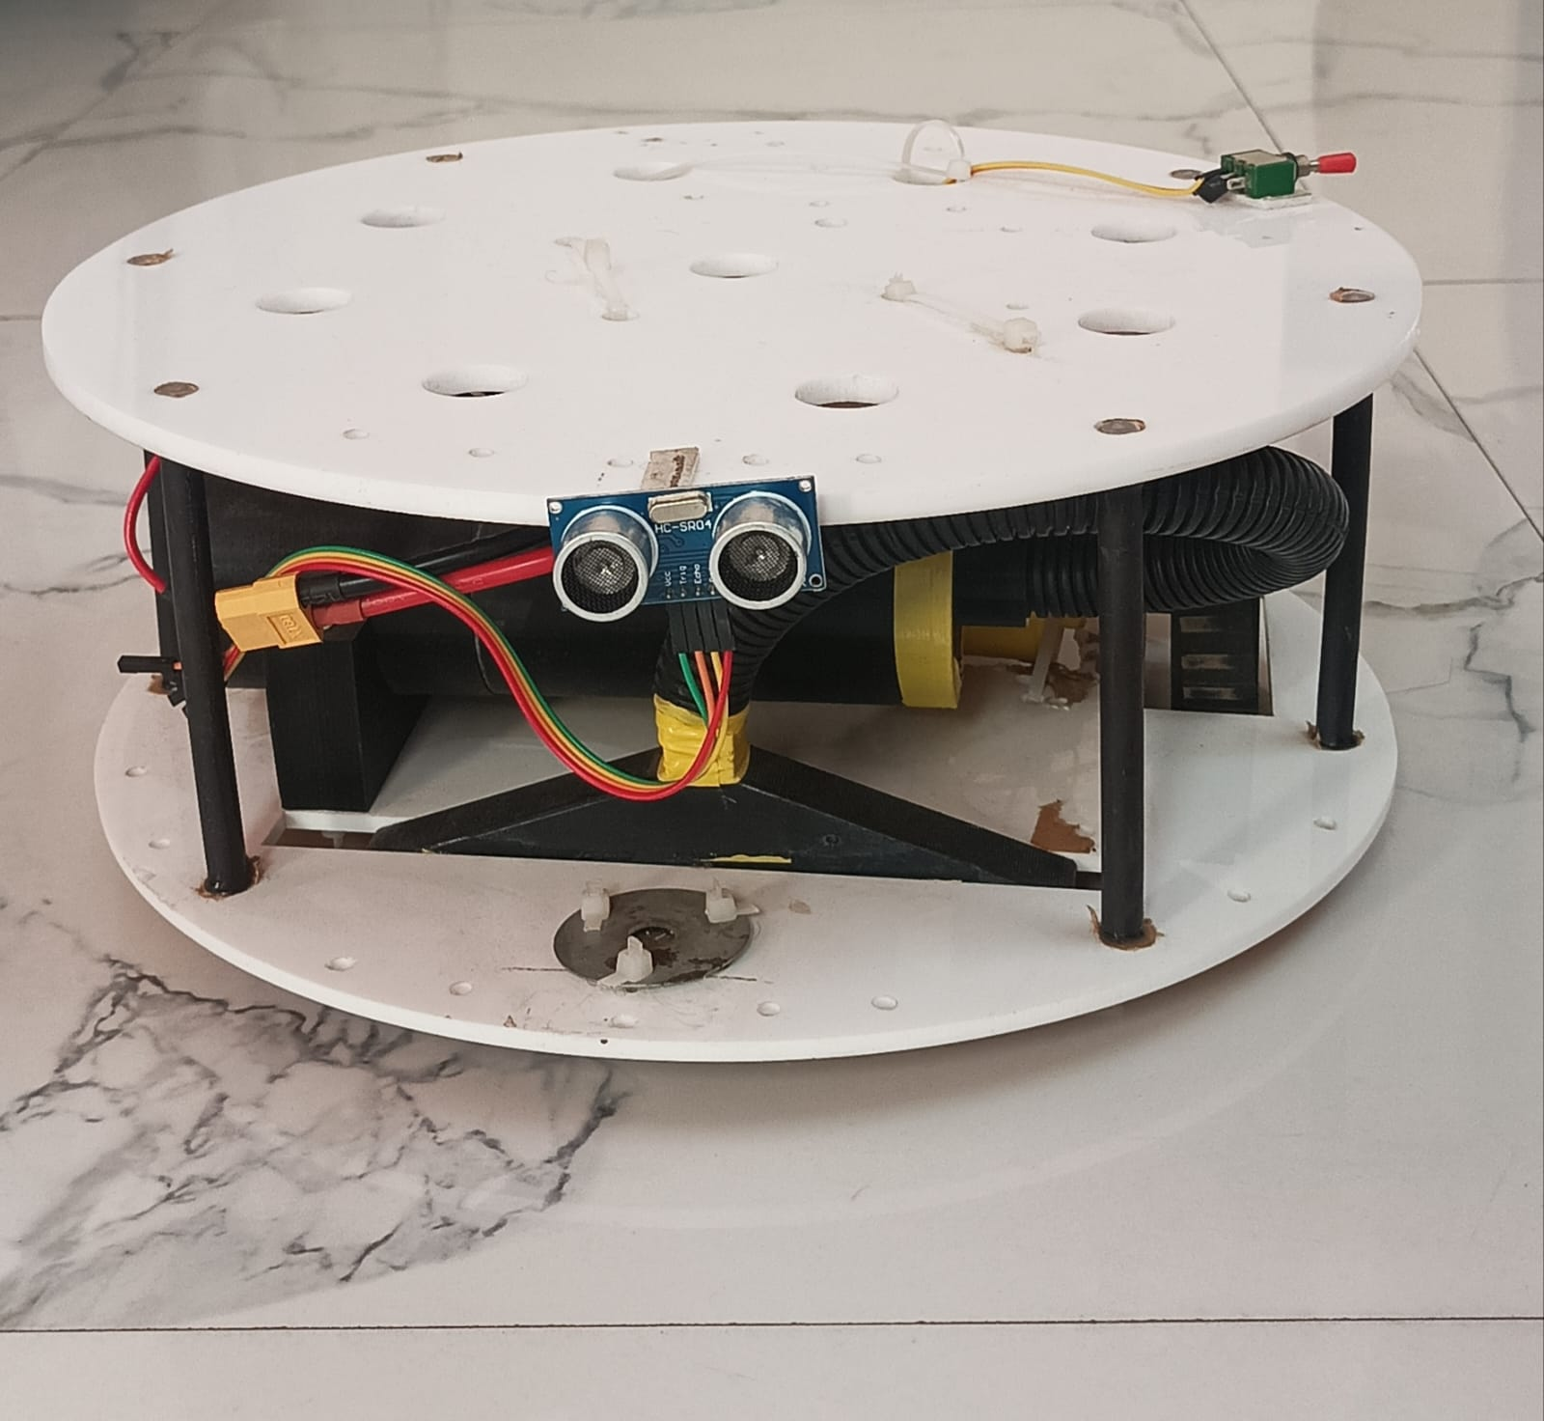

Fig.4: Fully functional bot

Manual control of the bot is done using an application called Bluedot. Bluedot is an android application that allows users to control the Raspberry Pi projects wirelessly – it is a Bluetooth remote application which is programmed in python language. It can be moved forward, backwards, left and right.

*C.* *Integration of Computer Vision*

The Open-Source Computer Vision Library widely used for different machine learning projects that provides various tools for processing visual data from cameras, images or videos. In this paper, computer vision was integrated into the development of an automatic cleaning bot to detect the presence or absence of dust on the floor and trigger the appropriate cleaning mechanism (vacuum or mopper) based on the detection result. To detect the dust on the floor, the automatic cleaning bot was equipped with a Logitech camera of 720p (1280 x 720 pixel i.e.0.9 megapixels) mounted on top of it that captured a grayscale image of the floor area to be cleaned and then GLCM technique was applied to extract texture features from the grayscale image which is a statistical method commonly used in image processing and texture analysis. The workflow for this algorithm has been represented in Fig.5.

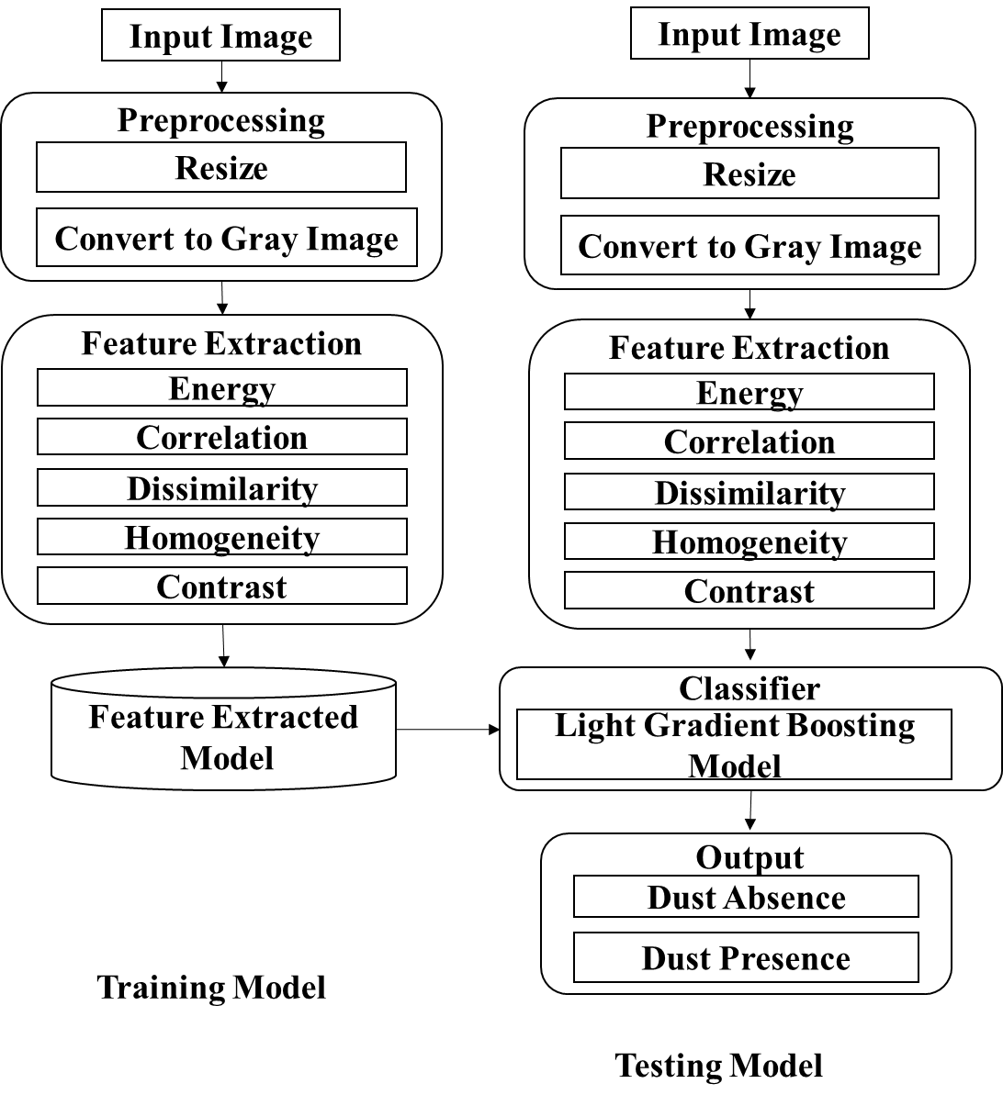

Fig .5: Model Workflow for Data Pre-processing and Feature Extraction for Dust Detection

Data Pre-processing:

In the pre-processing step, the raw RGB images were converted to grayscale. This conversion helped to simplify the image data while retaining the important features for dust detection. Then, the grayscale images were resized to a fixed dimension of 224 x 224. This step was essential to ensure that the images were consistent in size and scales. Finally, the pixel values of the resized images were normalized to a range of [0, 1] by dividing each pixel value by 255.This was followed by the application of the GLCM algorithm to extract texture features from the pre-processed images. This normalization step helped to improve the performance of the Light Gradient Boosting Machine (LGBM) classifier during training and testing by making the input data more suitable for the model.

To analyse the image dataset, the mean and variance of the pixel values were calculated. It helps in providing insights about the distribution of the image data and helps in selection of appropriate techniques. Using this we find the skewness of the pixel values. The values for the same has been shown in table 4 to check whether distribution is skewed to left or right which gives symmetry of the pixel value distribution.

Table 4: Descriptive Statistics Table for pixel values

|  |  |  |  |  |
| --- | --- | --- | --- | --- |
| **Images** | **Mean**  **intensity** | **Median**  **intensity** | **Standard Deviation**  **of intensity** | **Skew**  **-ness Value** |
| **With Dust** | 165.24 | 166 | 17.42 | -0.17 |
| **Without**  **Dust** | 242.50 | 244 | 18.26 | -0.24 |

Fig.6 shows Histogram distribution used to study the distribution of pixel values in images and improving the accuracy of dust detection models. By analysing the histograms in Fig .6 of images with dust and without dust present, the image with dust present has a left-skewed distribution pixel values indicating greater number of dark pixels. The image without dust present shows an even distribution of the pixel values. These help us to study the dataset to implement appropriate techniques and feature extraction algorithms that are effective at detecting dust in images.

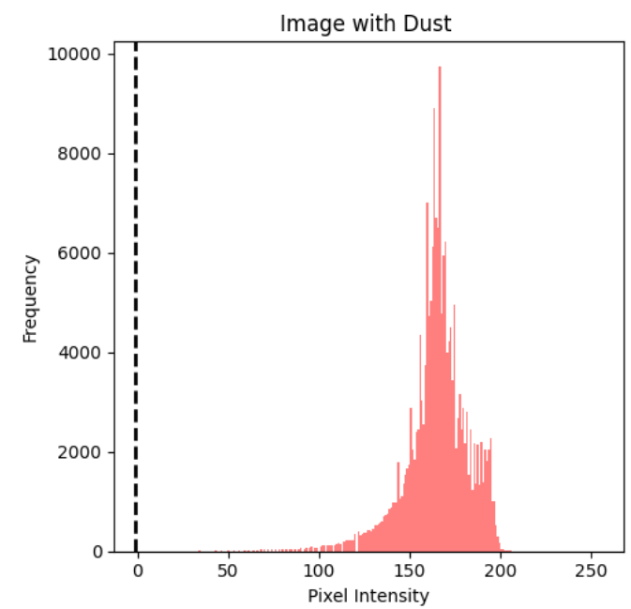

1. Frequency distribution of pixels for image with dust particles

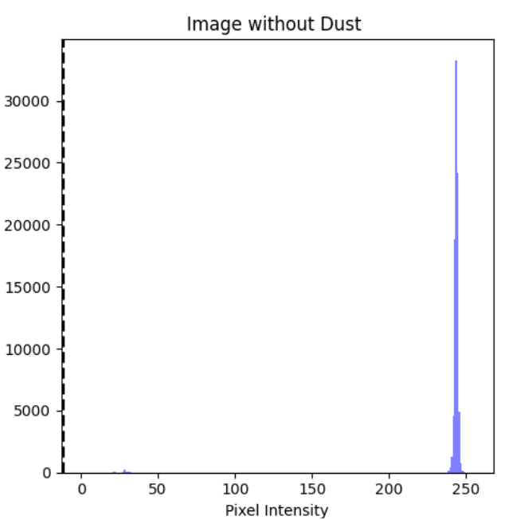

1. Frequency distribution of pixels for image without dust

Fig 6: Histogram analysis

Feature Extraction:

Feature extraction is a crucial step in image processing and computer vision applications. It involves transforming raw image data into a set of meaningful features that can be used for subsequent analysis and classification. In the context of this paper, the GLCM technique was used for feature extraction from the input images. The technique involves calculating the statistical relationship between pairs of pixels in an image, based on their relative positions and gray-level values. The GLCM generates a matrix that describes the frequency of occurrence of pairs of gray-level values at specified pixel distances and angles

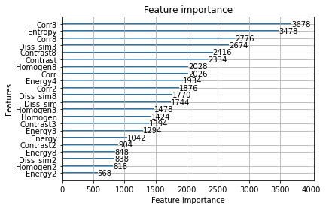

Fig.7: Extracted GLCM feature visualization.

The GLCM-based features included contrast, correlation, energy, homogeneity, and dissimilarity, which are commonly used texture features in image processing. The graph for the features extracted has been shown in fig. 7. These features were calculated for each input image and used to train the LGBM classifier for dust detection. By extracting relevant features using the GLCM technique, it was possible to train a machine learning algorithm to accurately classify images as either "with dust" or "without dust".

Classification:

LightGBM is based on gradient boosting, which is a technique that combines multiple weak models to create a strong model. It works by iteratively training a sequence of weak models and then combining their predictions to improve the overall accuracy of the model. During training, the algorithm splits the dataset into subsets based on feature values, and recursively creates a binary tree structure until a stopping criterion is met. The output of the model is the weighted sum of the predictions of all the trees.

In the proposed model, LightGBM was used as the classifier for dust detection in the input images. The GLCM-based features extracted from the input images were used to train the LightGBM model. The dataset used for training and testing the LightGBM model consisted of 3000 images, with 1500 images containing dust and 1500 images without dust. The trained model was then used to predict the presence or absence of dust in new input images. The hyper parameters of LightGBM, such as learning rate, boosting type, and maximum depth, can be tuned to optimize the performance of the model. The 'dart' boosting type used in this project introduces the concept of dropouts, which can help prevent overfitting by randomly dropping some of the trees during training.

In the proposed paper, the Light GBM classifier was trained on a dataset of labelled images (with and without dust) to learn the patterns of dust presence or absence based on the extracted features. Once trained, the Light GBM classifier was used to predict the presence or absence of dust in real-time by classifying the features extracted from the current image. Based on the prediction result, the cleaning bot activated either the vacuum or mop mechanism.

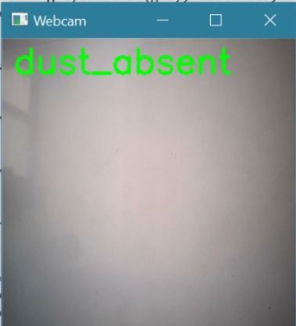

Fig. 8: Dust absent condition identified by GLCM.

Fig. 9 shows the camera predicting “dust present” for the uncleaned area.

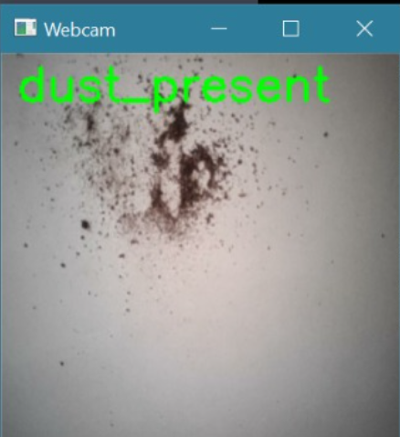

Fig 9: Dust present condition identified by GLCM.

If dust was detected, the vacuum and mopping mechanism was activated to remove the dust from the floor. Otherwise, if no dust was detected, both the mechanisms were turned off. Fig. 8 shows the webcam predicting “dust absent” for the clean area. The integration of computer vision libraries allowed the cleaning bot to perform real-time dust detection and activate the appropriate cleaning mechanism, accordingly, leading to an efficient and effective cleaning process.

*D.**Automatic mode with obstacle avoidance and dust detection*

The cleaning bot was designed to operate in two modes: automatic and manual. In automatic mode, the bot used an ultrasonic sensor for obstacle avoidance and the GLCM technique of computer vision integration for dust detection. The ultrasonic sensor was mounted on the front of the bot to detect obstacles in its path.

When an obstacle was detected, the bot would automatically stop and change direction to avoid the obstacle. This feature helped to ensure that the bot could operate safely and effectively in a variety of environments. The dust detection system used the camera mounted on the top plate of the bot to capture floor images. Captured images were processed using the GLCM technique to detect the presence or absence of dust. If dust was detected, the bot would activate the vacuum mechanism to remove the dust from the floor. The flow diagram for this has been shown in Fig. 10.

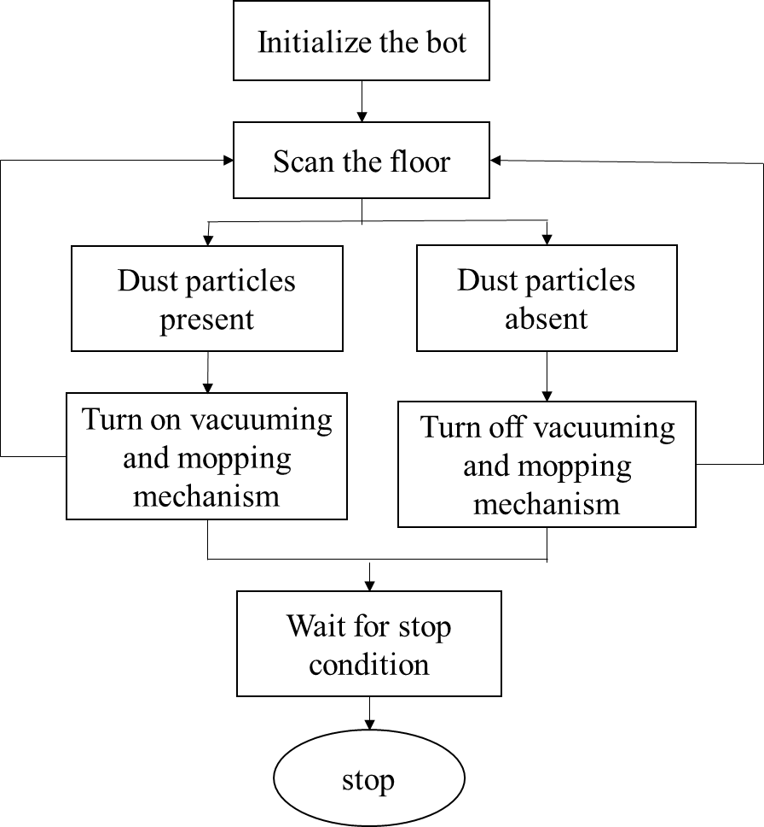

Fig. 10: Flow diagram representing automatic mode.

The bot operates without the need for human intervention in automatic mode. This helped to reduce the time and effort required for cleaning and allowed for more efficient use of resources such as water, cleaning solutions, and battery power.

*E. Manual control interface using Bluedot Application.*

In addition to the automatic mode, the cleaning bot can also be controlled manually using a mobile application called Bluedot. The application allows the user to toggle between the automatic and manual mode using two blue dots as shown in Fig 11. To enable manual mode, the user needs to tap on the first blue dot. This will activate the manual control interface, which will allow the user to control the cleaning bot's movement manually. The user can move the cleaning bot forward, backward, left, and right using the virtual joystick on the screen. To return to automatic mode, the user needs to tap on the second blue dot. This will deactivate the manual control interface, and the cleaning bot will resume its automatic cleaning operation. The workflow for this mode of operation has been shown in Fig. 12.



Fig.11: Bluetooth Application Interface

The Bluedot application communicates with the cleaning bot via Bluetooth connectivity. The cleaning bot is equipped with a Bluetooth module that allows it to receive commands from the mobile application. The application sends the commands to the cleaning bot in real-time, allowing the user to control the cleaning bot's movement smoothly and efficiently.

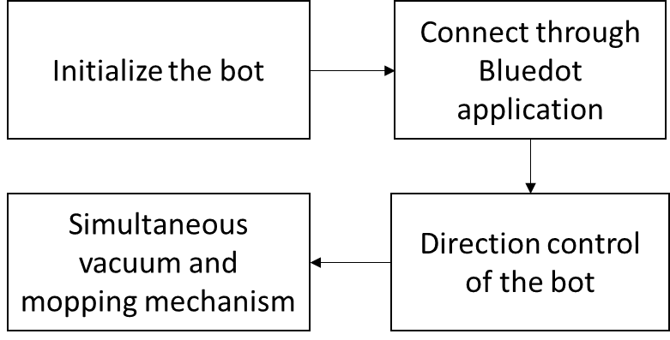

Fig. 12: Workflow for manual movement of the bot

In summary, the cleaning bot can be controlled manually using the BlueDot application, which provides a simple and intuitive interface for the user to control the bot's movement. The Bluetooth connectivity ensures real-time communication between the mobile application and the cleaning bot, allowing for smooth and efficient manual control.

*F. Performance Analysis*

From the dataset of 3000 images, the accuracy, precision, recall score and F1 score were obtained using the LGBM classifier. The obtained values have been shown in Table 5.

Table 5: Performance Evaluation table for Dust Detection model

|  |  |
| --- | --- |
| **Metrics** | **Values** |
| Accuracy | 95.83 % |
| Precision Score | 95.44 % |
| Recall Score | 95.83 % |
| F1 Score | 95.83 % |

These results suggest that the system has a relatively high accuracy of 95.83% in detecting dust particles.

IV. RESULTS AND DISCUSSION

An autonomous robot cleaning bot with the integration of computer vision for dust detection has been designed with the features of vacuuming and mopping the floor using Raspberry Pi microcontroller. The performance evolution of the proposed automatic cleaning bot with dust detection using the GLCM technique of computer vision integration, experiments were conducted in different environmental conditions in a standard-sized room.

In the proposed model, a dataset of 3000 images was collected, with half of the images containing dust and the other half not containing dust. The dataset was used to train and test a light GBM classifier to predict the presence or absence of dust using the GLCM technique of computer vision integration. The accuracy of the classifier was measured using the confusion matrix, in which the light GBM classifier achieved an accuracy of 95.83% in detecting the presence or absence of dust. The high accuracy rate obtained in this study demonstrated the effectiveness of the light GBM classifier in predicting the presence or absence of dust. The results showed that the classifier can be used as a reliable tool to detect dust on the floor, which can then be used to activate the appropriate cleaning mechanism of the cleaning bot leading to faster cleaning times and reduced consumption of cleaning resources.

The proposed system was able to reduce the consumption of cleaning resources, such as water and cleaning solutions. The reason for this is that the cleaning bot with the dust detection system only activated the mop mechanism when dust was detected, which eliminated the need for water and cleaning solutions in areas that did not need cleaning. The autonomous mode of operation allowed the bot to navigate and clean floors without human intervention, which reduced the user's workload. The manual mode of operation also provided the user with the flexibility to control the movement of the bot in case it misses any spots or if there are any areas that require extra attention.

V. CONCLUSION AND FUTURE SCOPE

The proposed model presented the design and development of an electronic bot for household cleaning that integrates computer vision for dust prediction and an ultrasonic sensor for obstacle avoidance. The electronic bot was able to accurately predict dust accumulation and effectively avoid obstacles, improving the efficiency of the cleaning process. The cleaning bot was designed with a vacuum and mopping mechanism that could be operated in both manual and automatic modes wirelessly using an android application. The cleaning bot also demonstrated a high degree of accuracy in cleaning floors, with the ability to navigate and clean floors autonomously in automatic mode, or under manual control using the Bluedot application. With the implementation of this automatic floor cleaning bot, the cleaning process can be done in an easier manner and more efficiently. The development of this cleaning bot has the potential to revolutionize the way in which cleaning is performed in various environments, such as households, hospitals, and public places. The automatic mode of operation reduces the workload of the user, while the manual mode provides users with the flexibility in movement control of the bot and clean areas that require extra attention.

The findings of this study demonstrated the potential of using innovative technologies to improve cleaning efficiency and reduce human labour and can contribute to the development of more advanced and reliable electronic bots that can perform various cleaning tasks with minimal human intervention.

Future research can focus on the optimization of the cleaning bot's design, the improvement of the cleaning mechanism's efficiency, and the investigation of the cleaning bot's performance in various environments. The use of advanced image processing techniques and machine learning algorithms can also be further explored to develop more advanced cleaning bots that can detect and clean various types of dirt and debris. Additionally, the development of autonomous navigation systems can improve the efficiency and reliability of electronic bots, enabling them to perform more complex cleaning tasks with minimal human intervention. The scope can be accelerated by including GSM modules to the bot in order to make it function and handy from any part of the sector and convey a message that the robot has finished the cleaning task. Cleaner brushes can be brought to the hoover cleaning mechanism to boost the efficiency of dirt amassing. Lithium polymer batteries can be used in order to reduce the load of the bot which can in addition reduce energy consumption.

REFERENCES

1. P. S. Adithya, R. Tejas, V. Sai Varun, and B. N. Prashanth in "Design and development of an automatic mopping and cleaning robot." in IOP Conference Series: MSE, volume 577, issue 1. 2019 IOP Publishing.
2. Prayash, HA S. Hossen, Md R. Shaharear, , S. Islam, N. Hossain, S. Datta and Md F. Islam in "Designing and optimization of an autonomous vacuum floor cleaning robot." In 2019 IEEE (RAAICON), 2019.
3. Vishaal,, P. Raghavan, Raj, R. Rajesh, S. Michael, and M R Elara. In "Design of dual purpose cleaning robot." In PCS 133 (2018): 518-525.
4. Khan, Jahida, U. Bhapkar, A. Chougule, J. Bhat, and S. Sangale. In "Design and development of smart solar powered street sweeping machine." In Materials Today: Proceedings 46 (2021): 8663-8667.
5. Muthugala, J. Viraj , SM Bhagya P. Samarakoon, P. Veerajagadheswar, and MR Elara. "Ensuring Area Coverage and Safety of a Reconfigurable Staircase Cleaning Robot." in IEEE Access 9 (2021): 150049-150059.
6. Parween, Rizuwana, M V Heredia, M M Rayguru, R E Abdulkader, and M R Elara, "Autonomous self-reconfigurable floor cleaning robot." In IEEE (2020): 114433-114442.
7. Pleshkova, Snejana, Z. Zahariev, and A. Bekiarski, "Development of speech recognition algorithm and lab view model for voice command control of mobille robot motio." In 2018 International Conference on HiTech for Sustainable Development, IEEE, 2018.
8. G Bansal, R Setia ,A Taneja, N. Hema ,“Moedor Cleaning Robot System.” In IEEE Xplore (2018 ): [10.1109/IC3.2018.8530503](https://doi.org/10.1109/IC3.2018.8530503).
9. S Yatmonom, M Khairudin, A Asmara, and H S Pramono. “Development of Intelligent Floor Cleaning Robot”, in (JOP) 2019: 1413 012014.
10. S. Kamble, S. Dorle, M. Kapgate, H Sathawane and V. Buddhe, “Design and Development of Wireless Floor Cleaning Robot”.in IJESC (2017) Research Article.
11. S. Mungale, S. Malavadikar, T. Johri and H Lokhande. “Automatic Cleaner Robot.”in IERJ(2017).
12. Ogiso, Satoki, K. Mizutani, T. Kawagishi, ,N.Wakatsuki, and K. Zempo. "Self-localization method for mobile robot using acoustic beacons." In ROBOMECH Journal 2, (2015): 1-12.
13. L Lin, Sui and Linghui, "Design of household cleaning robot based on low-cost 2D LiDAR SLAM." In IEEE, 2020.
14. Bormann, Richard, J Hampp, and Hägele. "New brooms sweep clean-an autonomous robotic cleaning assistant for professional office cleaning." In ICRA, pp. 4470-4477. IEEE, 2015.
15. R. Ishalavath M, N. Sandhyashree , R Rakshitha and A Shankar. “Design and Development of an Automated Floor Cleaning Robot for Domestic Applications.” in IJERT Volume 8 (2020): ISSN: 2278-0181.