

# Experiment No. 6

**Problem Statement:**

Histogram Equalization using python

**AIM:**

Write a Python Code for following Enhancement Operations:

1. Plotting a Histogram for an Image
2. Linear Stretching
3. Histogram Equalization

# Objective(s) of Experiment:

# To perform the histogram of an image, linear stretching, and histogram equalization.

# Introduction:

# An image histogram is a type of histogram that acts as a graphical representation of the tonal

# distribution in a digital image. It plots the number of pixels for each tonal value. By looking at the histogram for a specific image a viewer will be able to judge the entire tonal distribution at a glance.

# The horizontal axis of the graph represents the tonal variations, while the vertical axis represents the number of pixels in that particular tone. The left side of the horizontal axis represents the black and dark areas, the middle represents medium grey and the right-hand side represents light and pure white areas. The vertical axis represents the size of the area that is captured in each one of these zones.

# Flowchart:

# Code and Results:

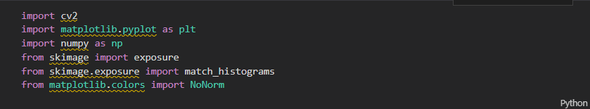

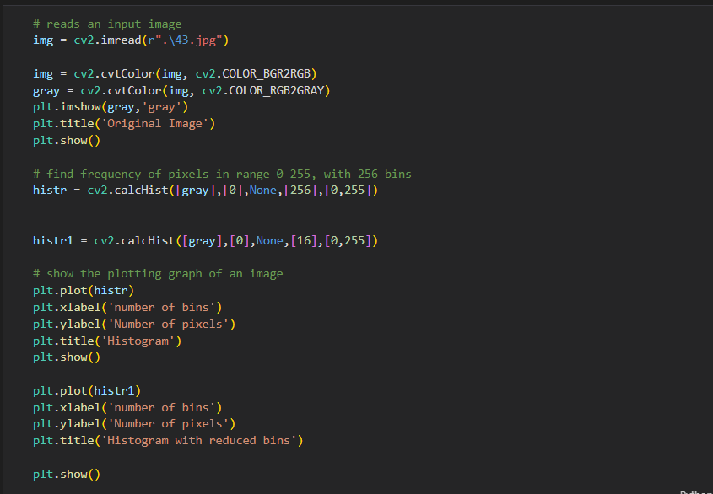

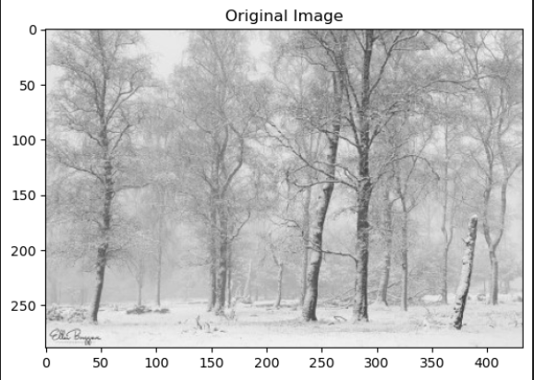

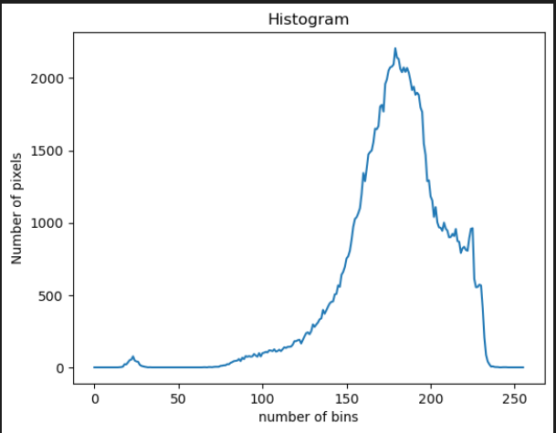

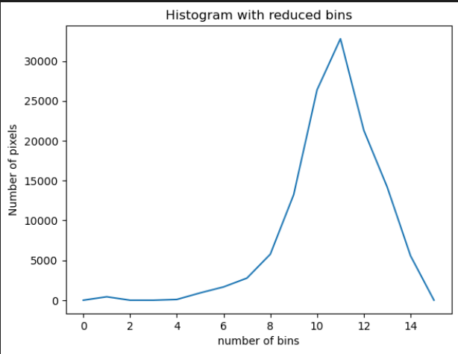

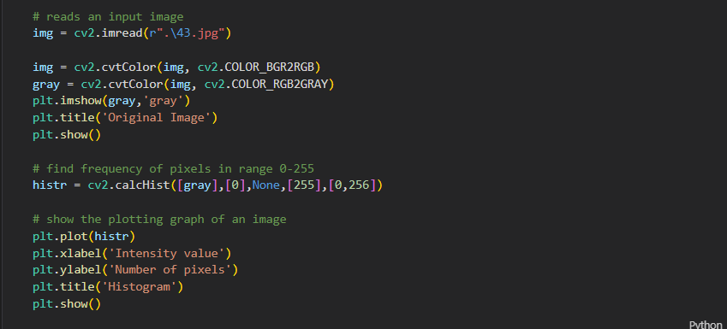

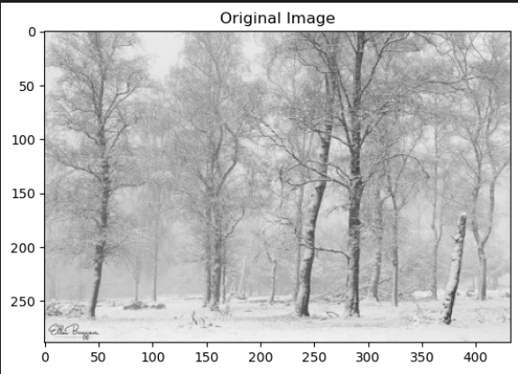

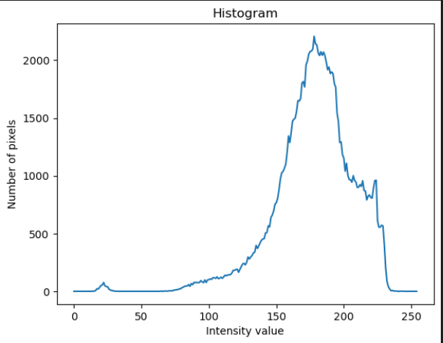

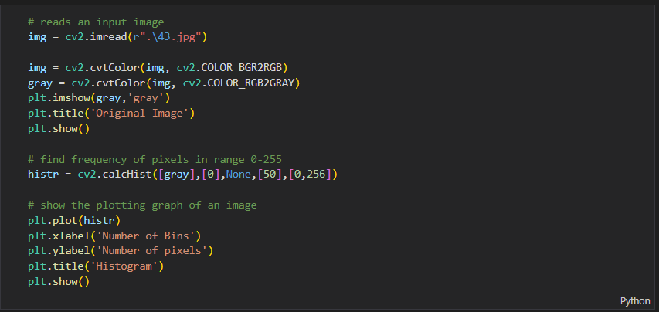

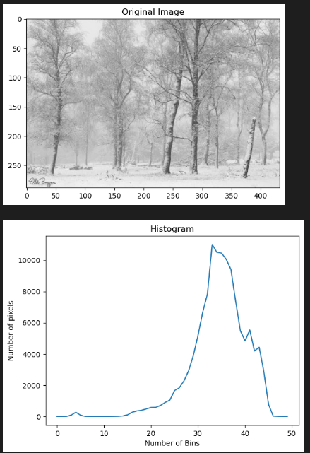

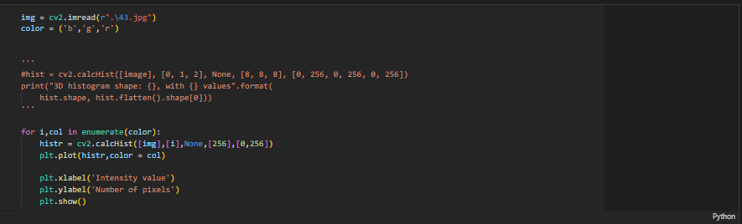

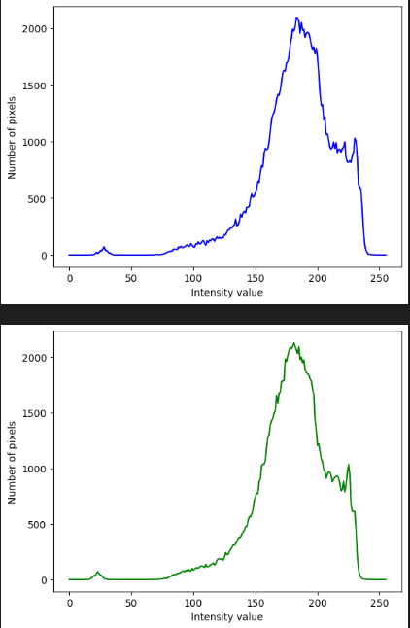

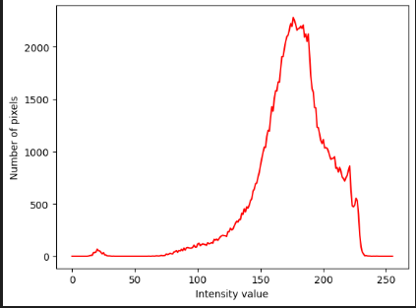

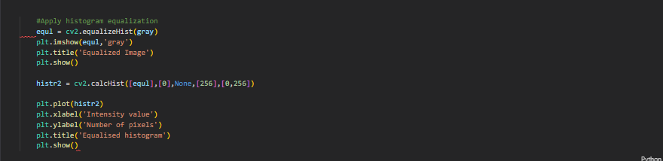

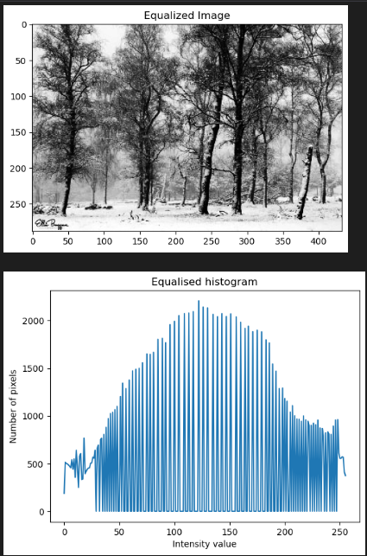

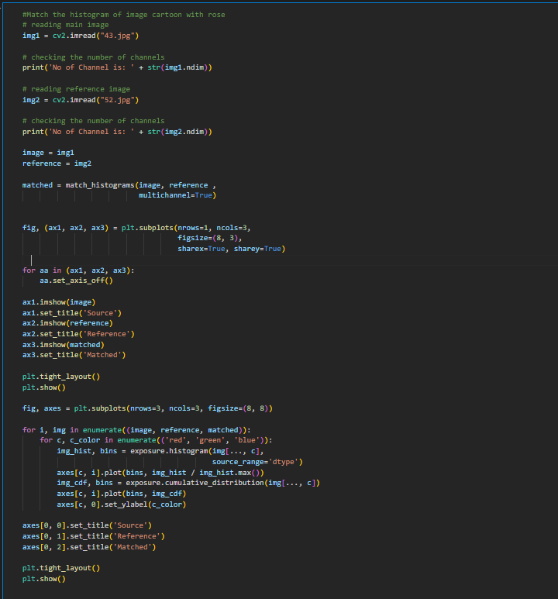

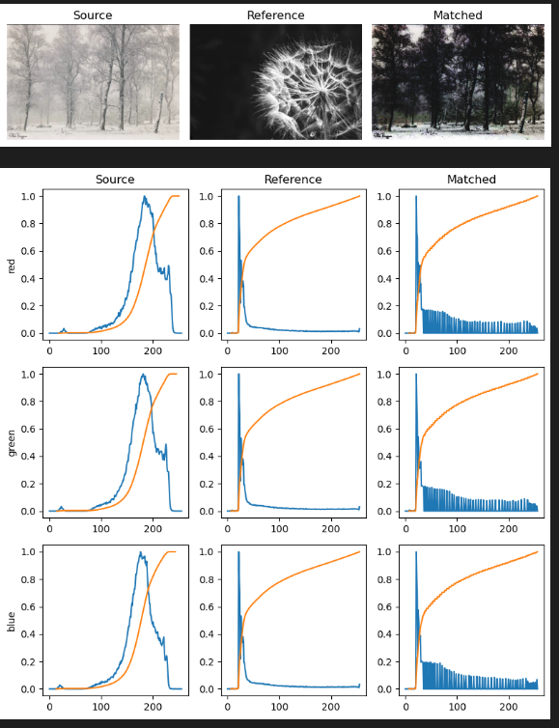

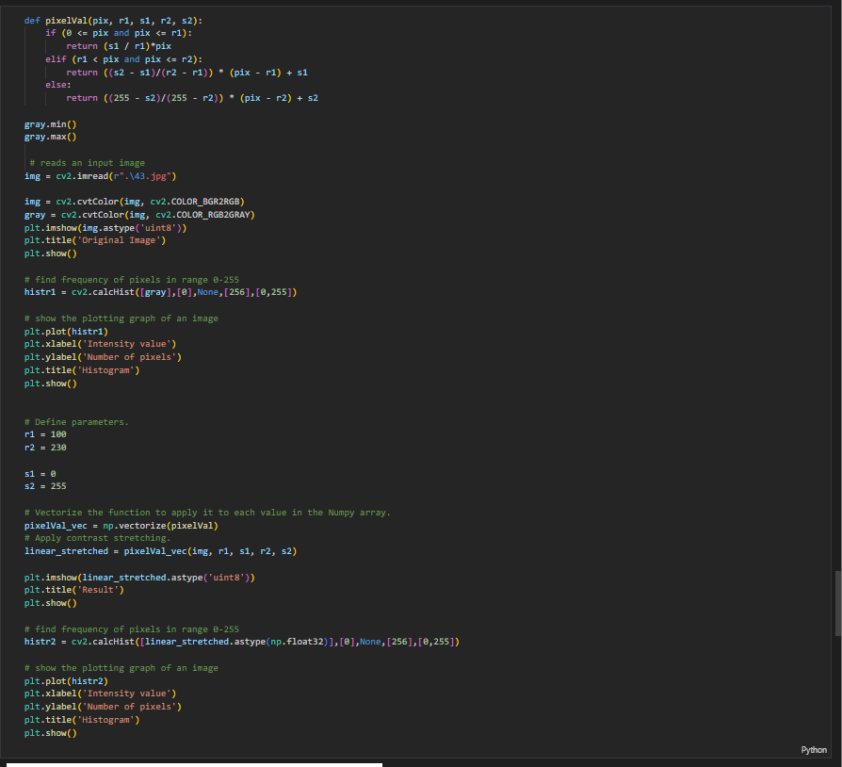

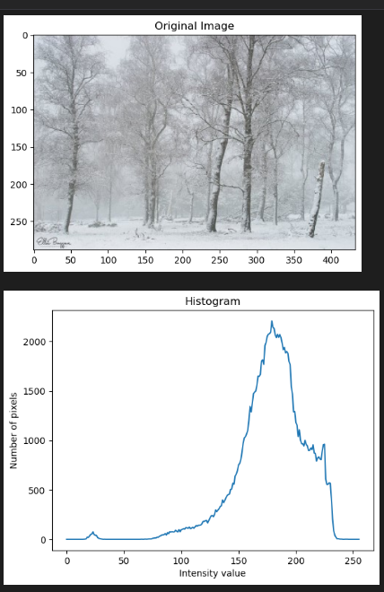

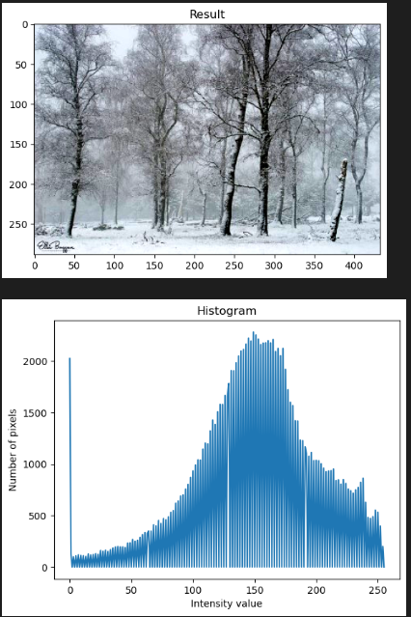

# Conclusions:

Histogram image contrast has been enhanced and its histogram has also been equalized. There is also one important thing to be note here that during histogram equalization the overall shape of the histogram changes, whereas in histogram stretching the overall shape of histogram remains same.