**ET: Computer Vision**

**Name Ot the Student: Chetan Shinde Roll No: 5**

**Div: D Batch: D1**

# Experiment No. 4

**Problem Statement:**

Geometric Transformations

**AIM:**

Write a Python Code for following Geometric Transformations:

1. Translation
2. Rotation
3. Scaling
4. Cropping
5. Shearing
6. Flipping

# Objective(s) of Experiment:

# To perform the geometric transformations of images.

# Introduction:

# Geometric transformations are widely used for image registration and the removal of geometric distortion. Scaling is just resizing of the image. Rotation is a concept in mathematics that is a motion of a certain space that preserves at least one point. Image rotation is a common image processing routine with applications in matching, alignment, and other image-based algorithms, it is also extensively in data augmentation, especially when it comes to image classification.

# Image transformation is a coordinate changing function, it maps some (x, y) points in one coordinate system to points (x', y') in another coordinate system. Shear mapping is a linear map that displaces each point in a fixed direction, it substitutes every point horizontally or vertically by a specific value in proportion to its x or y coordinates, there are two types of shearing effects. Image cropping is the removal of unwanted outer areas from an image, a lot of the above examples introduced black pixels, you can easily remove them using cropping.

# Common applications include construction of mosaics, geographical mapping, stereo and video.

**Flowchart:**

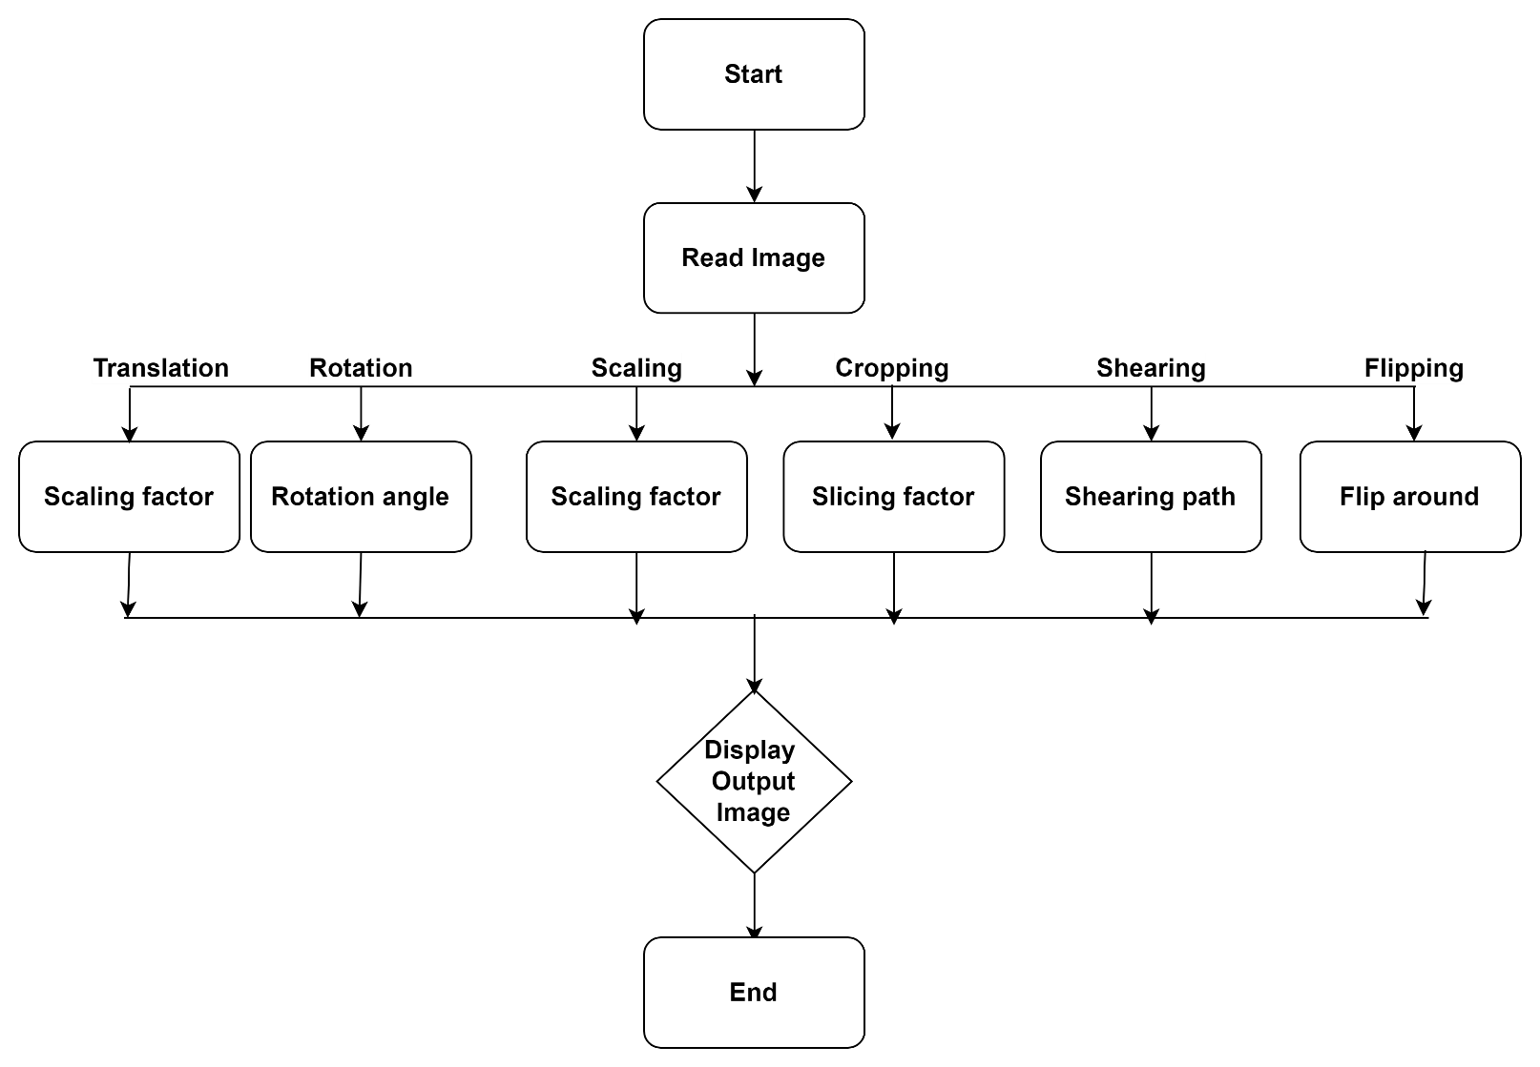

# Code and results:

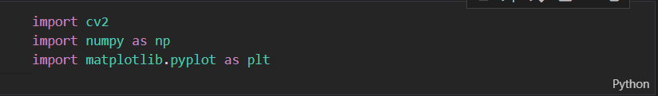

**Translation:-**

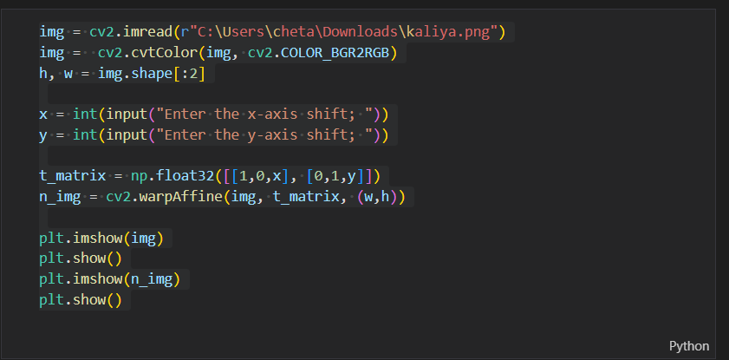

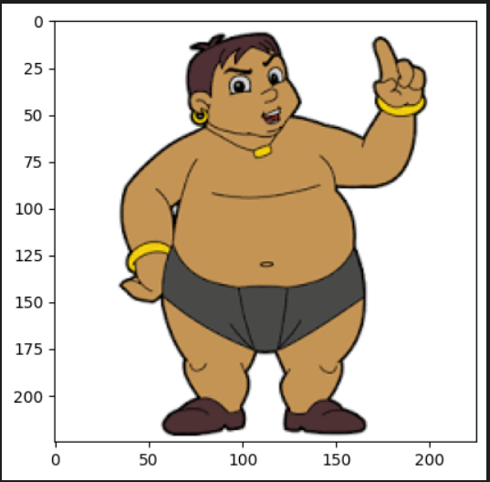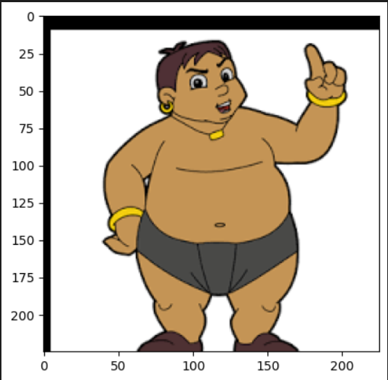

* cv2.wrapAffine(): function to implement translations. This function requires a 2×3 array. The numpy array should be of float type.
* Syntax: cv2.warpAffine(src, M, dsize, dst, flags, borderMode

**Rotation:-**

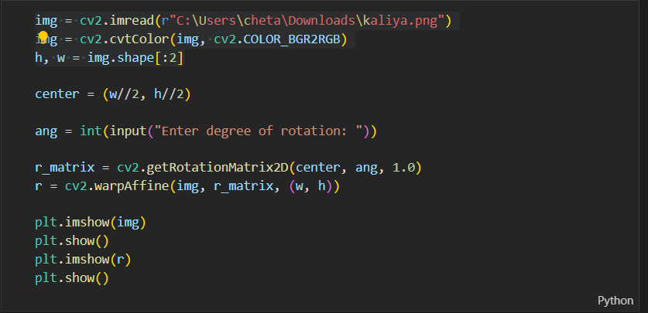

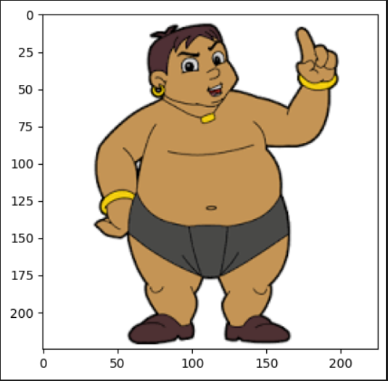

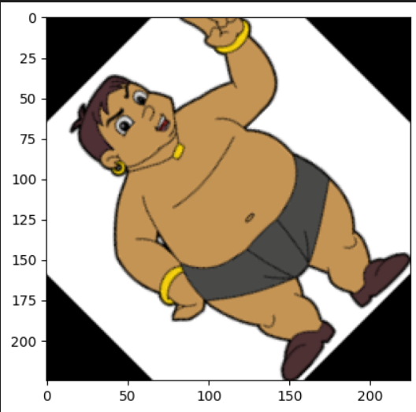

**Scaling:-**

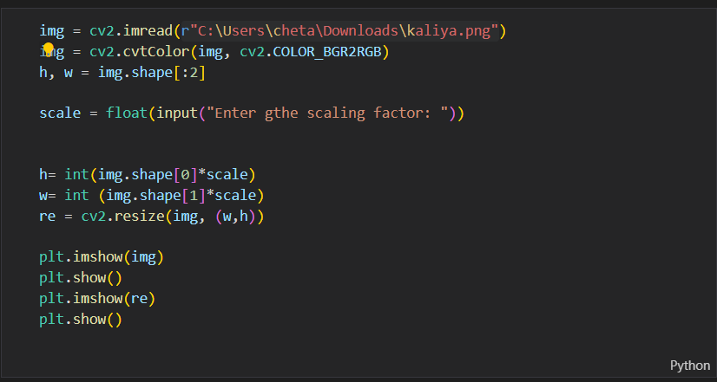

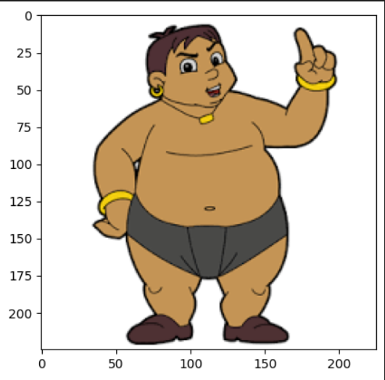

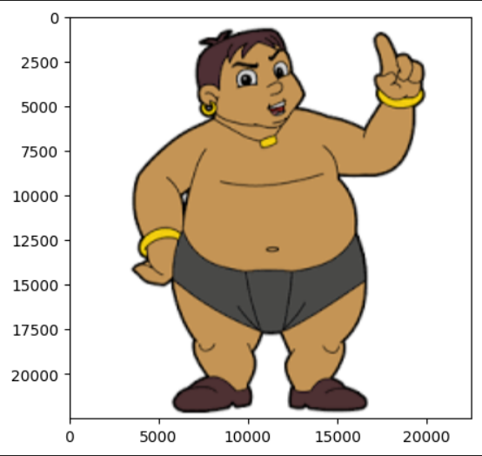

**Cropping:-**

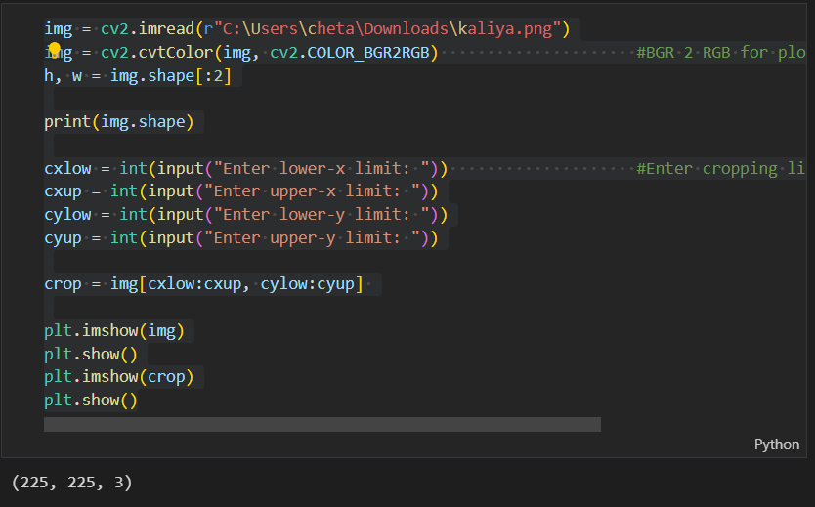

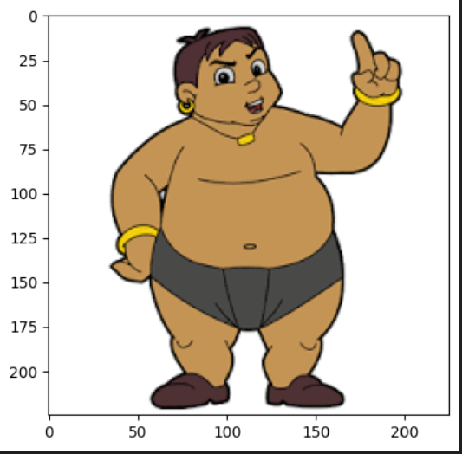

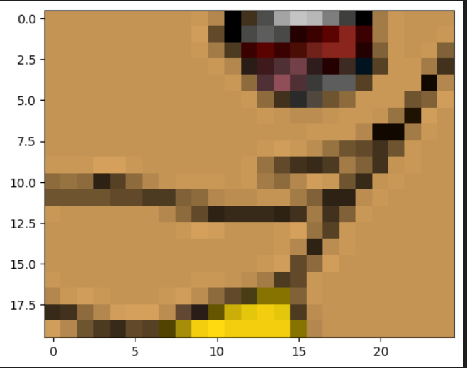

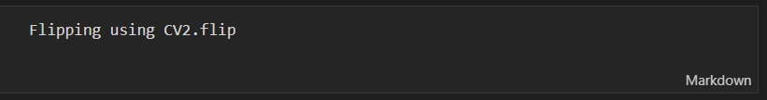

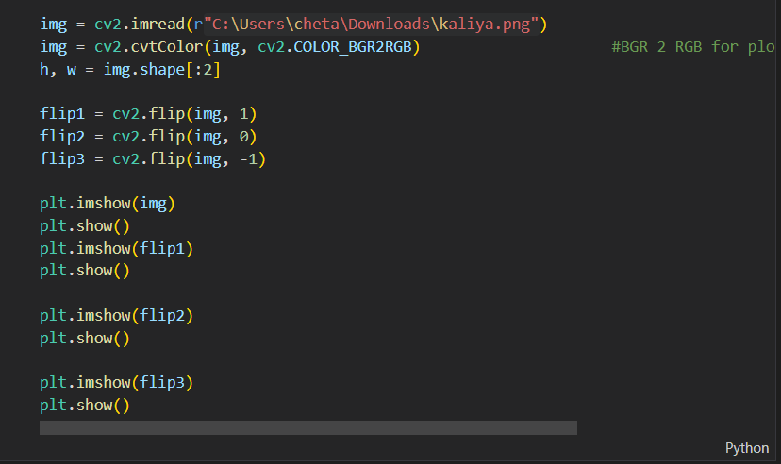

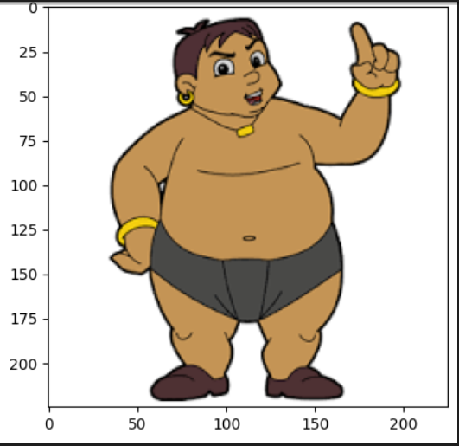

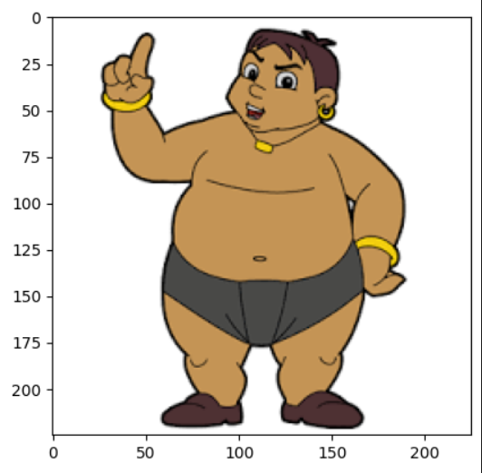

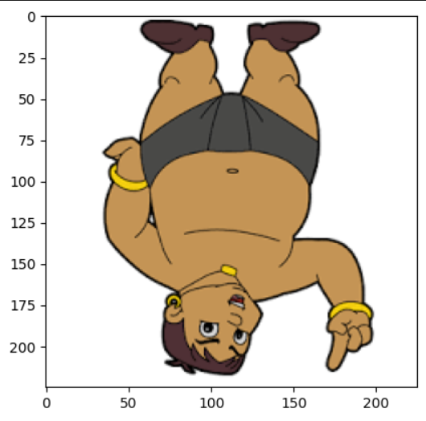

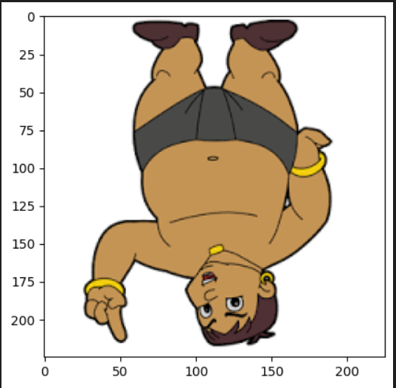

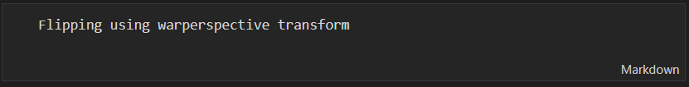

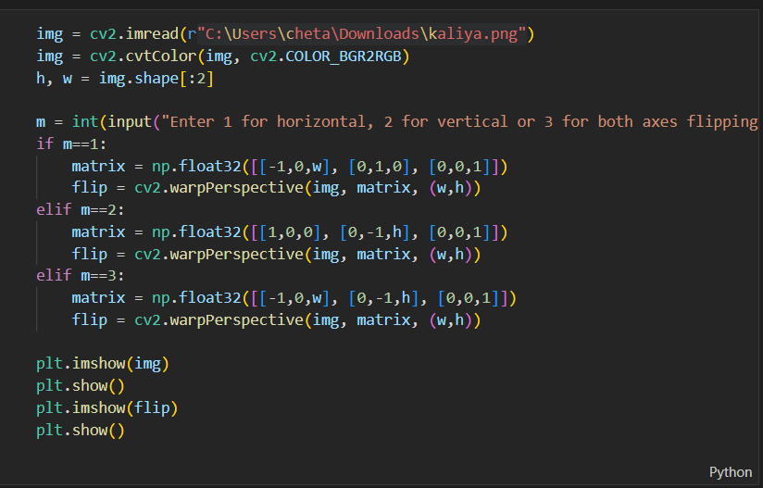

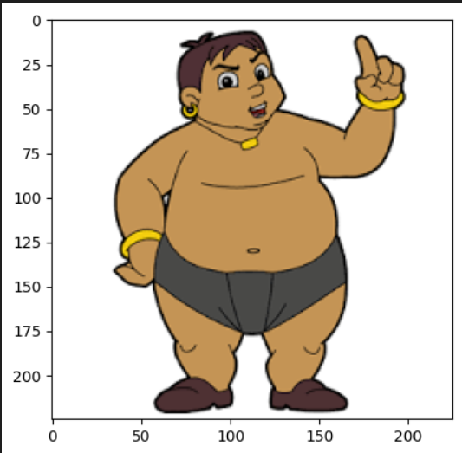

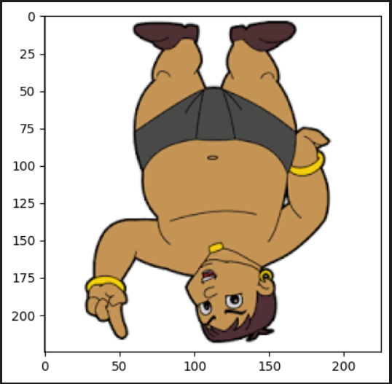

# 

# Conclusions:

# In these experiments, we performed the basics of image processing and transformation, which are image translation, scaling, shearing, reflection, rotation, and cropping.

1. translations using - wrapAffing Function()
2. Rotation using - cv2.getRotationMatrix2D() and wrapAffine()
3. Scaling using - cv2.resize()
4. Cropping - img[cxlow:cxup, cylow:cyup]
5. flipping using - cv2.flip()