Automatic Pesticide Sprayer Bot
Chetan Shinde¹, Akash Shekhavat², Ajinkya Sathe3, Shripad Bhatlawande4
¹²³⁴Vishwakarma Institute of Technology, Pune - 37

Abstract— Pesticide spraying is a necessary activity in agriculture to get more yield and to protect our crops from weeds, insects and fungus. As a result, manual pesticide spraying is practiced in most parts of India. Manual spraying results in direct contact with pesticides which give birth to numerous health problems including severe diseases to farmers. As a part of the solution, we propose an Automatic pesticide sprayer. Using this bot farmers will be able to spray pesticides remotely without any physical contact during spraying. Generally, more than one person is involved in manual spraying but using this bot single person can operate spraying activity using a mobile application remotely.
Keywords: Pesticide spraying, Automatic spraying, Agriculture, Spraying, Pesticides.
- Introduction
Agriculture is one of the huge and important sectors which fulfills food requirements of the world. Agriculture involves different activities in which pesticide spraying is major one. Farmers used to spray pesticide to protect their crop from insects, weeds, fungus and from many other diseases. Due to lack of cheap technology available for pesticide spraying majority of farmers using traditional spraying methods i.e., manual pesticide spraying. This traditional method is not only time consuming but also hectic, inefficient at the same time. In manual spraying farmers takes heavy pesticide loaded tanks on their back and they have to spray all day into the grown farms. This increases the difficulty of spraying for farmers. In manual spraying farmers are exposed to the poisonous pesticides which are hazardous to both farmer’s life as well as for working labors.
According to many studies done worldwide on farmers affected by exposure to poisonous pesticides the casualties are in thousands. The exposure to those poisonous pesticides causes many diseases like skin diseases, eye irritations, respiratory diseases and even leads to cancer [2]. These all practices are done due to less availability of cheap spraying technologies for contactless spraying. The automatic pesticide sprayer bot that we propose can be solution for all those problems faced by the farmers. This bot can be operated from long distance over Wi-Fi technology which will insure the contactless spraying. This bot itself will be able to spray into the crop which will be operated by the farmer at a distance. Bot has two spokes wheels, a tank for pesticide, a dc water pump, high torque dc motors, lithium ion battery, ESP8266 Wi-Fi module, motor driver. The communication between the operator and the bot will be done over Wi-Fi which has range up to 8 to 10 meters.
- Literature Review
Technology is the need of today’s world. Every sector is growing by introducing modern technologies to their work and enjoys high efficiency and huge profit. Similarly, agriculture also takes foot forward in using new technologies in its agricultural work [2]. It is also a sector that requires huge labor and intense physical work. Technology is the thing that can change the face of agriculture forever [3]. Agriculture means practicing numerous practices, right from sowing the seed to cutting the crops. Pesticide spraying is one of those activities that is so hectic, inefficient, and hazardous.
Advanced and expensive technologies are unaffordable to common farmers, and they require cheaper equipment with well-equipped technology. 80% of farmers use the traditional spraying method for pesticide spraying [5]. Traditional spraying involves direct contact with hazardous pesticides. While performing activities like mixing, loading, spraying, and cleaning spray pumps farmers get chronic intoxication. Which can cause chronic diseases like skin cancer, respiratory diseases, multiple basal cell carcinomas, and squamous cell carcinomas [6]. The farmers feel fatigue and dizzy or have headaches because of the constant manual spraying [7].
Technology is the need of today’s world. Every sector is growing by introducing modern technologies to their work and enjoys high efficiency and huge profit. Similarly, agriculture also takes foot forward in using new technologies in its agricultural work. It is also a sector that requires huge labor and intense physical work. Technology is the thing that can change the face of agriculture forever. Agriculture means practicing numerous practices, right from sowing the seed to cutting the crops. Pesticide spraying is one of those activities that is so hectic, inefficient, and hazardous [2].
The insects and pests are living under the crop’s leaves, it is difficult and hard labor to spray under the leaves of the crop. These results in reduced yields, lowered quality, and damaged plants or plant products that cannot be sold. In this paper, the aim is to design and develop an autonomous pesticide sprayer for the chili fertigation system. In chili fertigation farms, pests such as mites, snails, and maggots are a common type of pest that can be found in this farm by making the plants as their source of food and breeding ground. Normally, the worker needs to manually spray the pesticide while wearing protective gear and walking from crop to crop. This method indeed inefficient practice and hazardous chemicals used in spraying can be fatal to the worker even wearing protective gear because research conducted found that the protective gears do not stop the chemical but only reduce the amount of exposure. Further, the study is intended to implement a flexible sprayer arm to spray the pesticide under the crop’s leaves, respectively [4].
In this paper, the purpose was to know the health impact of pesticide from pesticide using methods of spraying by the workers and farmers in Sumber Mufakat village Kabanjahe Karo. This is an analytical survey with cross sectional design to find out the health impact from pesticides sprayed work farmers method. This research concluded that there was a significant relation between pesticide using methods with health impact. Recommended for the sprayed worker farmer to protect themselves by using safety equipment to avoid the direct exposure from pesticide [5].
In India, nearly 70% of people are dependent upon agriculture. So, the agriculture system in India should be advanced to reduce the efforts of farmers. In this paper, a robot is made for spraying pesticides on farms and its main task is spraying pesticides in the irrigation system. The whole robot is designed on a four-wheel car base mechanism and controlled through remote switches. This robot worked on a 33V (12+12+9) DC battery. Pesticide level indicator is also included in it. This is for indicating a pesticide level. The indicator is supplied by a 9V battery. The pesticide level is indicated by the L.E.D. This robot can work in any climate condition [6].
A pesticide mixer which automatically mixes the pesticide and water in particular ratio and the mixer is automatically sprayed to the field on the programmed date with the help of PLC. Also soil moisture condition and water level is monitored using moisture sensors and ultrasonic sensors. If the soil moisture level is low or high, the transmitter RF sends a signal to the receiver RF and accordingly the motor is turned ON/OFF with the help of PLC. The PLC is programmed with the date and time for the automatic pesticide mixer operation. Manual mode is also included in case of emergency by switching ON even before the programmed date arrives [7].
Multipurpose pesticide sprayer can also be seen in the market. A manually operated pesticide and fertilizer sprayer [8] can be effective for middle class farmers but it also adds the manual touch to pesticide spraying. So, this type of manual sprayer again makes the job worse for farmers.
Using CNC machine, a proposed Automatic Robot which can walk at any point of the plant for farming crops autonomously. Robot designed to be able to plant plants with solid media and dimensions of planting area that can be adjusted according to the needs [10].
Movement of the robot can be controlled using the PLC microcontroller. Using PID controller in the closed loop feedback of sprinkler motor for online flow control of spray, linear and automatic flow control can be obtained. The automaticity of the bot can be increased by using lidar sensor. Plant detection, autonomous controlling and achieving autonomous spraying can be achieve by lidar.

- Methodology

The manufacturing of the bot is divided into three steps. In the first step, the rough model is created in tinker cad a 3D modelling software to ideate the design of bot. After that the final design is modelled in 3-D modelling software, in the second step the hardware components were selected according to the requirement of bot’s frame. Along with the hardware components electronics components were also decided and selection of power source was completed. In the third step includes the interfacing assembling the bot’s frame as per the 3D model and the software part is done in the third step.

  - 3D Modelling
This is the first step of implementation, and the 3-D model of the bot is created using online software called Tinker cad. It is basic modelling software that provides the environment for simple and quick modelling of any object [Fig I]. This step includes two sub steps. In first sub step the rough design is created. Taking learnings from it the final 3D model is created with taking all the measurements into considerations. The final design is also modelled in the same 3D modelling software Tinker cad.

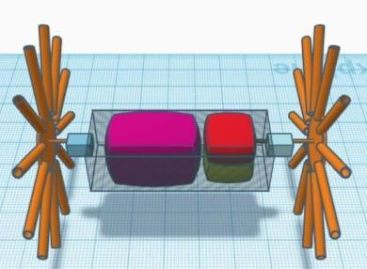

Fig. 1 3D Model

  - Hardware

Once the 3D model is finish and all the measurements are ready the hardware is chosen. Special attention is given on material selection. To avoid overweight of the bot, aluminium is main building material with plywood. We will require 6mm hollow aluminium pipes for the spokes of wheels. Each wheel will have 12 such pipes i.e., overall, we used 24 pipes for 2 wheels of the bot. We make use of 6 mm plywood for the container present between the wheels as it needs to be strong and rigid. We use a small 400ml tank for carrying pesticides. We use 50+ nut bolts to attach aluminium pipes to plywood. As a modification in the bot, we used T-shape connectors at the end of the aluminium rod which will be in contact with the ground. For spraying we use a 3mm pipe with a nozzle at the end.

  - Electronics Components and Software
To get sufficient torque, we use 2 motors of 60 rpm each. Each motor can provide a torque of 2 kg-cm and draws a max load current of 300 mA. A 12V DC pump is used for spraying pesticides. Its working current is between 0.5 to 0.7A. Its power requirements are between 4W-7W, and its max water flow is in between 1-3L/min. the 2 channel LM298 series motor driver is used to run the DC pump and our main wheel motors. 12V li-ion batteries are being used to power up the whole assembly. For communication, we have use ESP 8266 Wi-Fi module. Its operation voltage is 3.3V.
We use a free online IoT platform called Blynk. It is available in both a web app and an android application. In this application, we use two sliders one for controlling the speed of the bot and another one for pump operation. Four buttons are used to set the forward and backward motion of the bot. We have added a joystick for better handling purposes. Arduino IDE is an Arduino Integrated Development Environment. After collecting all hardware components assemble them according to the 3-D model. We have two main parts made and those are wheels and containers.

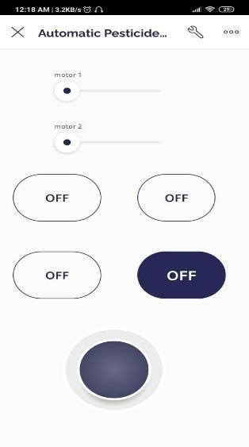
Fig. 2 3D Model

Wheel Dimensions

We made the wheel as it is a crucial part of the bot. Each wheel consists of 12 aluminium rods having a T-shape connector at the end of each wheel. The length of each aluminium rod is 24 cm from the ground. All Aluminium rods are Fixed with nuts and bolts to a 3mm plywood disc with a diameter of 18 cm. Rods are fixed such that they are 3 cm inside of the disc. Thus, after adding the length of the rod and disc we get the diameter of the wheel as 54 cm. 12 wheels were fixed on the circumference of plywood. The angle between the two aluminium rods is 30⁰.

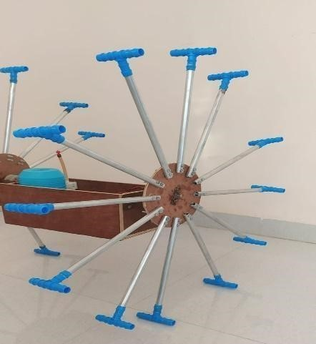
Fig. 3 Spoke Wheel Design

Container Dimensions

The container is the part between the two wheels of the bot, and it will carry all the electronic components along with the pesticide tank and the DC pump. The container is a rectangular box of 29 cm in length, 12 cm in height, and a width of 14 cm. Its sizing is sufficient to hold a pesticide tank with a pump and all electronic components. [Fig.4]

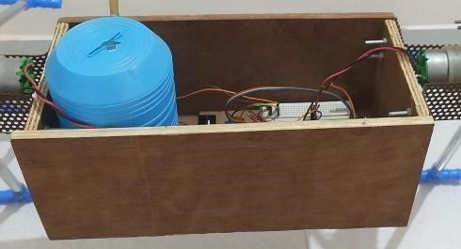

Fig. 3 Container with Electronic Circuit

Communication with Bot

Once we have collected all components and manufactured all required parts the only thing, we are left with is programming our components and designing our UI in the Blynk console. By using Arduino IDE, we have done the programming of the ESP 8266 Wi-Fi module. On blynk, we have designed UI in which we have buttons and sliders to operate our bot [Fig II.]. Once we made all electronic components connections, we will be able to operate the bot with the blynk 8266 Wi-Fi module has Wi-Fi transceiver operation with the range between 2400-2484 MHz and it also supports TCP/IP communication stack and Wi-Fi security including WAP3 [Fig 5].
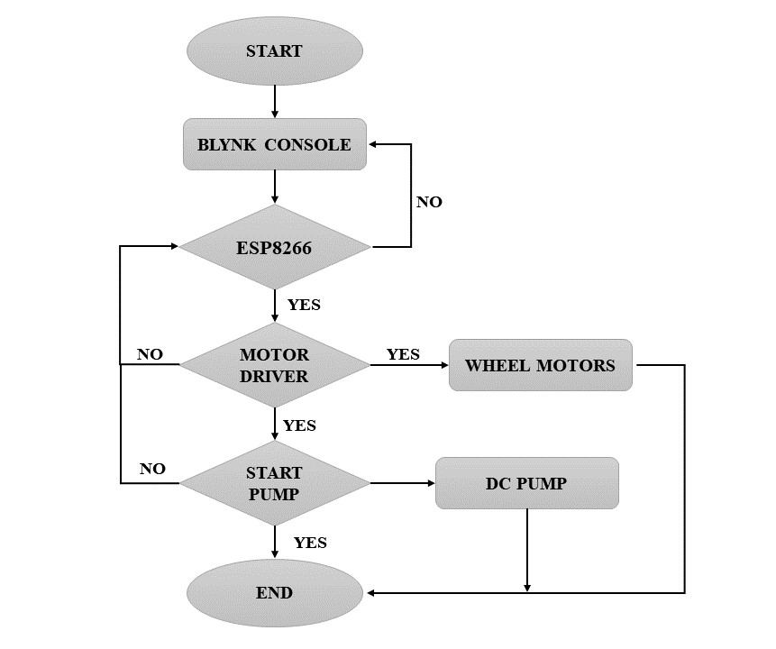
Fig. 5 Communication between the Bot and Mobile Application Flowchart

- Results and Discussion
When the bot was manufactured completely, we have done its testing on 3 different surfaces. The first surface is a plane surface, the second one is on the playground, and the third is on rocky soil which is like farm soil. While it’s first testing, we found that instead of wheels the container between the wheels starts rotating. This happens due to the torque produced by the motors adds up and rotates the container which was not expected as the outcome. The ends of aluminium rods of wheels were found to get fixed and et dip into the ground which makes it unable to move forward even though enough torque is provided by the motors which lead the containers to rotate. To overcome this t-shape connectors were fitted at the end of each rod of the wheel. Due to this arrangement, the problem of fixing of rod’s end of wheels into the ground was solved.
The second modification we have done is by attaching two small wheels of 7.5 cm in diameter in the front and backside of the container to counter the torque generated by the DC motors of the wheels. This arrangement ensures that the container does not rotate. After these two modifications, Bot was able to run. After testing the bot on the first three surfaces max efficiency of the bot was seen on the second surface in which testing was carried out on the normal ground. In the first test which was carried out on a plane surface, wheels manage to roll but not with that efficiency. Less friction was the issue with the plane surface. On the third rocky soil surface, the bot was perfectly moving in the presence of small rocks but struggles to move in large rocks.
- Limitations
When the bot was manufactured completely, we have done its testing on 3 different surfaces. The first surface is a plane surface, the second one is on the playground, and the third is on rocky soil which is like farm soil. While it’s first testing, we found that instead of wheels the container between the wheels starts rotating. This happens due to the torque produced by the motors adds up and rotates the container which was not expected as the outcome. The ends of aluminium rods of wheels were found to get fixed and et dip into the ground which makes it unable to move forward even though enough torque is provided by the motors which lead the containers to rotate. To overcome this t-shape connectors were fitted at the end of each rod of the wheel. Due to this arrangement, the problem of fixing of rod’s end of wheels into the ground was solved.
The second modification we have done is by attaching two small wheels of 7.5 cm in diameter in the front and backside of the container to counter the torque generated by the DC motors of the wheels. This arrangement ensures that the container does not rotate. After these two modifications, Bot was able to run. After testing the bot on the first three surfaces max efficiency of the bot was seen on the second surface in which testing was carried out on the normal ground. In the first test which was carried out on a plane surface, wheels manage to roll but not with that efficiency. Less friction was the issue with the plane surface. On the third rocky soil surface, the bot was perfectly moving in the presence of small rocks but struggles to move in large rocks.

- Conclusion
Once the bot is completed and ready for testing and after taking different parameters into consideration our bot will be able to spray on the farm. The spraying can be controlled by the farmer or the user remotely within the WiFi range. It will be able to spray directly into the crops by going directly between them. Currently taking the height of our bot into consideration it will mostly be able to spray on short crops. It is perfect to spray on crops like grams, soybeans, wheat, cotton, and many more similar farms in their initial growing stage. It will be able to spray on all those farms in their growing stage because of the small height of the bot. Spokes wheels make the bot more rigid to the uneven land with soil rocks on farms. Those special design wheels will make it happen to run our bot in farm soil conditions. The bot may face the problem in muddy soil conditions as its wheel has spokes and they are easy to get stuck in muddy soil conditions.
The two-wheel configuration is unstable because the torque produced by the motors adds up to rotate the payload box which is in between the wheels. Extra two wheels must be attached to the payload box to counterbalance the torque produced by the motors. Thus, this makes our two wheels bot into four wheels unexpectedly. But still, it is able to run on the ground.

References
- Spiewak, R. (2001). Pesticide as a causes of occupational skin diseases in farmers. Annals of agricultural and environmental medicine, 8(1).
- Ahalya, M., Muktha, A., Veena, G., Vidyashree, and Rehna, V. J. (2017). Solar Powered Semi-Automatic Pesticide Sprayer for use in Vineyards. International Journal of Electrical and Computer Engineering (IJECE), April 2017. doi: 10.14445/23488549/IJECE
- Mahyuni, E. L., and Sinaga, M. M. (2016). Health impact of pesticide using method, at sprayed worker farmer in Sumber Mufakat Village, Karo. In Proceedings of the 1st Public Health International Conference (PH-ICo), (pp. 150-154). Atlanti’s Press.
- Anuradha, T., Ramya, K., and Selvam, R. (2019). Design and Implementation of Solar Powered Automatic Pesticide Sprayer for Agriculture. Journal of Physics: Conference Series, 1362(1), 012048. doi: 10.1088/1742-6596/1362/1/012048
- Sowjanya, K., Sindhu, R., Parijatham, M., Srikanth, K., and Bhargav, P. (2017). Multipurpose, autonomous agricultural robot. In Proceedings of the International Conference of Electronics, Communication and Aerospace Technology (IC-ECA), vol. 2, (pp. 696-699). IEEE.
- Cozma, P., Apostol, L. C., Hlihor, R. R., Simion, I. M., and Gavrilescu, M. (2017). Overview of human health hazards posed by pesticides in plant products. In Proceedings of the E-Health and Bioengineering Conference (EHB), Jun 2017, (pp. 293-296). IEEE.

- Martini, N., De Agostini, P. A., Tamami, N., and Alasiry, A. H. (2020). Design and Development of Automatic Plant Robots with Scheduling System. In Proceedings of the International Electronics Symposium (IE-S), Sep 2020, (pp. 302-307). IEEE.
- Aishwarya, B., Varun, G., Archana, and Umayal, C. (2015). Agriculture robotic vehicle based pesticide sprayer with efficiency optimization. In Proceedings of the Technological Innovation in ICT for Agriculture and Rural Development (TIAR), Jul 2015, (pp. 59-65). IEEE.
- Prajith, A. S., Nowfiya, B. S., Noushad, N., Subi, S., and Lal, D. (2020). Automatic Agricultural Robot—Agrobot. In Proceedings of the IEEE Bangalore Humanitarian Technology Conference (B-HTC), Oct 2020, (pp. 1-5). IEEE.
- Zhao, W., Wang, X., Qi, B., and Runge, T. (2020). Ground-Level Mappings and Navigation for the Agriculture Based on Internet of Things and Computer visions. IEEE Access Journal, 8, (pp. 221975-221985). doi: 10.1109/ACCESS.2020.3042528.

