# Lab 1. DC analysis of NMOS and PMOS for varying threshold voltage and W/L ratio.

**Experiment No.1**  
**Title: DC analysis of NMOS and PMOS for varying threshold voltage and W/L ratio.**  
**Aim:** To perform dc analysis of NMOS and PMOS for varying threshold voltage and W/L ratio in NGSPICE Simulation Tool.  
**Learning objectives:**  
1. To understand the characteristics of NMOS and PMOS.  
2. To demonstrate dc analysis of NMOS and PMOS.  
3. To analyse the effect of varying threshold voltage and W/L ratio on output voltage.  
**Outcomes:**After completion of the experiment, students’ will be able --  
1. To implement various circuits using NMOS and PMOS.  
   
**Software used:** NGSPICE 30  
**Theory:**  
1. Voltage sweep characteristics of NMOS and PMOS.  
2. What is threshold voltage?  
3. How does the variation in W/L ratio effect the functioning of NMOS and PMOS?  
**Circuit Diagram:**  
   
**Netlist:**

**PMOS:-**

*pMOS Characteristics

.model p pmos vto=-0.7V

Vds 3 0 dc -5V

Vgs 1 0 dc 5V

Vd 3 2 dc 0V

M1 2 1 0 0 p L=0.18U W=0.36U

*.DC Vds 0 5 0.1

*.dc Vgs -3 0 0.1

.dc Vds -5 0 0.2 Vgs -5 0 0.5

*.dc Vgs -5 0 0.2 Vds -5 0 0.2

.control

run

plot i(Vd)

.endc

.end  
   
**Results:**

**Pmos result:-**

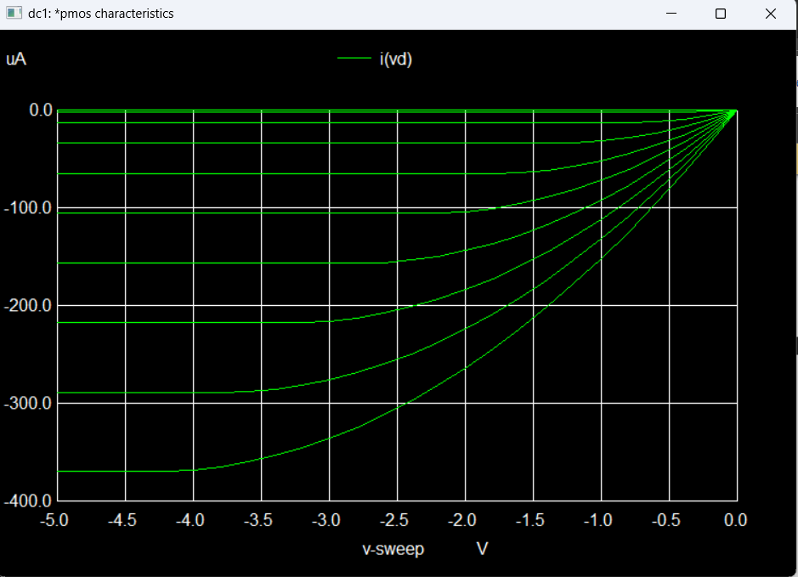  
   
**Conclusions:**