

**Tutorial 1**

Q1. Explain the MOS capacitive model. Write the equation for all the capacitances present in the MOSFET (Parasitic and Junction).

ANS:-

mosfet:

- 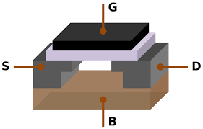

In a metal-oxide-semiconductor (MOS) device, the MOS capacitive mode refers to the operation of the device as a capacitor. In this mode, the MOS device is used to store electrical charge. A MOS capacitor is formed by creating a layer of insulating material, called the oxide layer, between a metal layer (the gate) and a semiconductor layer (usually silicon). When a voltage is applied to the gate, it creates an electric field that modulates the conductivity of the semiconductor layer. This allows the MOS capacitor to store a charge, which can be used to represent binary data in electronic circuits. MOS capacitors are widely used in many electronic devices, such as smartphones, computers, and other electronic devices. They are important components in the operation of MOS transistors, which are widely used in digital circuits.

**There are total 5 types of capacitors formed in mosfet.**

1. the capacitor between gate and body C ${gb}_{}$
2. The capacitor between gate and source C ${gs}_{}$
3. The capacitor between gate and drain C ${gd}_{}$
4. The capacitance between source and body C ${sb}_{}$
5. The capacitance between drain and body C $db$

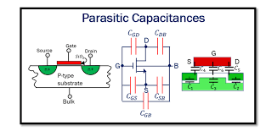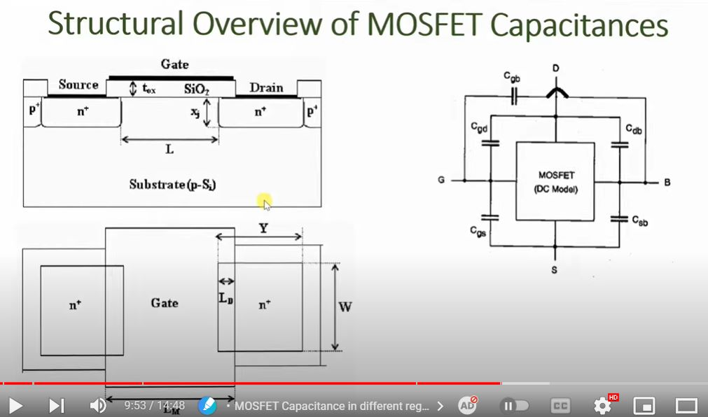

**There are three opeaartion region of capacitor**

1. **cutoff**
2. **linear region**
3. **saturation region**

**Equations:-**

**Cutoff region**

1. C ${gb}_{}$ = C ${ox}_{}$* L * W
2. C ${gs}_{}$ = C ${ox}_{}$* L $d_{}$* W
3. C ${gd}_{}$ = C ${ox}_{}$* L $d_{}$* W

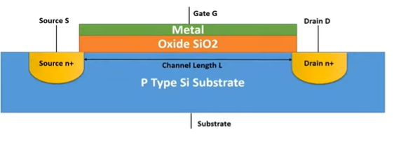

**Linear Region**

1. C ${gb}_{}$ = 0
2. C ${gs}_{}$ =½(C ${ox}_{}$* L * W) + C ${ox}_{}$* L $d_{}$* W
3. C ${gd}_{}$ = ½(C ${ox}_{}$* L * W) + C ${ox}_{}$* L $d_{}$* W

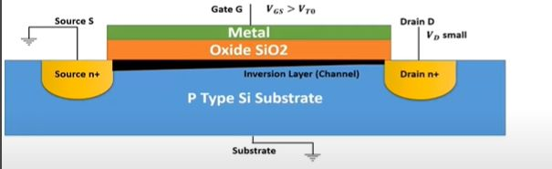

**Saturation region**

1. C ${gb}_{}$ = 0
2. C ${gs}_{}$ = C ${ox}_{}$* L $d_{}$* W
3. C ${gd}_{}$ = 2/3(C ${ox}_{}$* L * W) + C ${ox}_{}$* L $d_{}$* W

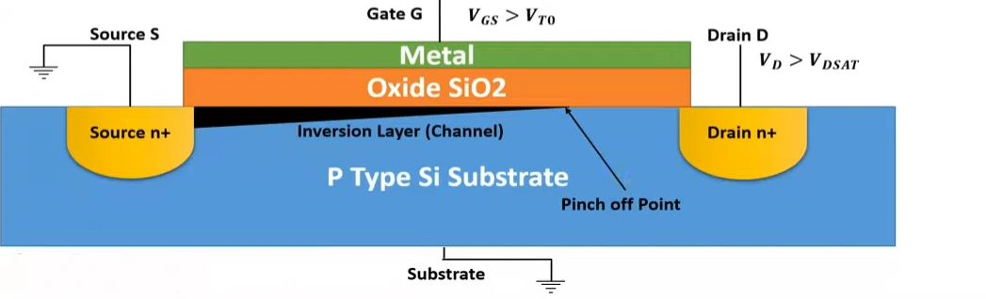

Q2. Explain Channel Length Modulation.

ans:-

* Channel length modulation in a MOSFET refers to the phenomenon where the effective channel length of the device changes as the drain-source voltage (VDS) is increased. As VDS increases, the potential at the drain end of the channel becomes more positive relative to the potential at the source end, which in turn causes the depletion region to extend further into the channel, effectively "shortening" the channel length. This can lead to an increase in the device's drain resistance, which can limit its maximum current carrying capacity and reduce its overall performance

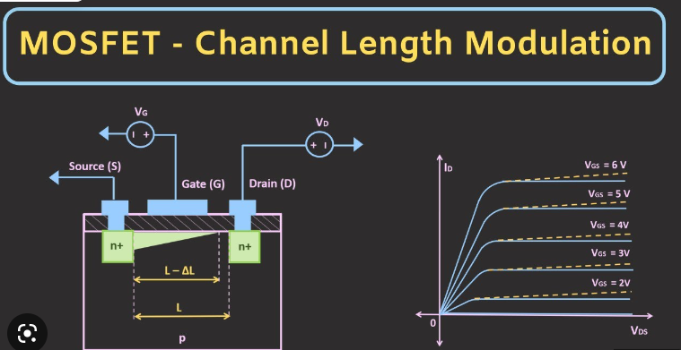

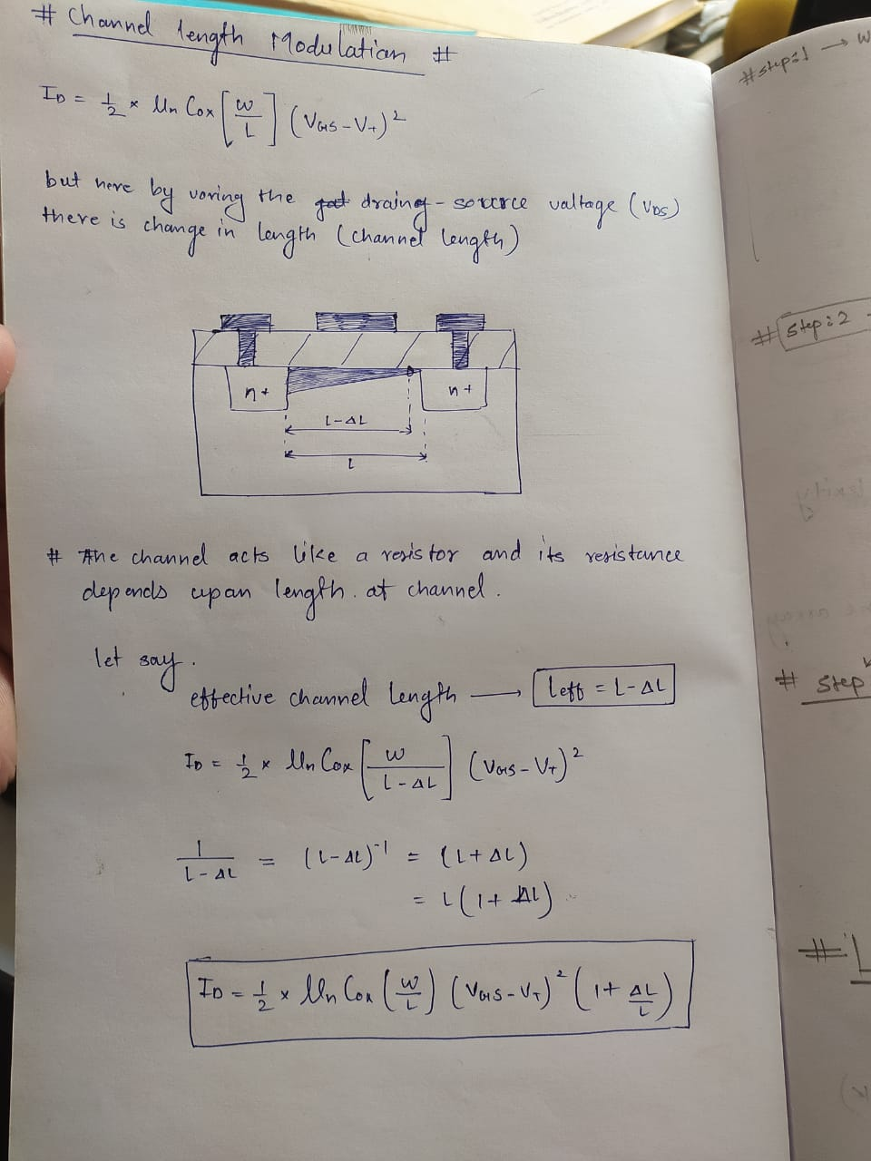

Q3. Explain the effect of scaling on threshold, current, power, and delay.

ANS:-

* Scaling refers to the process of reducing the physical dimensions of a MOSFET device in order to improve its performance and reduce power consumption. The effect of scaling on different parameters of a MOSFET device can be as follows:
* Threshold voltage (Vt): Scaling can lead to a reduction in the threshold voltage, which means that a lower gate-source voltage (VGS) is required to turn on the device and allow current to flow through the channel. This can result in a higher drive current and improved device switching speed.
* Current: As the device dimensions are scaled down, the channel length also decreases, which results in a higher current density. This leads to an increase in the device's current carrying capacity, which can improve its overall performance.
* Power: Scaling can lead to a reduction in the power consumption of a device. This is because as the device dimensions are scaled down, the parasitic capacitances associated with the device also decrease. This can lead to a reduction in the amount of power required to charge and discharge these capacitances during device switching, which can result in a reduction in power consumption.
* Delay: Scaling can have an effect on the delay of a device. As the device dimensions are scaled down, the parasitic capacitances associated with the device also decrease, which can lead to a reduction in the amount of time required to charge and discharge these capacitances during device switching. This can result in a reduction in the delay of the device and improved its overall performance. However, as the device dimensions are scaled down, the resistance of the channel also increases, which can increase the delay of the device.
* It's worth noting that while scaling can improve the performance of a MOSFET device, it also has some limitations. As the device dimensions are scaled down, it becomes increasingly difficult to control the doping profile of the channel, which can lead to increased short channel effects and reduced device reliability. Additionally, as the device dimensions are scaled down, the device's gate oxide thickness also decreases, which can lead to increased gate leakage current and reduced device reliability.