Banking Customer Analysis

Project Summary
Banking Customer Analysis focuses on evaluating loan and deposit patterns to assess liquidity, risk exposure, and customer behavior. The analysis shows deposits slightly exceed loans, indicating strong financial stability, while high-income customers drive the majority of lending revenue. Most clients fall into low to medium risk categories, with a small high loan-to-deposit segment requiring close monitoring. These insights support better risk management, customer segmentation, and targeted business growth strategies.

Project Overview
The project involves designing and managing a structured banking database using SQL, followed by connecting the data to Python for cleaning and Exploratory Data Analysis (EDA). Key insights and metrics were extracted through SQL queries and analytical processing in Python. The refined data was then integrated into Power BI to build interactive dashboards that visualize customer behavior, loan–deposit trends, and risk indicators for business decision-making.

Tools & Technologies Used
  - Python (Pandas, NumPy, Matplotlib) – Data cleaning and EDA
  - SQL (SQL Server) – Data querying and insight extraction
  - Power BI – Interactive dashboards and visual storytelling
  - Jupyter Notebook – Analysis and documentation

Dataset Summary
- Total Rows (Records): 3000
- Total Columns (Features): 25
- Key Features: Age, Location ID, Occupation, Estimated Income, Loyalty Classification, Credit Card Balance, Bank Loans, Bank Deposits, Properties Owned, Risk Weighting.
- Null / Missing Values Analysis: No missing or null values found in any column.
This means the dataset is clean and ready for analysis, with no need for missing-value treatment.

Exploratory Data Analysis (EDA) using Python
Step 1: Data Collection Using SQL
- The banking data was first extracted from the database using SQL queries.
- The final dataset was exported and saved as a CSV file for further analysis.

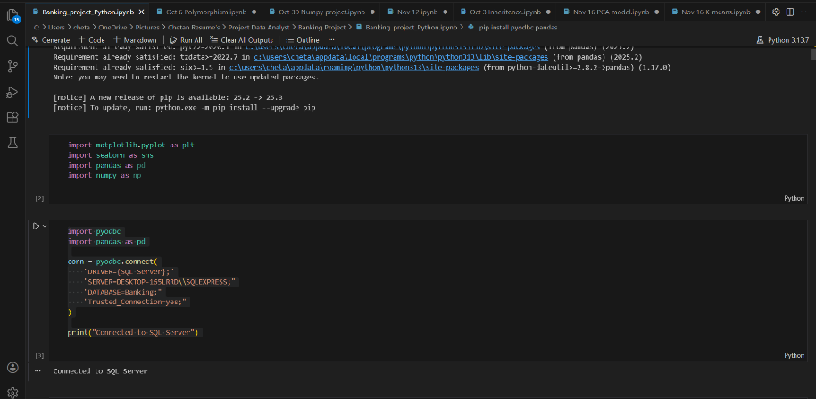

Step 2: Data Loading in Python
- The extracted CSV file was loaded into Python using the Pandas library.
- The dataset was stored in a DataFrame for analysis.

Step 3: Initial Data Preview

Used df.head () to view the first 5 rows of the dataset.

This helped in understanding:

Column names

Type of data stored in each column

Overall structure of the dataset

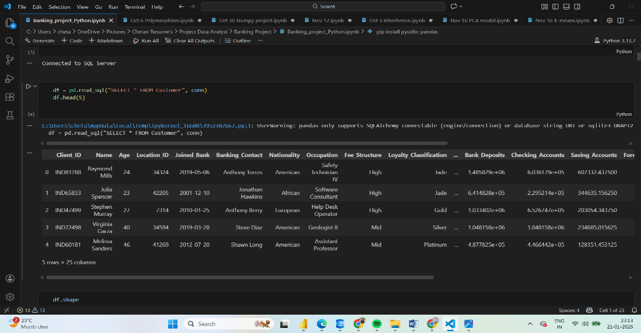

Step 4: Dataset Shape Analysis
- Used df.shape to find:
Total number of rows (records)
Total number of columns (features)


Step 5: Key Column Selection for EDA:
(Age, Estimated Income, Bank Loans , Bank Deposits , Credit Card Balance, Loyalty Classification, Risk Weighting)

Step 6: Basic Distribution Analysis
- Analysed how data is distributed across key numerical variables.
- Identified trends in income levels, loan amounts, and deposits.
- Helped in customer segmentation and risk analysis.
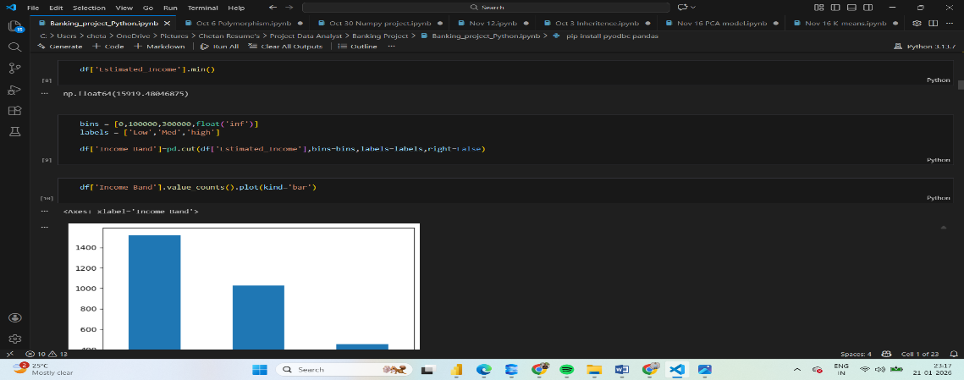

Step 7 : EDA Output for Dashboard Creation:
Final insights from EDA were used to:
- Define KPIs
- Choose appropriate charts
- Build Power BI dashboards for business analysis
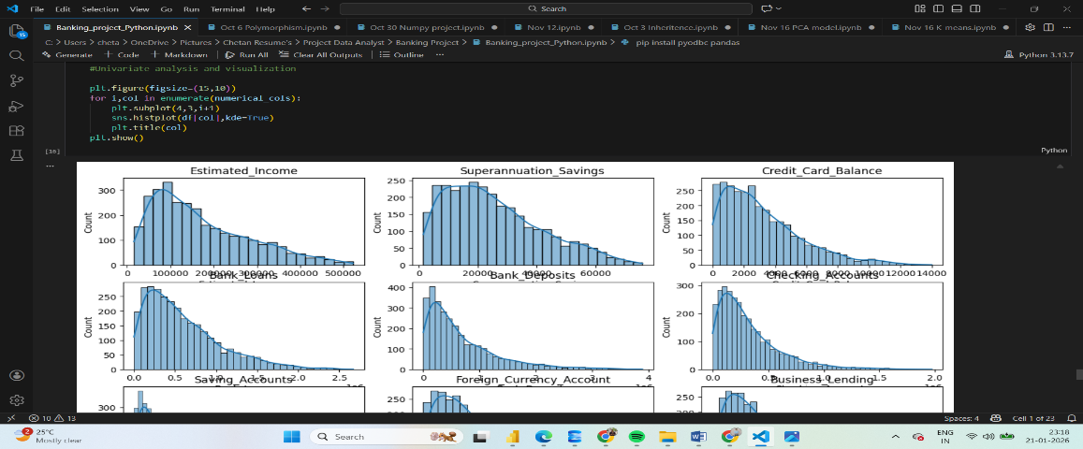

Insights using SQL
SQL analysis provided insights into customer segmentation, income patterns, loan and deposit behavior, loyalty impact, and risk distribution, supporting data-driven banking decisions.

- Customers belong to each gender:
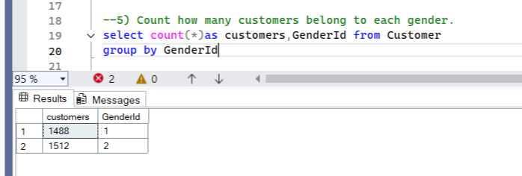
Male : 1488 Female : 1512

- Identified the top 10 customers contributing the highest total deposits, highlighting high-value clients. 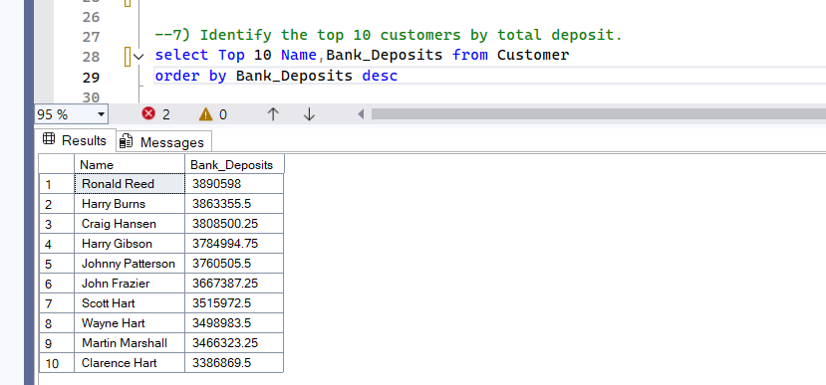

- Gender-Based Financial Contribution Analysis
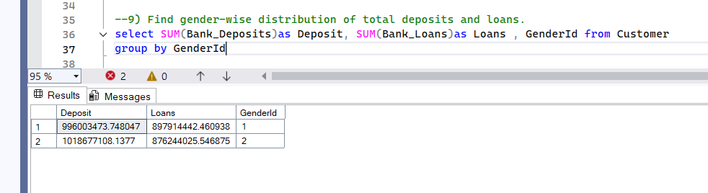

- Loan vs Deposit Exposure Identification
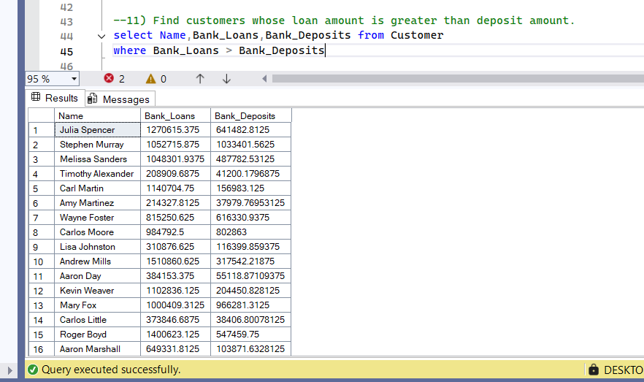

- Loan–Deposit Gap Analysis
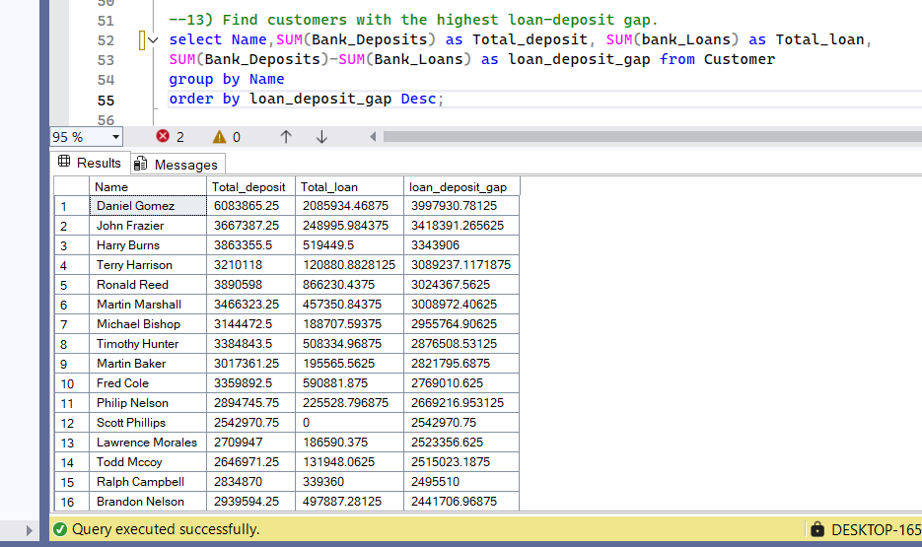

- High-Risk Customer Identification
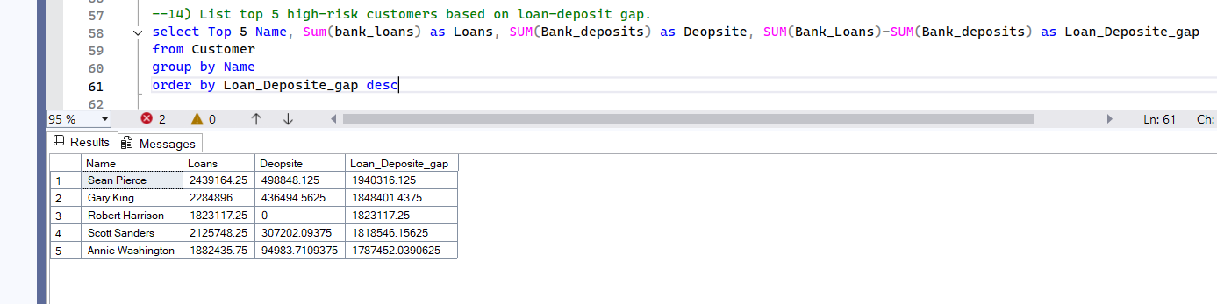

- Excessive Loan Exposure Detection
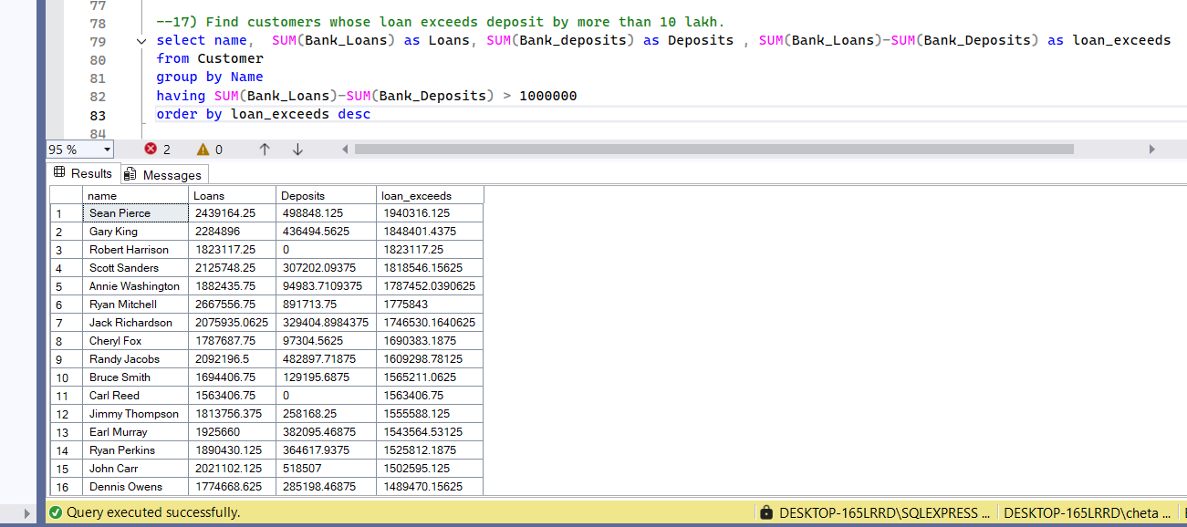

- Long-Term High-Value Customer Analysis
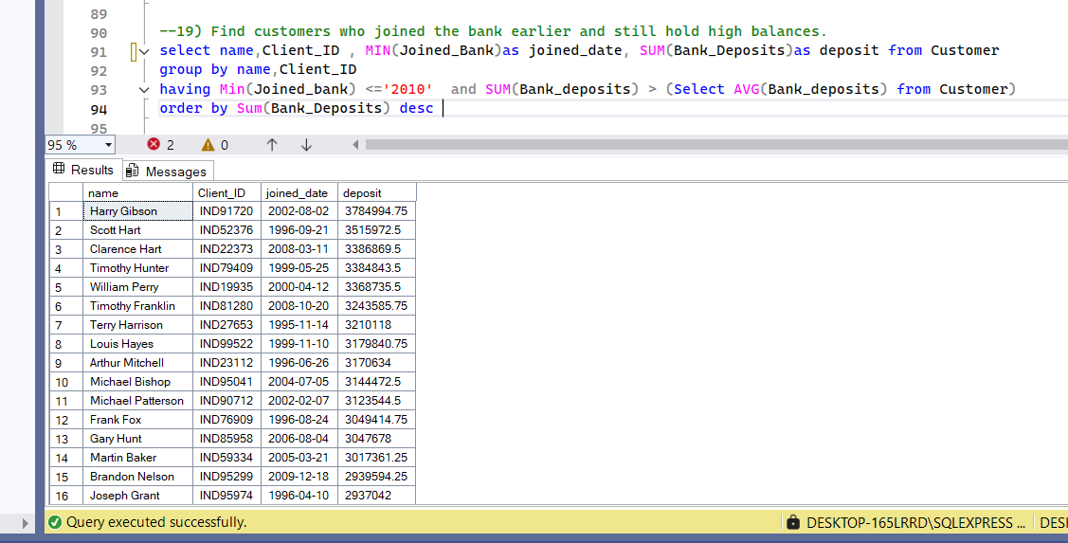

Dashboards
The dashboard provides a consolidated view of customer demographics, loans, deposits, and risk indicators, enabling quick identification of high-value and high-risk customers.

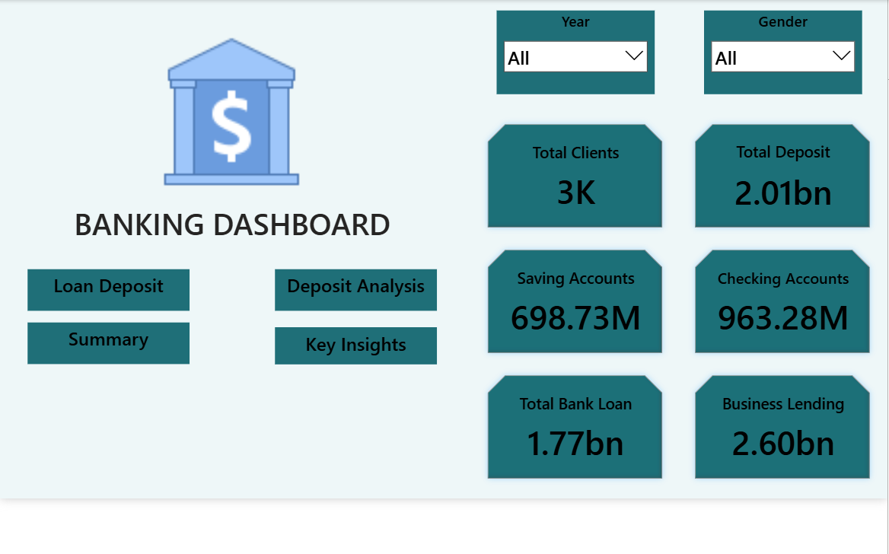

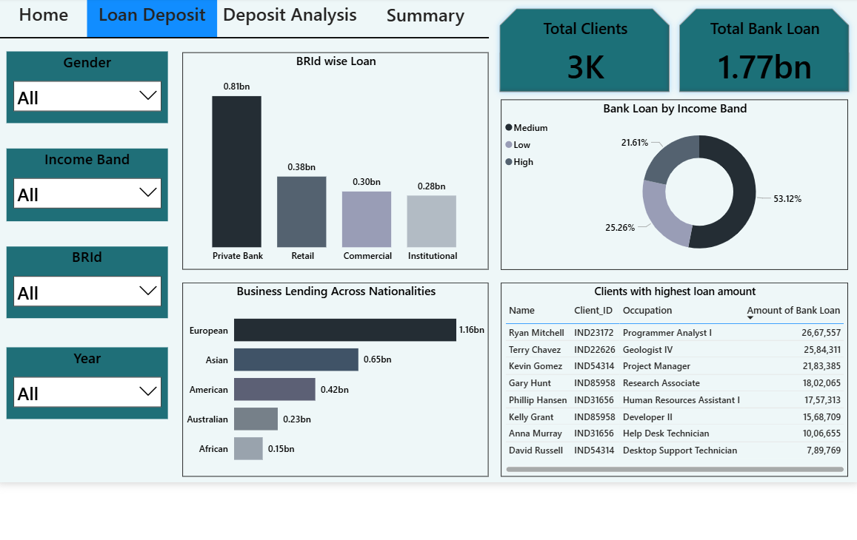

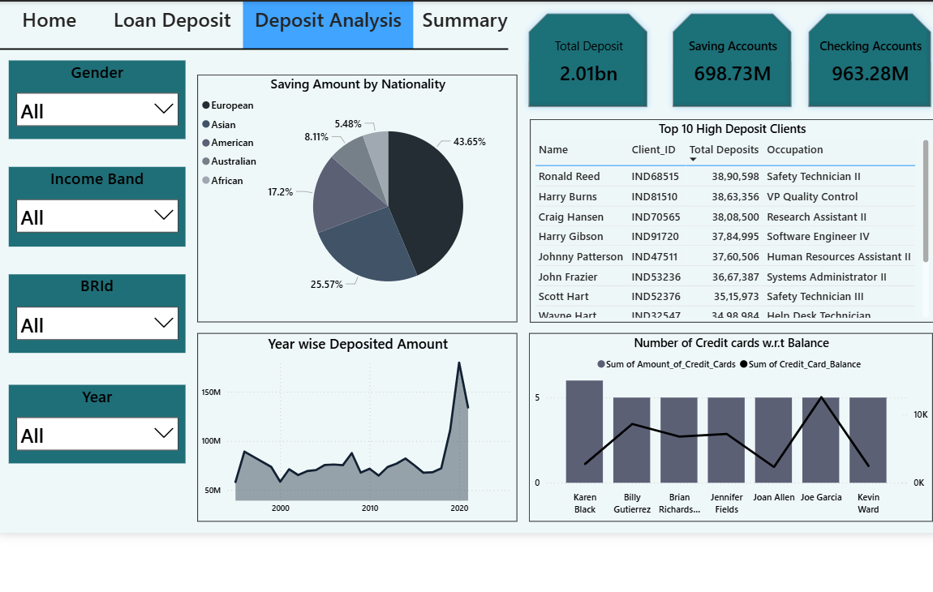

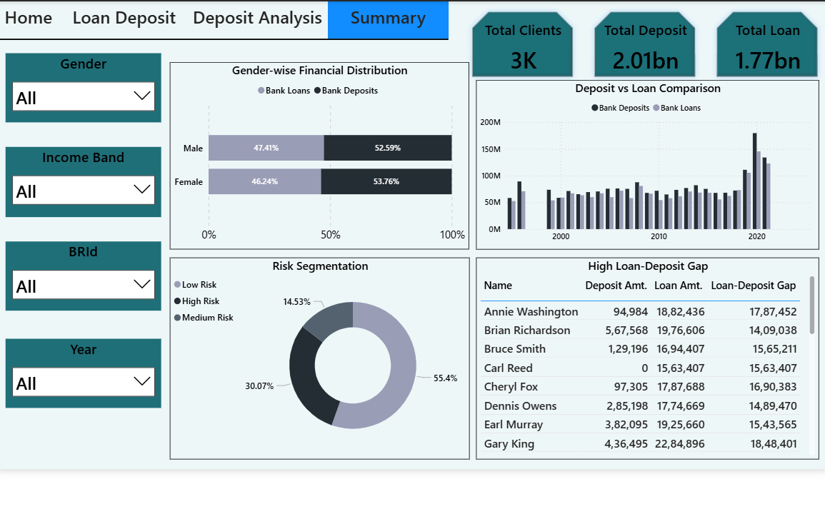

Business Recommendations

Strengthen High-Income Customer Relationships :

This helps maximize revenue while improving long-term customer retention.

Maintain Healthy Liquidity While Scaling Lending :

Focus on secured loans and top-tier customers to improve profitability without increasing risk.

- Leverage Strong Deposit Growth :
Promote long-term savings, fixed deposits, and investment products to retain growing deposits.

- Expand Business Lending in Key Regions :
Increase focus on European and Asian markets where business lending demand is highest.

