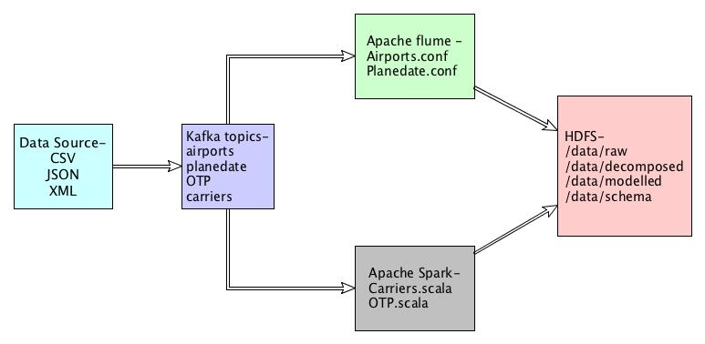
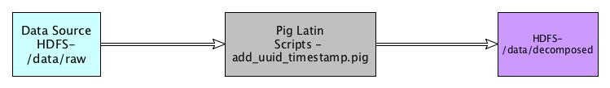
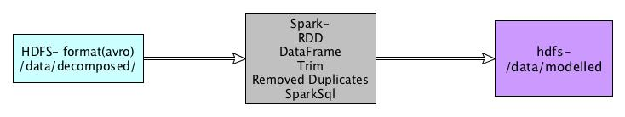
Data Science full-stack developer – Case Study

As a full stack Data science engineer I would like to build/test & support large-scale data processing systems and be an expert in the latest Big Data, NoSQL, advanced analytic tools & AI concepts. Here I will be demonstrating a complete data application lifecycle – data ingestion, modeling, processing & prediction solutions using AI techniques (Deep Learning/Machine Learning) to meet business needs of the organization. From my experienced I came up with the following problem solving solution.

Use-Case: Airline on-time performance

Have you ever been stuck in an airport because your flight was delayed or cancelled and wondered if you could have predicted it if you'd had more data?

Well as a Data Science Engineer I would like to come up with the solution by analyzing all the existing data (flight arrival and departure information from October 1987 to April 2008) and streaming real time data and come up with prediction and updated our customer with the real time data, so customer can benefitted from it and avoid all the consciences.

The Framework Implementations:

For implementing the framework I have used the following lists of tools:

OS – Mac
Bigdata tool -

- Spark 2.1.1
- Kafka 1.0.0
- Flume 1.8.0
- Hadoop 2.7.2
- Pig 0.17.0
- Zeppelin 0.7.1
- R Studio 1.1.423

Step by Step guide to install and configured these tools:

  - Install Spark

Here is the official site for downloading Spark

- https://spark.apache.org/downloads.html
- tar –xvzf spark-2.2.1-bin-hadoop2.7.tgz

Start Spark Master and slave by using below command

sbin/start-master.sh -h 127.0.0.1 -p 7077
sbin/start-slave.sh spark://127.0.0.1:7077

  - Install kafka
Here is the official site for downloading Kafka

- https://kafka.apache.org/
- http://redrockdigimark.com/apachemirror/kafka/1.0.0/kafka_2.11-1.0.0.tgz
- tar -xvzf kafka_2.11-1.0.0.tgz

Start Zookeeper server and Kafka Server

bin/zookeeper-server-start.sh config/zookeeper.properties
bin/kafka-server-start.sh config/server.properties

Create Topic in Kafka

bin/kafka-topics.sh --create --zookeeper localhost:2181 --replication-factor 1 --partitions 1 --topic Airports
bin/kafka-topics.sh --create --zookeeper localhost:2181 --replication-factor 1 --partitions 1 --topic Carriers
bin/kafka-topics.sh --create --zookeeper localhost:2181 --replication-factor 1 --partitions 1 --topic Planedate
bin/kafka-topics.sh --create --zookeeper localhost:2181 --replication-factor 1 --partitions 1 --topic OTP

Read the source data in topics

bin/kafka-console-producer.sh --broker-list localhost:9092 --topic Airports < /Users/cruise/Documents/developer/emirates/airports.csv
bin/kafka-console-producer.sh --broker-list localhost:9092 --topic Planedate < /Users/cruise/Documents/developer/emirates/plane-data.csv
bin/kafka-console-producer.sh --broker-list localhost:9092 --topic Carriers < /Users/cruise/Documents/developer/emirates/carriers.csv

Get data into consumer

bin/kafka-console-consumer.sh --zookeeper localhost:2181 --bootstrap-server localhost:9092 --topic Airports --from-beginning
bin/kafka-console-consumer.sh --zookeeper localhost:2181 --bootstrap-server localhost:9092 --topic Planedate --from-beginning
bin/kafka-console-consumer.sh --zookeeper localhost:2181 --bootstrap-server localhost:9092 --topic Carriers --from-beginning

  - Install Flume

Here is the official site for downloading Flume

- https://flume.apache.org/download.html
- apache-flume-1.8.0-bin.tar.gz

- tar -xvzf apache-flume-1.8.0-bin.tar.gz

create conf file and put it in conf directory of flume

bin/flume-ng agent --conf conf --conf-file conf/Airports.conf --name flume1 -Dflume.root.logger=INFO,console

bin/flume-ng agent --conf conf --conf-file conf/Planedate.conf --name flume1 -Dflume.root.logger=INFO,console

  - Install Hadoop

Here is the official site for downloading Hadoop

- http://hadoop.apache.org/releases.html

After making change in conf file (core-site.xml, hdfs-site.xml, hadoop-env.sh) of hadoop, start namenode and datanode by using below command

sbin/start-dfs.sh

bin/hdfs dfs -mkdir -p /data/raw/
bin/hdfs dfs -mkdir -p /data/decomposed/
bin/hdfs dfs -mkdir -p /data/modelled/
bin/hdfs dfs -mkdir -p /data/schema/

  - Install Pig

Here is the official site for downloading Pig

- http://www-eu.apache.org/dist/pig/pig-0.17.0/
- download pig-0.17.0.tar.gz
- tar -xvzf pig-0.17.0.tar.gz

Created pig script and execute with below command

bin/pig -x local /Users/cruise/Documents/developer/emirates/add_uuid_timestamp.pig

  - Install Zeppelin

Here is the official site for downloading Zeppelin
- http://www.apache.org/dyn/closer.cgi/zeppelin/zeppelin-0.7.3/zeppelin-0.7.3-bin-all.tgz
- tar -xvzf zeppelin-0.7.3-bin-all.tgz

Start Zeppelin by using below command

bin/zeppelin-daemon.sh start

  - Install Rstudio
Donwload Binary package of R and Rstudio

- https://www.rstudio.com/products/rstudio/download/

Data Pipeline:

Implementation of the data Pipeline:

- 1st of all I read the data from the csv file, which is proved in the case study.
- Next I have ported those data into the Kafka topics
- From topics Airport and planedate I have read the data through Apache Flume and save the data into HDFS under the directory /data/raw
- From topics OTP and Carriers I have read the data using Apache Spark(Spark Streaming) and save those data into HDFS under the directory /data/raw

Data decomposition:

For adding timestamp and UUID, I have used Pig Latin Scripts
In which, I’ve read the contain from HDFS data/raw directory and those decomposed data I have added back to HDFS under the directory /data/decomposed in AVRO format.

Data Modeling and Processing:

- In data modeling, I have read the data from data/decomposed directory and convert the data into data frame by using the package com.databricks.spark.avro
- Next I trimmed those data, remove special characters and null
- For removing duplicate data I have used dataframe.distinct and save the refined data into HDFS into parquet format

Develop a solution using R/Python/Spark MLlib tools and Big Data platform to answer the following questions. Demonstrate your expertise in each tools.

· Which carrier performs better?

I have done in zeppelin notebook and I have exported zeppelin notebook in github directory.
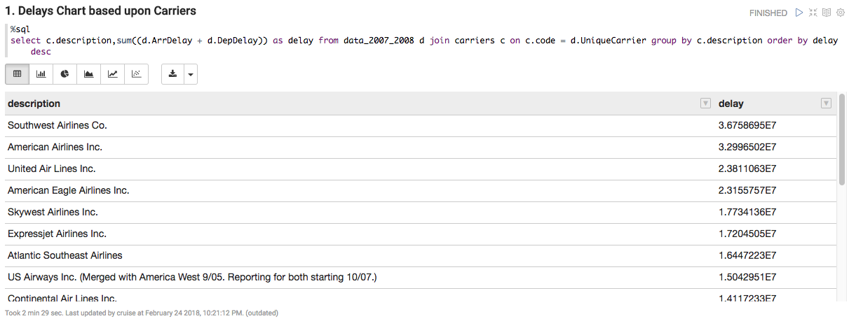

· When is the best time of day/day of week/time of year to fly to minimize delays?
I have done in zeppelin notebook and I have exported zeppelin notebook in github directory.
From September to November is the best time in the year with minimize delays as show in the below chart.

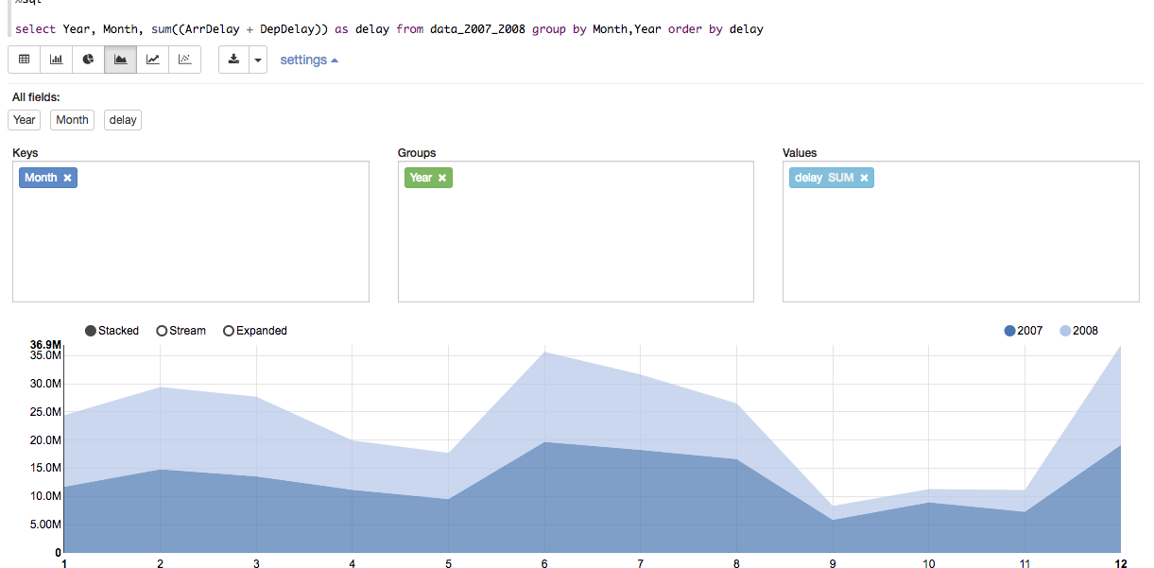
· Do older planes suffer more delays?

No, even new planes have too much delay as you can in the output. Plane of 2008 have more delays.

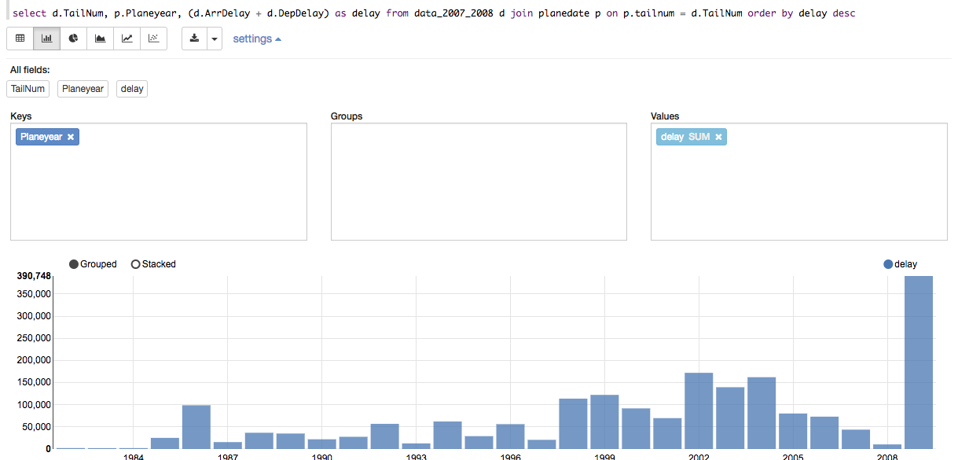

· Create a model to predict flight delays

This is have done in Rstudio using SparkR. I have upload the code on github. In this I have just find out the delays for each month.

· How well does weather predict plane delays?
I didn't found OTP data.

For complete code, please visit github link

Repo link-
https://github.com/Chetan8256/assignment

Repo zip link-
https://github.com/Chetan8256/assignment/archive/master.zip

Repo clone link
https://github.com/Chetan8256/assignment.git

Note: I didn't use any cluster tool like (Hortonworks, Cloudera). But I have worked on these. I have also done some projects in Python using Pyspark and pandas.

And I can aslo configure all these in Linux.

