Linux Basics Assignment
Name: Chetan
GitHub link: https://github.com/ChetanCR-303/Linux_Basics_Chetan
I did all the tasks on Ubuntu running on WSL in Windows 10. Each task below has the command, a screenshot and a short explanation.
Task 1: Create a directory
Command: mkdir test_dir
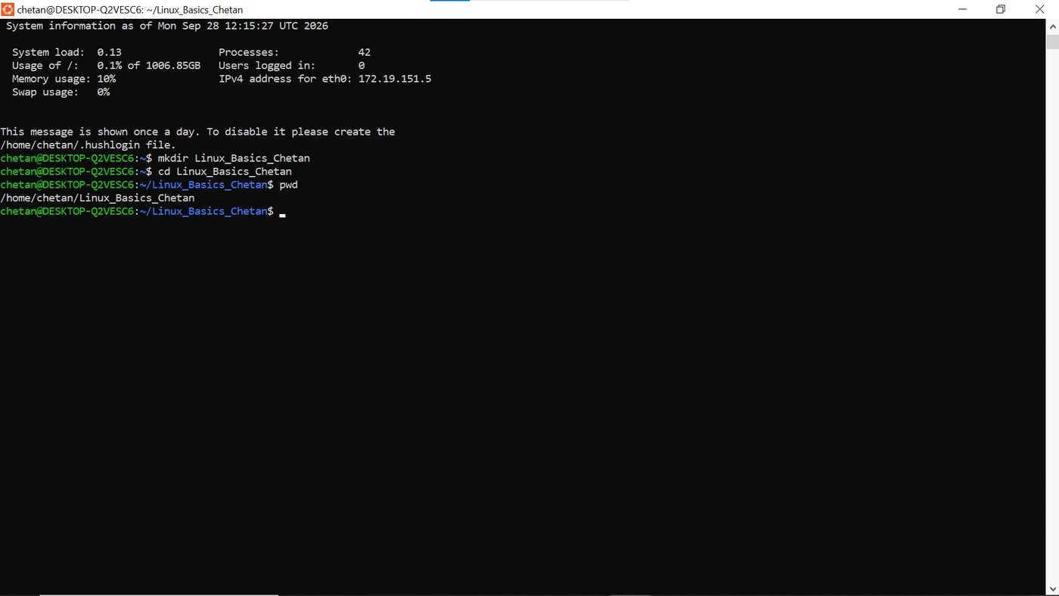

I used mkdir to make a new folder called test_dir.
Task 2: Create an empty file
Command: touch test_dir/example.txt
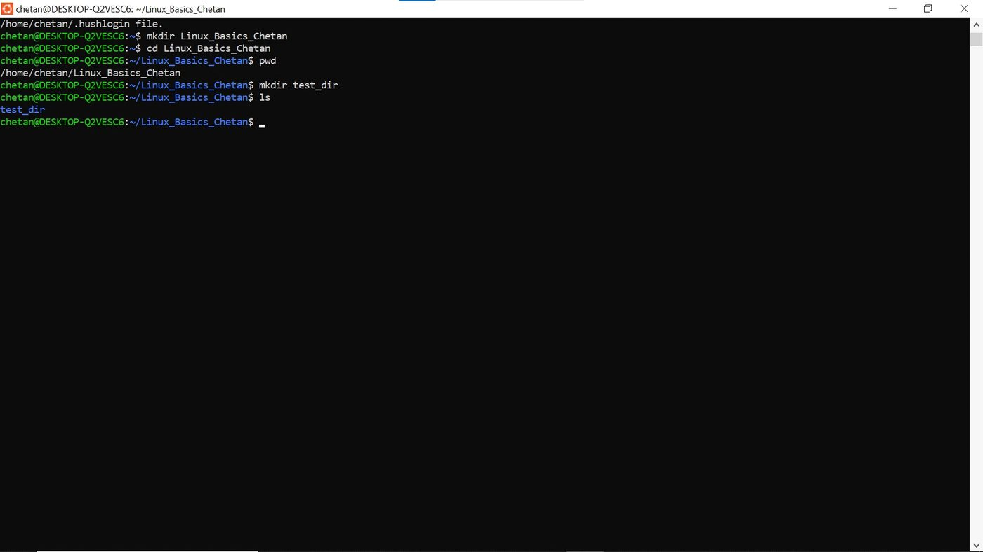

touch creates an empty file. I made example.txt inside test_dir.
Task 3: Rename the file
Command: mv test_dir/example.txt test_dir/renamed_example.txt
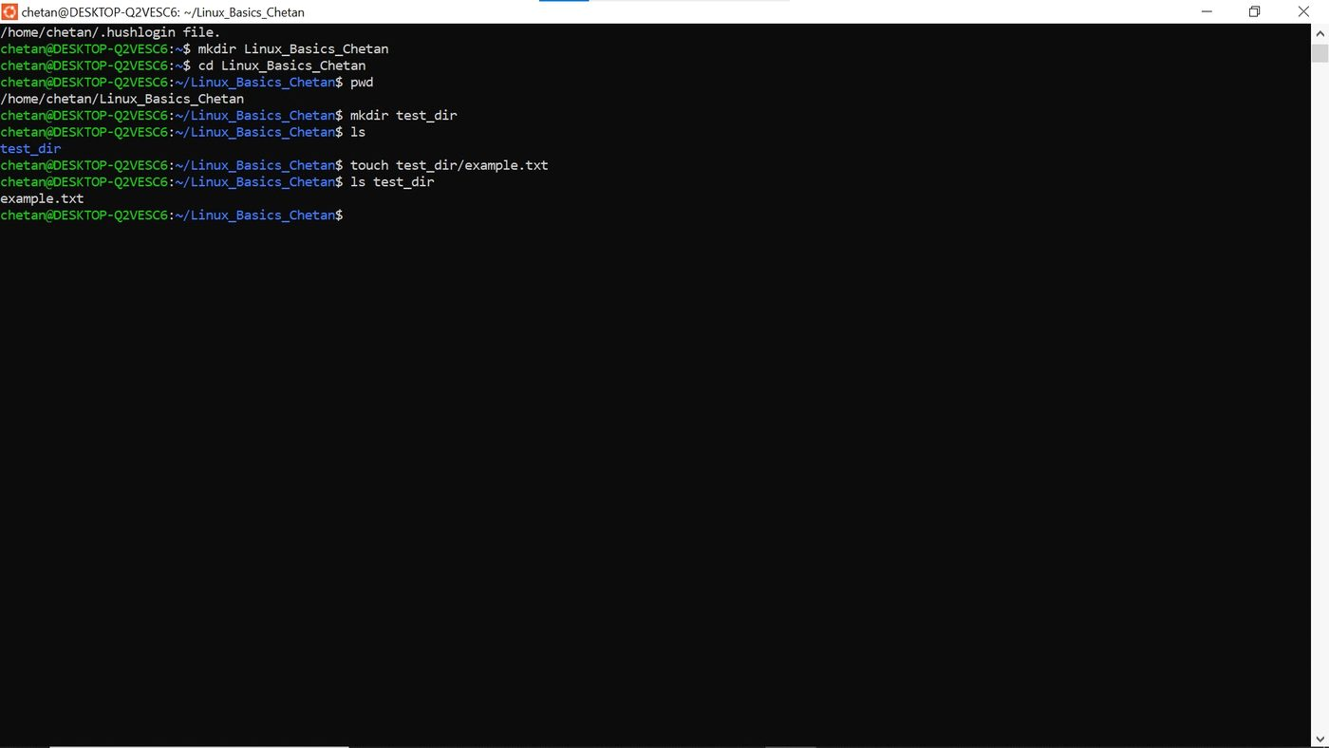

mv moves a file, and it can also rename it. Here I just changed the name of example.txt to renamed_example.txt.
Task 4: View /etc/passwd
Command: cat /etc/passwd
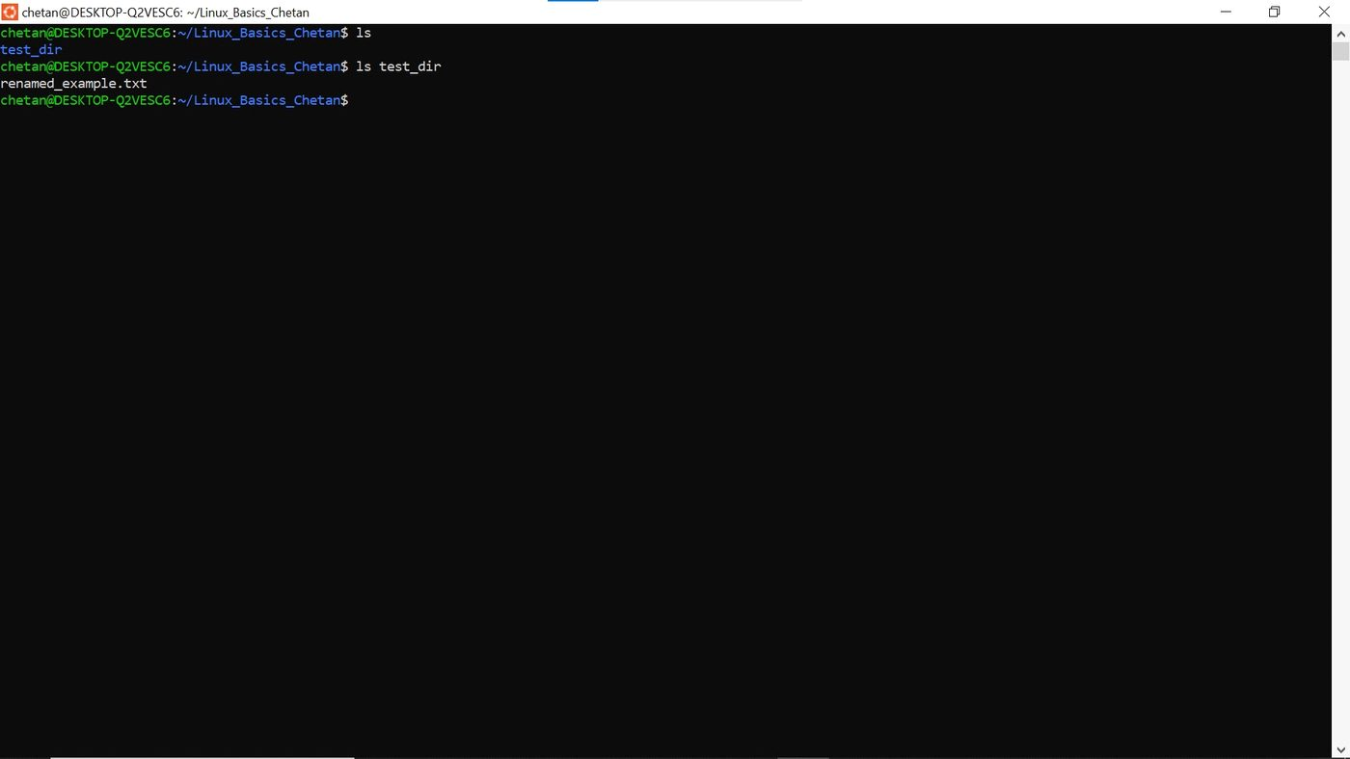
cat prints the whole file on the screen. This file has the list of user accounts on the system.
Task 5: First 5 lines
Command: head -n 5 /etc/passwd
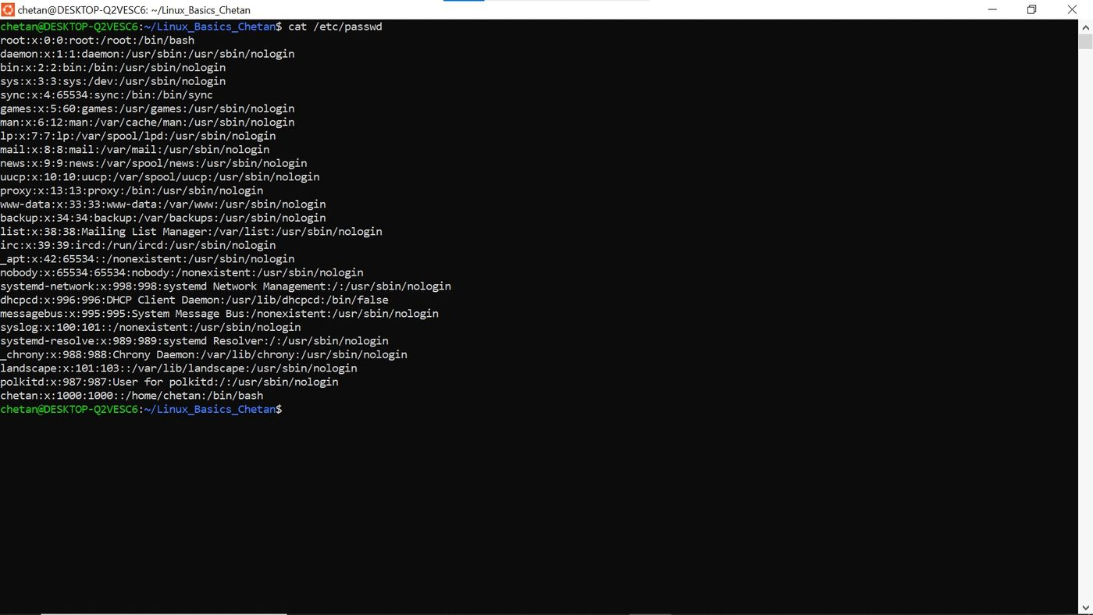

head shows the start of a file. -n 5 means only the first 5 lines.
Task 6: Last 5 lines
Command: tail -n 5 /etc/passwd
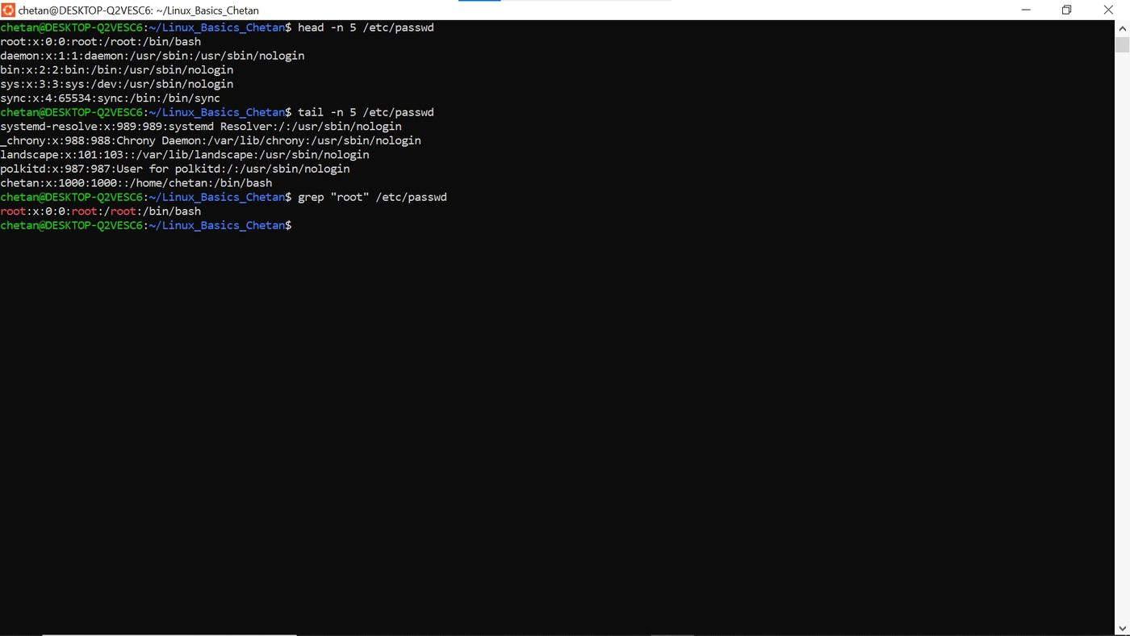

tail shows the end of a file. -n 5 means only the last 5 lines.
Task 7: Search for "root"
Command: grep "root" /etc/passwd
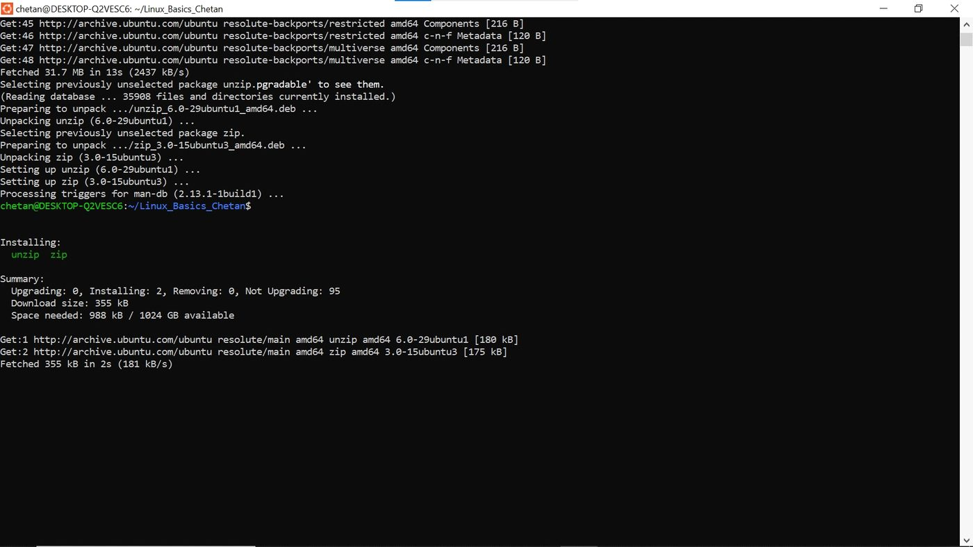

grep searches for a word in a file and prints only the lines that have it.
Task 8: Zip the folder
Command: zip -r test_dir.zip test_dir
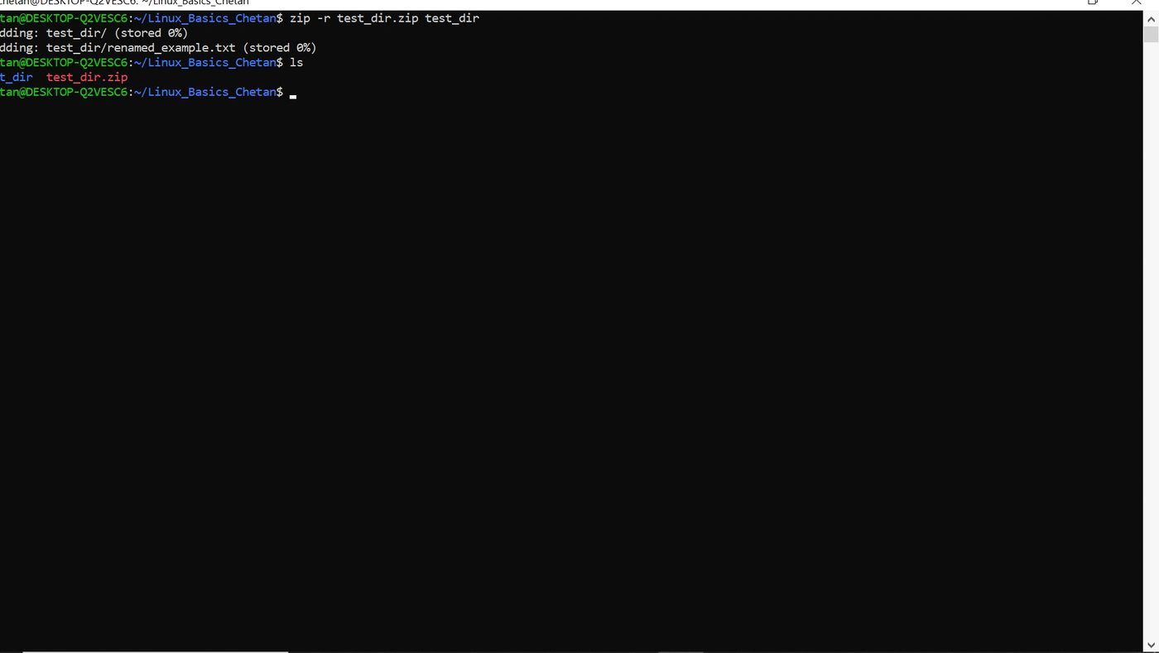
zip makes a compressed .zip file. I used -r so it includes everything inside the folder.
Task 9: Unzip the file
Command: unzip test_dir.zip -d unzipped_dir
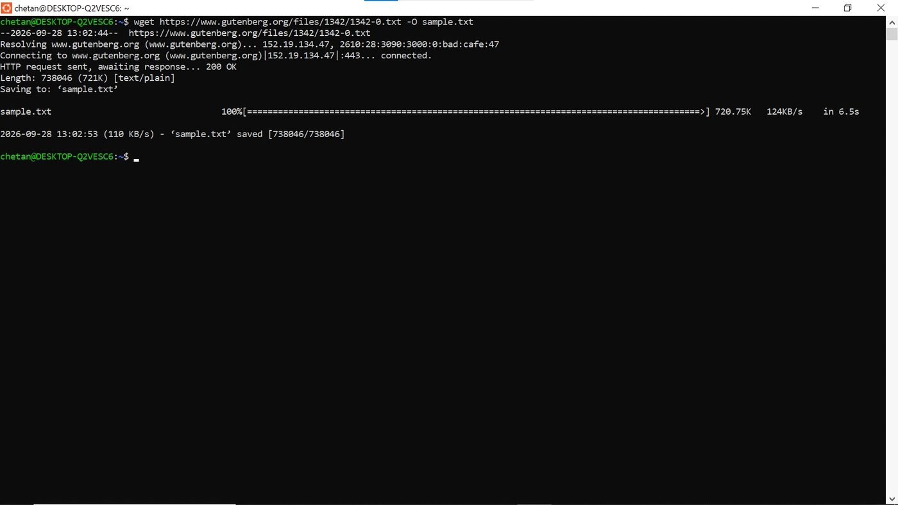

unzip extracts a zip file. -d tells it which folder to extract into, so the files went into unzipped_dir.
Task 10: Download a file
Command: wget https://www.gutenberg.org/files/1342/1342-0.txt -O sample.txt
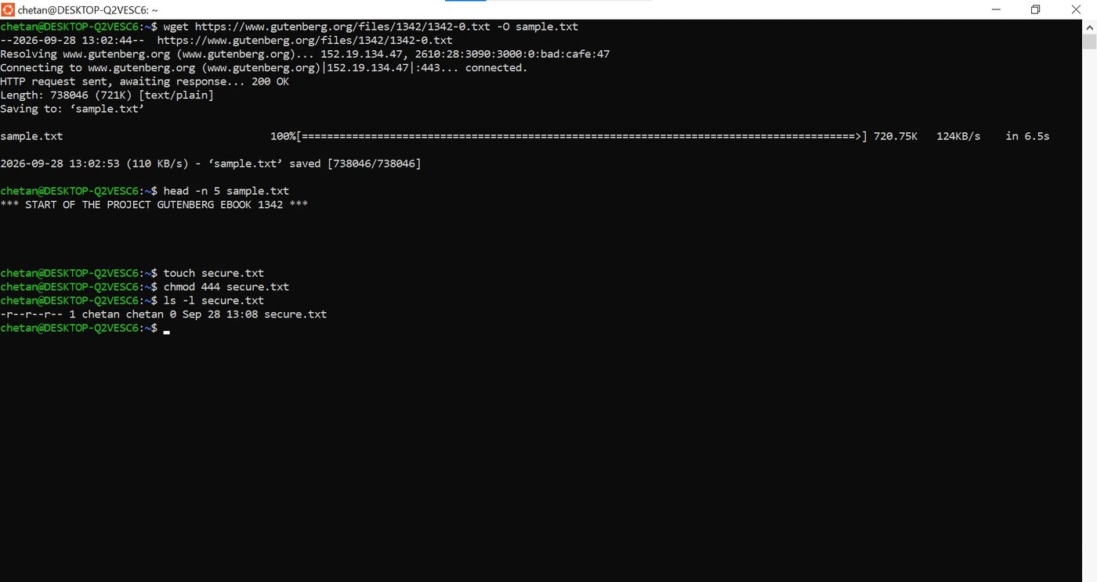

wget downloads a file from the internet. -O lets me choose the file name, so I saved it as sample.txt. I used a real URL because example.com/sample.txt does not exist.
Task 11: Make a file read-only
Command: touch secure.txt
chmod 444 secure.txt
ls -l secure.txt
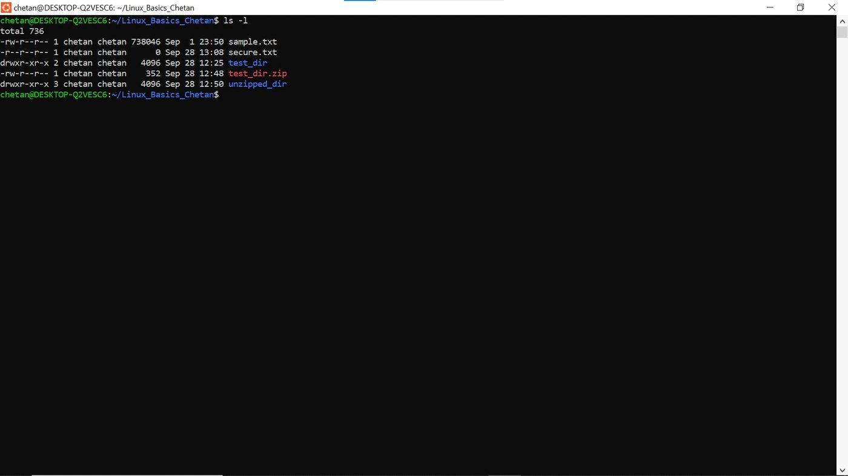

I created secure.txt and used chmod 444 to give read-only permission to everyone. ls -l shows -r--r--r--, which confirms it.
Task 12: Environment variable
Command: export MY_VAR="Hello, Linux!"
echo $MY_VAR
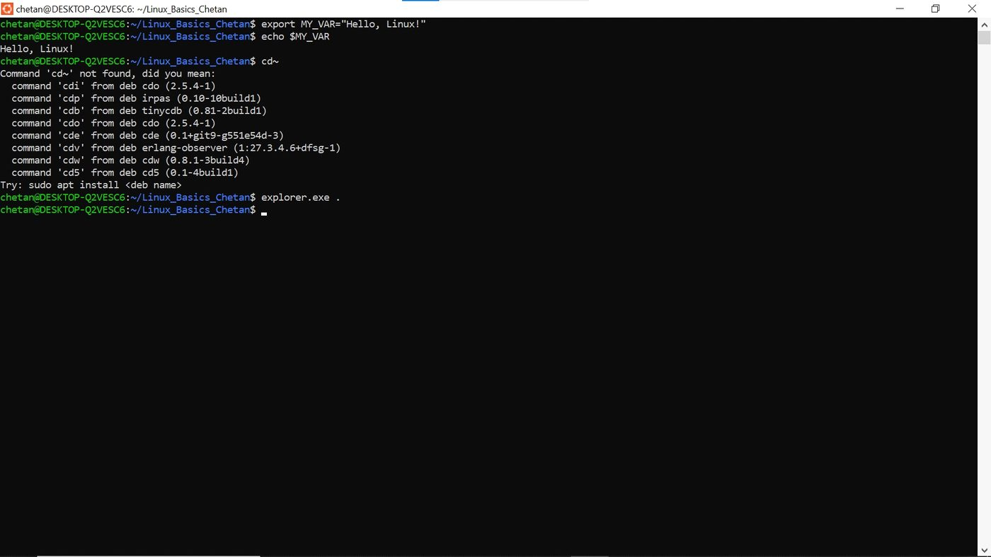

export creates a variable that the terminal can use. echo prints its value. It only lasts until I close the terminal.

