TIMILSENA CHETAN
STUDENT - DONG-EUI UNIVERSITY

CONTACT
+82 10-2156-1299

timilsenachetan53@gmail.com

PROFILE
Hello! I'm Chetan Timilsena, an international student studying in South Korea. I am passionate about creating meaningful digital experiences and solving complex problems through innovative solutions. I believe in continuous learning and staying updated with the latest technologies and trends.

Eomgwang-ro 208, Busanjin-gu, Busan

chetantimilsena.com.np

WORK EXPERIENCE

StartUp Nepko

Software Developer

2024 - PRESENT

TECHNICAL SKILLS
Python C/C++ HTML5 CSS

SOFT SKILLS
Teamwork
Time Management
Solved complex algorithmic problems and built foundational software utilities using C and C++, demonstrating a strong grasp of data structures and memory management.
Developed clean, automated scripts in Python to process data, parse files, and handle everyday system automation tasks efficiently.
Created structured web pages using HTML5 and stylized them with modern CSS3 layout techniques (Flexbox/Grid) to ensure smooth user experiences across mobile and desktop devices.

EDUCATION

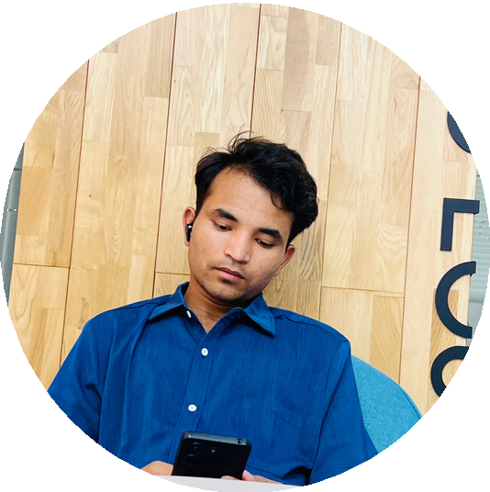
Leadership
Effective Communication Critical Thinking

LANGUAGES
English Nepali Korean Hindi

Bachelor in Intelligence Computing

Dong-eui Global College| Dong-eui University, Korea

Higher Secondary education Premier College, Kathmandu Nepal GPA: 3.07 / 4.0
2024- PRESENT

2022 - 2024

