Question 1

Create python program and provide result

Create Docker image and upload to Docker hub

# 1 LOGIN TO UBUNTU VM

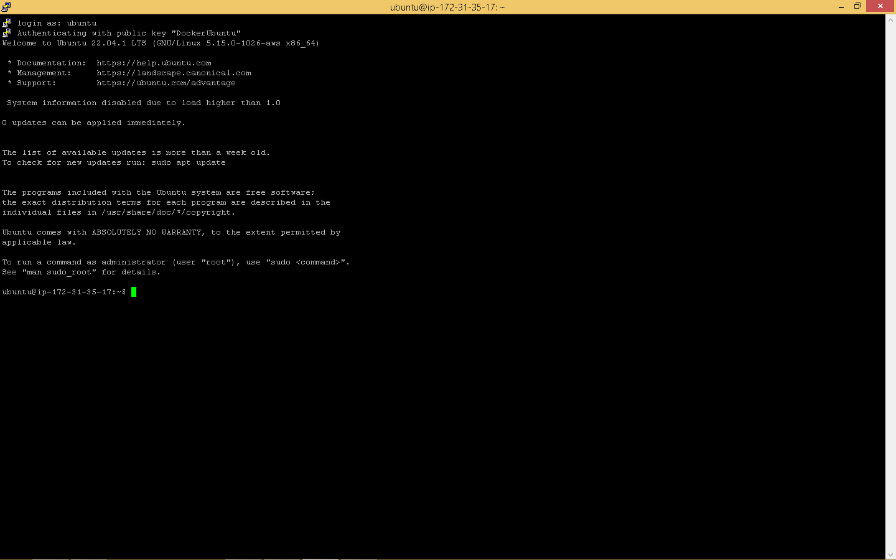

# 2 CREATED PYTHON PROGRAM WITH PROBLEM STATEMENT IN CORRECT DIRECTORY

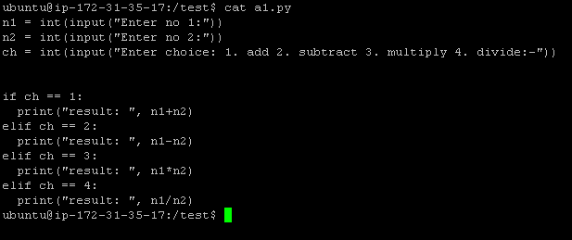

# 3 INSTALLED DOCKER ON THE MACHINE

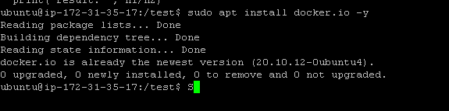

# 4 WE PULL A LIGHTWEIGHT PYTHON TO SAVE RESOURCES

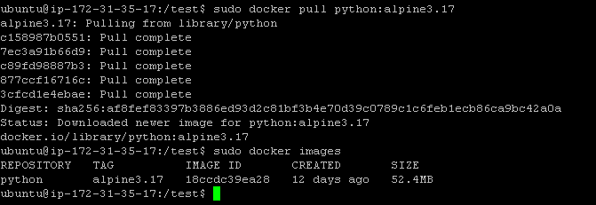

# 5 WE CREATE DOCKERFILE INSIDE THE TEST DIRECTORY

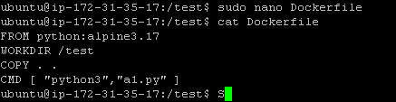

# 6 BUILT AND CREATED THE IMAGE AND TEST PROGRAM INSIDE CONTAINER

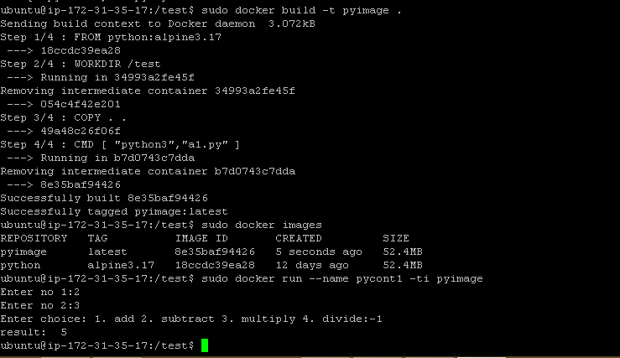

# 7 PUSHED TO DOCKER HUB

