Question statement:

1. Create repository on github.com

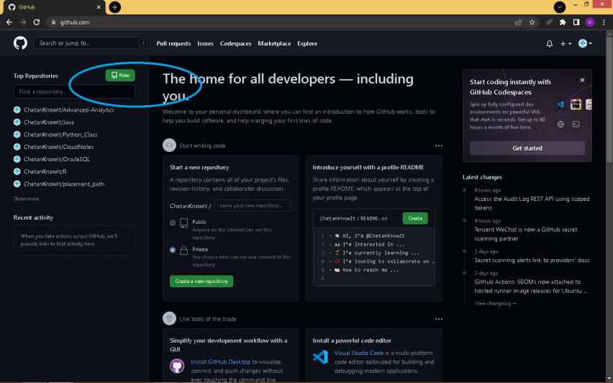

1. Name the repository and scroll down to click create

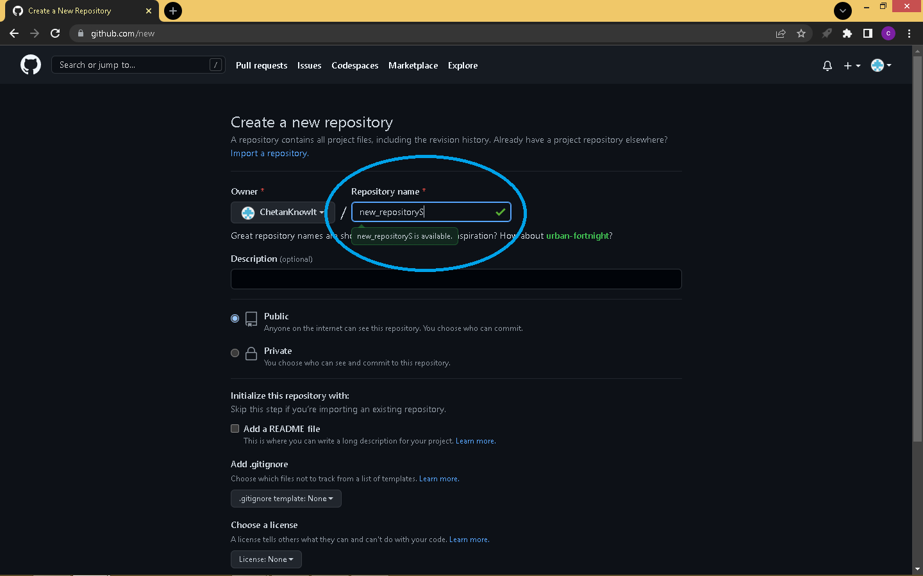

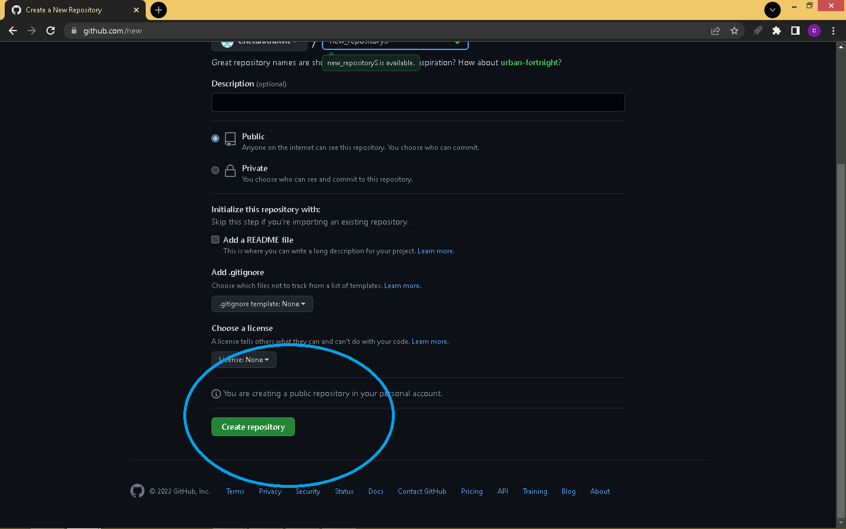

1. INCLUDE README FILE

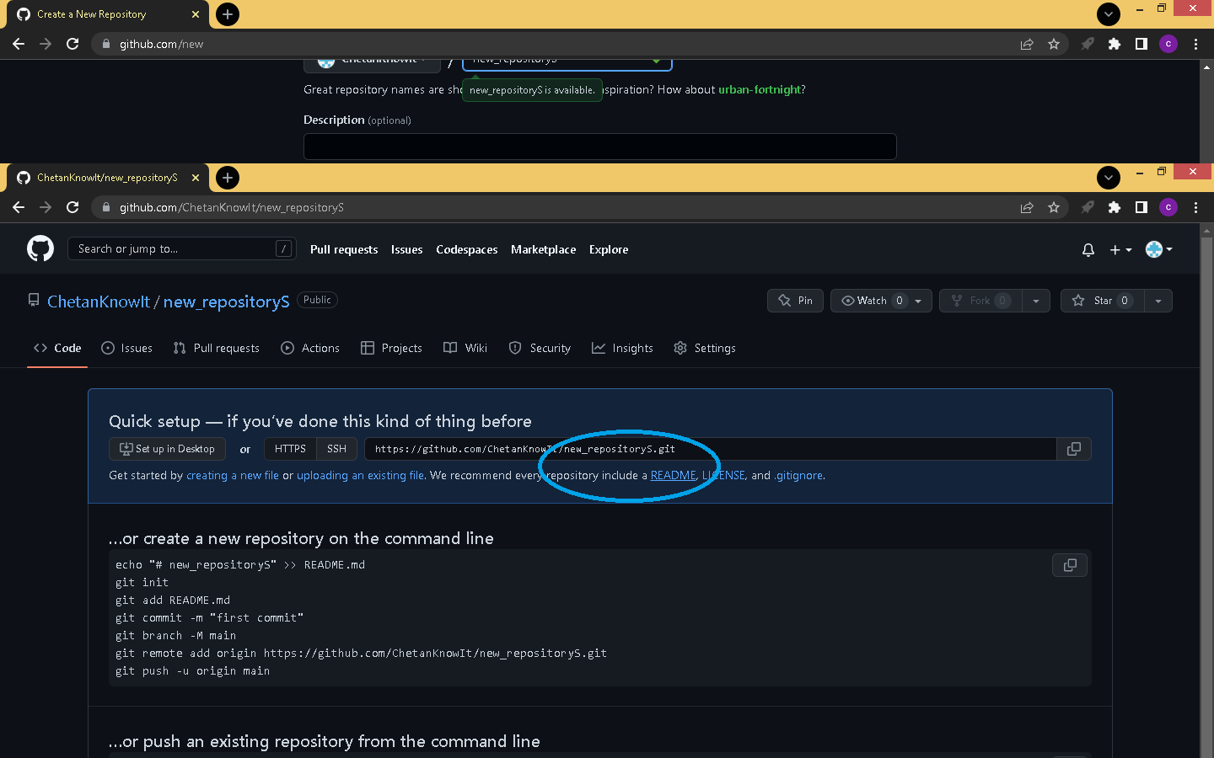

1. COMMIT README.MD

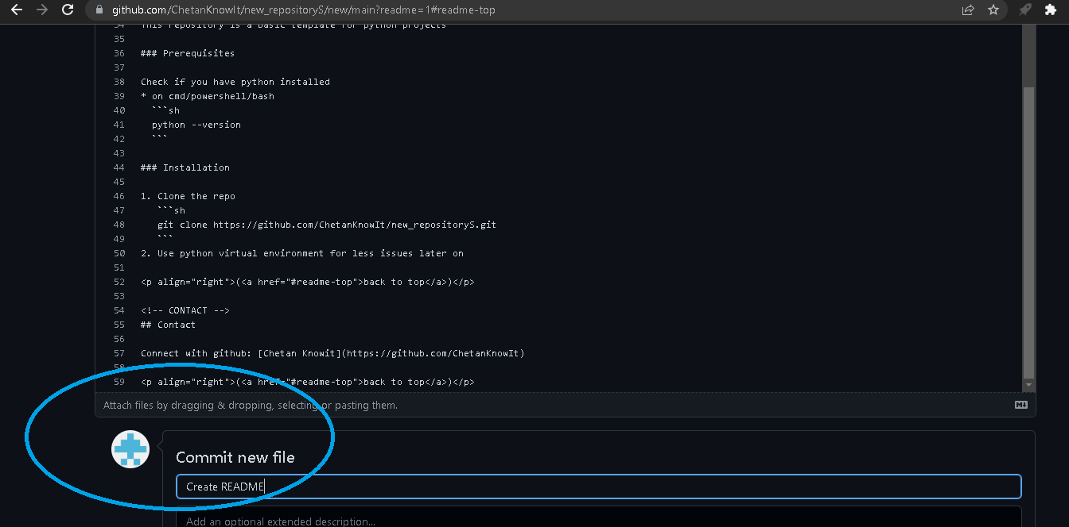

1. CREATE NEW FILE

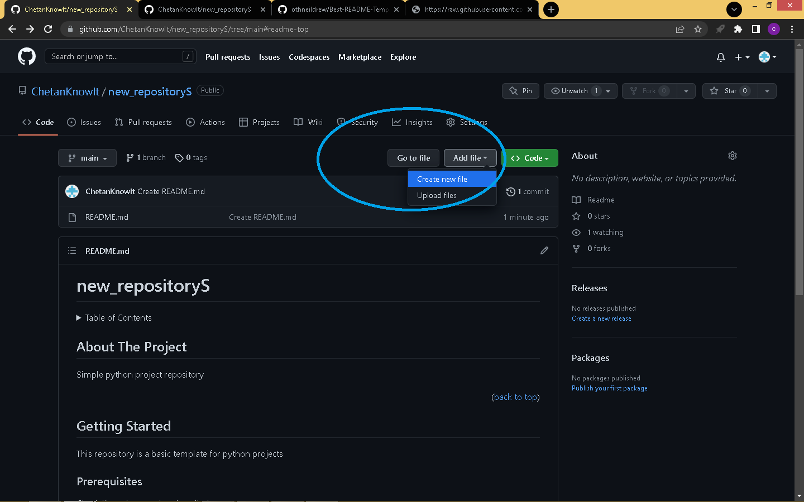

1. ENTER PROGRAM AND COMMIT

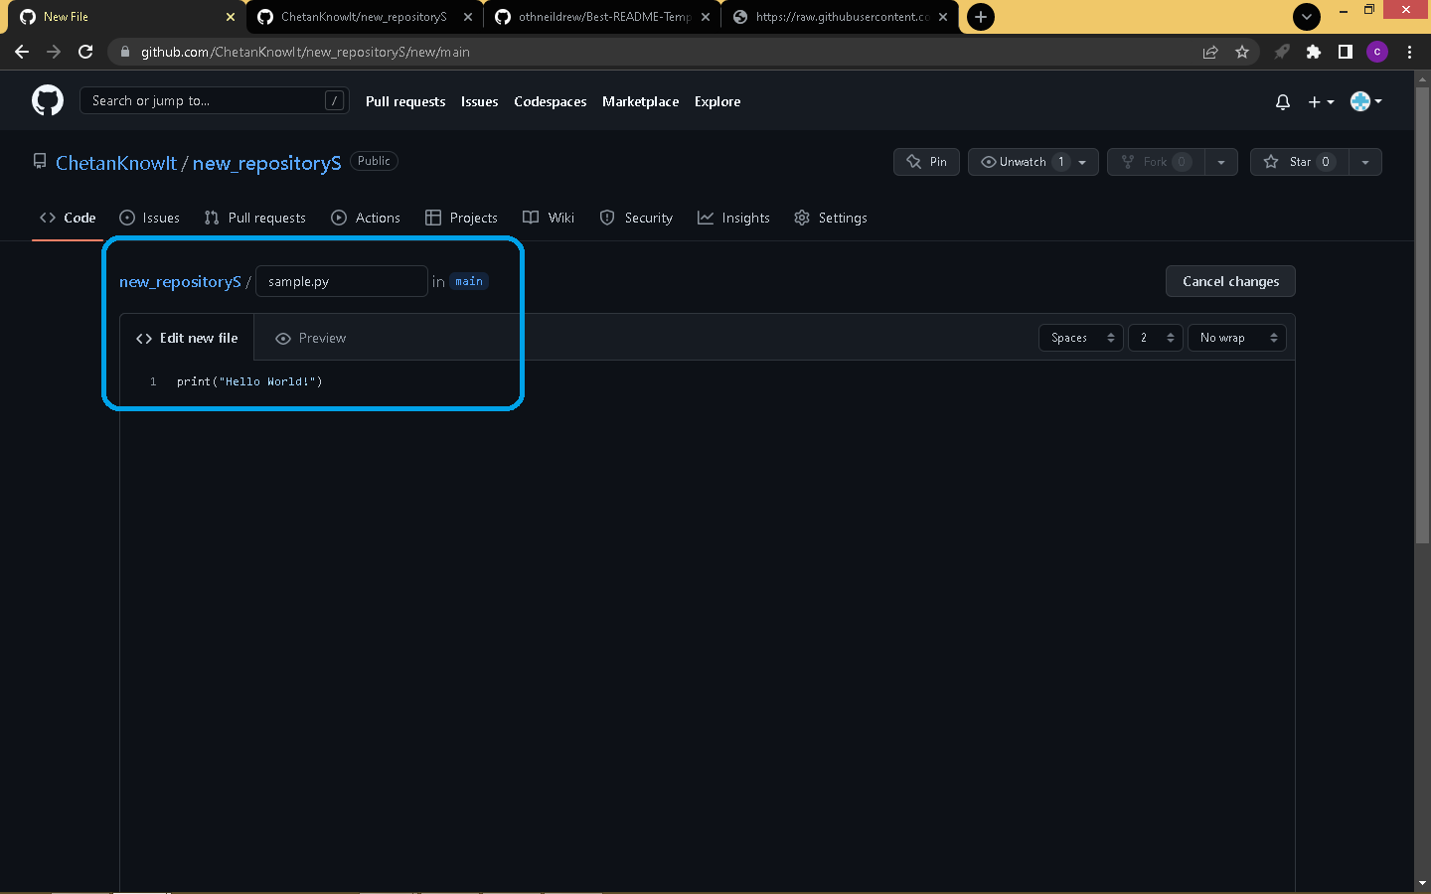

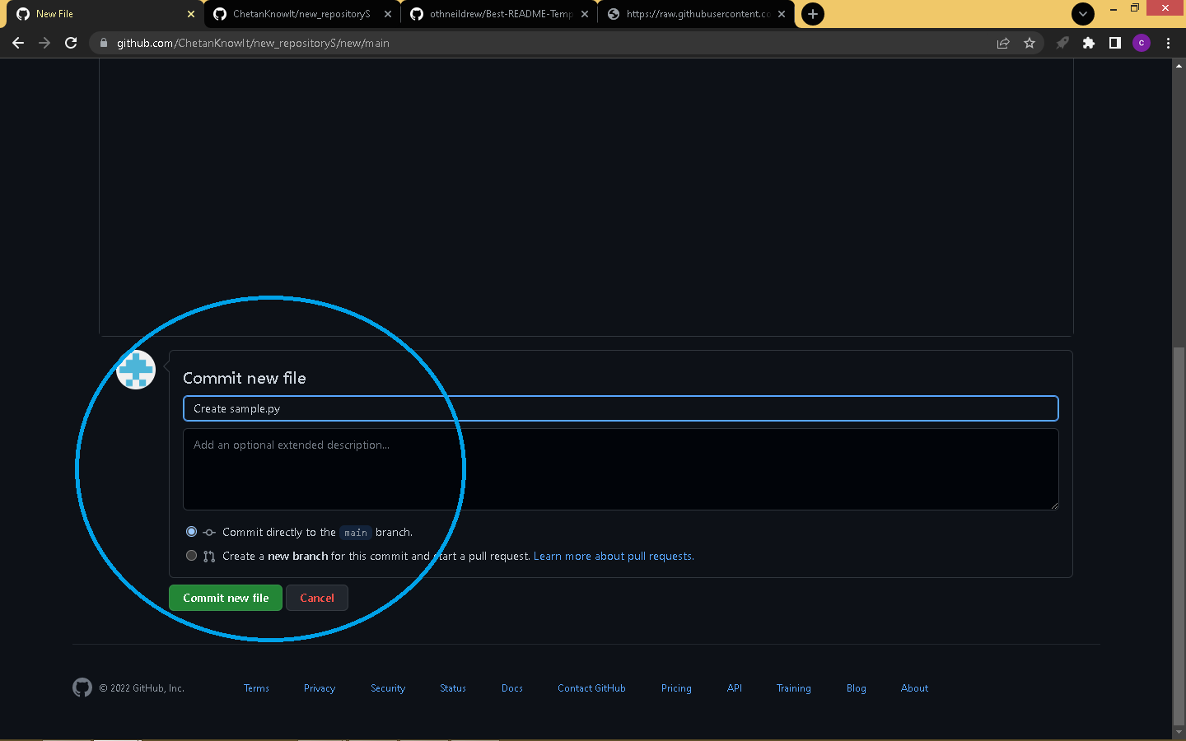

1. CLONE WITH GIT BASH

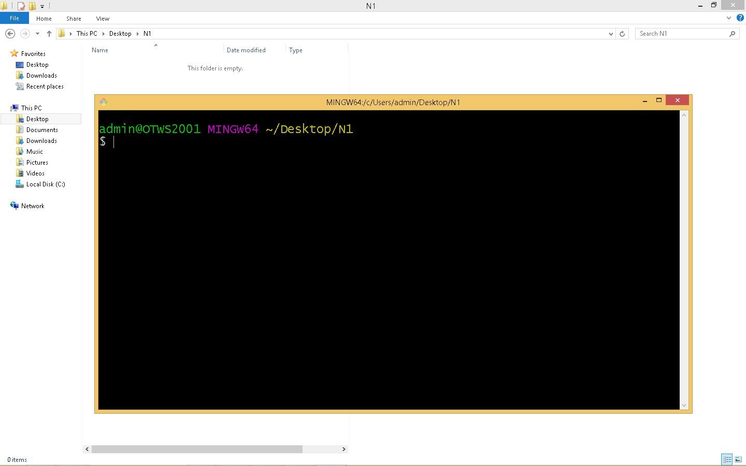

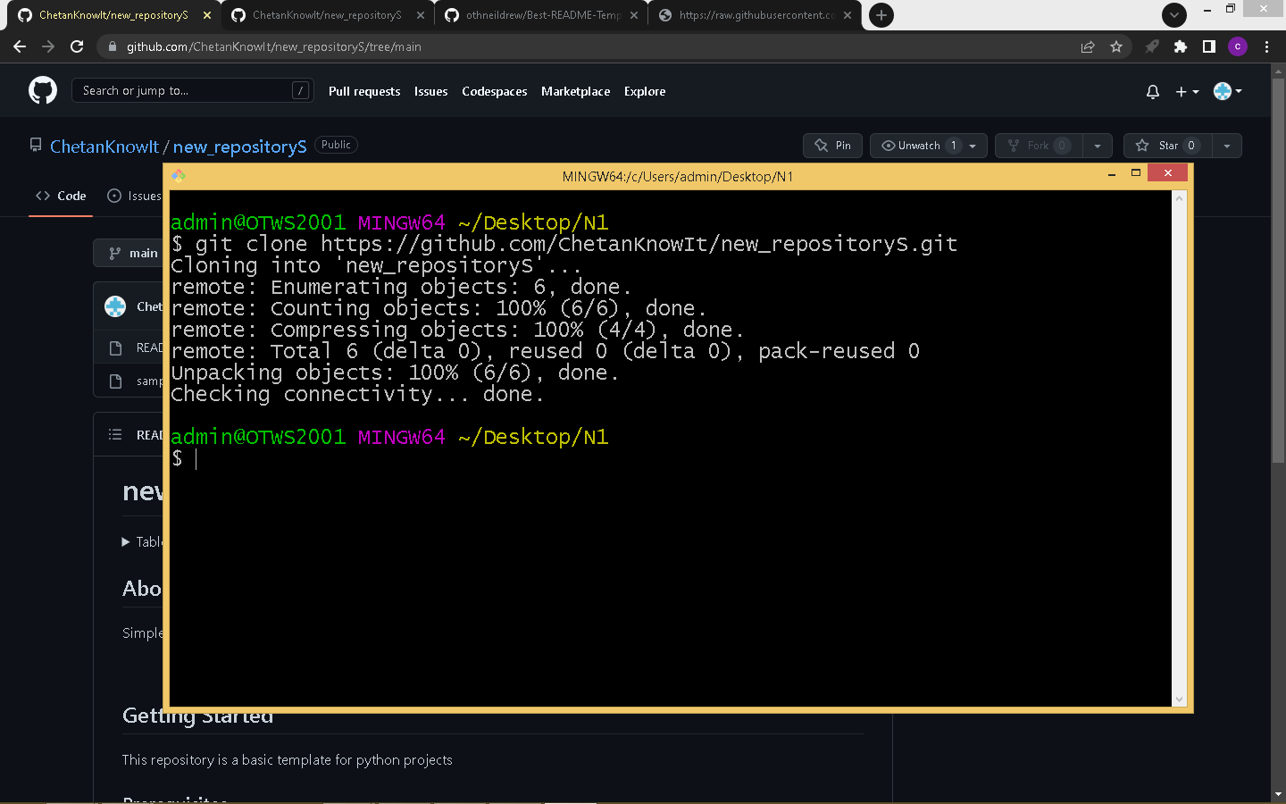

1. CEATE NEW FILE IN THE REPO

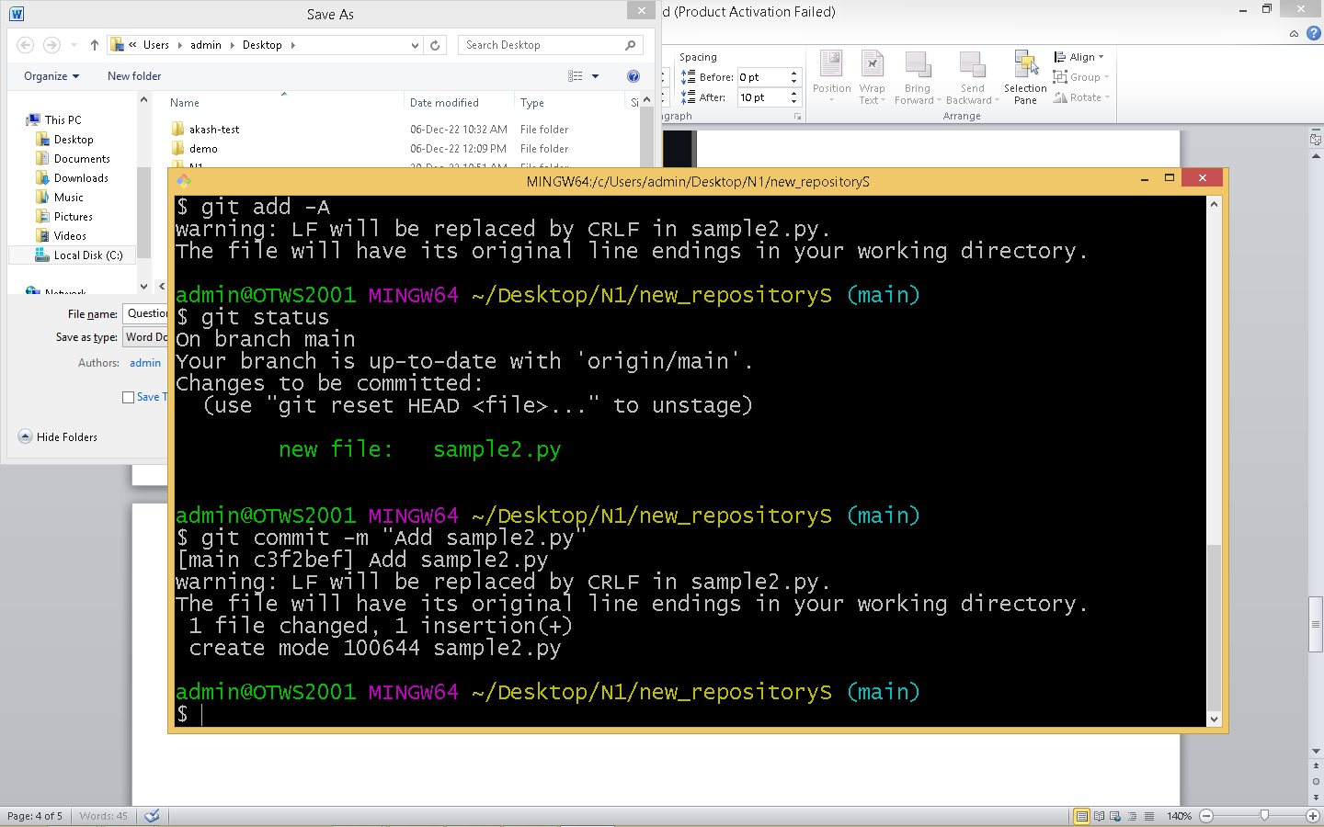

1. GIT PUSH –U ORIGIN MAIN TO PUSH TO REMOTE

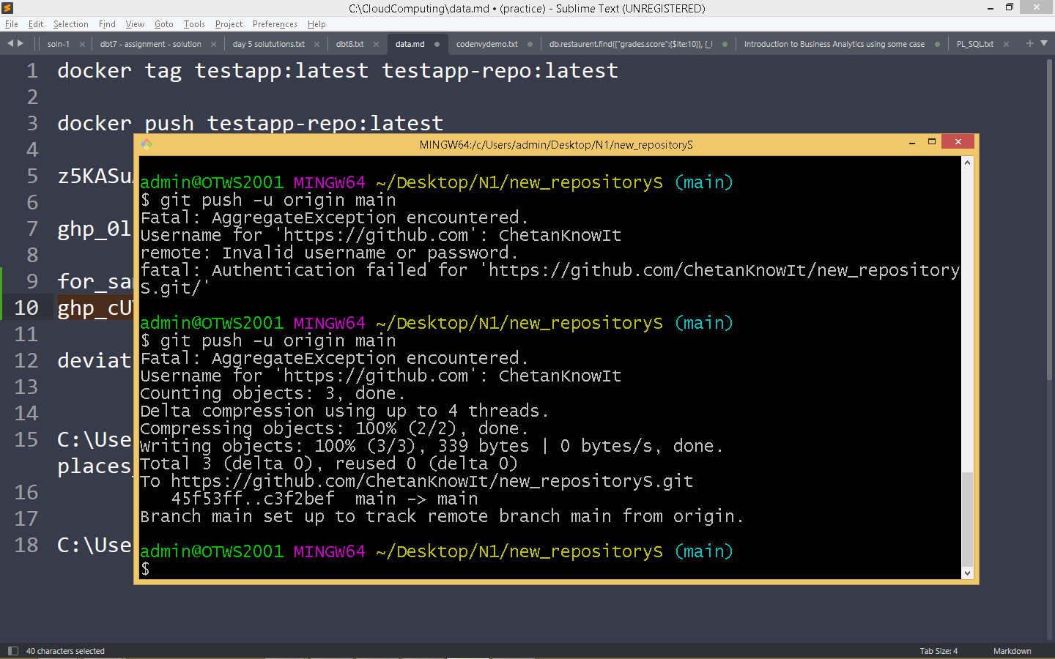

1. Now we have 2 files on the repository

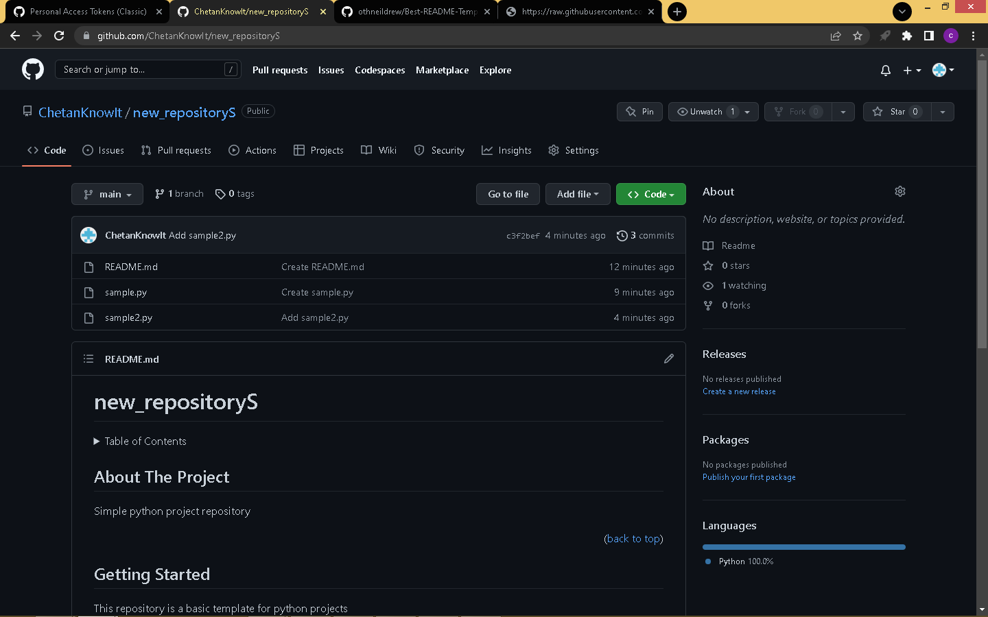

1. Link to repository

https://github.com/ChetanKnowIt/new_repositoryS