Transformation from TSP to Reliable Network Problem

# Chetan Krishna Palicherla

# Net ID: cp1234

# Email: cp1234@scarletmail.rutgers.edu

# Shrey J Patel

# Net ID: sp2675

# Email:

# sp2675@scarletmail.rutgers.edu

# Yiheng Liu

# Net ID: yl2258

# Email: [yl2258@scarletmail.rutgers.edu](mailto:yl2258@scarletmail.rutgers.edu)

***Abstract*—In this project what we are essentially doing is transforming Traveling Salesman Problem (TSP) into the Re- liable Network Problem (RNP). Given a TSP instance defined by a distance matrix** *Dij* **and a budget** *b***, we compute a cycle (tour) that satisfies the constraints. The outputs of the TSP solution, including the cycle, budget matrix, and reliable matrix** *rij* **, serve as inputs to the Reliable Network Problem. In the RNP, we construct a graph** *G*(*V, E*) **such that the total cost of the edges is within the budget** *b***, and the graph satisfies reliability requirements with at least** *rij* **vertex-disjoint paths between every pair of nodes. The transformation is computationally feasible for small input sizes, with a time complexity of** *O*(*n*!) **for solving the**

**TSP and** *O*(*n*2) **for transforming the inputs to the RNP.**

***Index Terms*—algorithms, Traveling Salesman Problem, Reli- able Network, computational complexity.**

1. Input and Output Formats
2. *Case 1: Fully Connected Graph*

**Input Format:** A CSV file containing the distance matrix for a fully connected graph. Each cell (*i, j*) represents the distance between vertex *i* and vertex *j*. All entries are finite numbers, except the diagonal entries, which are 0 (representing no self-loops).

**Input:** Fully connected graph with the following distance matrix:

TABLE I

Fully Connected Distance Matrix

|  |  |  |  |  |  |
| --- | --- | --- | --- | --- | --- |
|  | A | B | C | D | E |
| A | 0 | 10 | 15 | 20 | 25 |
| B | 10 | 0 | 35 | 25 | 30 |
| C | 15 | 35 | 0 | 30 | 20 |
| D | 20 | 25 | 30 | 0 | 15 |
| E | 25 | 30 | 20 | 15 | 0 |

Budget: *b* = 100.

**Output:** The minimal TSP tour and the Reliable Network graph:

* Minimal TSP Tour Cost: 85
* Minimal TSP Tour: *A → B → D → E → C → A*

1. *Case 2: Disconnected Graph*

**Input Format:** A CSV file containing the distance matrix for a disconnected graph. Each cell (*i, j*) represents the distance between vertex *i* and vertex *j*. Infinite (*∞*) values represent missing edges, indicating no direct path exists be- tween those vertices.

**Input:** Disconnected graph with the following distance matrix:

TABLE II

Disconnected Distance Matrix

|  |  |  |  |  |  |
| --- | --- | --- | --- | --- | --- |
|  | A | B | C | D | E |
| A | 0 | inf | 15 | inf | inf |
| B | inf | 0 | inf | 25 | inf |
| C | 15 | inf | 0 | inf | 20 |
| D | inf | 25 | inf | 0 | inf |
| E | inf | inf | 20 | inf | 0 |

Budget: *b* = 100.

**Output:** No valid TSP tour exists within the given budget for a disconnected graph. Therefore, it is not possible to construct a Reliable Network.

1. Transformation

The transformation from the Traveling Salesman Problem (TSP) to the Reliable Network Problem (RNP) involves the following steps:

1. *Solving the TSP*

Given a distance matrix *Dij* and a budget *b*, solve the TSP to obtain a cycle (tour) that minimizes the total travel cost while ensuring that the cost is within *b*. The output includes the TSP cycle and the associated cost.

1. *Generating the Budget Matrix*

From the TSP output, construct the budget matrix *Bij*, where each cell represents the cost of traveling between node *i* and node *j* along the edges in the TSP cycle. This budget matrix serves as input for the RNP.

1. *Creating the Requirement Matrix*

The requirement matrix *rij* is generated such that *rij ≥* 0 for *i ̸*= *j*, specifying the number of vertex-disjoint paths required between nodes *i* and *j*. The diagonal entries (*rii*) are set to 0, as no self-paths are required.

1. *Time Complexity*

- Copying the distance matrix for the budget matrix involves no additional computation, resulting in a time complexity of

*O*(1). - Setting the Reliable Network budget equal to the TSP budget is also *O*(1). - Creating the requirement matrix

involves iterating over all *n*2 pairs of vertices, leading to a time complexity of *O*(*n*2).

**Overall Transformation Time Complexity:** *O*(*n*2).

1. Sample Input and Output
2. *Fully Connected Graph*
3. *Disconnected Graph*

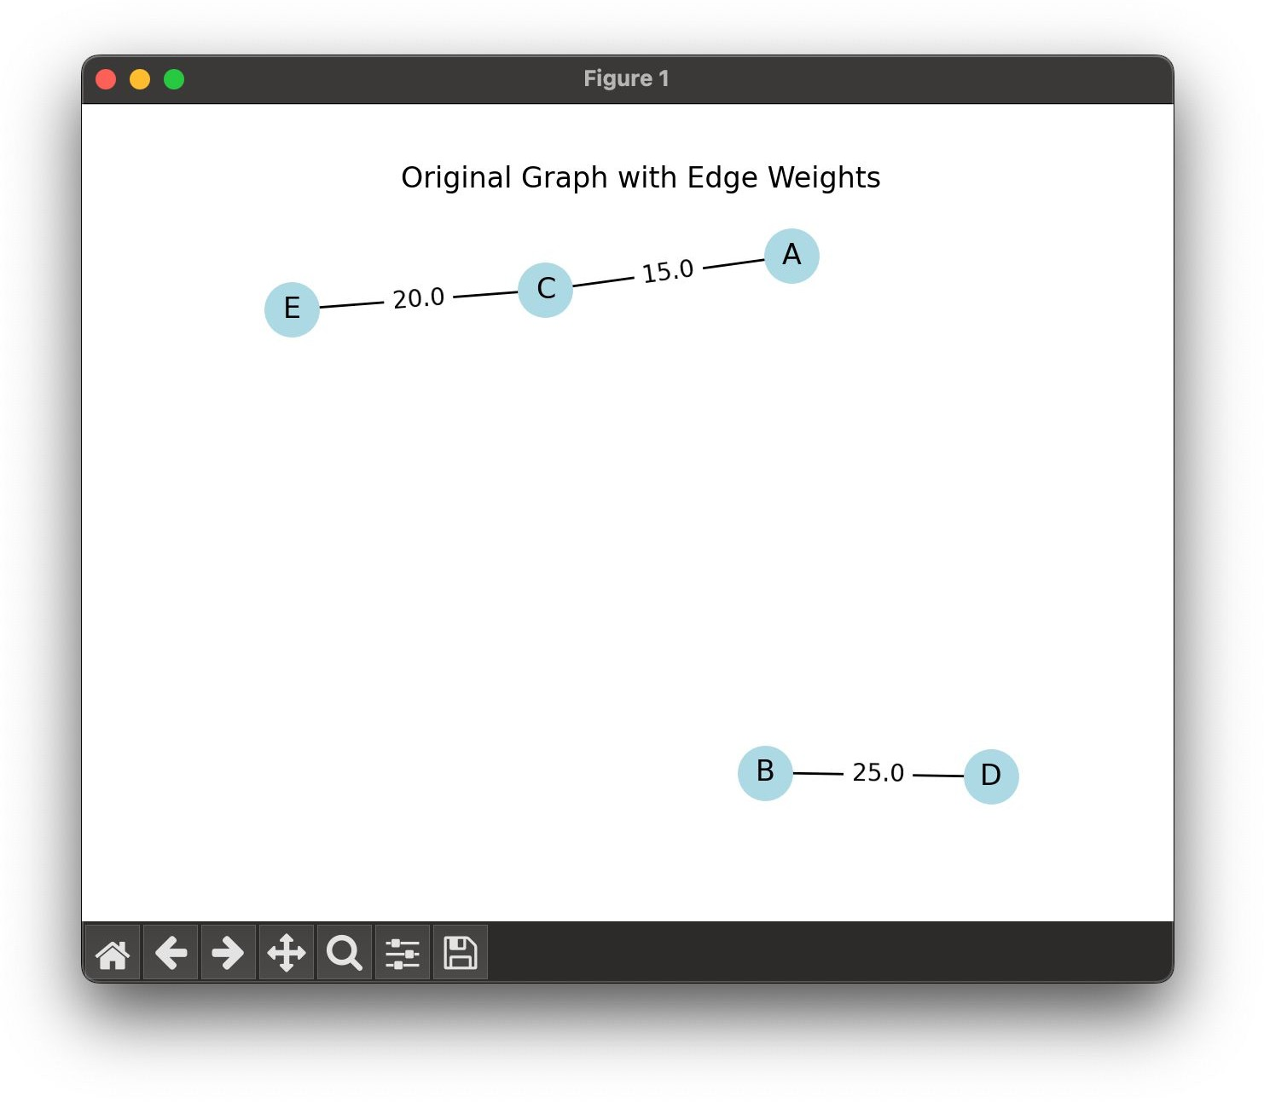

Fig. 3. Disconnected Input Graph for TSP with Edge Weights

**Output:** No solution available for the disconnected graph.

1. Programming Language and Libraries Used

The implementation uses Python for solving the TSP and constructing the Reliable Network. The libraries include:

* NumPy 1.26
* Matplotlib 3.8
* NetworkX 2.8

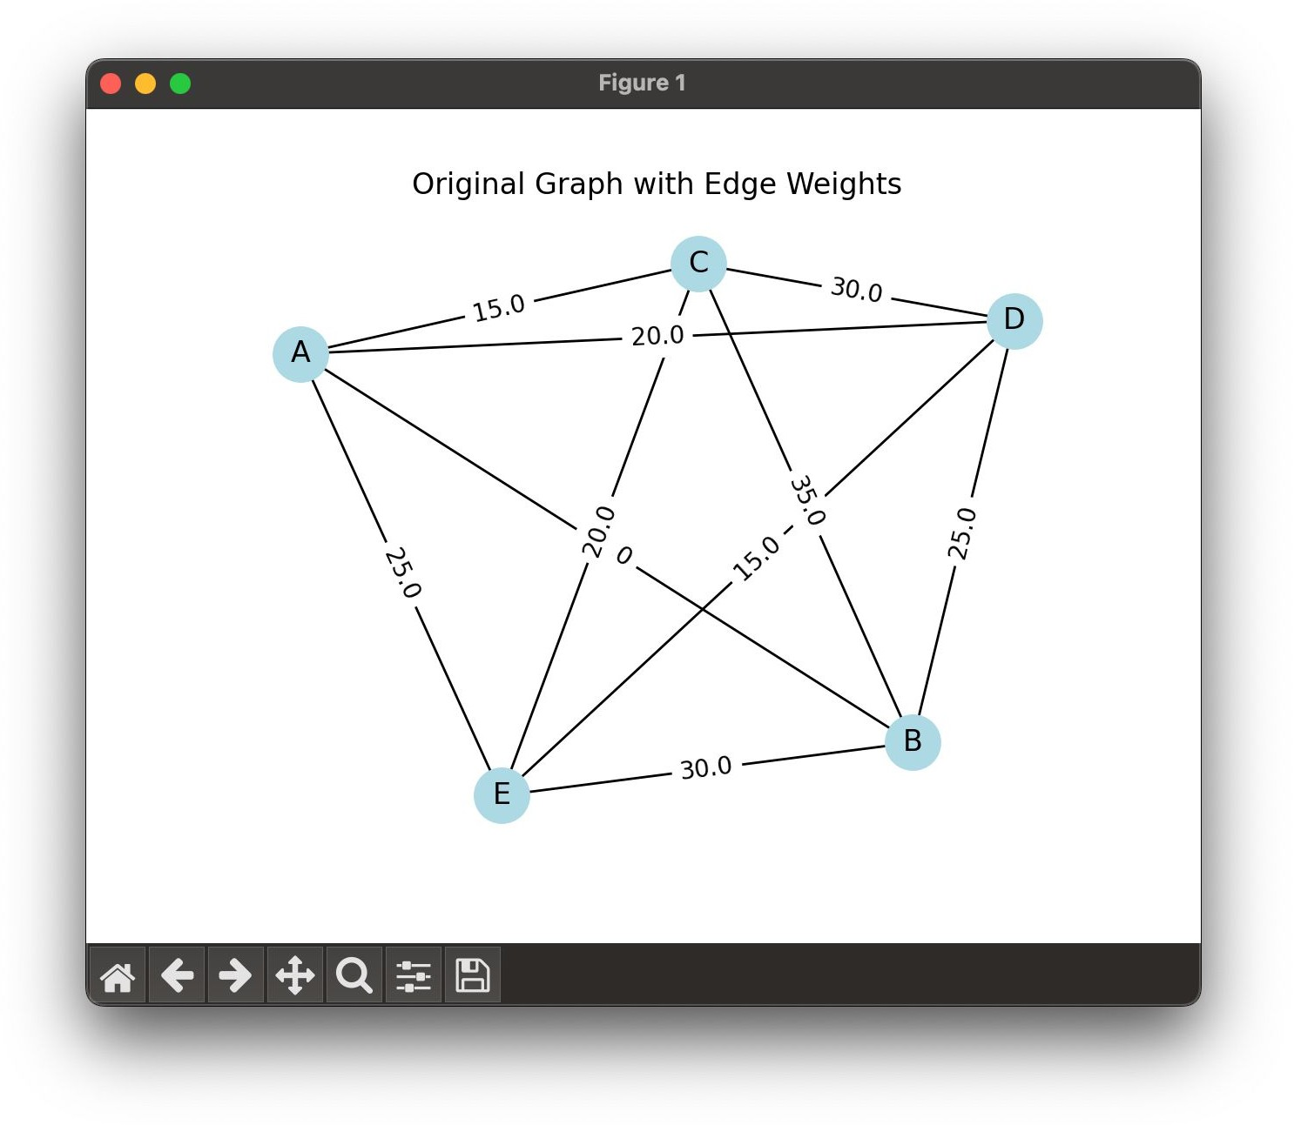Fig. 1. Fully Connected Input Graph for TSP with Edge Weights

1. Conclusions

In this project, we successfully transformed the Traveling Salesman Problem (TSP) into the Reliable Network Problem (RNP). Starting with a distance matrix *Dij* and a budget *b*, we computed an optimal TSP tour and generated the inputs for the Reliable Network: the budget *b* and a reliability matrix *Rij*. The input graph depicted the TSP instance with travel costs, while the output graph illustrated the Reliable Network satisfying cost and reliability constraints. Despite the NP- hard complexity of solving TSP (*O*(*n*!)), the transformation, including generating *Rij*, operated efficiently with *O*(*n*2) complexity. This project highlights the practical applications of TSP in network design and the computational challenges of NP-hard problems.

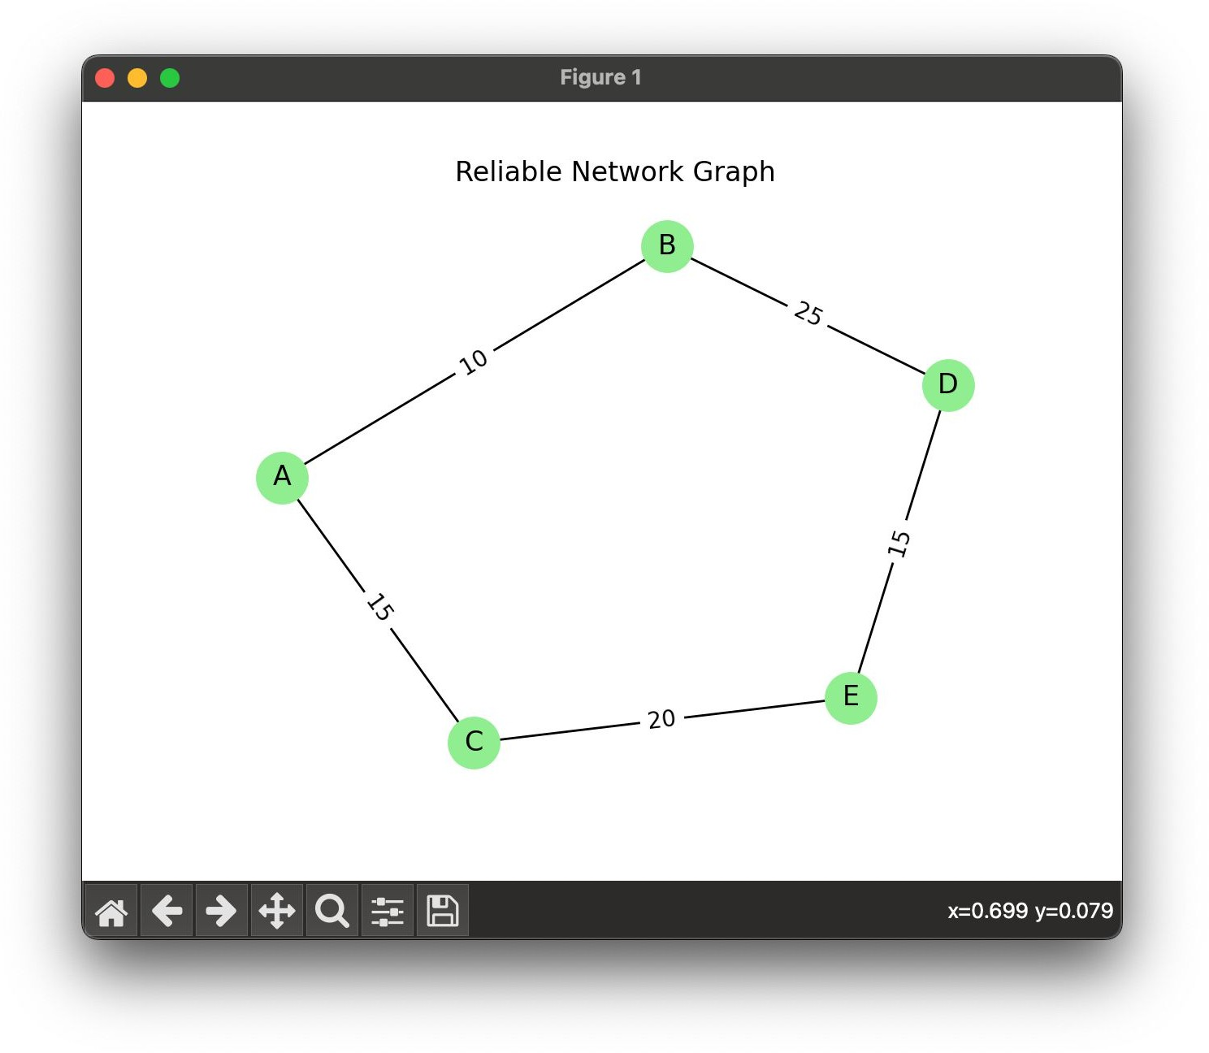Fig. 2. Reliable Network Graph for Fully Connected Input

References

1. Sanjoy Dasgupta, Christos H. Papadimitriou, and Umesh Vazirani. *Algo- rithms*. McGraw-Hill, 2006.
2. T. H. Cormen, C. E. Leiserson, R. L. Rivest, and C. Stein, *Introduction to Algorithms*, 3rd ed. Cambridge, MA, USA: MIT Press, 2009.