## **Cytokine data tables and Search table:**

**Cytokine_heatmps table:** This holds the pre-calculated heatmap images for each demographic group

**Trauma_Pateints_cytokines:** This holds the 32 cytokines readings of trauma patients and their demographic details. This is the table that gets updated through ‘input’ data option of this application.

**Search_Table:** This table holds the search keywords and the description of search results if there is a hit.

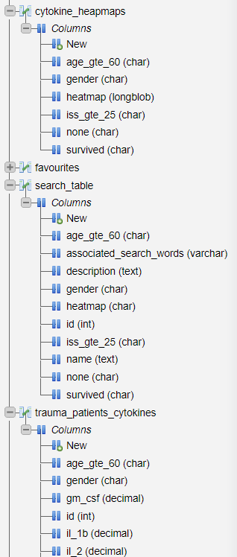

## **Login and Registration System Tables: users table:** This table get updated when any new user is registered.

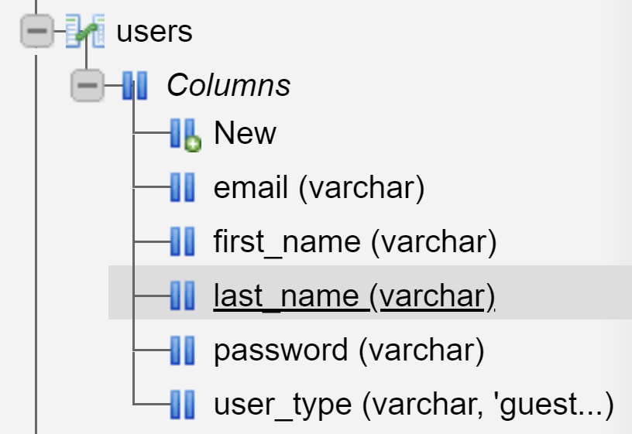

## **User Activity Logging tables or Tables used in the Dashboard:**

**Content_access**: this table holds the content that was accessed by a user through ‘get data’ option of this application

**User_actions:** All the user actions – login, logout, data insert, data access will be logged in this table.

**Zero_result_search:** This table holds all search tokens which returned zero results. Upon inspection of this data, we can update the search table’s associated_words column to improve search results.

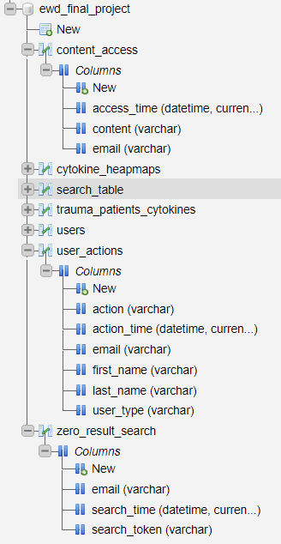

## **Favourites, User Profile Vector, and User Search Sort Order:**

**Favourites** – This table holds the list of favourite contents marked by users

**User_Profiles –** This is the profile vectors table for all users. This contains all keywords of the contents of this application against each user along with the keys words appearance count and averages among their favourite contents.

**User_Search_Sort** – This table holds all the content’s relation score with each of the user. This is got by checking each content’s keywords against the user profiles average score. This relation score is used for sorting search results.

