Business Dost

**PREREQUISITES**

* JDK 1.8
* Android SDK
  + Android NDK

**DEVELOPMENT ENVIRONMENT**

The app is written entirely in java and uses the Gradle build system.

To build the app, use the gradlew build command or use "Import Project" in Android Studio.

**Business-Dost Android App**

Business-Dost is an android application built with aim to simplify the process of tracking, managing raw materials and keep track of all the transactions with vendors and customers.

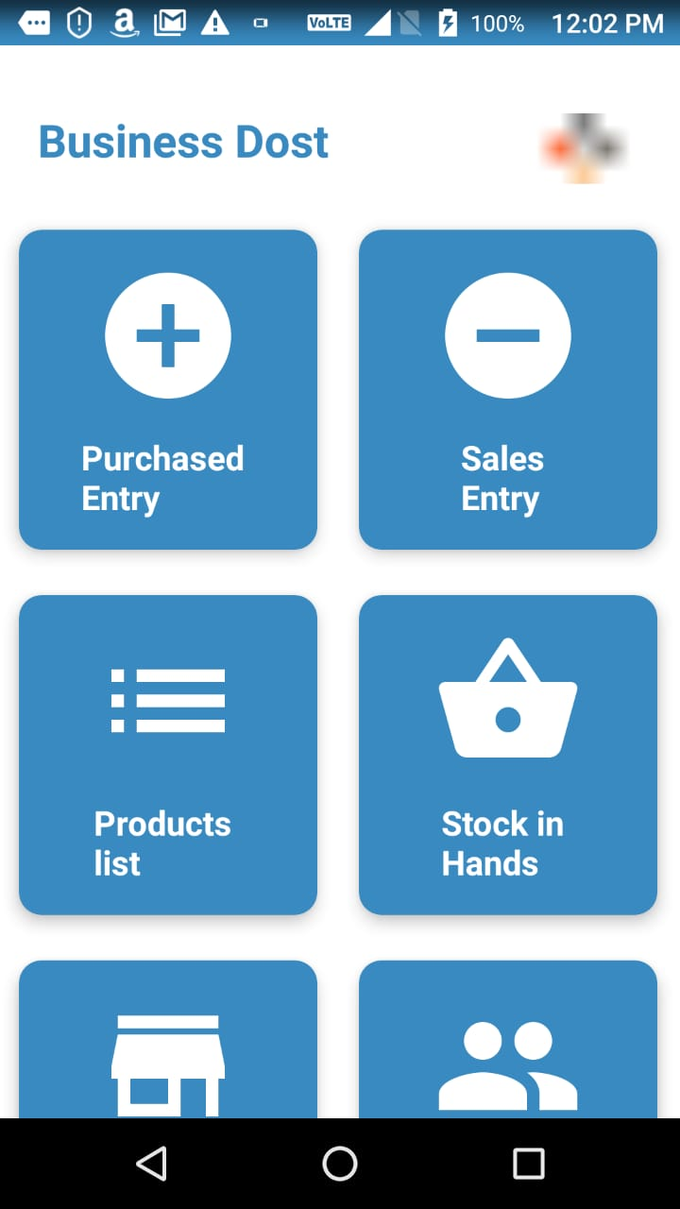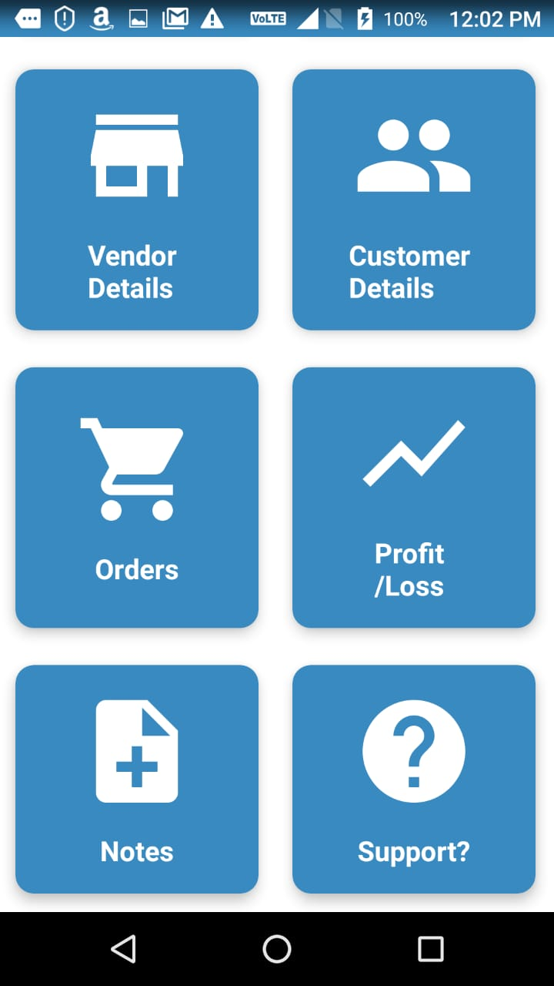

The UI of the application has been kept simple as the users are either micro or medium scale entrepreneurs. Many different features have been added to the application without increasing complexity of the UI.

**FIREBASE**

The app makes considerable use of the following Firebase components:

* [Cloud Firestore](https://firebase.google.com/docs/firestore/) is our source for all user data (events starred or reserved by a user). Firestore gave us automatic sync and also seamlessly managed offline functionality for us.
* [Firebase Cloud Functions](https://firebase.google.com/docs/functions/) allowed us to run backend code. The reservations feature heavily depended on Cloud Functions working in conjuction with Firestore.
* [Firebase Cloud Messaging](https://firebase.google.com/docs/cloud-messaging/concept-options) let us inform the app about changes to conference data on our server.
* [Remote Config](https://firebase.google.com/docs/remote-config/) helped us manage in-app constants.

**COPYRIGHT**

Copyrights 2019 Chetan Madabony. All rights reserved.