Annexure3b- Complete filing INVENTION DISCLOSURE FORM

Details of Invention for better understanding:
- Title: AI-Enabled Smart System for Real-Time Waste Classification and Management.
- INTERNAL INVENTOR(S)/ STUDENT(S): All fields in this column are mandatory to be filled

A. Full name | Mungalpara Chetan Pravinbhai
Mobile Number | 9924800485
Email (personal) | chetanpm9898@gmail.com
UID/Registration number | 12207641
Address of Internal Inventors | Lovely Professional University, Punjab-144411, India
Signature (Mandatory) | 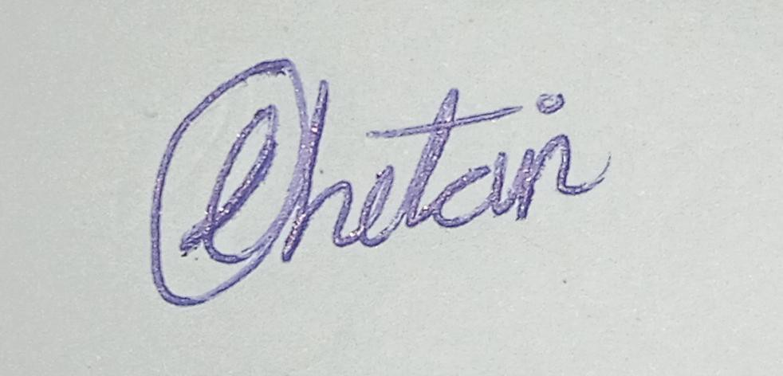
B. Full name | Subhash Suthar
Mobile Number | 8769434956
Email (personal) | subhashsuthar196@gmail.com
UID/Registration number | 12215865
Address of Internal Inventors | Lovely Professional University, Punjab-144411, India
Signature (Mandatory) | 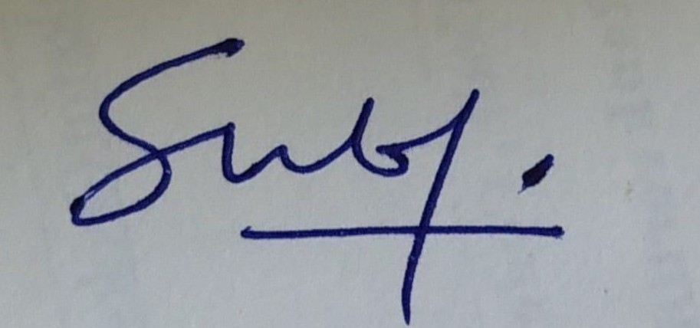
C. Full name | Krishna Pradhan
Mobile Number | 7005460357
Email (personal) | pradhankrishna119@gmail.com
UID/Registration number | 12224021
Address of Internal Inventors | Lovely Professional University, Punjab-144411, India
Signature (Mandatory) | 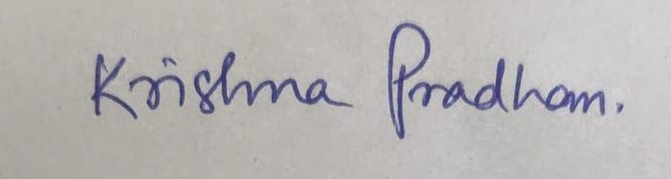

D. Full name | Shashi Kant Kumar
Mobile Number | 7986365068
Email (personal) | shashisingh1327@gmail.com
UID/Registration number | 12214125
Address of Internal Inventors | Lovely Professional University, Punjab-144411, India
Signature (Mandatory) | 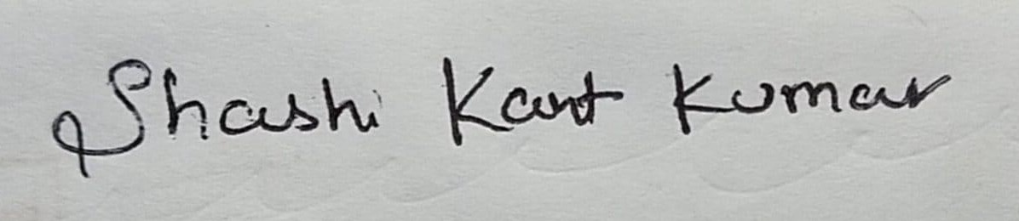
E. Full name | Gaurav Kumar Sahu
Mobile Number | 8120044609
Email (personal) | gauravkumarsahu16@gmail.com
UID/Registration number | 12216579
Address of Internal Inventors | Lovely Professional University, Punjab-144411, India
Signature (Mandatory) | 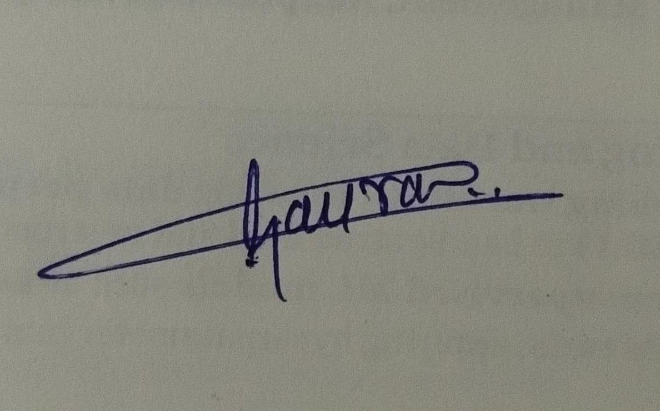
F. Full name | Vishal Biswakarma
Mobile Number | 8822363761
Email (personal) | vishalgezmer@gmail.com
UID/Registration number | 12206477
Address of Internal Inventors | Lovely Professional University, Punjab-144411, India
Signature (Mandatory) | 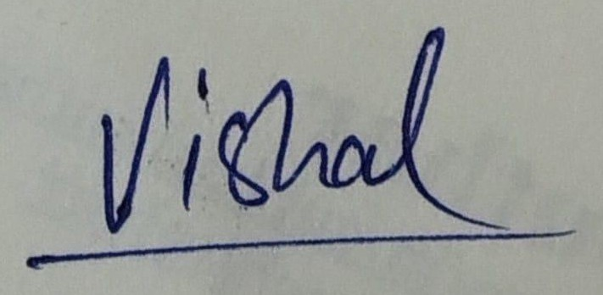

DESCRIPTION OF THE INVENTION:
This invention discloses an Artificial Intelligence-driven system and method for the real-time classification of municipal solid waste.
This system integrates a novel data acquisition pipeline with a scalable web-based classification engine. The core of the invention is an AI model (train.py) trained on a custom, region-specific dataset. This dataset is created using a specialized data acquisition tool (capture.py) designed to rapidly capture and label local waste items

The trained AI model is deployed via a web application programming interface (API), for example, using a Flask server (app.py). This API is designed to receive an image of a waste item (e.g., as a base64 string) from a client application (such as a mobile app or a smart bin's camera).
The server's processing unit executes the AI model to analyze the image and determine its waste category (e.g., "organic," "recyclable," "hazardous," "e-waste"). The system then returns this classification as a structured data response (e.g., JSON), which can be used to inform a user or trigger a separate, connected system. This creates an affordable, scalable, and adaptable solution for providing accurate waste classification on demand.

Key Features & Innovations
  - Region-Specific AI Model: Instead of using generic datasets, the system's high accuracy is achieved by training a model on a custom dataset of local waste items, created with the included data capture tool (capture.py).
  - Flexible Deployment (API): The system is architected as a scalable web service (app.py). This allows any number of client devices (phones, cameras, computers) to access the powerful AI classification engine over a network.
  - Scalable and Adaptable: The capture.py tool allows the system to be rapidly re-trained and deployed in any new region with different waste streams, making the solution universally adaptable.
  - Decoupled Architecture: The invention provides the "intelligence" (classification) as a service. This allows it to be integrated into many different applications (mobile advisory apps, educational tools, or as a component in a future physical sorting bin) without being tied to a specific piece of hardware.

PROBLEM ADDRESSED BY THE INVENTION

Traditional municipal waste management relies on manual sorting, which is (1) error-prone,
(2) unhygienic, and (3) inefficient. This leads to high rates of cross-contamination, which significantly degrades the value of recyclable materials.
While software applications exist to identify waste, they often use generic AI models trained on international datasets (like TrashNet). These models perform poorly on the unique food waste, packaging, and plastic types found in specific regions (e.g., India).
This invention solves these issues by providing (1) a novel tool for rapid, region-specific dataset creation, and (2) a web-based AI engine trained on that dataset, which can deliver highly accurate classification results as a service.

OBJECTIVES OF THE INVENTION
  - To create an AI-enabled system that can accurately detect and classify common waste categories in real-time from an image.
  - To provide a novel data acquisition tool (capture.py) that allows for the rapid creation of a high-quality, region-specific, and pre-cropped image dataset.

  - To design a flexible and scalable system architecture as a web API (app.py) that can serve predictions to multiple clients.
  - To make the product affordable and replicable by using common, off-the-shelf hardware (for the server) and open-source software (Python, PyTorch, Flask).
  - To support sustainability by providing the accurate information needed to reduce landfill waste and minimize the contamination of recyclables.

STATE OF THE ART / RESEARCH GAP / NOVELTY

Existing solutions are often either (1) large-scale industrial sorting plants, unsuitable for point-of-disposal use, or (2) simple mobile apps with generic, inaccurate models.
The primary research gap is the lack of an accessible and adaptable AI engine that can provide accurate, region-specific classification on demand.
The present invention describes something that is uniquely novel in the following ways:

  - A Novel Data-Capture-to-Model Pipeline.
  - Flexible Deployment Architecture.

Sr.No. | Patent ID | Abstract | Research Gap | Novelty
1 | US20200082354A1 | A hardware and software system that uses multiple sensors (fill, location, temperature, humidity, odor, etc.) to monitor waste bins. This data is used to optimize garbage collection routes and provide resident incentives. | The system is entirely sensor-based (fill level, temperature) and focused on collection logistics. It has no mechanism for AI-driven image classification to identify the type of waste (e.g., organic, recyclable) for segregation. | Provides a smart logistics platform. It optimizes collection routes based on real-time sensor data and includes a resident incentive system.
2 | US20210188541A1 | A system with a smart waste bin sensor device that sends data to a cloud server. It includes environmental sensors, a "waste and litter sensor" to detect waste type/volume, and a pathogen biosensor with a sterilizer. | While it mentions detecting "waste type," it relies on non-visual "sensors" rather than AI-driven computer vision. It is heavily focused on biohazards and pathogens, not on classifying common municipal waste (organic, recyclable, etc.) from a visual image. | Its novelty lies in its focus on public health and safety. It includes a dedicated pathogen biosensor and a sterilizer to kill pathogens inside the bin.
3 | US11335086B2 | Discloses methods and devices for waste management using an AI-based waste object categorizing engine. The method includes acquiring an image, detecting a waste object, | This patent describes a system for identifying a waste object. However, it relies on matching to "pre-stored" objects, which may not be flexible. It doesn't specify a method for creating new, | The novelty is the "AI-based waste object categorizing engine". Your invention's novelty, in contrast, is the complete pipeline, including the capture.py tool for rapidly creating

 |  | matching it with a pre-stored object, and identifying its type. | region-specific datasets, which is a key part of your capture.py tool. | a custom, regional dataset, not just using a pre-stored one.
4 | CN111126138A | The invention provides a garbage classification AI image recognition method. It includes steps for: 1) obtaining picture data, 2) performing data cleaning, and 3) using deep learning for classification to reduce manual operation. | This patent describes the general method of using deep learning for classification. It does not specify a novel, user-friendly tool for data capture (capture.py) or the flexible deployment of this model as a scalable web API (app.py). | Its novelty is the application of a deep learning method to garbage classification. Your novelty is more specific: it's the system that combines a specific data capture tool (with burst mode and cropping) and the architecture of deploying this custom model as a web service (app.py) for other clients to use.
5 | US11335086B2 | Discloses methods and electronic devices for waste management by using an "artificial intelligence based waste object categorizing engine." The method includes acquiring an image, detecting a waste object, and identifying its type by matching it with a "pre-stored waste object." | The system relies on matching to a "pre-stored" database of objects. This is less flexible than a deep learning model and does not include a novel method for users to create their own region-specific datasets, which is a key part of your capture.py tool. | The novelty is the "AI-based waste object categorizing engine" that is part of an electronic device, suggesting a hardware-based solution. Your invention's novelty is the complete software pipeline, including the capture.py tool for rapid custom dataset creation and the flexible app.py API architecture.
6 | US20180016096 A1 | A waste sorting system that uses various sensors to automatically determine a type of a piece of waste and dispense it into an appropriate bin. It also determines if a recyclable item meets a "recyclability threshold" before sorting it. | This system is primarily sensor-based and hardware-focused. It does not appear to be primarily based on AI image classification. It lacks the flexible, API-driven architecture and the ability to be retrained with a custom dataset by the user. | Its novelty lies in the concept of a "recyclability threshold". This suggests it does more than just identify the material (e.g., a plastic bottle); it may also check if it's too contaminated or crushed to be recycled, which is a

 |  |  |  | different focus from your project.
7 | CN111126138A | The invention provides a garbage classification AI image recognition method using deep learning. It involves: 1) obtaining picture data, 2) performing data cleaning, and 3) using the model to achieve accurate, intelligent, and automatic classification to reduce manual operation. | This patent describes the general method of using deep learning for classification. It does not specify a novel, user-friendly tool for data capture (capture.py) or the flexible deployment of this model as a scalable web API (app.py) for other clients to use. | Its novelty is the application of a complete deep learning method (from data cleaning to modeling) specifically for garbage  classification. Your novelty is more specific: it's the end-to-end system that combines a specific data capture tool (with burst  mode/cropping) and the architecture of deploying this custom model as a web service (app.py).

Patent Claims Drafting & Workflow
- Data Acquisition: Operator uses the custom capture.py tool to build a dataset of local waste items (organic, recyclable, hazardous, e-waste) using a webcam.
- Model Training: The custom dataset is used to train a lightweight, pre-trained model (e.g., MobileNetV2) using the train.py script, creating a waste_classifier.pth file.
- Image Acquisition (Client-Side): A client device (e.g., a smartphone) captures an image of a waste item.
- API Request: The client device sends the image (e.g., as a base64 string) to the /predict endpoint of the deployed Flask server (app.py).
- Waste Classification: The server's AI model (waste_classifier.pth) classifies the waste item in real-time.
- JSON Response: The server returns the classification (e.g., {"category": "Recyclable"}) to the client device.
- Client-Side Action: The client device receives the JSON response and displays the information to the user.

Draft Patent Claims
  - Claim 1: A smart waste classification system which has: a client-side image acquisition unit (camera); a remote processing unit (server); a classification unit on said server executing a deep learning engine; and a response generation unit that transmits the classification back to the client as data (e.g., JSON).
  - Claim 2: The system of Claim 1, where the classification unit is executed in real-time on a remote server via a web application programming interface (API).

  - Claim 3: The system of Claim 1, wherein the deep learning engine is a machine learning model (e.g., MobileNetV2) trained via transfer learning.
  - Claim 4: The Claim 1 system in which the response generation unit transmits the classification (e.g., 'organic', 'recyclable') as a structured data file (e.g., JSON).
  - Claim 5: The system of Claim 1, where a user on a client device (e.g., a web application) receives the classification data from the server's response.
  - Claim 6: The system of Claim 1, wherein the deep learning engine is trained on a custom, region-specific dataset, said dataset generated by a specialized data acquisition tool.

Detailed Description
The invention provides a software-based system for waste classification. An end-user on a client device (like a smartphone) captures an image of a waste item. This image is sent to a remote Flask server. The server uses a pre-trained, specialized AI model to identify the waste. The server then returns a simple text-based (JSON) answer, such as "Recyclable," to the user's device. The system's intelligence comes from its model, which is trained on a unique dataset created by the capture.py tool.

Advantages of the Invention
  - High Accuracy.
  - Low Cost & Scalable.
  - Adaptable.
  - Flexible Integration.

Expansion Possibilities
  - Integration with mobile apps that guide users on how to recycle.
  - Use by municipal services to create a "waste dictionary" for residents.
  - The API could be used by future "smart bin" manufacturers to provide the "brain" for their physical sorting hardware.
  - A reward-based system where users can scan items to earn points for correct disposal.

Working Prototype / Design
The working prototype is a complete and functional software system. It consists of three main components: a data acquisition script (capture.py) that uses a webcam with center-cropping and burst-mode to create a custom, labeled dataset; a PyTorch-based model training pipeline (train.py) that uses transfer learning to create a specialized waste_classifier.pth model; and a Flask web API (app.py). This Flask server loads the trained model, exposes a /predict endpoint that accepts a Base64-encoded image, and successfully returns the waste classification (e.g., 'organic', 'recyclable') as a JSON response, making the system ready for deployment.

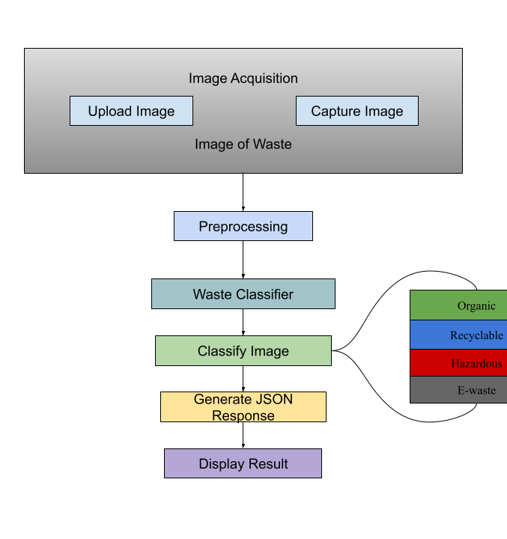

Flowchart
E. Working Prototype/ Formulation/ Design/ Composition
Working prototype is ready. The complete software pipeline, from data acquisition (capture.py) to model training (train.py) and API deployment (app.py), is functional and has been tested.
- Use and Disclosure (Important): Please answer the following questions:

A. Have you described or shown your invention/ design to anyone or in any conference? |  | NO (No)
B. Have you made any attempts to commercialize your invention (for example, have you approached any companies about purchasing  or manufacturing your invention)? |  | NO (No)
C. Has your invention been described in any printed publication, or any other form of media, such as the Internet? |  | NO (No)
D. Do you have any collaboration with any other institute or organization on the same? Provide name and other details. |  | NO (No)
E. Name of Regulatory body or any other approvals if required. |  | NO (No)

- Provide links and dates for such actions if the information has been made public (Google, research papers, YouTube videos, etc.) before sharing with us. NA
- Provide the terms and conditions of the MOU also if the work is done in collaboration within or outside university (Any Industry, other Universities, or any other entity). NA
- Potential Chances of Commercialization. Yes
- List of the companies that can be reached out to in order to commercialize and the link to the website.
  - Municipal Corporations & Smart City Projects: (e.g., Swachh Bharat Mission) - Can integrate this API into public-facing educational apps.
  - Waste Management Companies: (e.g., Waste Management, Inc., Republic Services, or Indian companies like Re-sustainability) - Can use the API to build sorting-guide apps for their clients. https://www.re-sustainability.com/
  - Smart Bin Manufacturers: (e.g., Bigbelly, Enevo) - Can integrate this API as the "brain" for their next-generation hardware. https://bigbelly.com/
  - App Development Companies: (e.g., TCS, Infosys, Wipro) - Can license the API for inclusion in a "Smart City" or "Sustainability" app suite for corporate clients.https://www.tcs.com/ https://www.wipro.com/
  - Retail & FMCG Companies: (e.g., Unilever, Procter & Gamble) - Can use the API in apps to show customers how to recycle their specific packaging.https://www.unilever.com/
- FILING OPTIONS: Please indicate the level of your work which can be considered for provisional/ complete/ PCT filings - (Provisional)
- Keyword
  - AI-powered waste classification
  - Computer Vision in waste management
  - Region-specific AI model
  - Flask API for machine learning
  - Deep Learning for waste sorting
  - Custom dataset generation
  - Transfer Learning (MobileNetV2)

