**Name : Dion D Rodrigues Assignment.no: 01**

**Roll.no : 56 Class : FYMCA B Subject : ML Lab Batch : B3**

**------------------------------------------------------------------------------------------------------------------------------------------**

**# a) IMPORTING LIBRARIES**

***import pandas as pd***

***import numpy as np***

***from sklearn.preprocessing import OneHotEncoder***

***from sklearn.model_selection import train_test_split***

***from sklearn.impute import SimpleImputer***

#b) **IMPORTING LIBRARIES**

***data= pd.read_csv('C:/Users/Admin/Desktop/ML/Assignment_1/Online_shopper.csv')***

***print(data)***

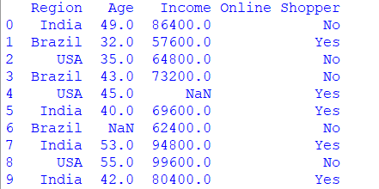

# c) **IDENTIFYING AND HANDLING MISSING DATA**

**#identifying**

***print (data.isnull())***

***print(data.isnull().sum())***

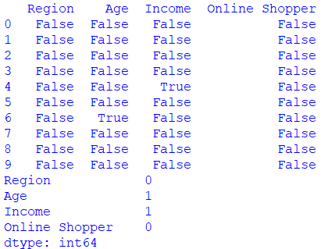

**#handling (FILL WITH THE MODE OF THE COLUMN)**

***data['Age']=data['Age'].fillna(data['Age'].mode())***

***print(data)***

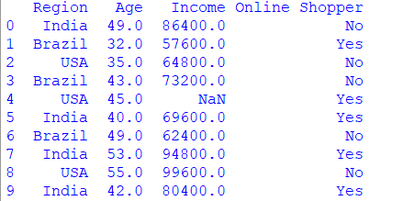

**#handling (FILL WITH THE MEAN OF THE COLUMN)**

***data['Income']=data['Income'].fillna(data['Income'].mean())***

***print(data)***

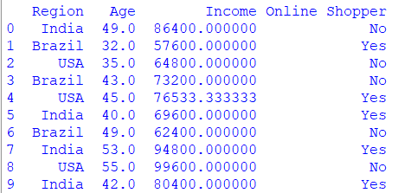

**# Verify if missing data is handled**

***print(data.isnull().sum())***

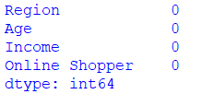

**#d) IDENTIFYING AND HANDLING CATEGORICAL DATAZ**

**#identify categorial columns**

***categorical_columns = data.select_dtypes(include=[np.number]).columns***

***print(categorical_columns)***



**#handling missing data by replacing with the mode (for categorical columns)**

***imputer = SimpleImputer (strategy='most_frequent')***

***data[categorical_columns]=imputer.fit_transform(data[categorical_columns])***

**#verify if missing data is handled**

***print(data.isnull().sum())***

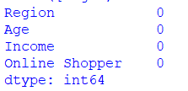

**#Apply OneHotEnchoder to Categorical columns**

***encoder = OneHotEncoder(sparse_output=False,drop='first')***

***encoded_data = encoder.fit_transform(data[categorical_columns])***

**# Getting the names of encoded columns**

***encoded_columns=encoder.get_feature_names_out(categorical_columns)***

**#Drop original categorical columns and concatenate encoded columns**

***data =data.drop(categorical_columns,axis=1)***

***data=pd.concat([data,pd.DataFrame (encoded_data,columns=encoded_columns)],axis=1)***

**#Assuming 'Online shopping ' is the target variable, adjust if different**

***x=data.drop('Online Shopper',axis=1)***

***y=data['Online Shopper']***

**#e) SPLIT THE DATA INTO TRAINING AND TESTING SETS (e.g., 80% train,20% test)**

***x_train, x_test, y_train, y_test = train_test_split(x,y,test_size=0.2,random_state=42)***

***print("Traning set Shape : ",x_train.shape,y_train.shape)***

***print("Testing set Shape : ",x_test.shape, y_test.shape)***

