**Name : Dion D Rodrigues Assignment.no: 02**

**Roll.no : 53 Class : FYMCA B Subject : ML Lab Batch : B3**

**# IMPORTING LIBRARIES**

***import pandas as pd***

***import numpy as np***

***from sklearn.impute import SimpleImputer***

***from sklearn.preprocessing import OneHotEncoder***

***from sklearn.preprocessing import StandardScaler***

***from sklearn.decomposition import PCA***

**#IMPORTING DATASET**

***data = pd.read_csv('C:/Users/Admin/Desktop/ML/Assignment_2/mobile_sales.csv')***

***print(data)***

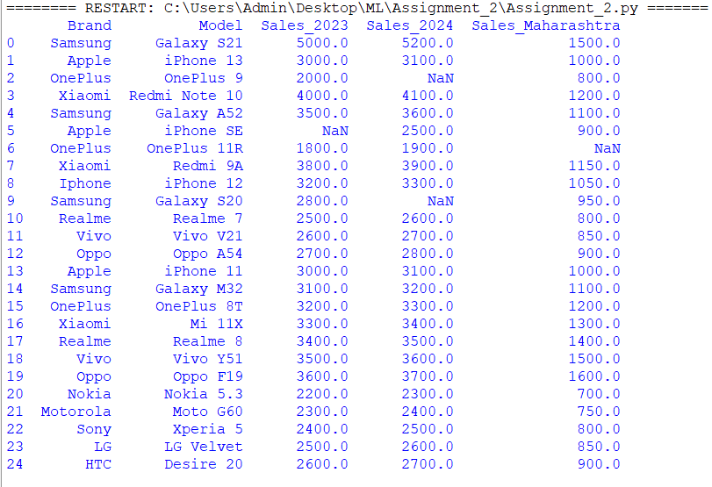

**#CHECKING FOR MISSING DATA**

***print()***

***print(data.isnull().sum())***

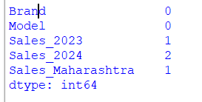

**#HANDLING MISSING VALUES IF ANY**

***numerical_col= data.select_dtypes(include=[np.number]).columns***

***imputer = SimpleImputer(strategy='median')***

***data[numerical_col] = imputer.fit_transform(data[numerical_col])***

**#VERIFY IF MISSING VALUES ARE HANDLED**

***print()***

***print(data.isnull().sum())***

***print()***

***print(data)***

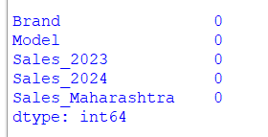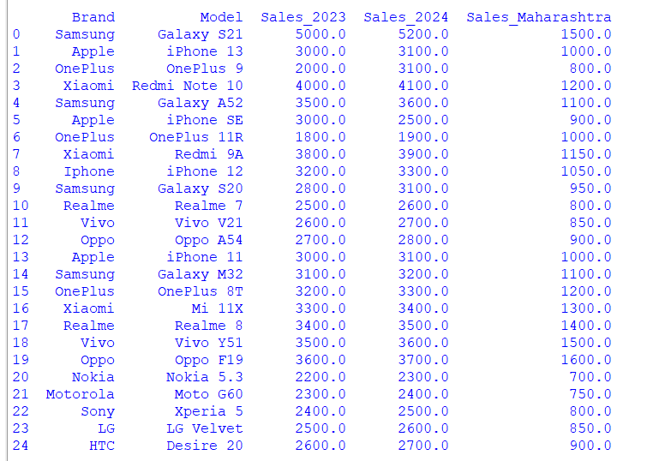

**#SELECT NUMERICAL COLUMNS (REPLACE WITH ACTUAL COLUMN NAMES)**

***numerical_features = ['Sales_2023','Sales_2024','Sales_Maharashtra']***

***x= data[numerical_features]***

***print()***

***print(x)***

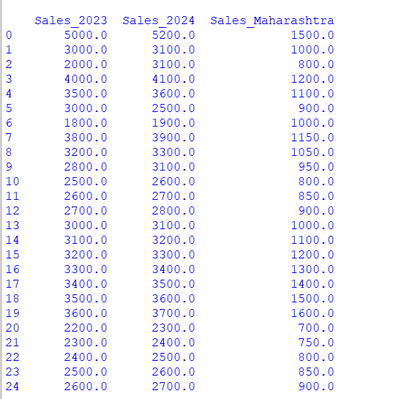

**#STANDARDIZE THE DATA**

**x= StandardScaler().fit_transform(x)**

**pca= PCA(n_components=3) #choose the number of components you want to keep**

**principalComponents = pca.fit_transform(x)**

**principalDf = pd.DataFrame(data = principalComponents , columns =['principal component 1','principal component 2', 'principal component 3])**

**print()**

**print(principalDf)**

