HTML Block and Inline Elements

**HTML Elements** are classified as **Block Level** and **Inline Level** elements on the basics of their **display**. Some elements display as blocks and some inline.

To check an HTML Element is block or inline, open browser inspect and check display property in user agent stylesheet. If its display: block, it is block level, else it is inline level.

## **Block Vs Inline level Elements**

<p> <div> <h1> < h2> <address> etc are **block level elements**, whereas <b>, <strong>, <i>, <span>, <u> and <s> are **inline level elements**.

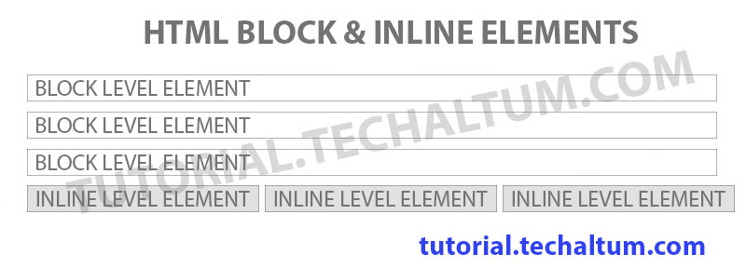HTML Block and inline Elements

A **block level element** can have both inline and block elements as children or descendent, but inline level elements can have only inline elements as children or descendent. (*Except anchor tag or hyperlink*).

## **HTML Block Elements**

**HTML Block level elements** are elements who behave like blocks, like <p>, <h1>, <div>, <ul>, <ol>, <pre> and <address>. These elements always starts from a new line and occupy full width of parent element. **Block elements** can contain both **inline elements** and **block elements**. Here are some **block elements**.

### **HTML Block Level Elements List**

|  |  |  |
| --- | --- | --- |
| **Element Name** | **Code** | **Use** |
| **Html Tag** | <html> </html> | Root tag to build html page. |
| **Body Tag** | <body> </body> | To group visible content of a webpage. |
| **Para Tag** | <p> </p> | Create new **paragraph** |
| **Pre Tag** | <pre> </pre> | Create **pre formatted text**. |
| **hr** | <hr> | **Thematic Break** or formally known as **Horizontal rule**, used to break with 2px gradient shadow. |
| **Blockquote** | <blockquote> </blockquote> | Create a **blockquote** from new line. |
| **Div Tag** | <div> </div> | Create new New **Division** |
| **ul Tag** | <ul> </ul> | Create new **Unordered List**. [Unordered List](https://tutorial.techaltum.com/htmlList.html#unordered) |
| **ol Tag** | <ol> </ol> | Create new **Ordered List**. [Ordered List](https://tutorial.techaltum.com/htmlList.html#ordered) |
| **Address** | <address> </address> | Create **Postal Address** |
| **Headings** | <h1> </h1>, <h2> </h2> till <h6> </h6> | Create **Headings** and sub-headings.[HTML Headings](https://tutorial.techaltum.com/HtmlHeadings.html) |
| **Form Tag** | <form> </form> | Used to group **Form controls and send form data.**. [HTML Form](https://tutorial.techaltum.com/htmlform.html) |
| **Fieldset** | <fieldset> </fieldset> | This is a fieldset, used to group form element. |

HTML **Block Level** elements always start from a new line and occupy full width of parent element. They support **width**, **height** and **text-align** as they occupy full width of container.

## **HTML Inline Elements**

HTML**inline elements** always start in the same line. Their width is equal to their content. Maximum **inline elements** are presentational, for exp, <b>, <i>, <s>, <u>. Some functional **inline elements** are <strong>, <em>, <del>, <time> etc.

### **HTML Inline Level Elements List**

|  |  |  |  |
| --- | --- | --- | --- |
| **Element Name** | **Code** | **Use** | **Example** |
| span Tag | <span> </span> | Used to group **inline elements**. | This is a span. |
| anchor Tag | <a href="">Link</a> | Used to create **hyperlinks**. | I am [hyperlink](javascript:Void()). |
| b Tag | <b> </b> | Used to give **bold appearance**. | I am **bold**. |
| i Tag | <i> </i> | Presentational Element used to **italicize**text. | I am *italic*. |
| Strong Tag | <strong> </strong> | Gives **bold appearance** and highlight content in **searching** . | I am **strong**. |
| em tag | <em> </em> | **Italicize**text and highlight content in **searching** . | I am *em*. |
| small tag | I am <small>small</small> | **small**print. | I am small. |
| u tag | <u> </u> | **underline**text. | I am underlined. |
| s tag | <s> </s> | Shows **struck**text . | I am  text. |
| del tag | <del> </del> | Shows **deleted**text . | Product Price is ₹ 95. |
| sup tag | <sup> </sup> | Shows **superscript**text. | 2000 = 2 * 103. |
| sub tag | <sub> </sub> | Shows **subscript**text . | Chemical formula of water is H2O. |
| abbr tag | <abbr title="Prime Minister">PM</abbr> | Shows full version of **abbreviation**in title tag . | He is our PM. |
| kbd tag | <kbd> </kbd> | Shows **keyboard command** . | To print this page, press Ctrl + p. |
| code tag | <code> </code> | To show **computer code**. | Here is the equation var x = "string";. |
| q tag | <q> </q> | To show **quotes**. | This is a quote. |
| cite tag | I resides in <cite>India </cite> | To show **cited title** of work. | I resides in India. |
| samp tag | <samp> </samp> | To show **sample**. | This is a sample password. |
| ins tag | <ins> </ins> | To indicate addition to document | This is inserted text for above column |
| var tag | <var> </var> | to show **variables** in code . | x +y = z |

**HTML Inline Level** elements are elements generally used inside **block level elements**. They doesn't support **width**, **height** and **text-align** as are used inside line. Only **<img>** tag supports width and height.

### **Div tag**

Html **div tag** is used to create divisions. Div is **block level**, thus starts from new line and occupy full width of parent. Div can group all **block level elements**.

<div>

// content inside div

</div>

### **Span tag**

Html **span tag** is used to create division inside line. Span is **inline level**, thus starts in the same line and occupy width of content. Span is used to group **inline level elements**.

<span>

// content inside div

</span>