**LINUX BASIC COMMANDS DOCUMENT**

Nano to create file – its an editor basically.

Eg: nano filename or nano /home/cloudera/filename

Pwd – gives information or prints working directory (current directory)

Echo - just a normal print statement

Example : echo “hello world”

Return: hello world

Any command added with –help gives all possible arguments you can pass to that command with what it returns also. (ex: ls –help)

Ls – gives the list of commands

Ls -l – gives content with owner settings, timestamp and also permission information of the files in that particular directory.

Ls -l > abc.txt – here the list of the files are written to a txt file named abc. Or you can assume that the result of the commands executed are written to the abc.txt file.

Cd – used to change the directory

Cd ../ - used to come back to the root from one step ahead

Cd ~ - will bring you to your home path , executed from anywhere

Cat – gives the content of the file

Eg: cat filename or cat /home/cloudera/abc.txt

Cat -b – will return the content including line numbers in it but not to blank lines

Eg: cat -b filename or cat -b /home/cloudera/abc.txt

Cat -n – will return the content including line numbers in it also to blank lines

Eg: cat -n filename or cat -n /home/cloudera/abc.txt

Less – opens content of the file in a fresh window (you can press q to quit from there)

Eg: less filename or less /home/cloudera/abc.txt

Grep – used to search for something in a file

Eg: grep word filename or grep word /home/cloudera/abc.txt

Grep -I – used to search irrespective of case sensitiveness

Eg: grep -I word filename or grep word /home/cloudera/abc.txt

Sort – used to sort the content of the file

Eg: sort filename or sort /home/cloudera/abc.txt

Sort -r – used to sort the content of the file in reverse

Eg: sort -r filename or sort -r /home/cloudera/abc.txt

Sort -n – used to sort the content of the file numerically

Eg: sort -n filename or sort -n /home/cloudera/abc.txt

Cp – used to copy file from source to destination

Eg: cp filename /home/cloudera/demo/

Cp -v – used to copy the file with verbos (information about the file when copying, something about the process what’s happening during copying, used when copying large files)

Mv – used to move the file from source to destination

Eg: mv filename /home/cloudera/demo

Rm – used to remove the file from a directory

Eg: rm filename

Mkdir – used to make a new directory

Eg: mkdir /home/cloudera/new_demo

Touch – used to create multiple files at same time

Eg: touch file1.txt file2.txt file3.txt

Rmdir – used to remove directory, complete directory

Eg: rmdir /home/cloudera/dirname

Nl – for number of lines

Eg: nl /home/cloudera/file_path

Gedit – text editor

Eg: gedit /home/cloudera/file_path

Stat – display file attributes

Eg: stat /home/cloudera/file_path

Wc – count bytes/words/lines

Eg: wc /home/cloudera/file_path

Chown – change file owner

Eg: chown owner_name file_path (chown new_user /home/cloudera/desktop/abc.txt)

Chgrp – change file group

Eg: chgrp group_name /home/cloudera/file_path

Ifconfig – display network information / ip address

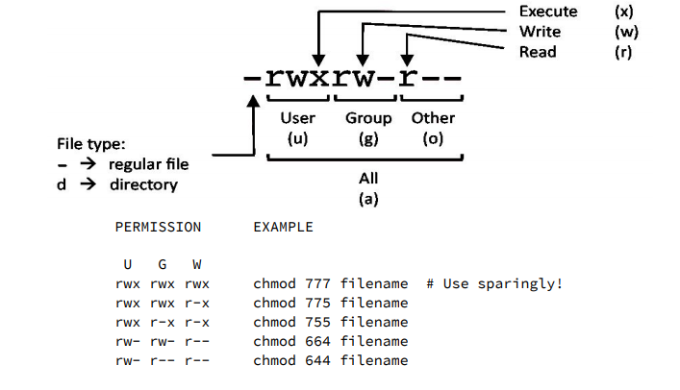

U = User G = Group W = World

r = Read w = write x = execute - = no access