🏏 Cricbuzz LiveStats
A multi-page Streamlit dashboard combining live cricket data from the Cricbuzz API with a PostgreSQL database for analytics and CRUD operations.

Features
- Home — live summary metrics (teams, players, matches, series), quick player search, and navigation shortcuts
- Live Matches — real-time match data from the Cricbuzz API, filterable by format, with on-demand scorecards
- Top Player Stats — live ICC-style rankings alongside database-driven leaderboards with bar-chart visualizations and player drill-down history
- SQL Analytics — analytics questions selectable from a dropdown, with the SQL query shown alongside results and optional bar-chart visualization
- CRUD Operations — full Create/Read/Update/Delete for Players and Teams, with search/filter, validation, and delete confirmation safeguards

Tech Stack
Layer | Technology
Frontend | Streamlit
Database | PostgreSQL (hosted on Supabase)
External API | Cricbuzz Cricket API (via RapidAPI)
Libraries | psycopg2, pandas, plotly, python-dotenv, requests
Deployment | Streamlit Community Cloud

Folder Structure
cricbuzz-livestats/
├── main.py # Streamlit entry point / Home page
├── config.py # Loads secrets from .env or Streamlit Cloud
├── requirements.txt
├── .env.example # Template for required environment variables
├── database/ → db_connection.py
├── api/ → cricbuzz_client.py
├── services/ → business logic (one file per feature area)
├── pages/ → one Streamlit page file per feature
├── utils/ → validators.py, error_handlers.py
├── sql/ → schema.sql, seed_data.sql
└── .streamlit/ → config.toml (theme)

Database Setup
The schema is a normalized (3NF) relational design with 8 tables: teams, players, venues, series, matches, and three performance tables (batting, bowling, fielding performances).
- Create a PostgreSQL database (locally, or a free instance on Supabase)
- Run sql/schema.sql to create all tables
- Run sql/seed_data.sql to load sample data
Note: if connecting to Supabase from a network without IPv6 support, use the connection pooler host rather than the direct host, or you'll hit a DNS resolution error.

API Setup
- Create a free account at RapidAPI
- Subscribe to the Cricbuzz Cricket API (BASIC/free tier is sufficient)
- Copy your API key from the Endpoints tab
Note: the free tier has a limited monthly request quota — the app fails gracefully (showing "unavailable" messages) rather than crashing if the quota is exhausted.

Installation & Running Locally
git clone https://github.com/Chetana870/cricbuzz-livestats.git
cd cricbuzz-livestats
pip install -r requirements.txt
cp .env.example .env
streamlit run main.py

Deployment
Deployed on Streamlit Community Cloud, connected to a Supabase PostgreSQL instance. Secrets are configured via Streamlit Cloud's built-in Secrets manager and are never committed to the repository.

Screenshots
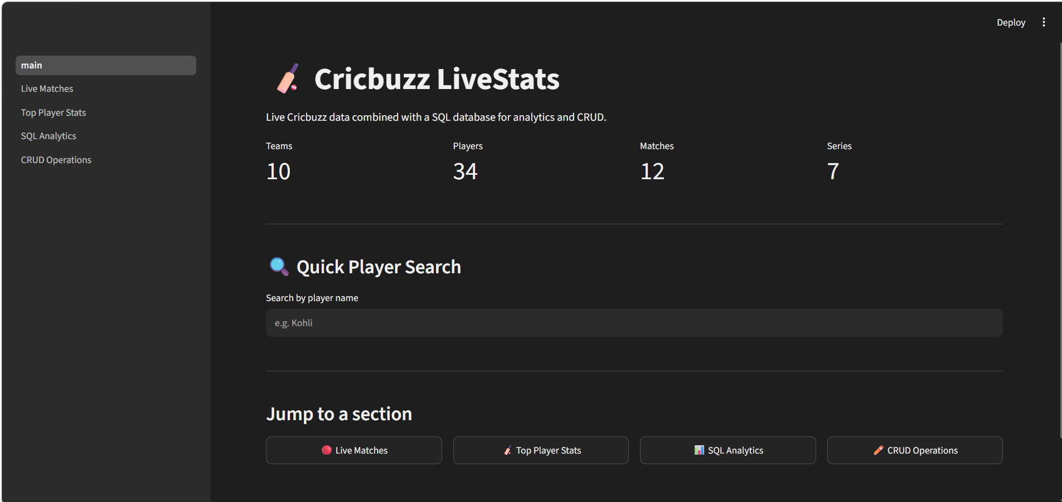
Home page — live summary metrics and quick player search
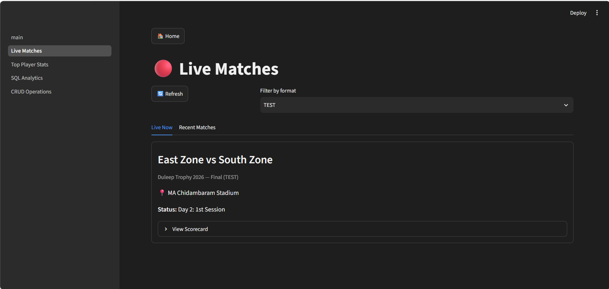
Live Matches — real-time data from the Cricbuzz API
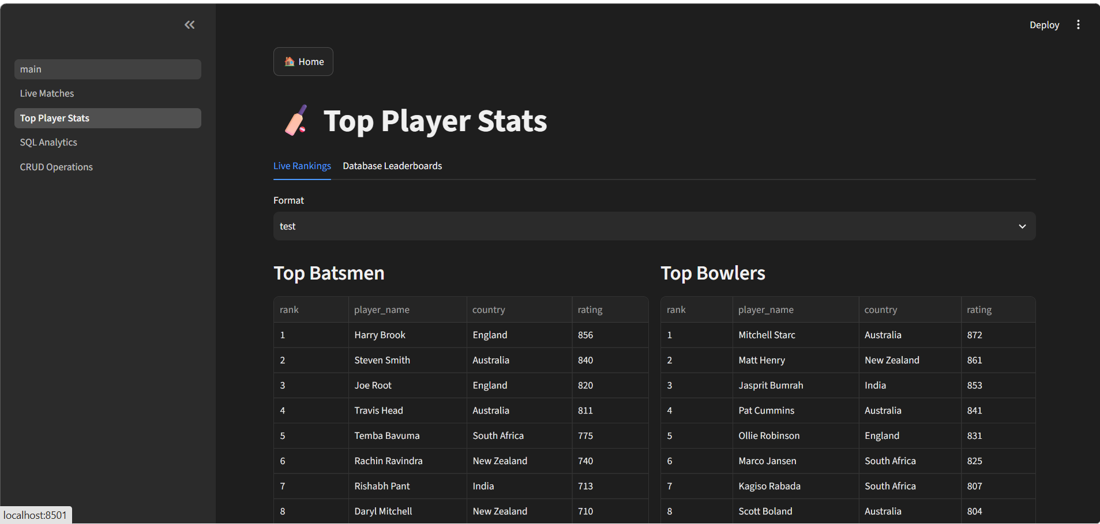
Top Player Stats — live ICC-style rankings
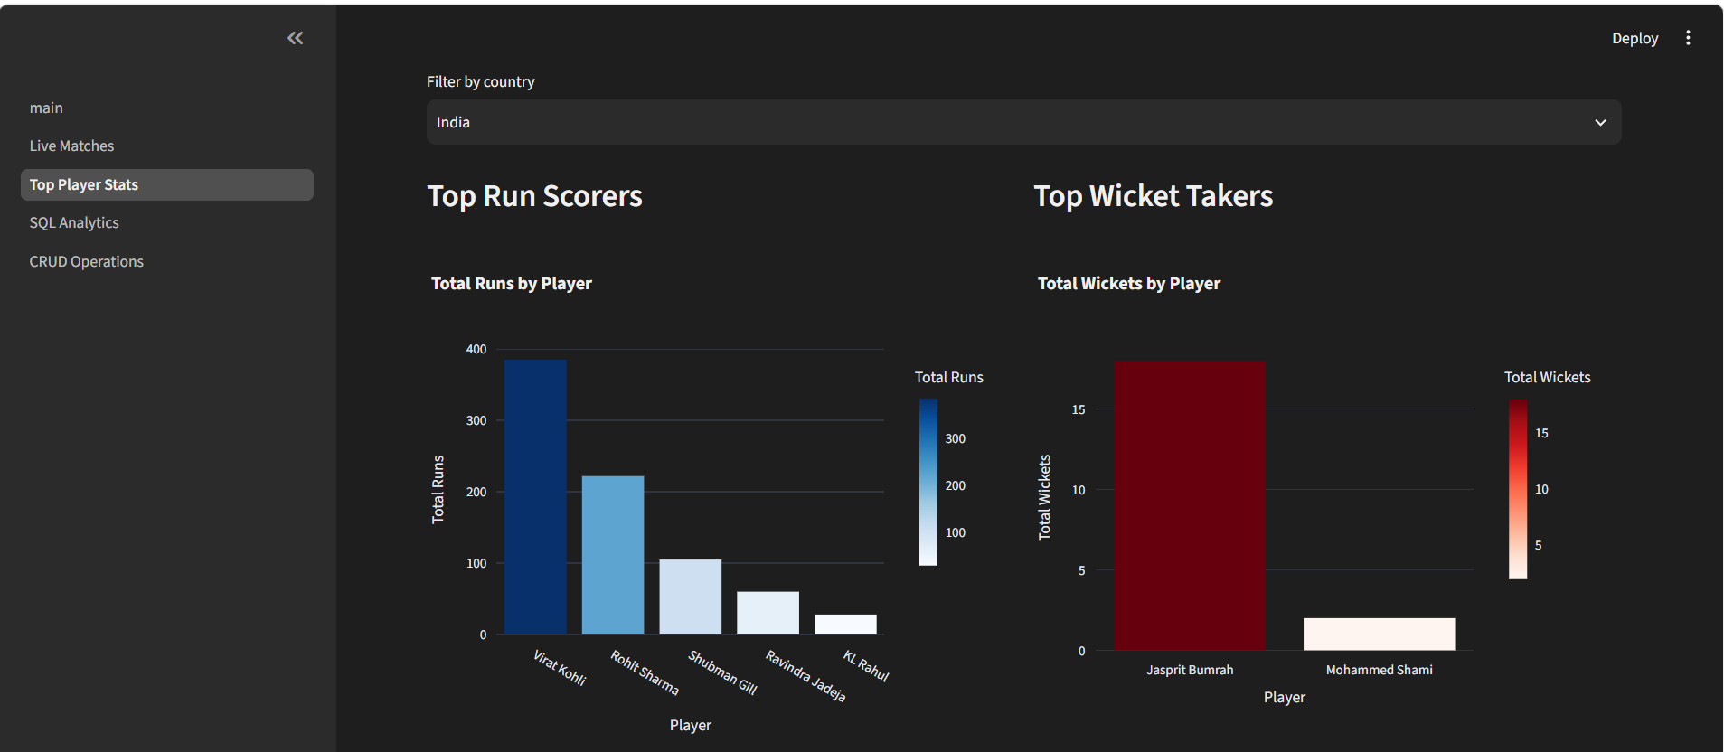
Top Player Stats — database leaderboards with bar-chart visualization
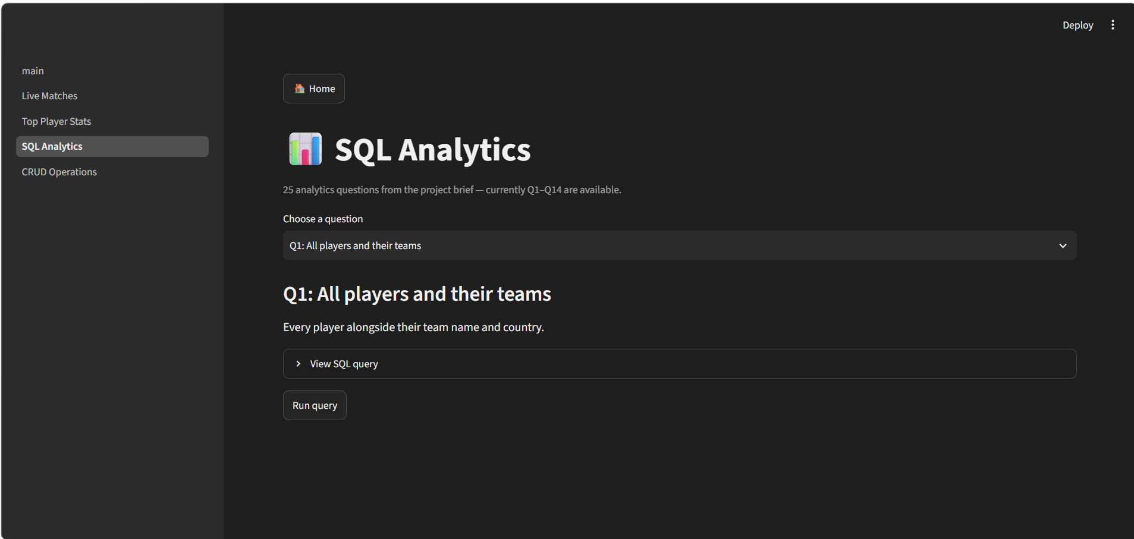
SQL Analytics — interactive query selector
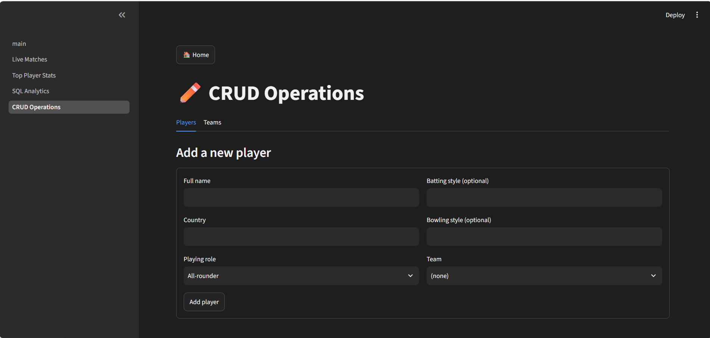
CRUD Operations — add/edit player form

Future Improvements
- Complete SQL Analytics Questions 17–25 (window functions, CTEs, advanced ranking)
- Add line charts and scatter plots once more historical match data is available
- Add automated test suite (pytest) for services and validators
- Add authentication if multi-user access control becomes a requirement

