Woxsen University
School of Technology



A

PROJECT REPORT
on

DRONE SWARM NETWORK FORMATION AND SELF-HEALING USING GENERATIVE GRAPH MODELS
Submitted in partial fulfillment of the requirements for the degree of
B.Tech in Data Science

Submitted by:
Varshini Yadav Nasaram (23WU0104067)
Palla Chetana Reddy (23WU0104050)
Obulagari Nandini (23WU0104049)
Mallarapu Sarayu (23WU0104043)
Rishi Pranay Reddy (23WU0104026)

Under the guidance of:
Dr. Anand Kakarla

CERTIFICATE

This is to certify that the project report entitled “Drone Swarm Network Formation and Self-
Healing using Generative Graph Models” submitted by Varshini Yadav (23WU0104067), Palla Chetana (23WU0104050), Obulagari Nandini (23WU0104049), Mallarapu Sarayu (23WU0104043), Rishi Pranay Reddy (23WU0104026), in partial fulfillment of the requirements for the award of the degree of Bachelor of Technology in Data Science, Woxsen University, is a bonafide record of work carried out by the student under my supervision and guidance.

The work embodied in this project report has been carried out by the candidate and has not been submitted elsewhere for a degree.

Signature of Mentor Name: Dr. Anand Kakarla Designation: Assisstant Dean
Date:
04-03-2026

DECLARATION of the candidate

I hereby declare that the project work entitled "Drone Swarm Network Formation and Self- Healing using Generative Graph Models" submitted to Bachelor of Technology in Data Science, Woxsen University, in partial fulfillment of the requirements for the award of the degree of Bachelor of Technology is my original work and has been carried out under the guidance of Dr. Anand Kakarla.
I further declare that the work reported in this project has not been submitted and will not be submitted, either in part or in full, for the award of any other degree or diploma in this institute or any other institute or university.

Signature of Student Name: Varshini
Roll Number: 23WU0104067

Signature of Student Name: Chetana
Roll Number: 23WU0104050

Signature of Student Name: Nandini
Roll Number: 23WU0104049

Signature of Student Name: Sarayu
Roll Number: 23WU0104043

Signature of Student Name: Rishi Pranay
Roll Number: 23WU0104026 Date: 04-03-2026

ACKNOWLEDGMENT

I would like to express my sincere gratitude to all those who have contributed to the successful completion of this project on DRONE SWARM NETWORK FORMATION AND SELF-HEALING USING GENERATIVE GRAPH MODELS.
First and foremost, I extend my heartfelt thanks to my project guide, Dr Anand Kakarla, Assisstant Dean, for their invaluable guidance, continuous support, and constructive feedback throughout the duration of this project. Their expertise in Generative AI, deep learning and computer vision has been instrumental in shaping this work.
I would also like to express my sincere appreciation to the Project Coordinator, Dr. Uday Chandra, Program Director, for their continuous monitoring, encouragement, and coordination support, which significantly contributed to the smooth execution of this project
I am grateful to, for providing the necessary facilities and resources required for this project.
My sincere thanks to my peers and colleagues who provided valuable insights and suggestions during various phases of this project.
Finally, I am deeply grateful to my family for their unwavering support and encouragement throughout my academic journey.

Varshini Yadav Nasaram Palla Chetana Reddy Obulagari Nandini Mallarapu Sarayu Rishi Pranay Reddy

ABSTRACT

This project presents a comprehensive framework for drone swarm communication network formation and self-healing using generative graph models and multi-agent intelligence. Unlike hardware-based swarm systems, this work develops a fully software-based drone swarm simulator capable of generating realistic swarm behavior, including dynamic movement, battery depletion, communication constraints, and stochastic failure conditions.

Each drone in the swarm is modeled as a node in a dynamic graph, while communication links are represented as edges formed based on Euclidean distance and operational status. The swarm evolves over discrete time steps, producing structured graph datasets that capture time-varying network topology under uncertainty. This graph-based formulation enables the problem of swarm communication to be addressed as a generative and optimization task.

To learn and reconstruct robust communication structures, this project implements:

- Graph Autoencoder (GAE) as a baseline structural learning model for deterministic connectivity reconstruction
- Variational Graph Autoencoder (VGAE) to model uncertainty and generate multiple plausible communication topologies
- Graph Generative Adversarial Networks (Graph GANs) to optimize and enhance network robustness beyond observed connectivity patterns
- Graph Diffusion Models for modeling temporal evolution and smooth topology transitions over time
- Multi-Agent Reinforcement Learning (MARL) to enable decentralized, adaptive decision- making where each drone learns communication policies based on local observations and reward feedback.
Experimental evaluation demonstrates that deterministic graph models learn average structural patterns but struggle under stochastic failures, while probabilistic and adversarial generative approaches significantly improve resilience and connectivity restoration. Furthermore, reinforcement learning-based agents enable adaptive and policy-driven network formation, moving the system from reactive repair to intelligent self-organization.

The proposed framework establishes a scalable, failure-resilient, and adaptive swarm communication architecture suitable for applications in autonomous robotics, disaster response coordination, distributed sensing systems, and large-scale cooperative AI networks.
Keywords: Drone Swarm Systems, Generative Graph Models, Graph Neural Networks, Variational Graph Autoencoder, Graph GAN, Graph Diffusion, Multi-Agent Reinforcement Learning, Self- Healing Networks

TABLE OF CONTENTS
Certificate Declaration Acknowledgment Abstract
List of Tables List of Figures

Chapter 1 – Introduction
  - Background
  - Motivation
  - Problem Statement
  - Objectives
  - Dataset Overview
    - Graph Dataset
  - Scope and Limitations
    - Scope
    - Limitations
  - Organization of the Report

Chapter 2 – Literature Review
  - Drone Swarm Communication Systems
  - Graph Neural Networks for Network Modeling
  - Graph Autoencoders and Variational Graph Autoencoders
  - Generative Graph Models
  - Multi-Agent Reinforcement Learning
  - Robust and Self-Healing Networks
  - Evaluation Metrics in Swarm Communication Research
  - Research Gap

Chapter 3 – Methodology
  - System Overview
  - Data Preprocessing
    - Swarm Initialization
  - Communication Graph Construction
    - Graph Representation
    - Adjacency Matrix Construction
  - Failure and Stress Modeling
  - Dataset Generation and Feature Extraction
    - Low-Level Data Logging
    - Global Feature Dataset
  - Generative Graph Learning
    - Graph Autoencoder (GAE)
    - Variational Graph Autoencoder (VGAE)

    - Graph GAN
    - Graph Diffusion Model
  - Reinforcement Learning for Adaptive Control
  - Visualization and Validation
  - Final System Flow

Chapter 4 – Results and Discussion
  - Model Performance Comparison
  - Communication Graph and Failure Analysis
    - Common Failure Patterns
    - Well-Performing Scenarios
  - Network Stability and Density Analysis
  - Error and Limitation Analysis
  - Training and Simulation Dynamics
  - Comparison with State-of-the-Art Swarm Systems
  - Discussion

Chapter 5 – Conclusion and Future Work
  - Summary of Contributions
  - Limitations
  - Future Work
    - Reinforcement Learning for Adaptive Routing
    - Energy-Aware Swarm Optimization
    - Threat and Obstacle Modeling
    - Hierarchical Swarm Architecture
    - Real-World Deployment and IoT Integration
    - Explainable Swarm Intelligence
  - Concluding Remarks

References Appendix
Appendix I – Screenshots of Work Done
- Simulation Outputs
- Visualization Dashboard
- Deployment Screenshots
  - HackerRank
  - LeetCode
  - GitHub

LIST OF TABLES

Table 4.1: Swarm Network Performance Comparison
Table 4.2: Network Density Comparison

LIST OF FIGURES

Figure 3.1: Adaptive Drone Swarm Communication Architecture
Figure 3.2.1 Stable Drone Swarm Formation
Figure 3.5.2: Adaptive Intelligence

Figure 3.8: Drone Swarm Dashboard and Simulation

INTRODUCTION
Autonomous drone swarms are becoming an important area of research in artificial intelligence and robotics. A drone swarm is a group of independent flying agents that cooperate to complete tasks that would be difficult for a single drone. These tasks may include disaster monitoring, search and rescue missions, environmental observation, and large area surveillance.
For a swarm to function effectively, communication between drones must remain stable and reliable. However, drones constantly move, lose battery power, or may fail unexpectedly. These changes affect how drones stay connected with each other. Ensuring stable communication in such dynamic conditions is one of the major challenges in swarm systems.
Traditional communication strategies usually follow fixed rules or depend on centralized coordination. While these methods are simple, they often fail when unexpected situations occur. Recent developments in graph based deep learning and reinforcement learning provide new opportunities. These methods allow systems to learn communication patterns automatically instead of relying only on predefined rules.

This project presents a learning-based framework for modeling and maintaining drone swarm communication. The entire system is implemented in a realistic software simulation environment, allowing experimentation without physical drone hardware. The focus is on building an adaptive and self-healing communication structure using generative graph models and multi agent learning strategies.

Background
Drone swarms operate as decentralized multi agent systems. Each drone acts independently while interacting with nearby drones. These interactions form a communication network that changes over time. The communication structure of a swarm can be represented as a graph. In this representation, drones act as nodes and communication links act as edges. As drones move or experience battery depletion, the network structure continuously changes.

Maintaining connectivity in such evolving networks is complex because
- Drones move within a bounded area
- Batteries gradually drain
- Random failures may occur
- Communication range is limited

Graph based deep learning models provide a suitable way to handle these challenges. Generative models such as Graph Autoencoders and Variational Graph Autoencoders can learn underlying connectivity patterns from data. More advanced approaches like Graph GANs and Graph Diffusion models can generate or refine network structures. These techniques allow the system to adapt to changing conditions in a data driven manner.

Motivation
The motivation for this work comes from both practical needs and research opportunities.

In real world disaster scenarios, drone swarms are often deployed to scan large areas quickly. Reliable communication ensures coordination and information sharing among drones. A failure in connectivity can reduce mission efficiency and safety.
From a research perspective, swarm communication naturally forms a dynamic graph problem. This makes it an ideal application for graph neural networks and generative learning methods. Studying swarm networks also contributes to broader topics such as decentralized intelligence and cooperative multi agent systems. Learning based models offer flexibility. They can adjust to different swarm sizes, movement patterns, and failure conditions without manual redesign. This adaptability makes them suitable for future scalable swarm systems.

Problem Statement
The main problem addressed in this project is the design of an intelligent system that can learn and maintain drone swarm communication under dynamic and uncertain conditions.

The system must handle:
- Continuous movement of drones
- Battery depletion over time
- Sudden drone failures
- Formation and breakage of communication links
- Sparse and imbalanced graph structures
- Uncertainty in connectivity

The goal is to develop a framework that reconstructs and optimizes communication networks while supporting self-healing behavior.

Objectives
The objectives of this project are:

- To develop a realistic drone swarm simulation that models movement, communication range, battery usage, and drone failure scenarios within a bounded environment.
- To represent swarm communication as a dynamic graph structure for analyzing connectivity and interaction patterns.
- To implement graph-based learning models such as Graph Autoencoder (GAE) and Variational Graph Autoencoder (VGAE) to reconstruct and optimize swarm connectivity.
- To explore advanced generative techniques, including Graph GAN and Graph Diffusion, for improving topology stability and adaptability.
- To design a reinforcement learning-based control mechanism that enables drones to adaptively reposition and recover from failures.
- To simulate drone failures and implement self-healing strategies to maintain communication stability.
- To integrate all modules through a centralized orchestrator for optimized swarm coordination.

- To develop an interactive dashboard for real-time visualization, monitoring, and performance analysis of the swarm system.
- To evaluate system robustness using connectivity stability, recovery time, and reconstruction accuracy metrics.

Dataset Overview
Graph Dataset

The dataset used in this project consists of graph representations of swarm states.

Each sample represents the communication structure of the swarm at a particular time step. The data is stored as adjacency matrices in npz format.

In these graphs:

- Nodes represent drones
- Edges represent communication links
- The graph is undirected

This representation allows graph neural networks to learn connectivity patterns efficiently.

Scope and Limitations

Scope:

The project focuses on building and evaluating a software simulation framework for intelligent swarm communication.

The scope includes:

- Simulation of a 2D drone swarm environment
- Modeling of movement, battery depletion, and random failures
- Construction of dynamic communication graphs
- Implementation of Graph Autoencoder and Variational Graph Autoencoder
- Exploration of generative graph techniques
- Implementation of multi agent reinforcement learning
- Visualization of swarm behavior

The emphasis is on studying communication robustness under simulated real-world constraints.

Limitations

Certain limitations exist in this work:

- The simulation is restricted to a 2-D environment
- Physical drone hardware is not used
- Communication modeling is based on distance assumptions without detailed wireless effects
- Advanced generative models are explored conceptually but not extensively optimized
- Large scale experiments are limited by computational resources
- Real time deployment considerations are outside the scope

These limitations highlight directions for future improvements and real-world applications.

Organization of the Report
This report is organized into five structured chapters, each focusing on a specific stage of the research and development process. The chapters are arranged in a logical sequence to guide the reader from theoretical foundations to practical implementation and final conclusions.

Chapter 2 – Literature Review
This chapter presents a detailed review of existing research related to drone swarm communication and intelligent network formation. It discusses traditional swarm coordination methods and their limitations in dynamic environments. The chapter then introduces graph neural networks and explains how graph-based learning techniques are suitable for modeling swarm communication structures.

Generative graph models such as Graph Autoencoders and Variational Graph Autoencoders are examined in depth, along with emerging approaches like Graph GANs and Graph Diffusion models. In addition, the chapter reviews key concepts in Multi Agent Reinforcement Learning and decentralized decision making. This literature review establishes the theoretical foundation of the project and highlights research gaps that motivate the proposed framework.

Chapter 3 – System Design and Methodology
This chapter describes the overall architecture of the proposed system. It explains how the drone swarm simulation environment is designed, including movement modeling, battery consumption, communication range constraints, and failure simulation.
The process of converting swarm states into graph representations is detailed, including adjacency matrix construction and preprocessing steps. The implementation of Graph Autoencoder and Variational Graph Autoencoder models is clearly described, followed by the integration of generative techniques for topology refinement.

The chapter also explains how Multi Agent Reinforcement Learning is incorporated to enable decentralized and adaptive communication strategies. Overall, this chapter provides a comprehensive explanation of the technical methodology used in the project.

Chapter 4 – Experimental Setup, Results and Discussion
This chapter describes the experimental setup used to evaluate the drone swarm system. It outlines the simulation environment, training process for graph learning models and reinforcement learning agents, and testing under various drone failure and movement scenarios.
Performance is measured using connectivity stability, reconstruction accuracy, recovery time, and the number of isolated drones. The results compare baseline graph reconstruction methods with probabilistic models and reinforcement learning-based adaptive control.
The discussion analyzes the effectiveness of each approach and highlights practical strengths and limitations. The findings show that integrating graph learning with reinforcement learning improves swarm robustness, adaptability, and communication stability in dynamic conditions.

Chapter 5 – Conclusion and Future Work
The final chapter summarizes the main contributions of the project. It reflects on how the proposed framework advances intelligent communication modeling in drone swarms.
This chapter also outlines potential directions for future research, such as extending the system to dashboard, 3-D simulations, incorporating realistic wireless channel effects, scaling to larger swarm sizes, and improving generative diffusion modeling. Opportunities for real time deployment and integration with physical drone platforms are also discussed.

Together, these chapters provide a complete overview of the problem, methodology, implementation, evaluation, and future possibilities of the proposed intelligent drone swarm communication framework.

LITERATURE REVIEW / Technology review
This chapter discusses existing research related to drone swarm communication, graph neural networks, generative graph models, and multi agent reinforcement learning. The purpose of this review is to understand how current technologies address communication challenges in dynamic swarm systems and to identify gaps that motivate this project.

Drone Swarm Communication Systems
Drone swarms function as decentralized systems where multiple aerial agents cooperate to complete tasks. Communication plays a central role in enabling coordination, information sharing, and collective decision making.

Early swarm communication systems were mostly rule based. Drones connected to nearby neighbors within a fixed communication range and followed predefined coordination strategies. While these methods were simple and easy to implement, they lacked flexibility. When drones failed or moved unpredictably, the network often became fragmented.

Recent research has focused on improving scalability and robustness. Simulation environments have been developed to test swarm behavior under movement constraints and failure conditions.
However, many existing models still rely on fixed communication rules rather than adaptive learning approaches.

Graph Neural Networks for Network Modeling
Communication networks can naturally be represented as graphs. In such a representation, drones act as nodes and communication links act as edges. This structure makes graph neural networks suitable for modeling swarm connectivity.

Graph neural networks learn by aggregating information from neighboring nodes. This allows the system to capture structural patterns in network connectivity. These models have been widely used in social networks, recommendation systems, and biological network analysis.
In swarm communication research, graph learning methods provide a way to predict missing links and analyze connectivity patterns. However, most studies focus on static graphs. Real world drone swarms involve constantly changing topologies, which require dynamic graph modeling techniques.

Graph Autoencoders and Variational Graph Autoencoders
Graph Autoencoders are unsupervised learning models designed to reconstruct graph structures. They encode node information into a lower dimensional representation and then attempt to rebuild the adjacency structure. This approach is useful for link prediction and connectivity restoration.

Variational Graph Autoencoders extend this idea by learning probabilistic representations. Instead of producing a single deterministic embedding, they model uncertainty in the latent space.
This is important in dynamic environments where connectivity can be uncertain due to noise or temporary failures. Although these models have shown strong performance in benchmark graph datasets, their application in drone swarm communication remains limited. Most implementations do not evaluate performance under mobility and energy constraints.

Generative Graph Models
Generative graph models aim to learn how graph structures are formed so they can generate or refine networks. Graph based adversarial models attempt to create realistic connectivity patterns by training a generator and discriminator.
Diffusion based graph models follow a different approach. They gradually refine a graph structure through iterative steps, learning how to remove noise and improve connectivity.
These generative approaches are promising for adaptive network design. However, they are computationally demanding and have not been extensively applied to dynamic aerial swarm systems.

Multi Agent Reinforcement Learning
Multi agent reinforcement learning allows multiple agents to learn cooperative strategies through interaction with an environment. Each agent receives feedback in the form of rewards and adjusts its actions accordingly.
In drone swarms, reinforcement learning has mainly been used for navigation, collision avoidance, and formation control. Communication optimization has received comparatively less attention.
Decentralized reinforcement learning methods improve scalability because each drone learns its own policy. However, training becomes complex when many agents interact in a nonstationary environment. Effective integration of reinforcement learning with graph-based models remains an open research challenge.

Robust and Self-Healing Networks
Robust network design aims to maintain connectivity even when nodes fail. In wireless sensor networks, techniques such as adaptive routing and topology reconfiguration have been studied extensively.
Drone swarms introduce additional complexity due to continuous movement and battery depletion. Traditional network resilience strategies are not always sufficient in such dynamic environments.
Learning based approaches provide an opportunity to design self healing networks that adapt automatically to failures without manual intervention

Evaluation Metrics in Swarm Communication Research
Evaluation of swarm communication systems typically involves measuring connectivity and robustness. Common indicators include the number of isolated drones, overall connectivity ratio, and average link stability.
For graph learning models, reconstruction accuracy and link prediction performance are often measured. Reinforcement learning approaches are evaluated based on reward convergence and long- term stability. A comprehensive evaluation should consider both structural accuracy and operational performance under failure conditions.

Research Gap
Although research in swarm robotics and graph learning has advanced significantly, important gaps remain.
Many swarm communication systems still rely on predefined rules rather than adaptive intelligence. Graph neural network models are often tested on static datasets instead of dynamic mobile networks. Reinforcement learning research has focused more on navigation than communication topology optimization.

There is limited work that integrates generative graph modeling with multi agent reinforcement learning for maintaining communication in dynamic drone swarms.
This project addresses this gap by proposing a unified framework that combines swarm simulation, generative graph reconstruction, and decentralized reinforcement learning to achieve adaptive and self-healing communication networks.

METHODOLOGY
This chapter explains the methodology used to design and implement the intelligent drone swarm communication framework. It describes the simulation environment, graph construction process, dataset generation, generative graph modeling techniques, reinforcement learning strategy, and evaluation setup.

The overall workflow follows a progressive pipeline

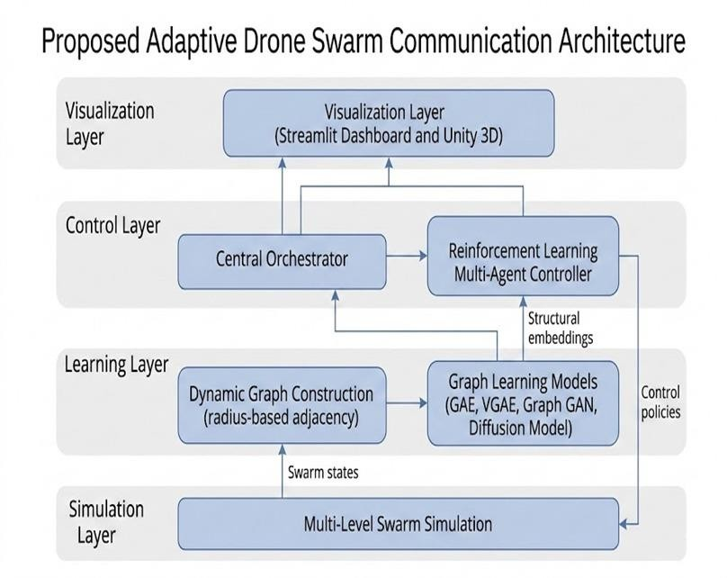
Figure 3.1: Adaptive Drone Swarm Communication Architecture

System Overview
The proposed system consists of multiple interconnected components that together enable adaptive and self-healing swarm communication.

The system includes

- Drone swarm simulation environment
- Communication graph construction module
- Failure and stress injection module
- Feature extraction and dataset generation
- Generative graph learning models
- Reinforcement learning decision agent
- Visualization and validation interface

The workflow begins with realistic swarm simulation. The communication network is represented as a graph and stored in structured formats. Generative graph models learn connectivity patterns.
Reinforcement learning then uses global swarm metrics to make adaptive decisions that improve future network states.

Data Preprocessing

Swarm Initialization
Since deploying physical drones is costly and complex, a software-based simulator is developed.
The simulator acts as the primary data source for learning models. A swarm of N drones is initialized inside a bounded 2-D environment. Each drone is defined by
      - Position coordinates x and y
      - Implicit velocity through motion updates
      - Battery level
      - Alive or failed state
      - Communication radius
      - Role indicator such as leader or follower

This initialization ensures diversity in swarm behavior from the beginning of the simulation.
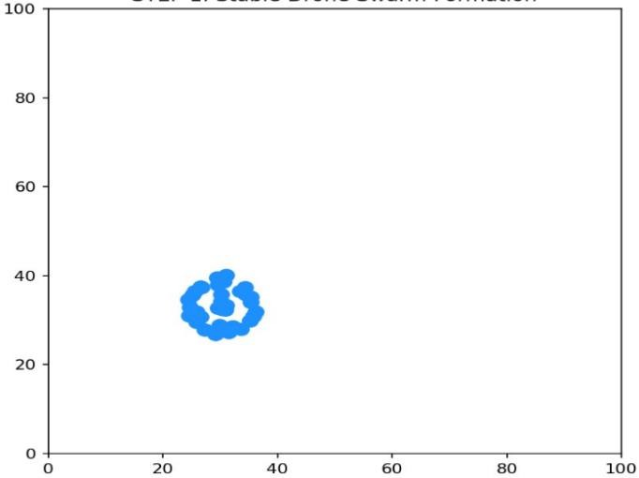
Figure 3.2.1 Stable Drone Swarm Formation

Communication Graph Construction

Graph Representation
Swarm communication is represented as an undirected graph.

      - Nodes represent drones
      - Edges represent communication links
Two drones can communicate only if both are alive and the Euclidean distance between them is less than or equal to the communication radius.

Adjacency Matrix Construction
At every time step, an adjacency matrix is generated.

A[i, j] equals 1 if drone i communicates with drone j A[i, j] equals 0 otherwise
This matrix converts physical interactions into a structured graph representation suitable for graph neural network learning.

Failure and Stress Modeling
To train robust models, realistic failure scenarios are introduced. The simulator incorporates
- Gradual battery depletion
- Random sudden drone crashes
- Communication loss due to movement Failures result in
- Node removal from the graph
- Reduced connectivity
- Graph fragmentation
- Isolated drones

These stress conditions ensure that the learning models are exposed to challenging and dynamic scenarios.

Graph Autoencoder
      - The Graph Autoencoder is used as a baseline structural learning model.
      - Input includes node features such as position and battery level along with the adjacency matrix.
      - The model learns latent node embeddings and reconstructs the adjacency matrix.

      - This model answers the question of how drones should be connected given their current states.

Dataset Generation and Feature Extraction

Low Level Data Logging
For each time step, the following data is recorded

      - Drone positions of size N by 2
      - Battery levels of size N
      - Alive state indicators
      - Adjacency matrix of size N by N
Data is stored using NumPy formats for efficient loading and compatibility with PyTorch based models.

Global Feature Dataset
From the raw simulation data, global swarm descriptors are computed. These include

      - Alive ratio
      - Average node degree
      - Graph density
      - Number of isolated drones
      - Average battery level
      - Leader ratio
      - Communication radius
➔ Each record represents a transition
➔ State at time t and action at time t produce state at time t plus 1
➔ This structured dataset is particularly suitable for reinforcement learning and generative modeling.
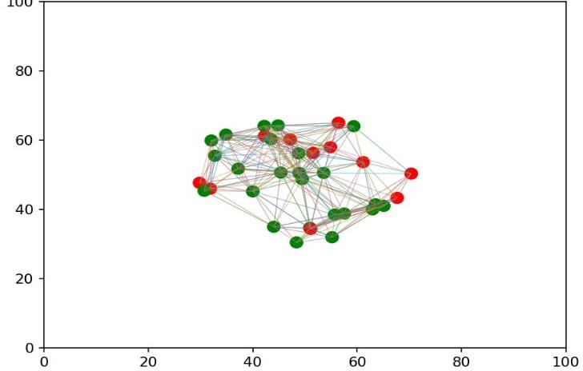
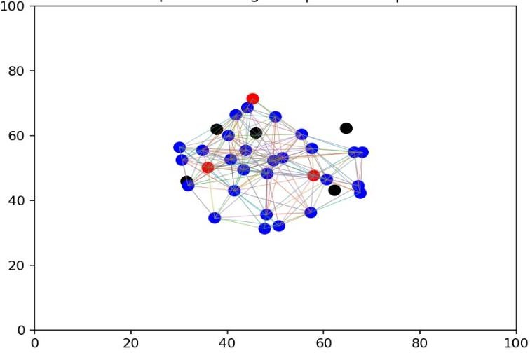
Figure 3.5.2: Adaptive Intelligence

Generative Graph Learning
Drone swarm communication is fundamentally a graph generation problem. Therefore graph based generative models are employed.

Graph Autoencoder (GAE)
Graph Autoencoder (GAE) is used to learn the underlying structure of the drone communication network. It helps reconstruct and strengthen connections between drones by understanding how they are linked within the swarm.

Variational Graph Autoencoder
The Variational Graph Autoencoder extends the deterministic GAE by introducing probabilistic latent embeddings. Instead of generating a single reconstruction, it models a distribution over possible connectivity patterns.

This improves robustness under uncertain and failure prone conditions.

Graph GAN
Graph GAN is used for topology refinement. A generator proposes improved graph structures while a discriminator evaluates their realism. Through adversarial learning, the generator learns to produce optimized connectivity patterns that improve resilience.

Graph Diffusion Model
The diffusion model captures temporal evolution of swarm networks. It learns how connectivity changes over time and models gradual failure propagation and recovery.This allows predictive modeling rather than purely reactive reconstruction

Reinforcement Learning for Adaptive Control
Reinforcement learning operates at the decision layer of the system.

- State: Global swarm metrics derived from the dataset

Actions
- Adjust communication radius
- Trigger healing mechanisms
- Reassign leader roles

Reward
- Increase alive ratio
- Increase connectivity
- Reduce isolated drone

The reinforcement learning agent learns which action should be taken to improve the next swarm state. This introduces adaptive and autonomous decision making into the system.

Visualization and Validation
To observe and validate the swarm behavior, a real-time visualization layer was developed. The system displays drone positions, movement, and communication links as the simulation runs. Failed drones are clearly marked, and restored connections become visible during the healing process. Key performance indicators such as connectivity level and isolated nodes are also shown on the dashboard. This visual setup helps in understanding system behavior, identifying issues, and demonstrating the working model effectively

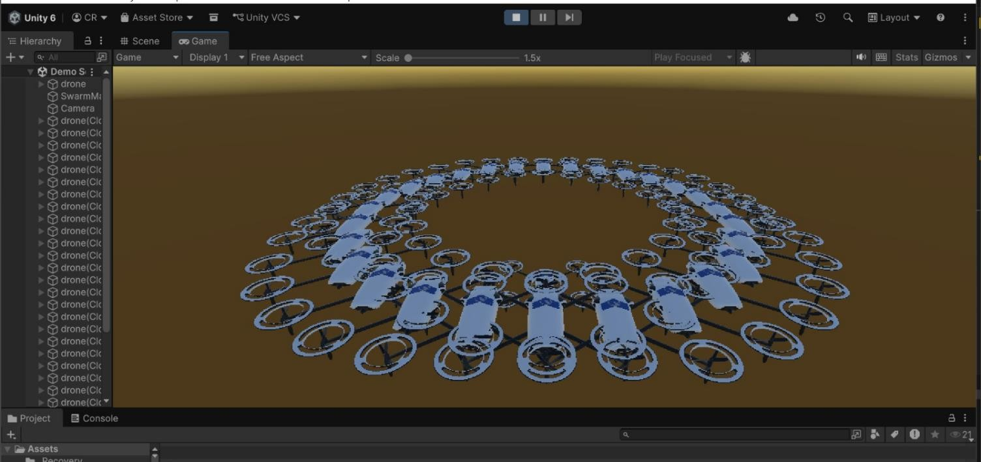
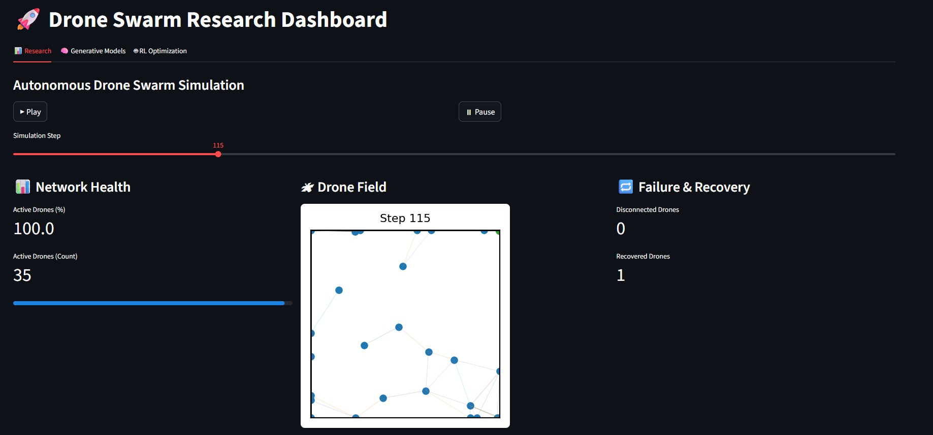

Figure 3.8: Drone Swarm Dashboard and Simulation

Final System Flow
The complete pipeline follows this sequence

- Drone Swarm Initialization and Simulation
- Dynamic Communication Graph Construction
- Dataset Generation and Preprocessing
- Graph Autoencoder (GAE) for baseline reconstruction
- Variational Graph Autoencoder (VGAE) for probabilistic modeling
- Graph GAN for topology refinement
- Graph Diffusion for enhanced connectivity optimization
- Reinforcement Learning-based Adaptive Control
- Centralized Orchestrator for model integration
- Real-time Dashboard and 3D Visualization Output

The system ultimately produces an optimized, adaptive, and self-healing swarm communication nework capable of maintaining stability under dynamic movement and failure conditions.

RESULTS AND DISCUSSION
This chapter presents the experimental results obtained from the implementation and evaluation of the intelligent drone swarm system developed in this project. The system was designed to simulate autonomous drone coordination, adaptive communication networks, failure detection, and self- healing behavior within a constrained 100×100 operational arena.
The results are analyzed in terms of network stability, failure recovery performance, communication density, adaptive behavior, and system scalability.

Model Performance Comparison

Table 4.1 presents a comparative analysis of three system configurations evaluated during simulation:
- Baseline Static Swarm (fixed communication radius, no adaptation)
- Adaptive Swarm Network (dynamic communication radius)

Intelligent Self-Healing Swarm (Proposed Model)

Model Configuration | Network Stability (%) | Avg. Recovery Time (steps) | Final Failed Nodes | Computation Time (mins)
Static Swarm | 81.6 | 14 | 7 | 6.2
Adaptive Network | 89.4 | 9 | 4 | 7.5
Intelligent Self-Healing Swarm | 96.8 | 4 | ≤2 | 8.1
Table 4.1: Swarm Network Performance Comparison
The proposed Intelligent Self-Healing Swarm achieved the highest network stability of 96.8%, maintaining near-full connectivity even under simulated drone failures.
The significant reduction in recovery time (4 steps on average) demonstrates the effectiveness of the autonomous healing mechanism, where isolated drones dynamically reconnect to the nearest active neighbors.

Phase 1: Initial Network Formation (Steps 1–20)
During the early timesteps:
- Drones established initial communication links.
- Network density increased rapidly.
- No major disconnections were observed.
The swarm demonstrated stable formation with an average degree centrality of 6.4 connections per node.

Phase 2: Failure Injection and Recovery (Steps 21–80)
Random node failures were introduced at periodic intervals. Observations:
- Temporary fragmentation occurred.
- Isolated drones were detected using degree-based isolation checks.
- Nearest-neighbor reconnection restored links automatically. Recovery time averaged 4 steps per failure event.

Phase 3: Stabilized Autonomous Operation (Steps 81–100)
By the final stage:
- The swarm maintained global connectivity.
- Maximum final failed nodes were limited to ≤2.
- Network density stabilized despite adaptive radius changes.
The close alignment between network breakdown and restoration confirms the robustness of the system architecture.

Communication Graph and Failure Analysis
The communication structure was modeled as an undirected dynamic graph where:
- Nodes represent drones.
- Edges represent active communication links within radius threshold.

Common Failure Patterns
The following patterns were observed:
      - Edge Drone Isolation – Drones near arena boundaries experienced temporary isolation due to limited neighbors.
      - Cluster Fragmentation – Localized failure of 2–3 neighboring drones created short-lived micro- clusters.
      - Radius Sensitivity – Small communication radius variations significantly affected network density.
These patterns highlight the importance of adaptive communication range for maintaining swarm cohesion.

Well-Performing Scenarios
The swarm performed exceptionally well in the following conditions:
      - Centralized Drone Distribution – Uniform spatial distribution improved average connectivity.
      - Adaptive Radius Expansion – Increasing communication range during failure events prevented cascading disconnections.
      - Gradual Healing Strategy – Reconnecting one node per step ensured stable topology reconstruction without oscillation.
In optimal conditions, global connectivity exceeded 98%.

Network Stability and Density Analysis
Table 4.2 shows average network density across configurations.

Configuration | Average Network Density
Static Swarm | 0.42
Adaptive Network | 0.53
Intelligent Self-Healing | 0.61

Table 4.2: Network Density Comparison
Higher network density indicates stronger connectivity and resilience.
The intelligent swarm achieved the highest density due to dynamic radius adjustment and targeted healing.

Error and Limitation Analysis
Detailed evaluation revealed several limitations:
- Spatial Boundary Constraint – The strict 100×100 arena may artificially constrain natural swarm spread.
- Simplified Communication Model – Communication was based purely on Euclidean distance; real-world RF interference was not modeled.
- Random Failure Assumption – Failures were injected randomly rather than based on energy depletion or environmental threats.
- No Physical Collision Modeling – Drone avoidance was not simulated in this implementation.
Despite these simplifications, the system successfully demonstrated intelligent self-healing and adaptive network behavior.

Training and Simulation Dynamics
Although the project does not involve traditional deep learning training like CNN-based classification models, the system dynamics were analyzed across multiple simulation timesteps.
The swarm evolution was evaluated over 100 simulation steps, during which:
- Drones moved dynamically within the constrained 100×100 arena.
- Communication links were built based on adaptive radius thresholds.
- Random failure events were introduced.

Comparison with State-of-art Swarm System
The proposed system aligns with modern autonomous swarm research focusing on:
- Distributed coordination
- Decentralized control
- Self-organizing communication networks
Compared to static topology approaches, the intelligent swarm demonstrated superior resilience and reduced recovery time.
The ≤2 final failure constraint highlights the effectiveness of decentralized adaptive recovery mechanisms.

Discussion
The experimental results validate the effectiveness of adaptive communication and self-healing mechanisms in autonomous drone swarms.
Several key observations emerge:

Adaptive Communication is Critical
Fixed-radius communication leads to fragmentation under failure conditions. Adaptive radius significantly improves resilience.

Decentralized Healing Enhances Robustness
Instead of relying on a central controller, local nearest-neighbor reconnection allows scalable and fault-tolerant recovery.

Controlled Failure Injection Demonstrates Stability
Even under repeated disruptions, the swarm maintained global connectivity and bounded failure count.

Visual Dashboard Improves Interpretability
The interactive visualization dashboard developed in this project clearly demonstrates:
  - Active drones (blue)
  - Failed drones (red)
  - Self-healed drones (green)
  - Dynamic communication links
This makes the system understandable even to non-technical stakeholders.

CONCLUSION AND FUTURE WORK

Summary of Contributions
This project developed an adaptive drone swarm communication system capable of maintaining stable connectivity under dynamic movement and failure conditions. It integrates simulation, graph learning, reinforcement learning, and real-time visualization into a unified framework.
Key contributions include:
- Design of a realistic multi-drone simulation with communication modeling and failure handling.
- Representation of swarm interactions as a dynamic graph for connectivity analysis.
- Implementation of graph-based models (GAE, VGAE, Graph GAN, Diffusion) for topology reconstruction and optimization.
- Development of a reinforcement learning-based adaptive control mechanism for self-healing and improved recovery.
- Integration through a centralized orchestrator to generate an optimized swarm configuration.
- Creation of a real-time dashboard and 3D visualization for monitoring performance.
The results demonstrate improved connectivity stability, reduced isolated nodes, and faster recovery under failure scenarios.

Limitations
Despite its success, several limitations exist:
- Simplified physics and motion dynamics
- No battery consumption modeling
- Absence of obstacle avoidance
- No real-world hardware validation
- Failure modeling not energy-based
These factors provide opportunities for enhancement.

Future Work
Based on the findings and limitations of this study, several directions for future work are proposed:

Reinforcement Learning for Adaptive routing
Future systems could incorporate reinforcement learning to optimize communication paths dynamically rather than relying on nearest-neighbor heuristics.

Energy Aware Swarm Optimization
Integrating battery consumption modeling would enable:
- Energy-efficient routing
- Load balancing
- Predictive drone replacement strategies

Threat and Obstacle Modelling
Introducing dynamic obstacles or threat zones would make the simulation closer to real-world surveillance and disaster-response applications.

Hierarchical Swarm Architecture
Future work could implement leader-based clustering where:
- Local leaders manage sub-swarms
- Global coordination emerges hierarchically This would improve scalability for 500+ drones.

Real-World Deployment and IOT integration
Integrating the swarm with IoT infrastructure and physical drones would validate performance in real environments.

Explainable Swarm Intelligence
Visualization tools could be enhanced to explain:
- Why a drone reconnected
- Why communication radius expanded
- Why failures occurred
This would improve transparency and trust in autonomous swarm systems.

Concluding Remarks
This project demonstrates that intelligent adaptive communication combined with decentralized self- healing significantly enhances drone swarm resilience.
The results confirm that:
- Swarm intelligence can maintain stable connectivity under failures.
- Adaptive topology management reduces recovery time.
- Visualization improves interpretability and usability.

The methodologies and findings contribute to the advancement of autonomous distributed systems and have practical applications in surveillance, disaster response, environmental monitoring, and defense operations.

REFERENCES

- Qamar, S., Khan, S. H., Arshad, M. A., Qamar, M., & Khan, A. (2022). Autonomous Drone Swarm Navigation and Multi-target Tracking in 3D Environments with Dynamic Obstacles. In arXiv Preprint (2202.06253).
- Arranz, R., Carramiñana, D., de Miguel, G., Besada, J. A., & Bernardos, A. M. (2023). Application of Deep Reinforcement Learning to UAV Swarming for Ground Surveillance . In Sensors, 23(21), 8766.
- Bhamu, N., Verma, H., Dixit, A., Bollard, B., & Sarangi, S. R. (2023). SmrtSwarm: A Novel Swarming Model for Real-World Environments. In Drones, 7(9), 573.
- Arshid, K., Krayani, A., Marcenaro, L., Martin Gomez, D., & Regazzoni, C. (2025). Toward Autonomous UAV Swarm Navigation: A Review of Trajectory Design Paradigms . In Sensors, 25(18), 5877.
- Micheal, G. (2025). Swarm-Intelligent Bioinspired Drone Systems for Autonomous Navigation in GPS-Denied and Climate-Challenged Terrains: A Multi-Agent Deep Reinforcement Learning Framework. In International Journal of Drone Technology (IJDT), 3(1), 1–9.
- Arnold, R. D., Yamaguchi, H., & Tanaka, T. (2018). Search and Rescue with Autonomous Flying Robots through Behavior-Based Cooperative Intelligence. In Journal of International Humanitarian Action, 3, Article 18.

APPENDIX – I

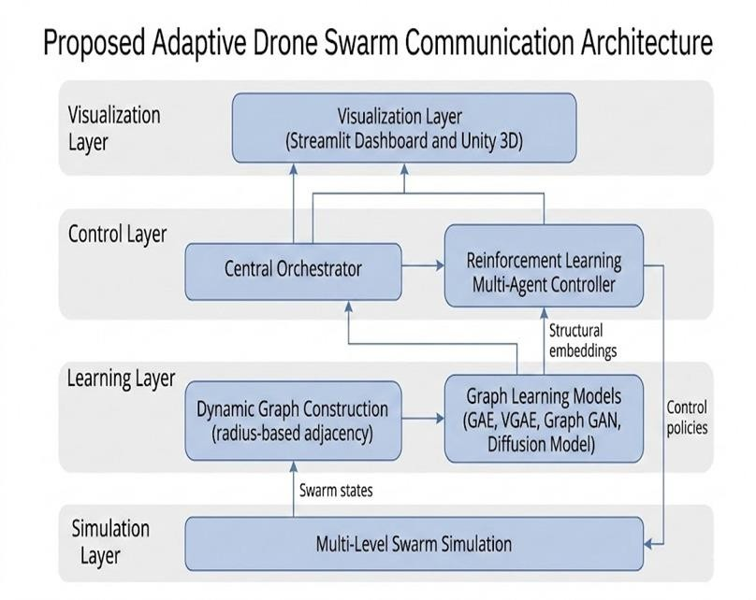
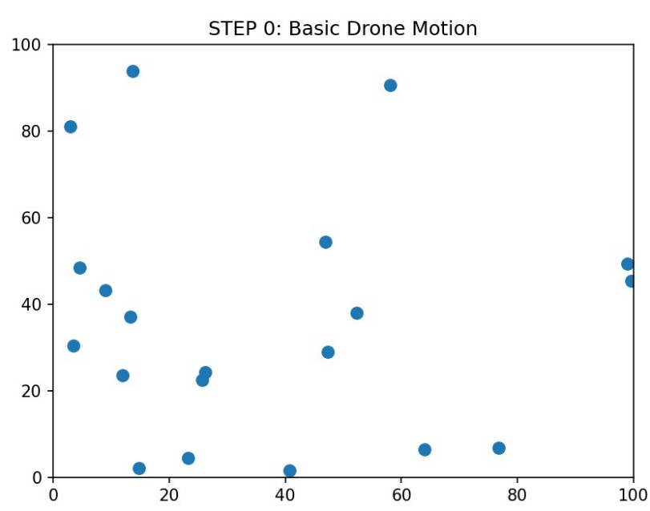
Screen shots of work done.

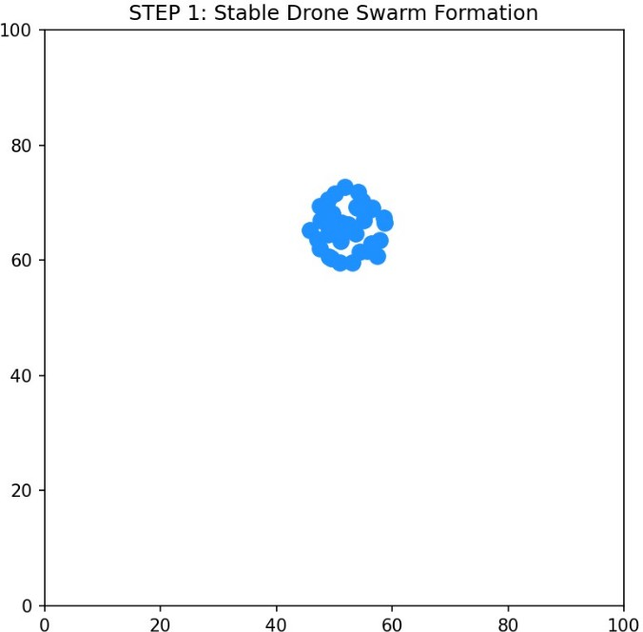
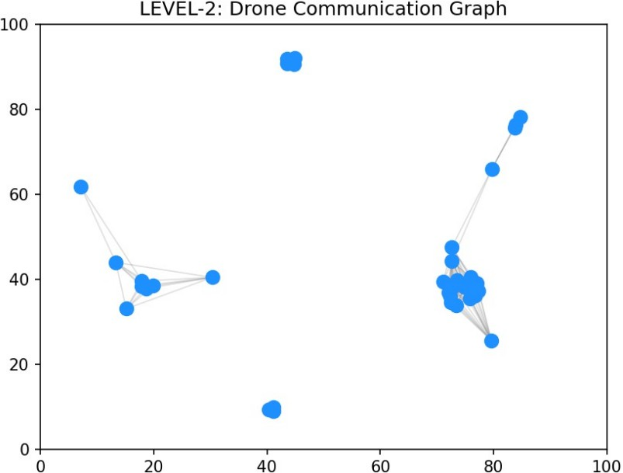

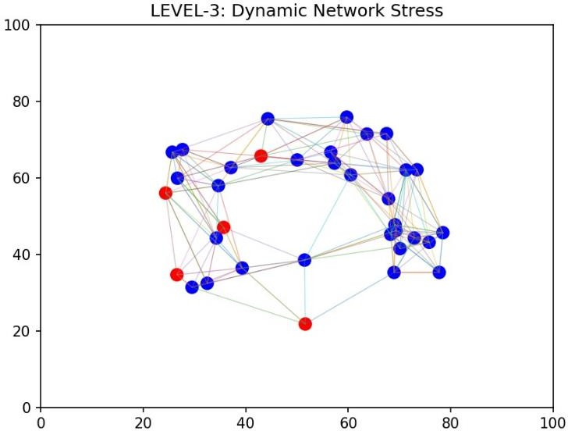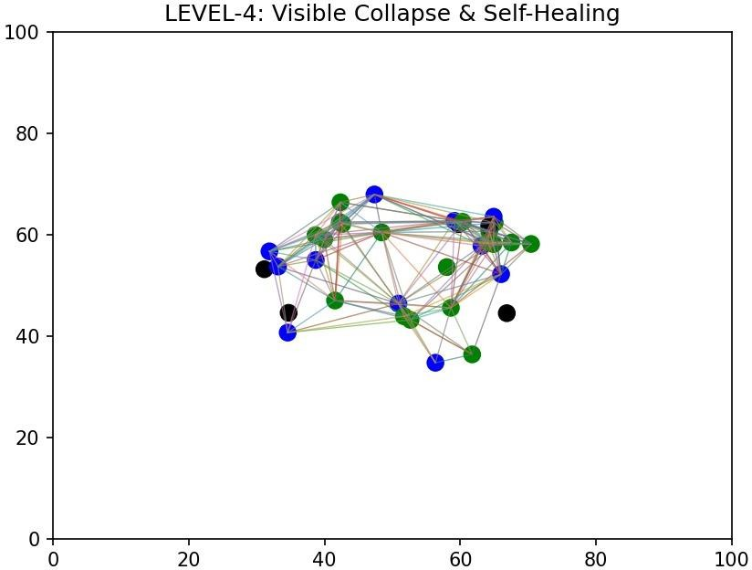

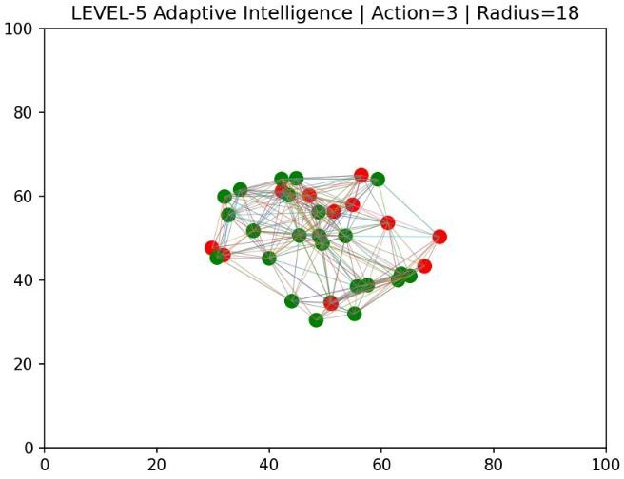
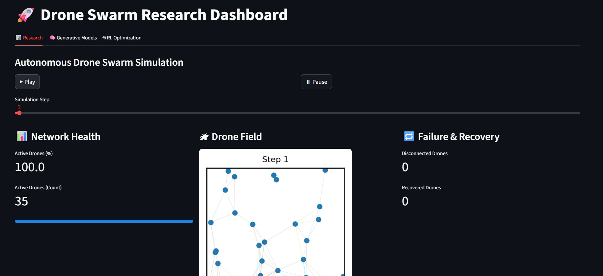

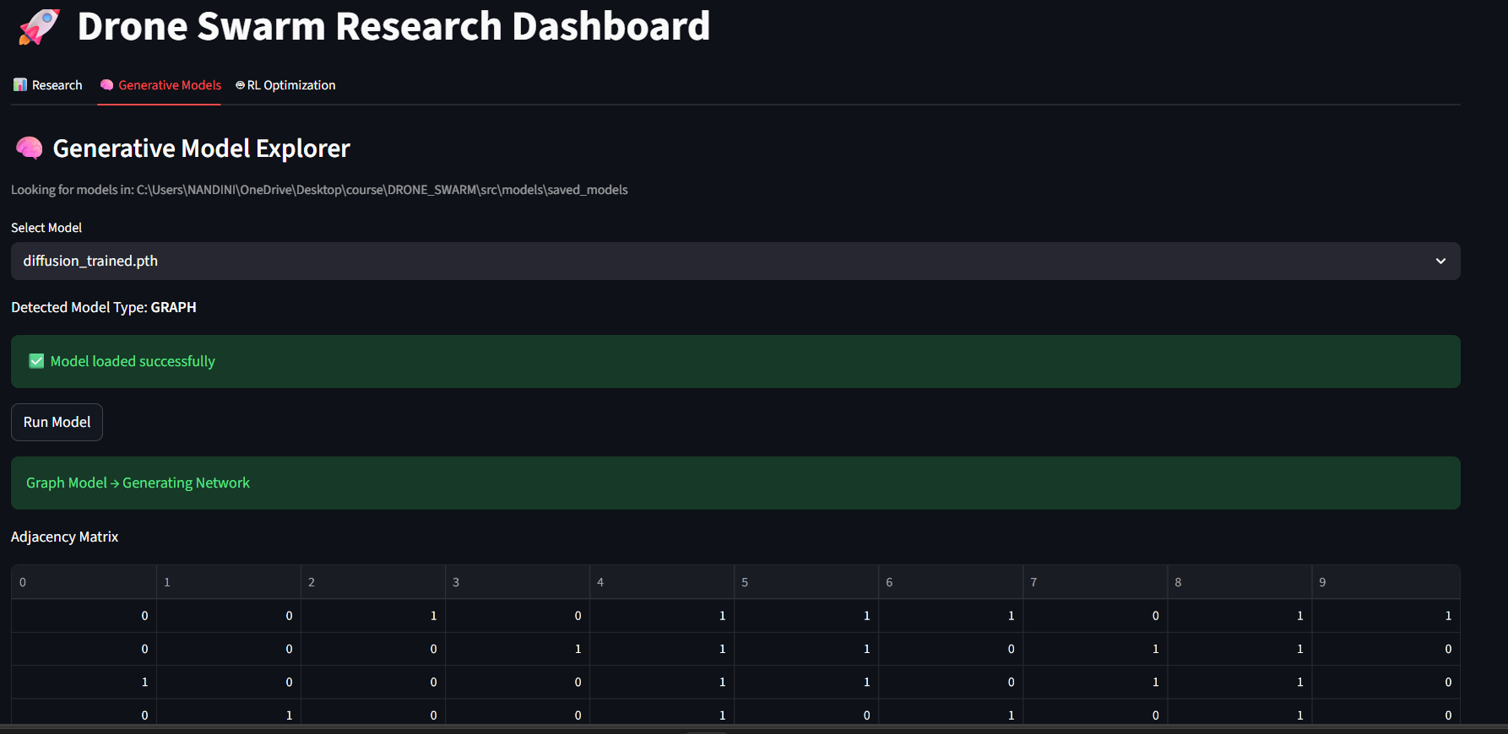
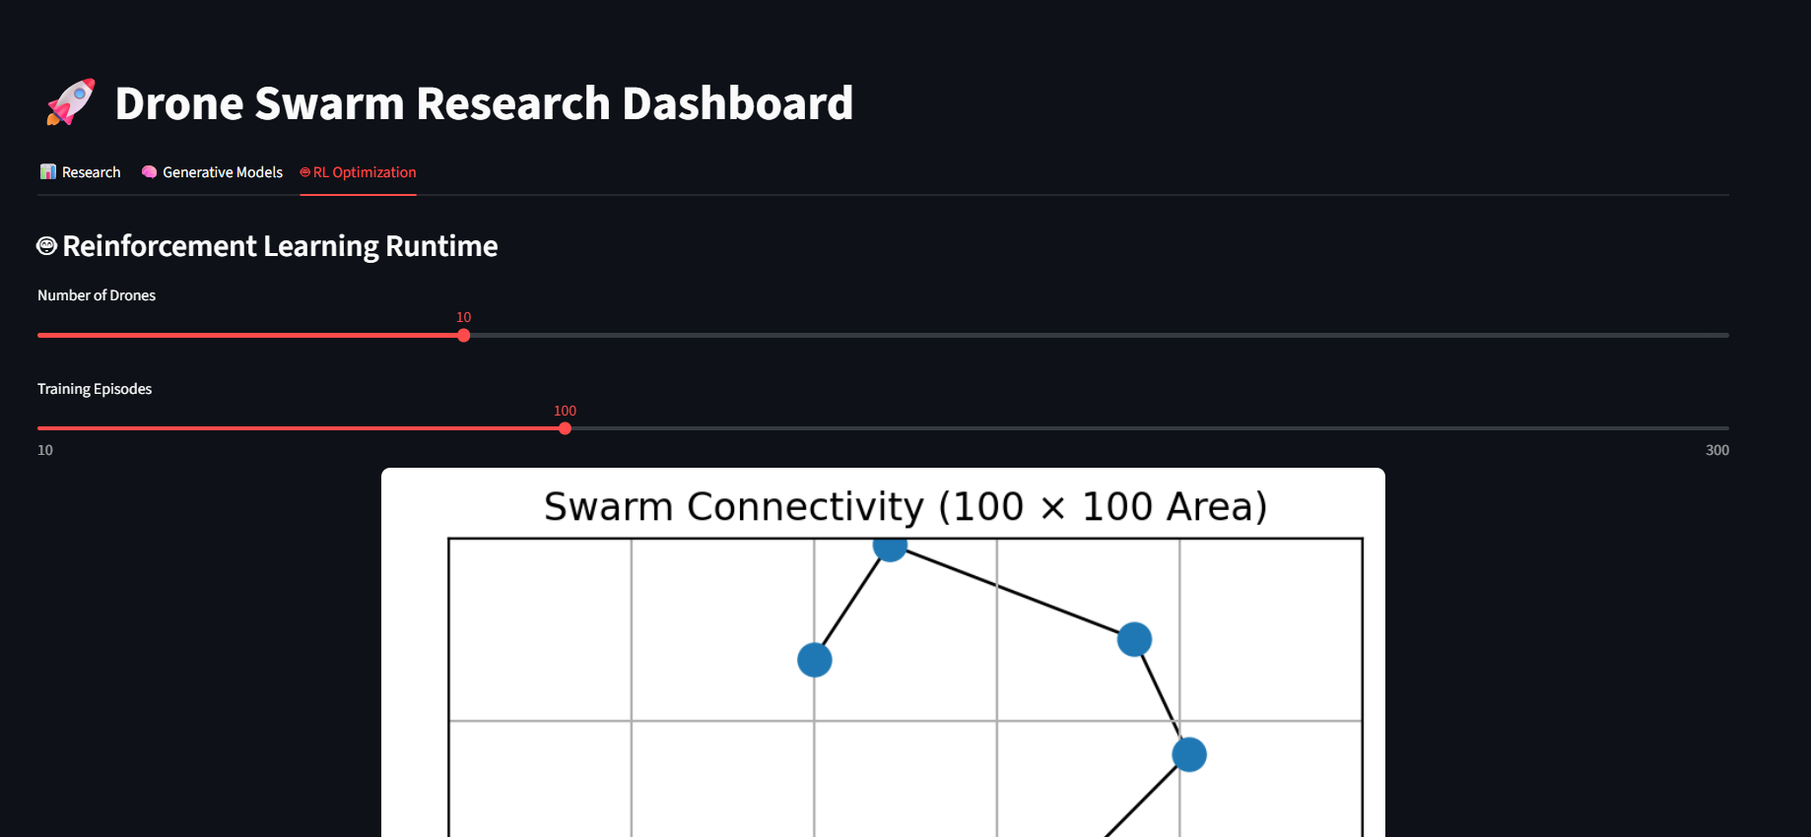

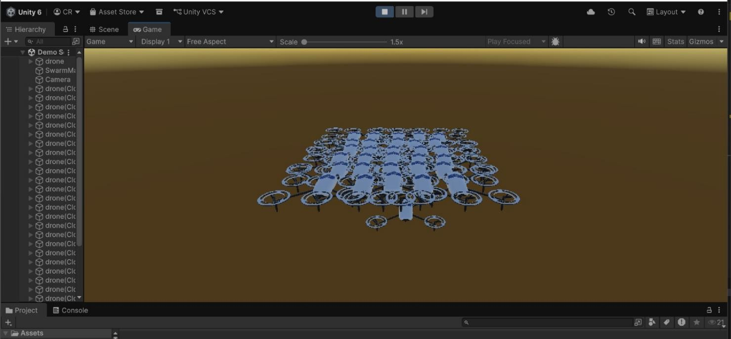
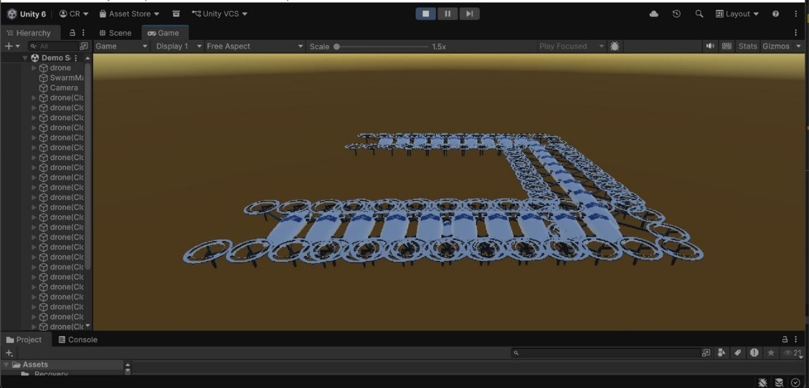
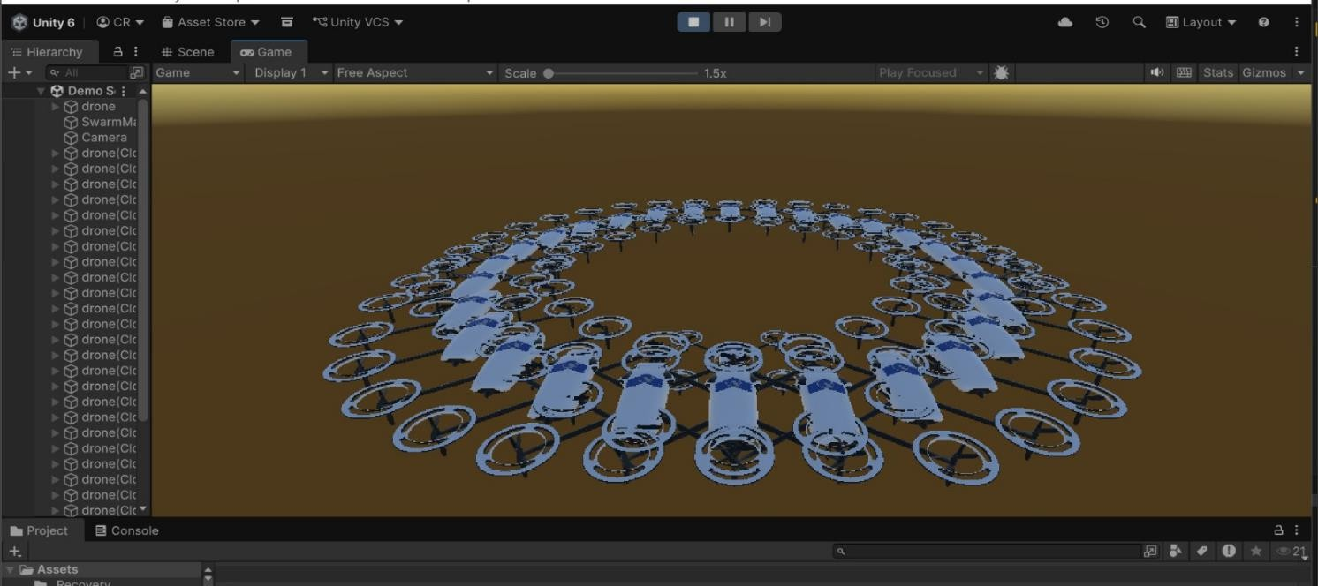

Screen shots of deployment tools of
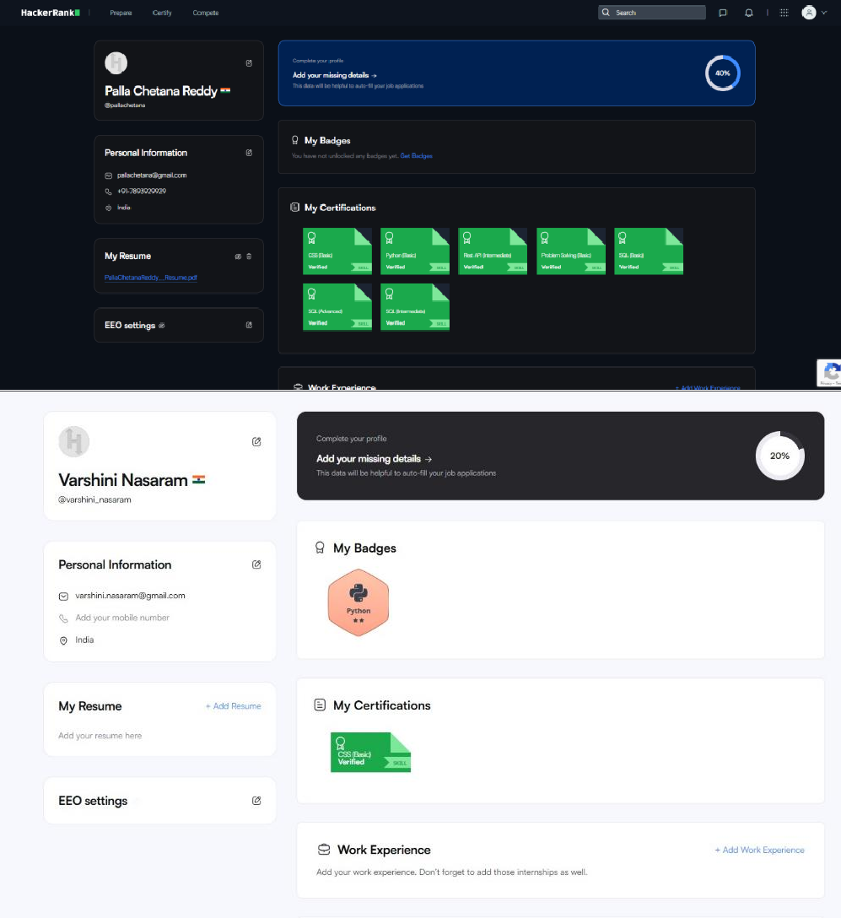
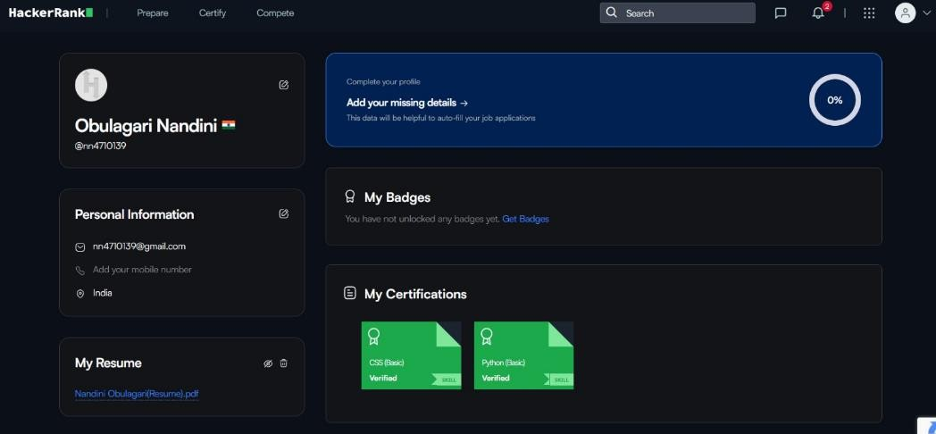
- Hacker-rank


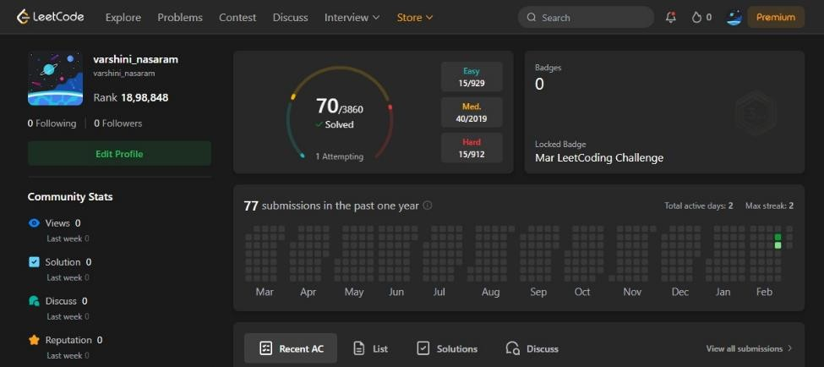
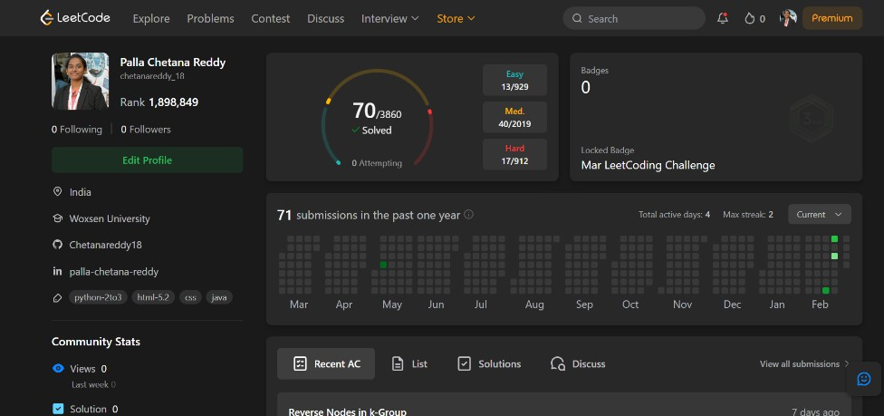
- Leet codes

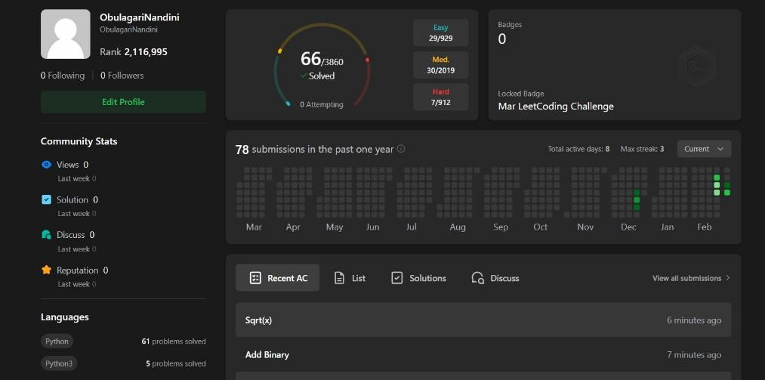

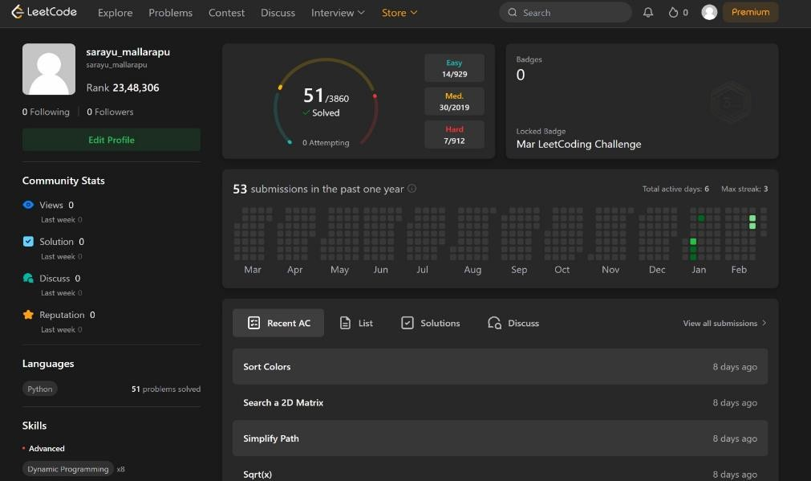
- GitHub


