KAIROS: A Proactive Causal Business Intelligence Pipeline for Multi-Source Monitoring
Palla Chetana Reddy, Varshini Yadav Nasaram, and Obulagari Nandini
School of Technology, Woxsen University
Capstone Project-I, Bachelor of Technology in Computer Science and Engineering

Abstract
Business intelligence dashboards often require a person to notice a problem and ask for an explanation, while correlation-based summaries do not establish which metric moved first. KAIROS is a prototype for scheduled monitoring of multi-source business metrics. Protocol adapters ingest database, file, SFTP/FTP, REST, and pushed data; aggregation may occur near the source, with parallel resumable transfer available for raw files. A seasonal median/MAD detector, optionally combined with Prophet, flags unusual values. DYNOTEARS estimates a lagged causal graph, and a fact-grounded reporter checks numerical and metric-name claims before alert delivery. On synthetic data with known structure, DYNOTEARS achieved F1 = 0.97 ± 0.02 across ten seeds and identified both injected incident origins in every run. In a localhost benchmark with a 50-Mbit/s per-connection cap, eight-stream transfer was 6.4 times faster than single-stream raw FTP; edge aggregation reduced a 105.6-MB export to 192.7 KB. These findings demonstrate feasibility under controlled conditions, not validated production accuracy.
Keywords: proactive business intelligence, anomaly detection, causal discovery, DYNOTEARS, root-cause analysis, data ingestion

Introduction
Business intelligence (BI) dashboards are useful when an analyst knows which question to ask, but a pull-based workflow can leave an operational change unnoticed between reviews. A second difficulty is explanation: a metric that moves with an incident is not necessarily its cause. Data is also distributed across databases, file drops, APIs, and spreadsheets, making repeated full-data transfers costly.
KAIROS is a prototype that links scheduled metric collection, anomaly detection, temporal causal discovery, and guarded reporting in one repeatable workflow. Its design contributions are (1) a fixed, scheduled monitoring pipeline that investigates only alert-worthy new anomalies; (2) a Causal Business Metric Graph (CBMG) learned with DYNOTEARS and used to rank candidate upstream origins; (3) schema-mapping assistance and protocol-level ingestion, including aggregation near the source; and (4) a report verifier that checks numeric and metric-name claims before delivery.
This paper evaluates technical behaviour on synthetic time series with known causal structure and a controlled, localhost transfer benchmark. It asks whether the pipeline recovers the planted graph and incident origins, and how its transfer methods compare under the benchmark's stated network cap. The results should be interpreted as prototype evidence: they do not establish performance on production data or causal validity in an unobserved business environment.
Related Work
Robust time-series monitoring commonly uses median-based location and scale estimates to reduce sensitivity to outliers (Rousseeuw & Croux, 1993; Leys et al., 2013). Prophet models trend and seasonality and supplies forecast intervals that can be used to identify unusual observations (Taylor & Letham, 2018). KAIROS uses a seasonal robust z-score and can combine it with Prophet; it does not implement the Anomaly Transformer.
Granger tests ask whether past values of one series improve prediction of another, but predictive precedence is not equivalent to intervention-level causality (Granger, 1969). NOTEARS expresses acyclicity as a smooth optimisation constraint (Zheng et al., 2018), and DYNOTEARS extends this approach to contemporaneous and lagged time-series relations (Pamfil et al., 2020). KAIROS uses DYNOTEARS as its primary discovery method, with alternative discovery procedures as fallbacks. DoWhy provides a separate framework for causal-effect estimation and refutation (Sharma & Kiciman, 2020); any effect estimate remains conditional on the learned graph and its assumptions.
LLM-based reporting can make analysis readable, but generated prose may include unsupported claims. The LLM-Modulo perspective places an external checker around a language-model proposal rather than treating the model as the final authority (Kambhampati et al., 2024). KAIROS applies a narrow deterministic check to numbers and metric identifiers and falls back to a template when a draft does not pass. Edge computing motivates aggregating data close to where it is generated, reducing the volume that needs to move (Shi et al., 2016).
System Design
A scheduler starts a LangGraph state machine at a configured interval. The pipeline collects source data, maps it to timestamped metrics, stores it in DuckDB, detects anomalies, conditionally investigates, prepares a grounded report, and records or delivers an alert. Investigation and narrative generation are skipped when detection produces no new anomaly that passes recency, severity, and cooldown rules.
The ingestion layer uses adapters for SQL, local or cloud files, SFTP/FTP, REST, Google Sheets, and push submissions. A shared contract returns canonical metric rows and connector state. SQL aggregation can execute in the source query; DuckDB can aggregate file data; and an edge client can aggregate locally before pushing KPI records. When a raw file must be transferred, Fast Transfer divides it into chunks, compresses them, uploads them in parallel, resumes missing chunks, and verifies checksums.
For each metric series, the detector compares values with a rolling or seasonal median and scales residuals by the median absolute deviation. Prophet is an optional second detector; both scores are interpreted on a common robust-sigma scale. Before graph discovery, the investigator aligns, winsorises, and standardises the selected metric window. DYNOTEARS estimates contemporaneous and lagged edges; bootstrap refits provide a coarse stability measure. Candidate root-cause chains are ranked using edge strength, stability, and the temporal order of observed anomalies. These are candidate explanations, not proof of causation.
The reporter supplies computed facts to an optional language model. A deterministic critic checks reported numbers and metric identifiers; a rejected draft is retried once and then replaced with a template. The checked scope does not cover every qualitative statement, recommendation, or causal interpretation.
Figure 1
KAIROS system architecture
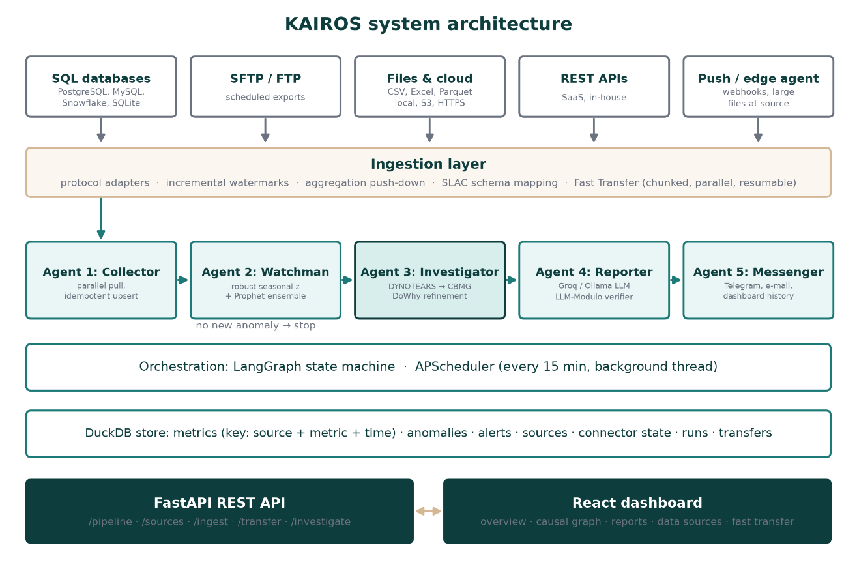
Evaluation
The causal benchmark contains 15 metrics from four simulated sources, 336 hourly observations, 12 planted lagged edges, two injected incidents, and six point anomalies. Discovery was evaluated over ten random seeds using precision, recall, F1, and structural Hamming distance (SHD). The benchmark also tests whether the pipeline identifies the planted incident origins.
DYNOTEARS achieved precision 1.00 ± 0.00, recall 0.95 ± 0.04, F1 0.97 ± 0.02, and SHD 0.6 ± 0.5. Granger regression achieved F1 0.90 ± 0.08, VARLiNGAM 0.87 ± 0.08, and Pearson correlation 0.50 ± 0.03. Both injected origins were identified in every run; the complete investigation took 1.58 ± 0.57 seconds on the reported machine. These results are from synthetic data whose linear lagged structure is intentionally compatible with the primary model.
For anomaly detection, the robust-z and Prophet ensemble reached 100% event recall and 75.2% point precision over five seeds; robust seasonal z-score alone reached 100% event recall and 77.2% point precision over ten seeds. For the report critic, all five faithful examples and all 200 one-decimal rounding examples were accepted, 98.5% of 200 corrupted-number examples were rejected, and all 50 invented metric-name examples were rejected. The sample sizes and narrow test cases limit these estimates.
The transfer benchmark used a 2,000,000-row, 105.6 MB CSV and capped each connection at 50 Mbit/s on localhost. Eight-stream Fast Transfer with zstd took 2.63 seconds and was reported as 6.4× faster than single-stream raw FTP. Edge aggregation sent 192.7 KB of KPI data in 1.34 seconds, corresponding to 12.6× the reported FTP throughput comparison. The capped localhost link is an emulation, not a wide-area network measurement.
Figure 2
Causal discovery benchmark results
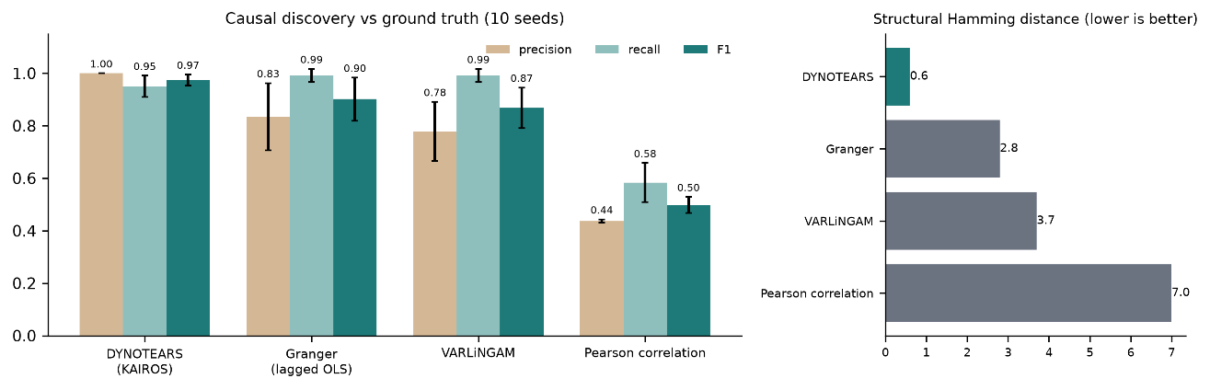
Discussion
The prototype demonstrates that collection, detection, candidate causal analysis, and reporting can be composed as a scheduled service while avoiding repeated transmission of raw records in suitable workflows. On the chosen synthetic benchmark, DYNOTEARS returned fewer false edges than the tested predictive and correlation baselines, while correlation remained a useful simple reference. Transfer results show the practical effect of parallelism, compression, resumption, and local aggregation in this specific setup.
Several validity limits matter. Synthetic data uses a known, linear lagged graph and does not represent hidden confounding, nonlinear effects, changing business mechanisms, or measurement error. DYNOTEARS depends on assumptions including causal sufficiency and approximate linearity; the ranking heuristic and thresholds were selected manually. Anomaly precision is below 80% at the chosen settings. The LLM critic tests only selected surface claims. Transfer speed is hardware- and workload-dependent, and no real-company user study or real-WAN experiment has been conducted.
Accordingly, the system should be treated as a decision-support prototype. A production trial should run in shadow mode, record analyst feedback, measure false-alert burden, and compare discoveries with domain-reviewed incidents before any automated action is taken.
Conclusion and Future Work
KAIROS combines proactive monitoring, robust anomaly scoring, temporal graph discovery, guarded narrative reporting, and low-volume ingestion in one open-source prototype. In repeated synthetic trials, the primary discovery method achieved F1 0.97 ± 0.02 and identified both planted origins in every run. A capped localhost benchmark showed faster parallel transfer and substantial byte reduction when aggregation was possible. These measurements establish feasibility under controlled conditions, not general effectiveness.
Next steps are evaluation on partner or carefully constructed semi-synthetic business data, expert review of candidate causes, nonlinear and latent-confounder-aware discovery, broader verification of qualitative claims, real-WAN benchmarking, and a user study. Thresholds and cooldowns should be calibrated against the operational cost of missed and unnecessary alerts.
References
Granger, C. W. J. (1969). Investigating causal relations by econometric models and cross-spectral methods. Econometrica, 37(3), 424–438.
Kambhampati, S., Valmeekam, K., Guan, L., Verma, M., Stechly, K., Bhambri, S., Saldyt, L., & Murthy, A. (2024). Position: LLMs can’t plan, but can help planning in LLM-Modulo frameworks. Proceedings of the 41st International Conference on Machine Learning.
Leys, C., Ley, C., Klein, O., Bernard, P., & Licata, L. (2013). Detecting outliers: Do not use standard deviation around the mean, use absolute deviation around the median. Journal of Experimental Social Psychology, 49(4), 764–766.
Pamfil, R., Sriwattanaworachai, N., Desai, S., Pilgerstorfer, P., Beaumont, P., Georgatzis, K., & Aragam, B. (2020). DYNOTEARS: Structure learning from time-series data. Proceedings of the 23rd International Conference on Artificial Intelligence and Statistics, 1595–1605.
Rousseeuw, P. J., & Croux, C. (1993). Alternatives to the median absolute deviation. Journal of the American Statistical Association, 88(424), 1273–1283.
Sharma, A., & Kiciman, E. (2020). DoWhy: An end-to-end library for causal inference. arXiv:2011.04216.
Shi, W., Cao, J., Zhang, Q., Li, Y., & Xu, L. (2016). Edge computing: Vision and challenges. IEEE Internet of Things Journal, 3(5), 637–646.
Taylor, S. J., & Letham, B. (2018). Forecasting at scale. The American Statistician, 72(1), 37–45.
Zheng, X., Aragam, B., Ravikumar, P., & Xing, E. P. (2018). DAGs with NO TEARS: Continuous optimization for structure learning. Advances in Neural Information Processing Systems.

