KAIROS: Proactive Causal Root-Cause Analysis of Business Metrics with DYNOTEARS and Verified LLM Reporting
Palla Chetana Reddy  School of Technology  Woxsen University  Hyderabad, India | Varshini Yadav Nasaram  School of Technology  Woxsen University  Hyderabad, India | Obulagari Nandini  School of Technology  Woxsen University  Hyderabad, India | Dr. K RajKumar  Associate Professor, HOD  Department of CSE and BIC  Woxsen University  Hyderabad, India

Abstract—Business intelligence dashboards wait for a person to ask a question, and the explanations they give for a sudden change are correlations. This paper presents KAIROS, an autonomous multi-agent system that monitors business metrics without being asked, finds the causal origin of each anomaly and reports it in plain language whose numbers have been checked. Anomalies are scored with a seasonal robust z-score; DYNOTEARS learns a lagged causal graph of the metrics, which is walked backwards from each anomaly and ranked by strength, bootstrap stability and timing; an LLM-Modulo verifier rejects any report whose numbers or metric names do not match the computed facts; and a low-cost ingestion layer with a chunked, parallel Fast Transfer service feeds the system from SQL, SFTP/FTP, files, REST APIs and edge agents. On a benchmark of 15 metrics with 12 known causal edges over ten seeds, DYNOTEARS reached an F1 score of 0.974, which is 8.1% higher than Granger regression, 12.2% higher than VARLiNGAM and 95.6% higher than correlation, with 79–91% fewer structural errors. KAIROS named both true incident origins in 100% of runs, against 70% for a top-movers dashboard heuristic and 60%, 40% and 30% when the same ranking used Granger, VARLiNGAM or correlation graphs. The verifier caught 98.5% of corrupted numbers, against 59.5% for a tolerance rule, while accepting every faithful report, and Fast Transfer moved a 106 MB export 6.1 times faster than FTP.
Index Terms—Business Intelligence, Anomaly Detection, Causal Discovery, DYNOTEARS, Root Cause Analysis, Large Language Models, LLM Verification, Multi-Agent Systems, Data Ingestion.
I. Introduction
Business intelligence (BI) platforms such as Power BI and Tableau are the standard way for managers to follow revenue, orders, churn and operational metrics, and two decades of research link their use to better decisions [1]. They are, however, reactive: a problem is found only when someone opens the right dashboard and notices it. Augmented analytics adds automatic insights [2], but these rank fields by statistical association, which cannot tell a cause from its effect or from a shared driver [3]. An analyst who sees revenue fall must still trace by hand whether the cause was fewer visitors, a broken checkout or a paused campaign, and by the time the cause is found the loss has already grown.
Three research threads make an autonomous alternative possible. Robust and forecasting-based detectors monitor seasonal series reliably [4], [5], [6]. Continuous-optimisation structure learning, NOTEARS [7] and its time-series form DYNOTEARS [8], recovers directed and lagged dependencies from observational data and has since been applied to real time series [9]. Large language models (LLMs) [10] turn findings into readable text but also produce fluent statements that are not supported by their input [11], [12]. No existing system joins the three for business metrics: BI tools stop at association, root-cause tools from IT operations target server telemetry [13], and LLM-based analysts are not checked against the data.
This paper combines these threads into KAIROS and makes four contributions:
- a five-agent pipeline that runs on a schedule, stores every anomaly and alerts only on first sightings, so monitoring needs no human trigger;
- a root-cause procedure on top of a DYNOTEARS graph of business metrics that ranks causal chains by edge strength, bootstrap stability and anomaly timing, and names the origin of an incident;
- a deterministic verifier, following the LLM-Modulo principle of sound external critics [14], that checks every number at the precision written and every metric name before a report is delivered;
- a low-cost ingestion layer of five protocol adapters and a resumable, parallel Fast Transfer service, delivered with a working web dashboard.
Against six baselines on a benchmark with known ground truth, KAIROS gives the most accurate causal graph, the only perfect origin localisation and a verifier that misses 96% fewer corrupted numbers than a tolerance rule. Section II reviews related work, Section III compares KAIROS with existing systems, Sections IV and V describe the system and its methods, Sections VI and VII report the evaluation, and Sections VIII to X discuss the results, future scope and conclusions.
II. Related Work
Anomaly detection. Recent surveys group time-series detectors into statistical, forecasting-based and learned families [6], [15]. Prophet [4] models trend and seasonality and flags points outside its forecast band, and robust statistics such as the median absolute deviation give scale estimates that the outliers themselves do not inflate [5]. Deep detectors, reviewed by Pang et al. [16] and Zamanzadeh Darban et al. [17], perform well on public benchmarks but need training for each dataset and give no causal explanation.
Causal discovery. Reviews by Glymour et al. [18], Vowels et al. [19], Zanga et al. [20] and Nogueira et al. [21] cover constraint-based, score-based, functional and continuous-optimisation methods. For time series, Granger causality [22] tests whether past values of one series improve the prediction of another, VARLiNGAM [23] identifies a structural vector autoregression, PCMCI [24] uses conditional-independence tests with lagged conditioning sets [25] and TCDF [26] uses attention in convolutional networks. DYNOTEARS [8] learns same-step and lagged weights jointly under a smooth acyclicity constraint; its behaviour on real data has been studied in recent journal work [9], [27]. Surveys of temporal causal discovery [28], [29], [30], [31] compare these families, causal-learn [32] implements many of them, and DoWhy-GCM [33] estimates effects once a graph is known.
Root-cause analysis. HotSpot [34] localises a change in an additive KPI to the dimension values, such as a region or a browser, that explain it; it answers where a total changed, not which other metric caused it. In IT operations, the survey by Soldani and Brogi [13] reviews dozens of methods. CauseInfer [35] builds a hierarchical causality graph of cloud services, CausalRCA [36] learns weighted causal graphs from microservice metrics, Żurkowski and Zieliński [37] localise faults in cloud-native applications and DGERCL [38] uses dynamic graph embeddings. All of them target infrastructure telemetry and engineers rather than business KPIs and managers.
LLMs for analysis and their verification. LLMs are now used as software and data assistants [39], for example to translate business questions into SQL [40], [41], and Kıcıman et al. [42] study their causal reasoning. Because LLMs hallucinate [11], [12], detection methods such as semantic entropy [43] and fact-checking pipelines [44] have been proposed. These estimate the reliability of an answer statistically, whereas Kambhampati [14] argues that LLM output should be checked by sound external critics, the principle that KAIROS applies to numbers.
Agents and data movement. Surveys of LLM-based agents [45], [46] describe how planning, memory and tools are combined into multi-step agents, which KAIROS runs as a state machine. For data movement, edge computing moves computation next to the data [47], and parallel streams with tuned concurrency are the established way to accelerate large transfers over wide-area links [48].
III. Comparison with Existing Work
Table I compares KAIROS with representative tools and research systems on six properties that a business user needs. A tick means that the property is a design goal of the published system, a half circle means partial support and a dash means not applicable.
TABLE I
Comparison of KAIROS with existing BI tools and root-cause analysis systems
System | Domain | Runs unprompted | Directed causal graph | Lagged effects | Business KPIs | Plain-language report | Report checked against data
Power BI Key Influencers | BI tool | ◐ | ✗ | ✗ | ✓ | ◐ | —
Tableau Explain Data | BI tool | ✗ | ✗ | ✗ | ✓ | ◐ | —
HotSpot [34] | Additive KPIs | ✓ | ✗ | ✗ | ✓ | ✗ | —
CauseInfer [35] | Cloud services | ✓ | ✓ | ✗ | ✗ | ✗ | —
CausalRCA [36] | Microservices | ✓ | ✓ | ✗ | ✗ | ✗ | —
PCMCI [24] | Earth science | ✗ | ✓ | ✓ | ✗ | ✗ | —
LLM text-to-SQL [40], [41] | Databases | ✗ | ✗ | ✗ | ✓ | ✓ | ◐
KAIROS (this work) | Business KPIs | ✓ | ✓ | ✓ | ✓ | ✓ | ✓

Three gaps stand out. First, BI tools explain by association and wait for the user, so a manager learns of a problem late and receives a list of correlated fields. Second, KPI localisers find the slice of the data in which a total changed, and AIOps systems find the faulty service, but neither connects business metrics such as advertising spend, conversion, delivery delay and churn into one directed, lagged graph. Third, LLM data assistants answer a question that the user must first think to ask, and their explanations are not checked against the data. KAIROS is the only system in Table I with all six properties, and it is built only from free, open components. Section VII measures the gain: against the graph learners used by prior causal methods, KAIROS raises exact origin localisation from 40–60% to 100%.
IV. System Architecture
A. Agent Pipeline
Fig. 1 shows the architecture. Data from every source is normalised to rows of (source, metric, timestamp, value) and upserted into an embedded DuckDB store on that key, so repeated loads never duplicate data. A LangGraph state machine runs five agents every 15 minutes: collect, detect, investigate, report and alert [45]. The graph ends after detection when no new alert-worthy anomaly exists, which keeps quiet cycles cheap and prevents repeated alerts. A FastAPI service exposes the results, and alerts are sent through Telegram, e-mail or the dashboard.
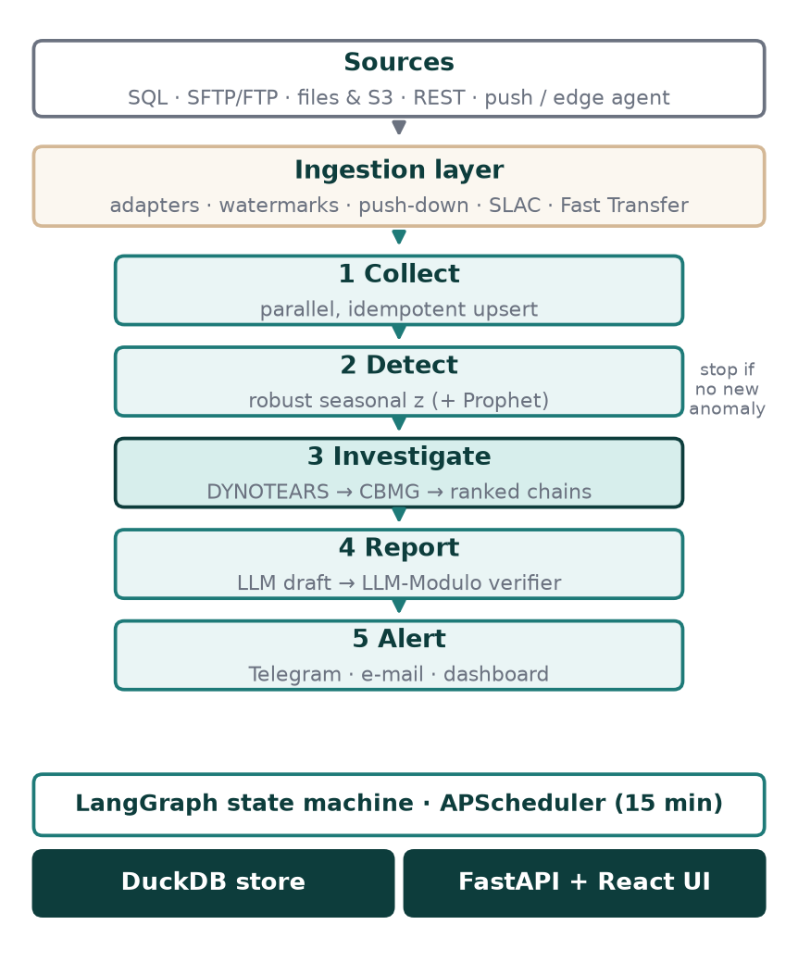
Fig. 1. KAIROS pipeline. The investigation stage (bold) is the focus of this paper.
B. Low-Cost Ingestion and Fast Transfer
Instead of one connector per product, KAIROS uses five protocol adapters that cover almost every company system. The SQL adapter pushes the aggregation query into the source database, so a large table returns a few kilobytes of KPIs. The SFTP/FTP adapter fetches only files that are new since the last sync. The file adapter reads CSV, Excel and Parquet from disk or cloud storage, the REST adapter handles authentication, paging and incremental queries, and push clients or an edge agent [47] post KPIs that are aggregated next to the data. Column names are mapped to metrics by rule-based schema matching.
When a raw file must move, the Fast Transfer service splits it into chunks of 1 to 32 MB, compresses each chunk with gzip or Zstandard, hashes it with SHA-256 and uploads the chunks over parallel HTTPS connections with retries [48]. The server checks every chunk, writes it at its offset and, after a dropped connection, asks only for the missing chunks. This gives the speed of commercial transfer accelerators at no cost and without per-row connector fees. Fig. 2 shows both parts running in the dashboard.
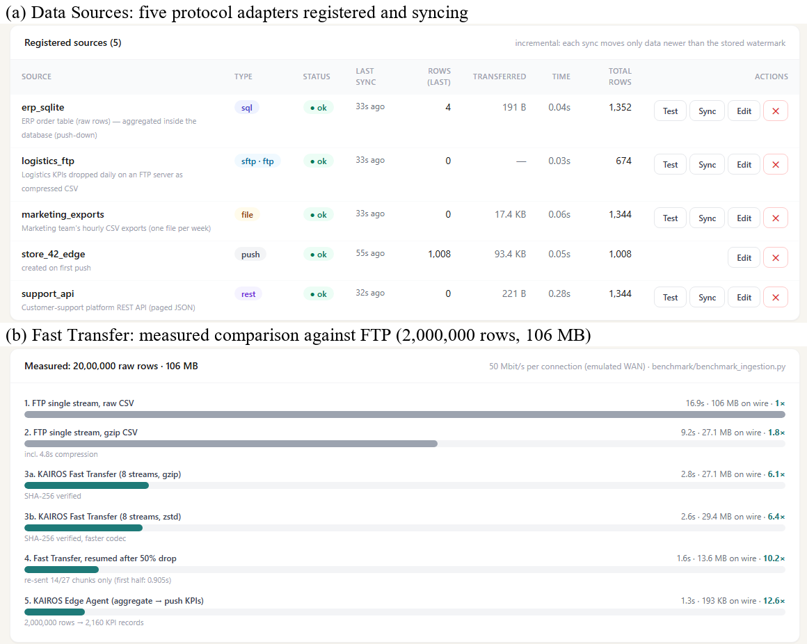
Fig. 2. Ingestion in the dashboard: (a) five sources registered through the SQL, SFTP/FTP, file, push and REST adapters, synced incrementally; (b) measured transfer of the same export by FTP, Fast Transfer and the edge agent.
C. Dashboard
The React dashboard has five pages. The Overview (Fig. 3) shows the monitored metrics, the anomalies by severity, a detail chart and recent pipeline runs. Causal Analysis draws the learned graph and the ranked chains (Fig. 4). Reports & Alerts shows the verified executive report (Fig. 5), and Data Sources and Fast Transfer manage ingestion (Fig. 2). All figures are screenshots of the running system on simulated company data.
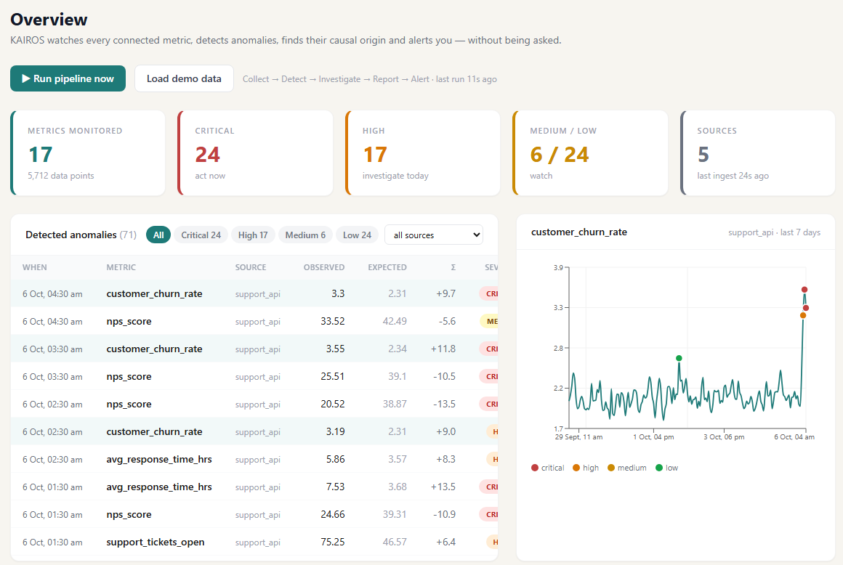
Fig. 3. KAIROS Overview dashboard: 17 metrics from 5 sources are monitored without a user query; anomalies are listed by severity with observed value, expected value and robust z-score, and the selected metric is plotted with its anomalies.
V. Method
A. Seasonal Robust Detection
For a metric series $x_{t}$, the expected value $m_{t}$ is a centred rolling median plus an hour-of-day profile of the residuals, kept only when it reduces their spread. The residual $r_{t} = x_{t} - m_{t}$ is scaled by the median absolute deviation (MAD) [5], which the outliers themselves do not inflate, giving the robust score
$z_{t} = \frac{x_{t} - m_{t}}{1.4826 · MAD(r)}$ (1)
A point is anomalous when $|z_{t}| ≥ 3.5$; severity is medium from 4.5, high from 6 and critical from 9. Prophet [4] can be added as a second detector. Anomalies are stored with their key, so a point is reported as new only once.
B. Causal Discovery with DYNOTEARS
The metrics are aligned to a common grid, winsorised at 3.5 robust standard deviations so that the anomalies do not shape the learned structure, and standardised. DYNOTEARS [8] models them as a structural vector autoregression
$X_{t} = X_{t}W + X_{t-1}A + E$ (2)
where $X_{t}$ is the $n × d$ matrix of the $d$ metrics, $W$ ($d × d$) holds same-step edges, $A$ holds one-step lagged edges and $E$ is noise. With the squared loss
$l(W,A) = \frac{1}{2n}‖X_{t} - X_{t}W - X_{t-1}A‖_{F}^{2}$ (3)
the weights solve the sparse problem
$\min_{W,A}{l(W,A) + λ_{W}‖W‖_{1} + λ_{A}‖A‖_{1}}$ (4)
subject to the smooth acyclicity constraint of NOTEARS [7]
$h(W) = \operatorname{tr}{(e^{W∘W})} - d = 0$ (5)
where ∘ is the element-wise product. The problem is solved by an augmented Lagrangian with L-BFGS-B on the positive and negative parts of the weights, implemented directly in NumPy [49] and SciPy [50]. Edges with $|w| ≥ τ = 0.15$ form the Causal Business Metric Graph (CBMG), with $λ_{W} = λ_{A} = 0.05$. Each edge receives a confidence equal to the fraction of block-bootstrap refits, on 75% windows, that keep it.
C. Root-Cause Ranking
For every anomalous metric $e$, each ancestor $c$ in the CBMG is a candidate cause. The strongest path from $c$ to $e$ is found, and its strength $S$ is the product of the edge weights along it. A candidate is temporally supported if $c$ itself was anomalous at most one path lag plus two steps before an anomaly of $e$. The chain score is
$R(c,e) = S^{1/k} · κ · α · β · (1 + 0.05k)$ (6)
where $k$ is the path length, $κ$ is the mean edge confidence, $α = 1.5$ if the cause is temporally supported and 1 otherwise, and $β = 2$ if the cause is an origin, that is, a supported cause with no anomalous, supported ancestor of its own, and 1 otherwise. The geometric mean $S^{1/k}$ prevents long chains, which explain more of a cascade, from being penalised merely for their length. DoWhy [33] estimates a back-door adjusted effect for each direct edge.
D. LLM-Modulo Report Verification
The LLM receives only computed facts: values, expectations, percentage changes, severities and the ranked chains. Its draft is checked by a deterministic critic [14]. Every number in the text must equal a fact once the fact is rounded to the number of decimals written, so 3.97 may be written 3.97, 4.0 or 4, but never 3.78. Every snake_case identifier must be a known metric. A failing draft is returned once with the list of errors, and a second failure falls back to a template that is correct by construction.
VI. Experimental Setup
Real business data with labelled root causes is not publicly available, so a benchmark with known structure was generated. It has 15 hourly metrics from four simulated sources over 336 hours, linked by 12 lagged causal edges in two chains. The marketing chain runs from advertising spend through click-through and conversion to orders and revenue; the operations chain runs from delivery delay through support tickets and response time to NPS and churn. Daily seasonality is added. Two incidents are injected in the last 24 hours, a three-hour collapse in advertising spend and a spike in delivery delay, plus six isolated anomalies of graded size. Every experiment is repeated over ten seeds.
Causal discovery is scored against the 12 true edges with precision, recall, F1 and structural Hamming distance (SHD). The baselines are lagged OLS (Granger) [22], VARLiNGAM [23] from causal-learn [32], and Pearson correlation with |r| ≥ 0.3. Origin localisation compares KAIROS with six strategies that receive the same detector output: the two metrics with the largest |z| (the top movers a dashboard shows), the two earliest anomalies, the KAIROS ranking applied to Granger, VARLiNGAM and correlation graphs, and KAIROS without bootstrap confidence. Detection is scored by event recall and point precision. The ingestion benchmark moves a raw export of 2,000,000 order rows (105.6 MB) over a 50 Mbit/s link per connection, emulated on one machine, with Fast Transfer using 8 streams and 4 MB chunks. All runs used a laptop, and every script is released with the system.
VII. Results
A. Causal Discovery
TABLE II
Causal discovery over ten seeds (mean ± s.d.)
Method | Precision | Recall | F1 | SHD | F1 gain of KAIROS
KAIROS (DYNOTEARS) | 1.000 ± 0.000 | 0.950 ± 0.041 | 0.974 ± 0.021 | 0.6 | —
Granger [22] | 0.835 ± 0.128 | 0.992 ± 0.025 | 0.901 ± 0.082 | 2.8 | +8.1%
VARLiNGAM [23] | 0.778 ± 0.113 | 0.992 ± 0.025 | 0.868 ± 0.077 | 3.7 | +12.2%
Correlation | 0.437 ± 0.007 | 0.583 ± 0.075 | 0.498 ± 0.031 | 7.0 | +95.6%

Table II shows that DYNOTEARS added no false edge in any of the ten runs, a precision of 1.000 against 0.835 for Granger and 0.778 for VARLiNGAM. Its F1 score is 8.1%, 12.2% and 95.6% higher than the three baselines, and its structural Hamming distance of 0.6 is 78.6%, 83.8% and 91.4% lower. Its occasional miss was the weakest true link, from average order value to revenue. Granger regression and VARLiNGAM found nearly every true edge but also linked metrics that share a driver, and correlation, which has no direction, was worst. The acyclicity constraint and the joint fit of same-step and lagged weights are what remove these spurious edges.
B. Origin Localisation
TABLE III
Incident origin localisation over ten seeds
Strategy | Exact origins | Origin F1 | Top-5 chain precision
Largest deviation (top movers) | 70% | 85.0% | —
Earliest anomaly | 0% | 35.0% | —
Correlation graph + ranking | 30% | 73.7% | 30.0%
Granger graph + ranking | 60% | 86.7% | 98.0%
VARLiNGAM graph + ranking | 40% | 80.0% | 98.0%
KAIROS without bootstrap | 100% | 100% | 100%
KAIROS (full) | 100% | 100% | 100%

Table III reports how often each strategy named exactly the two injected origins. KAIROS did so in all ten runs, 30 percentage points more than the best non-causal heuristic and 40 to 70 points more than the same ranking on the baseline graphs. The top-movers heuristic failed in three runs because a downstream metric, support tickets, deviated more than its cause. The earliest-anomaly rule never succeeded, because an unrelated isolated anomaly occurred before both incidents. On the Granger and VARLiNGAM graphs, spurious edges gave a true origin an apparent anomalous parent, so it was demoted and origin recall fell to 80% and 70%. The correlation graph, having no direction, produced correct top-five chains only 30% of the time, against 100% for KAIROS. A full investigation took 0.95 s on average. Fig. 4 shows the result in the dashboard: both origins are starred and the chain from delivery delay to churn is ranked first.
C. Detection and Sensitivity
TABLE IV
Sensitivity (mean of ten seeds)
Setting | Values | Result
τ (λ = 0.05) | 0.10 / 0.15 / 0.20 / 0.30 | F1 0.93 / 0.97 / 0.94 / 0.90
λ (τ = 0.15) | 0.01 / 0.05 / 0.10 | F1 0.85 / 0.97 / 0.94
z threshold | 3.0 / 3.5 / 4.0 / 5.0 | Prec. 0.54 / 0.77 / 0.93 / 1.00
z threshold | 3.0 / 3.5 / 4.0 / 5.0 | Recall 1.00 / 1.00 / 0.99 / 0.99

The robust detector found every injected event (event recall 100%) with point precision of 77.2 ± 6.2%, in 0.23 s per cycle. Adding Prophet gave 75.2% precision at 14.3 times the cost, so the robust detector is both 2.0 points more precise and an order of magnitude faster, and Prophet is kept optional. Table IV shows that the chosen settings sit in a stable region: F1 stays above 0.89 for τ between 0.10 and 0.30, and raising z to 4.0 lifts precision by 15.7 points to 92.9% while event recall stays at 99.4%.
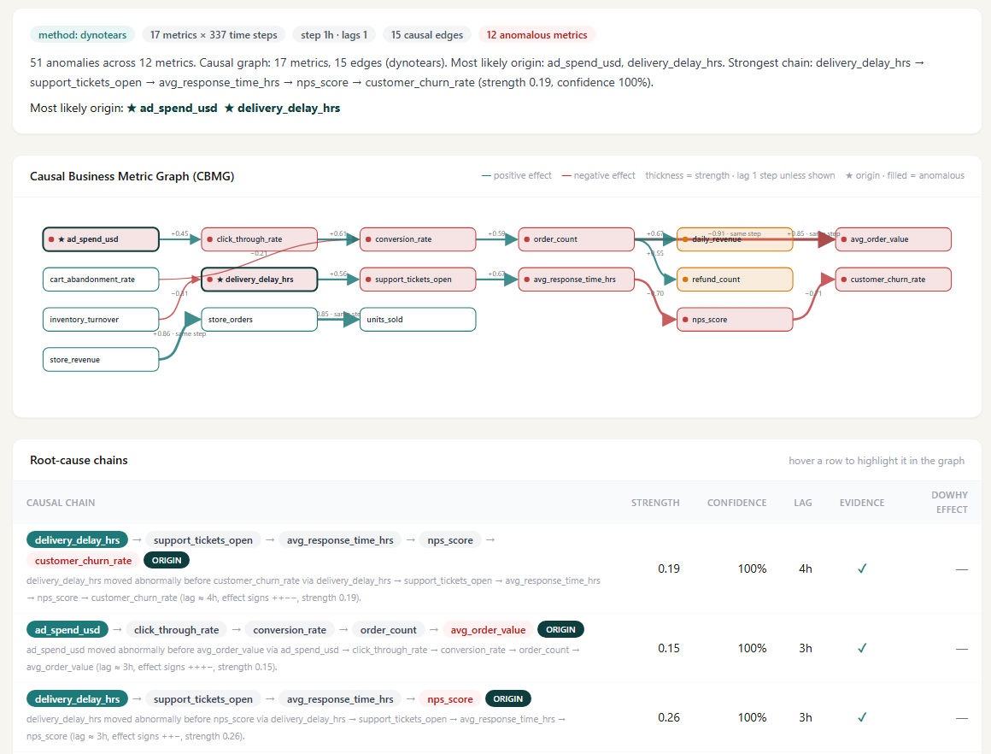
Fig. 4. Causal Analysis page: the learned Causal Business Metric Graph (red nodes are anomalous, starred nodes are the origins found) and the ranked root-cause chains with strength, bootstrap confidence, lag and temporal evidence.
D. Verifier
TABLE V
LLM-Modulo verifier stress test
Test | Cases | Tolerance rule | KAIROS
Corrupted numbers caught | 200 | 59.5% | 98.5%
Invented metric names caught | 50 | — | 100%
Faithful rounding accepted | 200 | 100% | 100%
Faithful reports accepted | 5 | 100% | 100%

Correct reports were corrupted by scaling and shifting one number, by renaming a metric, or by rounding a number to one decimal, which is faithful. A tolerance rule that accepts any value within 2% of a fact or with the same integer part caught only 59.5% of corrupted numbers, for instance accepting 7.03 for 6.71. Comparing at the written precision raised this to 98.5% (Table V), 39 points higher, so 96.3% fewer corrupted numbers reach a reader, without rejecting a single faithful rounding. In a live run on simulated company data, an LLM served through the Groq API produced a report that passed on the first attempt (Fig. 5).
E. Ingestion and Large-File Transfer
TABLE VI
Moving a 2,000,000-row (105.6 MB) export
Method | Time (s) | On wire | Speed-up
FTP, raw CSV | 16.90 | 105.6 MB | 1.0×
FTP, gzip CSV | 9.18 | 27.1 MB | 1.8×
KAIROS Fast Transfer (gzip) | 2.76 | 27.1 MB | 6.1×
KAIROS Fast Transfer (zstd) | 2.63 | 29.4 MB | 6.4×
Fast Transfer, resumed after a 50% drop | 1.65 | 13.6 MB | 10.2×
KAIROS edge agent (KPIs only) | 1.34 | 192.7 KB | 12.6×

Table VI and Fig. 2(b) show that Fast Transfer cut the transfer time by 83.7% compared with plain FTP and was 3.3 times faster than FTP with compression, while sending 74.3% fewer bytes and verifying every chunk with SHA-256. After a connection was dropped halfway, only the 14 missing chunks out of 27 were sent again. When only KPIs are needed, the edge agent reduced 2,000,000 rows to 2,160 KPI records and the bytes on the wire by 99.8%.
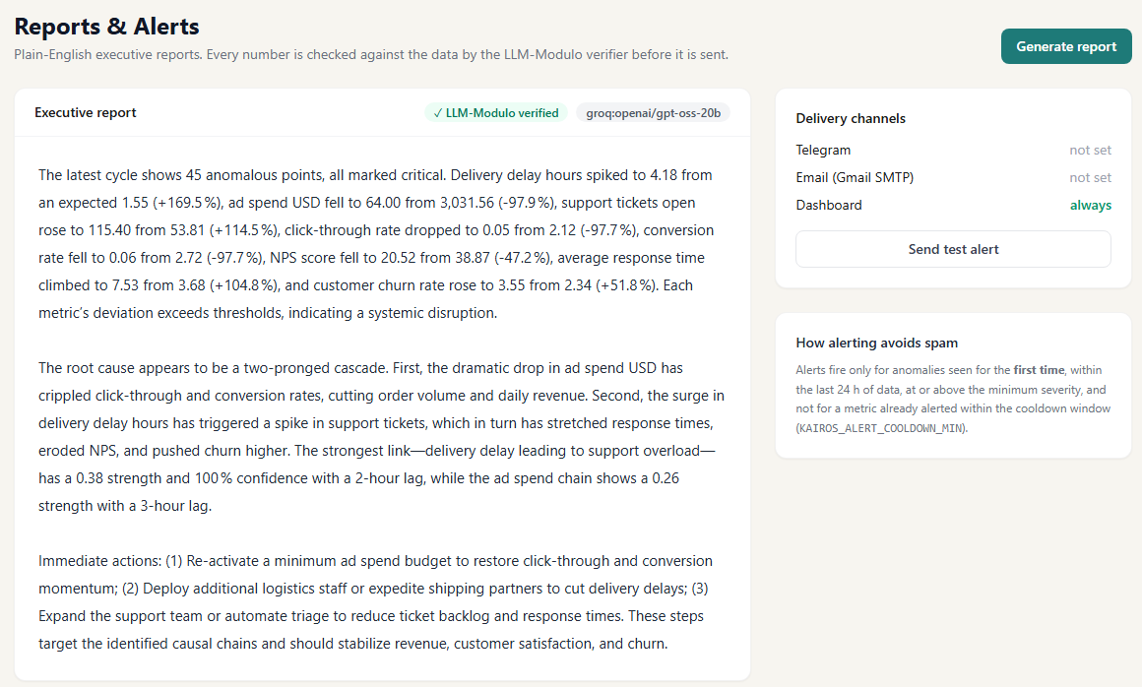
Fig. 5. Reports & Alerts page: an executive report written by an LLM and marked as verified by the LLM-Modulo critic, with delivery channels and the de-duplicated alert history.
VIII. Discussion
The results show that a causal graph turns a list of correlated anomalies into a short, ordered explanation that matches the analyst's question: what moved first? The quality of the graph decides the quality of the answer. With the same ranking, the precise DYNOTEARS graph gave 100% exact origins, while graphs with spurious edges gave 40–60%, and simple heuristics were misled by large downstream effects or unrelated early anomalies. These are the situations that a manager meets every day, which is why a correlation-based dashboard often points to the symptom rather than the cause.
The verifier makes the plain-language report safe to send: the LLM supplies the wording, but every number and metric name is checked against computed facts, so a manager never acts on an invented figure. The ingestion layer keeps the cost close to zero, since one adapter per protocol replaces paid per-product connectors and Fast Transfer replaces slow FTP uploads. The complete cycle, from new data to a verified alert, finishes in a few seconds on a laptop, against hours of manual dashboard tracing.
IX. Future Scope
KAIROS can be extended in several directions:
- Nonlinear and confounder-aware discovery with PCMCI [24], TCDF [26] and FCI-style search, so that the graph also captures threshold and saturation effects;
- Pilot deployments with partner companies and public e-commerce data, with a study of how much faster managers act on KAIROS alerts;
- Claim-level verification that checks qualitative statements, such as severity words and causal claims, building on recent fact-checking research [44], [43];
- Drill-down by dimension, combining the causal graph with HotSpot-style localisation [34] to say both which metric and which region or product caused a change;
- What-if simulation with DoWhy [33] to estimate the effect of an action, such as restoring advertising spend, before it is taken;
- Streaming ingestion with change data capture and multi-tenant cloud deployment, and deep learned detectors [17] for high-dimensional metrics.
X. Conclusion
KAIROS shows that business monitoring can be proactive, causal and verifiable using free, open components. DYNOTEARS recovered the benchmark structure with an F1 score of 0.974, 8.1–95.6% higher than three baselines; the ranking named every incident origin in 100% of runs, against at most 70% for the alternatives; the LLM-Modulo verifier stopped 98.5% of numerical errors, against 59.5% for a tolerance rule; and Fast Transfer moved large exports 6.1 times faster than FTP. The working dashboard brings these results to managers without a single query.
Acknowledgment
The authors thank their faculty mentor, Dr. K RajKumar, School of Technology, Woxsen University, for the guidance and support given throughout this project.
References
[1] N. Ain, G. Vaia, W. H. DeLone, and M. Waheed, "Two decades of research on business intelligence system adoption, utilization and success – A systematic literature review," Decision Support Systems, vol. 125, Art. no. 113113, 2019, doi: 10.1016/j.dss.2019.113113.
[2] N. Prat, "Augmented analytics," Business & Information Systems Engineering, vol. 61, no. 3, pp. 375–380, 2019, doi: 10.1007/s12599-019-00589-0.
[3] B. Schölkopf et al., "Toward causal representation learning," Proceedings of the IEEE, vol. 109, no. 5, pp. 612–634, 2021, doi: 10.1109/JPROC.2021.3058954.
[4] S. J. Taylor and B. Letham, "Forecasting at scale," The American Statistician, vol. 72, no. 1, pp. 37–45, 2018, doi: 10.1080/00031305.2017.1380080.
[5] P. J. Rousseeuw and M. Hubert, "Anomaly detection by robust statistics," WIREs Data Mining and Knowledge Discovery, vol. 8, no. 2, Art. no. e1236, 2018, doi: 10.1002/widm.1236.
[6] A. Blázquez-García, A. Conde, U. Mori, and J. A. Lozano, "A review on outlier/anomaly detection in time series data," ACM Computing Surveys, vol. 54, no. 3, pp. 1–33, 2022, doi: 10.1145/3444690.
[7] X. Zheng, B. Aragam, P. Ravikumar, and E. P. Xing, "DAGs with NO TEARS: Continuous optimization for structure learning," arXiv:1803.01422, 2018.
[8] R. Pamfil, N. Sriwattanaworachai, S. Desai, P. Pilgerstorfer, P. Beaumont, K. Georgatzis, and B. Aragam, "DYNOTEARS: Structure learning from time-series data," arXiv:2002.00498, 2020.
[9] A. Thomas, M. Niranjan, and J. P. Legg, "Causal analysis of physiological sleep data using Granger causality and score-based structure learning," Sensors, vol. 23, no. 23, Art. no. 9455, 2023, doi: 10.3390/s23239455.
[10] Y. Chang et al., "A survey on evaluation of large language models," ACM Transactions on Intelligent Systems and Technology, vol. 15, no. 3, pp. 1–45, 2024, doi: 10.1145/3641289.
[11] Z. Ji et al., "Survey of hallucination in natural language generation," ACM Computing Surveys, vol. 55, no. 12, pp. 1–38, 2023, doi: 10.1145/3571730.
[12] L. Huang et al., "A survey on hallucination in large language models: Principles, taxonomy, challenges, and open questions," ACM Transactions on Information Systems, vol. 43, no. 2, pp. 1–55, 2025, doi: 10.1145/3703155.
[13] J. Soldani and A. Brogi, "Anomaly detection and failure root cause analysis in (micro)service-based cloud applications: A survey," ACM Computing Surveys, vol. 55, no. 3, pp. 1–39, 2023, doi: 10.1145/3501297.
[14] S. Kambhampati, "Can large language models reason and plan?," Annals of the New York Academy of Sciences, vol. 1534, no. 1, pp. 15–18, 2024, doi: 10.1111/nyas.15125.
[15] K. Choi, J. Yi, C. Park, and S. Yoon, "Deep learning for anomaly detection in time-series data: Review, analysis, and guidelines," IEEE Access, vol. 9, pp. 120043–120065, 2021, doi: 10.1109/ACCESS.2021.3107975.
[16] G. Pang, C. Shen, L. Cao, and A. van den Hengel, "Deep learning for anomaly detection: A review," ACM Computing Surveys, vol. 54, no. 2, pp. 1–38, 2022, doi: 10.1145/3439950.
[17] Z. Zamanzadeh Darban, G. I. Webb, S. Pan, C. Aggarwal, and M. Salehi, "Deep learning for time series anomaly detection: A survey," ACM Computing Surveys, vol. 57, no. 1, pp. 1–42, 2025, doi: 10.1145/3691338.
[18] C. Glymour, K. Zhang, and P. Spirtes, "Review of causal discovery methods based on graphical models," Frontiers in Genetics, vol. 10, Art. no. 524, 2019, doi: 10.3389/fgene.2019.00524.
[19] M. J. Vowels, N. C. Camgoz, and R. Bowden, "D'ya like DAGs? A survey on structure learning and causal discovery," ACM Computing Surveys, vol. 55, no. 4, pp. 1–36, 2023, doi: 10.1145/3527154.
[20] A. Zanga, E. Ozkirimli, and F. Stella, "A survey on causal discovery: Theory and practice," International Journal of Approximate Reasoning, vol. 151, pp. 101–129, 2022, doi: 10.1016/j.ijar.2022.09.004.
[21] A. R. Nogueira, A. Pugnana, S. Ruggieri, D. Pedreschi, and J. Gama, "Methods and tools for causal discovery and causal inference," WIREs Data Mining and Knowledge Discovery, vol. 12, no. 2, Art. no. e1449, 2022, doi: 10.1002/widm.1449.
[22] A. Shojaie and E. B. Fox, "Granger causality: A review and recent advances," Annual Review of Statistics and Its Application, vol. 9, no. 1, pp. 289–319, 2022, doi: 10.1146/annurev-statistics-040120-010930.
[23] A. Hyvärinen, K. Zhang, S. Shimizu, and P. O. Hoyer, "Estimation of a structural vector autoregression model using non-Gaussianity," Journal of Machine Learning Research, vol. 11, no. 56, pp. 1709–1731, 2010. [Online]. Available: https://jmlr.org/papers/v11/hyvarinen10a.html
[24] J. Runge, P. Nowack, M. Kretschmer, S. Flaxman, and D. Sejdinovic, "Detecting and quantifying causal associations in large nonlinear time series datasets," Science Advances, vol. 5, no. 11, Art. no. eaau4996, 2019, doi: 10.1126/sciadv.aau4996.
[25] J. Runge et al., "Inferring causation from time series in Earth system sciences," Nature Communications, vol. 10, no. 1, Art. no. 2553, 2019, doi: 10.1038/s41467-019-10105-3.
[26] M. Nauta, D. Bucur, and C. Seifert, "Causal discovery with attention-based convolutional neural networks," Machine Learning and Knowledge Extraction, vol. 1, no. 1, pp. 312–340, 2019, doi: 10.3390/make1010019.
[27] M. Kaiser and M. Sipos, "Unsuitability of NOTEARS for causal graph discovery when dealing with dimensional quantities," Neural Processing Letters, vol. 54, no. 3, pp. 1587–1595, 2022, doi: 10.1007/s11063-021-10694-5.
[28] C. K. Assaad, E. Devijver, and E. Gaussier, "Survey and evaluation of causal discovery methods for time series," Journal of Artificial Intelligence Research, vol. 73, pp. 767–819, 2022, doi: 10.1613/jair.1.13428.
[29] U. Hasan, E. Hossain, and M. O. Gani, "A survey on causal discovery methods for I.I.D. and time series data," Transactions on Machine Learning Research, 2023. [Online]. Available: https://openreview.net/forum?id=YdMrdhGx9y
[30] R. Moraffah et al., "Causal inference for time series analysis: Problems, methods and evaluation," Knowledge and Information Systems, vol. 63, no. 12, pp. 3041–3085, 2021, doi: 10.1007/s10115-021-01621-0.
[31] C. Gong, C. Zhang, D. Yao, J. Bi, W. Li, and Y. Xu, "Causal discovery from temporal data: An overview and new perspectives," ACM Computing Surveys, vol. 57, no. 4, pp. 1–38, 2025, doi: 10.1145/3705297.
[32] Y. Zheng et al., "Causal-learn: Causal discovery in Python," Journal of Machine Learning Research, vol. 25, no. 60, pp. 1–8, 2024. [Online]. Available: https://jmlr.org/papers/v25/23-0970.html
[33] P. Blöbaum, P. Götz, K. Budhathoki, A. A. Mastakouri, and D. Janzing, "DoWhy-GCM: An extension of DoWhy for causal inference in graphical causal models," Journal of Machine Learning Research, vol. 25, no. 147, pp. 1–7, 2024. [Online]. Available: https://jmlr.org/papers/v25/22-1258.html
[34] Y. Sun et al., "HotSpot: Anomaly localization for additive KPIs with multi-dimensional attributes," IEEE Access, vol. 6, pp. 10909–10923, 2018, doi: 10.1109/ACCESS.2018.2804764.
[35] P. Chen, Y. Qi, and D. Hou, "CauseInfer: Automated end-to-end performance diagnosis with hierarchical causality graph in cloud environment," IEEE Transactions on Services Computing, vol. 12, no. 2, pp. 214–230, 2019, doi: 10.1109/TSC.2016.2607739.
[36] R. Xin, P. Chen, and Z. Zhao, "CausalRCA: Causal inference based precise fine-grained root cause localization for microservice applications," Journal of Systems and Software, vol. 203, Art. no. 111724, 2023, doi: 10.1016/j.jss.2023.111724.
[37] B. Żurkowski and K. Zieliński, "Root cause analysis for cloud-native applications," IEEE Transactions on Cloud Computing, vol. 12, no. 1, pp. 232–250, 2024, doi: 10.1109/TCC.2024.3358823.
[38] H. Cheng, Q. Li, B. Liu, S. Liu, and L. Pan, "DGERCL: A dynamic graph embedding approach for root cause localization in microservice systems," IEEE Transactions on Services Computing, vol. 17, no. 6, pp. 3417–3428, 2024, doi: 10.1109/TSC.2024.3437742.
[39] X. Hou et al., "Large language models for software engineering: A systematic literature review," ACM Transactions on Software Engineering and Methodology, vol. 33, no. 8, pp. 1–79, 2024, doi: 10.1145/3695988.
[40] Z. Hong, Z. Yuan, Q. Zhang, H. Chen, J. Dong, F. Huang, and X. Huang, "Next-generation database interfaces: A survey of LLM-based text-to-SQL," IEEE Transactions on Knowledge and Data Engineering, vol. 37, no. 12, pp. 7328–7345, 2025, doi: 10.1109/TKDE.2025.3609486.
[41] X. Liu et al., "A survey of text-to-SQL in the era of LLMs: Where are we, and where are we going?," IEEE Transactions on Knowledge and Data Engineering, vol. 37, no. 10, pp. 5735–5754, 2025, doi: 10.1109/TKDE.2025.3592032.
[42] E. Kıcıman, R. Ness, A. Sharma, and C. Tan, "Causal reasoning and large language models: Opening a new frontier for causality," Transactions on Machine Learning Research, 2024. [Online]. Available: https://openreview.net/forum?id=mqoxLkX210
[43] S. Farquhar, J. Kossen, L. Kuhn, and Y. Gal, "Detecting hallucinations in large language models using semantic entropy," Nature, vol. 630, no. 8017, pp. 625–630, 2024, doi: 10.1038/s41586-024-07421-0.
[44] I. Augenstein et al., "Factuality challenges in the era of large language models and opportunities for fact-checking," Nature Machine Intelligence, vol. 6, no. 8, pp. 852–863, 2024, doi: 10.1038/s42256-024-00881-z.
[45] L. Wang et al., "A survey on large language model based autonomous agents," Frontiers of Computer Science, vol. 18, no. 6, Art. no. 186345, 2024, doi: 10.1007/s11704-024-40231-1.
[46] Z. Xi et al., "The rise and potential of large language model based agents: A survey," Science China Information Sciences, vol. 68, no. 2, Art. no. 121101, 2025, doi: 10.1007/s11432-024-4222-0.
[47] K. Cao, Y. Liu, G. Meng, and Q. Sun, "An overview on edge computing research," IEEE Access, vol. 8, pp. 85714–85728, 2020, doi: 10.1109/ACCESS.2020.2991734.
[48] M. S. Q. Z. Nine and T. Kosar, "A two-phase dynamic throughput optimization model for big data transfers," IEEE Transactions on Parallel and Distributed Systems, vol. 32, no. 2, pp. 269–280, 2021, doi: 10.1109/TPDS.2020.3012929.
[49] C. R. Harris et al., "Array programming with NumPy," Nature, vol. 585, no. 7825, pp. 357–362, 2020, doi: 10.1038/s41586-020-2649-2.
[50] P. Virtanen et al., "SciPy 1.0: Fundamental algorithms for scientific computing in Python," Nature Methods, vol. 17, no. 3, pp. 261–272, 2020, doi: 10.1038/s41592-019-0686-2.

