



Leave Management System

Document Version / Details: Ver. 1.0/

11/Feb/2021

**Technical Design Document**

**Record of Release**

|  |  |  |  |  |  |
| --- | --- | --- | --- | --- | --- |
| Version No. | Modified By | Reviewed By | Authorized By | Release Date | Modifications Done |
| 1 | Chetan N S | Hasan Ali Doulatganjwala, Anjum Fathima | Hasan Ali Doulatganjwala, Anjum Fathima | 15/02/2021 |  |

**Table of Contents**

1. Introduction 4

1.1 Document Reference 4

1.2 Document Approval 4

2. Technical Overview 5

2.1 Integration Solution Design 5

2.2 Assumptions 5

2.3 Dependencies & Constraints 5

2.4 Technologies 5

3. Integration Component Details 6

3.1 Register Component 6

3.1.1 Component details 6

3.1.2 Services and Components 7

3.2 Login Component 7

3.2.1 Component details 7

3.2.2 Services and Components 9

3.3 Apply Leave Component 9

3.3.1 Component details 9

3.3.2 Services and Components 10

3.4 Approve Leave Component 10

3.4.1 Component details 10

3.4.2 Services and Components 11

3.5 Leave Status Component 11

3.5.1 Component details 12

3.5.2 Services and Components 12

3.6 Log Out Component 12

3.6.1 Component details 13

3.6.2 Services and Components 13

3.7 Home Component 13

3.7.1 Component details 13

3.7.2 Services and Components 14

4. Error Handling Notification and Reporting 15

4.1 Technical & Business error 15

5. Application Flow Diagram 16

6. Glossary 17

# Introduction

1. The introduction of the **Requirements Specification** provides an overview of the entire document. It includes the purpose, scope, definitions, acronyms, abbreviations, references, and overview of the document.
2. The **Requirments Specification** captures the complete software requirements for the system, or a portion of the system. Following is a typical outline for a project **using use case modeling**. This artifact consists of a package containing use cases of the use case model and applicable Supplemental Specifications and other supporting information.
3. This subsection describes what the rest of the **Requirements Specification** contains and explains how the document is organized.

This document provides a detailed description about the components and a also the Technical details that is used to build these components. The application has five major components Register, Login, Apply Leave, Approve Leave, Leave Status. The application built using Asp.net MVC framework and Entity framework and database used is MS SQL.

## Document Reference

| Document Name | Comments |
| --- | --- |
|  |  |
| Use case Specification | This document contains the list of use cases that is used to develop the application |

## Document Approval

**Approvers Only – Sign-Off Required**

| Date of Approval | Version # | Document Approver | Role from Sign-off Matrix |
| --- | --- | --- | --- |
|  |  |  |  |
| 10-02-2021 | 1.0 | Anjum Fathima |  |

# Technical Overview

## Integration Solution Design

The application has five major components Register, Login, Apply Leave, Approve Leave and Leave Status. The application built using Asp.net MVC framework and Entity framework and database used is MS SQL. This is a database first application

## Assumptions

* One of the assumptions is that Employee data provided by the organization is complete and up-to-date as any lag in the data may cause problem for the user to register to the application.
* We assume that the user register before the user logins.

## Dependencies & Constraints

* One of the dependencies is the Employee data provided by the organization.

## Technologies

|  |  |  |  |  |
| --- | --- | --- | --- | --- |
| Sr. No. | Application Name | System/  Application Details | Version | Operating System |
| 1. | Microsoft SQL Server | Sql Server is used to create the components of the BackEnd Part of the application such as Database, Tables and Procedures. | V12.0.2000.8 | Windows Professional single language |
| 2 | C# Asp.Net MVC | ASP.NET MVC is an open-source software from Microsoft. Its web development framework combines the features of MVC (Model-View-Controller) architecture, the most up-to-date ideas and techniques from Agile development and the best parts of the existing ASP.NET platform. | V | Windows Home single language |

# Integration Component Details

## Register Component

This component is used to register a new user to the application. The user is asked to enter the information like Employee Id and the password for registration. Once the details are provided the Employee Id is used to check if the user is present in the Employee table only if the user is present than the user is allowed to register.

### Component details

|  |  |
| --- | --- |
| Component Name | Register |
| Service Implementation | Adding the new user to the database |
| Description | The register component take in the value enter by the user and validate the entered values. If value are valid it adds the user to the application |
| Input values | Employee Id(PS Number) and Password |
| Response Message | Registration was Successfully and Please Login with same credentials |
| Validations | Employee Id, Password |
| Type of component | Authentication |
| Error Message | ER1, ER2, ER5 |

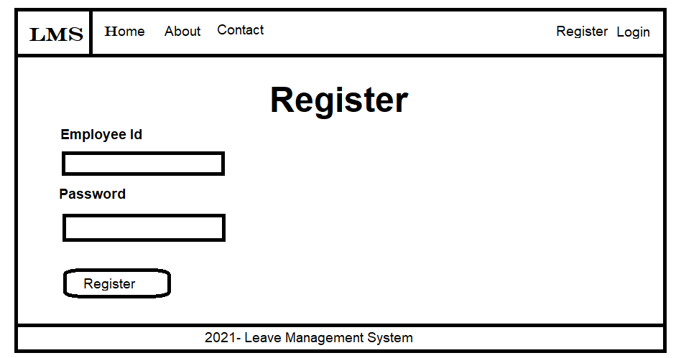

### Services and Components

|  |  |  |
| --- | --- | --- |
| Name | location | Description |
| Error.cshtml | Inside application views folder | When an unexpected error occurs displays a Message “An error occurred while processing your request.” |
| EmployeeCheck (Validation) | Inside application Models folder | Check if the user is present inside employee table based on the employee id provided by the user. |
| RegistrationCheck (Validation) | Inside application Models folder | Check if the user is already registered or not |

## Login Component

Once the user is registered then the user has to login to the application using login component. User is asked to enter employee id and password which can be used to authenticate the user. If the user is valid then the control is transferred to Home page else the error message is displayed.

### Component details

|  |  |
| --- | --- |
| Component Name | Login |
| Service Implementation | Authenticating the user |
| Description | User is asked to enter employee id and password which can be used to authenticate the user. If the user is valid then the control is transferred to Home page else the error message is displayed. |
| Input values | Employee Id(PS Number) and Password |
| Response Message | Login was Successfully. Welcome to Leave Management System |
| Validations | Employee Id, Password |
| Type of component | Authentication |
| Error Message | ER3, ER5 |

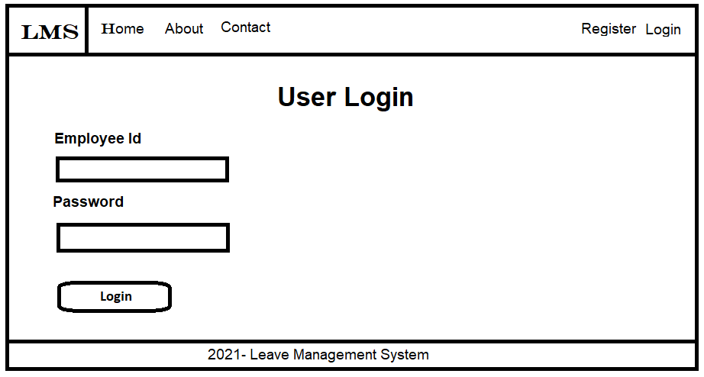

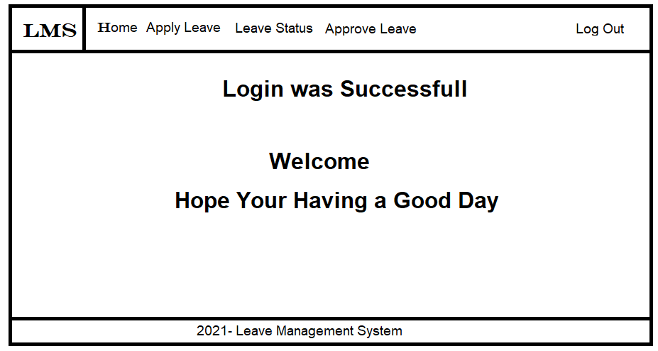

### Services and Components

|  |  |  |
| --- | --- | --- |
| Name | location | Description |
| Error.cshtml | Inside application views folder | When an unexpected error occurs displays a Message “An error occurred while processing your request.” |
| EmployeeCheck (Validation) | Inside application Models folder | Check if the user is present inside employee table based on the employee id provided by the user. |

## Apply Leave Component

When the user wants to apply leave user can make use of the Apply Leave component. This component can only be accessed once user is logged in to the application with the valid credentials

### Component details

|  |  |
| --- | --- |
| Component Name | Apply Leave |
| Service Implementation | Applying Leave for approval |
| Description | Application asks for the Leave details. Once received application will save the details along with Leave status shows the message as “Leave request has been Submitted” |
| Input values | FormDate, ToDate, Days, Reason |
| Response Message | “Leave Application is Successfully Submitted and waiting the manager approval” |
| Validation | FromDate, TillDate, Days, Reason |
| Type of component | Functional |
| Error Message | ER4, ER5 |

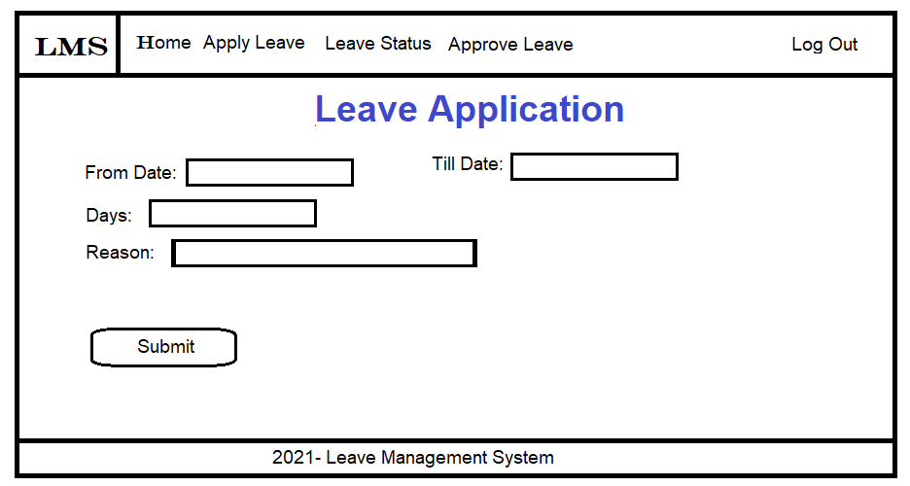

### Services and Components

|  |  |  |
| --- | --- | --- |
| Name | location | Description |
| Error.cshtml | Inside application views folder | When an unexpected error occurs displays a Message “An error occurred while processing your request.” |

## Approve Leave Component

When a manager login to the system He/she can approve or rejected the leave application applied by employee under he/she based on the leave dates

### Component details

|  |  |
| --- | --- |
| Component Name | Approve Leave |
| Service Implementation | Approve or Reject the applied Leave application |
| Description | Manager is the one who as the authority to approve or reject the leave application of the employee under him/she. |
| Input values | Approve Event or Reject Event |
| Response Message | “Leave application is Approved” or “Leave application is Rejected” |
| Type of component | Functional |
| Error Message | ER5 |

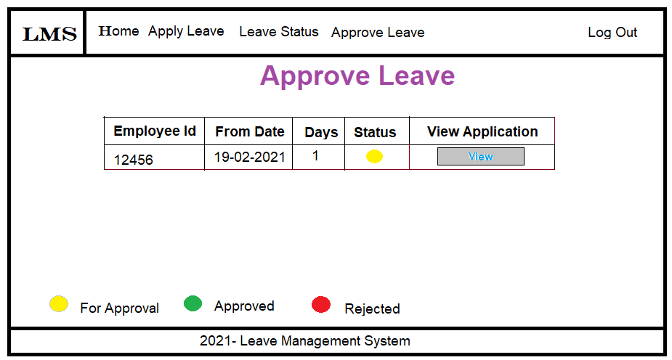

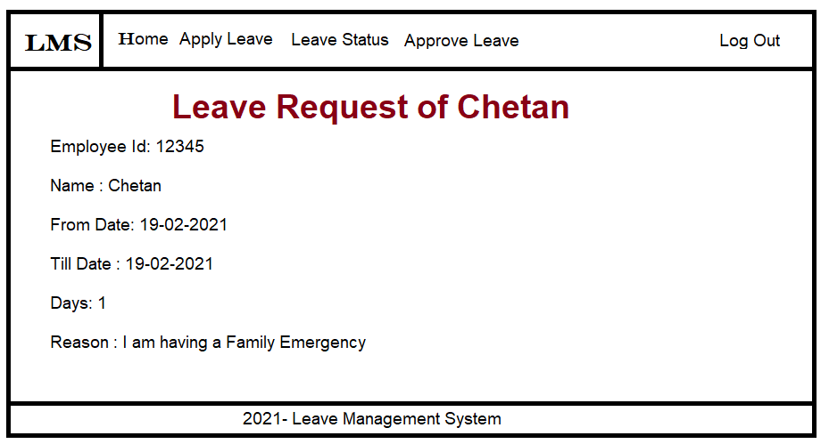

### Services and Components

|  |  |  |
| --- | --- | --- |
| Name | location | Description |
| Error.cshtml | Inside application views folder | When an unexpected error occurs displays a Message “An error occurred while processing your request.” |

## Leave Status Component

All users can view the status of their leave application. To view the leave status user has to login to the application and select the Leave Status component where user can view their status

### Component details

|  |  |
| --- | --- |
| Component Name | Leave status |
| Service Implementation | View the users Leave status |
| Description | Once the users select the Leave status component user can view the all the leave application user has requested |
| Input values | View status Event |
| Response | List of leave application |
| Type of component | Functional |
| Error Message | ER5 |

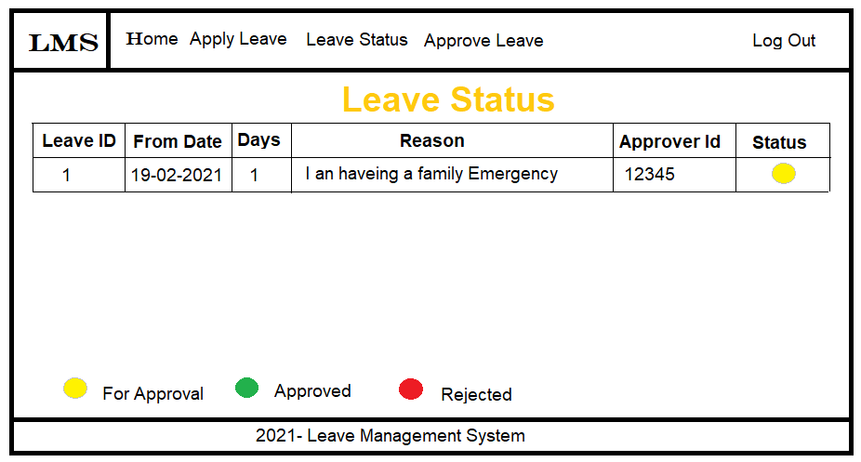

### Services and Components

|  |  |  |
| --- | --- | --- |
| Name | location | Description |
| Error.cshtml | Inside application views folder | When an unexpected error occurs displays a Message “An error occurred while processing your request.” |

## Log Out Component

All users can logout of the application. Users can only logout of the application if the user has previously logged in to the application. Logout button is provided at the top-right corner of the application

### Component details

|  |  |
| --- | --- |
| Component Name | Logout |
| Service Implementation | Logs out of the application |
| Description | Logged in user can logout of the application if user wants using the functional button provided in the application |
| Input values | Log Out Event |
| Response Message | “You have Successfully Logged out of the application” |
| Type of component | Authentication |
| Error Message | ER5 |

### Services and Components

|  |  |  |
| --- | --- | --- |
| Name | location | Description |
| Error.cshtml | Inside application views folder | When an unexpected error occurs displays a Message “An error occurred while processing your request.” |

## Home Component

This component can be viewed as an entry point to the application. It contains a welcome message and also option to Login or Register for the users

### Component details

|  |  |
| --- | --- |
| Component Name | Home |
| Service Implementation | Welcome Page |
| Description | Home page shows the welcome message and also the displays the buttons for login and Register |
| Input | When Home page is accessed |
| Response Message | Welcome message |
| Type of component | Functional |
| Error Message | ER5 |

### Services and Components

|  |  |  |
| --- | --- | --- |
| Name | location | Description |
| Error.cshtml | Inside application views folder | When an unexpected error occurs displays a Message “An error occurred while processing your request.” |

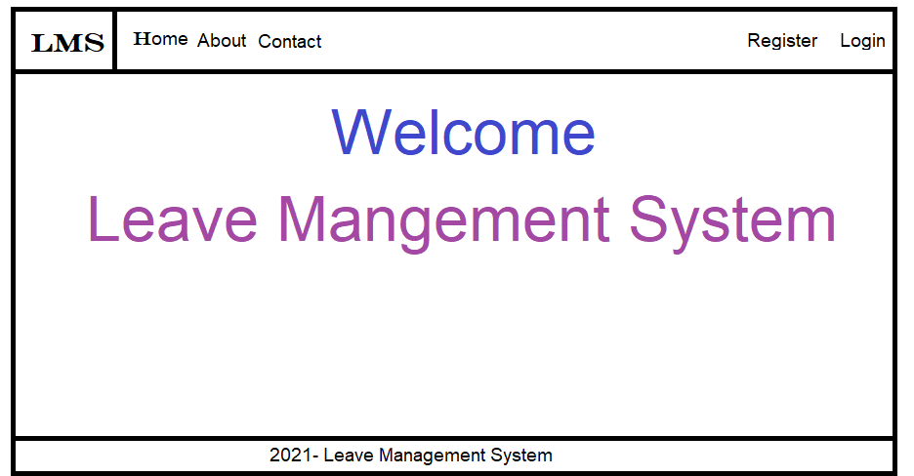

1. The intent of this section is to record the Testing requirements. Reference the Testing Requirements (TE.005).
2. The intent of this section is to include the Services Portfolio. Individual SOA Services may be referenced by the Use Cases. Reference the **Service Portfolio (**RA.025).

# Error Handling Notification and Reporting

## Technical & Business error

|  |  |  |
| --- | --- | --- |
| NO | Error | Message |
| ER1 | Invalid Employee No | Please Enter the correct Employee Id |
| ER2 | Employee already registered | Your already Registered Please login |
| ER3 | Invalid Employee No & password | Please Enter the correct Employee Id or Password |
| ER4 | Required fields not filled | Please enter the all the required Details |
| ER5 | Unexpected Error | Some problem occurred while processing your request |

# Application Flow Diagram

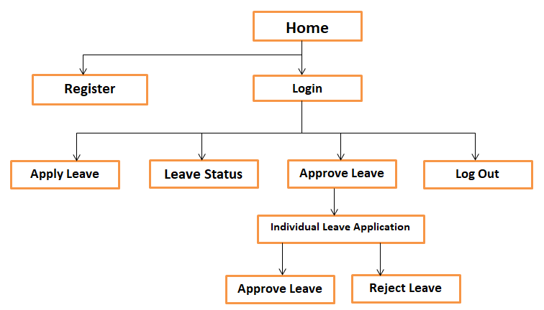

**Manager Application Flow Diagram**

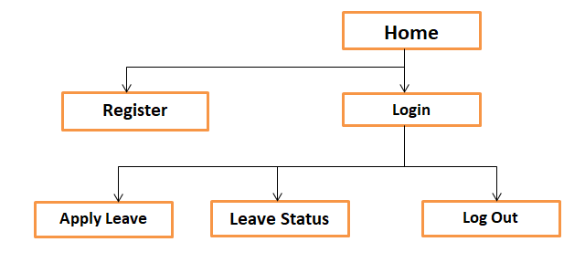

**Employee Application Flow Diagram**

# Glossary

|  |  |
| --- | --- |
| **Term** | **Definition** |
| XSD | XML Schema Definition |
| XML | Extensible Markup Language |
| XSL | Extensible Style sheet Language |
| WSDL | Web Service Definition Language |
| FMW | Fusion Middleware |
| BPEL | Business Process Execution Language |
| OSB | Oracle Service Bus |
| EBS | Oracle E-business Suite |