HousePrices

Chetan

23/02/2022

## Load Data

# reading csv file  
data <- read.csv('./Table2.1HousePrices-NoID.csv')

## Question 1:

Write a function that takes SqFt and Brick (Yes or No) as inputs and returns the average price of all the houses which are less than or equal to the square feet and match the Brick type provided as arguments in the function. For example, if the function has 2000 and “No” as inputs, it should return the average of non-brick houses which are less than or equal to 2000 square feet in size.

## Answer 1:

avg_fun <- function(sqft, brick){  
 total<-0  
 avg <- 0  
 count<-0  
 # iterating each rows  
 for(i in 1:length(data$Price)){   
 # applying condition if match then  
 if(data$SqFt[i] <= sqft && data$Brick[i] == brick){   
 # price will added to total  
 total<- total + data$Price[i]   
 # counting number of entries  
 count<- count + 1   
 }  
 }  
 # calculating average  
 avg <- total / count   
 avg <- round(avg, 2)  
 # now printing  
 print(paste("Average price is: ",avg))   
}  
  
# calling function  
avg_fun(2000,"No")

## [1] "Average price is: 111730.43"

## Question 2:

Write another function which also takes “Neighborhood” as an input in addition to SqFt and Brick as in (1).

## Answer 2:

avg_fun_hood <- function(sqft, brick, neighborhood){  
 total<-0  
 avg <- 0  
 count<-0  
 # iterating each rows  
 for(i in 1:length(data$Price)){   
 # applying condition if match then  
 if(data$SqFt[i] <= sqft && data$Brick[i] == brick && data$Neighborhood == neighborhood){   
 # price will added to total  
 total<- total + data$Price[i]   
 # counting number of entries  
 count<- count + 1   
 }  
 }  
 # calculating average  
 avg <- total / count   
 avg <- round(avg, 2)  
 # printing  
 print(paste("Average price is: ",avg))   
}  
  
# calling function  
avg_fun_hood(2200,"No", "East")

## [1] "Average price is: 118420.27"

Question 3: Create a histogram of Price by changing the default values of several arguments of hist function. Your output should have proper title, axes labels and reasonable number of bins.

## Answer 3:

# ploting histogram  
hist(data$Price, xlab="Price" , main="Histogram for Price", breaks = 5)

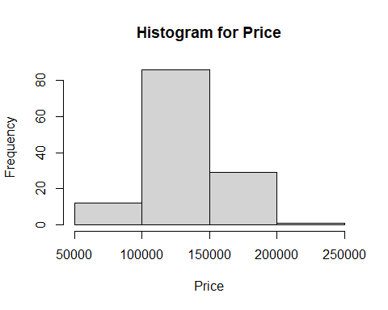

## Answer 4:

avg_price_bedroom_using_for <- function(bedroom){  
 total<-0  
 avg <- 0  
 count<-0  
 # iterating each rows  
 for(i in 1:length(data$Price)){   
 # applying condition if match then  
 if(data$Bedrooms[i] == bedroom){   
 # price will added to total  
 total<- total + data$Price[i]   
 # counting number of entries  
 count<- count + 1   
 }  
 }  
 # calculating average  
 avg <- total / count   
 # now printing  
 print(paste("Average price is: ",avg))   
}  
  
# calling function  
avg_price_bedroom_using_for(2)

## [1] "Average price is: 115260"

## Answer 5:

avg_price_bedroom_using_while <- function(bedroom){  
 total<-0  
 avg <- 0  
 count<-0  
 # iterating each rows  
 i <- length(data$Price)  
 class(i)  
 # Using while loop to check the condition   
 while(i >= 1){   
 # using if to check number of bedrooms  
 if(data$Bedrooms[i] == bedroom){   
 # price will added to total  
 total<- total + data$Price[i]   
 # counting number of entries  
 count<- count + 1   
 }  
   
 i = i - 1  
 }  
 # calculating average  
 avg <- total / count   
 # printing result  
 print(paste("Average price is: ",avg))   
}  
  
# calling function  
avg_price_bedroom_using_while(2)

## [1] "Average price is: 115260"