**Texas A&M University**

**ECEN 602 600: COMPUTER COMM & NET**

**Machine Problem-1**

**By: Chetan Sai Borra (UIN: 436000947)**

**Ganesh Vairavan Arumugam (UIN: 136004789)**

**Test Cases Report:**

1. **line of text terminated by a newline:**

We use “\n” to mark the end of a line and begin the next message on a new line.

**At server side:**

**At Client side:**

1. **line of text the maximum line length without a newline**

**At Server Side**

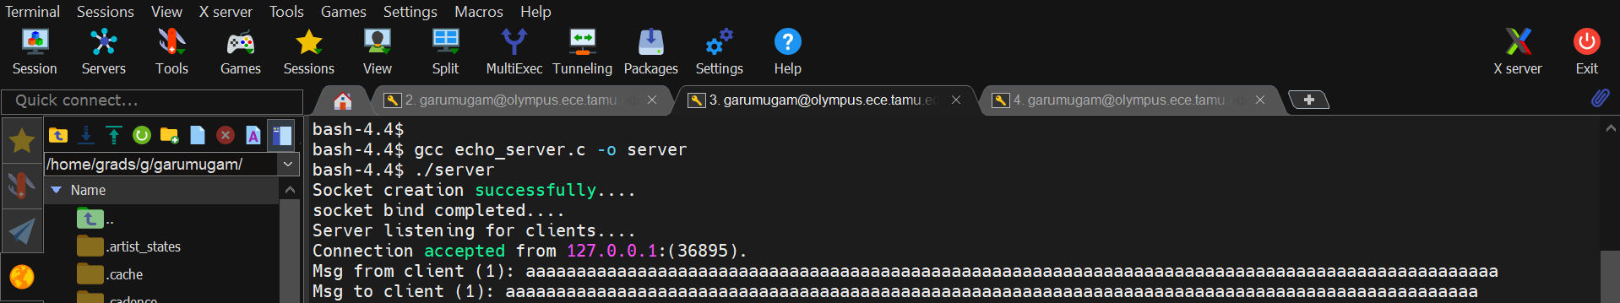

**At Client side**

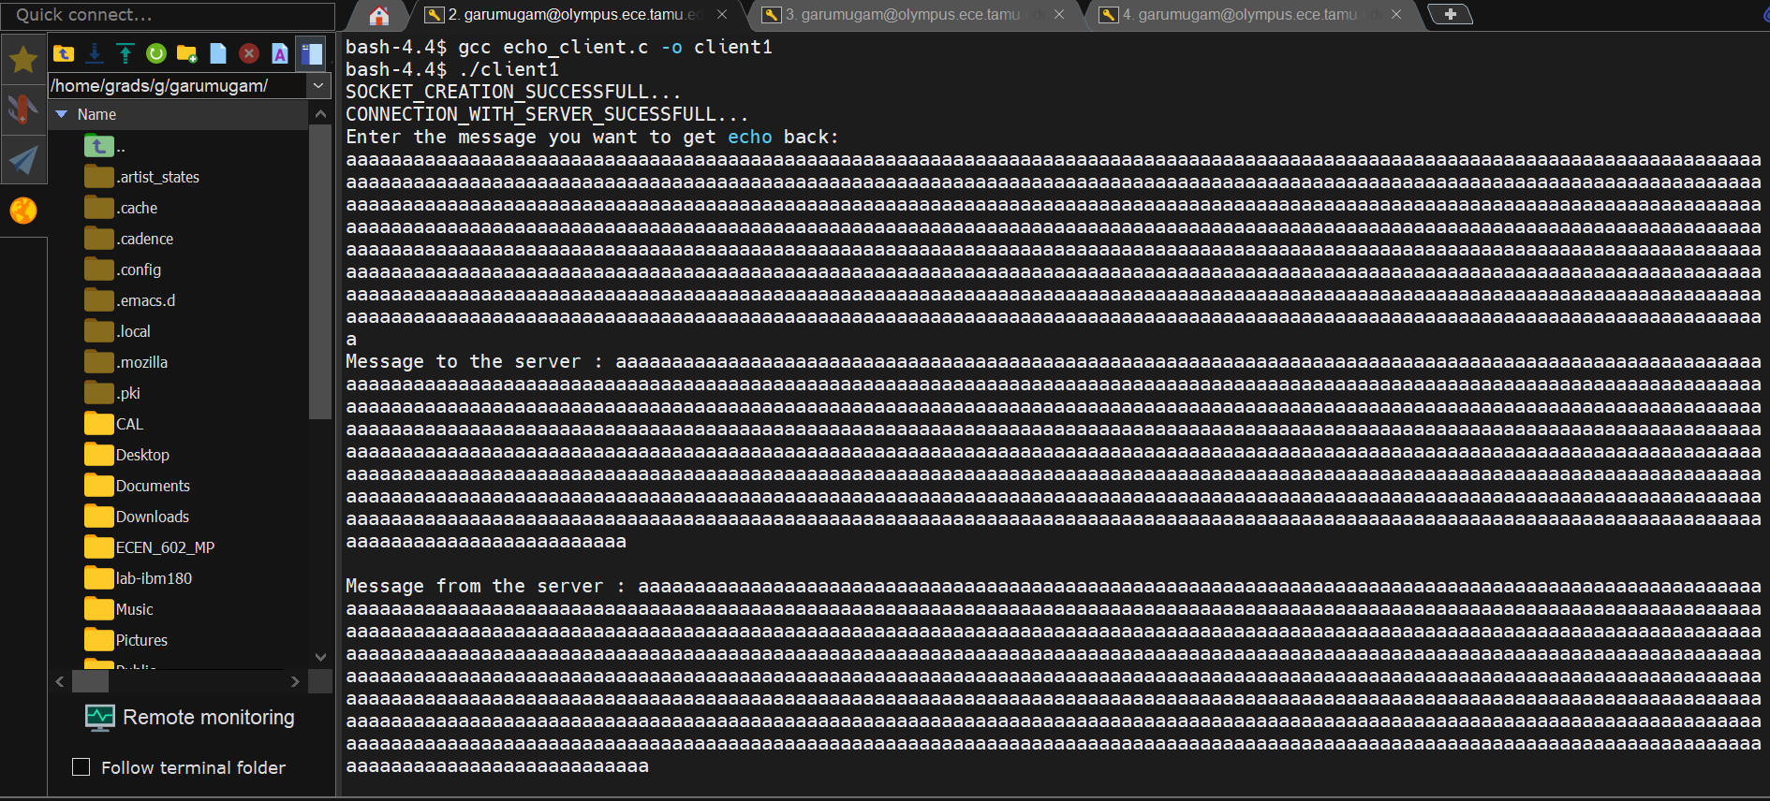

1. **line with nocharacters and EOF:**

It is possible to send the message with no characters and EOF.

**At Server Side:**

**At Client Side:**

1. **client terminated after entering text:**

The Clients are terminated after entering the following text in there message **“exit”.**

**At Server Side:**

**At Client Side:**

1. **Three clientsconnected to the server:**

The server can connect to different clients simultaneously and echo the clients simultaneously.

**At Server Side:**

**All the clients:**

The other versions of the code given by ChatGPT.

**C Source Code**

1. **ChatGPT version code**

**Echo Server code**

#include <stdio.h>

#include <stdlib.h>

#include <string.h>

#include <unistd.h>

#include <arpa/inet.h>

#include <sys/socket.h>

#include <pthread.h>

#define BUFFER_SIZE 1024

void *handle_client(void *arg) {

int client_socket = *(int *)arg;

free(arg);

char buffer[BUFFER_SIZE];

int bytes_read;

while ((bytes_read = read(client_socket, buffer, BUFFER_SIZE)) > 0) {

write(client_socket, buffer, bytes_read);

}

close(client_socket);

return NULL;

}

int main(int argc, char *argv[]) {

if (argc != 2) {

fprintf(stderr, "Usage: %s <Port>\n", argv[0]);

exit(EXIT_FAILURE);

}

int server_socket, *client_socket;

struct sockaddr_in server_addr, client_addr;

socklen_t client_addr_len = sizeof(client_addr);

pthread_t tid;

server_socket = socket(AF_INET, SOCK_STREAM, 0);

if (server_socket < 0) {

perror("Socket creation failed");

exit(EXIT_FAILURE);

}

server_addr.sin_family = AF_INET;

server_addr.sin_addr.s_addr = INADDR_ANY;

server_addr.sin_port = htons(atoi(argv[1]));

if (bind(server_socket, (struct sockaddr *)&server_addr, sizeof(server_addr)) < 0) {

perror("Bind failed");

close(server_socket);

exit(EXIT_FAILURE);

}

if (listen(server_socket, 10) < 0) {

perror("Listen failed");

close(server_socket);

exit(EXIT_FAILURE);

}

printf("Server listening on port %s\n", argv[1]);

while (1) {

client_socket = malloc(sizeof(int));

*client_socket = accept(server_socket, (struct sockaddr *)&client_addr, &client_addr_len);

if (*client_socket < 0) {

perror("Accept failed");

free(client_socket);

continue;

}

pthread_create(&tid, NULL, handle_client, client_socket);

pthread_detach(tid);

}

close(server_socket);

return 0;

}

**Echo Client code**

#include <stdio.h>

#include <stdlib.h>

#include <string.h>

#include <unistd.h>

#include <arpa/inet.h>

#define BUFFER_SIZE 1024

int main(int argc, char *argv[]) {

if (argc != 3) {

fprintf(stderr, "Usage: %s <IP Address> <Port>\n", argv[0]);

exit(EXIT_FAILURE);

}

int client_socket;

struct sockaddr_in server_addr;

char buffer[BUFFER_SIZE];

client_socket = socket(AF_INET, SOCK_STREAM, 0);

if (client_socket < 0) {

perror("Socket creation failed");

exit(EXIT_FAILURE);

}

server_addr.sin_family = AF_INET;

server_addr.sin_port = htons(atoi(argv[2]));

if (inet_pton(AF_INET, argv[1], &server_addr.sin_addr) <= 0) {

perror("Invalid address");

close(client_socket);

exit(EXIT_FAILURE);

}

if (connect(client_socket, (struct sockaddr *)&server_addr, sizeof(server_addr)) < 0) {

perror("Connection failed");

close(client_socket);

exit(EXIT_FAILURE);

}

while (fgets(buffer, BUFFER_SIZE, stdin) != NULL) {

write(client_socket, buffer, strlen(buffer));

int bytes_read = read(client_socket, buffer, BUFFER_SIZE);

if (bytes_read > 0) {

buffer[bytes_read] = '\0';

printf("Echo: %s", buffer);

}

}

close(client_socket);

return 0;

}

1. **ChatGPT Enhance version code**

**Echo Server code**

#include <stdio.h>

#include <stdlib.h>

#include <string.h>

#include <unistd.h>

#include <arpa/inet.h>

#include <sys/socket.h>

#include <sys/types.h>

#include <netinet/in.h>

#include <signal.h>

#define PORT 8080

#define BUFFER_SIZE 1024

void handle_client(int client_socket, int client_count) {

char buffer[BUFFER_SIZE];

ssize_t bytes_read;

while (1) {

memset(buffer, 0, BUFFER_SIZE);

bytes_read = read(client_socket, buffer, sizeof(buffer));

if (bytes_read <= 0) {

break;

}

printf("Msg from client (%d): %s\n", client_count, buffer);

write(client_socket, buffer, bytes_read);

if (strncmp("exit", buffer, 4) == 0) {

printf("Server Exit...\n");

break;

}

}

close(client_socket);

}

int main() {

int server_socket, client_socket;

struct sockaddr_in server_addr, client_addr;

socklen_t client_addr_len = sizeof(client_addr);

pid_t childpid;

int client_count = 0;

signal(SIGCHLD, SIG_IGN); // Prevent zombie processes

server_socket = socket(AF_INET, SOCK_STREAM, 0);

if (server_socket < 0) {

perror("Socket creation failed");

exit(EXIT_FAILURE);

}

printf("Socket creation successful.\n");

memset(&server_addr, 0, sizeof(server_addr));

server_addr.sin_family = AF_INET;

server_addr.sin_addr.s_addr = INADDR_ANY;

server_addr.sin_port = htons(PORT);

if (bind(server_socket, (struct sockaddr*)&server_addr, sizeof(server_addr)) < 0) {

perror("Bind failed");

close(server_socket);

exit(EXIT_FAILURE);

}

printf("Socket bind successful.\n");

if (listen(server_socket, 10) < 0) {

perror("Listen failed");

close(server_socket);

exit(EXIT_FAILURE);

}

printf("Server listening on port %d...\n", PORT);

while (1) {

client_socket = accept(server_socket, (struct sockaddr*)&client_addr, &client_addr_len);

if (client_socket < 0) {

perror("Accept failed");

continue;

}

printf("Connection accepted from %s:%d.\n", inet_ntoa(client_addr.sin_addr), ntohs(client_addr.sin_port));

client_count++;

if ((childpid = fork()) == 0) {

close(server_socket);

handle_client(client_socket, client_count);

exit(0);

}

close(client_socket);

}

close(server_socket);

return 0;

}

Enhancement done in,

* Signal Handling: Added signal (SIGCHLD, SIG_IGN); to prevent zombie processes by automatically reaping terminated child processes.
* Error Handling: Improved error messages using perror() for better diagnostics.
* Resource Management: Ensured sockets are properly closed in both parent and child processes.

**Echo Client code**

#include <stdio.h>

#include <stdlib.h>

#include <string.h>

#include <unistd.h>

#include <arpa/inet.h>

#include <sys/socket.h>

#define BUFFER_SIZE 1024

#define PORT 8080

void communicate_with_server(int server_socket) {

char buffer[BUFFER_SIZE];

ssize_t bytes_read;

while (1) {

memset(buffer, 0, BUFFER_SIZE);

printf("Msg to server: ");

fgets(buffer, BUFFER_SIZE, stdin);

write(server_socket, buffer, strlen(buffer));

memset(buffer, 0, BUFFER_SIZE);

bytes_read = read(server_socket, buffer, sizeof(buffer));

if (bytes_read <= 0) {

break;

}

printf("Msg from server: %s", buffer);

if (strncmp(buffer, "exit", 4) == 0) {

printf("Client Exit...\n");

break;

}

}

}

int main() {

int server_socket;

struct sockaddr_in server_addr;

server_socket = socket(AF_INET, SOCK_STREAM, 0);

if (server_socket < 0) {

perror("Socket creation failed");

exit(EXIT_FAILURE);

}

printf("Socket creation successful.\n");

memset(&server_addr, 0, sizeof(server_addr));

server_addr.sin_family = AF_INET;

server_addr.sin_port = htons(PORT);

server_addr.sin_addr.s_addr = inet_addr("127.0.0.1");

if (connect(server_socket, (struct sockaddr*)&server_addr, sizeof(server_addr)) != 0) {

perror("Connection to the server failed");

close(server_socket);

exit(EXIT_FAILURE);

}

printf("Connected to the server.\n");

communicate_with_server(server_socket);

close(server_socket);

return 0;

}

Enhancement done in,

* Buffer Management: Used fgets() for reading input to avoid buffer overflow.
* Resource Management: Ensured the socket is closed properly upon exit.