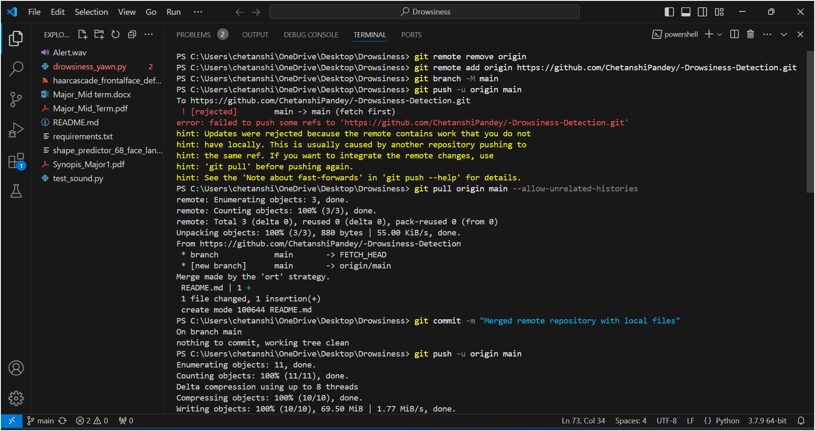

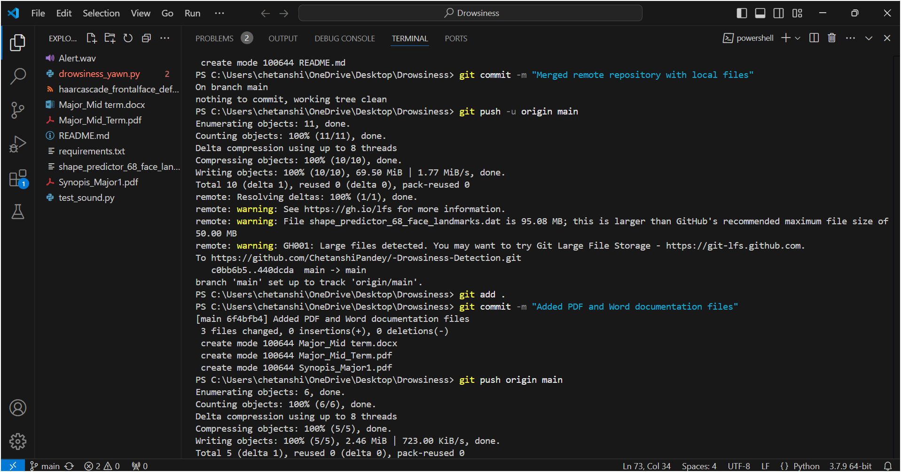

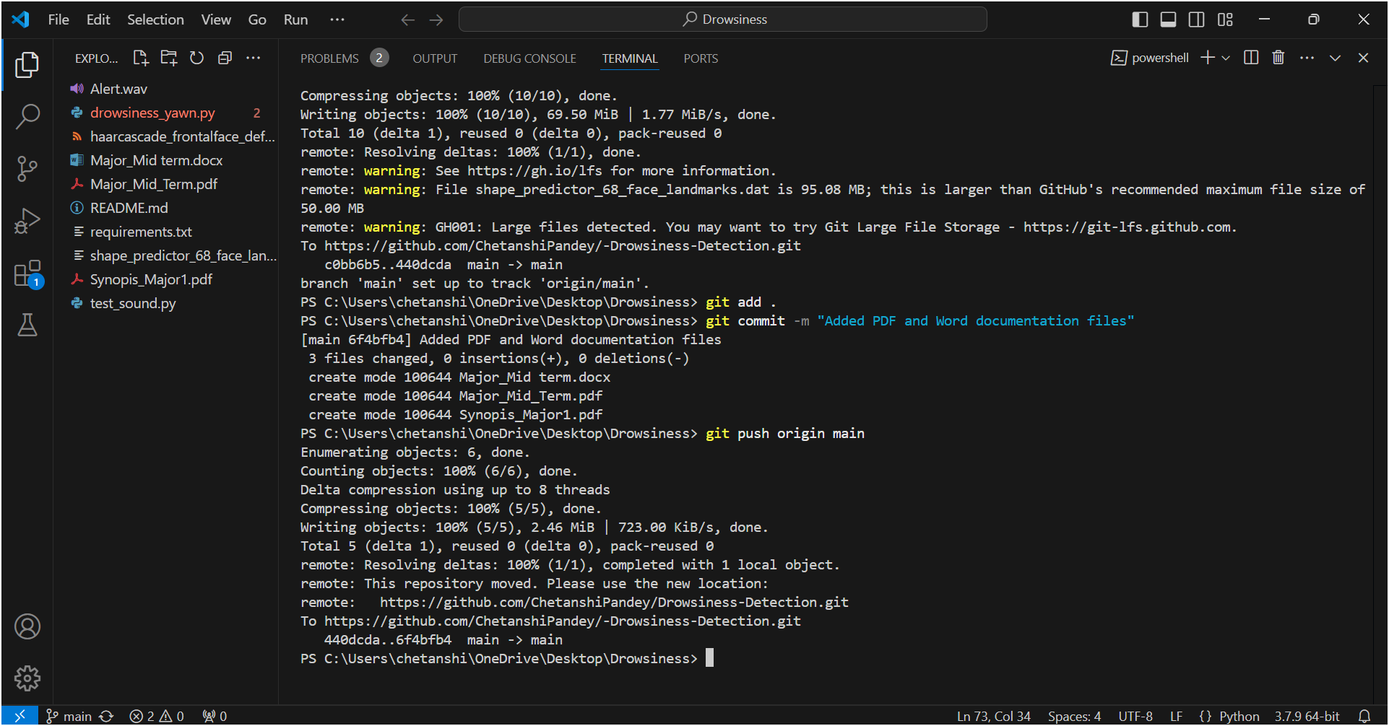

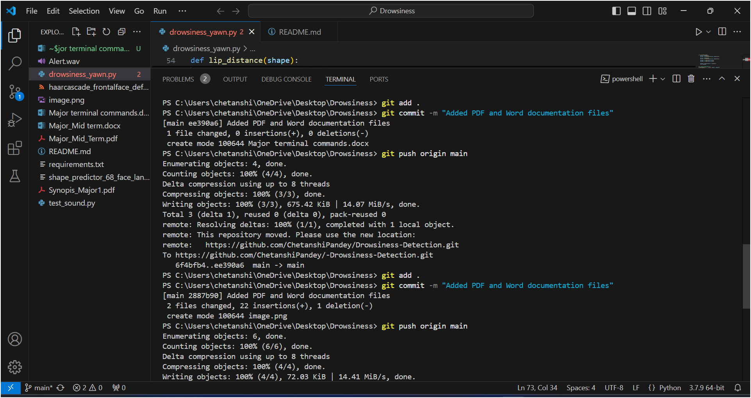

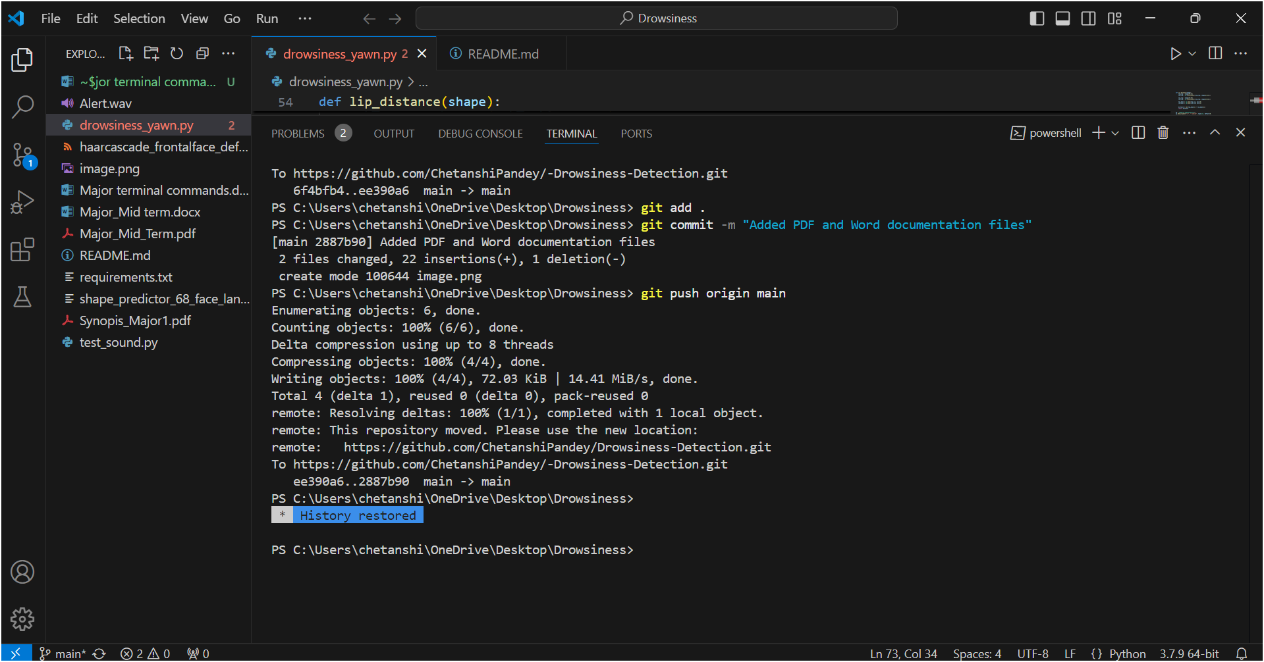

* Commit the Changes to GitHub

1) Use this command to stage the updated file:

**git add drowsiness_yawn.py**

2) Commit the Changes Write a meaningful commit message to document the update:

**git commit -m "Updated frame output to fullscreen mode in drowsiness_yawn.py"**

3) Push the Changes Push the changes to your GitHub repository:

**git push origin main**

* Run the Code Locally

**python drowsiness_yawn.py --webcam 0**