**Bearer token Means** means that **whoever holds the token can use it**.

* Ex: The **ticket** is like a **Bearer Token**.
* The **Authorization: Bearer** line in an HTTP request is how you show your ticket to a system (like Azure or Microsoft Graph).
* The system checks the token and says: “Okay, you’re allowed to do this

============================================================================

Entra ID Pass reset using logic Apps:

**Prerequisites: Azure AD App Registration with:**

* **API permissions: User.ReadWrite.All**
* **Admin consent granted**

Register an User Identity with appropriate permissions for connections in Logic apps.

============================================================================

Steps:

Sentinel INC Trigger >> initiate a variable called Pass >> Set the same variable >> Get User Entity >> Now here follow Below Steps

Call a **HTTP - Reset a password >> Under this define below steps**

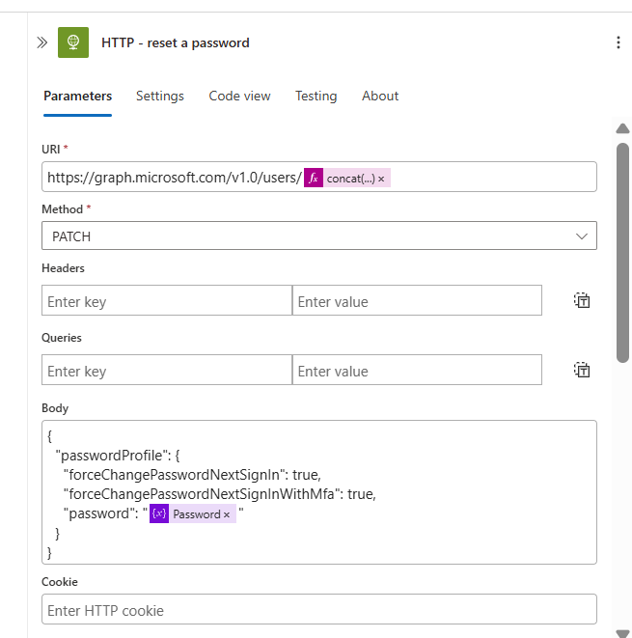

**Define URL: https://graph.microsoft.com/v1.0/users/UsrID/**

**Method: Patch**

**Body:**

**{  
"passwordProfile": {  
"forceChangePasswordNextSignIn": true,  
"forceChangePasswordNextSignInWithMfa": true,  
"password": ""  
}  
}**

**And Under Authentication, Fill Client ID and Secret Value which we told above to register an app.**

**After this User pass will get reset, now to send an email to user Manager, follow below Steps**

**Call a HTTP - get manager and Define Below Details**

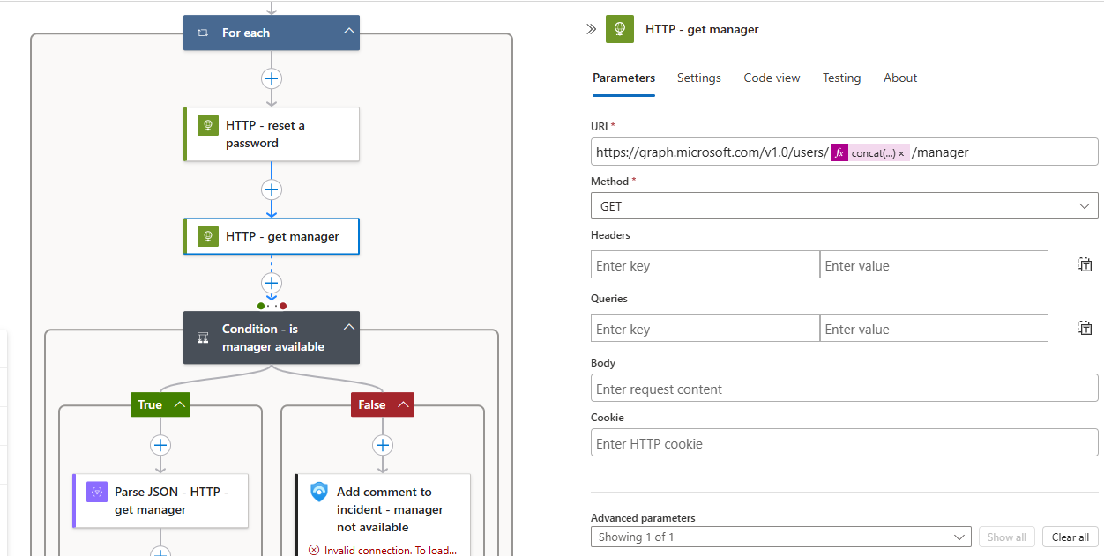

**URL:** [**https://graph.microsoft.com/v1.0/users/userID/manager**](https://graph.microsoft.com/v1.0/users/userID/manager)

**Method: Get**

**And similar authentication Details**

