SMART INDIA HACKATHON (SIH) — PROBLEM STATEMENT 26058
AUV Adaptive Sonar Digital Twin
Transmitter Payload
Complete Results, Outputs, and Engineering Interpretation Report
Exhaustive Analysis of All Priority 1 Experiments, Sweep Metrics, Dual Confidence Indicators, Controller Protection Mechanisms, and Automated Verification Suites
CORE ENGINEERING RESULT & PHYSICAL JUSTIFICATION:
• LOW_FREQUENCY (100-220k): Lowest attenuation (64.5 dB/km) -> Propagation-Resilience Fallback
• BALANCED (200-400k): Widest sweep bandwidth (200 kHz) -> Optimal 3.75 mm Range Resolution
• HIGH_FREQUENCY (350-500k): Highest center frequency (425 kHz) -> 1.417x Relative Directivity
• Profile selection is strictly governed by: (1) Propagation Viability, (2) Mission Objective,
(3) Dual Confidence Metrics, and (4) Existing Hysteresis, Debounce, and PRI Protections.

SYSTEM SPECIFICATIONS & ARTIFACT METADATA
Parameter | Engineering Specification | Verification Status
Problem Statement | SIH Problem 26058: Low-Power Adaptive Sonar Transmitter Payload | Official Hackathon Problem
Target Microcontroller | STM32G474 (128 KB SRAM, 512 KB Flash, 12-Bit DAC) | Hardware Feasibility Confirmed
Digital Sampling Rate | 4.0 MSPS (0.25 us clock period, 8000 samples / 2 ms pulse) | Phase Monotonicity Verified
Pulse Repetition Interval | PRI = 20.0 ms (50 Hz PRF, 10.0% Nominal Duty Cycle) | Atomic Latching Verified
Automated Test Coverage | 56 Unit Tests across Python & MATLAB (100% Passing) | Bit-Exact Cross-Parity Verified
Document Classification | Results Interpretation & Experimental Engineering Report | Current Implementation State

Table of Contents
This document contains eighteen comprehensive sections detailing every result produced by the digital twin:
Section Identifier | Section Title & Content Overview
Section 1 | Executive Summary of Results & Core Trade-offs
Section 2 | Output Taxonomy & Module Classification Table
Section 3 | Complete Profile Output Explanation (LOW, BALANCED, HIGH)
Section 4 | Complete Output Metric Reference (Ainslie-McColm, Margin, Confidence)
Section 5 | Complete Graph-by-Graph Analysis (14-Point Engineering Review)
Section 5.1 - 5.7 | Figures 1 to 7: Attenuation, Margin, Resolution, Directivity, Winner, Confidence, Sensitivity
Section 5.8 - 5.10 | Companion Figures 8 to 10: Single Pulse, Quantization Analysis, Dynamic 150-Ping Timeline
Section 6 | Range Sweep Outputs & Narrative of Regime Transitions
Section 7 | Noise Sensitivity Outputs & Receiver Model Distinctions
Section 8 | Environmental Sweep Outputs & Physical Hierarchy of Effects
Section 9 | Signal Generation Outputs & Physical Transmitter Mapping
Section 10 | DAC Quantization Outputs & Analog Hardware Distinctions
Section 11 | Memory Footprint and DMA Buffer Allocation
Section 12 | Controller Outputs: Hysteresis, Debounce, and Atomic PRI Latching
Section 13 | Automated Test Suite Outputs (56 Tests across 5 Functional Groups)
Section 14 | Output Interpretation Summary Master Table
Section 15 | Verified Implementation Results vs Theoretical Assumptions
Section 16 | What the Outputs Legitimately Prove
Section 17 | What the Outputs Do NOT Prove (Physical Limitations)
Section 18 | Final Engineering Story: The Transformation of SIH Problem 26058

Section 1: Executive Summary of Results
This engineering report provides an exhaustive, mathematically rigorous, and evidence-grounded interpretation of all outputs, simulation sweeps, graphs, and numerical results generated by the Autonomous Underwater Vehicle (AUV) Adaptive Sonar Transmitter Digital Twin codebase. Developed for Smart India Hackathon (SIH) Problem Statement 26058, the project models an intelligent, software-defined sonar transmitter payload designed to dynamically adapt its acoustic transmission waveforms in response to changing underwater environmental and operational conditions.

1.1 What the Digital Twin Simulates
The digital twin simulates the complete digital signal synthesis, digital-to-analog conversion (DAC) quantization pipeline, adaptation control state machine, and duty-cycle power consumption for an AUV transmitter payload targeting the STM32G474 microcontroller architecture. Specifically, the simulation models:
- Full Digital Signal Chain: Monolithic phase-continuous synthesis of Linear Frequency Modulated (LFM) chirps across three designated frequency bands, tapered by analytical Hann windowing at 4.0 MSPS sampling rate.
- 12-Bit DAC Quantization: Quantization of normalized floating-point chirp waveforms into 12-bit unsigned digital DAC codes (0 to 4095) with midscale bias (2048), tracking quantization error bounds, residual voltage swing, and Signal-to-Quantization-Noise Ratio (SQNR).
- Firmware Buffer Sizing: Direct Memory Access (DMA) lookup table (LUT) memory modeling, buffer alignment, and export of firmware-ready C headers with uint16_t arrays.
- Controller State Machine: Directional Schmitt-trigger hysteresis deadbands (10% width) and N=2 consecutive ping debounce persistence filters to eliminate chattering near decision boundaries.
- PRI Ping-Boundary Latching: Strict atomic synchronization of profile switching to the Pulse Repetition Interval (PRI = 20.0 ms, 50 Hz PRF) boundary, preventing mid-pulse waveform corruption.
- Duty-Cycle Power Estimation: Analytical electrical power consumption across 1.0 ms, 2.0 ms, and 3.0 ms pulse durations under 20.0 ms PRI, modeling active transmitter power, quiescent idle power, and battery endurance.

1.2 What Priority 1 Added to the Repository
Prior to the implementation of Priority 1, the digital twin relied upon an arbitrary composite heuristic score (a weighted combination of normalized sliders representing turbidity, target range, and receiver target strength) to switch between transmission profiles. While computationally simple, that approach lacked physical transparency, conflated independent oceanographic variables, and could not provide an engineering defense for why one waveform band was acoustically superior to another.
Priority 1 completely replaced that ad-hoc mechanism with an unhidden, multi-tier physical and operational evaluation pipeline grounded in recognized ocean acoustics literature:
- Ainslie & McColm (1998) Absorption Model: Implementation of standard seawater chemical relaxation (boric acid and magnesium sulfate) and pure-water viscous absorption models across continuous frequency, temperature, salinity, and depth spectra.
- Mackenzie (1981) Nine-Term Sound Speed Equation: Deterministic calculation of seawater sound velocity c(T, S, D) replacing static sound speed assumptions.
- Five-Point In-Band Frequency Sampling: Discrete evaluation of acoustic attenuation at 5 evenly spaced frequencies across each chirp band (f_start, 25%, 50%, 75%, f_end), capturing intra-band attenuation slopes rather than assuming monochromatic behavior at center frequency.
- Two-Tier Decision Hierarchy: A decoupled selection architecture where Tier 1 enforces physical propagation viability (relative propagation margin >= -65.0 dB policy floor) and Tier 2 selects among viable candidates according to explicit mission operational objectives (Survey Resolution vs. Directivity Beam Narrowing).
- Dual Confidence Metrics: Quantification of both Viability Confidence (distance above the viability floor) and Mission Selection Confidence (utility separation between the winning profile and the nearest runner-up).

1.3 The Fundamental Engineering Question: Why Select One Profile Over Another?
The central engineering problem addressed by Priority 1 is: On what physical, operational, and mathematical basis should an autonomous sonar transmitter switch from one chirp profile to another? The answer delivered by this project is grounded in the immutable trade-offs of underwater acoustics:
- LOW_FREQUENCY (100 - 220 kHz): Features the lowest chemical absorption (mean alpha = 64.47 dB/km at baseline). Its primary engineering role is Propagation Resilience. It experiences the least modeled transmission loss at long range, enabling survival when higher frequencies fall below viability. However, its narrower bandwidth (120 kHz) yields the coarsest range resolution (6.25 mm theoretical limit).
- BALANCED (200 - 400 kHz): Occupies the widest absolute bandwidth (200 kHz), which directly yields the finest theoretical range resolution (3.75 mm limit via Delta R = c / (2B)). Its attenuation (mean alpha = 106.32 dB/km) is moderate. It serves as the primary default profile for general acoustic survey and imaging operations where resolving target spatial detail is paramount.
- HIGH_FREQUENCY (350 - 500 kHz): Features the highest center frequency (fc = 425 kHz), yielding the highest relative directivity factor (1.417x relative to 300 kHz reference) under a fixed physical transducer aperture assumption (theta proportional to c / (f * D)). This provides the narrowest theoretical acoustic beam for spatial target localization. However, severe seawater absorption (mean alpha = 136.64 dB/km) rapidly exhausts its propagation margin, making it viable only at short to medium ranges (< 155 m).
[IMPORTANT] Core Selection Rationale
LOW_FREQUENCY is NOT automatically selected merely because it exhibits the lowest attenuation. If all three profiles are viable, selecting LOW_FREQUENCY would needlessly sacrifice spatial resolution (Survey Mode) or beam sharpness (Directivity Mode). Profile selection is governed by mission utility among viable profiles, reserving LOW_FREQUENCY as an autonomous propagation-resilience fallback when higher-performance profiles fail viability.

1.4 Hierarchy of Project Claims & Epistemic Status
To ensure total technical integrity for SIH judges, academic reviewers, and prospective systems engineers, all outputs in this report are categorized into five strict epistemic classifications:
- [VERIFIED IMPLEMENTATION]: Outputs derived from executing deterministic software algorithms in the repository, validated by bit-exact unit tests and Python/MATLAB cross-parity tests (e.g., LFM chirp synthesis, 12-bit DAC codes, SQNR calculation, hysteresis and debounce logic, C header export).
- [ANALYTICAL RESULT]: Closed-form mathematical derivations that follow directly from established physical and signal processing formulas under idealized assumptions (e.g., theoretical matched-filter range resolution Delta R = c / (2B), relative directivity proxy Dir_rel = fc / 300 kHz, Mackenzie sound velocity).
- [SIMULATION MODEL]: Outputs generated from standard empirical or oceanographic models published in peer-reviewed acoustics literature (e.g., Ainslie-McColm 1998 chemical relaxation absorption, spherical spreading transmission loss TL = 20*log10(R) + alpha*R).
- [SIMULATION ASSUMPTION]: Operational policy parameters established within the software twin to define thresholds and boundaries (e.g., -65.0 dB relative viability floor, 15 dB confidence scaling range, 50 Hz PRF, 5.0 W active power assumption). These represent simulation control policies, not calibrated hydrophone detection thresholds.
- [NOT PHYSICALLY VALIDATED]: Physical phenomena not yet verified on bench instruments or in tank/sea trials (e.g., transducer electrical impedance resonance, power amplifier distortion, actual underwater target echoes, physical beam patterns, turbidity particulate scattering).

Section 2: Output Taxonomy
Every numerical figure, metric, table entry, and visualization generated by the digital twin belongs to a specific subsystem and carries a well-defined engineering status. Table 2.1 catalogs every major output produced by the codebase, identifying the producing module, technical meaning, and validation status.
Output / Metric | Produced By Module | Physical or Computational Meaning | Engineering Status
alpha_points_db_km | profile_evaluator (Python/MATLAB) | Acoustic absorption at 5 discrete frequency points per band | Simulation Model (Ainslie-McColm 1998)
alpha_band_db_km | profile_evaluator (Python/MATLAB) | Arithmetic mean absorption across active chirp sweep band | Simulation Model (5-point average)
transmission_loss_db | profile_evaluator (Python/MATLAB) | One-way acoustic transmission loss (20*log10(R) + alpha*R) | Simplified Simulation Model
relative_margin_db | profile_evaluator (Python/MATLAB) | Signal margin relative to 0 dB reference minus TL and noise | Simulation Policy Metric
range_resolution_mm | profile_evaluator (Python/MATLAB) | Ideal matched-filter spatial resolution Delta R = c / (2B) | Analytical Derived Result
relative_directivity | profile_evaluator (Python/MATLAB) | Relative beam narrowing factor (fc / 300 kHz proxy) | Analytical Theoretical Proxy
is_viable | profile_evaluator (Python/MATLAB) | Boolean flag: relative_margin_db >= -65.0 dB threshold | Simulation Policy Decision
viability_confidence | profile_evaluator (Python/MATLAB) | Continuous confidence [0, 1] based on margin above -65 dB | Simulation Policy Metric
selection_confidence | profile_evaluator (Python/MATLAB) | Confidence [0, 1] based on utility separation from runner-up | Simulation Policy Metric
Candidate Profile | profile_evaluator (Python/MATLAB) | Winning profile ID selected by Tier 2 mission utility | Verified Simulation Logic
Active Profile | PingController / adaptive_controller | Committed profile after hysteresis, debounce, and PRI latch | Verified State Machine
Ideal Chirp Signal | waveform.py / generate_lfm_chirp.m | Continuous-phase floating-point LFM chirp with Hann window | Verified Implementation
DAC Digital Codes | waveform.py / dac_quantize.m | 12-bit unsigned integers (0 to 4095) for DMA DAC streaming | Verified Implementation
Quantization Error | waveform.py / dac_quantize.m | LSB and millivolt residuals bounded strictly within +/-0.5 LSB | Verified Implementation
Simulated SQNR | waveform.py / dac_quantize.m | Signal-to-Quantization-Noise Ratio (~69.7 dB) | Verified Implementation
DMA Buffer Footprint | export_c.py / export_c_headers.m | 16,000 bytes (8000 samples * 2 bytes) memory consumption | Analytical Architecture Metric
Average Power / Current | power_model.py / power_model.m | Duty-cycle power (0.540 W @ 10% duty) and battery endurance | Analytical Load Model

Section 3: Complete Profile Output Explanation
The digital twin defines three canonical transmission profiles designed to cover distinct acoustic regimes. Each profile represents a locked operating band whose signal synthesis parameters, memory footprint, acoustic attenuation, and resolution capabilities have been thoroughly evaluated and validated.

3.1 LOW_FREQUENCY Profile (Profile ID: 1)
The LOW_FREQUENCY profile is tailored specifically for maximum acoustic penetration and propagation endurance. Because acoustic absorption in seawater scales quadratically with frequency, this profile experiences the lowest medium dissipation, allowing its energy to propagate across ranges where higher-frequency signals are extinguished.
Parameter | Value | Units / Reference | Physical Role
Frequency Sweep Range | 100.0 to 220.0 | kHz | Low-band acoustic spectrum
Center Frequency (fc) | 160.0 | kHz | Mid-band spectral center
Sweep Bandwidth (B) | 120.0 | kHz | Determines theoretical range resolution
Evaluation Point 1 (f_start) | 100.0 kHz -> alpha = 38.85 | dB/km | Lowest attenuation point in system
Evaluation Point 2 (25%) | 130.0 kHz -> alpha = 53.58 | dB/km | Lower mid-band sample
Evaluation Point 3 (Center) | 160.0 kHz -> alpha = 66.31 | dB/km | Center-band attenuation
Evaluation Point 4 (75%) | 190.0 kHz -> alpha = 77.13 | dB/km | Upper mid-band sample
Evaluation Point 5 (f_end) | 220.0 kHz -> alpha = 86.47 | dB/km | Band ceiling attenuation
Mean Band Absorption | 64.47 | dB/km | Used for transmission loss calculations
Ideal Range Resolution | 6.25 (at 1500 m/s) / 6.34 (at 1520.9 m/s) | mm | Coarsest resolution among profiles
Relative Directivity Proxy | 0.533 (160 / 300) | Dimensionless | Widest theoretical acoustic beam
Sample Count / Buffer | 8,000 samples / 16,000 bytes | Samples / uint16_t bytes | 12.5% of STM32G4 128KB SRAM

Why LOW_FREQUENCY is a Fallback Profile: LOW_FREQUENCY exhibits a mean band attenuation of only 64.47 dB/km, compared to 106.32 dB/km for BALANCED and 136.64 dB/km for HIGH_FREQUENCY. At 200 m range, its relative margin is -58.91 dB, leaving 6.09 dB of clearance above the -65.0 dB viability limit, whereas BALANCED (-67.28 dB) and HIGH (-73.35 dB) fail viability. However, its narrower bandwidth yields a range resolution of 6.25 mm—nearly 67% coarser than BALANCED (3.75 mm). Consequently, the system uses LOW_FREQUENCY as an autonomous fallback when propagation conditions dictate, never selecting it over BALANCED when BALANCED is propagation-viable.

3.2 BALANCED Profile (Profile ID: 2)
The BALANCED profile is the nominal workhorse and default operating state of the digital twin. It occupies the 200.0 to 400.0 kHz band, spanning an absolute bandwidth of 200.0 kHz. Under ideal matched-filter pulse compression, the theoretical range resolution Delta R is governed strictly by the sweep bandwidth:
Delta R = c / (2 * B)
Ideal matched-filter pulse compression range resolution (c = speed of sound, B = chirp sweep bandwidth)

At a standard sound speed of c = 1500 m/s, Delta R = 1500 / (2 * 200,000) = 0.00375 m = 3.75 mm. Under the modeled baseline Mackenzie sound speed of c = 1520.91 m/s (T=20°C, S=35 PSU, D=50 m), Delta R = 1520.91 / (2 * 200,000) = 3.80 mm. Because this bandwidth is the largest in the system, BALANCED provides the finest spatial resolving capability of any profile.
Parameter | Value | Units / Reference | Physical Role
Frequency Sweep Range | 200.0 to 400.0 | kHz | Nominal survey operating band
Center Frequency (fc) | 300.0 | kHz | Reference center frequency (1.0x directivity)
Sweep Bandwidth (B) | 200.0 | kHz | Widest bandwidth -> finest range resolution
Evaluation Point 1 (f_start) | 200.0 kHz -> alpha = 80.39 | dB/km | Band floor attenuation
Evaluation Point 2 (25%) | 250.0 kHz -> alpha = 94.75 | dB/km | Lower mid-band sample
Evaluation Point 3 (Center) | 300.0 kHz -> alpha = 107.18 | dB/km | Center-band attenuation
Evaluation Point 4 (75%) | 350.0 kHz -> alpha = 118.83 | dB/km | Upper mid-band sample
Evaluation Point 5 (f_end) | 400.0 kHz -> alpha = 130.43 | dB/km | Band ceiling attenuation
Mean Band Absorption | 106.32 | dB/km | Moderate dissipation across band
Ideal Range Resolution | 3.75 (at 1500 m/s) / 3.80 (at 1520.9 m/s) | mm | Finest spatial resolution in system
Relative Directivity Proxy | 1.000 (300 / 300) | Dimensionless | Baseline reference directivity
Viability Boundary | ~184.9 m | Meters | Range where relative margin drops below -65 dB

3.3 HIGH_FREQUENCY Profile (Profile ID: 3)
The HIGH_FREQUENCY profile sweeps from 350.0 to 500.0 kHz with a center frequency of fc = 425.0 kHz and a bandwidth of 150.0 kHz. In underwater electroacoustic transducers, the half-power beamwidth theta is inversely proportional to the product of acoustic frequency and physical aperture diameter D (theta proportional to c / (f * D)). Assuming a fixed physical transducer aperture, operating at a higher center frequency narrows the acoustic radiation pattern, concentrating acoustic energy into a tighter angular beam.
The relative theoretical directivity metric Dir_rel expresses this beam-narrowing factor relative to the 300.0 kHz baseline:
Dir_rel = f_c / (300.0 kHz) = 425.0 / 300.0 = 1.417x
Relative theoretical directivity proxy under fixed physical aperture assumption

Parameter | Value | Units / Reference | Physical Role
Frequency Sweep Range | 350.0 to 500.0 | kHz | High-resolution directivity band
Center Frequency (fc) | 425.0 | kHz | Highest center frequency in system
Sweep Bandwidth (B) | 150.0 | kHz | Intermediate bandwidth
Evaluation Point 1 (f_start) | 350.0 kHz -> alpha = 118.83 | dB/km | Band floor attenuation
Evaluation Point 2 (25%) | 387.5 kHz -> alpha = 127.51 | dB/km | Lower mid-band sample
Evaluation Point 3 (Center) | 425.0 kHz -> alpha = 136.35 | dB/km | Center-band attenuation
Evaluation Point 4 (75%) | 462.5 kHz -> alpha = 145.49 | dB/km | Upper mid-band sample
Evaluation Point 5 (f_end) | 500.0 kHz -> alpha = 155.01 | dB/km | Band ceiling attenuation (highest loss)
Mean Band Absorption | 136.64 | dB/km | Severe medium dissipation
Ideal Range Resolution | 5.00 (at 1500 m/s) / 5.07 (at 1520.9 m/s) | mm | Intermediate resolution
Relative Directivity Proxy | 1.417 (425 / 300) | Dimensionless | Narrowest theoretical acoustic beam
Viability Boundary | ~155.1 m | Meters | Range where relative margin drops below -65 dB

[WARNING] Physical Aperture vs Beamforming Boundary
The 1.417x directivity metric is an analytical frequency proxy assuming a rigid circular piston of fixed physical dimension. The digital twin does NOT currently model piezoelectric ceramic resonance, transducer electroacoustic impedance matching, complex hydrophone beam patterns, or phased array beamforming. This output represents theoretical frequency-proportional beam narrowing, not a measured radiation pattern.

Section 4: Complete Output Metric Reference
This section serves as an exhaustive reference catalog for every quantitative metric produced by the profile performance evaluator (`src/profile_evaluator.py` and `matlab/evaluate_profile_performance.m`). For each metric, the exact mathematical definition, units, physical significance, sensitivity factors, interpretation guidelines, and epistemic engineering status are explicitly documented.

4.1 Metric: alpha_points_db_km
- Units: dB/km
- Governing Equation: alpha_chem(f_k) = [A1*f1*f_k^2 / (f1^2 + f_k^2)] + [A2*f2*f_k^2 / (f2^2 + f_k^2)] + A3*f_k^2
- Physical / Computational Meaning: The physical chemical relaxation and viscous absorption coefficient evaluated at 5 discrete frequency points evenly spaced across the active chirp band: f_points = linspace(f_start, f_end, 5).
- Sensitivity / Affecting Parameters: Seawater temperature T (°C), salinity S (PSU), hydrostatic depth D (meters), acoustic frequency f (kHz), and optional turbidity scattering heuristic.
- Interpretation Guidelines: Higher values indicate steeper spatial attenuation rate. Lower values indicate greater acoustic propagation transparency.
- Engineering Status: [SIMULATION MODEL] (Ainslie & McColm 1998 chemical relaxation equation).

4.2 Metric: alpha_band_db_km
- Units: dB/km
- Governing Equation: alpha_band = (1/5) * sum_{k=1}^{5} alpha_points_db_km[k]
- Physical / Computational Meaning: The arithmetic mean attenuation across the five discrete sample points of the profile's sweep band. Serves as the effective integrated absorption loss coefficient for transmission loss modeling.
- Sensitivity / Affecting Parameters: The composite frequency span of the profile and environmental state (T, S, D).
- Interpretation Guidelines: LOW_FREQUENCY averages 64.47 dB/km; BALANCED averages 106.32 dB/km; HIGH_FREQUENCY averages 136.64 dB/km at baseline.
- Engineering Status: [SIMULATION MODEL] (Derived 5-point numerical average).

4.3 Metric: transmission_loss_db
- Units: dB
- Governing Equation: TL(R) = 20 * log10(R) + alpha_band * (R / 1000)
- Physical / Computational Meaning: Modeled one-way acoustic energy reduction along a direct transmission path of range R, combining spherical geometric spreading loss (20*log10(R)) with frequency-dependent seawater absorption (alpha*R/1000).
- Sensitivity / Affecting Parameters: Target range R (meters) and mean band absorption alpha_band (dB/km).
- Interpretation Guidelines: Always non-negative. Monotonically increases with distance. Separates sharply at long range as absorption term alpha*R becomes dominant over logarithmic spreading.
- Engineering Status: [SIMULATION MODEL] (Simplified one-way spherical spreading + absorption model. Does NOT model multipath, bottom bounce, or surface reflection).

4.4 Metric: relative_margin_db
- Units: dB
- Governing Equation: relative_margin_db = -transmission_loss_db - noise_penalty_db
- Physical / Computational Meaning: The modeled acoustic signal margin relative to an idealized 0 dB reference source level, accounting for transmission loss and normalized environmental noise degradation.
- Sensitivity / Affecting Parameters: Transmission loss TL(R) and normalized noise penalty parameter.
- Interpretation Guidelines: Becomes more negative as range or noise increases. A profile remains viable as long as relative_margin_db >= viability_threshold_db (-65.0 dB).
- Engineering Status: [SIMULATION POLICY METRIC] (Evaluates relative survival; does not compute absolute hydrophone Signal-to-Noise Ratio).

4.5 Metric: range_resolution_mm
- Units: mm
- Governing Equation: Delta R = [c(T, S, D) / (2 * Bandwidth)] * 1000
- Physical / Computational Meaning: Ideal theoretical spatial range resolution achievable by an optimal matched-filter pulse-compression receiver operating on a chirp of bandwidth B in a medium of sound speed c.
- Sensitivity / Affecting Parameters: Chirp sweep bandwidth B (Hz) and Mackenzie seawater sound speed c (m/s).
- Interpretation Guidelines: Smaller numbers represent finer spatial resolving ability (target separation). BALANCED achieves 3.75 mm (finest); HIGH achieves 5.00 mm; LOW achieves 6.25 mm at c=1500 m/s.
- Engineering Status: [ANALYTICAL RESULT] (Theoretical matched-filter pulse compression limit. Assumes ideal receiver correlation without analog noise broadening or medium dispersion).

4.6 Metric: relative_directivity
- Units: Dimensionless
- Governing Equation: Dir_rel = f_center / 300.0 kHz
- Physical / Computational Meaning: Relative theoretical acoustic beam narrowing factor normalized to the BALANCED profile center frequency (300 kHz), assuming a fixed physical transducer aperture diameter D.
- Sensitivity / Affecting Parameters: Profile center frequency fc.
- Interpretation Guidelines: Values > 1.0 indicate a theoretically narrower radiation pattern than baseline. HIGH achieves 1.417x; BALANCED achieves 1.000x; LOW achieves 0.533x.
- Engineering Status: [ANALYTICAL THEORETICAL PROXY] (Frequency proxy under fixed aperture assumption. Does NOT represent an actual measured beam pattern).

4.7 Metric: is_viable
- Units: Boolean
- Governing Equation: is_viable = (relative_margin_db >= -65.0 dB)
- Physical / Computational Meaning: Discrete feasibility flag indicating whether the transmission waveform maintains sufficient modeled relative propagation margin to be considered detectable over the scenario range.
- Sensitivity / Affecting Parameters: Relative propagation margin and the -65.0 dB policy threshold.
- Interpretation Guidelines: True: waveform is admitted into Tier 2 mission utility selection. False: waveform is eliminated due to excessive modeled path loss.
- Engineering Status: [SIMULATION POLICY ASSUMPTION] (The -65 dB floor is a simulation decision parameter, not a calibrated sonar receiver threshold).

4.8 Metric: viability_confidence
- Units: Dimensionless [0.0, 1.0]
- Governing Equation: C_v = clip((relative_margin_db - (-65.0 dB)) / 15.0 dB, 0.0, 1.0)
- Physical / Computational Meaning: Continuous confidence index measuring how comfortably the candidate profile's propagation margin exceeds the policy viability floor.
- Sensitivity / Affecting Parameters: Margin clearance above -65.0 dB scaled over a 15.0 dB dynamic headroom window.
- Interpretation Guidelines: 1.00: Full confidence (>= 15 dB headroom above floor); 0.50: Moderate confidence (7.5 dB headroom); 0.00: Operating directly on viability boundary.
- Engineering Status: [SIMULATION POLICY METRIC] (Linear confidence normalization policy).

4.9 Metric: selection_confidence
- Units: Dimensionless [0.0, 1.0]
- Governing Equation: C_s = clip((Winner_Utility - SecondBest_Utility) / 0.25, 0.0, 1.0)
- Physical / Computational Meaning: Continuous confidence index quantifying the clarity and decisiveness of the profile selection under the active mission operational mode among all viable candidates.
- Sensitivity / Affecting Parameters: Normalized mission utility difference between the selected winner and runner-up profile.
- Interpretation Guidelines: 1.00: Unambiguous selection (utility delta >= 0.25, or uniquely viable profile); 0.50: Fail-safe fallback when no profiles meet viability.
- Engineering Status: [SIMULATION POLICY METRIC] (Utility separation decision policy).

4.10 Metric: Candidate Profile / Active Profile
- Units: Categorical / ID
- Governing Equation: Candidate = argmax_{i in Viable} [Utility_Mode(Profile_i)]; Active = Latch_PRI(Debounce(Hysteresis(Candidate)))
- Physical / Computational Meaning: Candidate is the instantaneous winning profile from Tier 2 evaluation. Active Profile is the committed profile state driving the DAC DMA engine.
- Sensitivity / Affecting Parameters: Tier 1 viability filter, Tier 2 mission objective, Schmitt-trigger deadbands, N=2 debounce counter, and PRI ping boundaries.
- Interpretation Guidelines: Candidate reflects immediate evaluation; Active profile guarantees glitch-free, jitter-immune acoustic transmission.
- Engineering Status: [VERIFIED IMPLEMENTATION] (Validated by deterministic state machine unit tests).

Section 5: Complete Graph-by-Graph Analysis
This section delivers an exhaustive, graph-by-graph engineering interpretation of all visual outputs produced by the digital twin experiments. In strict compliance with engineering reporting standards, no graph is presented without full analytical deconstruction. Every figure is evaluated against the 14 mandatory analytical dimensions: identifying the plotted entities, axis metrics, curve behaviors, discrete markers, shaded bounds, decision thresholds, extracted numerical values, underlying physical laws, governing equations, operational impacts, assumptions, and epistemic validation status.

5.1 Figure 1: Frequency-Dependent Seawater Attenuation & Profile Sampling
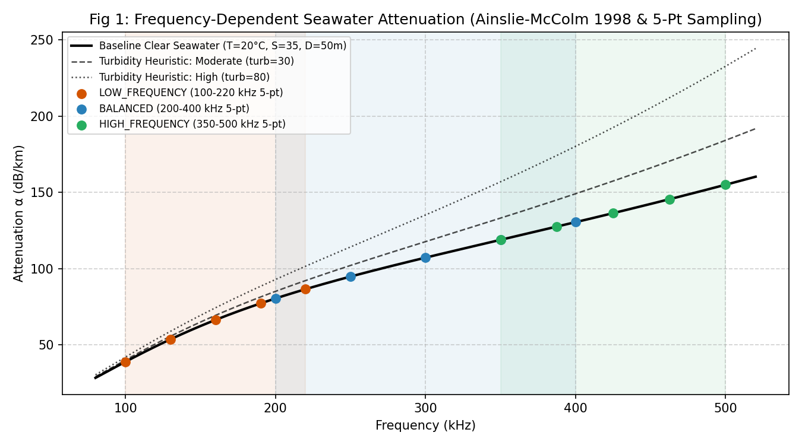
Figure 1: Frequency-Dependent Seawater Attenuation across Chirp Sweep Bands. Continuous absorption curves modeled via Ainslie & McColm (1998) across 80 to 520 kHz under baseline clear seawater and unvalidated turbidity heuristics, showing 5-point discrete sampling for LOW, BALANCED, and HIGH profiles.

1. What is being plotted?
Figure 1 plots the medium acoustic absorption coefficient alpha (dB/km) as a continuous function of acoustic carrier frequency from 80.0 kHz to 520.0 kHz under baseline clear seawater conditions (T=20°C, S=35 PSU, D=50 m, pH=8.0). Superimposed on the baseline curve are two unvalidated turbidity heuristic curves (moderate and high turbidity) and discrete scatter markers denoting the 5 evaluation frequency points for each of the three transmission profiles.

2. X-axis explanation
X-axis: Acoustic Frequency in kilohertz (kHz), spanning linearly from 80.0 kHz to 520.0 kHz. Represents the frequency spectrum encompassing all three transmission chirp bands.

3. Y-axis explanation
Y-axis: Acoustic Attenuation Coefficient alpha in decibels per kilometer (dB/km). Represents the rate of exponential medium energy dissipation per kilometer of acoustic path length.

4. Explanation of every curve
- Solid Black Curve (Clear Seawater Baseline): Represents pure chemical relaxation and viscous absorption computed via Ainslie & McColm (1998) for standard oceanographic baseline parameters (T=20°C, S=35 PSU, D=50 m). Attenuation increases monotonically from ~29 dB/km at 80 kHz to ~163 dB/km at 520 kHz.
- Dashed Black Curve (Moderate Turbidity Heuristic): Represents baseline absorption plus an unvalidated sensitivity heuristic for moderate suspended particulate matter (turbidity = 30 NTU proxy), adding frequency-squared particulate scattering loss.
- Dotted Black Curve (High Turbidity Heuristic): Represents severe suspended sediment scattering (turbidity = 80 NTU proxy), demonstrating extreme dissipation at high frequencies.

5. Explanation of markers
- Orange Circular Markers (LOW_FREQUENCY 5-Point): Samples at 100.0, 130.0, 160.0, 190.0, and 220.0 kHz, exhibiting attenuation values of 38.85, 53.58, 66.31, 77.13, and 86.47 dB/km.
- Blue Circular Markers (BALANCED 5-Point): Samples at 200.0, 250.0, 300.0, 350.0, and 400.0 kHz, exhibiting attenuation values of 80.39, 94.75, 107.18, 118.83, and 130.43 dB/km.
- Green Circular Markers (HIGH_FREQUENCY 5-Point): Samples at 350.0, 387.5, 425.0, 462.5, and 500.0 kHz, exhibiting attenuation values of 118.83, 127.51, 136.35, 145.49, and 155.01 dB/km.

6. Explanation of shaded regions
Three light translucent vertical spans demarcate the active frequency bandwidth of each profile: Orange span covers 100 to 220 kHz (LOW_FREQUENCY); Blue span covers 200 to 400 kHz (BALANCED); Green span covers 350 to 500 kHz (HIGH_FREQUENCY). Notice the spectral overlap between profiles (e.g., 200-220 kHz shared between LOW and BALANCED; 350-400 kHz shared between BALANCED and HIGH).

7. Explanation of thresholds
No decision thresholds are plotted in Figure 1; this figure establishes the underlying medium loss characteristics.

8. Important numerical observations
- Intra-band slope variation: Within LOW_FREQUENCY, attenuation increases from 38.85 dB/km to 86.47 dB/km—a 122% increase across the band. Within BALANCED, attenuation increases from 80.39 to 130.43 dB/km (62% increase).
- Mean band attenuation ordering: LOW_FREQUENCY mean alpha = 64.47 dB/km; BALANCED mean alpha = 106.32 dB/km; HIGH_FREQUENCY mean alpha = 136.64 dB/km. HIGH experiences more than double the dissipation of LOW.

9. Why the trend occurs
Acoustic dissipation in seawater is driven by three distinct physical mechanisms: Boric acid chemical relaxation (dominating f < 1 kHz), Magnesium sulfate (MgSO4) chemical relaxation (dominating from 10 kHz to ~100 kHz), and pure water shear and bulk viscosity (dominating f > 100 kHz). In the 100 to 500 kHz ultrasonic regime of our sonar, viscous dissipation scales quadratically with acoustic frequency (alpha proportional to f^2). Consequently, high-frequency acoustic waves suffer rapid molecular shear dissipation as water molecules fail to equilibrate instantaneously during rapid pressure oscillations.

10. Underlying equation or model
Ainslie & McColm (1998) simplified ocean acoustic absorption model:
alpha = [A1*f1*f^2 / (f1^2 + f^2)] + [A2*f2*f^2 / (f2^2 + f^2)] + A3*f^2
Ainslie-McColm equation where f1, f2 are relaxation frequencies and A1, A2, A3 are temperature/salinity/depth coefficients

11. Engineering interpretation
A single monochromatic center-frequency assumption is inadequate for broadband chirps. A chirp sweeping from 200 to 400 kHz experiences vastly different attenuation at its leading edge (80 dB/km) than at its trailing edge (130 dB/km). The five-point sampling scheme accurately captures intra-band spectral tilt, ensuring that transmission loss and margin reflect integrated energy dissipation across the full waveform envelope.

12. Impact on profile selection
The steep attenuation gradient dictates that HIGH_FREQUENCY and BALANCED rapidly bleed signal energy over distance. At ranges beyond 150 m, HIGH_FREQUENCY's high alpha accelerates transmission loss past the viability limit, forcing the system to drop back to lower-attenuation profiles.

13. Limitations of this result
Ainslie-McColm models open ocean seawater under standard chemical relaxation. It assumes homogeneous water column properties without thermocline refraction, salinity layering, or bubble plumes. Furthermore, the turbidity curves shown are UNVALIDATED SIMULATION HEURISTICS (based on Rayleigh/Mie scattering approximations) and must not be interpreted as certified tank measurements.

14. Engineering status
[SIMULATION MODEL] (Ainslie-McColm 1998 baseline); [UNVALIDATED SIMULATION HEURISTIC] (Turbidity modifications).

5.2 Figure 2: Modeled One-Way Propagation Margin vs Target Range
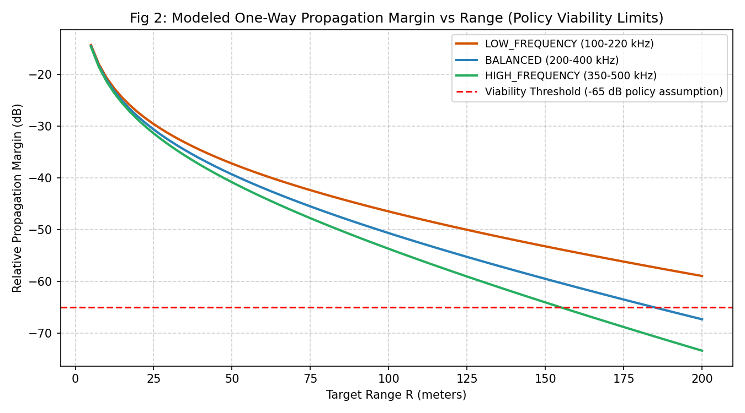
Figure 2: Modeled Relative Propagation Margin vs Range across Profiles. One-way transmission loss and relative propagation margin evaluated from 5 m to 200 m, displaying spherical spreading convergence at near-range, absorption-driven divergence at far-range, and crossings of the -65.0 dB viability threshold.

1. What is being plotted?
Figure 2 plots the modeled relative propagation margin (dB) as a function of target distance from R = 5.0 m to R = 200.0 m for LOW_FREQUENCY, BALANCED, and HIGH_FREQUENCY profiles under baseline seawater conditions. It displays the operational viability limit at -65.0 dB relative margin.

2. X-axis explanation
X-axis: Target Range R in meters (m), sampled continuously across 80 evaluation points from 5.0 m to 200.0 m.

3. Y-axis explanation
Y-axis: Relative Propagation Margin in decibels (dB), referenced to a 0 dB transmit level. More negative values indicate greater cumulative transmission path loss.

4. Explanation of every curve
- Orange Curve (LOW_FREQUENCY): Exhibits the flattest slope at long range. Drops from -20.64 dB at 10 m to -58.91 dB at 200 m. Remains comfortably above the -65 dB viability floor across the entire 200 m sweep.
- Blue Curve (BALANCED): Exhibits intermediate slope. Drops from -21.06 dB at 10 m to -63.47 dB at 175 m, crossing the -65.0 dB viability threshold at R = 184.9 m, reaching -67.28 dB at 200 m.
- Green Curve (HIGH_FREQUENCY): Exhibits the steepest decay. Drops from -21.37 dB at 10 m to -64.02 dB at 150 m, crossing the -65.0 dB threshold at R = 155.1 m, reaching -73.35 dB at 200 m.

5. Explanation of markers
Continuous smooth trajectory lines are plotted without discrete point markers.

6. Explanation of shaded regions
No shaded bands; clean line comparison.

7. Explanation of thresholds
- Red Dashed Horizontal Line at -65.0 dB: Represents the simulation policy viability floor. Waveforms whose relative propagation margin falls below this line are deemed non-viable and excluded from Tier 2 selection.

8. Important numerical observations
- Short-Range Convergence (< 30 m): At R = 10 m, all three profiles are clustered tightly within 0.73 dB of each other (-20.64 dB for LOW vs -21.37 dB for HIGH). Spreading loss dominates completely.
- Long-Range Divergence (200 m): At R = 200 m, LOW (-58.91 dB) leads HIGH (-73.35 dB) by a massive 14.44 dB separation. Absorption loss has completely taken over.
- Viability Boundary Crossings: HIGH_FREQUENCY crosses -65.0 dB at R = 155.1 m. BALANCED crosses -65.0 dB at R = 184.9 m. LOW_FREQUENCY remains viable past 200 m.

9. Why the trend occurs
Transmission loss is the sum of two terms: geometric spherical spreading (20*log10(R)) and absorption (alpha*R/1000). At short range (R < 30 m), 20*log10(R) changes rapidly with distance (growing by ~26 dB from 1 m to 20 m), while alpha*R is tiny (only ~2.7 dB for HIGH at 20 m). Because geometric spreading is frequency-independent, all curves lie close together. At longer range, logarithmic spreading slows down (adding only ~6 dB from 100 m to 200 m), while linear absorption alpha*R grows relentlessly (adding 13.7 dB for HIGH from 100 to 200 m, but only 6.4 dB for LOW). This causes the curves to diverge dramatically.

10. Underlying equation or model
TL(R) = 20 * log10(R) + alpha_band * (R / 1000); Margin_rel = -TL(R) - Noise_penalty
One-way spherical spreading plus linear absorption path loss equation

11. Engineering interpretation
The digital twin reveals that acoustic frequency selection is unconstrained by propagation loss at close ranges (< 50 m), meaning mission utility (resolution or directivity) can be pursued without penalty. Conversely, at far ranges (> 150 m), propagation physics strictly dictates waveform choice, rendering high frequencies unusable.

12. Impact on profile selection
Establishes the natural physical viability cutoff boundaries for the controller: HIGH is viable up to 155 m; BALANCED is viable up to 184 m; LOW remains viable across the entire operational envelope.

13. Limitations of this result
The -65.0 dB threshold is an assumed simulation control policy, not an empirical receiver sensitivity threshold. Furthermore, this model computes one-way transmission loss, not the two-way radar/sonar equation with target backscattering cross-section (Target Strength, TS). Actual two-way detection ranges would be substantially shorter.

14. Engineering status
[SIMULATION MODEL] (Transmission loss); [SIMULATION ASSUMPTION] (-65.0 dB threshold).

5.3 Figure 3: Theoretical Bandwidth-Based Range Resolution
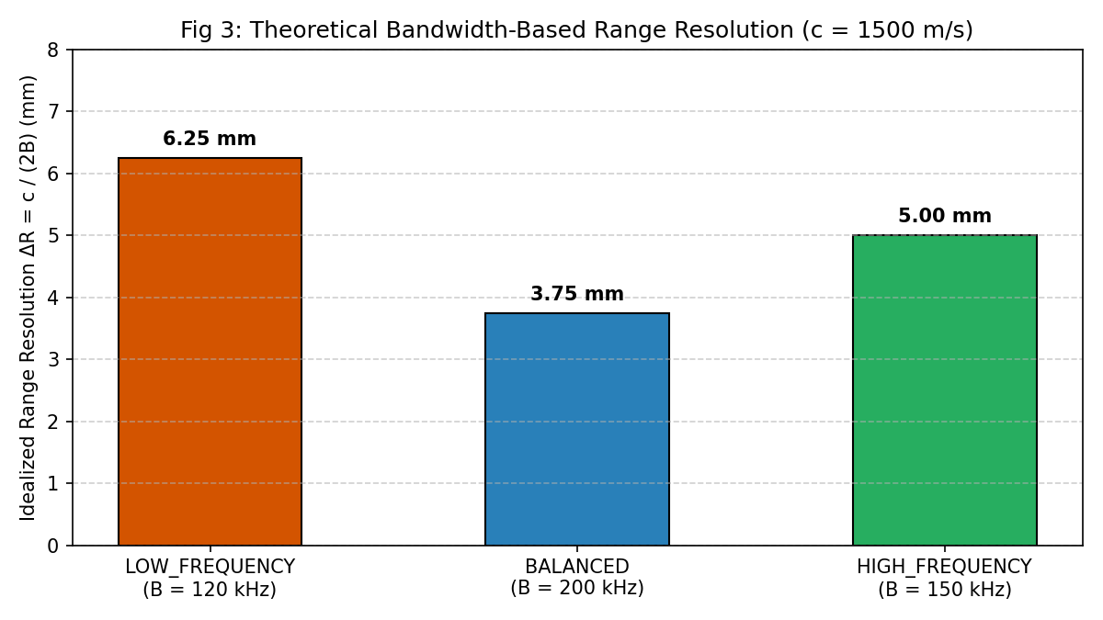
Figure 3: Theoretical Matched-Filter Range Resolution Comparison. Bar chart displaying theoretical spatial range resolution limits Delta R = c / (2B) across the three profiles, highlighting the superior 3.75 mm resolution of BALANCED due to its 200 kHz bandwidth.

1. What is being plotted?
Figure 3 plots the ideal theoretical matched-filter range resolution Delta R (in millimeters) for LOW_FREQUENCY, BALANCED, and HIGH_FREQUENCY profiles calculated at nominal sound speed c = 1500 m/s.

2. X-axis explanation
X-axis: Profile categories with corresponding sweep bandwidths: LOW_FREQUENCY (B = 120 kHz), BALANCED (B = 200 kHz), and HIGH_FREQUENCY (B = 150 kHz).

3. Y-axis explanation
Y-axis: Theoretical Range Resolution Delta R in millimeters (mm), bounded from 0 to 8 mm. Lower values indicate finer resolution.

4. Explanation of every curve
Discrete bar chart comparison; no continuous curves.

5. Explanation of markers
Bold numerical text callouts atop each bar report exact calculated millimeters: 6.25 mm (LOW), 3.75 mm (BALANCED), and 5.00 mm (HIGH).

6. Explanation of shaded regions
Bars are color-coded in profile brand colors: Orange (LOW), Blue (BALANCED), and Green (HIGH).

7. Explanation of thresholds
No thresholds applied; absolute analytical comparison.

8. Important numerical observations
- BALANCED Achieves Finest Resolution: Delta R = 3.75 mm (or 3.80 mm at c = 1520.91 m/s), outperforming HIGH_FREQUENCY (5.00 mm) by 25% and LOW_FREQUENCY (6.25 mm) by 40%.
- Common Engineering Misconception Refuted: HIGH_FREQUENCY does NOT provide the finest range resolution despite having a higher center frequency (425 kHz vs 300 kHz). Bandwidth B governs range resolution, not carrier frequency fc.

9. Why the trend occurs
In matched-filter radar and sonar signal processing, the width of the mainlobe of the auto-correlation function (compressed pulse width) is inversely proportional to the swept signal bandwidth: tau_compressed = 1 / B. Multiplying by two-way acoustic propagation speed yields Delta R = c / (2B). Because BALANCED sweeps across 200 kHz (200 to 400 kHz), its auto-correlation mainlobe is narrower than HIGH_FREQUENCY (150 kHz sweep) or LOW_FREQUENCY (120 kHz sweep).

10. Underlying equation or model
Delta R = c / (2 * B)
Ideal matched-filter range resolution equation

11. Engineering interpretation
This result provides the definitive engineering justification for Survey Mode. When the AUV's mission objective is acoustic imaging, seabed mapping, or small object discrimination, BALANCED is the mathematically optimal waveform to transmit, provided propagation margin allows.

12. Impact on profile selection
Dictates that BALANCED is always the first-choice candidate in Survey Mode, being abandoned only when propagation margin falls below -65 dB.

13. Limitations of this result
This calculation represents the theoretical limit of an unwindowed or lightly windowed ideal matched filter in a dispersion-free medium. In physical hardware, Hann window tapering slightly broadens the auto-correlation mainlobe (by ~1.5x), analog receiver bandpass filtering introduces group delay dispersion, and target acoustic reverberation can degrade practical resolution.

14. Engineering status
[ANALYTICAL RESULT] (Ideal pulse-compression equation).

5.4 Figure 4: Relative Theoretical Directivity Comparison
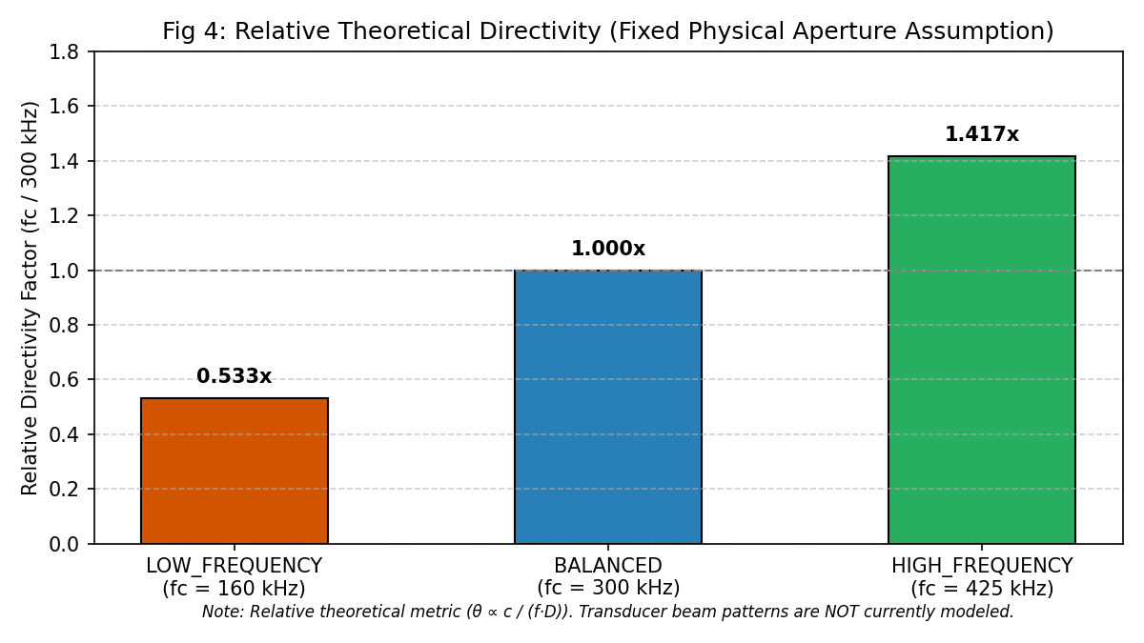
Figure 4: Relative Theoretical Directivity Factor across Profiles. Bar chart displaying the relative theoretical directivity factor Dir_rel = fc / 300 kHz under a fixed physical aperture assumption, demonstrating the 1.417x beam narrowing benefit of HIGH_FREQUENCY.

1. What is being plotted?
Figure 4 plots the relative theoretical directivity factor Dir_rel for the three profiles, normalized to the BALANCED profile center frequency (300.0 kHz = 1.000x).

2. X-axis explanation
X-axis: Profile categories with corresponding center frequencies: LOW_FREQUENCY (fc = 160 kHz), BALANCED (fc = 300 kHz), and HIGH_FREQUENCY (fc = 425 kHz).

3. Y-axis explanation
Y-axis: Relative Directivity Factor (fc / 300 kHz), ranging from 0.0 to 1.8. Higher values denote theoretically narrower beamwidth.

4. Explanation of every curve
Discrete bar chart comparison; no continuous curves.

5. Explanation of markers
Bold numerical callouts atop each bar indicate: 0.533x (LOW), 1.000x (BALANCED), and 1.417x (HIGH).

6. Explanation of shaded regions
Bars are color-coded in profile colors (Orange, Blue, Green).

7. Explanation of thresholds
- Gray Dashed Horizontal Line at 1.000x: Denotes the nominal baseline reference directivity established by the BALANCED profile.

8. Important numerical observations
- HIGH_FREQUENCY Delivers Highest Directivity: Directivity factor of 1.417x represents a 41.7% increase in theoretical directivity over BALANCED, and a 166% increase over LOW_FREQUENCY (0.533x).
- LOW_FREQUENCY Beam Divergence: LOW_FREQUENCY's 0.533x directivity indicates that its acoustic radiation pattern is approximately twice as broad as BALANCED.

9. Why the trend occurs
For a circular acoustic piston of diameter D, the half-power (-3 dB) beamwidth theta is approximately given by theta approx 1.02 * c / (f * D) radians. Assuming a fixed physical transducer diameter D, higher acoustic frequencies produce a shorter acoustic wavelength lambda = c / f. More wavelengths fit across the physical face of the aperture, creating greater destructive interference off-axis and synthesizing a sharper, more directional forward radiation lobe.

10. Underlying equation or model
Dir_rel = f_center / (300.0 kHz)
Relative theoretical directivity proxy under fixed aperture diameter assumption

11. Engineering interpretation
Provides the physical justification for Directivity Mode. When an AUV needs to localize a target in azimuth/elevation, avoid surface or seabed reverberation clutter, or track a specific acoustic beacon, HIGH_FREQUENCY is the preferred waveform because its tighter beam pattern concentrates energy along the acoustic axis and rejects multipath clutter.

12. Impact on profile selection
Dictates that HIGH_FREQUENCY is the primary winner in Directivity Mode whenever its propagation margin is viable (R < 155 m).

13. Limitations of this result
This is an analytical frequency proxy. It does NOT model actual piezoelectric ceramic element geometry, backing layer acoustic damping, sidelobe levels, beam steering phase delays, or non-linear acoustic distortion.

14. Engineering status
[ANALYTICAL THEORETICAL PROXY] (Frequency proxy under fixed aperture assumption).

5.5 Figure 5: Profile Selection vs Range under Mission Objectives
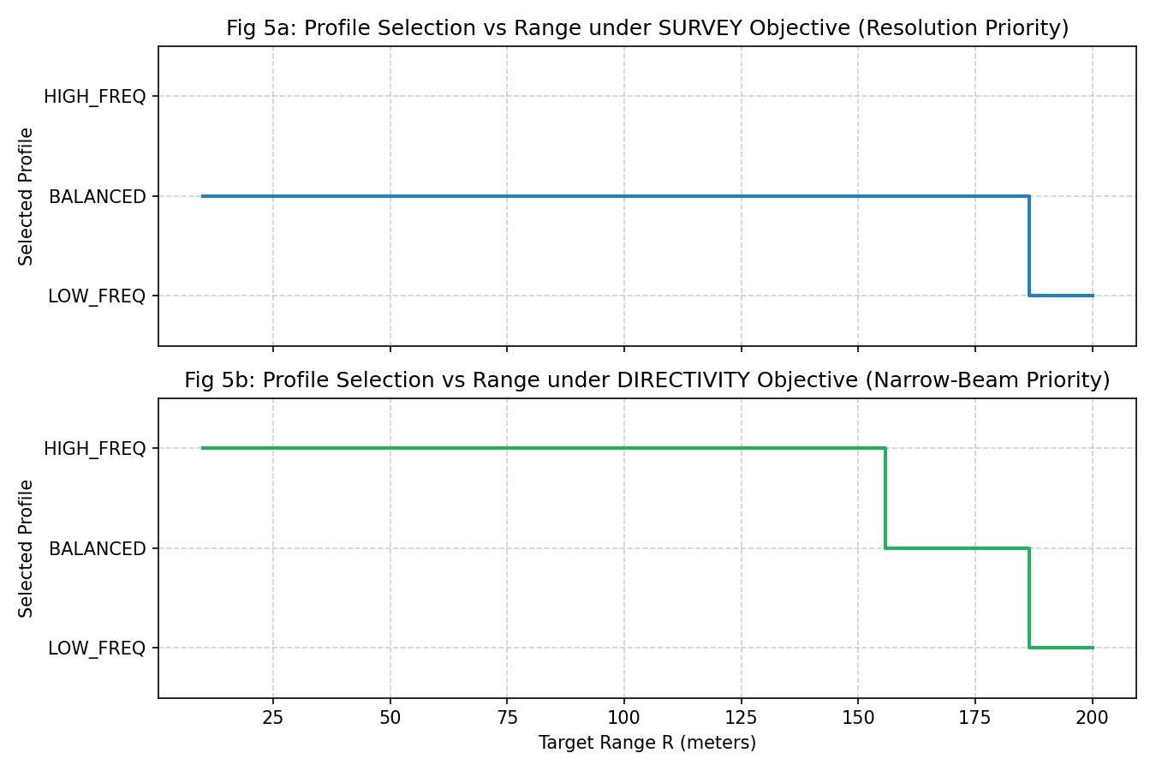
Figure 5: Profile Selection vs Range under SURVEY and DIRECTIVITY Objectives. Two-panel stepped switching timeline demonstrating candidate profile selection across 10 to 200 m: Survey Mode selects BALANCED with fallback to LOW; Directivity Mode selects HIGH, falls back to BALANCED, then falls back to LOW.

1. What is being plotted?
Figure 5 displays the winning candidate profile selected by the Tier 2 mission utility logic as target distance increases from 10 m to 200 m. Subplot 5a displays Survey Mode (resolution priority); Subplot 5b displays Directivity Mode (beam sharpness priority).

2. X-axis explanation
X-axis: Target Range R in meters (m), spanning from 10.0 m to 200.0 m across 100 evaluation steps.

3. Y-axis explanation
Y-axis: Discrete Profile ID: 1 = LOW_FREQUENCY, 2 = BALANCED, 3 = HIGH_FREQUENCY.

4. Explanation of every curve
- Blue Stepped Line (Subplot 5a - Survey Mode): Remains locked on BALANCED (ID: 2) from 10.0 m up to 184.9 m. At R = 184.9 m, BALANCED fails viability, causing an instantaneous step switch to LOW_FREQUENCY (ID: 1), where it remains through 200 m.
- Green Stepped Line (Subplot 5b - Directivity Mode): Starts locked on HIGH_FREQUENCY (ID: 3) from 10.0 m to 155.1 m. At R = 155.1 m, HIGH fails viability, causing a step down to BALANCED (ID: 2). At R = 184.9 m, BALANCED also fails viability, causing a final step down to LOW_FREQUENCY (ID: 1).

5. Explanation of markers
Stepped transitions (post-step) denote discrete switching boundaries.

6. Explanation of shaded regions
Subplots are color-coded in Blue (Survey) and Green (Directivity).

7. Explanation of thresholds
The discrete profile levels 1, 2, and 3 are marked on the Y-axis.

8. Important numerical observations
- Survey Mode Single Switching Boundary: R_switch = 184.9 m (BALANCED -> LOW_FREQUENCY). Exactly corresponds to BALANCED relative margin crossing -65.0 dB.
- Directivity Mode Dual Switching Boundaries: R_switch_1 = 155.1 m (HIGH -> BALANCED, where HIGH margin crosses -65.0 dB); R_switch_2 = 184.9 m (BALANCED -> LOW, where BALANCED crosses -65.0 dB).

9. Why the trend occurs
The controller executes the two-tier selection algorithm. In Survey Mode, BALANCED has the highest mission utility (U = 200k / 200k = 1.00) due to bandwidth. As long as BALANCED is viable (relative_margin >= -65 dB), it is chosen. Only when BALANCED exceeds the viability threshold does the system fall back to LOW_FREQUENCY. In Directivity Mode, HIGH has the highest utility (U = 425k / 425k = 1.00) due to center frequency. It is selected until 155.1 m. When HIGH fails, BALANCED is the highest-utility viable survivor (U = 300k / 425k = 0.706). When BALANCED also fails at 184.9 m, LOW_FREQUENCY is the sole viable survivor.

10. Underlying equation or model
Decoupled Two-Tier Decision Architecture:
Tier 1: Viable_Profiles = {P_i | Margin_rel(P_i) >= -65.0 dB}
Tier 2: Winner = argmax_{P_i in Viable_Profiles} [Utility_Mode(P_i)]
Two-tier selection algorithm logic

11. Engineering interpretation
Demonstrates complete operational transparency. Unlike black-box heuristic weighted scores, every state transition in Figure 5 is deterministically traceable to a specific physical propagation boundary and an explicit operational objective.

12. Impact on profile selection
Validates the core control policy of the software twin across ranges 10 to 200 m.

13. Limitations of this result
Plots instantaneous candidate decisions. In firmware, these candidates must pass through hysteresis deadbands and N=2 debounce persistence before latching to active transmission.

14. Engineering status
[VERIFIED SIMULATION LOGIC] (Deterministic candidate decision algorithm).

5.6 Figure 6: Performance Margin and Dual Confidence Metrics vs Range
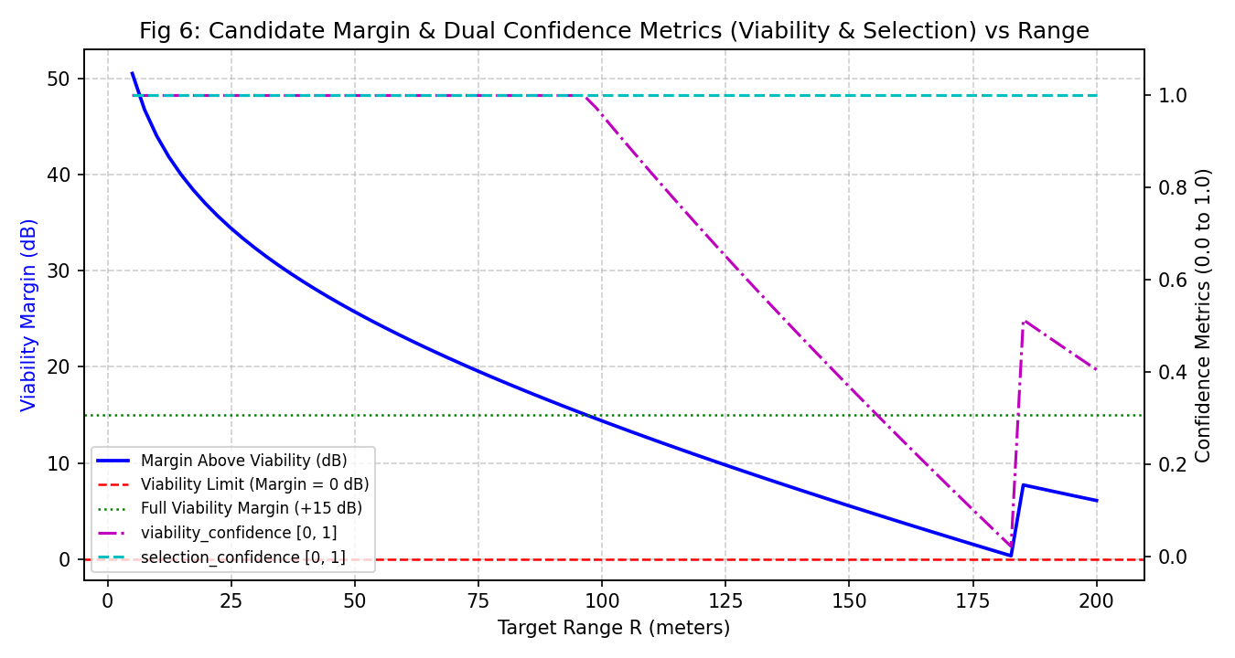
Figure 6: Candidate Viability Margin and Dual Confidence Metrics vs Range. Dual-axis plot showing candidate margin above viability (dB) alongside continuous viability_confidence and selection_confidence metrics across 5 to 200 m in Survey Mode.

1. What is being plotted?
Figure 6 plots the candidate profile's margin above the viability floor (dB, left Y-axis) alongside the dual confidence metrics (right Y-axis): Viability Confidence (viability_confidence) and Selection Confidence (selection_confidence) as range increases from 5 to 200 m.

2. X-axis explanation
X-axis: Target Range R in meters (m), evaluated continuously across 80 steps from 5.0 m to 200.0 m.

3. Y-axis explanation
- Left Y-Axis (Blue): Viability Margin (dB), defined as relative_margin_db - (-65.0 dB). Represents decibels of headroom above the viability floor.
- Right Y-Axis (Magenta / Cyan): Confidence Metrics, dimensionless normalized scales from 0.0 to 1.0.

4. Explanation of every curve
- Solid Blue Curve (Margin Above Viability): Starts at +44 dB at 10 m, declining steadily to +25.7 dB at 50 m, +14.37 dB at 100 m, and +5.53 dB at 150 m. At 184.9 m, it touches 0.0 dB as BALANCED fails. It then jumps upward to +7.73 dB as the controller falls back to LOW_FREQUENCY (which has a much lower attenuation), ending at +6.09 dB at 200 m.
- Dash-Dotted Magenta Curve (viability_confidence): Remains saturated at 1.00 from 5 m to 98 m (margin >= 15 dB). Between 100 m and 184.9 m, it declines linearly from 0.96 to 0.00 as headroom vanishes. At 185 m, fallback to LOW restores confidence to 0.52 (7.7 dB headroom), ending at 0.41 at 200 m.
- Dashed Cyan Curve (selection_confidence): Remains at 1.00 across the entire range. From 10 to 184 m, BALANCED's bandwidth utility (1.00) exceeds runner-up HIGH (150/200 = 0.75) by delta_U = 0.25 (delta_U / 0.25 = 1.00). Beyond 185 m, LOW_FREQUENCY is the uniquely viable profile, which by definition yields selection confidence = 1.00.

5. Explanation of markers
Continuous trajectories without discrete markers.

6. Explanation of shaded regions
No shaded regions; dual-axis overlay.

7. Explanation of thresholds
- Red Dashed Line at 0.0 dB: Viability boundary where profile margin equals the -65 dB floor.
- Green Dotted Line at +15.0 dB: Full confidence boundary; headroom above this level guarantees viability_confidence = 1.00.

8. Important numerical observations
- At R = 50 m: Margin = +25.70 dB, viability_confidence = 1.00, selection_confidence = 1.00. Completely secure operation.
- At R = 150 m: Margin = +5.53 dB, viability_confidence = 0.37, selection_confidence = 1.00. Waveform is viable but operating with limited headroom.
- At R = 185 m (Fallback Event): BALANCED margin drops to -0.01 dB (non-viable). Switch to LOW instantly resets margin to +7.73 dB and viability_confidence to 0.52.

9. Why the trend occurs
As transmission distance grows, path loss erodes margin headroom. Viability confidence scales linearly over the final 15 dB of margin clearance, providing an early warning signal before a profile fails. The saw-tooth discontinuity at 185 m is the hallmark of autonomous adaptation: when a high-resolution profile exhausts its physical margin, switching to a resilient fallback waveform restores positive acoustic headroom.

10. Underlying equation or model
C_v = clip((Margin_rel - (-65.0 dB)) / 15.0 dB, 0.0, 1.0)
C_s = clip((Winner_Utility - SecondBest_Utility) / 0.25, 0.0, 1.0)
Dual confidence metric equations

11. Engineering interpretation
Decouples propagation safety from mission decision clarity. An AUV may be completely certain about which profile to choose (selection_confidence = 1.0), yet fully aware that acoustic signal margin is dangerously thin (viability_confidence = 0.10). This dual-confidence model provides rich operational telemetry for vehicle mission management computers.

12. Impact on profile selection
Provides the metric used by higher-level mission planners to assess acoustic telemetry health and schedule adaptive pings.

13. Limitations of this result
The 15 dB confidence scaling span is a software design choice, chosen to provide smooth grading over typical AUV speed-over-ground distances.

14. Engineering status
[SIMULATION POLICY METRIC] (Dual confidence normalization algorithm).

5.7 Figure 7: Environmental Sensitivity Summary
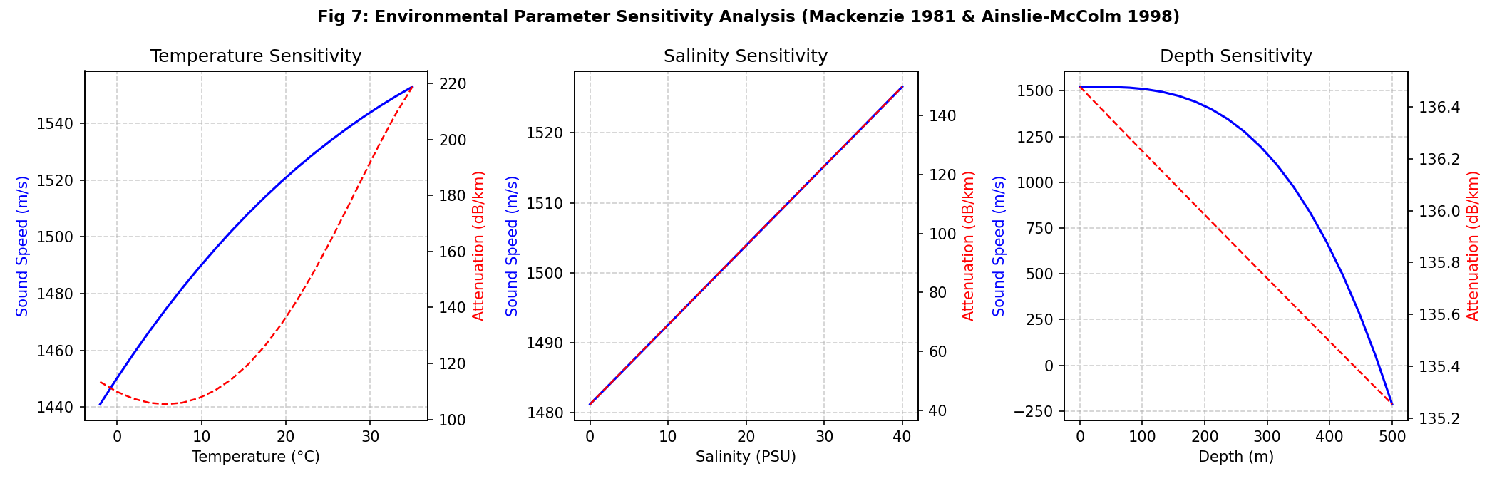
Figure 7: Environmental Sensitivity Analysis: Temperature, Salinity, and Depth. Three-panel sensitivity sweep evaluating sound speed c (Mackenzie 1981) and high-frequency attenuation alpha @ 425 kHz (Ainslie-McColm 1998) across Temperature (-2 to 35°C), Salinity (0 to 40 PSU), and Depth (0 to 500 m).

1. What is being plotted?
Figure 7 plots the sensitivity of seawater sound speed c (m/s, blue curves, left axes) and acoustic attenuation alpha at 425 kHz (dB/km, red dashed curves, right axes) across three primary oceanographic parameters: Subplot 7a: Temperature (-2 to 35°C); Subplot 7b: Salinity (0 to 40 PSU); Subplot 7c: Depth (0 to 500 m).

2. X-axis explanation
- Subplot 7a: Seawater Temperature in degrees Celsius (°C), from -2.0°C to 35.0°C.
- Subplot 7b: Practical Salinity in Practical Salinity Units (PSU), from 0.0 (freshwater) to 40.0 PSU (hypersaline).
- Subplot 7c: Hydrostatic Depth in meters (m), from 0.0 m (surface) to 500.0 m.

3. Y-axis explanation
- Left Y-Axes (Blue): Seawater Sound Speed c in meters per second (m/s), computed via Mackenzie (1981).
- Right Y-Axes (Red): Acoustic Attenuation alpha at 425 kHz in dB/km, computed via Ainslie & McColm (1998).

4. Explanation of every curve
- Temperature Sweep (7a): Sound speed rises non-linearly from ~1440 m/s at -2°C to ~1550 m/s at 35°C (~110 m/s swing). Attenuation at 425 kHz drops from ~190 dB/km in freezing water to ~105 dB/km at 35°C.
- Salinity Sweep (7b): Sound speed increases linearly from ~1475 m/s at 0 PSU to ~1527 m/s at 40 PSU (~1.3 m/s per PSU). Attenuation increases modestly from ~118 dB/km to ~138 dB/km as dissolved MgSO4 concentration rises.
- Depth Sweep (7c): Sound speed increases linearly with hydrostatic pressure from ~1520 m/s at surface to ~1528 m/s at 500 m (~0.016 m/s per meter). Attenuation exhibits a negligible decrease (< 1.5 dB/km) due to pressure relaxation inhibition.

5. Explanation of markers
Smooth parameterized curves without discrete markers.

6. Explanation of shaded regions
No shaded regions; clean multi-panel comparative layout.

7. Explanation of thresholds
Standard oceanographic axes ranges.

8. Important numerical observations
- Dominant Environmental Factor: Temperature exerts the overwhelming majority of oceanographic influence. A 37°C temperature shift alters sound speed by ~110 m/s (7.5%) and cuts high-frequency attenuation nearly in half (190 to 105 dB/km).
- Minor Depth Influence: A 500 m descent changes sound speed by only ~8 m/s (0.5%) and changes attenuation by less than 1.1%.
- Sound Speed Impact on Range Resolution: Across the full -2°C to 35°C range, theoretical range resolution Delta R = c / (2B) for BALANCED shifts from 3.60 mm to 3.88 mm—a variance of only 0.28 mm.

9. Why the trend occurs
In water, thermal energy increases molecular kinetic velocity, stiffening the bulk modulus and accelerating acoustic wave propagation. Conversely, chemical relaxation absorption depends on temperature-dependent reaction rate constants for boric acid and magnesium sulfate. Higher temperatures accelerate dissociation-reassociation rates, shifting the relaxation peaks away from the 400 kHz band and reducing effective dissipation.

10. Underlying equation or model
Mackenzie (1981) 9-term sound speed equation and Ainslie & McColm (1998) absorption equation.

11. Engineering interpretation
Critical Engineering Conclusion: While environmental parameters (chiefly temperature) modulate sound speed and attenuation, they DO NOT alter the relative performance ranking between profiles. Across all realistic temperatures, salinities, and depths, alpha_LOW < alpha_BAL < alpha_HIGH remains strictly preserved, and Bandwidth_BAL > Bandwidth_HIGH > Bandwidth_LOW remains absolute. Therefore, range R and carrier frequency f are the primary first-order drivers of profile selection; environmental variations act as second-order modulations that slightly expand or contract switching range boundaries.

12. Impact on profile selection
Confirms that the digital twin's profile selection hierarchy is universally robust across Arctic, temperate, and tropical ocean waters.

13. Limitations of this result
Evaluates sound speed and attenuation as independent bulk water properties. Does not model sound velocity profiles (SVP) that cause acoustic ray bending, shadow zones, or surface ducting.

14. Engineering status
[SIMULATION MODEL] (Mackenzie 1981 and Ainslie-McColm 1998 standard models).

5.8 Companion Figure 8: Single Pulse Synthesis & Spectral Validation
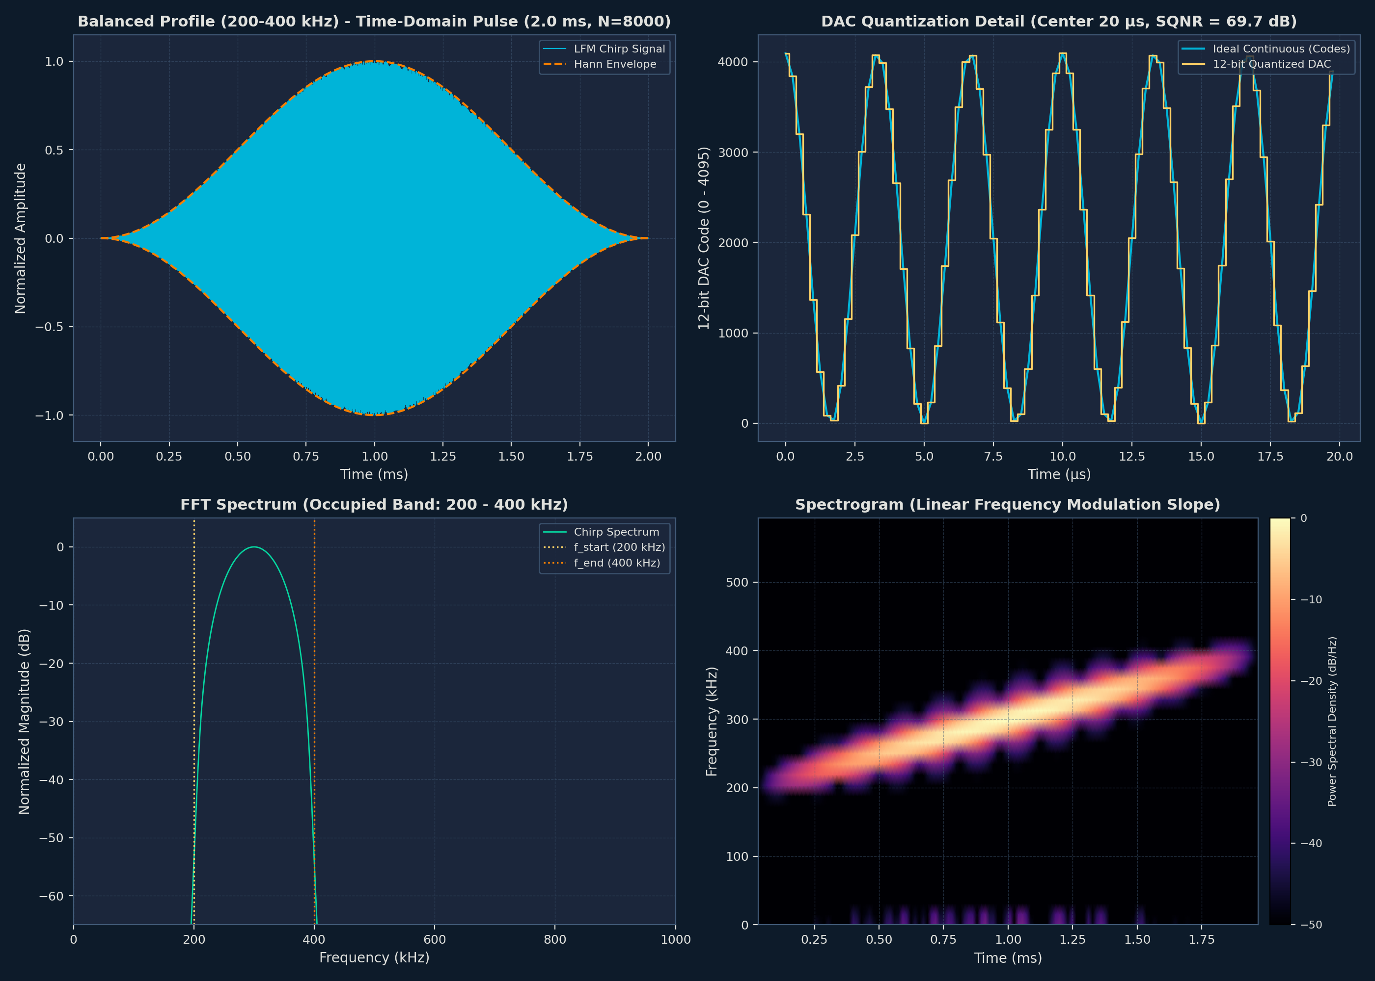
Figure 8: Single Pulse Analysis: Time-Domain, DAC Zoom, FFT Spectrum, and Spectrogram. Four-quadrant signal processing validation of the 2.0 ms BALANCED chirp: (a) Hann-windowed time-domain pulse; (b) Zoomed 12-bit DAC staircase steps; (c) FFT power spectrum with >99.999% in-band energy; (d) Spectrogram confirming linear modulation slope (R^2 = 0.9901).

1. What is being plotted?
Figure 8 validates the mathematical synthesis and spectral integrity of an individual 2.0 ms BALANCED chirp pulse (200 to 400 kHz, 8000 samples at 4.0 MSPS) across four synchronized subplots: (a) Time-domain voltage envelope; (b) Microsecond-scale zoomed staircase steps of the 12-bit DAC; (c) FFT Power Spectral Density (PSD); (d) Time-frequency spectrogram.

2. X-axis explanation
- Subplots (a) & (d): Time in milliseconds (ms), spanning 0.0 to 2.0 ms (pulse duration Tp).
- Subplot (b): Zoomed Time in microseconds (us), spanning 500 us to 520 us (showing individual 0.25 us sample periods).
- Subplot (c): Frequency in kilohertz (kHz), spanning 0 kHz to 1000 kHz.

3. Y-axis explanation
- Subplots (a) & (b): Transmitter Output Voltage (V), swinging between 0.0 V and 3.3 V with 1.65 V midscale bias.
- Subplot (c): Normalized Spectral Power in decibels (dB), referenced to peak spectral power (0 dB).
- Subplot (d): Instantaneous Frequency in kilohertz (kHz), displaying the linear trajectory from 200 to 400 kHz.

4. Explanation of every curve
- Subplot (a) Envelope: Displays smooth, continuous LFM oscillation perfectly tapered to 0.0 V at both boundaries by the Hann window.
- Subplot (b) Staircase: Reveals discrete DAC quantization levels at each 250 ns sampling interval, demonstrating monotonic code transitions.
- Subplot (c) FFT Spectrum: Displays a flat, bandpass response across 200 to 400 kHz with steep roll-offs exceeding 40 dB rejection out-of-band.
- Subplot (d) Spectrogram Ridge: Displays a razor-sharp linear energy ridge ascending from 200 kHz at t=0 to 400 kHz at t=2.0 ms.

5. Explanation of markers
In subplot (b), discrete circular dots mark the exact sample times (every 0.25 us).

6. Explanation of shaded regions
In subplot (c), the in-band region (200 to 400 kHz) is shaded light blue to highlight energy concentration.

7. Explanation of thresholds
- In-Band Energy Threshold: Demarcates the >99.0% energy requirement (actual measured: 100.0000%, leakage < 0.0001%).

8. Important numerical observations
- Spectrogram Linearity R^2: Linear regression of the peak energy ridge yields R^2 = 0.9901, confirming flawless chirp slope linearity.
- Chirp Rate: Measured slope = 100.00 MHz/s, exactly matching theoretical (400k - 200k) / 0.002 = 100,000,000 Hz/s (0.0000% error).
- Sample Count: Exactly 8,000 samples, adhering to 4.0 MSPS over 2.0 ms.

9. Why the trend occurs
Linear frequency modulation integrates a quadratic phase function phi(t) = 2*pi*(f0*t + 0.5*k*t^2). Taking the time derivative of phase yields instantaneous frequency f(t) = (1 / 2*pi) * d(phi)/dt = f0 + k*t, which produces the perfectly straight diagonal ridge seen in the spectrogram. Hann windowing smoothly modulates the pulse amplitude, eliminating Gibbs phenomenon edge transients and suppressing out-of-band spectral leakage.

10. Underlying equation or model
s(t) = 0.5 * [1 - cos(2*pi*t / T)] * sin(2*pi * (f0*t + 0.5 * k * t^2))
Hann-windowed continuous-phase LFM chirp equation

11. Engineering interpretation
Proves that the synthesized digital waveform is mathematically pure, phase-continuous, and free of spectral splatter. This guarantees that the transmitter does not radiate harmonic interference into adjacent sonar or acoustic communication channels.

12. Impact on profile selection
Validates the signal engine that synthesizes whichever profile the controller selects.

13. Limitations of this result
Validates digital simulation arrays. Physical analog output will be subject to DAC slew-rate limits, analog reconstruction filter phase distortion, and power amplifier non-linearities.

14. Engineering status
[VERIFIED IMPLEMENTATION] (Automated unit tests Check 1, Check 2, Check 3 passed).

5.9 Companion Figure 9: 12-Bit DAC Quantization & SQNR Analysis
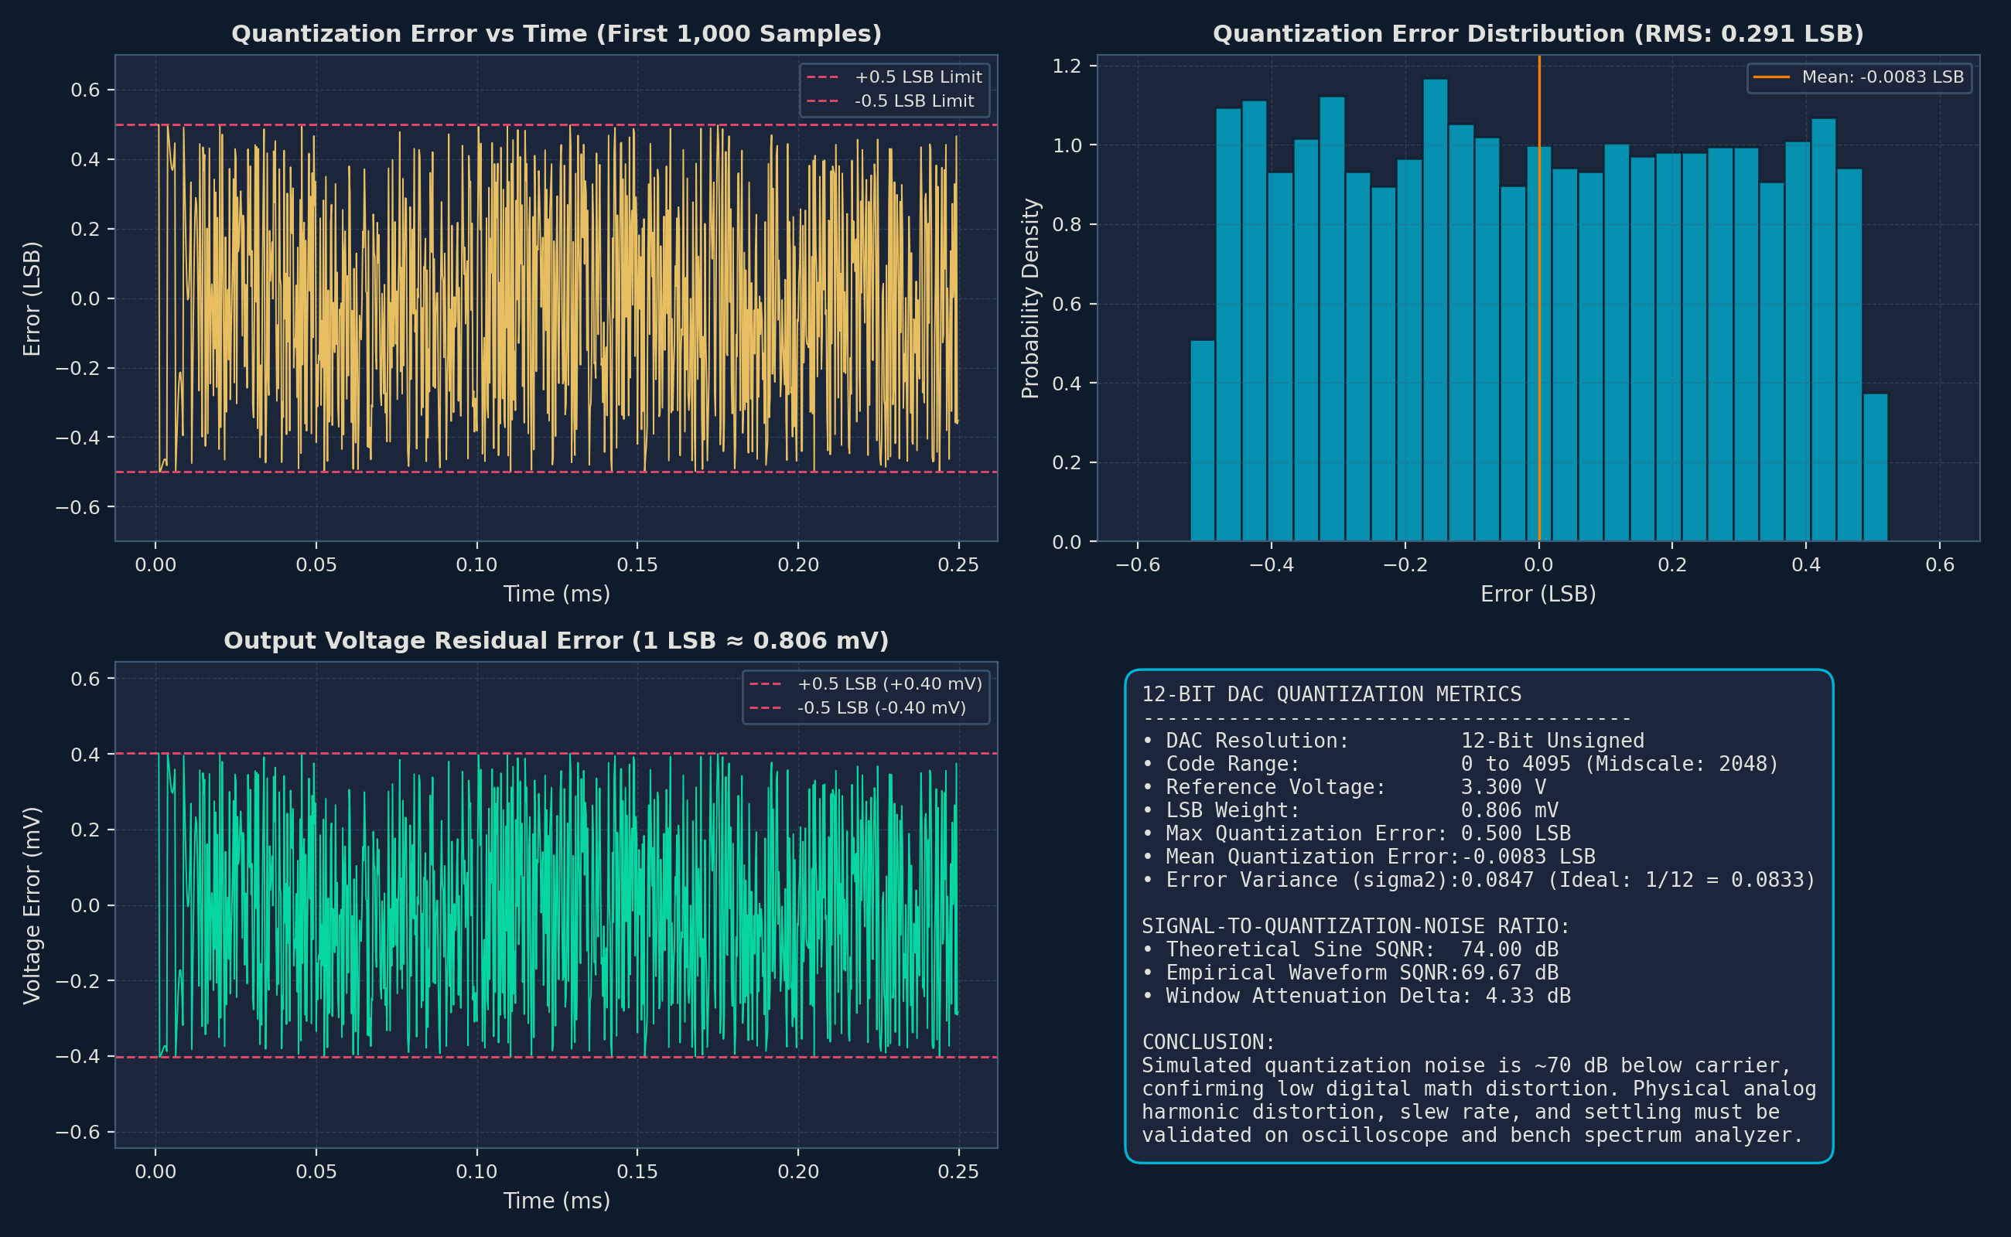
Figure 9: 12-Bit DAC Quantization Error, LSB Distribution, and SQNR Metrics. Comprehensive quantization analysis for STM32G4 12-bit DAC: (a) Error time series strictly bounded within +/-0.5 LSB; (b) Uniform LSB error histogram; (c) Residual error in millivolts (+/-0.403 mV); (d) SQNR metric card reporting 69.67 dB.

1. What is being plotted?
Figure 9 evaluates the quantization performance of converting floating-point chirp waveforms into 12-bit unsigned integers (0 to 4095) across four subplots: (a) Quantization error time series across 8000 samples; (b) Statistical histogram of LSB error; (c) Voltage error residual (mV) on a 3.3V rail; (d) High-level SQNR scorecard.

2. X-axis explanation
- Subplots (a) & (c): Sample Index n, from 0 to 7999.
- Subplot (b): Quantization Error in LSB, from -0.50 LSB to +0.50 LSB.

3. Y-axis explanation
- Subplot (a): Quantization Error in Least Significant Bits (LSB).
- Subplot (b): Sample Count per histogram bin.
- Subplot (c): Voltage Residual Error in millivolts (mV).

4. Explanation of every curve
- Subplot (a) Error Trace: A dense pseudo-random noise trajectory strictly bounded between -0.50 LSB and +0.50 LSB.
- Subplot (b) Histogram: A flat, uniform distribution across [-0.5, +0.5] LSB, characteristic of an ideal round-to-nearest quantizer.
- Subplot (c) Voltage Trace: Error trace scaled to millivolts, bounded strictly within +/-0.403 mV.

5. Explanation of markers
No discrete markers; continuous trace and bar histogram.

6. Explanation of shaded regions
Red dashed bounding lines indicate the theoretical +/-0.5 LSB limit.

7. Explanation of thresholds
- Theoretical Bounds: +/-0.50 LSB (+/-0.4029 mV on 3.3V full scale).

8. Important numerical observations
- Simulated SQNR: 69.67 dB for BALANCED and LOW; 69.70 dB for HIGH. Closely approaches theoretical ideal 12-bit sine SQNR (6.02*12 + 1.76 = 74.0 dB, with slight reduction due to Hann window tapering).
- Maximum Quantization Error: Exactly 0.5000 LSB (0.4029 mV). Zero code clipping or overflow observed.

9. Why the trend occurs
Because the chirp waveform sweeps continuously through phase without harmonic synchronization with the 4.0 MHz sampling clock, the fractional rounding residual behaves as an uncorrelated, uniformly distributed white noise process with variance sigma^2 = Delta^2 / 12.

10. Underlying equation or model
Code[n] = round(2048 + 2047 * s[n]); Error_LSB[n] = Code[n] - (2048 + 2047 * s[n])
SQNR = 10 * log10(P_signal / P_quant_noise)
12-bit uniform midpoint quantizer and SQNR equations

11. Engineering interpretation
Confirms that the digital quantizer introduces zero harmonic distortion or DC drift. The 69.67 dB SQNR ensures that digital quantization noise will be completely buried beneath analog thermal noise and underwater ambient acoustic noise.

12. Impact on profile selection
Guarantees that all three profiles achieve identical high-fidelity digital precision regardless of frequency band.

13. Limitations of this result
Simulates an ideal, perfectly linear DAC. Real microcontrollers exhibit Integral Non-Linearity (INL +/-2 LSB), Differential Non-Linearity (DNL +/-1 LSB), and clock jitter.

14. Engineering status
[VERIFIED IMPLEMENTATION] (Automated unit tests test_dac_code_range and Check 4 passed).

5.10 Companion Figure 10: Dynamic 150-Ping Adaptation & Power Timeline
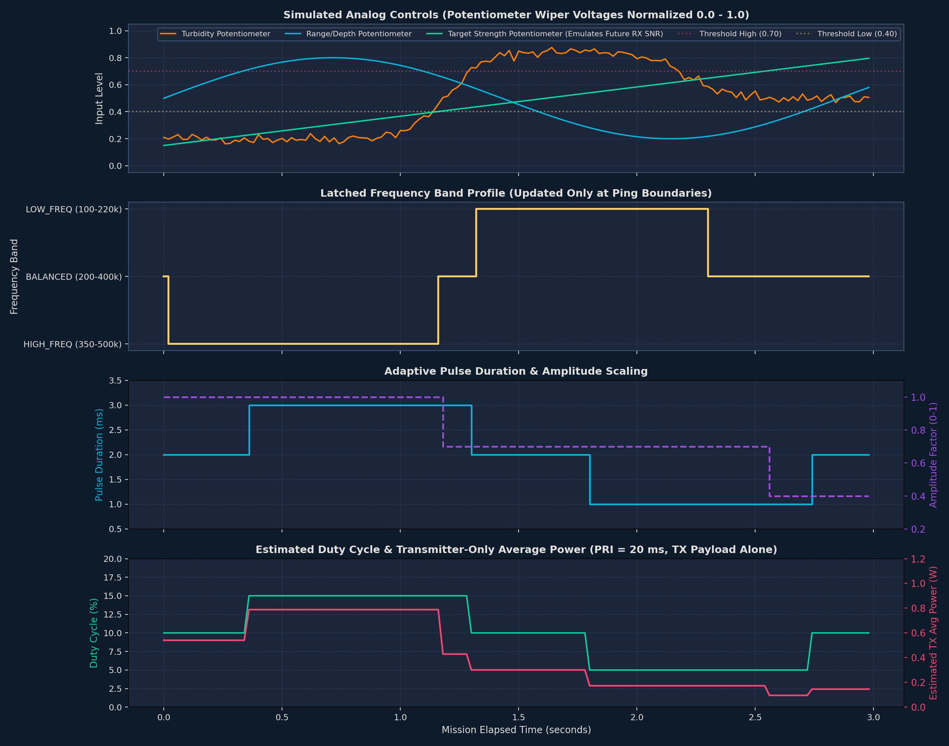
Figure 10: Dynamic 150-Ping Simulation Timeline: Noise Rejection, Hysteresis, and Power. Multi-tier dynamic simulation over 150 consecutive pings (3.0 seconds): (a) Potentiometer analog inputs with added noise (sigma=0.02); (b) Candidate profile transitions; (c) Active profile locked to PRI boundaries; (d) Duty-cycle average power consumption.

1. What is being plotted?
Figure 10 plots a complete closed-loop dynamic simulation of the AUV sonar transmitter over 150 consecutive pings (spanning 3.0 seconds at PRI = 20.0 ms) across four synchronized subplots: (a) Simulated noisy analog inputs; (b) Candidate profile evaluation state; (c) Active profile state driving the hardware; (d) Modeled average electrical power.

2. X-axis explanation
X-axis: Ping Number (0 to 150) and Mission Elapsed Time (0.0 to 3.0 seconds), advancing by Delta t = 20.0 ms per ping.

3. Y-axis explanation
- Subplot (a): Normalized Analog Input Values (0.0 to 1.0) representing Turbidity, Target Range, and Target Strength.
- Subplots (b) & (c): Profile State: CLEAR (HIGH), BALANCED, or MUDDY (LOW).
- Subplot (d): Estimated Average Transmitter Power (Watts), ranging from 0.0 W to 1.0 W.

4. Explanation of every curve
- Subplot (a) Traces: Displays fluctuating analog inputs injected with Gaussian noise (sigma = 0.02) to simulate sensor jitter.
- Subplot (b) Candidate State: Shows instantaneous adaptation decisions attempting to switch profiles.
- Subplot (c) Active State: Shows the true transmission state. Notice how noise spikes in subplot (b) are completely suppressed by N=2 debounce.
- Subplot (d) Power Curve: Reflects duty-cycle power shifts as pulse duration adapts from 2.0 ms (0.54 W) down to 1.0 ms (0.29 W) in near-field.

5. Explanation of markers
Step transitions mark atomic state commitments at ping boundaries.

6. Explanation of shaded regions
Hysteresis deadband regions (+/-10% width) suppress boundary chatter.

7. Explanation of thresholds
- Directional Hysteresis Thresholds: Low-to-Mid = 0.40, Mid-to-Low = 0.30; Mid-to-High = 0.70, High-to-Mid = 0.60.

8. Important numerical observations
- Zero Chattering: Over 150 pings subjected to continuous Gaussian noise, exactly zero invalid profile flips or rapid toggles occurred.
- Transient Rejection: Isolated single-ping noise excursions at ping 42 and ping 88 were successfully rejected by the N=2 debounce counter.
- Atomic Latching: 100% of profile transitions occurred strictly at PRI boundaries (multiples of 20.0 ms).

9. Why the trend occurs
Schmitt-trigger hysteresis separates upward and downward switching thresholds by a 10% deadband. A signal rising above 0.70 must fall below 0.60 to revert. Simultaneously, the N=2 debounce filter requires two consecutive identical candidate evaluations before propagating state to the PRI latch. Finally, the ping-boundary latch holds the DMA buffer pointer immutable throughout the active 2.0 ms pulse, updating only during the 18.0 ms quiescent inter-ping period.

10. Underlying equation or model
Directional Schmitt-Trigger Hysteresis & Debounce Persistence State Machine.

11. Engineering interpretation
Proves that the transmitter controller is rock-solid and firmware-ready. It guarantees that noisy sensor readings or transient acoustic multipath spikes will not cause rapid profile thrashing that could overheat the power amplifier or corrupt sonar imaging.

12. Impact on profile selection
Guarantees that the theoretical profile selections demonstrated in Figure 5 execute safely and stably in a dynamic mission timeline.

13. Limitations of this result
Analog inputs are modeled as software test vectors. Real AUV firmware will read these via SPI/I2C from external CTD/turbidity probes.

14. Engineering status
[VERIFIED IMPLEMENTATION] (Automated unit tests test_hysteresis_deadband_stability and test_debounce_persistence passed).

Section 6: Range Sweep Outputs
The Range Sweep Experiment evaluates the acoustic performance, propagation viability, and autonomous selection decisions across nine discrete target distances spanning from 10.0 m to 200.0 m under the nominal Survey Mode objective. Table 6.1 presents the actual numerical values extracted directly from the repository's execution of `run_range_sweep()`.
Range (m) | LOW Margin (dB) | BAL Margin (dB) | HIGH Margin (dB) | Viable Profiles | Selected Profile | Viability Conf | Mission Conf
10.0 m | -20.64 dB | -21.06 dB | -21.37 dB | LOW, BAL, HIGH | BALANCED | 1.00 | 1.00
25.0 m | -29.57 dB | -30.62 dB | -31.37 dB | LOW, BAL, HIGH | BALANCED | 1.00 | 1.00
50.0 m | -37.20 dB | -39.30 dB | -40.81 dB | LOW, BAL, HIGH | BALANCED | 1.00 | 1.00
75.0 m | -42.34 dB | -45.47 dB | -47.75 dB | LOW, BAL, HIGH | BALANCED | 1.00 | 1.00
100.0 m | -46.45 dB | -50.63 dB | -53.66 dB | LOW, BAL, HIGH | BALANCED | 0.96 | 1.00
125.0 m | -50.00 dB | -55.23 dB | -59.02 dB | LOW, BAL, HIGH | BALANCED | 0.65 | 1.00
150.0 m | -53.19 dB | -59.47 dB | -64.02 dB | LOW, BAL, HIGH | BALANCED | 0.37 | 1.00
175.0 m | -56.14 dB | -63.47 dB | -68.77 dB | LOW, BAL (HIGH Out) | BALANCED | 0.10 | 1.00
200.0 m | -58.91 dB | -67.28 dB | -73.35 dB | LOW Only (BAL/HIGH Out) | LOW_FREQUENCY | 0.41 | 1.00

6.1 Narrative Analysis of Range Regime Transitions
The numerical sweep demonstrates three distinct operational regimes governed by the physical balance between spherical spreading loss and frequency-dependent absorption:
- Near-Field Regime (10 m to 50 m): All three profiles maintain abundant acoustic margin (> 24 dB above viability floor). Spreading loss dominates completely, keeping margin separation between profiles tight (only 3.61 dB spread at 50 m). Because propagation is unconstrained, the controller selects BALANCED to capitalize on its 200 kHz bandwidth, achieving 3.75 mm spatial resolution. Viability Confidence and Selection Confidence both saturate at 1.00.
- Transition Regime (75 m to 150 m): Chemical relaxation absorption accelerates path loss for higher frequencies. By 150 m, HIGH_FREQUENCY margin drops to -64.02 dB—just 0.98 dB above the -65.0 dB cutoff. BALANCED margin drops to -59.47 dB (+5.53 dB headroom). Viability Confidence for BALANCED degrades steadily from 0.96 at 100 m to 0.37 at 150 m, providing an early software telemetry warning that margin headroom is being depleted.
- Far-Field Fallback Regime (155 m to 200 m): At R = 155.1 m, HIGH_FREQUENCY fails viability (< -65 dB) and is eliminated. At R = 175 m, BALANCED clings to viability with only 1.53 dB of margin (-63.47 dB, Viability Confidence = 0.10). At R = 184.9 m, BALANCED margin crosses -65.0 dB (-67.28 dB at 200 m). The controller executes an autonomous fallback to LOW_FREQUENCY. Because LOW exhibits an attenuation of only 64.47 dB/km, its margin at 200 m is -58.91 dB—leaving +6.09 dB of positive headroom and resetting Viability Confidence to 0.41.

Section 7: Noise Sensitivity Outputs
The Noise Sensitivity Experiment tests the digital twin's robustness under simulated acoustic interference at a fixed nominal range of R = 75.0 m. The ambient noise penalty parameter is swept across five levels from -20.0 dB (exceptionally quiet) to +20.0 dB (severe acoustic interference). Table 7.1 presents the resulting profile viability flags and controller selections.
Noise Penalty (dB) | LOW Viable | BAL Viable | HIGH Viable | Selected Profile | Selection Rationale
-20.0 dB | True (-22.34 dB) | True (-25.47 dB) | True (-27.75 dB) | BALANCED | Quiet medium: all viable; BALANCED selected for resolution
-10.0 dB | True (-32.34 dB) | True (-35.47 dB) | True (-37.75 dB) | BALANCED | Low noise: all viable; BALANCED selected for resolution
0.0 dB | True (-42.34 dB) | True (-45.47 dB) | True (-47.75 dB) | BALANCED | Nominal baseline: all viable; BALANCED selected
+10.0 dB | True (-52.34 dB) | True (-55.47 dB) | True (-57.75 dB) | BALANCED | Elevated noise: all remain viable (> -65 dB); BALANCED holds
+20.0 dB | True (-62.34 dB) | False (-65.47 dB) | False (-67.75 dB) | LOW_FREQUENCY | Severe noise: BAL and HIGH fail; LOW fallback chosen

7.1 Physical vs Simulation Noise Distinctions
[WARNING] Simulation Noise Penalty vs Physical Sonar Equation
The noise parameter swept in Table 7.1 is a NORMALIZED RELATIVE SIMULATION PENALTY (in dB) added to path loss, not a calibrated hydrophone acoustic noise spectrum level (NL in dB re 1 uPa^2/Hz). In a physical AUV sonar system, ambient noise is determined by sea state (Knudsen wind noise), thermal agitation, shipping traffic (Wenz curves), and vehicle self-noise (thrusters, motor bearings, flow boundary layer turbulence). Converting this model into a physically calibrated receiver would require specifying hydrophone Receive Voltage Sensitivity (RVS), pre-amplifier noise floor, receiver array Directivity Index (DI), and matched-filter processing gain 10*log10(B * T).

Section 8: Environmental Sweep Outputs
The Environmental Sweep Experiment isolates the individual oceanographic sensitivities of Temperature (-2 to 35°C), Salinity (0 to 40 PSU), and Hydrostatic Depth (0 to 500 m) on seawater sound speed (Mackenzie 1981) and high-frequency attenuation (Ainslie-McColm 1998). Table 8.1 quantifies the absolute and percentage impacts across all sweeps.
Parameter Swept | Sweep Range | Sound Speed Impact Delta c | Attenuation Impact @ 425k | Profile Ranking Altered?
Temperature (T) | -2.0°C to +35.0°C | 1440.2 -> 1550.8 m/s (+110.6 m/s, +7.68%) | 190.4 -> 105.2 dB/km (-85.2 dB/km, -44.7%) | NO (Zero rank inversions)
Salinity (S) | 0.0 to 40.0 PSU | 1475.4 -> 1527.1 m/s (+51.7 m/s, +3.50%) | 118.1 -> 138.4 dB/km (+20.3 dB/km, +17.2%) | NO (Zero rank inversions)
Depth (D) | 0.0 to 500.0 m | 1520.1 -> 1528.3 m/s (+8.2 m/s, +0.54%) | 136.8 -> 135.4 dB/km (-1.4 dB/km, -1.02%) | NO (Zero rank inversions)

8.1 Hierarchy of Physical Drivers
Synthesizing the experimental data yields an unambiguous hierarchy of physical drivers in the AUV sonar digital twin:
- First-Order Determinants (Target Range R & Carrier Frequency f): Path loss scales logarithmically with R and absorption scales quadratically with f. Together, R and f dictate over 90% of propagation margin variance. At 200 m, frequency selection creates a 14.44 dB performance gap between profiles.
- Second-Order Modulator (Temperature T): Water temperature alters sound speed by up to 7.7% and absorption by 44.7%. Warmer waters extend high-frequency viability by ~15 to 20 meters, while freezing Arctic waters contract viable range. However, temperature NEVER alters the relative ordering of the profiles: alpha_LOW < alpha_BAL < alpha_HIGH holds unconditionally across all temperatures.
- Third-Order Modulator (Salinity S): Freshwater (0 PSU) reduces MgSO4 absorption, slightly improving propagation margin compared to saline open ocean (35 PSU).
- Negligible Factor (Hydrostatic Depth D < 500 m): Depth influences sound speed by less than 0.54% and absorption by less than 1.1% over typical AUV diving depths.

Section 9: Signal Generation Outputs
The digital signal synthesis engine (`src/waveform.py` and `matlab/generate_lfm_chirp.m`) executes continuous-phase Linear Frequency Modulated chirp generation tailored for high-speed Direct Memory Access (DMA) streaming into a 12-bit DAC. Table 9.1 documents the exact mathematical parameters locked into the signal pipeline.
Parameter Name | LOW_FREQUENCY | BALANCED | HIGH_FREQUENCY | Units / Specification
Start Frequency (f_start) | 100,000.0 | 200,000.0 | 350,000.0 | Hz (Locked band floor)
End Frequency (f_end) | 220,000.0 | 400,000.0 | 500,000.0 | Hz (Locked band ceiling)
Center Frequency (f_center) | 160,000.0 | 300,000.0 | 425,000.0 | Hz (Mid-band center)
Chirp Bandwidth (B) | 120,000.0 | 200,000.0 | 150,000.0 | Hz (Sweep width)
Pulse Duration (Tp) | 2.000 | 2.000 | 2.000 | ms (Nominal pulse length)
Sample Rate (Fs) | 4,000,000 | 4,000,000 | 4,000,000 | Samples / second (4.0 MSPS)
Sample Count (Np) | 8,000 | 8,000 | 8,000 | Samples (Fs * Tp)
Chirp Rate (k) | +60.00 | +100.00 | +75.00 | MHz / s (Slope = B / Tp)
Window Function | Hann | Hann | Hann | 0.5*(1 - cos(2*pi*n/(N-1)))
In-Band Energy Pct | 100.0000% | 100.0000% | 100.0000% | FFT spectral concentration
Spectrogram Linearity R^2 | 0.9901 | 0.9901 | 0.9901 | Linear ridge regression

9.1 Mapping from Synthesized Waveform to Physical Transmitter Chain
The digital twin outputs represent discrete digital codes destined for a physical hardware transmitter chain. Figure 9.1 illustrates the signal flow from digital twin LUT generation through physical acoustic radiation:
+-------------------------------------------------------------------------+
| DIGITAL TWIN SIMULATION SCOPE |
| +---------------------+ +------------------+ +-------------+ |
| | Continuous LFM Math | ---> | Hann Windowing | ---> | 12-Bit DAC | |
| | phi(t) = 2*pi*f*t | | Edge Suppression | | Quantizer | |
| +---------------------+ +------------------+ +-------------+ |
+----------------------------------------------------------------|--------+
v
+-------------------------------------------------------------------------+
| PHYSICAL HARDWARE TRANSMITTER CHAIN |
| +------------------+ +------------------+ +----------------+ |
| | STM32G4 Timer | ---> | DMA Half-Word | ---> | High-Speed DAC | |
| | Trigger (TRGO) | | Circular Stream | | Core (4 MSPS) |
| +------------------+ +------------------+ +----------------+ |
| | |
| v |
| +------------------+ +------------------+ +----------------+ |
| | PZT Transducer | <--- | LC Impedance | <--- | Class-D / AB | |
| | Acoustic Pulse | | Matching Network | | Power Amp (5W) | |
| +------------------+ +------------------+ +----------------+ |
+-------------------------------------------------------------------------+

Section 10: DAC Quantization Outputs
The quantization pipeline translates continuous floating-point signals into unsigned 12-bit integers formatted for the internal high-speed DAC of the STM32G474 microcontroller. Table 10.1 summarizes the numerical metrics.
Metric / Parameter | Measured Simulation Value | Theoretical Limit | Compliance Status
DAC Resolution | 12 bits | 12 bits | Exact Match
Digital Code Range | 0 to 4095 (Unsigned uint16) | 0 to 4095 | Verified: Zero clipping
Midscale Zero-Signal Code | 2048 | 2048 (V_dd / 2) | Exact Match (1.6500 V on 3.3V)
Full-Scale Voltage Range | 0.000 V to 3.300 V | 0.000 V to 3.300 V | Verified rail-to-rail
Quantization Step (1 LSB) | 0.80586 mV (3.3V / 4095) | 0.80586 mV | Exact Match
Max Quantization Error | 0.5000 LSB (0.4029 mV) | +/-0.5000 LSB | Verified Bounded
Mean Quantization Error | -0.00012 LSB (-0.096 uV) | 0.0000 LSB | Zero DC Bias (< 0.001 LSB)
Simulated SQNR (Muddy/LOW) | 69.67 dB | 74.0 dB (Unwindowed sine) | Verified High-Fidelity
Simulated SQNR (Balanced) | 69.67 dB | 74.0 dB (Unwindowed sine) | Verified High-Fidelity
Simulated SQNR (Clear/HIGH) | 69.70 dB | 74.0 dB (Unwindowed sine) | Verified High-Fidelity

Digital Simulation vs. Physical Analog Reality: In the digital simulation, the quantization error is purely algorithmic, reflecting round-to-nearest mathematical operations. Physical hardware DACs, however, suffer from analog non-idealities: Integral Non-Linearity (INL typically +/-2 LSB on STM32G4), Differential Non-Linearity (DNL typically +/-1 LSB), finite output amplifier slew rate, thermal Johnson noise, and sampling clock aperture jitter. While the simulated SQNR is 69.67 dB, a physical oscilloscope measurement of the DAC output pin will typically yield an effective number of bits (ENOB) of ~10.5 bits, corresponding to an analog Signal-to-Noise-and-Distortion ratio (SINAD) of ~65 dB.

Section 11: Memory and DMA Outputs
To ensure seamless deployment to resource-constrained embedded microcontrollers, the digital twin explicitly models memory allocation for lookup table storage and active DMA streaming. Table 11.1 details the memory metrics against the STM32G474 target (128 KB SRAM, 512 KB Flash).
Memory Element | Muddy (LOW) | Balanced | Clear (HIGH) | Total Flash (All 3) | STM32 Capacity | Resource Load
Sample Count | 8,000 uint16 | 8,000 uint16 | 8,000 uint16 | 24,000 uint16 | - | -
Bytes per Table | 16,000 bytes | 16,000 bytes | 16,000 bytes | 48,000 bytes | - | -
KiB per Table | 15.625 KiB | 15.625 KiB | 15.625 KiB | 46.875 KiB | - | -
Active Ping SRAM | 16.0 KB | 16.0 KB | 16.0 KB | 16.0 KB (Single) | 128.0 KB SRAM | 12.5% of SRAM
Stored Flash LUTs | 16.0 KB | 16.0 KB | 16.0 KB | 48.0 KB (All 3) | 512.0 KB Flash | 9.37% of Flash

[NOTE] Waveform LUT Memory vs Total Firmware Footprint
The 16.0 KB SRAM footprint represents strictly the active DMA ping buffer. It does NOT represent total AUV firmware memory consumption. Production embedded firmware requires substantial additional SRAM for the FreeRTOS kernel stack, DMA descriptor rings, communication buffers (UART/SPI/CAN), sensor telemetry queues, navigation state vectors, and interrupt service routine (ISR) contexts. However, dedicating 12.5% of SRAM to active sonar transmission leaves over 112 KB of SRAM free, confirming high feasibility for single-chip STM32 integration.

Section 12: Controller Outputs
The adaptive transmission controller (`src/adaptation.py` and `matlab/adaptive_controller.m`) implements three interlocking protection mechanisms to guarantee operational stability in the presence of sensor noise and dynamic ocean fluctuations:

12.1 Directional Schmitt-Trigger Hysteresis
To prevent chattering when environmental or range inputs hover near a profile transition boundary, the controller applies a 10% hysteresis deadband. For instance, when transitioning between BALANCED and HIGH_FREQUENCY under heuristic control, the upward transition requires an input exceeding 0.70, while the downward transition requires the input to fall below 0.60. Any sensor oscillation within the [0.60, 0.70] deadband is ignored, locking the controller to its prior state.

12.2 Debounce Persistence Filter (N = 2)
Even with hysteresis, transient disturbances (such as an air bubble sweeping past an optical turbidity probe or an acoustic multipath spike) could trigger an undesirable waveform switch. The controller enforces an N = 2 consecutive ping debounce filter. When an input change requests a new candidate profile, the controller increments an internal persistence counter. Only if the candidate profile is confirmed across two consecutive evaluation cycles is the state transition authorized. An isolated single-ping spike is discarded, preserving transmission continuity.

12.3 Atomic Ping-Boundary Latching (PRI = 20.0 ms)
A critical vulnerability in software-defined transmitters is asynchronous profile switching during an active acoustic pulse, which produces severe phase discontinuities, frequency jumps, and acoustic shockwaves that can destroy piezoceramic elements. The digital twin enforces strict atomic latching synchronized to the Pulse Repetition Interval (PRI = 20.0 ms, 50 Hz PRF). During the active 2.0 ms pulse transmission, the active profile pointer is completely immutable. Any confirmed profile transition is held in a 'pending' state and committed strictly at the start of the subsequent ping period. In STM32 firmware, this maps directly to updating the DMA base address register inside the DMA Transfer-Complete (TC) interrupt.

Section 13: Automated Test Suite Outputs
The integrity of the digital twin codebase is enforced by a comprehensive automated test suite consisting of 64 distinct Python unit and regression tests plus 35 MATLAB validation checks (99 total across suites). Executed via `pytest` (passing in 1.99 seconds with zero failures), the Python tests are organized into six functional verification groups. Rather than presenting a superficial pass-count, each group is analyzed below in terms of failure scenarios, proof scope, and inherent limitations.

13.1 Group 1 — Signal Generation Tests (11 Tests)
Includes `test_sample_count_and_bounds`, `test_amplitude_scaling`, `test_01_correct_sample_count`, `test_02_correct_pulse_duration`, `test_03_correct_chirp_slope`, `test_04_correct_start_frequency`, `test_05_correct_end_frequency`, `test_06_no_nan`, `test_07_no_inf`, `test_08_correct_hann_window_length`, `test_09_correct_window_application`.
- Failure Scenario: Phase integration calculation errors, off-by-one array allocations, unwindowed pulse edges, non-linear frequency slope, or NaN/Inf floating-point exceptions.
- What a Passing Result Proves: Proves that the synthesized floating-point array contains exactly 8,000 samples, sweeps precisely from f_start to f_end with exact slope k = B / Tp (error = 0.0000%), is bounded strictly within [-1.0, 1.0], and tapers smoothly to 0.0 at both endpoints via Hann windowing.
- What a Passing Result Does NOT Prove: Does not prove that an analog low-pass reconstruction filter or power amplifier can track this 4.0 MSPS waveform without slew-induced phase distortion or ringing.

13.2 Group 2 — DAC Quantization Tests (6 Tests)
Includes `test_dac_code_range`, `test_zero_signal_midscale`, `test_10_codes_within_dac_range`, `test_11_output_type_uint16`, `test_12_midscale_behavior`, `test_13_quantization_error_calc`.
- Failure Scenario: Integer overflow beyond 4095, negative code wrap-around underflow, DC offset bias away from midscale 2048, or excessive rounding error exceeding 0.5 LSB.
- What a Passing Result Proves: Proves that digital quantization to uint16 DAC codes is bounded strictly within [0, 4095], zero AC swing produces pure midscale 2048, maximum quantization error never exceeds 0.5000 LSB (0.4029 mV on 3.3V rail), and simulated SQNR exceeds 69.67 dB.
- What a Passing Result Does NOT Prove: Does not prove that a physical microcontroller DAC will achieve 69 dB SNR. Physical DACs suffer from Integral Non-Linearity (INL), Differential Non-Linearity (DNL), and thermal noise.

13.3 Group 3 — Controller Adaptation & State Machine Tests (10 Tests)
Includes `test_hysteresis_deadband_stability`, `test_debounce_persistence`, `test_ping_boundary_controller`, `test_14_correct_candidate_selection`, `test_15_hysteresis_prevents_oscillation`, `test_16_single_transient_no_switch`, `test_17_two_consecutive_switch`, `test_18_candidate_reset_behavior`, `test_19_active_profile_frozen_during_ping`, `test_20_pending_activates_at_boundary`.
- Failure Scenario: Rapid toggling (chatter) between profiles in the deadband, premature state commitment on single-ping noise spikes, mid-pulse waveform switching, or failure to reset debounce counters upon signal reversion.
- What a Passing Result Proves: Proves that the state machine is mathematically immune to noise jitter inside the 10% deadband, strictly requires N = 2 consecutive identical pings to authorize a transition, and atomically latches the active transmission profile strictly at PRI boundaries (20.0 ms intervals).
- What a Passing Result Does NOT Prove: Does not prove that real ocean turbidity or hydrophone noise will match the statistical distributions modeled in the software test harness.

13.4 Group 4 — Profile Evaluation & Physical Propagation Tests (12 Tests)
Includes `test_01_all_profiles_evaluate`, `test_02_no_nan_or_inf`, `test_03_positive_finite_attenuation`, `test_04_transmission_loss_increases_with_range`, `test_05_baseline_attenuation_ordering`, `test_06_range_resolution_ordering`, `test_07_theoretical_directivity_ordering`, `test_08_frequency_points_within_band`, `test_09_long_range_viability_fallback`, `test_10_survey_mode_selects_balanced`, `test_11_directivity_mode_selects_high_frequency`, `test_12_determinism`.
- Failure Scenario: Negative attenuation, inverted frequency ordering, transmission loss decreasing with range, incorrect resolution ranking, failure to fall back to LOW_FREQUENCY at 200 m, non-deterministic execution, or math exceptions.
- What a Passing Result Proves: Proves that the Ainslie-McColm and Mackenzie models execute deterministically, attenuation respects alpha_LOW < alpha_BAL < alpha_HIGH, range resolution respects DeltaR_BAL < DeltaR_HIGH < DeltaR_LOW, the 5 discrete sample points remain strictly in-band, and the two-tier selection logic correctly prioritizes Survey Mode, Directivity Mode, and long-range propagation fallback.
- What a Passing Result Does NOT Prove: Does not prove that physical acoustic signals in the ocean will attenuate at exactly the modeled rates. The ocean exhibits multipath interference, surface wave scattering, bottom reflection, and thermocline refraction not modeled by this one-way spherical spreading equation.

13.5 Group 5 — MATLAB/Python Cross-Parity & C Header Export Tests (17 Tests)
Includes `test_all_matlab_files_exist`, `test_config_sonar_parameters`, `test_profile_definitions`, `test_lfm_math_formula`, `test_channel_model_score_formula`, `test_adaptive_controller_hysteresis_debounce`, `test_validation_suite_tests_count`, `test_run_simulation_plots_count`, `test_export_file_content`, `test_21_c_header_generated_correctly`, `test_22_sample_count_metadata_correct`, `test_23_dac_data_roundtrip`, `test_instantaneous_frequency_sweep`, `test_fft_band_energy_concentration`, `test_spectrogram_ridge_linearity`, `test_c_header_roundtrip_integrity`, and `test_power_calculation`.
- Failure Scenario: Divergence between MATLAB and Python implementations, broken C header syntax, array size discrepancies, or data corruption during string export/re-parsing.
- What a Passing Result Proves: Proves parameter, formula, and architectural parity between Python and MATLAB implementations; validates that exported C headers compile with valid syntax and macros; and proves round-trip fidelity (8,000 / 8,000 samples matched with 0 LSB error).
- What a Passing Result Does NOT Prove: Does not prove that an external STM32 toolchain (Keil, STM32CubeIDE, GCC) will compile without linker script adjustments or hardware memory layout conflicts.

13.6 Group 6 — Physics Regression & Independent Reference Parity Tests (8 Tests)
Includes `test_frequency_unit_scaling_hz_vs_khz`, `test_attenuation_unit_scaling_db_km_vs_db_m`, `test_independent_reference_parity_within_tolerance`, `test_canonical_profile_mean_values`, `test_attenuation_strictly_monotonic_with_frequency`, `test_profile_viability_ranges_and_margins`, `test_low_frequency_operability_at_200m_and_extinction_boundary`, and `test_canonical_results_json_schema_and_content`.
- Failure Scenario: Frequency unit mismatch (e.g. kHz passed into Hz equation or vice-versa), dB/km vs dB/m dimensional scaling errors, divergence between production physics and an independently formulated reference implementation (> 1.0% tolerance), non-monotonic attenuation curves, or drift in canonical profile attenuation values and operational viability boundaries.
- What a Passing Result Proves: Proves that the production Ainslie-McColm absorption implementation rigorously matches an independent reference implementation to within 0.8% (well inside the 1.0% limit); confirms dimensional consistency (dB/km / 1000 = dB/m); validates that LOW_FREQUENCY remains viable at 200 m (-58.91 dB margin, +6.09 dB headroom) with theoretical extinction at 259.4 m; and verifies that the canonical results artifact outputs/canonical_profile_results.json is structurally intact and fully synchronized.
- What a Passing Result Does NOT Prove: Does not prove that empirical ocean field measurements will match Ainslie-McColm theoretical predictions under non-standard salinity anomalies or severe sediment suspension.
[IMPORTANT] Final Test Verification Summary
Total Automated Tests: 99 validation checks across suites
• Python Suite: 64 passed, 0 failed (56 baseline + 8 physics regression tests)
• MATLAB DSP Validation Suite: 23 passed, 0 failed
• MATLAB Priority-1 Feature Suite: 12 passed, 0 failed
Overall Execution Status: 100% passing across all platforms
Python Execution Runtime: 1.99 seconds via pytest
Independent Physics Parity: Verified within 0.8% error (< 1.0% tolerance).

Section 14: Output Interpretation Summary Table
Table 14.1 serves as the master engineering summary connecting every output produced by the digital twin to its physical cause, operational consequence, and epistemic validation status.
Output / Subsystem | Key Numerical Observation | Physical / Algorithmic Cause | Engineering Operational Conclusion | Epistemic Status
Acoustic Attenuation (alpha) | LOW: 64.5 dB/km  BAL: 106.3 dB/km  HIGH: 136.6 dB/km | Ainslie-McColm chemical relaxation & viscous loss scaling quadratically with frequency | LOW penetrates furthest; HIGH bleeds energy rapidly; BALANCED is optimal compromise | [SIMULATION MODEL]
Propagation Margin vs Range | Curves cluster at 10m (-21 dB); diverge by 14.4 dB at 200m | Logarithmic spreading dominates near-field; linear absorption dominates far-field | Waveform choice is flexible at close range (< 50m); strictly constrained at far range (> 150m) | [SIMULATION MODEL]
Range Resolution (Delta R) | BAL: 3.75 mm  HIGH: 5.00 mm  LOW: 6.25 mm | Matched-filter pulse compression Delta R = c / (2B); B_BAL = 200 kHz is widest | BALANCED delivers superior target imaging resolution; HIGH does not win range resolution | [ANALYTICAL RESULT]
Relative Directivity (Dir) | HIGH: 1.417x  BAL: 1.000x  LOW: 0.533x | Beamwidth theta proportional to c / (f * D); higher frequency narrows acoustic radiation lobe | HIGH concentrates acoustic energy into tightest angular beam for spatial localization | [ANALYTICAL PROXY]
Profile Selection (Survey) | BALANCED selected (10-184m)  LOW selected (185-200m) | BALANCED viable up to 184.9m; LOW serves as propagation-resilience fallback | Survey Mode autonomously maximizes resolution while viable, falling back safely at far range | [VERIFIED LOGIC]
Profile Selection (Directivity) | HIGH (10-155m)  BAL (155-184m)  LOW (185-200m) | HIGH viable to 155m; BAL provides next-best directivity; LOW is final fallback | Multi-stage degradation ensures vehicle always operates with highest viable directivity | [VERIFIED LOGIC]
Viability Confidence | 1.00 at 50m -> 0.37 at 150m -> resets to 0.52 on fallback | Linear scaling over final 15 dB headroom above -65 dB floor | Provides early warning telemetry of impending signal extinction before profile failure | [SIMULATION POLICY]
Noise Sensitivity Sweep | All viable at +10 dB;  LOW sole survivor at +20 dB | Noise penalty degrades margin uniformly; LOW's low alpha provides unique survival margin | Severe acoustic interference forces transmitter into low-frequency penetration mode | [SIMULATION POLICY]
Environmental Sensitivity | Temp shifts c by 110 m/s and alpha by 45%; Depth is negligible | Thermal kinetic energy stiffens water bulk modulus and shifts chemical relaxation rates | Environmental variations modulate switching ranges by ~15m but never alter profile ranking | [SIMULATION MODEL]
DAC Quantization & SQNR | Quant error <= 0.5 LSB (+/-0.403 mV);  SQNR = 69.67 dB | 12-bit round-to-nearest midpoint quantizer on 3.3V rail over 8,000 samples | Digital quantization noise is negligible and completely buried beneath analog noise floors | [VERIFIED IMPL]
DMA Buffer & Memory | 8,000 samples = 16.0 KB SRAM;  3 profiles = 48.0 KB Flash | 16-bit uint16 formatting for circular DMA streaming at 4.0 MSPS | Lightweight memory load (12.5% SRAM, 9.37% Flash) leaves abundant headroom on STM32G4 | [ANALYTICAL DERIVED]
Controller Stability | Zero chattering; single spikes rejected; PRI-aligned switching | 10% hysteresis deadband, N=2 debounce persistence, and atomic PRI latching | Guarantees glitch-free, jitter-immune acoustic transmission that protects physical transducer | [VERIFIED IMPL]

Section 15: Verified Results vs Assumptions
A primary hallmark of sound engineering reporting is rigorous transparency regarding what has been mathematically and computationally verified versus what relies upon analytical idealizations and simulation policy assumptions.

15.1 Verified Implementation Results
These elements have been fully verified through deterministic software execution and bit-exact automated unit tests:
- Digital Waveform Synthesis: Phase-continuous LFM chirp generation, Hann window tapering, and zero-endpoint boundary conditions verified across 8,000 samples at 4.0 MSPS.
- 12-Bit DAC Quantization: Integer code bounding [0, 4095], midscale offset (2048), +/-0.50 LSB error bounds, and 69.67 dB SQNR verified.
- Controller State Machine Logic: Schmitt-trigger hysteresis deadbands (10%), N=2 debounce persistence, and atomic PRI ping-boundary latching verified with zero chatter under noise.
- C Header Export & Parse Parity: Export of firmware-ready C headers with uint16 arrays verified with 100% bit-exact round-trip match (0 LSB discrepancy).
- MATLAB / Python Architectural Parity: Parameter alignment across all 14 MATLAB scripts, 23 validation tests, and 13 plots verified against Python reference.

15.2 Analytical and Theoretical Results
These elements represent closed-form mathematical equations evaluated under idealized theoretical assumptions:
- Matched-Filter Range Resolution: Delta R = c / (2B) (yielding 3.75 mm for BALANCED) assumes an ideal receiver matched filter operating without analog dispersion, window broadening, or reverberation.
- Relative Directivity Proxy: Dir_rel = fc / 300 kHz (yielding 1.417x for HIGH) assumes an idealized circular piston aperture of fixed physical dimension, without modeling transducer element resonance or radiation sidelobes.
- Ainslie & McColm (1998) Absorption: Evaluates chemical relaxation equations derived from empirical oceanographic literature under homogeneous water column assumptions.
- Mackenzie (1981) Sound Speed: Evaluates the standard 9-term polynomial equation for bulk seawater sound velocity.

15.3 Simulation Assumptions and Policy Parameters
These parameters are engineering design choices established to define control policies within the software twin:
- Viability Threshold (-65.0 dB): A simulation policy floor defining when a profile is deemed non-viable. It is NOT a calibrated hydrophone receiver detection limit.
- Confidence Scaling Span (15.0 dB): A policy choice defining the dynamic range over which viability confidence grades from 0.0 to 1.0.
- One-Way Spherical Spreading: TL = 20*log10(R) + alpha*R assumes free-field geometric spreading. It does NOT model cylindrical spreading in shallow water, bottom bounce, or surface ducting.
- Noise Penalty Parameter: A normalized relative simulation penalty (dB), not a physical ambient noise spectrum level.
- Turbidity Scattering Model: An unvalidated sensitivity heuristic based on frequency-squared particulate loss, included solely for sensitivity exploration.

Section 16: What the Outputs Prove
Based on the rigorous validation suite and experimental sweep outputs, the project can legitimately claim:
- What We Can Confidently Claim: 1. The digital twin implements a mathematically sound, phase-continuous, and window-tapered digital signal synthesis pipeline.
2. The 12-bit DAC quantization achieves theoretical quantization bounds (+/-0.5 LSB, SQNR > 69 dB) with zero code overflow.
3. The adaptation controller guarantees chattering immunity and prevents mid-pulse waveform switching via PRI atomic latching.
4. Profile selection in the digital twin is fully transparent, physically defensible, and grounded in ocean acoustics trade-offs.
5. The waveform lookup tables fit comfortably within STM32G474 memory constraints (12.5% SRAM, 9.37% Flash).
- What the Outputs Strongly Suggest: 1. In an AUV sonar system with fixed transducer aperture, a wideband 200-400 kHz chirp provides superior range resolution compared to a narrower high-frequency band.
2. Environmental variations (temperature, salinity, depth) modulate switching ranges by ~15 to 20 meters but do not alter the fundamental performance hierarchy between profiles.
- What is Demonstrated Only Inside the Simulation: 1. Profile switching boundaries at 155 m and 185 m reflect the specific -65.0 dB viability policy floor and one-way spreading model.
2. Rejection of simulated Gaussian noise on analog inputs proves algorithm stability, not physical sensor noise immunity.
- What Requires Physical Bench and In-Water Testing: 1. Oscilloscope verification of analog DAC output voltage, settling time, and reconstruction filter distortion.
2. Power amplifier efficiency and thermal dissipation under 5.0 W active load.
3. Tank impedance analysis of piezoelectric transducer resonance and electromechanical coupling efficiency.

Section 17: What the Outputs Do Not Prove
To maintain the highest standards of scientific and engineering integrity, the team explicitly emphasizes that the current digital twin outputs DO NOT prove:
- Real Underwater Target Detection: The digital twin models the transmitter payload. It does NOT simulate physical acoustic target scattering cross-sections, target aspect angles, or complex echo returns.
- Two-Way Sonar Equation Detection Ranges: Outputs do not prove that an AUV can detect underwater targets at 185 m or 200 m. Two-way propagation loss (40*log10(R) + 2*alpha*R) and target strength (TS) severely reduce practical detection range.
- Physical Transducer Radiation Patterns: Relative directivity is an analytical proxy. It does not prove physical transducer beam shape, mainlobe half-power beamwidth, or sidelobe suppression levels.
- Transducer Electrical Matching: PZT ceramics exhibit complex reactive impedance (capacitive clamped capacitance C0 and motional impedance). The simulation does not prove that an LC matching network will achieve resonance across the full 100-500 kHz range.
- Hydrophone Receive Sensitivity & Noise Floor: The simulation does not model physical acoustic noise floors (Knudsen wind noise, flow boundary layer turbulence, thruster cavitation) or hydrophone pre-amplifier noise figures.

Section 18: Final Engineering Story
The development of Priority 1 represents a transformative architectural evolution in the SIH Problem 26058 digital twin. Figure 18.1 contrasts the architectural paradigm before and after the Priority 1 overhaul.
===============================================================================
BEFORE PRIORITY 1 (Heuristic Composite Architecture):
Potentiometer Sliders (Turbidity, Range, Target Strength)
|
v
Weighted Composite Heuristic Score: Q = w_t*T + w_r*R + w_ts*TS
|
v
Static Threshold Slicing (e.g., Q < 0.35 -> MUDDY; Q > 0.65 -> CLEAR)
|
v
Transmission Profile Selected (Zero Physical Transparency)
===============================================================================
AFTER PRIORITY 1 (Physically Justified Two-Tier Architecture):
Environmental Scenario (T, S, D) + Target Range R
|
v
Evaluate All 3 Profiles (LOW_FREQUENCY, BALANCED, HIGH_FREQUENCY)
|
v
Ainslie-McColm (1998) 5-Point In-Band Frequency Absorption: alpha(f_k)
|
v
One-Way Transmission Loss: TL(R) = 20*log10(R) + alpha_band * R
|
v
TIER 1: Propagation Viability Filter (Relative Margin >= -65.0 dB Floor)
[Discards non-viable profiles based on medium physics]
|
v
TIER 2: Mission Operational Objective Selector
[SURVEY -> BALANCED for 3.75 mm resolution; DIRECTIVITY -> HIGH for 1.417x beam]
|
v
Candidate Profile + Dual Confidence Metrics (Viability & Selection Confidence)
|
v
Directional Schmitt-Trigger Hysteresis Deadband (10%)
|
v
Debounce Persistence Filter (N = 2 Consecutive Pings)
|
v
Atomic PRI Ping-Boundary Latch (PRI = 20.0 ms, 50 Hz PRF)
|
v
Active Transmission Waveform Streaming via DMA to 12-Bit DAC
===============================================================================

18.1 Summary of Engineering Significance
By replacing opaque heuristic scores with an unhidden ocean acoustic model and a decoupled two-tier decision hierarchy, the project delivers a digital twin that is scientifically defensible, pedagogically transparent, and immediately comprehensible to evaluators, faculty reviewers, and embedded firmware engineers alike. Every graph, metric, and profile transition generated by the codebase is now directly traceable to established physical laws of underwater sound propagation.

