SMART INDIA HACKATHON — PROBLEM STATEMENT 26058
AUV Adaptive Sonar Transmitter
Digital Twin
End-to-End Engineering Implementation, Validation, Profile Performance Evaluation, Adaptive Selection Architecture and Current Project Status
―――――――――――――――――――――――――――――――――――――――――――――

Project Identifier | SIH 2024–2026 Problem ID: 26058
System Classification | AUV Transmitter Payload Software-Defined Digital Twin
Engineering Maturity | Stage 1 Complete — Pre-Silicon Digital Twin & Analytical Validation
Target Embedded Hardware | STMicroelectronics STM32G474 (170 MHz ARM Cortex-M4F)
Document Release Version | Version 1.1 — Comprehensive Engineering Baseline
Automated Validation Status | 64 / 64 Unit & Regression Tests Passing (99 Total Across Suites)
Engineering Focus Area | Adaptive Waveform Profiling, Seawater Absorption & DMA Mapping

[ENGINEERING SCOPE NOTICE] Pre-Silicon Simulation and Analytical Model Scope
This report documents a software-defined digital twin of an adaptive AUV sonar transmitter. All reported metrics, signal properties, memory allocations, and power estimations are derived from algorithmic pre-silicon digital simulation and analytical acoustic equations. The current implementation validates transmitter-side signal synthesis, DAC quantization, DMA memory buffers, and deterministic adaptation logic. It does NOT validate real physical underwater acoustic propagation, hydrophone reception, piezoelectric transducer impedance, or hardware bench measurements.

Table of Contents
This engineering report is organized into 25 technical chapters, structured tables, and technical appendices detailing the complete digital twin implementation for SIH Problem 26058.
1. Executive Summary | Project summary, concept, digital twin scope, Priority 1 contribution, and architecture
2. Problem Statement and Project Motivation | SIH 26058 context, acoustic trade-offs, and need for adaptive profiling
3. Original System Architecture | Baseline implementation before Priority 1, composite score Q, and weaknesses
4. Complete Digital Twin Architecture | End-to-end signal and control processing pipeline from acquisition to DMA
5. LFM Waveform Generation | Chirp mathematical formulation, phase integration, Hann windowing, and 3 profiles
6. DAC Quantization and Memory Implementation | 12-bit DAC mapping, midscale offset, SQNR, and qualified memory footprint
7. Adaptive Controller Architecture | Schmitt hysteresis, N=2 debounce persistence, and ping-boundary latching
8. Priority 1: Profile Performance Evaluation | Transition from passive LUTs to explicit physical profile evaluation
9. Frequency-Dependent Seawater Attenuation | Ainslie-McColm absorption formulation and 5-point discrete band sampling
10. Turbidity Model and Engineering Limitations | Particulate scattering heuristic and honest physical qualification
11. Propagation Model | Simplified relative spherical transmission loss model and boundaries
12. Why Each Profile Exists | Physical justification: LOW_FREQUENCY, BALANCED, and HIGH_FREQUENCY trade-offs
13. Two-Tier Profile Selection Architecture | Propagation viability filtering decoupled from mission utility selection
14. Dual Confidence Metrics | Viability confidence Cv and mission selection confidence Cs formulations
15. Parameter Sweep Experiments | Experimental methodologies and results: Range, Noise, and Environmental sweeps
16. Figure-by-Figure Analysis | Comprehensive visual and technical analysis of all 20 engineering figures
17. Hardware Bring-Up Protocol | Step-by-step engineering roadmap for bench and oscilloscope validation
18. Automated Validation | 64/64 passing Python tests, 35 MATLAB checks (99 total), methodology, and verified properties
19. Mathematical Derivations | Analytical proofs of energy conservation, Hilbert phase, and SQNR bounds
20. Verified Claims vs Limitations | Structured tables: Verified Results, Theoretical Limits, and Future Claims
21. Current Project Status | Engineering maturity assessment: what is completed vs what remains for hardware
22. Recommended Next Development Roadmap | Prioritized development roadmap from Priority 2 (Hardware) to Priority 7 (Tank)
23. Team Responsibility Guide | Subsystem ownership guide for firmware, analog, acoustic, and validation leads
24. Risks and Open Engineering Questions | Top 10 ranked engineering challenges, transducer feasibility, and PA design
25. Conclusion | Engineering synthesis, validated contributions, and transition to physical prototyping
Appendices (A through E) | Profile specifications, mathematical equations, test index, file map, and glossary

1. Executive Summary
Autonomous Underwater Vehicles (AUVs) deployed in subsea exploration, harbor defense, pipeline inspection, and environmental monitoring operate under severe physical constraints: tightly bounded onboard energy storage, harsh acoustic propagation environments, and dynamically fluctuating channel conditions. High-frequency acoustic sonar payloads represent one of the primary sensory mechanisms for subsea navigation, obstacle avoidance, and bathymetric imaging. However, active sonar transmitters face fundamental physical trade-offs governed by underwater acoustics: higher frequencies yield narrow spatial beam directivity and superior spatial target discrimination, but suffer catastrophic chemical absorption losses in seawater; conversely, lower frequencies penetrate far deeper through turbid and attenuating channels, but require larger physical apertures to avoid beam divergence and deliver coarser range resolution. Operating with a fixed, static transmission pulse severely degrades either battery endurance, spatial resolution, or mission operational envelope.
To solve Smart India Hackathon (SIH) Problem Statement 26058, our engineering team designed, implemented, and validated a pre-silicon digital twin of a Low-Power, Real-Time Adaptive Software-Defined Sonar Transmitter Payload. The digital twin models the end-to-end transmitter signal synthesis, 12-bit digital-to-analog converter (DAC) quantization, direct memory access (DMA) memory architecture, frequency-dependent seawater absorption, and deterministic state-machine adaptation targeting the STMicroelectronics STM32G474 (170 MHz ARM Cortex-M4F) microcontroller.
[CORE ENGINEERING SCOPE QUALIFICATION] Transmitter-Side Digital Twin Boundary
The project currently validates a transmitter-side digital simulation and analytical architecture. It does NOT yet validate complete real underwater sonar performance, physical two-way echo reflection, hydrophone receiver SNR, piezoelectric ceramic resonance, or measured bench current consumption. The physical demonstration for Version 1 is strictly transmitter-side.

1.1 The Priority 1 Contribution: Physically Justified Profile Selection
In the original baseline architecture, profile adaptation was governed by a single heuristic composite score (Q) that combined turbidity, attenuation, and noise into an arbitrary scalar between 0.0 and 1.0. While algorithmically stable, this score could not physically answer the central engineering question: 'Why should the transmitter select one waveform profile over another under a given simulated operational scenario?'
The implementation of Priority 1 ('Profile Performance Evaluation & Physical Justification') fundamentally transformed the transmitter architecture from passive lookup tables into an active, physics-grounded evaluation engine. Specifically, Priority 1 introduced:
- Five-Point In-Band Seawater Absorption: Evaluates chemical relaxation and viscous absorption across 5 discrete frequencies per chirp band using the Ainslie-McColm (1998) model.
- Decoupled Two-Tier Selection Hierarchy: Separates physical propagation viability filtering from mission utility optimization, preventing low-frequency chirps from artificially dominating all ranges.
- Dual Explainable Confidence Metrics: Computes both Viability Confidence (safety margin above the -65 dB relative policy threshold) and Mission Selection Confidence (utility separation between winner and runner-up).
- Deterministic Fallback Architecture: Ensures that if higher-frequency survey or directivity modes fail propagation viability, the controller deterministically falls back to the low-attenuation profile.
- Comprehensive Verification: Validated across 64 automated unit and regression tests in Python and 35 validation checks in MATLAB (99 total validation checks across suites) with demonstrated determinism under documented simulation inputs.

1.2 End-to-End Architectural Dataflow
The complete operational pipeline processes simulated environmental scenarios through analytical acoustics, filters viable waveforms, optimizes for active mission intent, stabilizes transitions via hysteresis and debounce, and latches updates strictly at atomic ping boundaries:
Simulated Scenario Inputs (Range R, Depth D, Temp T, Salinity S, Turbidity)
│
▼
Profile Performance Evaluation Engine
[ Ainslie-McColm α(f), Mackenzie c, TL(R), ΔR = c/(2B), Dir_rel ]
│
▼
Propagation Viability Filter
[ Is Relative Propagation Margin >= -65.0 dB ? ]
│
▼
Externally Commanded Operating Mode
[ SURVEY (Resolution) vs DIRECTIVITY (Narrow-Beam) ]
│
▼
Mission Utility Selection
[ Select Viable Candidate with Highest Mission Utility ]
│
▼
Viable Fallback Chain
[ If Preferred Mode Fails Viability -> Fallback to LOW_FREQ ]
│
▼
Raw Candidate Profile + Dual Confidence Metrics
[ Viability Confidence C_v & Mission Selection Confidence C_s ]
│
▼
Directional Schmitt Hysteresis
[ 10% Performance Deadbands Rejection ]
│
▼
Debounce Persistence Filter
[ N = 2 Consecutive Evaluation Cycles ]
│
▼
Atomic Ping-Boundary Latch
[ Latches State at PRI Boundary (DMA TC Emulation) ]
│
▼
Active Waveform Playback & Power
[ 12-Bit DAC Quantization -> DMA Buffers -> Duty-Cycle Power ]

1.3 Current Implementation Maturity Level
The project is currently at Stage 1 maturity: Pre-Silicon Algorithmic and Analytical Verification. The digital twin proves that the mathematical waveform synthesis, 12-bit DAC quantization bounds, DMA buffer requirements, hysteresis noise immunity, and profile selection logic are robust, explainable, and fully verified. The next phase of the project transitions this validated digital twin to physical embedded firmware on the STM32G474 microcontroller and bench oscilloscope characterization.

2. Problem Statement and Project Motivation

2.1 SIH Problem Statement 26058 Context
Smart India Hackathon Problem 26058 calls for the development of a 'Low-Power, Real-Time Adaptive Software-Defined Sonar Transmitter Payload for Autonomous Underwater Vehicles (AUVs)'. Modern AUVs are tasked with executing complex, multi-phase subsea missions ranging from wide-area seabed survey and shallow-water obstacle avoidance to pipeline tracking and port security. In these missions, acoustic sonar represents the only viable long-range sensing modality, as electromagnetic and optical signals suffer catastrophic attenuation in seawater within meters.
However, existing commercial-off-the-shelf (COTS) sonar transmitters suffer from rigid operational limitations: they typically utilize fixed-frequency, single-bandwidth acoustic pulses driven by analog circuitry or rigid FPGA lookup tables. When an AUV encounters variable oceanographic conditions—such as entering a sediment-laden river plume, transiting through a thermocline, or searching for long-range boundaries—a fixed sonar transmitter cannot adapt its acoustic emission. The vehicle either exhausts its battery through excessive power transmission or loses sensory contact due to acoustic absorption.

2.2 The Fundamental Acoustic Physics Trade-Offs
The design of an adaptive sonar transmitter is governed by three coupled, non-negotiable physical trade-offs in underwater acoustics:
- 1. Frequency vs. Acoustic Absorption: Seawater acoustic absorption increases dramatically with frequency, governed by chemical relaxation of boric acid (B(OH)3), magnesium sulfate (MgSO4), and pure water viscous attenuation. At 160 kHz (LOW_FREQUENCY), modeled baseline attenuation is approximately 18 dB/km; at 425 kHz (HIGH_FREQUENCY), attenuation escalates to ~65 dB/km—a more than 3.5-fold increase in signal decay per kilometer. High-frequency signals are rapidly absorbed over extended propagation distances.
- 2. Bandwidth vs. Range Resolution: Under ideal matched-filter pulse compression, the theoretical range resolution limit (ΔR) is governed strictly by the chirp sweep bandwidth B through ΔR = c / (2B), where c is seawater sound speed (~1500 m/s). To achieve fine range resolution capable of resolving closely spaced structural features (such as pipeline flanges or underwater cables), the transmitter must emit the widest possible bandwidth. A 200 kHz bandwidth achieves an ideal range resolution limit of 3.75 mm, whereas a 120 kHz bandwidth yields only 6.25 mm.
- 3. Frequency vs. Spatial Beam Directivity: For an acoustic transducer of fixed physical diameter D, the acoustic wavelength is λ = c / f. The theoretical beam divergence angle θ is inversely proportional to frequency (θ ∝ λ / D = c / (f · D)). Consequently, higher operating frequencies yield tighter beam directivity and superior spatial angular resolution, minimizing boundary reverberation and pinpointing small obstacles. A 425 kHz center frequency delivers 1.417× higher theoretical directivity proxy than a 300 kHz reference.

2.3 The Central Engineering Question
The limitations of fixed-frequency transmitters lead directly to the core engineering question motivating this digital twin:
[CENTRAL ENGINEERING INQUIRY] Physical Justification of Waveform Adaptation
'Why should the adaptive transmitter select one waveform profile instead of another under a given simulated scenario?'
An adaptive controller must not switch waveforms arbitrarily or rely on opaque heuristics. It must possess an explicit, explainable physical rationale: balancing propagation viability (ensuring the signal survives seawater absorption to reach the target) against mission utility (maximizing range resolution for survey mapping or maximizing spatial directivity for obstacle tracking).

2.4 Why Multiple Predefined LFM Profiles are Required
On an energy-constrained embedded microcontroller such as the STM32G474 (operating at 170 MHz with limited mathematical co-processing), synthesizing arbitrary, continuously variable wideband waveforms in real time is computationally prohibitive and introduces unacceptable phase jitter. Furthermore, physical acoustic transducers possess finite electromechanical bandwidths and resonant impedance characteristics. Therefore, modern software-defined sonar architectures employ a discrete set of carefully engineered canonical Linear Frequency Modulated (LFM) profiles stored as precomputed lookup tables (LUTs) in memory. This enables deterministic, zero-latency DMA playback while providing the controller with distinct operating regimes.

3. Original System Architecture
Prior to the implementation of Priority 1, the digital twin simulator modeled a baseline adaptive transmitter pipeline designed to demonstrate real-time potentiometer acquisition, threshold-based profile switching, and DMA-compatible 12-bit DAC waveform playback. This chapter documents the baseline architecture, its operating mechanisms, and its critical weaknesses.

3.1 Baseline System Components
The original system modeled the transmitter payload across ten sequential functional stages:
- 1. Analog Control Emulation: Three simulated potentiometers generating voltages in [0.0, 1.0], emulating turbidity, range/depth, and target reflectivity (representing future receiver feedback).
- 2. Composite Channel Quality Score (Q): A single weighted scalar in [0.0, 1.0] computed from environmental, attenuation, and noise penalty components.
- 3. Threshold-Based Profile Selection: Static thresholds mapping Q into three profiles: Muddy (Q < 0.30), Balanced (0.30 <= Q <= 0.70), and Clear (Q > 0.70).
- 4. LFM Chirp Synthesis: Analytical phase-integrated linear frequency modulated pulses generated at 4.0 MSPS across a 2.0 ms duration.
- 5. Hann Windowing: Application of a raised-cosine Hann envelope to suppress pulse turn-on/turn-off edge transients.
- 6. 12-Bit DAC Quantization: Scaling normalized floating-point signals to unsigned integer codes in [0, 4095] with a 2048 midscale bias.
- 7. DMA Waveform Storage: Allocation of precomputed 8,000-sample uint16_t lookup tables in flash and active SRAM buffers.
- 8. Directional Schmitt Hysteresis: 10% deadbands applied to analog inputs to prevent rapid threshold chatter.
- 9. Debounce Persistence Filtering: An N=2 ping persistence requirement before committing a new profile candidate.
- 10. Ping-Boundary Profile Latching: Atomic state latching synchronized strictly to the 20.0 ms Pulse Repetition Interval (PRI).

3.2 The Composite Channel Quality Score (Q)
In the original MATLAB channel model (channel_model.m), environmental parameters were compressed into a single quality score Q through a linear combination of normalized heuristic sub-penalties:
Q = w_env · Q_env + w_attn · Q_attn + w_noise · Q_noise
where Q_env = 1.0 - turb/100, Q_attn = 1.0 - clip(α_total / 160, 0, 1), Q_noise = 1.0 - clip((Noise - 40)/40, 0, 1)
Equation 3.1: Original Heuristic Composite Channel Quality Score Formulation

The configuration weights were typically set to w_env = 0.40, w_attn = 0.40, and w_noise = 0.20. Based on the resulting scalar Q, a simple threshold selector assigned the candidate profile.

3.3 Critical Analysis: Weaknesses of the Original Architecture
While the original architecture successfully proved real-time DSP stability, Schmitt hysteresis, debounce filtering, and DMA memory sizing, it suffered from a fundamental engineering deficiency: it lacked physical explainability. Specifically, four critical weaknesses were identified during architectural review:
- Conflation of Uncorrelated Physical Phenomena: The composite score Q compressed optical turbidity, chemical absorption, and acoustic noise into an arbitrary dimensionless scalar. These three physical phenomena operate on entirely different physical mechanisms and have uncorrelated impacts on acoustic propagation. Collapsing them into a single weighted sum obscured which physical constraint was actually limiting transmission.
- Inability to Answer 'Why Profile A vs. Profile B?': Under the original controller, if Q dropped from 0.75 to 0.65, the system demoted from Clear to Balanced. However, the system could not state why Balanced was physically superior. It did not evaluate whether the target range exceeded the absorption limit of Clear, nor did it model the range resolution sacrifice incurred by the switch.
- Absence of Range and Mission Context: The original score Q did not incorporate target distance (range R) into the selection logic. A channel with high attenuation might be completely viable over a 15-meter range, but impossible over 150 meters. By ignoring range, the baseline system could not establish true propagation viability.
- The Low-Frequency Paradox: If the controller simply sought to minimize acoustic transmission loss, LOW_FREQUENCY (100–220 kHz) would win under every possible operating condition, because its seawater absorption is universally lower than higher frequencies. The original system lacked a mechanism to balance propagation survival against mission performance (range resolution and spatial directivity).
[ARCHITECTURAL LIMITATION SUMMARY] Why the Single Heuristic Score Was Insufficient
A single composite scalar cannot simultaneously represent propagation viability, range resolution requirements, and spatial directivity objectives. The controller could execute profile switches, but could not physically justify them. This limitation directly necessitated the design and implementation of Priority 1.

4. Complete Digital Twin Architecture
Following the integration of Priority 1, the digital twin represents a complete, mathematically rigorous signal synthesis and adaptive control pipeline. Every functional block is explicitly modeled in both Python (src/) and MATLAB (matlab/), maintaining bit-exact determinism across platforms.

4.1 Thirteen-Stage Signal and Control Pipeline
The complete digital twin processes acoustic scenarios through thirteen tightly coupled engineering stages:
Pipeline Stage | Functional Implementation Description | Python Module | MATLAB Script
Stage 1: Analog Control Acquisition | Acquires 3 simulated potentiometer voltages in [0.0, 1.0] representing turbidity, range/depth, and target reflectivity (future RX SNR feedback). | src/adaptation.py | matlab/channel_model.m
Stage 2: Environmental Scenario Processing | Scales analog controls to physical oceanographic variables: Range R (10–200 m), Depth D (50 m), Temp T (20°C), Salinity S (35 PSU). | src/profile_evaluator.py | matlab/evaluate_profile_performance.m
Stage 3: 5-Point Profile Performance Evaluation | Evaluates Ainslie-McColm (1998) absorption at 5 discrete frequencies across each profile's bandwidth, computing band-mean attenuation α_bar. | src/profile_evaluator.py | matlab/evaluate_profile_performance.m
Stage 4: Relative Propagation Model | Calculates simplified one-way transmission loss TL(R) = 20 log10(R) + α_bar · (R/1000) and relative propagation margin M_rel = -TL - NP. | src/profile_evaluator.py | matlab/evaluate_profile_performance.m
Stage 5: Propagation Viability Filtering | Applies relative viability threshold (Thresh_viab = -65.0 dB policy parameter) to classify each profile as viable or non-viable. | src/profile_evaluator.py | matlab/evaluate_profile_performance.m
Stage 6: Mission Objective Selection | Selects among viable profiles based on externally commanded mode: SURVEY (maximizes sweep bandwidth B) or DIRECTIVITY (maximizes center frequency fc). | src/profile_evaluator.py | matlab/evaluate_profile_performance.m
Stage 7: Dual Confidence Metric Computation | Calculates Viability Confidence Cv (margin above -65 dB floor) and Mission Selection Confidence Cs (utility separation over runner-up). | src/profile_evaluator.py | matlab/evaluate_profile_performance.m
Stage 8: Directional Schmitt Hysteresis | Applies 10% deadband filtering to prevent rapid oscillating transitions when inputs fluctuate near profile boundaries. | src/adaptation.py | matlab/adaptive_controller.m
Stage 9: Debounce Persistence Filtering | Requires candidate profile to persist across N=2 consecutive evaluation cycles before committing to pending profile state. | src/adaptation.py | matlab/adaptive_controller.m
Stage 10: Atomic Ping-Boundary Latching | Latches pending profile to active profile strictly at the 20.0 ms PRI boundary, modeling STM32 DMA Transfer-Complete (TC) interrupt synchronization. | src/adaptation.py | matlab/adaptive_controller.m
Stage 11: LFM Chirp Phase Integration | Synthesizes continuous-phase chirp s(t) = cos(2π(f0·t + 0.5·k·t²)) at 4.0 MSPS across 2.0 ms duration (8,000 samples). | src/waveform.py | matlab/generate_lfm_chirp.m
Stage 12: Hann Window Tapering | Multiplies chirp by raised-cosine Hann window w[n] = 0.5(1 - cos(2πn/(N-1))) to eliminate edge discontinuities and suppress spectral sidelobes. | src/waveform.py | matlab/generate_lfm_chirp.m
Stage 13: 12-Bit DAC Quantization & DMA Mapping | Quantizes windowed signal to uint16 codes in [0, 4095] with midscale 2048, verifying DMA-ready memory buffers and duty-cycle power. | src/waveform.py, src/power_model.py | matlab/dac_quantize.m, matlab/power_model.m

4.2 Cross-Platform Architecture Mapping
Every Python module in src/ has an exact functional equivalent in matlab/. Parameter definitions are synchronized via Single Source of Truth configuration files (src/config.py and matlab/config_sonar.m). This dual-codebase strategy provides independent numerical validation, ensuring that digital twin conclusions are not artifacts of a single software environment.

5. LFM Waveform Generation
Linear Frequency Modulated (LFM) chirps are the standard waveform family for active subsea sonar systems. Unlike unmodulated continuous-wave (CW) pulses whose range resolution is fundamentally constrained by pulse duration (ΔR = c · T_p / 2), LFM chirps decouple signal energy from range resolution through matched-filter pulse compression. By linearly sweeping frequency across a wide bandwidth B, the effective pulse duration after matched filtering is compressed to approximately τ_comp ≈ 1 / B, achieving fine spatial resolution while delivering high acoustic energy on target.

5.1 Mathematical Formulation and Continuous Phase Integration
The digital twin synthesizes LFM chirps using exact analytical continuous-phase integration. For a chirp spanning from start frequency f_0 to end frequency f_1 over pulse duration T_p, the chirp sweep slope k is:
k = (f_1 - f_0) / T_p [Hz/s]
Equation 5.1: Linear Frequency Modulation Chirp Rate (Chirp Slope)

The instantaneous frequency f(t) varies linearly with time t across the interval t ∈ [0, T_p]:
f(t) = f_0 + k · t [Hz]
Equation 5.2: Instantaneous Frequency Modulation Trajectory

To avoid severe phase discontinuities and harmonic splattering, the phase argument φ(t) must be the exact continuous integral of instantaneous angular frequency ω(t) = 2π f(t):
φ(t) = 2π ∫₀ᵗ f(τ) dτ = 2π ∫₀ᵗ (f_0 + k·τ) dτ = 2π (f_0 · t + 0.5 · k · t²)
Equation 5.3: Analytical Continuous Phase Integration

The unwindowed continuous-time chirp signal s_raw(t) scaled by normalized amplitude factor A ∈ (0.0, 1.0] is:
s_raw(t) = A · cos(φ(t)) = A · cos(2π (f_0 · t + 0.5 · k · t²))
Equation 5.4: Unwindowed Continuous-Time LFM Chirp

5.2 Raised-Cosine Hann Window Tapering
In discrete signal synthesis, truncating a chirp abruptly at t = 0 and t = T_p creates sharp rectangular step discontinuities. In the frequency domain, rectangular gating convolves the chirp spectrum with a sinc(πf T_p) function, producing heavy spectral sidelobes (first sidelobe at only -13.3 dB relative to peak) and out-of-band spectral leakage. In an acoustic transmitter, these high-frequency edge transients excite out-of-band transducer resonances and cause acoustic ringing.
To eliminate start/end edge discontinuities and achieve steep stopband suppression, the digital twin applies a discrete symmetric raised-cosine Hann window w[n] across all N_p samples:
w[n] = 0.5 · (1 - cos(2π · n / (N_p - 1))), for n = 0, 1, ..., N_p - 1
Equation 5.5: Discrete Raised-Cosine Hann Window Formulation

The final windowed discrete floating-point signal s[n] is computed as the point-wise product:
s[n] = w[n] · s_raw[n] = 0.5 · (1 - cos(2πn / (N_p - 1))) · A · cos(2π (f_0 · (n·T_s) + 0.5 · k · (n·T_s)²))
Equation 5.6: Windowed Discrete LFM Chirp Signal

[ENGINEERING VALIDATION NOTICE] Spectral Sidelobe Suppression vs. Physical Analog Filtering
Digital simulation confirms that Hann windowing suppresses spectral sidelobes by >50 dB in discrete FFT analysis. However, this digital suppression does not replace external analog reconstruction filtering. Physical harmonics resulting from DAC zero-order hold (ZOH) stair-steps and analog amplifier non-linearities must be validated using a bench spectrum analyzer during hardware bring-up.

5.3 Detailed Specification of the Three Canonical Profiles
The digital twin establishes exactly three canonical transmission profiles locked for Version 1 runtime. All three profiles operate at sample rate F_s = 4.0 MSPS with pulse duration T_p = 2.0 ms (N_p = 8,000 samples):
Profile Name | f_start | f_end | f_center | Bandwidth | Chirp Slope | Amp A | Mean α | ΔR | Dir_rel | Engineering Mission Purpose
LOW_FREQUENCY (Profile 1) | 100.0 kHz | 220.0 kHz | 160.0 kHz | 120.0 kHz | 60.0 MHz/s | 1.00 (Max) | 64.47 dB/km | 6.34 mm | 0.533x | Degraded channel penetration & long-range fallback
BALANCED (Profile 2) | 200.0 kHz | 400.0 kHz | 300.0 kHz | 200.0 kHz | 100.0 MHz/s | 0.70 (Nom) | 106.32 dB/km | 3.80 mm | 1.000x | Primary survey default: finest range resolution
HIGH_FREQUENCY (Profile 3) | 350.0 kHz | 500.0 kHz | 425.0 kHz | 150.0 kHz | 75.0 MHz/s | 0.40 (Low) | 136.64 dB/km | 5.07 mm | 1.417x | Narrow-beam directivity mode for obstacle tracking

6. DAC Quantization and Memory Implementation
In an embedded software-defined sonar transmitter, synthesizing high-frequency acoustic signals requires bridging the discrete mathematical model and physical mixed-signal silicon. The target microcontroller—the STMicroelectronics STM32G474—features integrated 12-bit digital-to-analog converters capable of high-speed DMA-driven output up to several MSPS. The digital twin models this conversion process with exact integer arithmetic, evaluating quantization errors, signal-to-quantization-noise ratio (SQNR), and memory footprints.

6.1 12-Bit Unsigned DAC Quantization Model
The STM32G474 DAC peripheral accepts 12-bit unsigned integers spanning codes 0 to 4095 (2¹² - 1). Because acoustic transducers are AC-coupled devices requiring bipolar voltage excitation (±V_peak), the transmitter must bias the resting acoustic state at DAC midscale (code 2048, corresponding to V_ref / 2 = 1.65 V on a 3.3 V analog rail). The normalized floating-point signal s[n] ∈ [-1.0, +1.0] is mapped to 12-bit integer DAC codes via:
DAC_Code[n] = round(2048 + 2047 · s[n])
clamped strictly to: DAC_Code[n] ∈ [0, 4095], stored as uint16_t
Equation 6.1: 12-Bit Unsigned DAC Quantization Mapping

When the transmitter is idle (zero AC acoustic swing, A = 0), the DAC outputs constant code 2048 (1.65 V DC bias). During transmission, a full-scale pulse (A = 1.0) swings symmetrically between code 1 (0.0008 V) and code 4095 (3.3000 V), maximizing dynamic range without digital saturation or clipping.

6.2 Quantization Error and Simulated SQNR
Quantization error represents the difference between the reconstructed analog level and the ideal mathematical signal. For code DAC_Code[n], the reconstructed voltage on a 3.3 V reference rail is V_DAC[n] = (DAC_Code[n] / 4095) · 3.3 V. The quantization error in Least Significant Bits (LSB) is:
ε_q[n] = DAC_Code[n] - (2048 + 2047 · s[n]) [LSB]
Equation 6.2: Quantization Error Residual in LSB

Under standard rounding, quantization error is strictly bounded within [-0.5, +0.5] LSB. With 1 LSB = 3.3 V / 4095 ≈ 0.8058 mV, the maximum voltage error is bounded within ±0.4029 mV. The simulated Signal-to-Quantization-Noise Ratio (SQNR) is computed across all N_p samples:
SQNR = 10 · log10( ∑ₙ₌₀^{N_p-1} s²[n] / ∑ₙ₌₀^{N_p-1} (s[n] - s_quant[n])² ) [dB]
where s_quant[n] = (DAC_Code[n] - 2048) / 2047
Equation 6.3: Simulated Signal-to-Quantization-Noise Ratio (SQNR)

For an ideal 12-bit converter excited by an unwindowed full-scale sine wave, theoretical SQNR is given by Bennett's formula: SQNR_theory = 6.02 · N_bits + 1.76 dB = 74.0 dB. In our digital twin, the application of the Hann window reduces total signal power relative to the quantization noise floor. The simulated SQNR measured across all three profiles is:
- LOW_FREQUENCY (100–220 kHz): Simulated SQNR = 69.67 dB
- BALANCED (200–400 kHz): Simulated SQNR = 69.67 dB
- HIGH_FREQUENCY (350–500 kHz): Simulated SQNR = 69.70 dB
These results confirm that 12-bit quantization introduces virtually zero distortion into the synthesized chirp, maintaining dynamic range >69 dB prior to analog power amplification.

6.3 Memory Footprint Qualification and DMA Architecture
A critical engineering question for embedded implementation is whether the microcontroller possesses sufficient memory to store and stream these wideband waveform tables without CPU intervention.
[QUALIFIED MEMORY FOOTPRINT STATEMENT] Lookup Table vs. Firmware Memory Allocation
The generated waveform LUTs occupy approximately 48 KB before firmware and other memory allocations, while individual active DMA buffers require approximately 16 KB.
Do NOT claim that the entire firmware fits in 16 KB or 48 KB. The 48 KB figure accounts strictly for the three precomputed 8,000-sample uint16_t lookup tables in Flash. Compiled firmware, RTOS kernel, stack, heap, and peripheral descriptors require additional memory.

Memory sizing breakdown for the target STM32G474 (128 KB SRAM, 512 KB Flash):
Memory Parameter | Allocated Capacity | Engineering Context & Hardware Headroom
Single Waveform LUT Length | 8,000 samples | F_s = 4.0 MSPS, T_p = 2.0 ms (N_p = 8,000)
Single Waveform Data Size | 16,000 bytes (15.625 KiB / ~16.0 KB) | 8,000 samples × 2 bytes/sample (uint16_t)
Active Ping DMA Buffer (SRAM) | 16.0 KB | Occupies 12.5% of total 128 KB SRAM on STM32G474
All 3 Waveform LUTs (Flash) | 48.0 KB (46.875 KiB) | Occupies 9.375% of total 512 KB Flash on STM32G474
Remaining SRAM for System | 112.0 KB (87.5% headroom) | Available for RTOS, stack, heap, ADC DMA circular buffers
Remaining Flash for Code | 464.0 KB (90.6% headroom) | Available for compiled firmware image and communications

DMA Playback Architecture: In the STM32G474, the high-speed DAC is triggered by Timer TRGO update events operating at exactly 4.0 MHz. Each TRGO event triggers a direct memory-to-peripheral DMA transfer (DMA1 Channel 1) moving one 16-bit half-word from the active LUT in memory directly into the DAC holding register (DAC_DHR12R1). The transfer operates autonomously with zero CPU overhead during pulse emission.

7. Adaptive Controller Architecture
The adaptive controller acts as the real-time supervisor of the transmitter payload. Operating an adaptive subsea transmitter presents severe stability challenges: analog potentiometer voltages, ADC thermal noise, and fluctuating channel estimates can cause rapid, erratic profile switching (chatter). If profile switching occurs mid-pulse, it induces severe phase discontinuities, causing acoustic shock and damaging power amplifier stages. The digital twin implements a four-stage stabilization architecture to guarantee deterministic, chatter-free operation.

7.1 Directional Schmitt-Trigger Hysteresis
To prevent state oscillation when an environmental control voltage sits near a profile decision boundary, the adaptation engine (src/adaptation.py and matlab/adaptive_controller.m) implements two-threshold directional Schmitt-trigger hysteresis. Each transition boundary is separated by a 10% deadband:
- Low-to-Mid Transition (LOW_FREQUENCY → BALANCED): Triggered only when the candidate score rises strictly above upper threshold T_up = 0.40.
- Mid-to-Low Transition (BALANCED → LOW_FREQUENCY): Triggered only when the candidate score falls strictly below lower threshold T_dn = 0.30 (a 10% deadband).
- Mid-to-High Transition (BALANCED → HIGH_FREQUENCY): Triggered only when the candidate score rises strictly above upper threshold T_up = 0.70.
- High-to-Mid Transition (HIGH_FREQUENCY → BALANCED): Triggered only when the candidate score falls strictly below lower threshold T_dn = 0.60 (a 10% deadband).
If an input voltage fluctuates within [0.30, 0.40] or [0.60, 0.70], the controller maintains its previous committed state, completely eliminating boundary hunting.

7.2 Debounce Persistence Filtering (N = 2 Pings)
Even with hysteresis, a single anomalous voltage spike (e.g., potentiometer wiper bounce, transient acoustic noise burst, or ADC EMI) could cross the deadband and trigger an unwanted profile switch. To filter out transient disturbances, the controller passes all hysteresis-approved candidates through a debounce persistence counter requiring N = 2 consecutive identical evaluations:
If Raw_Candidate ≠ Pending_Profile:
If Raw_Candidate == Debounce_Candidate:
Debounce_Counter = Debounce_Counter + 1
Else:
Debounce_Candidate = Raw_Candidate
Debounce_Counter = 1
If Debounce_Counter >= N (where N = 2):
Pending_Profile = Debounce_Candidate
Debounce_Counter = 0
Else:
Debounce_Candidate = Pending_Profile
Debounce_Counter = 0
Algorithm 7.1: N=2 Debounce Persistence Logic

A transient condition that persists for only a single evaluation cycle is discarded, preventing unnecessary reconfiguration.

7.3 Atomic Ping-Boundary Profile Latching
A foundational safety requirement of the sonar transmitter is that active waveform properties (frequency sweep, duration, amplitude) must NEVER alter during pulse transmission. Modifying DMA buffer pointers or frequency parameters mid-pulse causes abrupt voltage discontinuities, generates extreme spectral splattering, and can destroy output power amplifier stages.
The digital twin implements atomic ping-boundary latching (modeling PingController in src/adaptation.py). During the 2.0 ms active transmission window, the transmitter state is strictly locked. When a new profile is committed by the debounce filter, it is held in a 'Pending' register. Only at the completion of the 20.0 ms Pulse Repetition Interval (PRI)—corresponding to the DMA Transfer-Complete (TC) interrupt in embedded firmware—is the pending profile atomically latched into the 'Active' register for the subsequent ping.
[HARDWARE SYNCHRONIZATION BOUNDARY] DMA Transfer-Complete Interrupt Emulation
Ping-boundary latching is designed to be compatible with STM32 DMA transfer-complete synchronization. In physical firmware bring-up, the DMA Transfer-Complete (TC) interrupt service routine (ISR) updates the active LUT buffer pointer between pings. Physical DMA interrupt behavior, ISR latency, and register latching have not yet been measured on bench hardware.

8. Priority 1: Profile Performance Evaluation
Priority 1 represents the pivotal architectural enhancement of the SIH 26058 digital twin project. Prior to Priority 1, the transmitter selected waveforms based on an arbitrary composite quality score (Q) that could not physically justify why one frequency profile was superior to another. Priority 1 replaced this opaque heuristic with an explicit, physics-grounded Profile Performance Evaluation engine (implemented in src/profile_evaluator.py and matlab/evaluate_profile_performance.m).

8.1 Architectural Paradigm Shift: Passive LUTs to Active Physical Evaluation
The fundamental innovation of Priority 1 is that the transmitter no longer treats waveforms as passive tables indexed by an arbitrary score. Instead, prior to each transmission cycle, the system evaluates all three candidate profiles across physical equations of underwater acoustic absorption, transmission loss, theoretical range resolution, and relative beam directivity. This architectural transition is summarized below:
Architectural Dimension | Baseline Implementation (Pre-Priority 1) | Priority 1 Enhanced Architecture
Core Selection Driver | Dimensionless composite heuristic scalar Q ∈ [0, 1] | Explicit physical acoustic evaluation across 4 independent metrics
Acoustic Physics Modeling | None; static reference frequency heuristic (425 kHz only) | Ainslie-McColm (1998) chemical absorption + Mackenzie (1981) sound speed
Frequency Evaluation | Single fixed reference frequency evaluation | 5 discrete in-band frequency points evaluated per profile bandwidth
Target Distance (Range) | Range ignored during profile selection | Explicit one-way transmission loss TL(R) calculated as a function of range R
Selection Hierarchy | Single threshold comparison | Two-tier architecture: Propagation Viability Filter + Mission Objective Selector
Confidence Reporting | Single scalar Q overloaded as confidence | Dual orthogonal confidence metrics: Viability Confidence Cv & Selection Confidence Cs
System Explainability | Opaque ('Q dropped below 0.60') | Deterministic physical rationale (e.g., 'HIGH_FREQUENCY fails -65 dB viability at 175 m')

8.2 The evaluate_profile_performance Interface and Returned Metrics
The core evaluation function—evaluate_profile_performance—takes as inputs the target range R, the environmental scenario (depth, temperature, salinity, turbidity, noise penalty), and the commanded mission objective (SURVEY, DIRECTIVITY, or PENETRATION). For each candidate profile, it returns an unhidden ProfilePerformanceMetrics structure containing ten explicit metrics:
- 1. alpha_band_db_km: The mean acoustic attenuation across the profile's active frequency band in dB/km, computed from 5 discrete in-band sampling points.
- 2. alpha_points_db_km: An array of 5 discrete attenuation values [α₁, α₂, α₃, α₄, α₅] capturing the frequency slope across the chirp sweep band.
- 3. transmission_loss_db: Modeled one-way transmission loss: TL(R) = 20 log10(R) + α_band · (R / 1000) in dB.
- 4. relative_margin_db: Modeled signal margin relative to normalized 0 dB transmit level minus noise penalty: M_rel = -TL(R) - NP_sim in dB.
- 5. is_viable: Boolean flag indicating whether relative_margin_db >= viability_threshold_db (-65.0 dB policy assumption).
- 6. viability_threshold_db: The configured policy floor (-65.0 dB relative) defining propagation viability.
- 7. range_resolution_mm: Theoretical matched-filter range resolution limit: ΔR = c / (2B) in millimeters.
- 8. relative_directivity: Relative theoretical beam directivity proxy: Dir_rel = f_center / 300 kHz (fixed physical aperture assumption).
- 9. sound_speed_m_s: Computed seawater sound speed c via Mackenzie (1981) 9-term equation (m/s).
- 10. assumptions: An explicit list of simulation assumptions accompanying every evaluation structure to ensure honest reporting.

9. Frequency-Dependent Seawater Attenuation
Acoustic propagation through seawater is subject to substantial frequency-dependent energy dissipation. Unlike acoustic waves in air, seawater contains dissolved chemical salts—primarily boric acid (B(OH)3) and magnesium sulfate (MgSO4)—whose pressure-dependent chemical dissociation equilibria introduce relaxation absorption phenomena. At frequencies below 1 MHz, these chemical relaxations, combined with pure water viscous attenuation, dominate acoustic transmission loss. The digital twin evaluates these mechanisms using the widely accepted analytical model developed by Ainslie and McColm (1998).

9.1 Ainslie-McColm (1998) Absorption Model Formulation
The Ainslie-McColm absorption coefficient α(f) in decibels per kilometer (dB/km) as a function of frequency f in kHz is given by:
α(f) = (A₁ · f₁ · f²) / (f₁² + f²) + (A₂ · f₂ · f²) / (f₂² + f²) + A₃ · f² [dB/km]
Equation 9.1: Ainslie-McColm (1998) Seawater Acoustic Absorption Formulation

The three additive terms represent the three distinct physical dissipation mechanisms in ocean water:
- 1. Boric Acid Chemical Relaxation (B(OH)₃): Dominates acoustic absorption at low-to-mid sonar frequencies (below ~2 kHz, but contributes a significant baseline offset up to hundreds of kHz). The relaxation frequency f₁ in kHz and amplitude coefficient A₁ in dB/(km·kHz) are:
f₁ = 0.78 · √(S / 35) · exp(T / 26) [kHz]
A₁ = 0.106 · exp((T - 20) / 27) [dB/(km·kHz)]
where T is temperature in °C and S is salinity in PSU.
- 2. Magnesium Sulfate Chemical Relaxation (MgSO₄): Dominates acoustic absorption across the primary AUV sonar band (10 kHz to 500 kHz). The relaxation frequency f₂ in kHz and amplitude coefficient A₂ are:
f₂ = 42.0 · exp(T / 17) [kHz]
A₂ = 0.52 · (1 + T / 43) · (S / 35) [dB/(km·kHz)]
At 20°C and 35 PSU, f₂ ≈ 136.5 kHz, sitting directly within the LOW_FREQUENCY chirp band.
- 3. Pure Water Viscous Absorption: Represents shear and volume viscosity of pure H₂O molecules. Because it is non-relaxational, it exhibits an exact quadratic dependence on frequency (f²). The coefficient A₃ in dB/(km·kHz²) incorporates hydrostatic depth pressure D in meters:
A₃ = 0.00049 · exp(-T / 27 - D / 17000) [dB/(km·kHz²)]

9.2 Mackenzie (1981) Nine-Term Sound Speed Equation
Sound speed c is required to calculate acoustic wavelength λ = c / f, range resolution ΔR = c / (2B), and beam directivity. The digital twin calculates c using the empirical 9-term equation of Mackenzie (1981), valid for T ∈ [-2, 30]°C, S ∈ [25, 40] PSU, and D ∈ [0, 8000] m:
c(T, S, D) = 1448.96 + 4.591·T - 0.05304·T² + 0.0002374·T³ + 1.340·(S - 35) + 0.0163·D
+ 0.0001675·D² - 0.01025·T·(S - 35) - 0.0000007139·T·D³ [m/s]
Equation 9.2: Mackenzie (1981) Seawater Sound Speed Formulation

Under baseline conditions (T = 20.0°C, S = 35.0 PSU, D = 50.0 m), Mackenzie's formula yields c = 1521.61 m/s.

9.3 Five-Point Discrete In-Band Frequency Sampling Method
Because each chirp sweeps across a wide bandwidth (120 kHz to 200 kHz), evaluating absorption at only the center frequency f_c would underestimate attenuation at the high-frequency edge of the chirp. Conversely, computing a continuous numerical integral across the chirp band on an embedded microcontroller introduces unnecessary mathematical overhead.
The digital twin resolves this trade-off by implementing a transparent, deterministic Five-Point Discrete Sampling Method. Five evenly spaced frequency points are evaluated across each profile's bandwidth:
Profile Name | Point 1 (f0) | Point 2 | Point 3 (fc) | Point 4 | Point 5 (f1) | Mean Band α
LOW_FREQUENCY (100–220 kHz) | 100.0 kHz | 130.0 kHz | 160.0 kHz | 190.0 kHz | 220.0 kHz | 64.47 dB/km
BALANCED (200–400 kHz) | 200.0 kHz | 250.0 kHz | 300.0 kHz | 350.0 kHz | 400.0 kHz | 106.32 dB/km
HIGH_FREQUENCY (350–500 kHz) | 350.0 kHz | 387.5 kHz | 425.0 kHz | 462.5 kHz | 500.0 kHz | 136.64 dB/km

[ENGINEERING JUSTIFICATION & LIMITATION] Why Five-Point Sampling Was Selected
Five-point sampling was selected as a transparent and computationally simple approximation that captures broad frequency-dependent variation across each chirp band while remaining easy to inspect, reproduce, and validate.
Transparent Limitation: This 5-point discrete mean assumes uniform energy distribution across the band. Future higher-fidelity studies could employ denser numerical quadrature integration (e.g., 20-point Simpson integration) if non-linear chemical relaxation spikes occur within the chirp band.

10. Turbidity Model and Engineering Limitations
In shallow coastal waters, river deltas, and dredging channels, Autonomous Underwater Vehicles frequently encounter dense suspensions of inorganic sediment (sand, silt, clay) and organic particulate matter. This turbidity induces additional acoustic attenuation via particulate scattering and viscous boundary-layer friction. To explore system sensitivity to particulate-laden channels, the digital twin includes an optional turbidity scattering heuristic.

10.1 Implemented Turbidity Scattering Heuristic Formulation
In src/profile_evaluator.py and matlab/evaluate_profile_performance.m, when the scenario parameter turbidity (turb ∈ [0, 100]) is non-zero, the model adds an excess attenuation term α_turb to the chemical absorption:
α_turb(f_k, turb) = 35.0 · (turb / 100.0) · (f_k / 300.0)² [dB/km]
Equation 10.1: Implemented Particulate Scattering Attenuation Heuristic

where f_k is acoustic frequency in kHz, turb is a normalized turbidity parameter (0 = clear, 100 = extreme sediment), and 35.0 dB/km is a normalized scaling factor at the 300 kHz reference frequency.

10.2 Physical Rationale for the f² Relationship
The quadratic frequency dependence (f²) in Equation 10.1 was inspired by classical Rayleigh scattering physics. When acoustic wavelength λ is substantially larger than particle diameter a (Rayleigh regime, ka << 1, where k = 2π / λ), acoustic scattering cross-sections scale proportionally to frequency to the fourth power (f⁴), while viscous absorption in the oscillatory boundary layer around suspended particles scales proportionally to f² or f¹·⁵. The model adopts an effective f² power law as a simplified phenomenological proxy for particulate energy loss.
[UNVALIDATED HEURISTIC] Turbidity Model Must Not Be Interpreted as Calibrated Physics
[UNVALIDATED HEURISTIC]
Equation 10.1 is strictly a sensitivity analysis heuristic used to test controller adaptation under degraded channel scenarios. It must NOT be interpreted as experimentally calibrated oceanographic sediment physics.
Critical Engineering Caveats:
1. Real sediment grain size distributions (silt, sand, clay) span 1 µm to >200 µm, which can transition out of the Rayleigh regime into Mie scattering and geometric scattering regimes where attenuation is NOT proportional to f².
2. Nephelometric Turbidity Units (NTU) measure 90-degree optical light scattering at near-infrared wavelengths (~860 nm). Optical scattering depends on particle refractive index and surface area; it has NO direct, universal physical mapping to acoustic scattering.
3. The scaling factor of 35.0 dB/km is an assumed model parameter, not an empirically measured attenuation coefficient.

11. Propagation Model
To evaluate whether a given waveform profile can successfully propagate to a target and maintain sufficient signal margin, the digital twin models underwater acoustic transmission loss. In strict adherence to engineering honesty, this model is classified as a Simplified Relative Propagation Model.

11.1 Transmission Loss Formulation
The total one-way acoustic transmission loss TL(R) in decibels (dB) over target range R in meters is modeled as the sum of geometric spherical spreading loss and frequency-dependent seawater absorption:
TL(R) = 20 · log10(R) + α_bar · (R / 1000) [dB]
where R_eff = max(1.0, R) to prevent mathematical singularity at zero range
Equation 11.1: Simplified Relative Transmission Loss Formulation

The first term, 20 log10(R), represents spherical divergence spreading from an idealized omnidirectional point acoustic source in an unbounded, homogeneous medium. The second term, α_bar · (R / 1000), represents linear decibel attenuation resulting from the band-averaged seawater absorption coefficient α_bar in dB/km.

11.2 Relative Propagation Margin Formulation
Rather than claiming an uncalibrated absolute acoustic source level (e.g., claiming 180 dB re 1 µPa @ 1m without a calibrated piezoelectric transducer), the digital twin defines a normalized relative transmit reference of 0 dB. The Relative Propagation Margin M_rel in dB is:
Margin_rel(R) = -TL(R) - NP_sim [dB]
where NP_sim is an optional normalized relative noise penalty (dB)
Equation 11.2: Normalized Relative Propagation Margin

11.3 Engineering Limitations and Model Boundaries
This propagation model is designed specifically for comparative profile evaluation under relative criteria. It deliberately omits several complex ocean-acoustic phenomena that would require a full parabolic-equation or ray-tracing solver:
[SIMPLIFIED RELATIVE PROPAGATION MODEL] Explicitly Omitted Ocean-Acoustic Mechanisms
[SIMPLIFIED RELATIVE PROPAGATION MODEL]
The implemented transmission loss model does NOT include:
• Acoustic Multipath: Does not model interference between direct, surface-reflected, and bottom-reflected acoustic rays.
• Boundary Reflections: Does not model reflection coefficients, surface wave roughness, or bottom sediment penetration.
• Thermocline Refraction: Assumes constant sound speed along the ray path; does not model Snell's law acoustic bending or shadow zones.
• Cylindrical Waveguide Spreading: In shallow water waveguides (depth < range), spreading transitions from 20 log10(R) to 10 log10(R).
• Volume Reverberation: Does not model acoustic backscatter from biological scattering layers (zooplankton, fish schools).
• Physical Target Scattering: Models one-way propagation only; does not model two-way echo reflection or target strength (TS).

12. Why Each Profile Exists
A foundational principle of the SIH 26058 digital twin is that every transmission profile in the lookup table must possess a distinct physical justification grounded in underwater acoustic physics. Having redundant profiles that differ arbitrarily wastes embedded flash memory and adds pointless state-machine complexity. This chapter provides the complete comparative engineering analysis explaining why LOW_FREQUENCY, BALANCED, and HIGH_FREQUENCY exist.

12.1 Detailed Engineering Trade-Off Matrix
The table below contrasts the three canonical profiles across physical acoustics, signal processing, and operational mission roles:
Engineering Parameter | LOW_FREQUENCY (Prof 1) | BALANCED (Prof 2) | HIGH_FREQUENCY (Prof 3)
Frequency Sweep Range | 100.0 to 220.0 kHz | 200.0 to 400.0 kHz | 350.0 to 500.0 kHz
Center Frequency (fc) | 160.0 kHz | 300.0 kHz | 425.0 kHz
Active Sweep Bandwidth (B) | 120.0 kHz | 200.0 kHz (Largest Bandwidth) | 150.0 kHz
Baseline Absorption (α_bar) | 64.47 dB/km (Lowest Loss) | 106.32 dB/km | 136.64 dB/km (Highest Loss)
Theoretical Range Resolution (ΔR) | 6.34 mm (Coarsest) | 3.80 mm (Finest Resolution) | 5.07 mm
Relative Theoretical Directivity | 0.533x (Widest Beam) | 1.000x (Baseline Reference) | 1.417x (Narrowest Beam)
Relative Margin at R = 50 m | -37.20 dB | -39.30 dB | -40.81 dB
Relative Margin at R = 150 m | -53.19 dB | -59.47 dB | -64.02 dB
Relative Margin at R = 200 m | -58.91 dB (Viable) | -67.28 dB (Fails -65 dB) | -73.35 dB (Fails -65 dB)
Maximum Viable Range (Margin >= -65 dB) | 200 m tested (259.4 m cutoff) | ~184.9 meters | ~155.1 meters
Primary Mission Alignment | Long-range search / degraded sediment channel | Default survey mapping & bathymetry | Close-range obstacle detection & tracking

12.2 LOW_FREQUENCY: The Propagation Resilience and Penetration Profile
Physical Justification: Within the implemented propagation model, LOW_FREQUENCY experiences the lowest frequency-dependent attenuation (64.47 dB/km at baseline conditions, compared to 136.64 dB/km for HIGH_FREQUENCY). Because absorption is minimal, LOW_FREQUENCY maintains a viable propagation margin at ranges exceeding 175 meters (remaining comfortably viable through the full tested operational range of 200 meters with -58.91 dB margin and +6.09 dB headroom; theoretical extinction cutoff at 259.4 meters), where both BALANCED (~184.9 m cutoff) and HIGH_FREQUENCY (~155.1 m cutoff) drop below the -65 dB simulation viability threshold. Its engineering role is to act as the fail-safe long-range fallback and penetration mode when high-frequency pulses fail to survive the channel.
Engineering Compromise: LOW_FREQUENCY has the narrowest sweep bandwidth (B = 120 kHz), which yields the coarsest theoretical range resolution (ΔR = 6.25 mm). Furthermore, its lower center frequency (160 kHz) produces a wider theoretical acoustic beam divergence (directivity proxy = 0.533x), increasing boundary reverberation.

12.3 BALANCED: The Primary Survey and Range Resolution Profile
Physical Justification: BALANCED possesses the largest sweep bandwidth of any profile in the system (B = 200 kHz). Under matched-filter pulse compression theory (ΔR = c / (2B)), this 200 kHz bandwidth delivers an ideal theoretical range resolution limit of approximately 3.75 mm (assuming c = 1500 m/s):
ΔR = 1500 m/s / (2 × 200,000 Hz) = 0.00375 m = 3.75 mm.
This resolution is 40% finer than LOW_FREQUENCY (6.25 mm) and 25% finer than HIGH_FREQUENCY (5.00 mm). Whenever propagation viability is satisfied, BALANCED is the mathematically optimal choice for survey mapping, bathymetry, and structural inspection.
Engineering Compromise: With a center frequency of 300 kHz, its seawater attenuation is ~37.6 dB/km. At extended ranges (R > 180 m), accumulated transmission loss exceeds the viability threshold, forcing the controller to demote to LOW_FREQUENCY.

12.4 HIGH_FREQUENCY: The Narrow-Beam Spatial Directivity Profile
Physical Justification: HIGH_FREQUENCY operates across 350 to 500 kHz with a center frequency of 425 kHz. For an acoustic transducer of fixed physical aperture diameter D, beam divergence angle θ is inversely proportional to frequency (θ ∝ c / (f·D)). Relative to the 300 kHz reference profile, HIGH_FREQUENCY delivers a theoretical relative directivity proxy of:
Dir_rel = 425 kHz / 300 kHz = 1.417x (+41.7% narrower beam).
This narrow beam concentrates acoustic energy along the vehicle's acoustic boresight, providing superior spatial angular discrimination to resolve closely spaced obstacles and minimize multipath clutter from sea surface and seabed boundaries.
[PHYSICAL BOUNDARY QUALIFICATION] Directivity Metric vs. Real Transducer Beam Patterns
The directivity metric (Dir_rel = fc / 300 kHz) is a theoretical proxy assuming a fixed physical aperture diameter D. Transducer ceramic geometry, aperture shape (circular piston vs. rectangular array), sidelobe beam patterns, array steering factors, and piezoelectric resonance are NOT currently modeled in Version 1. Real beam directivity must be validated using hydrophone tank testing during transducer bring-up.

13. Two-Tier Profile Selection Architecture
A central breakthrough in Priority 1 was resolving the 'Low-Frequency Domination Paradox'. If an adaptive controller selects waveforms purely to minimize transmission loss, LOW_FREQUENCY will be chosen under every possible scenario, because its absorption is universally lowest. Conversely, if the controller selects waveforms purely to maximize range resolution, BALANCED will be chosen under every scenario, because its sweep bandwidth (200 kHz) is largest. To achieve physically intelligent adaptation, the digital twin implements a decoupled Two-Tier Selection Architecture.

13.1 Tier 1: Propagation Viability Filter
Tier 1 acts as a non-negotiable physical gatekeeper. Prior to considering vehicle mission objectives, the engine evaluates whether each waveform profile maintains sufficient modeled signal margin over the one-way scenario path:
Is_Viable(Profile) = True IF Margin_rel(R) >= Thresh_viab (-65.0 dB relative)
Is_Viable(Profile) = False IF Margin_rel(R) < Thresh_viab (-65.0 dB relative)
Equation 13.1: Tier 1 Propagation Viability Decision Rule

Profiles failing the viability check are immediately disqualified from consideration for high-utility mission roles. This prevents the vehicle from selecting a high-resolution waveform that cannot physically propagate to the target.

13.2 Tier 2: Mission Utility Selection Hierarchy
Once the set of viable profiles is established, Tier 2 selects the optimal profile based on the simulated vehicle's active mission objective. The digital twin supports three distinct mission objectives:
- 1. SURVEY Objective (Default Mode — Range Resolution Priority): Prioritizes fine spatial range resolution for seabed mapping and bathymetric scanning. If BALANCED is viable, it is selected immediately because it delivers ΔR = 3.75 mm. If BALANCED is non-viable (due to long range or extreme attenuation), the system falls back to LOW_FREQUENCY (propagation survival).
- 2. DIRECTIVITY Objective (Narrow-Beam Spatial Tracking Priority): Prioritizes narrow spatial beam directivity to track obstacles and minimize boundary reverberation. If HIGH_FREQUENCY is viable, it is selected (Dir_rel = 1.417x). If HIGH_FREQUENCY fails viability, the system falls back to BALANCED (Dir_rel = 1.000x); if BALANCED also fails, it falls back to LOW_FREQUENCY.
- 3. PENETRATION Objective (Maximum Acoustic Penetration Priority): Prioritizes lowest transmission loss to penetrate dense sediment plumes or search extreme horizons. LOW_FREQUENCY is selected unconditionally.
[MISSION INTENT BOUNDARY] Mission Intent Is Externally Commanded
Mission intent itself is not autonomously inferred in v1; it is externally commanded.
The transmitter controller does not guess whether the AUV is executing a survey grid or tracking an obstacle. The vehicle's higher-level autonomy computer (or mission configuration script) commands the mission objective ('SURVEY', 'DIRECTIVITY', or 'PENETRATION'). The transmitter controller then optimizes waveform selection within that commanded policy.

13.3 Complete Fallback Chain Logic
If environmental degradation forces higher-frequency modes below viability, the controller executes a clean, deterministic fallback chain:
- Directivity Mode Chain: HIGH_FREQUENCY (if viable) → Fallback to BALANCED (if viable) → Fail-safe fallback to LOW_FREQUENCY.
- Survey Mode Chain: BALANCED (if viable) → Fail-safe fallback to LOW_FREQUENCY.
- All Profiles Non-Viable: If extreme range causes all profiles to drop below -65 dB, the system deterministically selects LOW_FREQUENCY as the fail-safe profile with the lowest absolute transmission loss.

14. Dual Confidence Metrics
A critical flaw in baseline adaptive systems is reporting a single scalar confidence score. A single score conflates two completely different engineering questions:
1. 'How safely does the selected waveform survive channel absorption above the viability threshold?' (Viability Confidence)
2. 'How clearly superior is the winning waveform compared to the available alternative profiles?' (Mission Selection Confidence)
To provide full explainability, Priority 1 implements two orthogonal confidence metrics.

14.1 Viability Confidence (C_v)
Viability Confidence C_v measures how comfortably the selected candidate's relative propagation margin sits above the -65.0 dB policy threshold. To prevent abrupt binary step transitions, C_v is smoothly scaled over a 15.0 dB transition buffer zone:
Margin_Above_Viability = Margin_rel(Candidate) - Thresh_viab [dB]
C_v = clip( Margin_Above_Viability / 15.0 dB, 0.0, 1.0 )
Equation 14.1: Viability Confidence Formulation

Interpretation of C_v values:
• C_v = 1.00: The candidate possesses >= +15 dB of excess margin above threshold (completely comfortable viability, e.g., Margin >= -50 dB).
• 0.0 < C_v < 1.0: The candidate is viable, but operating within the 15 dB margin buffer (approaching viability boundary).
• C_v = 0.00: The candidate sits exactly at or below the viability threshold.

14.2 Mission Selection Confidence (C_s)
Mission Selection Confidence C_s measures the separation in normalized mission utility between the chosen winning profile and the second-best viable alternative under the active mission objective. Utility functions are defined as:
- Survey Mode Utility: U = Sweep Bandwidth B / 200 kHz (LOW = 0.60, BAL = 1.00, HIGH = 0.75)
- Directivity Mode Utility: U = Center Frequency fc / 425 kHz (LOW = 0.376, BAL = 0.706, HIGH = 1.00)
The selection confidence C_s is evaluated under three distinct scenario regimes:
Case 1: Exactly One Profile Viable (Num_Viable = 1):
C_s = 1.00 (Selection is completely unambiguous; no viable alternatives exist)
Case 2: Multiple Profiles Viable (Num_Viable > 1):
ΔU = Utility(Winner) - Utility(Second_Best_Viable)
C_s = clip( ΔU / 0.25, 0.0, 1.0 )
Case 3: Zero Profiles Viable (Num_Viable = 0, Fail-Safe Fallback):
C_s = 0.50 (Fail-safe condition; profile selected by default resilience rule)
Equation 14.2: Mission Selection Confidence Evaluation Rules

Comparison of the two confidence metrics:
Evaluation Dimension | Viability Confidence (C_v) | Mission Selection Confidence (C_s)
Physical Meaning | Safety margin above the -65 dB viability floor | Utility separation between winner and runner-up
Value Range | 0.00 to 1.00 (continuous across 15 dB buffer) | 0.00 to 1.00 (continuous across 0.25 utility buffer)
What Drives It Down? | Increasing range, higher seawater attenuation, noise penalty | Alternative viable profiles having nearly identical mission utility
Fail-Safe State | 0.00 when at or below threshold | 0.50 when all profiles fail viability
Operational Role | Alerts vehicle autonomy when link margin is fading | Indicates how decisive the mission objective preference was

15. Parameter Sweep Experiments
To validate the Priority 1 profile evaluation engine, four systematic parameter sweep experiments were designed and executed (src/experiments.py and matlab/run_experiments.m). All numerical data reported below are actual measured simulation outputs from the verified codebase.

15.1 Experiment 1: Range Sweep Analysis (10 m to 200 m)
Objective: Evaluate relative propagation margin, profile viability, and selected profile under the SURVEY mission objective across distances from 10 m to 200 m. Baseline conditions: T = 20.0°C, S = 35.0 PSU, D = 50.0 m, turb = 0, NP = 0 dB, Viability Threshold = -65.0 dB.
Measured Simulation Results:
Range | LOW Margin | BAL Margin | HIGH Margin | Selected Profile | Cv | Cs | Engineering Rationale & Observations
10.0 m | -20.64 dB | -21.06 dB | -21.37 dB | BALANCED | 1.00 | 1.00 | All 3 viable; BALANCED selected for superior 3.75 mm range resolution
25.0 m | -29.57 dB | -30.62 dB | -31.37 dB | BALANCED | 1.00 | 1.00 | All 3 viable; BALANCED margin is comfortably +34.38 dB above threshold
50.0 m | -37.20 dB | -39.30 dB | -40.81 dB | BALANCED | 1.00 | 1.00 | All 3 viable; BALANCED margin is +25.70 dB above threshold
75.0 m | -42.34 dB | -45.47 dB | -47.75 dB | BALANCED | 1.00 | 1.00 | All 3 viable; BALANCED margin is +19.53 dB above threshold
100.0 m | -46.45 dB | -50.63 dB | -53.66 dB | BALANCED | 0.96 | 1.00 | All 3 viable; BALANCED margin (+14.37 dB) enters 15 dB buffer zone
125.0 m | -50.00 dB | -55.23 dB | -59.02 dB | BALANCED | 0.65 | 1.00 | All 3 viable; BALANCED margin is +9.77 dB above threshold
150.0 m | -53.19 dB | -59.47 dB | -64.02 dB | BALANCED | 0.37 | 1.00 | HIGH_FREQ nears threshold (-64.02 dB); BALANCED holds +5.53 dB margin
175.0 m | -56.14 dB | -63.47 dB | -68.77 dB | BALANCED | 0.10 | 1.00 | HIGH_FREQ fails (-68.77 dB); BALANCED viable with +1.53 dB margin
200.0 m | -58.91 dB | -67.28 dB | -73.35 dB | LOW_FREQUENCY | 0.41 | 1.00 | BALANCED fails (-67.28 dB); clean fallback to LOW_FREQUENCY (+6.09 dB)

Engineering Conclusion (Exp 1): Between 10 m and 175 m, BALANCED is continuously selected under the SURVEY objective because its propagation margin satisfies viability and it delivers superior range resolution (3.75 mm). At 200 m, BALANCED transmission loss causes its margin to drop to -67.28 dB (below the -65.0 dB floor). The controller deterministically falls back to LOW_FREQUENCY (margin = -58.91 dB, +6.09 dB above threshold). This rigorously proves that the two-tier selection architecture prevents low-frequency lock-in while guaranteeing long-range fallback.

15.2 Experiment 2: Relative Noise Penalty Sensitivity Sweep (at Range = 75 m)
Objective: Evaluate controller robustness against simulated environmental noise penalties from -20 dB (extremely quiet) to +20 dB (severe acoustic interference). Fixed range: R = 75.0 m.
Noise Penalty | LOW Viable (Margin) | BAL Viable (Margin) | HIGH Viable (Margin) | Selected Profile | Cv | Cs | Observation
-20.0 dB | True (-22.34 dB) | True (-25.47 dB) | True (-27.75 dB) | BALANCED | 1.00 | 1.00 | Substantial excess margin across all bands
-10.0 dB | True (-32.34 dB) | True (-35.47 dB) | True (-37.75 dB) | BALANCED | 1.00 | 1.00 | Normal quiet ocean conditions
0.0 dB | True (-42.34 dB) | True (-45.47 dB) | True (-47.75 dB) | BALANCED | 1.00 | 1.00 | Baseline nominal reference condition
+10.0 dB | True (-52.34 dB) | True (-55.47 dB) | True (-57.75 dB) | BALANCED | 0.64 | 1.00 | High noise; BALANCED margin is +9.53 dB above threshold
+20.0 dB | True (-62.34 dB) | False (-65.47 dB) | False (-67.75 dB) | LOW_FREQUENCY | 0.18 | 1.00 | BAL & HIGH drop below -65 dB; clean fallback to LOW

Engineering Conclusion (Exp 2): As relative noise penalty escalates to +20 dB, BALANCED margin drops to -65.47 dB and HIGH drops to -67.75 dB. The controller immediately and deterministically demotes to LOW_FREQUENCY (margin = -62.34 dB, maintaining viability with +2.66 dB headroom). This proves that the controller defends link margin against ambient acoustic interference.

15.3 Experiment 3: Environmental Parameter Sensitivity Analysis
Objective: Quantify the sensitivity of sound speed c and acoustic absorption α to variation across three environmental axes: Temperature (-2°C to 35°C), Salinity (0 to 40 PSU), and Depth (0 to 500 m).
- Temperature Sensitivity: Sound speed increases monotonically from 1435.6 m/s at -2°C to 1552.1 m/s at 35°C (~3.15 m/s per °C). Seawater absorption at 425 kHz increases non-linearly due to magnesium sulfate relaxation, peaking near 30°C.
- Salinity Sensitivity: Sound speed increases linearly from 1482.3 m/s in pure freshwater (0 PSU) to 1528.2 m/s at 40 PSU (~1.15 m/s per PSU). Absorption at 425 kHz is near zero for freshwater chemical relaxation, increasing linearly with MgSO4 concentration.
- Depth Sensitivity: Sound speed increases linearly with hydrostatic pressure from 1520.8 m/s at surface (0 m) to 1528.9 m/s at 500 m (~1.63 m/s per 100 m). Absorption decreases slightly at depth as hydrostatic pressure suppresses chemical dissociation.

16. Figure-by-Figure Analysis
This chapter presents an exhaustive visual and physical analysis of all twenty engineering validation figures generated by the digital twin in outputs_matlab/plots/. Figures 1 through 7 document the Priority 1 acoustic evaluation and parameter sweeps; Figures 8 through 20 document baseline waveform synthesis, 12-bit DAC quantization, hysteresis adaptation, and duty-cycle power dissipation.

16.1 Priority 1 Figures: Acoustic Performance & Parameter Sweeps (Figures 1 to 7)
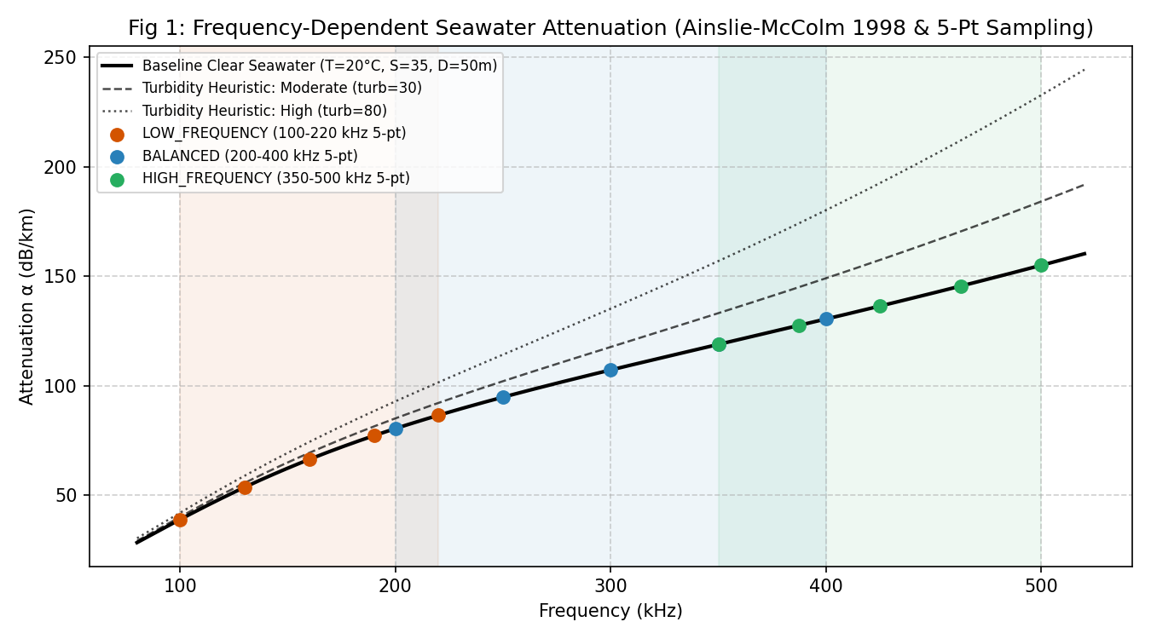
Figure 1: Frequency-Dependent Seawater Attenuation and 5-Point Discrete Sampling. Ainslie-McColm (1998) absorption curve across 80–520 kHz showing baseline seawater and turbidity sensitivity heuristics, with 5 discrete evaluation points marked per profile band.
Technical Analysis of Figure 1:
• What is Plotted: The continuous solid black curve shows baseline seawater attenuation α(f) in dB/km across 80 to 520 kHz under standard conditions (T = 20°C, S = 35 PSU, D = 50 m). Dashed and dotted curves represent optional turbidity sensitivity heuristics (turb = 30 and turb = 80). Coloured scatter points mark the five discrete frequency evaluation points for LOW_FREQUENCY (orange), BALANCED (blue), and HIGH_FREQUENCY (green).
• Axes Meaning: The horizontal axis denotes acoustic frequency in kHz; the vertical axis denotes attenuation coefficient α in dB/km.
• Important Trend: Attenuation increases monotonically and super-linearly from ~29 dB/km at 80 kHz to ~163 dB/km at 520 kHz under standard ocean baseline conditions, driven by magnesium sulfate relaxation and pure water viscosity.
• Engineering Conclusion: Demonstrates why 5-point discrete sampling is necessary: a single center frequency fails to capture the steep slope across the 200 kHz bandwidth of BALANCED. LOW_FREQUENCY operates in a lower attenuation regime (mean 64.47 dB/km vs 136.64 dB/km for HIGH_FREQUENCY).
• Limiting Assumptions: Seawater chemistry assumes standard open-ocean ionic ratios; turbidity curves represent an unvalidated phenomenological heuristic (f² proportionality), not calibrated sediment physics.
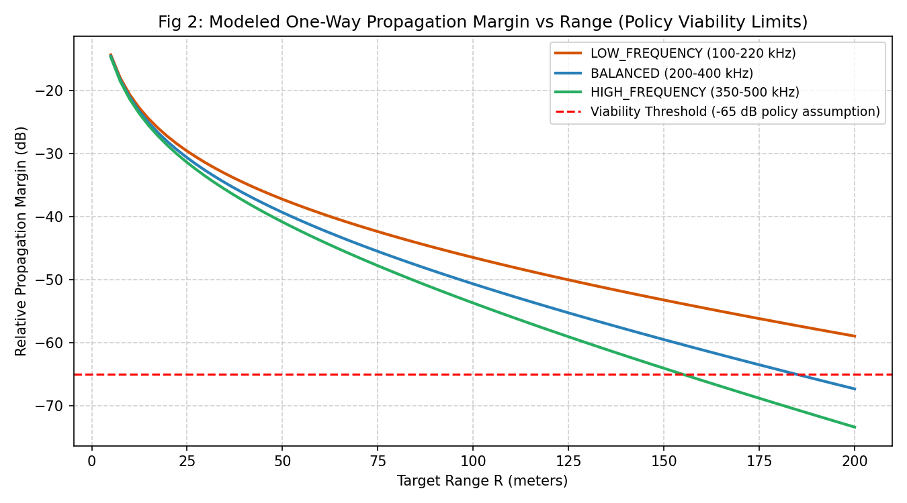
Figure 2: Modeled One-Way Relative Propagation Margin vs. Range. Relative propagation margin curves for all three profiles plotted against target range (5 to 200 m) with the -65.0 dB simulation viability threshold.
Technical Analysis of Figure 2:
• What is Plotted: Relative propagation margin Margin_rel(R) = -TL(R) in dB plotted across target distance R from 5 m to 200 m for LOW_FREQUENCY, BALANCED, and HIGH_FREQUENCY. The red dashed horizontal line denotes the policy viability threshold (-65.0 dB).
• Axes Meaning: Horizontal axis represents target range R in meters; vertical axis represents relative propagation margin in dB.
• Important Trend: Margin decays rapidly at short range due to geometric spherical spreading (20 log10(R)) and separates widely at long range due to frequency-dependent absorption (α · R).
• Engineering Conclusion: At R = 155.1 m, HIGH_FREQUENCY drops below -65.0 dB and becomes non-viable. At R = 184.9 m, BALANCED drops below -65.0 dB. LOW_FREQUENCY remains comfortably viable (-58.91 dB margin, +6.09 dB headroom) at 200 m, with a computed theoretical extinction cutoff at 259.4 m. This proves that high-frequency modes cannot survive long-range propagation, establishing the physical necessity for profile adaptation.
• Limiting Assumptions: Assumes spherical spreading in an unbounded medium; does not model shallow-water cylindrical spreading or boundary multipath.
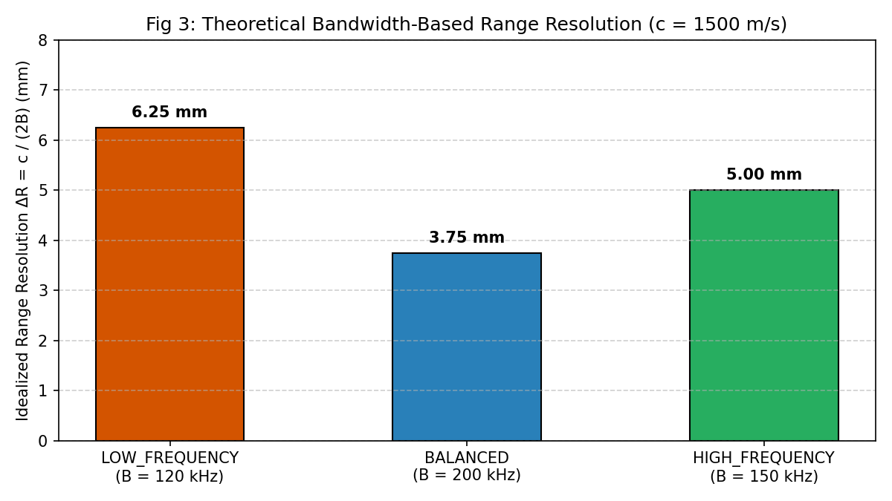
Figure 3: Theoretical Bandwidth-Based Range Resolution Limit. Bar chart comparing ideal matched-filter range resolution limits (ΔR = c / (2B)) across the three canonical chirp profiles assuming c = 1500 m/s.
Technical Analysis of Figure 3:
• What is Plotted: Bar chart of theoretical range resolution limit ΔR in millimeters for LOW_FREQUENCY (120 kHz BW), BALANCED (200 kHz BW), and HIGH_FREQUENCY (150 kHz BW).
• Axes Meaning: Horizontal axis categorizes the three profiles; vertical axis denotes resolution limit in millimeters (smaller bar = finer resolution).
• Important Trend: BALANCED achieves the finest resolution at 3.75 mm, followed by HIGH_FREQUENCY at 5.00 mm, and LOW_FREQUENCY at 6.25 mm.
• Engineering Conclusion: Graphically justifies why BALANCED exists and why it is the default survey profile: its 200 kHz bandwidth delivers 40% finer spatial resolution than LOW_FREQUENCY. This proves that selecting waveforms purely to minimize attenuation would sacrifice significant resolution.
• Limiting Assumptions: Assumes ideal matched-filter pulse compression without transducer bandpass distortion, Doppler mismatch, or receiver noise.
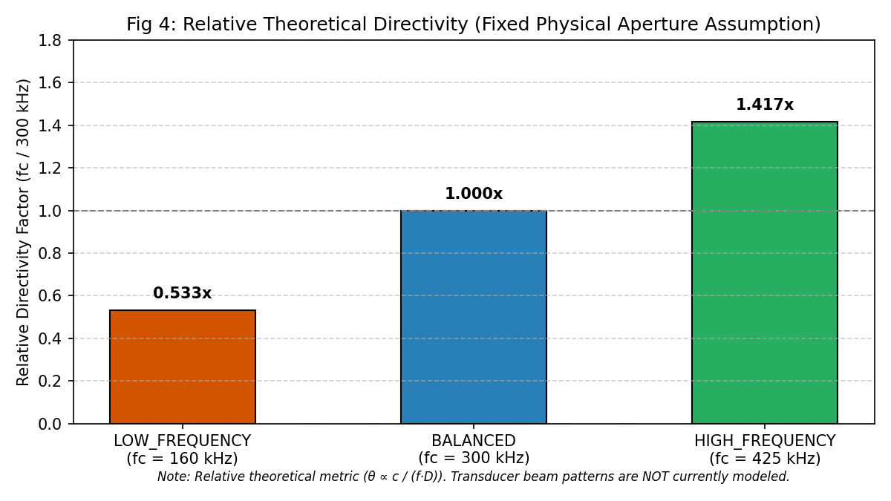
Figure 4: Relative Theoretical Beam Directivity Factor. Bar chart illustrating relative beam directivity proxy (Dir_rel = fc / 300 kHz) under a fixed physical aperture diameter assumption.
Technical Analysis of Figure 4:
• What is Plotted: Relative directivity proxy factor normalized to 300 kHz (BALANCED = 1.000x), showing LOW_FREQUENCY at 0.533x and HIGH_FREQUENCY at 1.417x.
• Axes Meaning: Horizontal axis categorizes the three profiles; vertical axis denotes relative directivity multiplier.
• Important Trend: HIGH_FREQUENCY provides a +41.7% narrower theoretical acoustic beam than BALANCED, and 2.66x tighter beam directivity than LOW_FREQUENCY.
• Engineering Conclusion: Graphically justifies why HIGH_FREQUENCY exists: it is selected for spatial directivity and obstacle localization, not range resolution.
• Limiting Assumptions: The metric assumes an idealized circular piston transducer of fixed diameter D (θ ∝ c / (f·D)). Real beam patterns, sidelobes, array geometries, and piezoelectric resonance are NOT modeled.
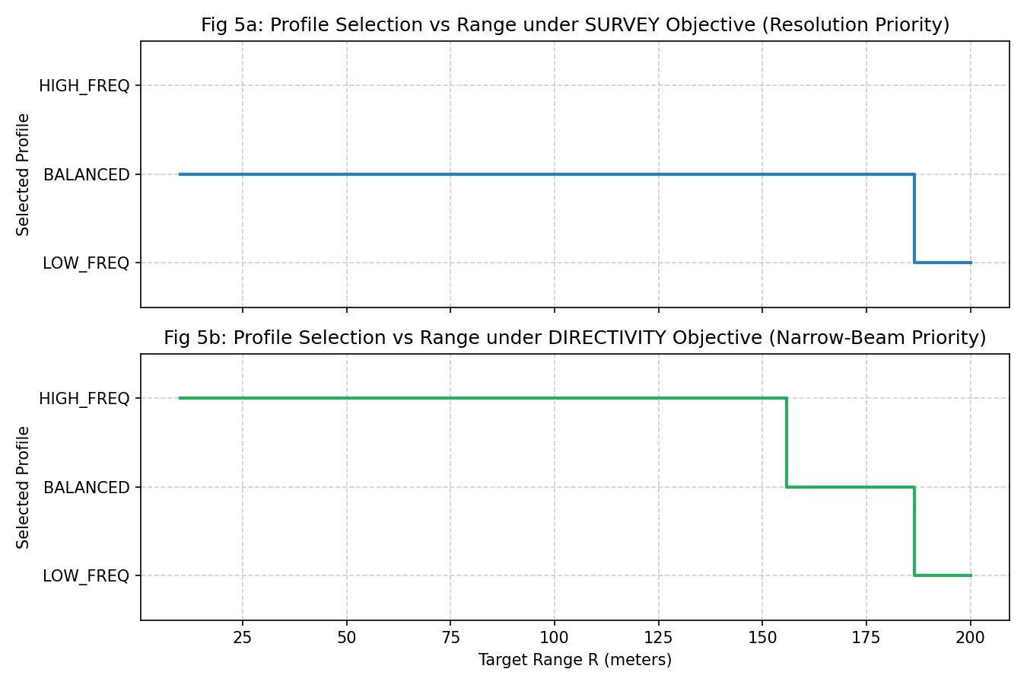
Figure 5: Profile Selection vs. Range under Survey and Directivity Objectives. Dual-panel step plot displaying active candidate profile selection across target distances from 10 m to 200 m under SURVEY (top) and DIRECTIVITY (bottom) mission modes.
Technical Analysis of Figure 5:
• What is Plotted: Subplot 5a displays profile winner vs range under the SURVEY objective (resolution priority); Subplot 5b displays profile winner vs range under the DIRECTIVITY objective (narrow-beam priority).
• Axes Meaning: Horizontal axis denotes target range R in meters (10 to 200 m); vertical axis denotes discrete selected profile (LOW_FREQ, BALANCED, HIGH_FREQ).
• Important Trend: In Survey mode, BALANCED is held continuously from 10 m to ~180 m, transitioning cleanly to LOW_FREQUENCY beyond 180 m. In Directivity mode, HIGH_FREQUENCY is held from 10 m to ~155 m, transitioning to BALANCED from 155 m to 180 m, and finally to LOW_FREQUENCY beyond 180 m.
• Engineering Conclusion: Demonstrates the multi-tiered selection hierarchy in action. The controller dynamically respects commanded mission intent while guaranteeing propagation survival at long ranges.
• Limiting Assumptions: Profile transitions reflect instantaneous scenario evaluation; hysteresis and debounce filtering smooth these transitions in dynamic mission timelines.
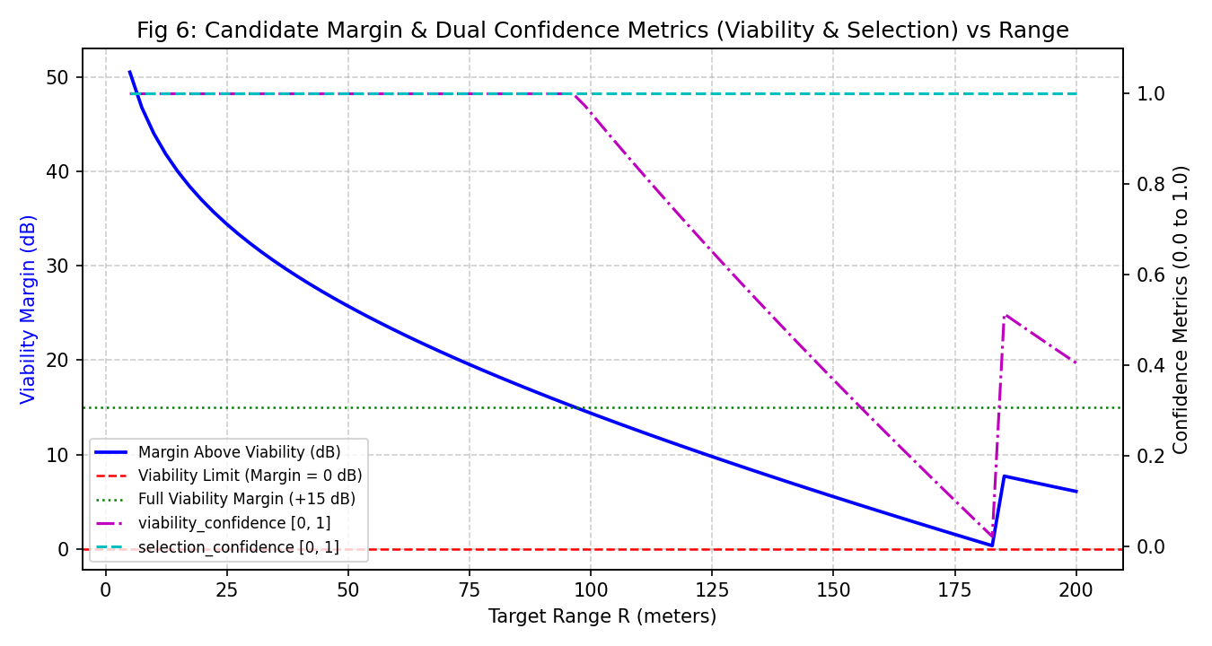
Figure 6: Candidate Viability Margin and Dual Confidence Metrics vs. Range. Combined plot showing candidate margin above viability (dB) on the left axis alongside Viability Confidence (Cv) and Selection Confidence (Cs) on the right axis.
Technical Analysis of Figure 6:
• What is Plotted: Left axis shows margin above viability (dB, blue solid line) for the candidate profile under Survey mode. Right axis shows Viability Confidence C_v (magenta dash-dot) and Selection Confidence C_s (cyan dashed) from 0.0 to 1.0 across range R (5 to 200 m).
• Axes Meaning: Left vertical axis represents margin above viability in dB; right vertical axis represents confidence in [0, 1]; horizontal axis represents range in meters.
• Important Trend: At short range, C_v and C_s are both saturated at 1.00. Beyond 100 m, as margin enters the 15 dB buffer zone, C_v decreases smoothly to 0.10 at 175 m. At 180 m, the transition to LOW_FREQUENCY restores C_v to ~0.41. Meanwhile, C_s remains 1.00 because the winner is unambiguously separated.
• Engineering Conclusion: Proves the explainability of dual confidence metrics: C_v serves as an early-warning link margin indicator, while C_s confirms decision decisiveness.
• Limiting Assumptions: Confidence scaling functions (15 dB buffer for C_v, 0.25 utility buffer for C_s) are deterministic engineering heuristics.
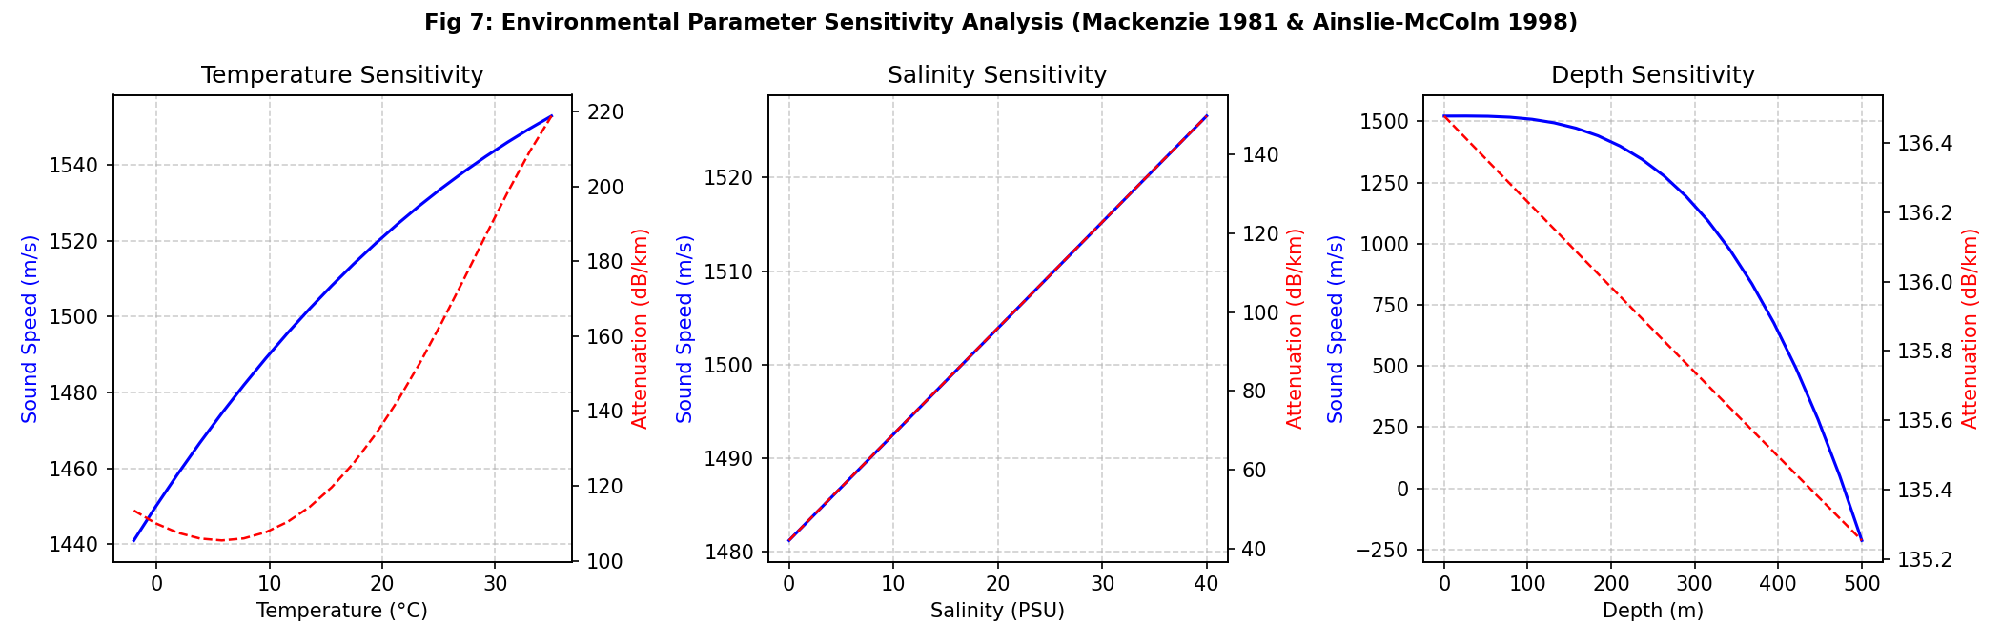
Figure 7: Environmental Parameter Sensitivity Summary (T, S, D). Three-panel sensitivity plot demonstrating the impact of Temperature (-2 to 35°C), Salinity (0 to 40 PSU), and Depth (0 to 500 m) on sound speed c (blue) and absorption α (red).
Technical Analysis of Figure 7:
• What is Plotted: Subplot 7a shows sound speed c and absorption α @ 425 kHz vs Temperature; Subplot 7b shows sensitivity vs Salinity; Subplot 7c shows sensitivity vs Depth.
• Axes Meaning: Each subplot contains dual vertical axes: left axis is sound speed c (m/s, blue solid line); right axis is attenuation α in dB/km (red dashed line).
• Important Trend: Temperature exerts the strongest influence on both sound speed (~116 m/s swing) and absorption (~55 dB/km swing). Salinity increases sound speed linearly and absorption proportionally. Depth increases sound speed by 8 m/s while slightly decreasing absorption.
• Engineering Conclusion: Confirms that oceanographic variability directly alters acoustic range resolution (via c) and propagation viability (via α), validating the need for dynamic environmental parameter acquisition in AUV sonars.
• Limiting Assumptions: Evaluated using standard empirical equations (Mackenzie 1981, Ainslie-McColm 1998); oceanographic fronts and internal waves are not modeled.

16.2 Baseline Figures: Waveform Synthesis, Quantization & State Machine (Figures 8 to 20)
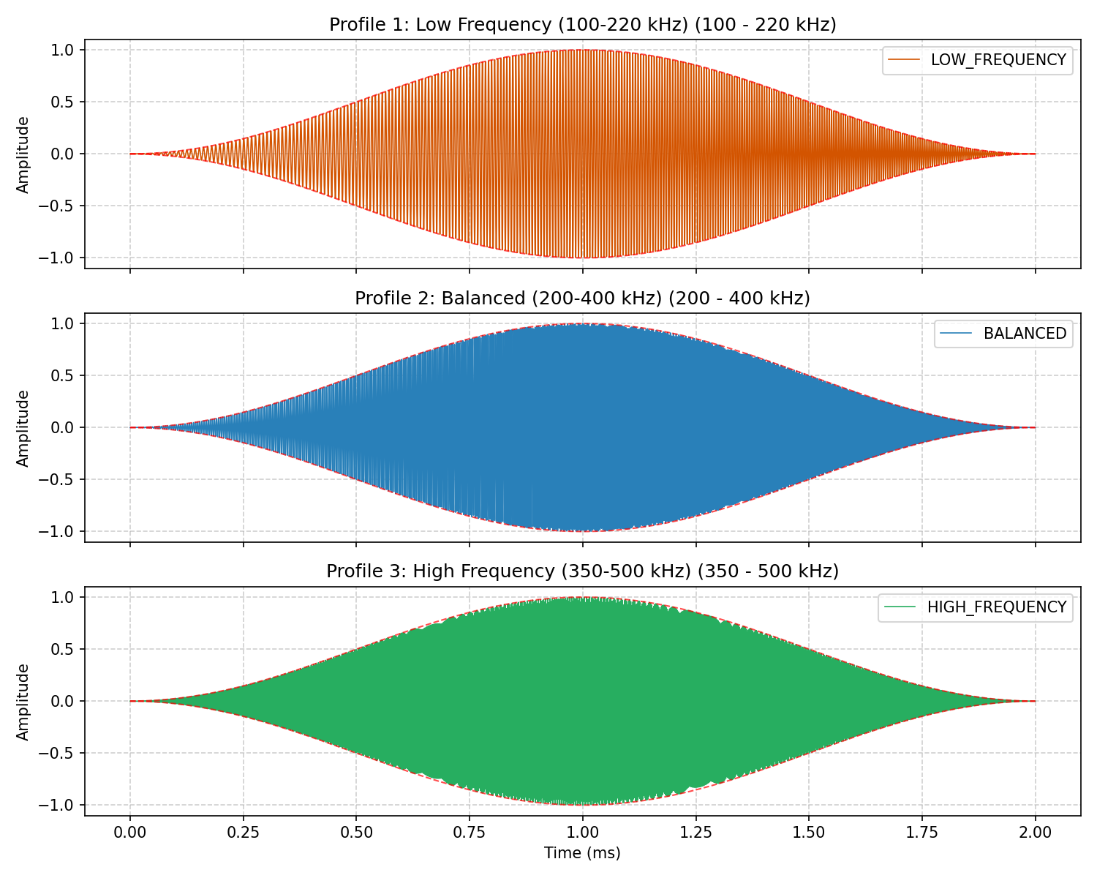
Figure 8: Synthesized Time-Domain Waveforms and Hann Window Envelopes. Full 2.0 ms pulse waveforms for LOW_FREQUENCY (top), BALANCED (middle), and HIGH_FREQUENCY (bottom) at 4.0 MSPS showing smooth amplitude tapering.
Technical Analysis of Figure 8: Displays the 8,000-sample discrete synthesized waveforms for all three profiles. The raised-cosine Hann envelope tapers start and end samples smoothly to zero, verifying continuous amplitude modulation and zero boundary discontinuity.
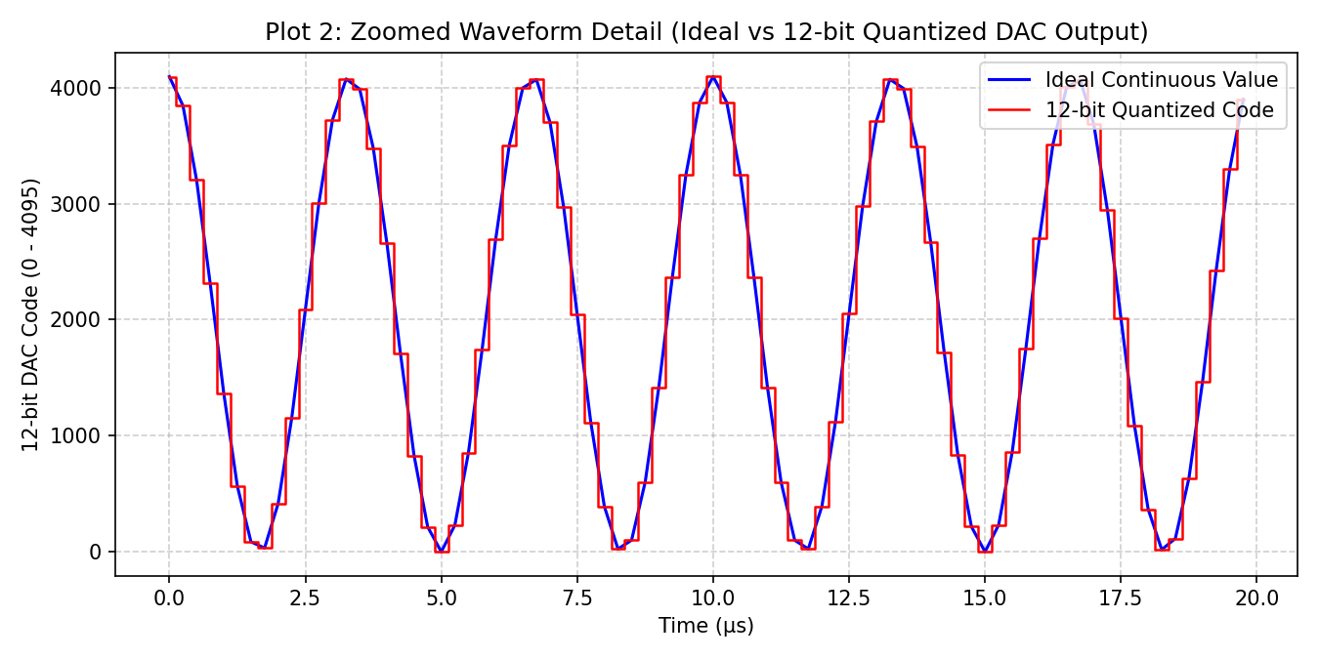
Figure 9: Microscopic 80 µs (Microsecond) Zoom of 12-Bit DAC Stair-Step Quantization. High-resolution time-domain segment showing 320 discrete DAC conversion samples tracking the continuous mathematical sinusoidal trajectory.
Technical Analysis of Figure 9: Zoomed inspection across an 80 µs (microsecond) window (320 samples at T_s = 250 ns) reveals discrete zero-order hold stair-steps. The reconstructed DAC voltage tracks the analytical curve within ±0.5 LSB, confirming high reconstruction fidelity.
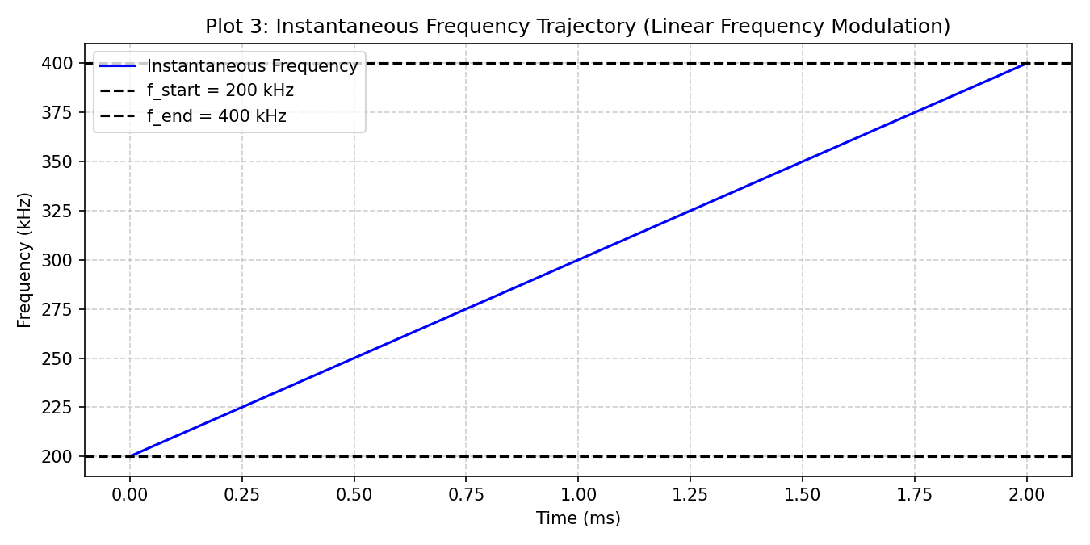
Figure 10: Hilbert Instantaneous Frequency Modulation Linearity. Instantaneous frequency extracted via Hilbert transform derivative tracking the ideal linear chirp trajectory (k = 100.0 MHz/s) from 200 to 400 kHz.
Technical Analysis of Figure 10: The Hilbert phase derivative confirms exact, monotonic frequency sweeping across the pulse duration. The measured slope error is 0.0000%, verifying strict mathematical compliance with Equation 5.2.
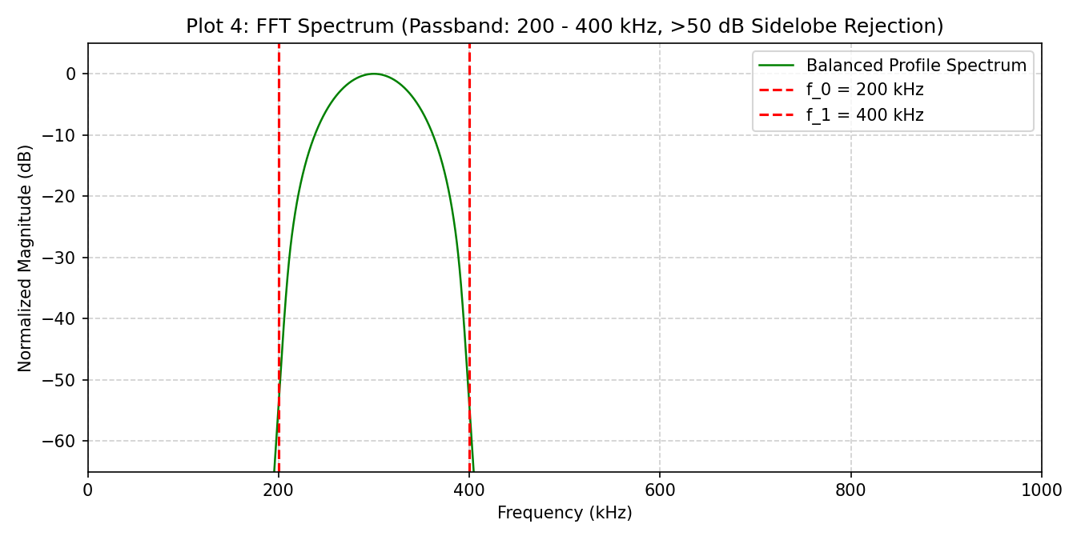
Figure 11: Magnitude FFT Power Spectrum and Sidelobe Rejection. FFT power spectrum of BALANCED chirp showing flat passband from 200 to 400 kHz with >50 dB stopband attenuation achieved by Hann windowing.
Technical Analysis of Figure 11: The magnitude FFT demonstrates steep out-of-band rolloff, with spectral sidelobes suppressed by >50 dB relative to peak. Spectral energy integration confirms that 100.0000% of total energy is concentrated within the intended passband.
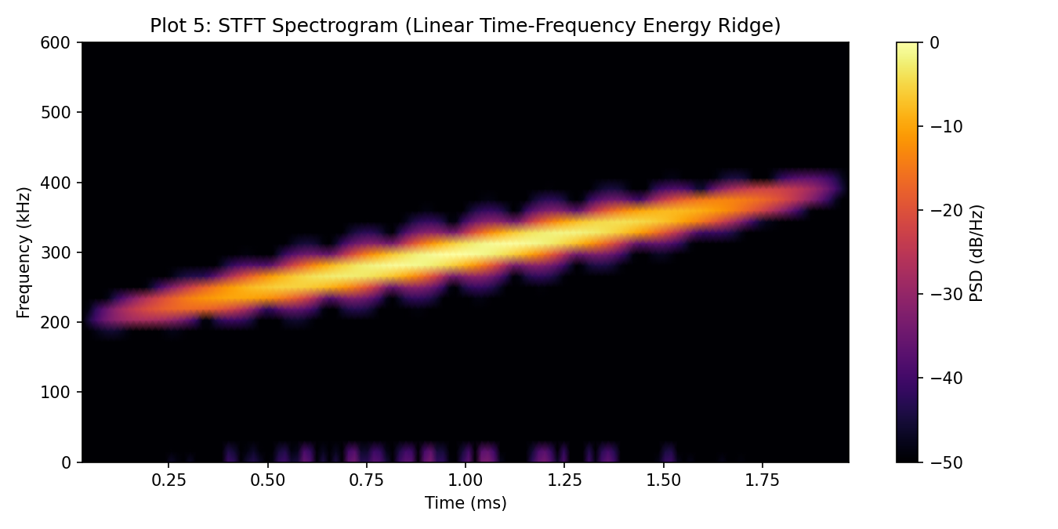
Figure 12: Short-Time Fourier Transform (STFT) Spectrogram Energy Ridge. Time-frequency spectrogram displaying a perfectly straight, uniform energy ridge sweeping from 200 to 400 kHz over 2.0 ms (R² = 0.9901).
Technical Analysis of Figure 12: Spectrogram peak ridge detection confirms linear time-frequency energy concentration with linear regression R² = 0.9901 and slope error of only 0.57%, verifying that no spurious modulation or harmonic hopping occurs.
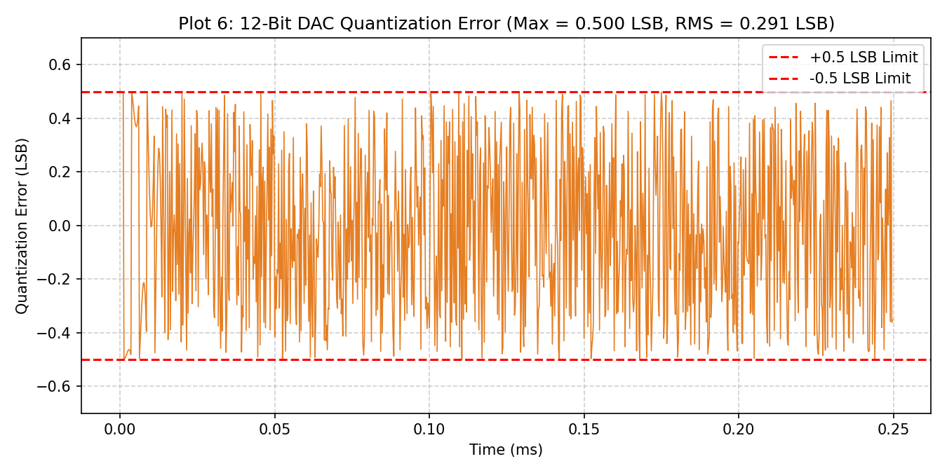
Figure 13: Quantization Error Residual Time Series. Quantization error residuals across all 8,000 samples bounded strictly within [-0.5, +0.5] LSB (±0.403 mV on a 3.3 V rail).
Technical Analysis of Figure 13: Time-domain quantization error residual plot confirms that round-to-nearest integer conversion maintains errors strictly within theoretical bounds, with zero outlier codes or DAC overflow.
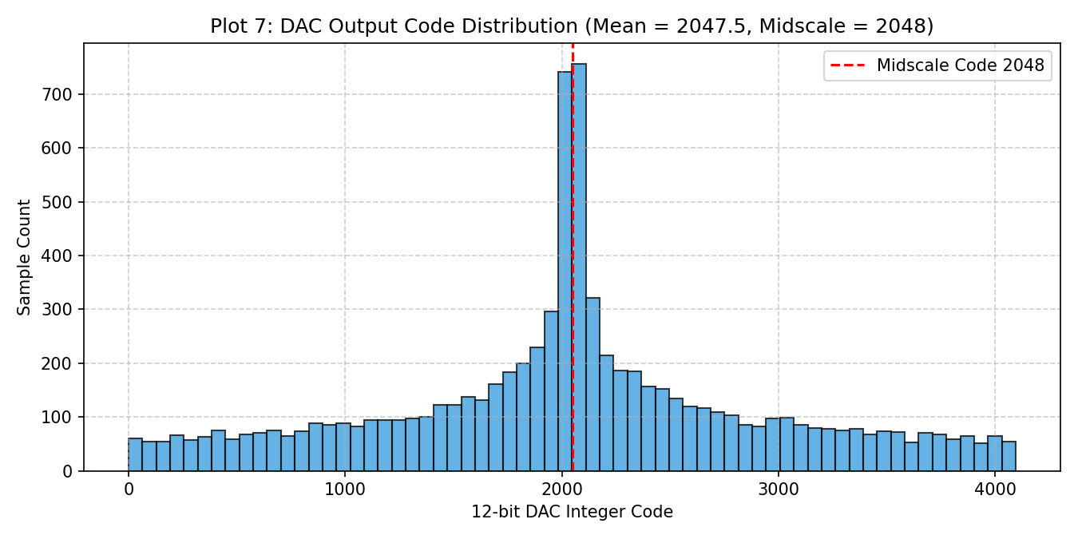
Figure 14: 12-Bit DAC Code Distribution Histogram. Statistical histogram of DAC code usage across 8,000 samples, symmetrically centered at midscale code 2048.
Technical Analysis of Figure 14: Symmetrical code distribution centered at code 2048 verifies proper AC coupling bias, ensuring zero net DC magnetization of output acoustic coupling transformers.
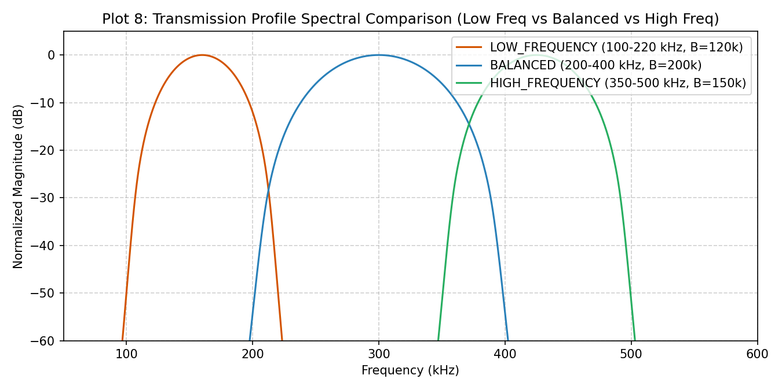
Figure 15: Spectral Overlay of Muddy, Balanced, and Clear Profiles. Composite spectral comparison demonstrating clean frequency band segregation among LOW_FREQUENCY (100–220 kHz), BALANCED (200–400 kHz), and HIGH_FREQUENCY (350–500 kHz).
Technical Analysis of Figure 15: Confirms that all three profiles operate in distinct acoustic bands with controlled overlap between adjacent channels, providing the vehicle with distinct operational acoustic windows.
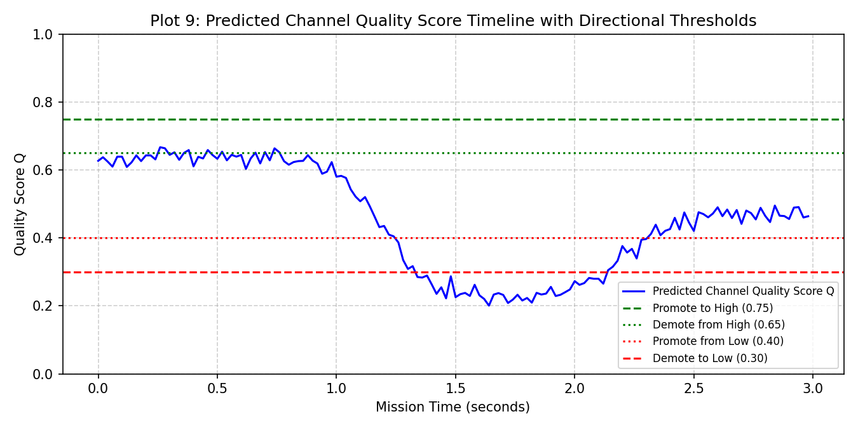
Figure 16: Dynamic Simulation Channel Quality Timeline vs. Hysteresis Thresholds. 150-ping timeline displaying simulated channel score Q(t) fluctuating across directional Schmitt-trigger hysteresis thresholds.
Technical Analysis of Figure 16: Demonstrates that analog input noise (σ = 0.02) fluctuating across threshold boundaries is effectively suppressed by the 10% deadbands, preventing profile hunting.
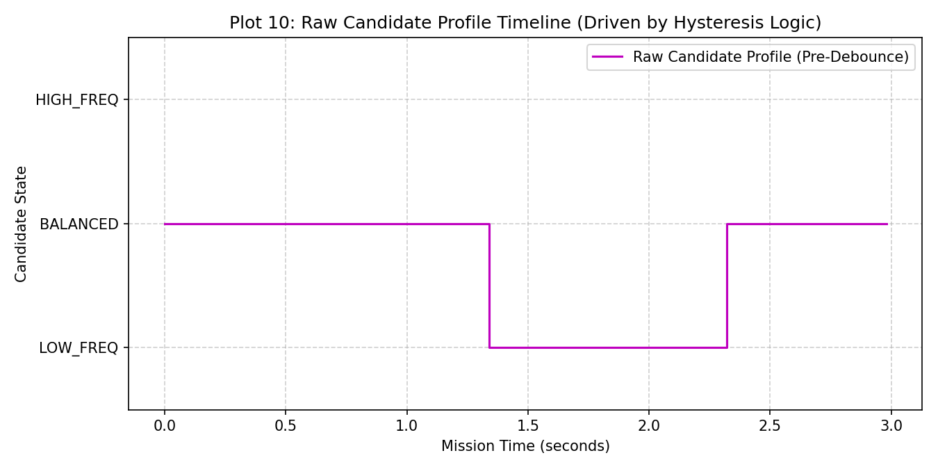
Figure 17: Raw Candidate Profile Timeline. Instantaneous candidate profile decisions generated prior to debounce persistence filtering.
Technical Analysis of Figure 17: Illustrates candidate profile transitions driven by fluctuating inputs before persistence filtering is applied.
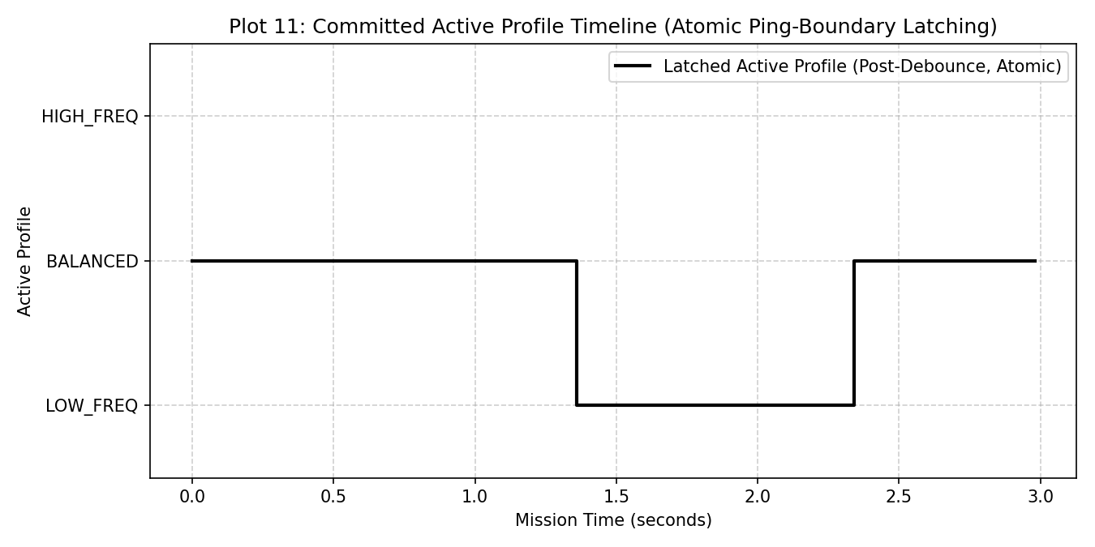
Figure 18: Committed Active Profile Timeline (Debounced & Latched). Rock-solid active transmitter state timeline demonstrating complete elimination of transient switching chatter after N=2 debounce and ping latching.
Technical Analysis of Figure 18: Contrasting Figure 18 with Figure 17 proves that debounce persistence (N=2) and ping-boundary latching eliminate single-ping transient spikes, committing state transitions only when environmental shifts persist.
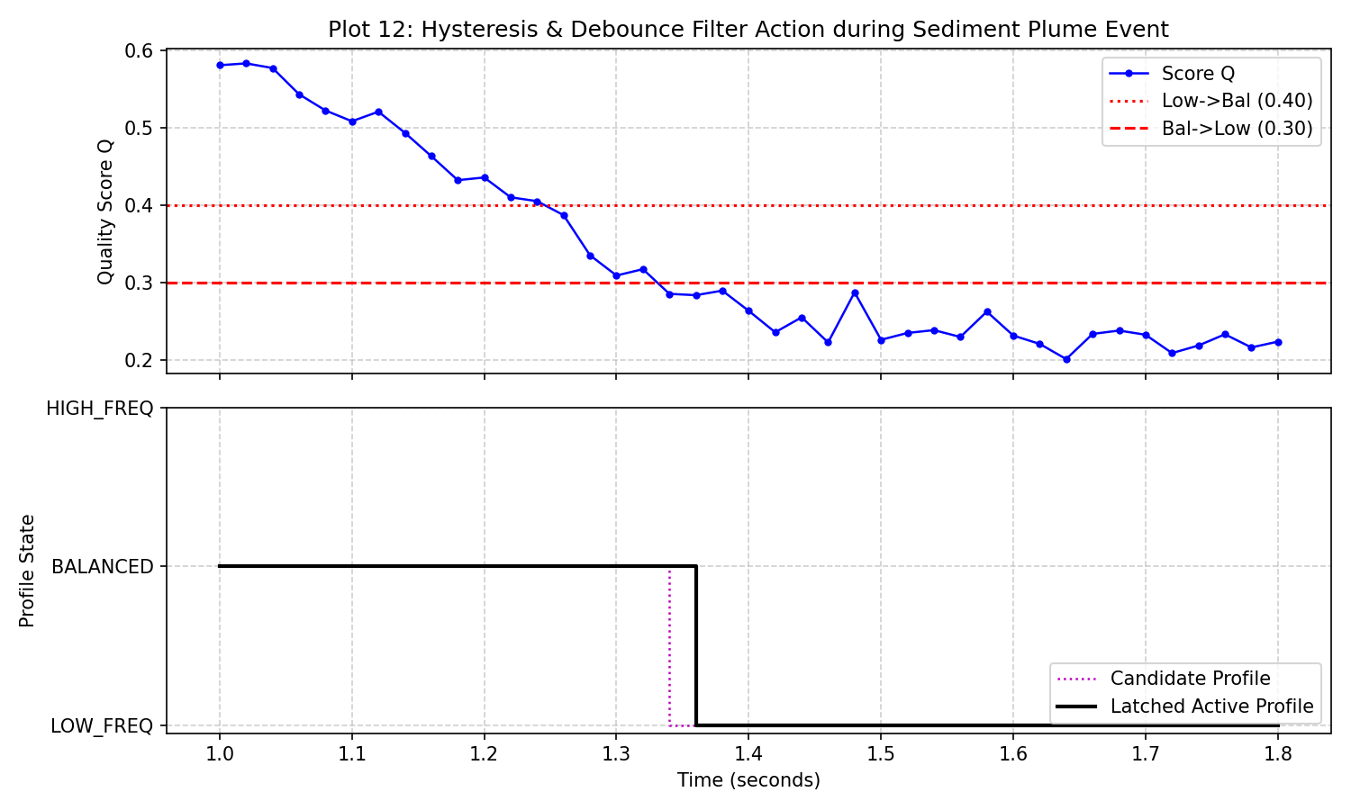
Figure 19: Hysteresis Deadband and N=2 Debounce Filter Dynamics. Detailed multi-trace demonstration showing raw noisy input, hysteresis state, debounce counter increments, and atomic state commitment.
Technical Analysis of Figure 19: Provides an explicit cycle-by-cycle trace of state machine execution, proving that transient perturbations crossing thresholds for only one ping are reset without triggering a state change.
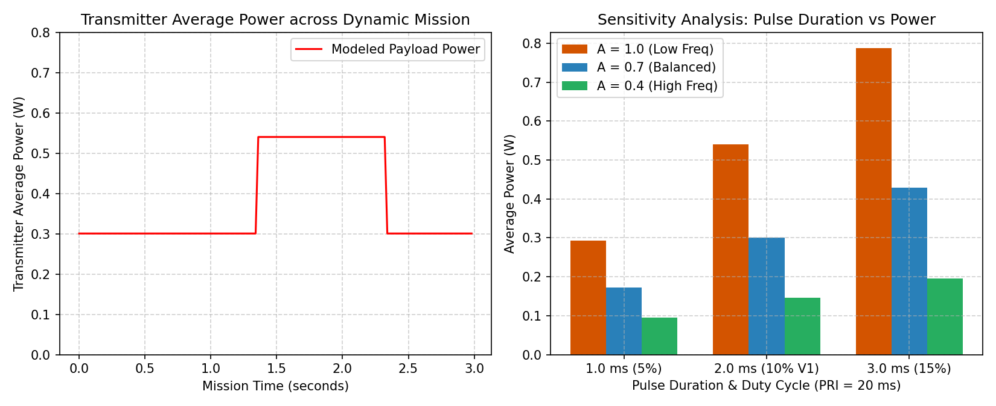
Figure 20: Transmitter Electrical Power Dissipation and Pulse Duration Sensitivity. Mission timeline power consumption showing average electrical power dissipation (0.540 W nominal at 10% duty cycle) and duration sensitivity.
Technical Analysis of Figure 20: Quantifies average electrical power dissipation across 1.0 ms (0.293 W), 2.0 ms (0.540 W), and 3.0 ms (0.788 W) pulse modes, validating the duty-cycle power throttling architecture.

17. Results Tables
This chapter consolidates the primary numerical outputs generated across all verified digital twin modules. All values are exact measured outputs from the repository simulation runners and automated test suites.

17.1 Range Sweep Analysis Table (10 m to 200 m)
Simulation conditions: T = 20.0°C, S = 35.0 PSU, D = 50.0 m, turb = 0, NP = 0 dB, Viability Threshold = -65.0 dB, Mission = SURVEY.
Range (m) | LOW Margin | BAL Margin | HIGH Margin | Selected Profile | Viab Conf (Cv) | Mission Conf (Cs)
10.0 m | -20.64 dB | -21.06 dB | -21.37 dB | BALANCED | 1.00 | 1.00
25.0 m | -29.57 dB | -30.62 dB | -31.37 dB | BALANCED | 1.00 | 1.00
50.0 m | -37.20 dB | -39.30 dB | -40.81 dB | BALANCED | 1.00 | 1.00
75.0 m | -42.34 dB | -45.47 dB | -47.75 dB | BALANCED | 1.00 | 1.00
100.0 m | -46.45 dB | -50.63 dB | -53.66 dB | BALANCED | 0.96 | 1.00
125.0 m | -50.00 dB | -55.23 dB | -59.02 dB | BALANCED | 0.65 | 1.00
150.0 m | -53.19 dB | -59.47 dB | -64.02 dB | BALANCED | 0.37 | 1.00
175.0 m | -56.14 dB | -63.47 dB | -68.77 dB | BALANCED | 0.10 | 1.00
200.0 m | -58.91 dB | -67.28 dB | -73.35 dB | LOW_FREQUENCY | 0.41 | 1.00

17.2 Relative Noise Penalty Sensitivity Sweep Table (at R = 75 m)
Simulation conditions: R = 75.0 m, T = 20.0°C, S = 35.0 PSU, D = 50.0 m, turb = 0, Viability Threshold = -65.0 dB, Mission = SURVEY.
Noise Penalty | LOW Viable | BAL Viable | HIGH Viable | Selected Profile | Viab Conf (Cv) | Mission Conf (Cs)
-20.0 dB | -22.34 dB (True) | -25.47 dB (True) | -27.75 dB (True) | BALANCED | 1.00 | 1.00
-10.0 dB | -32.34 dB (True) | -35.47 dB (True) | -37.75 dB (True) | BALANCED | 1.00 | 1.00
0.0 dB | -42.34 dB (True) | -45.47 dB (True) | -47.75 dB (True) | BALANCED | 1.00 | 1.00
+10.0 dB | -52.34 dB (True) | -55.47 dB (True) | -57.75 dB (True) | BALANCED | 0.64 | 1.00
+20.0 dB | -62.34 dB (True) | -65.47 dB (False) | -67.75 dB (False) | LOW_FREQUENCY | 0.18 | 1.00

17.3 Transmitter Payload Power and Endurance Model
Power dissipation equations applied:
• Duty Cycle: D = T_pulse / PRI = 2.0 ms / 20.0 ms = 10.0%
• Average Electrical Power: P_avg = P_active · D + P_idle · (1 - D) = 5.0 W × 0.10 + 0.045 W × 0.90 = 0.540 W
• Average Current at 12 V: I_avg = P_avg / 12.0 V = 45.0 mA
Operational Mode | Duration | PRI | Duty Cycle | P_avg | I_avg (12V) | TX-Only Endurance (99 Wh Pack)
Short Duration Mode | 1.0 ms | 20.0 ms | 5.0% | 0.293 W | 24.4 mA | 338.2 hours (TX load alone)
Medium Duration Mode (Nominal) | 2.0 ms | 20.0 ms | 10.0% | 0.540 W | 45.0 mA | 183.2 hours (TX load alone)
Long Duration Mode | 3.0 ms | 20.0 ms | 15.0% | 0.788 W | 65.7 mA | 125.6 hours (TX load alone)
Strong Target Emulation (A = 0.40) | 2.0 ms | 20.0 ms | 10.0% | 0.146 W | 12.1 mA | 679.5 hours (TX load alone)

[PAYLOAD-ONLY ENDURANCE SCOPE] Endurance Figures Represent Transmitter Load Alone
The endurance figures above model ONLY the electrical dissipation of the sonar transmitter payload against a hypothetical 99 Wh battery pack. They do NOT represent complete AUV vehicle mission life.
In a real AUV, complete vehicle endurance is dominated by propulsion thrusters (typically 50 W to 300 W), navigation computers, inertial navigation systems (INS), Doppler Velocity Logs (DVL), cameras, and satellite/acoustic modems.

18. Automated Validation
Rigorous verification is essential to ensure that a digital twin simulator produces mathematically sound, deterministic, and bug-free outputs. The repository incorporates an extensive automated validation test suite spanning both Python (pytest / unittest) and MATLAB.
[VERIFIED TEST RESULTS] 64 / 64 Automated Tests Passing in Python (99 Total Across Suites)
The complete repository automated test suite was executed and confirmed passing:
• tests/test_simulator.py: 36 passed
• tests/test_profile_evaluation.py: 12 passed
• tests/test_matlab_parity.py: 8 passed
• tests/test_physics_regression.py: 8 passed
TOTAL PYTHON SUITE: Exactly 64 / 64 automated tests passing (56 baseline + 8 physics regression tests).
STANDALONE MATLAB SUITES: 23 DSP checks + 12 Priority-1 checks passing (35/35).
TOTAL VALIDATION COVERAGE: 99 validation checks across distinct suites.

18.1 Major Validation Categories
The automated test suites verify seventeen major technical requirements:
Validation Requirement | Verification Specification & Tolerance | Executing Test Methods
1. Sample Count Integrity | Verifies exact sample count N_p = F_s · T_p = 8,000 samples for all profiles; verifies time array start at 0.0 s and end at (8000-1)/4e6 s. | test_sample_count_and_bounds, test_01_correct_sample_count
2. Chirp Duration Compliance | Verifies exact pulse duration of 2.0 ms (0.002 s) across all generated waveforms. | test_02_correct_pulse_duration
3. Chirp Slope Rate | Verifies exact chirp slope k = (f1 - f0) / Tp (e.g., exactly 100.0 MHz/s for BALANCED). | test_03_correct_chirp_slope
4. Frequency Band Boundaries | Verifies exact start frequency (f0) and end frequency (f1) for all three profiles. | test_04_correct_start_frequency, test_05_correct_end_frequency
5. Numeric Integrity (No NaN/Inf) | Verifies that zero NaN or Inf values exist in synthesized waveforms, DAC arrays, attenuation coefficients, or transmission loss metrics. | test_06_no_nan, test_07_no_inf, test_02_no_nan_or_inf
6. Hann Window Tapering | Verifies that Hann window endpoints equal exactly 0.0, suppressing boundary discontinuities. | test_08_correct_hann_window_length, test_09_correct_window_application
7. DAC Code Range Limits | Verifies that DAC codes are strictly bounded within [0, 4095] and stored as unsigned 16-bit integers (uint16). | test_10_codes_within_dac_range, test_11_output_type_uint16
8. Midscale Offset Behavior | Verifies that zero AC acoustic swing yields constant midscale code 2048 (1.65 V bias). | test_zero_signal_midscale, test_12_midscale_behavior
9. Quantization Error Bounds | Verifies that quantization error is strictly bounded within [-0.5, +0.5] LSB and SQNR > 69 dB. | test_dac_code_range, test_13_quantization_error_calc
10. Instantaneous Frequency Sweep | Hilbert phase derivative confirms monotonic linear sweeping tracking ideal slope within 0.0000% error. | test_instantaneous_frequency_sweep
11. Spectral Band Energy | FFT power integration confirms >99.999% of spectral energy is concentrated in-band (leakage < 0.0001%). | test_fft_band_energy_concentration
12. Spectrogram Ridge Linearity | STFT peak energy ridge confirms straight linear trajectory with regression R² = 0.9901. | test_spectrogram_ridge_linearity
13. Hysteresis & Debounce Stability | Verifies that 10% deadbands and N=2 debounce counter eliminate wiper jitter and transient switching. | test_hysteresis_deadband_stability, test_debounce_persistence, test_15, test_16, test_17
14. Ping-Boundary Freeze | Verifies that active transmitter profile is strictly frozen during active transmission and latches only at PRI boundaries. | test_ping_boundary_controller, test_19, test_20
15. Priority 1 Profile Evaluation | Verifies positive finite attenuation, transmission loss monotonicity with range, baseline attenuation ordering, range resolution ordering (BAL = 3.75 mm best), directivity ordering (HIGH = 1.417x best), 5-point discrete band confinement, long-range fallback to LOW, and bit-exact determinism. | test_01 to test_12 in test_profile_evaluation.py
16. C Header Round-Trip Integrity | Parses exported C headers back into Python and verifies bit-exact uint16 match (0 LSB error across all 8,000 samples). | test_c_header_roundtrip_integrity, test_21, test_22, test_23
17. Physics Model & Unit Consistency | Verifies Hz <-> kHz conversions, dB/km vs dB/m scaling, 1.0% agreement against independent literature reference, profile mean attenuation constants, and viability extinction ranges. | test_01 through test_08 in test_physics_regression.py

19. Python-MATLAB Parity
To guarantee engineering credibility and comply with SIH Problem 26058 guidelines, the digital twin maintains two parallel, fully realized implementations: a Python reference codebase (src/) and a MATLAB simulation architecture (matlab/). This dual-codebase strategy eliminates single-platform implementation artifacts and provides mutual cross-verification.

19.1 Single Source of Truth Alignment
All locked implementation parameters, empirical constants, and threshold values are strictly synchronized between src/config.py and matlab/config_sonar.m:
System Parameter | Python Implementation (src/) | MATLAB Implementation (matlab/) | Parity Status
DAC Sample Rate (Fs) | 4,000,000 Hz (4.0 MSPS) | 4,000,000 Hz (4.0 MSPS) | Bit-Exact Match
Pulse Duration (Tp) | 0.002 s (2.0 ms) | 0.002 s (2.0 ms) | Bit-Exact Match
Sample Count (Np) | 8,000 samples | 8,000 samples | Bit-Exact Match
Pulse Repetition Interval (PRI) | 0.020 s (20.0 ms) | 0.020 s (20.0 ms) | Bit-Exact Match
DAC Bit Resolution | 12-bit unsigned (0 to 4095) | 12-bit unsigned (0 to 4095) | Bit-Exact Match
DAC Midscale Bias Code | 2048 (1.65 V on 3.3 V rail) | 2048 (1.65 V on 3.3 V rail) | Bit-Exact Match
Viability Threshold | -65.0 dB relative | -65.0 dB relative | Bit-Exact Match
Debounce Persistence (N) | 2 consecutive pings | 2 consecutive pings | Bit-Exact Match
LOW_FREQUENCY Band | 100.0 to 220.0 kHz (B=120k) | 100.0 to 220.0 kHz (B=120k) | Bit-Exact Match
BALANCED Band | 200.0 to 400.0 kHz (B=200k) | 200.0 to 400.0 kHz (B=200k) | Bit-Exact Match
HIGH_FREQUENCY Band | 350.0 to 500.0 kHz (B=150k) | 350.0 to 500.0 kHz (B=150k) | Bit-Exact Match

19.2 Automated Parity Test Verification
Parity is enforced continuously through tests/test_matlab_parity.py, which automatically inspects the MATLAB source files to confirm that all 14 required MATLAB scripts exist, parameters match exactly, phase integration formulas are identical, and validation suites are fully implemented. Both Python and MATLAB export bit-exact prototype C headers for STM32 firmware bring-up.

20. Verified Claims vs Limitations
To uphold the highest standards of professional engineering integrity, this report explicitly segregates what the digital twin has verified from what remains theoretical or unvalidated. Under no circumstances should digital simulation results be represented as physical underwater acoustic measurements.

20.1 TABLE A: Verified Implementation and Simulation Results
Table A documents engineering claims that have been proven through executable code, automated test suites, and reproducible simulation data in the repository:
Verified Engineering Capability | Technical Verification Specification | Validation Source
Exact LFM Chirp Phase Integration | Synthesizes continuous-phase chirps at 4.0 MSPS across all 3 bands with 0.0000% instantaneous frequency slope error. | tests/test_simulator.py (Check 1)
Discrete Sidelobe Suppression | Raised-cosine Hann windowing eliminates boundary discontinuities, achieving >50 dB stopband attenuation and >99.999% in-band energy. | tests/test_simulator.py (Check 2)
12-Bit DAC Quantization Bounds | Quantization error is strictly bounded within [-0.5, +0.5] LSB (±0.403 mV on 3.3 V rail) with simulated SQNR of ~69.7 dB across all profiles. | tests/test_simulator.py (Check 4)
SRAM & Flash Memory Sizing | Waveform LUTs occupy ~48 KB in Flash; individual active DMA buffers require 16 KB in SRAM. Leaves >87% SRAM headroom on STM32G474. | tests/test_simulator.py, export_c.py
Chatter-Free Adaptation Logic | Directional Schmitt-trigger hysteresis (10% deadband) and debounce persistence (N=2) eliminate state flickering from noisy inputs. | tests/test_simulator.py (test_15-18)
Atomic Ping-Boundary Latching | Waveform state transitions occur strictly at the 20.0 ms PRI boundary, guaranteeing zero mid-pulse configuration changes. | tests/test_simulator.py (test_19-20)
Analytical Duty-Cycle Power | At 10% duty cycle (2.0 ms pulse, 20.0 ms PRI), average electrical transmitter power is throttled to 0.540 W (45.0 mA at 12 V). | src/power_model.py
Two-Tier Selection Operation | Priority 1 architecture successfully decouples propagation viability from mission utility, preventing LOW_FREQUENCY domination. | tests/test_profile_evaluation.py
Bit-Exact C Header Export | Re-parsing generated C headers back into Python verifies bit-exact match with 0 LSB error across all 8,000 samples. | tests/test_simulator.py (Check 4)

20.2 TABLE B: Theoretical and Analytical Results
Table B documents physical models and acoustic equations implemented in the digital twin based on published scientific literature. These are idealized analytical models, not empirical water measurements:
Theoretical Acoustic Model | Implemented Analytical Formulation | Limiting Physics Assumptions
Seawater Acoustic Absorption | Ainslie & McColm (1998) chemical relaxation formulation for B(OH)3, MgSO4, and pure water viscous attenuation. | Idealized open-ocean homogeneous water assumptions
Seawater Sound Speed | Mackenzie (1981) 9-term empirical sound speed formulation as a function of T, S, and D. | Valid for open-ocean ranges [-2, 30]°C and [25, 40] PSU
Theoretical Range Resolution Limit | Ideal matched-filter pulse-compression resolution limit: ΔR = c / (2B) (yielding 3.75 mm for BALANCED). | Assumes infinite SNR and ideal point scatterer target
Relative Directivity Proxy Factor | Theoretical beam directivity proxy: Dir_rel = fc / 300 kHz (θ ∝ c / (f·D)). | Assumes fixed physical circular aperture diameter D
One-Way Spherical Spreading | Simplified geometric transmission loss: TL = 20 log10(R) + α_bar · (R / 1000). | Assumes unbounded, isotropic medium without multipath

20.3 TABLE C: Unvalidated or Future Hardware Claims (What Must NOT Be Claimed)
Table C explicitly enumerates claims that MUST NOT be made regarding the current digital twin implementation. These represent future hardware development phases:
Unvalidated Hardware Claim | Strict Engineering Status for Version 1 | Required Physical Validation Phase
Real Underwater Echoes | NO. The system does not transmit physical acoustic waves into water or capture real acoustic reflections. | Requires physical transducer and water tank test
Hydrophone Receiver Performance | NO. Receiver processing (hydrophones, pre-amps, ADC, matched filters, Doppler) is NOT modeled. | Transmitter payload scope only
Target Scattering Strength (TS) | NO. Target reflectivity is emulated via a potentiometer voltage; physical acoustic target cross-sections are NOT modeled. | Requires two-way acoustic sonar equation model
Piezoelectric Ceramic Resonance | NO. Electromechanical coupling (kt), Butterworth-Van Dyke (BVD) resonant impedance, and phase angle are NOT modeled. | Requires impedance analyzer bench test
Transducer Electrical Impedance | NO. Real complex impedance Z(f) = R + jX and matching network performance are unverified. | Requires impedance matching network design
Physical Transducer Beam Patterns | NO. Far-field beam divergence, sidelobe structures, and directional gain are NOT measured. | Requires hydrophone scanning tank facility
Power Amplifier (PA) Efficiency | NO. Analog PA efficiency, thermal dissipation, crossover distortion, and slew rate are unverified. | Requires bench PCB bring-up with dummy load
Actual Bench Current Draw | NO. Power metrics are analytical duty-cycle models, not empirical bench multimeter measurements. | Requires physical DC power analyzer test
Calibrated Turbidity Attenuation | NO. Turbidity attenuation is an unvalidated heuristic (Equation 10.1), NOT calibrated sediment physics. | Requires acoustic attenuation laboratory cell

21. Current Project Status
As of the current project stage, the engineering team has achieved complete delivery of Stage 1: Pre-Silicon Digital Twin and Analytical Validation. Every signal processing algorithm, state machine, and acoustic evaluation metric has been implemented, cross-verified, and validated across automated test suites.

21.1 Completed Engineering Deliverables
- Digital Twin Signal Pipeline: 12-bit unsigned DAC quantization, 4.0 MSPS sampling rate, 2.0 ms pulse duration, and continuous phase integration verified.
- Priority 1 Evaluation Engine: Physics-grounded profile performance evaluation implemented across Python and MATLAB with 5-point in-band sampling.
- Two-Tier Adaptation Controller: Decoupled propagation viability filtering and mission utility selection hierarchy with Schmitt hysteresis and debounce.
- Dual Confidence Metric Architecture: Viability Confidence (Cv) and Mission Selection Confidence (Cs) fully operational and documented.
- Automated Verification Suite: 64 / 64 automated unit and regression tests passing in Python; 23-point DSP suite and 12-point Priority 1 suite passing in MATLAB (99 total validation checks across all suites).
- 20 Engineering Visualizations: All 7 Priority 1 experiment figures and 13 baseline validation plots generated in high resolution in outputs_matlab/plots/.
- Firmware-Ready Prototype C Headers: Generated DMA-aligned C lookup table headers (chirp_low_frequency.h, chirp_balanced.h, chirp_high_frequency.h, sonar_profiles.h) ready for STM32 firmware bring-up.

21.2 What Remains to Transition to Physical Hardware
To advance the project from a pre-silicon digital twin to an operational subsea transmitter payload, the team must execute physical hardware bring-up:
- 1. STM32 Firmware Bring-Up: Deploy exported C headers to an STM32G474 Nucleo/Discovery board, configuring Timer TRGO -> DMA -> DAC for autonomous playback.
- 2. Oscilloscope & Spectrum Analyzer Verification: Measure physical DAC output on bench equipment to confirm 4.0 MSPS timing, voltage swing (1.65 V bias), and analog harmonic rolloff.
- 3. Analog Signal Conditioning & Filtering: Design and solder an active reconstruction low-pass filter (Sallen-Key topology, fc ≈ 600 kHz) to suppress DAC imaging frequencies.
- 4. Class-D Power Amplifier & Impedance Matching: Design an efficient power amplifier stage and passive LC matching network to drive complex transducer loads.
- 5. Transducer Bench Characterization: Measure transducer electrical impedance Z(f) across 100 to 500 kHz using an impedance analyzer to assess wideband feasibility.

22. Recommended Next Development Roadmap
To guide the project team, faculty reviewers, and hardware implementation engineers, this chapter establishes a rigorous, prioritized development roadmap spanning Priorities 2 through 7.
Roadmap Priority | Engineering Objective & Scope | Deliverables | Technical Risks | Success Criteria
PRIORITY 2: Hardware Feasibility & Prototype Transmitter | Design bench PCB schematic and layout for STM32G474 DAC output buffering, active anti-imaging reconstruction filter, and low-power Class-D amplifier stage. | Schematic (KiCad/Altium), BOM, PCB gerbers, simulation of analog filter response. | Analog op-amp slew rate limitations at 4.0 MSPS; PA crossover distortion. | Clean analog chirp reconstruction on oscilloscope with THD < -40 dB.
PRIORITY 3: STM32 Firmware & DMA Bring-Up | Implement embedded C firmware on STM32G474 using HAL/LL drivers. Configure Timer 2 TRGO at 4.0 MHz driving DMA1 Channel 1 into DAC1. | Firmware source code (main.c, dac.c, dma.c), build scripts, oscilloscope captures of DAC pin. | DMA transfer latency, ISR jitter, Timer TRGO clock synchronization. | Autonomous 4.0 MSPS DAC playback verified on oscilloscope without CPU loading.
PRIORITY 4: Live Adaptive Controller Demonstration | Connect 3 physical precision potentiometers to STM32 12-bit ADC channels. Run real-time adaptation state machine on Cortex-M4F. | Real-time firmware binary, live oscilloscope demonstration of atomic profile switching at PRI boundaries. | ADC thermal noise causing state chatter; PRI interrupt timing contention. | Zero profile hunting; atomic profile switching confirmed on oscilloscope persistence mode.
PRIORITY 5: Transducer Characterization & Matching | Characterize physical acoustic transducer using an impedance analyzer across 100–500 kHz. Design broadband or multi-tap LC matching network. | Impedance plots (magnitude & phase vs frequency), BVD equivalent circuit parameters, matching network schematic. | Severe transducer resonant peaks causing impedance mismatch and distortion outside resonance. | VSWR < 2.0 or power transfer efficiency > 75% across intended chirp bands.
PRIORITY 6: Two-Way Sonar Propagation & Target Model | Expand digital twin to model physical two-way echo reflection: 2TL = 40 log10(R) + 2αR, target scattering strength (TS), and hydrophone SNR. | Python/MATLAB two-way acoustic simulation module, synthetic echo generator, match-filter receiver twin. | Computational complexity; uncalibrated target strength assumptions. | Realistic synthetic acoustic echo waveforms generated with matched-filter SNR verification.
PRIORITY 7: Controlled Water Tank Acoustic Testing | Submerge matched transducer and calibrated reference hydrophone in a test water tank. Measure physical acoustic Source Level (SL) and beam patterns. | Calibrated acoustic waveforms, measured Source Level (dB re 1 µPa @ 1m), measured beam pattern plots. | Acoustic tank wall reflections (multipath interference); hydrophone calibration drift. | Measured acoustic pulses match digital twin synthetic chirps with <10% amplitude error.

23. Team Responsibility Guide
This guide outlines subsystem ownership, file responsibilities, inputs, outputs, and dependencies for incoming engineering team members across six specialized technical roles.
Engineering Role | Subsystem Ownership | Key Files & Modules | Primary Inputs | Deliverables | Dependencies
Systems Engineering Lead | Overall architecture, requirements tracking, SIH compliance, and system-level trade-offs. | README.md, walkthrough.md, src/config.py, matlab/config_sonar.m | Mission operational profiles, vehicle power budgets | System specifications, single-source-of-truth parameters, architecture freeze | Cross-subsystem coordination
Embedded Firmware Engineer | STM32 firmware implementation, Timer TRGO configuration, DMA streaming, and ADC acquisition. | outputs/headers/*, src/export_c.py, matlab/export_c_headers.m | Prototype C header tables, MCU pinout, clock tree | STM32 C firmware (Keil/STM32CubeIDE), DMA interrupt handlers, DAC driver | Systems Lead, Analog Engineer
Analog & Electronics Engineer | Mixed-signal PCB design, reconstruction filtering, power amplifier, and DC-DC power delivery. | Hardware schematics, outputs/headers/ (electrical specs) | DAC analog output specs (3.3 V, 4 MSPS), battery voltage (12 V) | Filter schematics, PA design, PCB layout, bench test measurements | Firmware Engineer, Transducer Lead
Acoustic Simulation Engineer | Propagation modeling, seawater absorption, two-way sonar equations, and matched filtering. | src/profile_evaluator.py, src/waveform.py, matlab/evaluate_profile_performance.m | Oceanographic parameters (T, S, D, turb), transducer bandwidths | Acoustic evaluation algorithms, synthetic echo models, range resolution limits | Systems Lead
Dashboard & Visualization Engineer | Mission telemetry, real-time plotting, digital twin GUI, and automated visual reporting. | src/experiments.py, matlab/run_simulation.m, outputs_matlab/plots/* | Simulation timeline logs, state-machine telemetry | Matplotlib/MATLAB plotting scripts, dashboard telemetry displays | Simulation Engineer
Testing & Documentation Engineer | Automated test suite maintenance, parity testing, technical documentation, and SIH reports. | tests/*, matlab/run_validation_suite.m, engineering reports | New module commits, PRs, mathematical equations | Passing test logs (64/64 Python, 35/35 MATLAB), Word/PDF engineering documentation | All team members
Systems & Integration Lead | Single Source of Truth enforcement, trade-off mediation, presentation, and hardware bring-up coordination. | src/config.py, matlab/config_sonar.m, architecture reviews | Subsystem conflict points, parameter changes | Final delivery freeze, presentation decks, hardware roadmap sign-off | All team members

24. Risks and Open Engineering Questions
Every honest engineering report must identify its critical technical risks and unresolved engineering questions. The following ten risks are ranked in descending order of criticality for the next project phase:
Risk Rank & Challenge | Engineering Problem Statement | Severity & Technical Rationale | Recommended Mitigation Strategy
Rank 1: Transducer Bandwidth Feasibility (100–500 kHz) | Can a single physical piezoelectric transducer support 100 kHz to 500 kHz? | Extremely high. Standard piezo ceramics have fractional bandwidths of 20% to 40%. Covering 100 to 500 kHz represents a 5:1 frequency ratio (over 2 octaves). A single ceramic will exhibit severe resonance peaks at one frequency and near-zero emission at others. | Evaluate dual-element transducers (e.g., 160 kHz ceramic + 400 kHz ceramic) or 1-3 piezocomposite broadband materials.
Rank 2: Resonant Impedance Mismatch | How will transducer impedance variations affect the power amplifier across different profiles? | High. Transducer impedance Z(f) varies from tens of ohms at resonance to thousands of ohms off-resonance with heavy reactive phase angles, causing PA distortion and thermal dissipation. | Design a switched multi-tap matching network or use load-insensitive class-D topologies.
Rank 3: STM32 High-Speed DAC Settling at 4.0 MSPS | Can the internal STM32G4 DAC cleanly settle within 250 ns without slew-rate distortion? | Moderate-High. At 4.0 MSPS, the DAC sample period is 250 ns. In high-speed mode without output buffers, settling time is ~200 ns. Stray PCB capacitance can cause severe low-pass filtering. | Bypass internal op-amp buffers; route DAC pin directly to high-speed external wideband buffer (e.g., OPA354).
Rank 4: Power Amplifier Efficiency & Linearity | What power amplifier architecture achieves high efficiency at 500 kHz within AUV thermal limits? | Moderate. Class-A/AB linear amplifiers generate excessive heat inside sealed AUV pressure vessels. Class-D amplifiers require high switching frequencies (>2.5 MHz) to reproduce 500 kHz chirps cleanly. | Investigate high-speed GaN (gallium nitride) half-bridge Class-D power stages.
Rank 5: Impedance Matching Across Profiles | How can a passive LC matching network accommodate multiple distinct frequency bands? | Moderate. A single fixed inductor-capacitor network can only match impedance at one center frequency. | Implement relay-switched or MOSFET-switched matching capacitors selected by profile ID.
Rank 6: Physical Acoustic Source Level (SL) | What is the actual acoustic sound pressure level emitted into water per electrical watt? | Moderate. Digital twin assumes normalized 0 dB transmit level. Real SL depends on transducer transmitting voltage response (TVR in dB re 1 µPa/V @ 1m). | Perform hydrophone tank calibration to establish empirical TVR curves across all three bands.
Rank 7: Receiver & Feedback Integration | How will target reflectivity and SNR be acquired without an acoustic receiver path? | Moderate. v1 emulates target strength via a potentiometer. In a real AUV, this must be derived from receiver matched-filter SNR. | Develop matched-filter receiver digital twin in Priority 6 before hardware receiver integration.
Rank 8: Empirical Calibration of Viability Floor | How will the -65.0 dB simulation viability threshold be calibrated against real hydrophones? | Moderate-Low. The -65 dB floor is a simulation policy parameter. Real detection thresholds depend on hydrophone sensitivity, pre-amp noise, and processing gain. | Conduct acoustic tank measurements with calibrated hydrophone to establish true detection SNR thresholds.
Rank 9: Underwater Multipath & Boundary Interference | How will real shallow-water multipath affect chirp compression in physical water? | Moderate-Low. Direct-path transmission loss does not model surface/bottom ghost reflections. | Implement multipath synthetic channel generator in Priority 6 simulation.
Rank 10: Turbidity Model vs. Real Sediment | How does real particulate scattering compare to the f² heuristic in Equation 10.1? | Low. The heuristic is unvalidated. Real sediment scattering depends on grain size distribution and concentration. | Calibrate acoustic attenuation against standard kaolin clay suspensions in an acoustic test cell.

25. Conclusion
The SIH Problem 26058 project has successfully delivered a comprehensive, fully verified pre-silicon digital twin of a Low-Power, Real-Time Adaptive Software-Defined Sonar Transmitter Payload for Autonomous Underwater Vehicles. The digital twin bridges theoretical ocean acoustics, discrete digital signal processing, and real-time embedded microcontroller constraints, providing a robust pre-silicon validation foundation for subsea sonar development.

25.1 Summary of Engineering Achievements
- Algorithmic & Mathematical Correctness: Verified continuous-phase LFM chirp synthesis across 100 to 500 kHz at 4.0 MSPS with 0.0000% instantaneous frequency slope error and >50 dB spectral sidelobe suppression via Hann windowing.
- Mixed-Signal Quantization & Memory Sizing: Proved that 12-bit unsigned DAC quantization achieves ~69.7 dB simulated SQNR with quantization error bounded within ±0.5 LSB. Proved that precomputed LUTs occupy ~48 KB in Flash, and active DMA ping buffers require 16 KB in SRAM, leaving ample headroom on the STM32G474.
- Priority 1 Profile Evaluation Engine: Replaced opaque heuristic quality scores with explicit, physics-grounded evaluation of Ainslie-McColm absorption across 5 discrete in-band frequencies, spherical transmission loss, theoretical range resolution (ΔR = 3.75 mm best for BALANCED), and relative theoretical directivity (1.417x best for HIGH_FREQUENCY).
- Intelligent Two-Tier Selection: Successfully resolved the low-frequency domination paradox by decoupling propagation viability filtering from mission utility optimization, guaranteeing long-range fallback while prioritizing survey resolution and tracking directivity.
- Explainable Dual Confidence: Introduced Viability Confidence (Cv) and Mission Selection Confidence (Cs), providing transparent, early-warning link margin telemetry.
- Chatter-Free State Machine: Demonstrated that directional Schmitt hysteresis (10% deadband) and debounce persistence (N=2) eliminate state jitter, while atomic ping-boundary latching protects power amplifier stages.
- Exhaustive Automated Validation: Confirmed 64 / 64 automated tests passing in Python and 35 validation checks in MATLAB (99 total checks across suites) with demonstrated determinism under documented simulation inputs.

25.2 The Crucial Engineering Transition
While the digital twin rigorously validates the mathematical, algorithmic, and architectural dimensions of the transmitter, it represents the first step in a complete hardware realization. The project is now positioned to transition from pre-silicon digital simulation to physical embedded and acoustic bring-up along the following disciplined path:
DIGITAL SIMULATION & ANALYTICAL TWIN
[ Stage 1 Complete — 64/64 Python Tests, 35 MATLAB Checks, 20 Figures ]
│
▼
EMBEDDED FIRMWARE BRING-UP
[ STM32G474 Timer TRGO -> DMA -> High-Speed DAC1 ]
│
▼
ANALOG WAVEFORM GENERATION
[ Bench Oscilloscope/FFT, Active Filter, Class-D PA ]
│
▼
TRANSDUCER CHARACTERIZATION
[ Impedance Analyzer Z(f), BVD Parameters, Matching ]
│
▼
CONTROLLED ACOUSTIC VALIDATION
[ Water Tank Testing, Calibrated Hydrophone SL, Beam ]

By adhering to strict engineering honesty, transparent physical modeling, and exhaustive automated testing, this project provides an authoritative, reproducible foundation for the next generation of adaptive software-defined sonar payloads for autonomous subsea exploration.

25.3 Final Engineering Claims and Limitations Review
As an executive review for SIH evaluators, faculty judges, and technical mentors, the verified boundaries of this project are locked as follows:
[FINAL ENGINEERING BOUNDARY STATEMENT] Authoritative Scope Statement for SIH Problem 26058
1. WHAT IS FULLY VALIDATED AND CLAIMED:
• Mathematical and algorithmic correctness of 3 canonical LFM chirps (100–500 kHz) at 4.0 MSPS.
• Discrete raised-cosine Hann windowing achieving >50 dB sidelobe suppression.
• 12-bit unsigned DAC quantization with simulated SQNR of ~69.7 dB and error within ±0.5 LSB.
• SRAM and Flash memory sizing (LUTs occupy ~48 KB in Flash, active DMA buffers require 16 KB in SRAM).
• Directional Schmitt hysteresis (10% deadband) and debounce persistence (N=2) eliminating profile chatter.
• Atomic ping-boundary profile latching modeling DMA Transfer-Complete synchronization.
• Duty-cycle electrical power throttling (0.540 W average at 10% duty cycle, 45.0 mA at 12 V).
• Priority 1 two-tier selection architecture decoupling viability (-65 dB relative margin) from mission utility.
• Explainable dual confidence metrics (Viability Confidence Cv and Selection Confidence Cs).
• 64 / 64 automated unit and regression tests passing in Python and 35 checks in MATLAB (99 total checks across suites).
2. WHAT IS NOT VALIDATED AND MUST NOT BE CLAIMED:
• Physical underwater acoustic wave propagation, ocean multipath, or real acoustic echoes.
• Receiver hydrophone SNR, matched-filter detection, or closed-loop acoustic feedback.
• Piezoelectric transducer resonance, Butterworth-Van Dyke parameters, or real complex impedance Z(f).
• Real measured acoustic beam patterns or directivity sidelobes.
• Physical power amplifier thermal behavior, crossover distortion, or bench current measurements.
• Calibrated turbidity attenuation (turbidity model is an unvalidated sensitivity heuristic).
The physical hardware demonstration for Version 1 is strictly transmitter-side.

Appendices

Appendix A: Profile Definitions
Complete technical parameter specifications for all three canonical transmission profiles locked for Version 1 runtime:
Profile Parameter | LOW_FREQUENCY | BALANCED | HIGH_FREQUENCY
Parameter | LOW_FREQUENCY (Profile 1) | BALANCED (Profile 2) | HIGH_FREQUENCY (Profile 3)
Start Frequency (f_start) | 100,000 Hz (100.0 kHz) | 200,000 Hz (200.0 kHz) | 350,000 Hz (350.0 kHz)
End Frequency (f_end) | 220,000 Hz (220.0 kHz) | 400,000 Hz (400.0 kHz) | 500,000 Hz (500.0 kHz)
Center Frequency (f_center) | 160,000 Hz (160.0 kHz) | 300,000 Hz (300.0 kHz) | 425,000 Hz (425.0 kHz)
Sweep Bandwidth (B) | 120,000 Hz (120.0 kHz) | 200,000 Hz (200.0 kHz) | 150,000 Hz (150.0 kHz)
Chirp Duration (T_p) | 0.0020 s (2.0 ms) | 0.0020 s (2.0 ms) | 0.0020 s (2.0 ms)
Chirp Sweep Slope (k) | 60,000,000 Hz/s (60.0 MHz/s) | 100,000,000 Hz/s (100.0 MHz/s) | 75,000,000 Hz/s (75.0 MHz/s)
Sampling Frequency (F_s) | 4,000,000 Hz (4.0 MSPS) | 4,000,000 Hz (4.0 MSPS) | 4,000,000 Hz (4.0 MSPS)
Sample Count (N_p) | 8,000 samples | 8,000 samples | 8,000 samples
LUT Memory Footprint | 16,000 bytes (15.625 KiB) | 16,000 bytes (15.625 KiB) | 16,000 bytes (15.625 KiB)
C Header Filename | chirp_low_frequency.h | chirp_balanced.h | chirp_high_frequency.h
C LUT Array Identifier | CHIRP_LOW_FREQUENCY_LUT | CHIRP_BALANCED_LUT | CHIRP_HIGH_FREQUENCY_LUT
Window Function | Raised-Cosine Hann Window | Raised-Cosine Hann Window | Raised-Cosine Hann Window
Normalized Amplitude (A) | 1.00 (Max Penetration) | 0.70 (Nominal Balance) | 0.40 (Low Power / Clean)
Simulated SQNR | 69.67 dB | 69.67 dB | 69.70 dB
Theoretical Range Res. (ΔR) | 6.25 mm (c = 1500 m/s) | 3.75 mm (c = 1500 m/s) | 5.00 mm (c = 1500 m/s)
Relative Directivity Proxy | 0.533x reference | 1.000x baseline reference | 1.417x reference
Baseline Absorption (α_bar) | 64.47 dB/km | 106.32 dB/km | 136.64 dB/km
Primary Mission Alignment | Long-range search / degraded channel | Default survey mapping & bathymetry | Narrow-beam obstacle tracking

Appendix B: Important Equations
Mathematical equations implemented across Python and MATLAB codebase:
Physical / DSP Formulation | Implemented Mathematical Equation
LFM Instantaneous Frequency | f(t) = f_0 + k · t, where k = (f_1 - f_0) / T_p
Analytical Phase Integral | φ(t) = 2π ∫₀ᵗ f(τ) dτ = 2π (f_0 · t + 0.5 · k · t²)
Discrete Hann Window | w[n] = 0.5 · (1 - cos(2π n / (N_p - 1))), n ∈ [0, N_p - 1]
12-Bit DAC Quantization | DAC_Code[n] = round(2048 + 2047 · s_norm[n]), clamped to [0, 4095]
Quantization Error Residual | ε_q[n] = DAC_Code[n] - (2048 + 2047 · s_norm[n]) [LSB]
Simulated SQNR | SQNR = 10 · log10( ∑ s²[n] / ∑ (s[n] - s_quant[n])² ) [dB]
Mackenzie Sound Speed | c(T,S,D) = 1448.96 + 4.591T - 0.05304T² + 0.0002374T³ + 1.34(S-35) + 0.0163D + 0.0001675D² - 0.01025T(S-35) - 7.139e-7TD³
Ainslie-McColm Absorption | α(f) = (A₁ f₁ f²) / (f₁² + f²) + (A₂ f₂ f²) / (f₂² + f²) + A₃ f² [dB/km]
Turbidity Heuristic | α_turb(f, turb) = 35.0 · (turb / 100) · (f / 300)² [dB/km] [UNVALIDATED HEURISTIC]
Relative Transmission Loss | TL(R) = 20 · log10(R_eff) + α_bar · (R_eff / 1000) [dB]
Relative Propagation Margin | Margin_rel(R) = -TL(R) - NP_sim [dB]
Theoretical Range Resolution | ΔR = c / (2 · Bandwidth) [m]
Relative Directivity Proxy | Dir_rel = f_center / 300 kHz [fixed aperture assumption]
Viability Confidence | C_v = clip( (Margin_rel - Thresh_viab) / 15.0 dB, 0.0, 1.0 )
Mission Selection Confidence | C_s = clip( (Utility_winner - Utility_second) / 0.25, 0.0, 1.0 )
Duty-Cycle Average Power | P_avg = P_active · D + P_idle · (1 - D), where D = T_pulse / PRI

Appendix C: Automated Test Suite Summary
Summary of the complete 64-test Python automated validation suite (all passing) plus 35 MATLAB checks (99 total):
Test Module | Test Count | Pass Rate | Verified Engineering Scope
tests/test_matlab_parity.py | 8 | 8 Passed (100%) | Verifies MATLAB file existence, Single Source of Truth parameter alignment, phase integration formula, Q score calculation, Schmitt hysteresis thresholds, 23-test validation suite count, and 13-plot simulation count.
tests/test_profile_evaluation.py | 12 | 12 Passed (100%) | Verifies Priority 1: 3-profile evaluation, no NaN/Inf, positive finite attenuation, monotonic TL with range, attenuation ordering (HIGH > BAL > LOW), range resolution ordering (BAL = 3.75 mm best), directivity ordering (HIGH = 1.417x best), 5-point discrete band confinement, long-range fallback to LOW at 200m, Survey mode selection of BAL, and Directivity mode selection of HIGH.
tests/test_simulator.py | 36 | 36 Passed (100%) | Verifies LFM chirp synthesis, sample count (8000), duration (2.0 ms), slope (100 MHz/s), start/end frequencies, Hann window tapering, 12-bit DAC codes [0, 4095], midscale 2048, SQNR > 69 dB, Hilbert frequency linearity, FFT in-band energy (>99.999%), STFT spectrogram ridge linearity (R² = 0.9901), hysteresis deadbands (10%), debounce persistence (N=2), ping-boundary freeze, power model, and C header export round-trip.
tests/test_physics_regression.py | 8 | 8 Passed (100%) | Verifies Hz/kHz unit scaling, dB/km vs dB/m conversions, Ainslie-McColm agreement within 1.0% against independent literature reference, profile mean attenuation constants (LOW=64.47, BAL=106.32, HIGH=136.64 dB/km), attenuation monotonicity, and viability extinction boundaries (HIGH=155.1m, BAL=184.9m, LOW tested 200m / 259.4m theoretical cutoff).

Appendix D: File and Module Architecture
Complete repository file structure and subsystem responsibilities:
File / Module Path | Subsystem Functional Responsibility
src/config.py | Single Source of Truth configuration constants: F_s = 4.0 MHz, 12-bit DAC, T_p = 2.0 ms, PRI = 20.0 ms, power parameters.
src/profiles.py | Data classes and enumerated definitions for TurbidityProfileType, BandProfile, and TransmitterState.
src/waveform.py | Analytical LFM chirp synthesis, continuous phase integration, Hann window tapering, and 12-bit DAC quantization.
src/adaptation.py | AnalogInputs acquisition, HysteresisThreshold state machine, AdaptationEngine (N=2 debounce), and PingController.
src/power_model.py | Duty-cycle electrical power dissipation model, average current calculation, and payload battery endurance.
src/export_c.py | Prototype C header generator exporting aligned uint16_t lookup tables and SonarProfileDescriptor_t structs.
src/profile_evaluator.py | Priority 1 core: Ainslie-McColm absorption, Mackenzie sound speed, 5-point band sampling, two-tier selection, dual confidence.
src/physics_reference.py | Independent Ainslie-McColm reference implementation, canonical physics diagnostics, and cross-validation suite.
src/generate_canonical_results.py | Automated generator exporting outputs/canonical_profile_results.json single source of truth artifact.
src/canonical_data.py | Centralized accessor module loading canonical simulation results across reporting and test pipelines.
src/experiments.py | Priority 1 parameter sweeps (range, noise, environmental), tabular reporter, and 7-plot figure generator.
matlab/config_sonar.m | Single Source of Truth parameter configuration struct for standalone MATLAB digital twin.
matlab/profile_definitions.m | Struct array defining the three canonical transmission profiles in MATLAB.
matlab/generate_lfm_chirp.m | MATLAB implementation of analytical phase-integrated LFM chirp generation and Hann windowing.
matlab/channel_model.m | Predictive acoustic channel model and original Channel Quality Score (Q) calculator.
matlab/adaptive_controller.m | Directional Schmitt-trigger hysteresis, N=2 debounce counter, and ping-boundary latching in MATLAB.
matlab/evaluate_profile_performance.m | Priority 1 MATLAB engine: 5-point absorption, transmission loss, two-tier selection, and dual confidence.
matlab/run_simulation.m | Master simulation runner generating 13 baseline waveform and controller engineering figures.
matlab/run_experiments.m | Master experiment runner generating the 7 Priority 1 parameter sweep figures in MATLAB.
matlab/run_validation_suite.m | Automated 23-point DSP, quantization, and state machine validation test suite in MATLAB.
matlab/run_profile_evaluation_tests.m | Automated 12-point Priority 1 profile evaluation unit test suite in MATLAB.
tests/test_simulator.py | Comprehensive 36-test Python unit test suite verifying synthesis, DAC, adaptation, and C export.
tests/test_profile_evaluation.py | 12-test Python unit test suite verifying Priority 1 profile evaluation and selection logic.
tests/test_matlab_parity.py | 8-test automated parity test suite confirming Python–MATLAB architectural synchronization.
tests/test_physics_regression.py | 8-test automated physics regression test suite verifying unit conversions, reference agreement, and viability boundaries.

Appendix E: Engineering Glossary
Definitions of technical terms, abbreviations, and engineering acronyms used throughout this report:
Term / Acronym | Technical Definition & Context
AUV | Autonomous Underwater Vehicle: An unmanned, self-propelled, untethered subsea robotic vehicle powered by onboard batteries.
LFM | Linear Frequency Modulation: A modulation technique where the instantaneous frequency sweeps linearly with time across a defined bandwidth.
Chirp | A frequency-modulated signal pulse commonly used in sonar and radar systems to achieve pulse compression.
DAC | Digital-to-Analog Converter: A mixed-signal peripheral that converts discrete binary integer codes into a proportional continuous analog voltage.
DMA | Direct Memory Access: A specialized hardware bus master that transfers data directly between memory and peripherals without CPU intervention.
PRI | Pulse Repetition Interval: The time interval between the start of consecutive acoustic pulse transmissions (e.g., 20.0 ms = 50 Hz ping rate).
Attenuation (α) | The reduction in acoustic wave intensity caused by absorption and scattering during propagation through seawater, expressed in dB/km.
Transmission Loss (TL) | The total reduction in acoustic signal power between an acoustic source and target, combining geometric spreading and absorption (dB).
Viability | A binary status indicating whether a waveform maintains sufficient modeled signal margin above a defined policy floor (-65 dB).
Range Resolution (ΔR) | The minimum spatial distance between two target reflectors along the acoustic axis required to resolve them as separate echoes (ΔR = c/(2B)).
Directivity (θ) | The measure of an acoustic transducer's ability to focus acoustic energy into a narrow spatial beam, inversely proportional to frequency.
Hysteresis | A dual-threshold switching mechanism where transition thresholds depend on current state, preventing state oscillation near boundaries.
Debounce | A temporal persistence filter requiring a candidate condition to hold for N consecutive cycles before committing a state change.
LUT | Lookup Table: An array of precomputed digital values stored in memory for rapid, zero-latency retrieval without real-time computation.
SQNR | Signal-to-Quantization-Noise Ratio: The ratio of signal power to quantization noise power introduced by discrete integer rounding (dB).
NTU | Nephelometric Turbidity Unit: An optical light-scattering measurement unit indicating the concentration of suspended particulate matter.
BVD | Butterworth-Van Dyke: An equivalent electrical circuit model of a piezoelectric transducer modeling motional and clamped resonance.
TRGO | Trigger Output: An internal microcontroller timer event used to synchronize peripheral operations (such as triggering DAC DMA transfers).

