Installation
You'll need to install matplotlib first with either:
conda install matplotlib
or pip install matplotlib

Import the matplotlib.pyplot module under the name plt (the tidy way):
import matplotlib.pyplot as plt
You'll also need to use this line to see plots in the notebook:
%matplotlib inline
plt.show()-----in other platforms

import numpy as np
x = np.linspace(0, 5, 11)
y = x ** 2
x o/p = array([ 0. , 0.5, 1. , 1.5, 2. , 2.5, 3. , 3.5, 4. , 4.5, 5. ])
y o/p = array([ 0. , 0.25, 1. , 2.25, 4. , 6.25, 9. , 12.25,
16. , 20.25, 25. ])

plt.plot(x, y, 'r') # 'r' is the color red
plt.xlabel('X Axis Title Here')
plt.ylabel('Y Axis Title Here')
plt.title('String Title Here')
plt.show()

Subplot ----multiple plats created side by side
# plt.subplot(nrows, ncols, plot_number)
plt.subplot(1,2,1)
plt.plot(x, y, 'r--') # More on color options later
plt.subplot(1,2,2)
plt.plot(y, x, 'g*-');

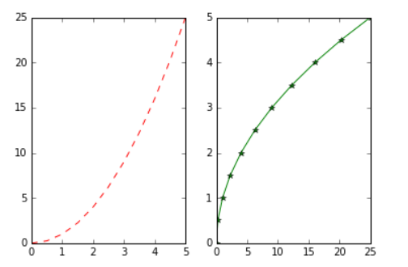

Matplotlib Object Oriented Method
Now that we've seen the basics, let's break it all down with a more formal introduction of Matplotlib's Object Oriented API. This means we will instantiate figure objects and then call methods or attributes from that object.

# Create Figure (empty canvas)
fig = plt.figure()

# Add set of axes to figure
axes = fig.add_axes([0.1, 0.1, 0.8, 0.8]) # left, bottom, width, height (range 0 to 1)

# Plot on that set of axes
axes.plot(x, y, 'b')
axes.set_xlabel('Set X Label') # Notice the use of set_ to begin methods
axes.set_ylabel('Set y Label')
axes.set_title('Set Title')
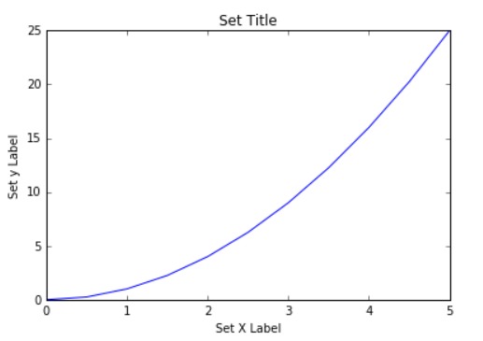

# Creates blank canvas
fig = plt.figure()

axes1 = fig.add_axes([0.1, 0.1, 0.8, 0.8]) # main axes
axes2 = fig.add_axes([0.2, 0.5, 0.4, 0.3]) # inset axes

# Larger Figure Axes 1
axes1.plot(x, y, 'b')
axes1.set_xlabel('X_label_axes2')
axes1.set_ylabel('Y_label_axes2')
axes1.set_title('Axes 2 Title')

# Insert Figure Axes 2
axes2.plot(y, x, 'r')
axes2.set_xlabel('X_label_axes2')
axes2.set_ylabel('Y_label_axes2')
axes2.set_title('Axes 2 Title');

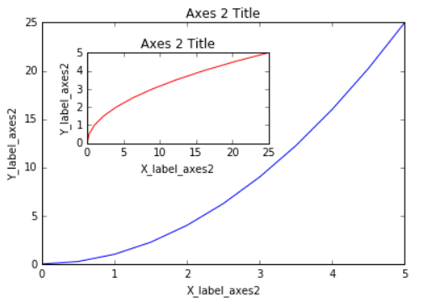

subplots()

The plt.subplots() object will act as a more automatic axis manager.

# Use similar to plt.figure() except use tuple unpacking to grab fig and axes
fig, axes = plt.subplots()

# Now use the axes object to add stuff to plot
axes.plot(x, y, 'r')
axes.set_xlabel('x')
axes.set_ylabel('y')
axes.set_title('title');

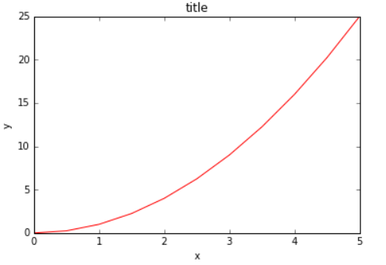

# Empty canvas of 1 by 2 subplots
fig, axes = plt.subplots(nrows=1, ncols=2)

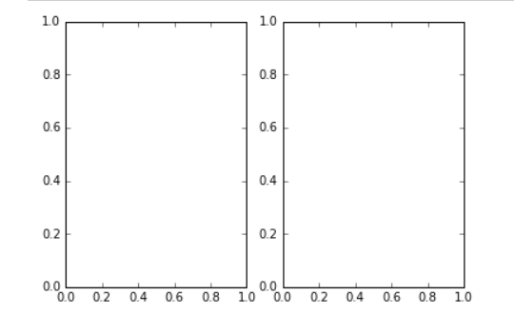

for ax in axes:
ax.plot(x, y, 'b')
ax.set_xlabel('x')
ax.set_ylabel('y')
ax.set_title('title')

# Display the figure object
Fig
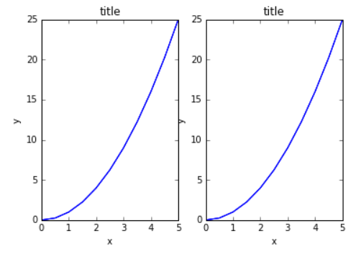
We ca use fig.tight_layout() or plt.tight_layout() method, to avoid overlapping

Figure size, aspect ratio and DPI
Matplotlib allows the aspect ratio, DPI and figure size to be specified when the Figure object is created. You can use the figsize and dpi keyword arguments.
- figsize is a tuple of the width and height of the figure in inches
- dpi is the dots-per-inch (pixel per inch).
fig = plt.figure(figsize=(8,4), dpi=100)

fig, axes = plt.subplots(figsize=(12,3))
axes.plot(x, y, 'r')
axes.set_xlabel('x')
axes.set_ylabel('y')
axes.set_title('title');

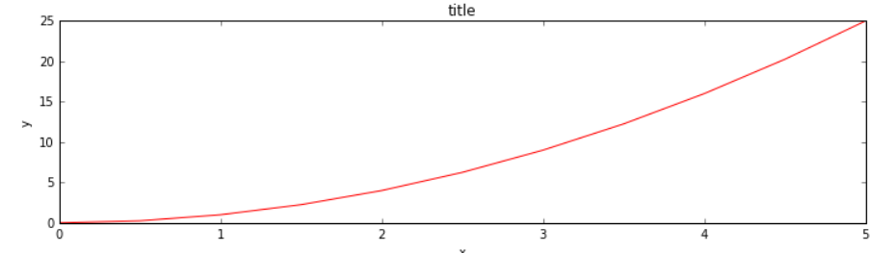

Saving figures
Matplotlib can generate high-quality output in a number formats, including PNG, JPG, EPS, SVG, PGF and PDF.

fig.savefig("filename.png")
fig.savefig("filename.png", dpi=200)

Legends
You can use the label="label text" keyword argument when plots or other objects are added to the figure, and then using the legend method without arguments to add the legend to the figure:

fig = plt.figure()
ax = fig.add_axes([0,0,1,1])
ax.plot(x, x**2, label="x**2")
ax.plot(x, x**3, label="x**3")
ax.legend()

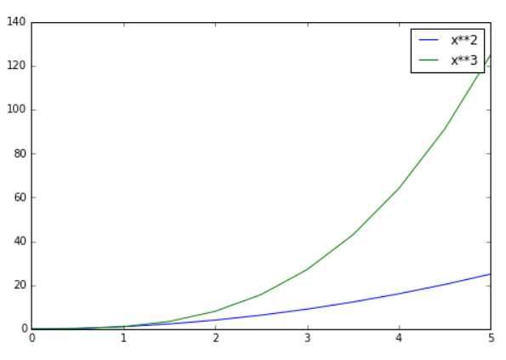
ax.legend(loc=1) # upper right corner
ax.legend(loc=2) # upper left corner
ax.legend(loc=3) # lower left corner
ax.legend(loc=4) # lower right corner
# .. many more options are available
# Most common to choose
ax.legend(loc=0) # let matplotlib decide the optimal location

fig, ax = plt.subplots()
ax.plot(x, x**2, 'b.-') # blue line with dots
ax.plot(x, x**3, 'g--') # green dashed line

Colors with MatLab like syntax
With matplotlib, we can define the colors of lines and other graphical elements in a number of ways. First of all, we can use the MATLAB-like syntax where 'b' means blue, 'g' means green, etc. The MATLAB API for selecting line styles are also supported: where, for example, 'b.-' means a blue line with dots:

# MATLAB style line color and style
fig, ax = plt.subplots()
ax.plot(x, x**2, 'b.-') # blue line with dots
ax.plot(x, x**3, 'g--') # green dashed line
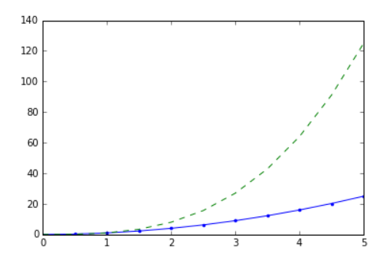

Multiple factos
ax.plot(x, x+16, color="purple", lw=1, ls='-', marker='s', markersize=8,
markerfacecolor="yellow", markeredgewidth=3, markeredgecolor="green");
lw = line width
ls =line style
marker = markers on line
color = line colour

Plot range
We can configure the ranges of the axes using the set_ylim and set_xlim methods in the axis object, or axis('tight') for automatically getting "tightly fitted" axes ranges

fig, axes = plt.subplots(1, 3, figsize=(12, 4))

axes[0].plot(x, x**2, x, x**3)
axes[0].set_title("default axes ranges")

axes[1].plot(x, x**2, x, x**3)
axes[1].axis('tight')
axes[1].set_title("tight axes")

axes[2].plot(x, x**2, x, x**3)
axes[2].set_ylim([0, 60])
axes[2].set_xlim([2, 5])
axes[2].set_title("custom axes range");

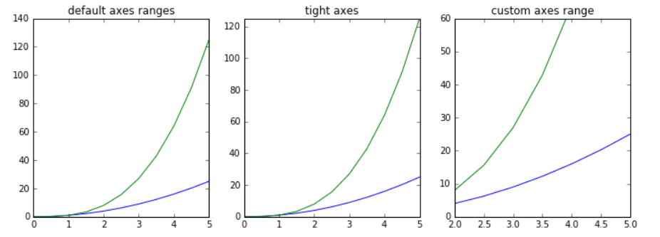

Special Plot Types
There are many specialized plots we can create, such as barplots, histograms, scatter plots, and much more. Most of these type of plots we will actually create using seaborn, a statistical plotting library for Python. But here are a few examples of these type of plots:

plt.scatter(x,y)

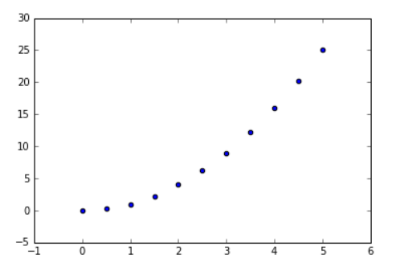

from random import sample
data = sample(range(1, 1000), 100)
plt.hist(data)

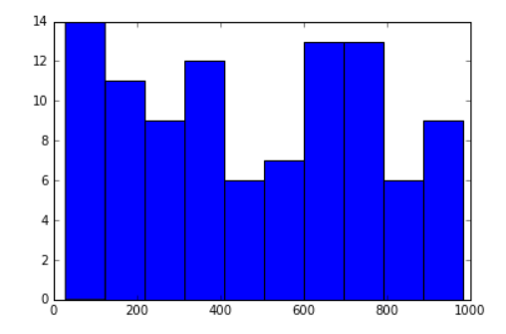

data = [np.random.normal(0, std, 100) for std in range(1, 4)]
# rectangular box plot
plt.boxplot(data,vert=True,patch_artist=True);

