Series
A Series is very similar to a NumPy array (in fact it is built on top of the NumPy array object). What differentiates the NumPy array from a Series, is that a Series can have axis labels, meaning it can be indexed by a label, instead of just a number location. It also doesn't need to hold numeric data, it can hold any arbitrary Python Object.
import numpy as np
import pandas as pd

below entities can be converted to series
labels = ['a','b','c']
my_list = [10,20,30]
arr = np.array([10,20,30])
d = {'a':10,'b':20,'c':30}

series creation

pd.Series(data=my_list)----index will be 0,1,2,3 by default
pd.Series(data=my_list,index=labels)
pd.Series(arr)
pd.Series(arr,labels)
pd.Series(d)

ser1 = pd.Series([1,2,3,4],index = ['USA', 'Germany','USSR', 'Japan'])
ser2 = pd.Series([1,2,5,4],index = ['USA', 'Germany','Italy', 'Japan'])

ser1['USA'] ---o/p : 1

ser1 + ser2
o/p :
Germany 4.0
Italy NaN
Japan 8.0
USA 2.0
USSR NaN
dtype: float64

DataFrames
DataFrames are the workhorse of pandas and are directly inspired by the R programming language. We can think of a DataFrame as a bunch of Series objects put together to share the same index. Let's use pandas to explore this topic!

from numpy.random import randn
np.random.seed(101)

pd.DataFrame(randn(5,4),index='A B C D E'.split(),columns='W X Y Z'.split())

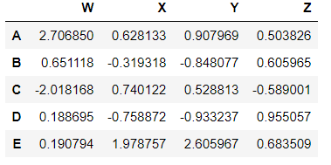

Selection and Indexing

df['W']-----first column will print with index
df[['W','Z']]
df['new'] = df['W'] + df['Y']----create new column
df.drop('new',axis=1) ----remove column and display, not permanent delete
df.drop('new',axis=1,inplace=True)-----permanent removal of column
df.drop('E',axis=0)----drop rows

df.loc['A']-----first row will be displayed with column header
df.iloc[2]------row number can be mentioned instead of index

** Selecting subset of rows and columns **

df.loc['B','Y'] ----particular value (-0.8480769834036315)
df.loc[['A','B'],['W','Y']]-----2 x 2matrix

df[df>0]
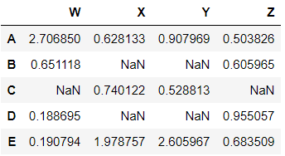

df[df['W']>0]------all the rows which satisfy W value greater than 0 whicha re A,B D and E with all columns

df[df['W']>0]['Y'] ----display only Y column

df[df['W']>0][['Y','X']] ---display Y and X columns

df[(df['W']>0) & (df['Y'] > 1)] ----- Multiple conditions

df.reset_index() ---current index will be new column and new index will be created with 0,1,2,3…

newind = 'CA NY WY OR CO'.split()
df['States'] = newind -----new column will be added

df.set_index('States',inplace=True) ------making existing column as index

Multi-Index and Index Hierarchy

outside = ['G1','G1','G1','G2','G2','G2']
inside = [1,2,3,1,2,3]
hier_index = list(zip(outside,inside))
hier_index = pd.MultiIndex.from_tuples(hier_index)

pd.DataFrame(np.random.randn(6,2),index=hier_index,columns=['A','B'])

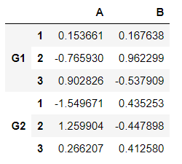

df.loc['G1']
df.loc['G1'].loc[1]
df.index.names = ['Group','Num']-----give header for indexes
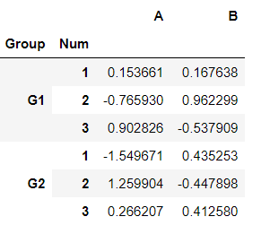

df.xs('G1') same as df.loc['G1']
df.xs(['G1',1])
df.xs(1,level='Num')

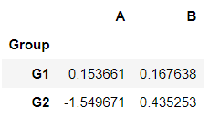

DataFrames can also be created like

df = pd.DataFrame({'A':[1,2,np.nan],
'B':[5,np.nan,np.nan],
'C':[1,2,3]})

df.dropna() ----drop nan value rows
df.dropna(axis=1)---- ----drop nan value rows columns
df.dropna(thresh=2)----drop row which has 2 nan

df.fillna(value='FILL VALUE')---fill nan to new values

Groupby
The groupby method allows you to group rows of data together and call aggregate functions

import pandas as pd
# Create dataframe
data = {'Company':['GOOG','GOOG','MSFT','MSFT','FB','FB'],
'Person':['Sam','Charlie','Amy','Vanessa','Carl','Sarah'],
'Sales':[200,120,340,124,243,350]}

df = pd.DataFrame(data)

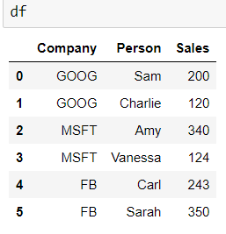

df.groupby('Company').mean()
df.groupby('Company').std()
df.groupby('Company').min()
df.groupby('Company').max()
df.groupby('Company').count()

Merging, Joining, and Concatenating

There are 3 main ways of combining DataFrames together: Merging, Joining and Concatenating. In this lecture we will discuss these 3 methods with examples.

df1 = pd.DataFrame({'A': ['A0', 'A1', 'A2', 'A3'],
'B': ['B0', 'B1', 'B2', 'B3'],
'C': ['C0', 'C1', 'C2', 'C3'],
'D': ['D0', 'D1', 'D2', 'D3']},
index=[0, 1, 2, 3])

df2 = pd.DataFrame({'A': ['A4', 'A5', 'A6', 'A7'],
'B': ['B4', 'B5', 'B6', 'B7'],
'C': ['C4', 'C5', 'C6', 'C7'],
'D': ['D4', 'D5', 'D6', 'D7']},
index=[4, 5, 6, 7])

df3 = pd.DataFrame({'A': ['A8', 'A9', 'A10', 'A11'],
'B': ['B8', 'B9', 'B10', 'B11'],
'C': ['C8', 'C9', 'C10', 'C11'],
'D': ['D8', 'D9', 'D10', 'D11']},
index=[8, 9, 10, 11])

pd.concat([df1,df2,df3])-----concat by row

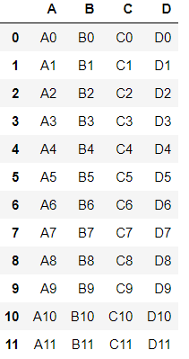

pd.concat([df1,df2,df3],axis=1)---concat by column

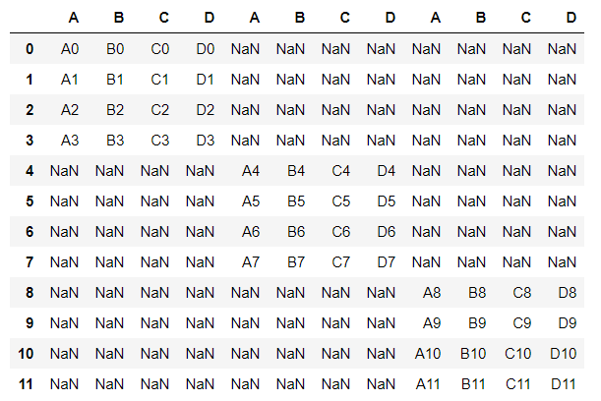

Merging
The merge function allows you to merge DataFrames together using a similar logic as merging SQL Tables together.

left = pd.DataFrame({'key': ['K0', 'K1', 'K2', 'K3'],
'A': ['A0', 'A1', 'A2', 'A3'],
'B': ['B0', 'B1', 'B2', 'B3']})

right = pd.DataFrame({'key': ['K0', 'K1', 'K2', 'K3'],
'C': ['C0', 'C1', 'C2', 'C3'],
'D': ['D0', 'D1', 'D2', 'D3']})

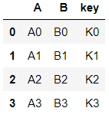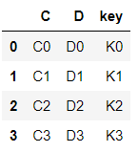

pd.merge(left,right,how='inner',on='key')

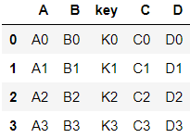

left = pd.DataFrame({'key1': ['K0', 'K0', 'K1', 'K2'],
'key2': ['K0', 'K1', 'K0', 'K1'],
'A': ['A0', 'A1', 'A2', 'A3'],
'B': ['B0', 'B1', 'B2', 'B3']})

right = pd.DataFrame({'key1': ['K0', 'K1', 'K1', 'K2'],
'key2': ['K0', 'K0', 'K0', 'K0'],
'C': ['C0', 'C1', 'C2', 'C3'],
'D': ['D0', 'D1', 'D2', 'D3']})

pd.merge(left, right, on=['key1', 'key2'])

pd.merge(left, right, how='outer', on=['key1', 'key2'])
pd.merge(left, right, how='right', on=['key1', 'key2'])
pd.merge(left, right, how='left', on=['key1', 'key2'])

Joining
Joining is a convenient method for combining the columns of two potentially differently-indexed DataFrames into a single result DataFrame.

left = pd.DataFrame({'A': ['A0', 'A1', 'A2'],
'B': ['B0', 'B1', 'B2']},
index=['K0', 'K1', 'K2'])

right = pd.DataFrame({'C': ['C0', 'C2', 'C3'],
'D': ['D0', 'D2', 'D3']},
index=['K0', 'K2', 'K3'])

left.join(right)

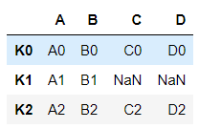

left.join(right, how='outer')

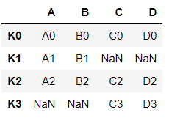

Summary

Series
labels = ['a','b','c']
my_list = [10,20,30]
arr = np.array([10,20,30])
d = {'a':10,'b':20,'c':30}

series creation

pd.Series(data=my_list)----index will be 0,1,2,3 by default
pd.Series(data=my_list,index=labels)
pd.Series(arr)
pd.Series(arr,labels)
pd.Series(d)

ser1 = pd.Series([1,2,3,4],index = ['USA', 'Germany','USSR', 'Japan'])
ser2 = pd.Series([1,2,5,4],index = ['USA', 'Germany','Italy', 'Japan'])

ser1['USA']
ser1 + ser2

DataFrames
pd.DataFrame(randn(5,4),index='A B C D E'.split(),columns='W X Y Z'.split())

Selection and Indexing

df['W']-----first column will print with index
df[['W','Z']]
df['new'] = df['W'] + df['Y']----create new column
df.drop('new',axis=1) ----remove column and display, not permanent delete
df.drop('new',axis=1,inplace=True)-----permanent removal of column
df.drop('E',axis=0)----drop rows

df.loc['A']-----first row will be displayed with column header
df.iloc[2]------row number can be mentioned instead of index

** Selecting subset of rows and columns **

df.loc['B','Y'] ----particular value (-0.8480769834036315)
df.loc[['A','B'],['W','Y']]-----2 x 2matrix

df[df>0]

df[df['W']>0]------all the rows which satisfy W value greater than 0 whicha re A,B D and E with all columns

df[df['W']>0]['Y'] ----display only Y column

df[df['W']>0][['Y','X']] ---display Y and X columns

df[(df['W']>0) & (df['Y'] > 1)] ----- Multiple conditions

df.reset_index() ---current index will be new column and new index will be created with 0,1,2,3…

newind = 'CA NY WY OR CO'.split()
df['States'] = newind -----new column will be added

df.set_index('States',inplace=True) ------making existing column as index

Multi-Index and Index Hierarchy

outside = ['G1','G1','G1','G2','G2','G2']
inside = [1,2,3,1,2,3]
hier_index = list(zip(outside,inside))
hier_index = pd.MultiIndex.from_tuples(hier_index)

pd.DataFrame(np.random.randn(6,2),index=hier_index,columns=['A','B'])

df.loc['G1']
df.loc['G1'].loc[1]
df.index.names = ['Group','Num']-----give header for indexes

DataFrames can also be created like

df = pd.DataFrame({'A':[1,2,np.nan],
'B':[5,np.nan,np.nan],
'C':[1,2,3]})

df.dropna() ----drop nan value rows
df.dropna(axis=1)---- ----drop nan value rows columns
df.dropna(thresh=2)----drop row which has 2 nan

df.fillna(value='FILL VALUE')---fill nan to new values

df.groupby('Company').mean()
df.groupby('Company').std()
df.groupby('Company').min()
df.groupby('Company').max()
df.groupby('Company').count()

pd.concat([df1,df2,df3])-----concat by row

pd.concat([df1,df2,df3],axis=1)---concat by column

pd.merge(left,right,how='inner',on='key')

pd.merge(left, right, on=['key1', 'key2'])

pd.merge(left, right, how='outer', on=['key1', 'key2'])
pd.merge(left, right, how='right', on=['key1', 'key2'])
pd.merge(left, right, how='left', on=['key1', 'key2'])

left.join(right)
left.join(right, how='outer')

df.head()
df['col2'].unique()
df['col2'].nunique()----index of unique value
df['col2'].value_counts()----gives numer of time each value repeated
newdf = df[(df['col1']>2) & (df['col2']==444)]

Applying Functions
def times2(x):
return x*2
df['col1'].apply(times2)----double the values of column
df['col3'].apply(len) ----gives length of value in the column

del df['col1']----permanently remove column

df.columns
df.index

df.sort_values(by='col2')
df.isnull()

