Diff types of plots
- distplot
- jointplot
- pairplot
- rugplot
- kdeplot

import seaborn as sns
%matplotlib inline
Seaborn comes with built-in data sets!
tips = sns.load_dataset('tips')
tips.head()
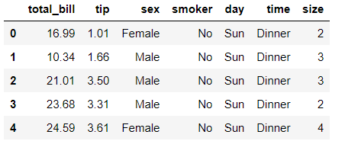
sns.distplot(tips['total_bill'])
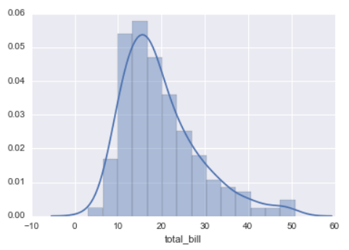
sns.distplot(tips['total_bill'],kde=False,bins=30)
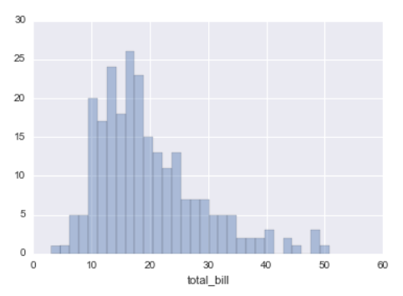

jointplot
jointplot() allows you to basically match up two distplots for bivariate data. With your choice of what kind parameter to compare with:
- “scatter”
- “reg”
- “resid”
- “kde”
- “hex
sns.jointplot(x='total_bill',y='tip',data=tips,kind='scatter')
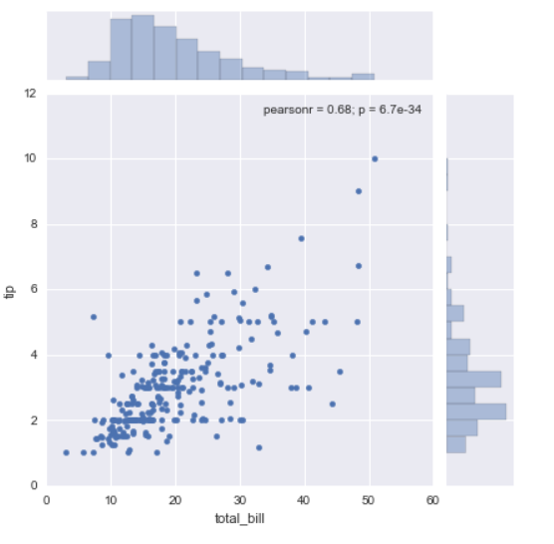

sns.jointplot(x='total_bill',y='tip',data=tips,kind='hex')
sns.jointplot(x='total_bill',y='tip',data=tips,kind='reg')

pairplot
pairplot will plot pairwise relationships across an entire dataframe (for the numerical columns) and supports a color hue argument (for categorical columns).

sns.pairplot(tips)
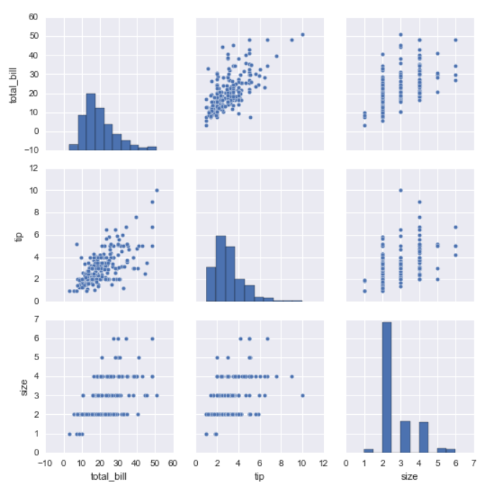

sns.pairplot(tips,hue='sex',palette='coolwarm')---hue will give segregation in the plot
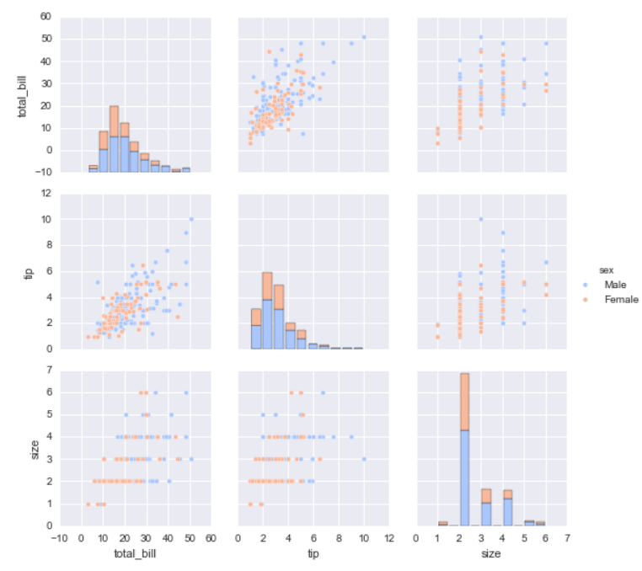

rugplot
rugplots are actually a very simple concept, they just draw a dash mark for every point on a univariate distribution. They are the building block of a KDE plot:
sns.rugplot(tips['total_bill'])

kdeplot
kdeplots are Kernel Density Estimation plots. These KDE plots replace every single observation with a Gaussian (Normal) distribution centered around that value.

Categorical Data Plots
Now let's discuss using seaborn to plot categorical data! There are a few main plot types for this:
- factorplot
- boxplot
- violinplot
- stripplot
- swarmplot
- barplot
- countplot

import seaborn as sns
%matplotlib inline

barplot and countplot
These very similar plots allow you to get aggregate data off a categorical feature in your data. barplot is a general plot that allows you to aggregate the categorical data based off some function, by default the mean:

sns.barplot(x='sex',y='total_bill',data=tips)

countplot
This is essentially the same as barplot except the estimator is explicitly counting the number of occurrences. Which is why we only pass the x value:

sns.countplot(x='sex',data=tips)

boxplot and violinplot

boxplots and violinplots are used to shown the distribution of categorical data. A box plot (or box-and-whisker plot) shows the distribution of quantitative data in a way that facilitates comparisons between variables or across levels of a categorical variable. The box shows the quartiles of the dataset while the whiskers extend to show the rest of the distribution, except for points that are determined to be “outliers” using a method that is a function of the inter-quartile range.

sns.boxplot(x="day", y="total_bill", data=tips,palette='rainbow')---pallet = color combination
sns.boxplot(data=tips,palette='rainbow',orient='h')----orient is horizontal
sns.boxplot(x="day", y="total_bill", hue="smoker",data=tips, palette="coolwarm")-----hue is differentiator

violinplot
A violin plot plays a similar role as a box and whisker plot. It shows the distribution of quantitative data across several levels of one (or more) categorical variables such that those distributions can be compared. Unlike a box plot, in which all of the plot components correspond to actual datapoints, the violin plot features a kernel density estimation of the underlying distribution.

sns.violinplot(x="day", y="total_bill", data=tips,palette='rainbow')
sns.violinplot(x="day", y="total_bill", data=tips,hue='sex',palette='Set1')
sns.violinplot(x="day", y="total_bill", data=tips,hue='sex',split=True,palette='Set1')----split hue as left and right in the same violin plot

stripplot and swarmplot
The stripplot will draw a scatterplot where one variable is categorical. A strip plot can be drawn on its own, but it is also a good complement to a box or violin plot in cases where you want to show all observations along with some representation of the underlying distribution.
The swarmplot is similar to stripplot(), but the points are adjusted (only along the categorical axis) so that they don’t overlap. This gives a better representation of the distribution of values, although it does not scale as well to large numbers of observations (both in terms of the ability to show all the points and in terms of the computation needed to arrange them).

sns.stripplot(x="day", y="total_bill", data=tips)
sns.stripplot(x="day", y="total_bill", data=tips,jitter=True)---gives some segregation between the points
sns.stripplot(x="day", y="total_bill", data=tips,jitter=True,hue='sex',palette='Set1')
sns.stripplot(x="day", y="total_bill", data=tips,jitter=True,hue='sex',palette='Set1',split=True) split between two hues

sns.swarmplot(x="day", y="total_bill", data=tips)
sns.swarmplot(x="day", y="total_bill",hue='sex',data=tips, palette="Set1", split=True)

Combining Categorical Plots

sns.violinplot(x="tip", y="day", data=tips,palette='rainbow')
sns.swarmplot(x="tip", y="day", data=tips,color='black',size=3)----merge two diff plots
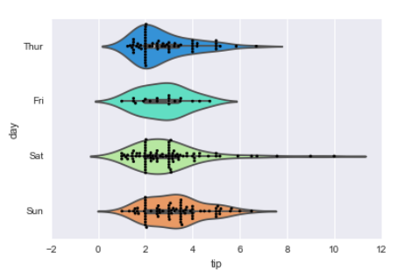

factorplot
factorplot is the most general form of a categorical plot. It can take in a kind parameter to adjust the plot type:

sns.factorplot(x='sex',y='total_bill',data=tips,kind='bar')----in kind we can mention what kind of plot we want to print

Matrix Plots
Matrix plots allow you to plot data as color-encoded matrices and can also be used to indicate clusters within the data (later in the machine learning section we will learn how to formally cluster data).
Let's begin by exploring seaborn's heatmap and clutermap:

import seaborn as sns
%matplotlib inline
flights = sns.load_dataset('flights')
tips = sns.load_dataset('tips')
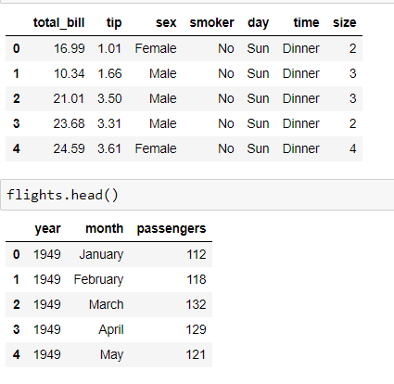

Heatmap

In order for a heatmap to work properly, your data should already be in a matrix form, the sns.heatmap function basically just colors it in for you. For example:

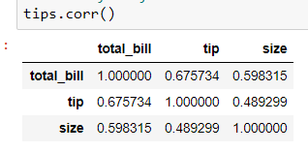

sns.heatmap(tips.corr())
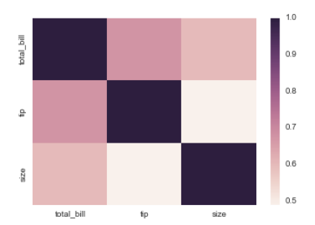
sns.heatmap(tips.corr(),cmap='coolwarm',annot=True)

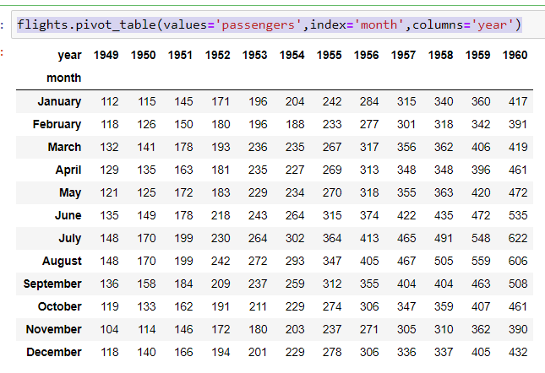

pvflights = flights.pivot_table(values='passengers',index='month',columns='year')
sns.heatmap(pvflights)

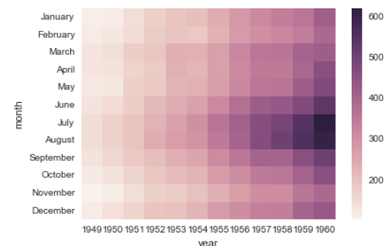
sns.heatmap(pvflights,cmap='magma',linecolor='white',linewidths=1)

clustermap
The clustermap uses hierarchal clustering to produce a clustered version of the heatmap. For example:

sns.clustermap(pvflights)
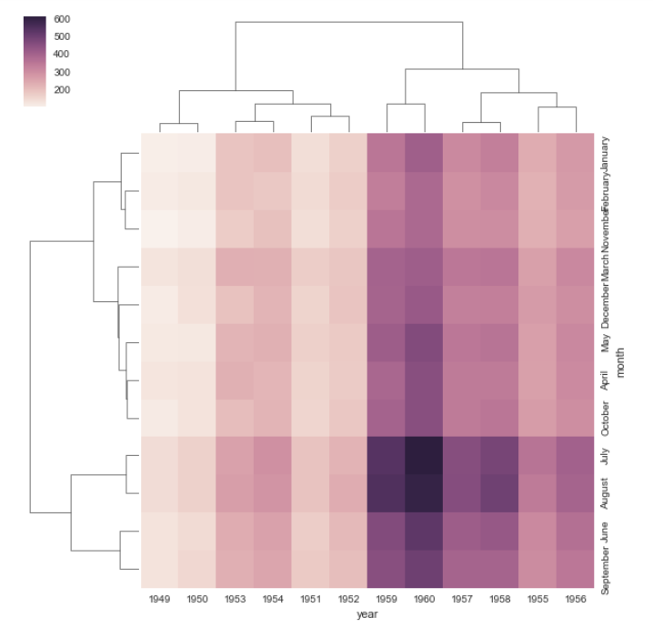

Grids
Grids are general types of plots that allow you to map plot types to rows and columns of a grid, this helps you create similar plots separated by features.

iris = sns.load_dataset('iris')
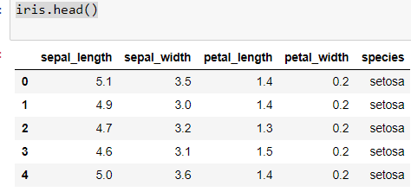
g = sns.PairGrid(iris)
g.map(plt.scatter)---- we can specify box, hist, stripplot, swornplot etc instead of scatter
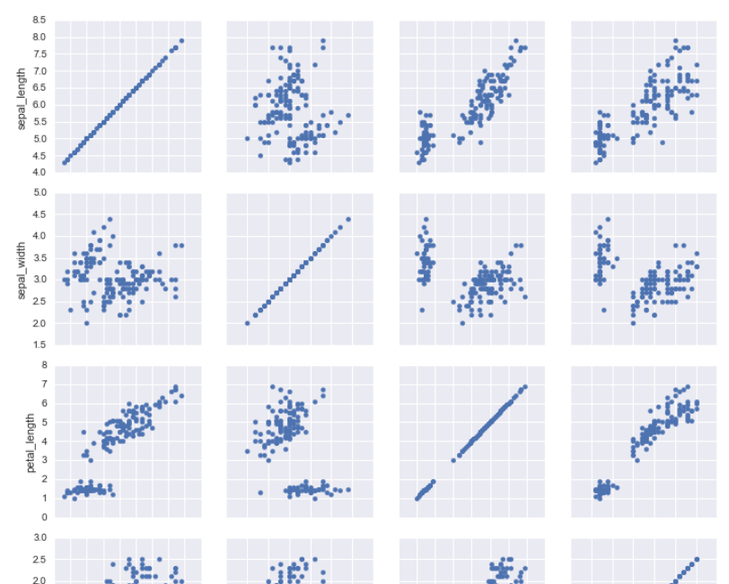

g = sns.PairGrid(iris)
g.map_diag(plt.hist)
g.map_upper(plt.scatter)----we can specify what kind of plot in upper and lower sections should print
g.map_lower(sns.kdeplot)

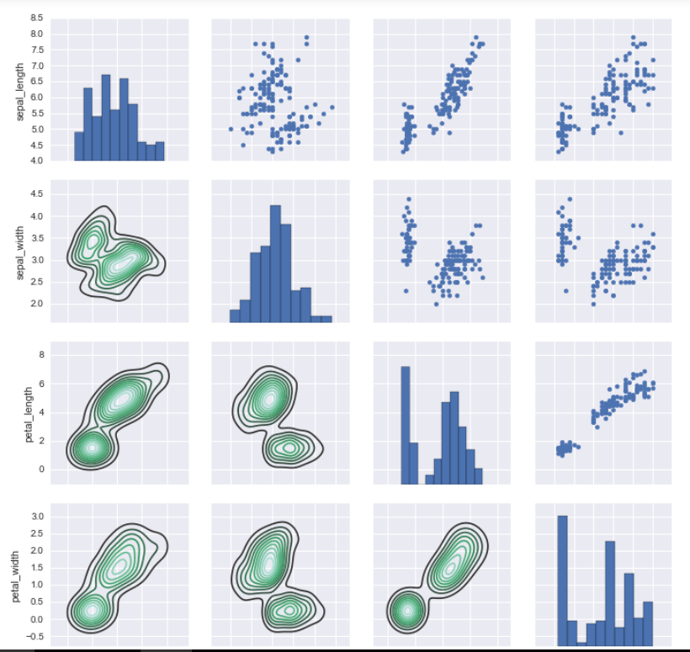

pairplot
pairplot is a simpler version of PairGrid (you'll use quite often)

sns.pairplot(iris)
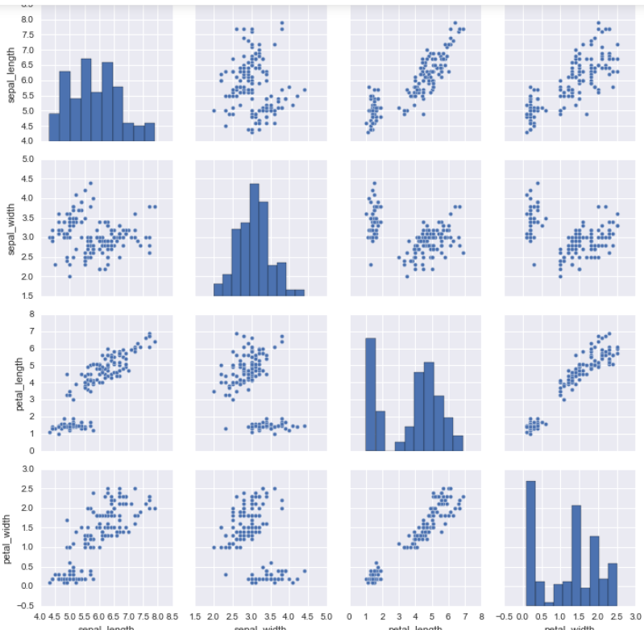

sns.pairplot(iris,hue='species',palette='rainbow')

Facet Grid
FacetGrid is the general way to create grids of plots based off of a feature:

g = sns.FacetGrid(tips, col="time", row="smoker")
g = g.map(plt.hist, "total_bill")

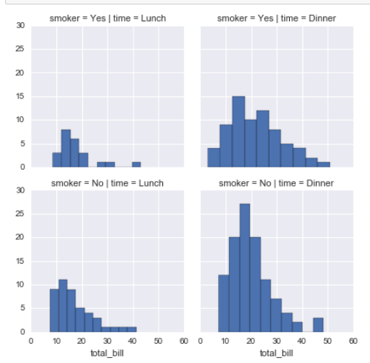

g = sns.FacetGrid(tips, col="time", row="smoker",hue='sex')----hue is used
# Notice hwo the arguments come after plt.scatter call
g = g.map(plt.scatter, "total_bill", "tip").add_legend() -----extra legend is added

JointGrid
JointGrid is the general version for jointplot() type grids, for a quick example:

g = sns.JointGrid(x="total_bill", y="tip", data=tips)
g = g.plot(sns.regplot, sns.distplot)
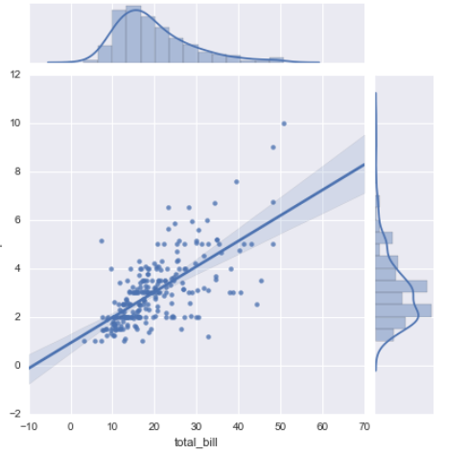

Regression Plots
Seaborn has many built-in capabilities for regression plots, however we won't really discuss regression until the machine learning section of the course, so we will only cover the lmplot() function for now.
lmplot allows you to display linear models, but it also conveniently allows you to split up those plots based off of features, as well as coloring the hue based off of features.
Let's explore how this works:

sns.lmplot(x='total_bill',y='tip',data=tips)

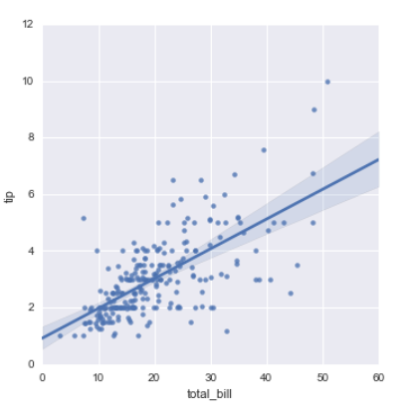
sns.lmplot(x='total_bill',y='tip',data=tips,hue='sex')

Working with Markers
lmplot kwargs get passed through to regplot which is a more general form of lmplot(). regplot has a scatter_kws parameter that gets passed to plt.scatter. So you want to set the s parameter in that dictionary, which corresponds (a bit confusingly) to the squared markersize. In other words you end up passing a dictionary with the base matplotlib arguments, in this case, s for size of a scatter plot. In general, you probably won't remember this off the top of your head, but instead reference the documentation.

sns.lmplot(x='total_bill',y='tip',data=tips,hue='sex',palette='coolwarm',
markers=['o','v'],scatter_kws={'s':100})-----markers type is mentioned here

Using a Grid
We can add more variable separation through columns and rows with the use of a grid. Just indicate this with the col or row arguments:

sns.lmplot(x='total_bill',y='tip',data=tips,col='sex')-----col is key here , sex has two value hence two colomns will be created

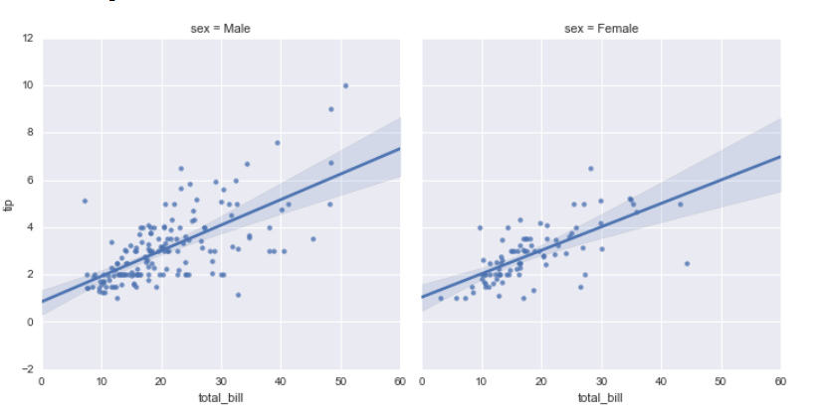

sns.lmplot(x="total_bill", y="tip", row="sex", col="time",data=tips)-----both row and columns are mentioned here

sns.lmplot(x='total_bill',y='tip',data=tips,col='day',hue='sex',palette='coolwarm')

Aspect and Size
Seaborn figures can have their size and aspect ratio adjusted with the size and aspect parameters:

sns.lmplot(x='total_bill',y='tip',data=tips,col='day',hue='sex',palette='coolwarm',
aspect=0.6,size=8)

