A DBMS PROJECT REPORT ON
Library Management System
A Fully Normalized MySQL Database for Inventory, Membership & Transaction Management
Submitted by
Shruti Singh SOT 25B2
Kunal Adtani SOT 25B2
Dhrumil Selarka SOT 25B2
Neeraj Saini SOT 25B2
Chetan Sai SOT 25B2

Academic Year: First-Year
Program: Integrated B.Tech in Computer Science
Institution: PW Institute Of Innovation
Location: Bengaluru
Date: June, 2026

Abstract
The Library Management System is a computerized relational database solution designed to store, retrieve, and manage transactions related to library inventory and user interactions. This project aims to digitize traditional library workflows, enhancing the convenience of book discovery, borrowing, and fine tracking for both library members and administrative staff.
The backend architecture is built entirely on MySQL, utilizing advanced relational database concepts — including stored procedures, complex views, and multi-table joins — to ensure data integrity, eliminate redundancy through 3NF normalization, and automate business logic such as late-fee calculations.
Beyond the schema itself, the project pairs the database with a lightweight HTML, CSS, and JavaScript frontend that consumes the underlying MySQL views directly, giving the team a working end-to-end demonstration of how a relational design translates into a usable application. This report documents the requirements gathered, the conceptual and relational models produced, the resulting interface, and the collaborative engineering process that produced the final system.

Contents
1. Introduction
1.1 Access Specification
2. Requirement Analysis
2.1 Functional Requirements
2.2 Non-Functional Requirements
3. Conceptual Models
3.1 Relational Schema
3.2 Entity-Relationship Diagram
4. System Implementation & Frontend
4.1 Application Walkthrough
5. System Design & Collaboration
6. Testing & Validation
7. Conclusion

1. Introduction
In an increasingly digital world, efficient information retrieval and inventory management are critical to the smooth operation of any institution that handles shared physical resources. A college or institutional library is, at its core, an inventory problem layered with a scheduling problem: every book exists in finite, trackable copies, and every copy moves between a shelf and a borrower on a predictable but constantly shifting timeline. The Library Management System presented in this report serves as a robust backend portal to handle these operations seamlessly, replacing the spreadsheets and paper registers that traditionally introduce delays, duplicate records, and human error into the process.
In order to use this service, a user registers as a Member — categorized as a Student, Faculty, or Staff — providing the necessary contact details such as name, address, and email. Membership itself is time-bound: every member record carries a membership date and an expiry date, and the system enforces that the expiry must always fall after the membership start, which prevents accidental creation of already-lapsed accounts.
The system manages a structured inventory of books, each tracked through its publisher, author, listed price, and the number of copies currently available on the shelf. The core functionality revolves around the borrow_records relation, which acts as the transactional junction between books and members. This table safely tracks when a book is issued, when it falls due, and — once the return_date is populated — enables the system to automatically calculate whether the return was late and what fine, if any, applies.
Because the catalog, the membership list, and the borrowing history are each stored once and referenced rather than duplicated, the design also lays the groundwork for the reporting layer described later in this report: a handful of SQL views can answer questions like “which books are overdue right now” or “which members owe fines” without the application layer needing to reimplement that logic in code.

1.1 Access Specification
The system supports distinct operational roles, each scoped to the actions that role is expected to perform:
- Librarians / Admins: Responsible for updating book inventory, registering new copies, processing physical issues and returns, and managing user access. This role has write access to every relation in the schema, since inventory and membership changes originate from the front desk.
- Registered Members: Can browse the active catalog, view their own active borrowings, and check any outstanding fines against their account. This role is intentionally read-only against the core tables and is served primarily through the reporting views rather than direct table access, which keeps the member-facing surface area small and auditable.
This two-tier access model mirrors how most real institutional library systems are operated: a small administrative staff with full inventory control, and a much larger membership base that only ever needs to read summarized, member-scoped information.

2. Requirement Analysis
Before any schema was drafted, the team worked through the expected behavior of the system from both the administrator's and the member's point of view. The requirements below were grouped using the standard functional / non-functional split so that each requirement could later be traced to a specific table, constraint, or view in the final implementation.

2.1 Functional Requirements
- Catalog Management: The system must allow admins to add books and publishers, and to track available copies against the total copies owned, so the catalog never advertises a book that cannot actually be issued.
- Transaction Processing: The system must handle the issuing and returning of books in a way that prevents the issuing of unavailable copies — the available count must be decremented at issue time and incremented again at return time, and these two operations must never drift out of sync with the borrow_records table.
- Fine Calculation: The system must dynamically calculate overdue days and generate fine records automatically upon late returns, rather than relying on a librarian to manually compute and enter a fine amount.
- Advanced Reporting: The system must generate analytical views for active borrowings, the book catalog, and member fine summaries, so that common questions can be answered with a single SELECT rather than a bespoke query each time.

2.2 Non-Functional Requirements
- Data Integrity: The database must enforce strict CHECK constraints — for example, a return date cannot precede its issue date, a due date cannot precede its issue date, prices cannot be negative, and available copy counts cannot go negative. These constraints catch data-entry mistakes at the database layer rather than relying on the application to validate everything correctly.
- Performance: Indexes must be utilized on highly queried columns — such as book titles, publisher references, the member foreign key on borrow records, and due dates — to ensure rapid data retrieval as the volume of historical borrowing records grows.
- Reliability: Transactions must utilize the ACID properties of MySQL so that inventory counts never fall out of sync with borrowing records, even if an operation is interrupted partway through.
- Usability: Common librarian and member queries should be exposed as simple, named views rather than requiring multi-table joins to be re-written by hand every time the same question is asked.

3. Conceptual Models

3.1 Relational Schema
The database is normalized up to the Third Normal Form (3NF). Each relation is defined below, together with the columns that act as primary key (PK) and foreign key (FK) references. Normalizing to 3NF means every non-key attribute depends only on the primary key of its own table — for instance, a publisher's address lives once in the publishers table rather than being repeated on every book row, which is what allows an address correction to be a single-row UPDATE instead of a multi-row search-and-replace.
Relation | Attributes
publishers | pub_id (PK), name, address
books | book_id (PK), title, author, price, available, pub_id (FK), shelf_no
members | member_id (PK), name, address, member_type, member_date, expiry_date, email, status
borrow_records | issue_id (PK), book_id (FK), member_id (FK), issue_date, due_date, return_date

Three relational views sit on top of these base tables to serve the reporting requirements identified in Section 2.1, without exposing the raw tables to every consumer of the data:
- vw_book_catalog: Joins books to publishers to produce a member-facing catalog — title, publisher name, author, available copies, and shelf location — in one row per book.
- vw_active_borrowings: Joins borrow_records, books, and members, filtered to rows where return_date is still NULL, and computes days_overdue via DATEDIFF so a librarian can see every book currently out, sorted by how overdue it is.
- vw_member_fine_summary: Aggregates, per member, the count of late returns and the unpaid fine amount, computed at five currency units per day overdue, whether the book has already been returned late or is still out and overdue today.

3.2 Entity-Relationship Diagram
The diagram below captures the four core entities — Books, Publisher, Member, and the Borrow relationship — along with their defining attributes. The Books – Publisher relationship is one-to-many (a publisher releases many books, but each book has one publisher), while Books and Member are connected through the Borrow relationship, which resolves what would otherwise be a many-to-many association between the two: a single book can be borrowed by many members over time, and a single member can borrow many books, with each individual borrowing event captured as its own record carrying an issue date, due date, and return date.
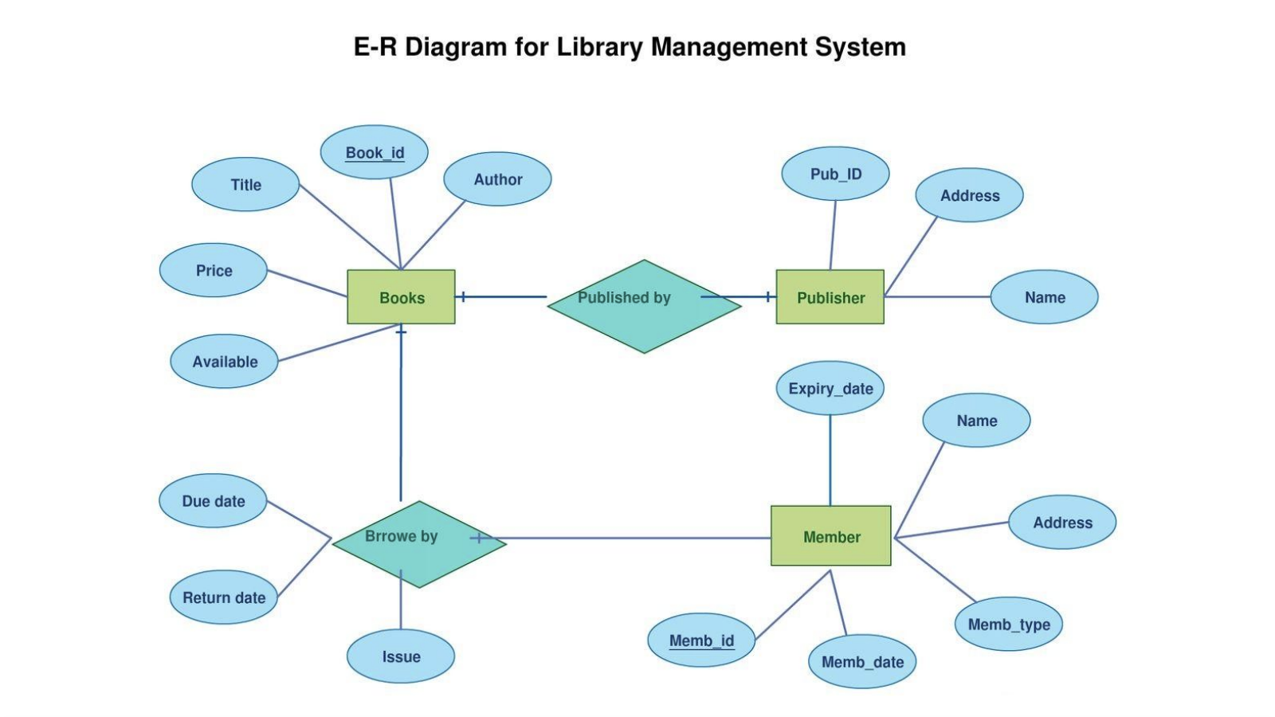
Figure 3.1 — Entity-Relationship diagram for the Library Management System

4. System Implementation & Frontend
While the relational schema is the heart of this project, the team also built a lightweight HTML, CSS, and JavaScript frontend so the database design could be demonstrated as a working application rather than as a set of isolated SQL scripts. The frontend connects directly to the MySQL backend and renders its pages from the views described in Section 3.1, which keeps the client-side code simple: each page issues a query against a single view and renders the result as a table, rather than re-implementing joins or fine calculations in JavaScript.

4.1 Application Walkthrough
The application opens on a Dashboard that gives administrative staff an at-a-glance summary of the library's current state — total titles in the catalog, total physical copies across all titles, registered members, and books that are currently out on active issue. These four figures are each the result of a simple aggregate query against the base tables, confirming on every page load that the frontend is reading live data rather than a static mock-up.
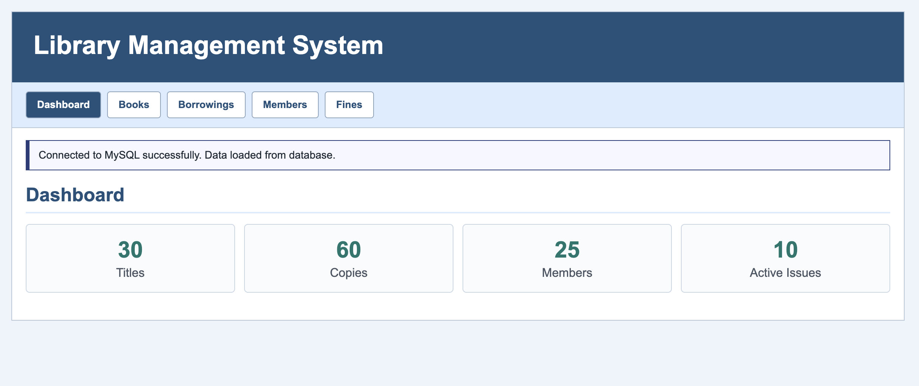
Figure 4.1 — Dashboard view, showing live aggregate counts pulled from MySQL
The Books tab renders the vw_book_catalog view directly, giving members and staff a searchable list of every title together with its publisher, author, current availability, and shelf location. Because this page reads from a view rather than the raw books and publishers tables, the publisher name is already resolved through the join — the frontend never needs to know that title and publisher live in separate relations.
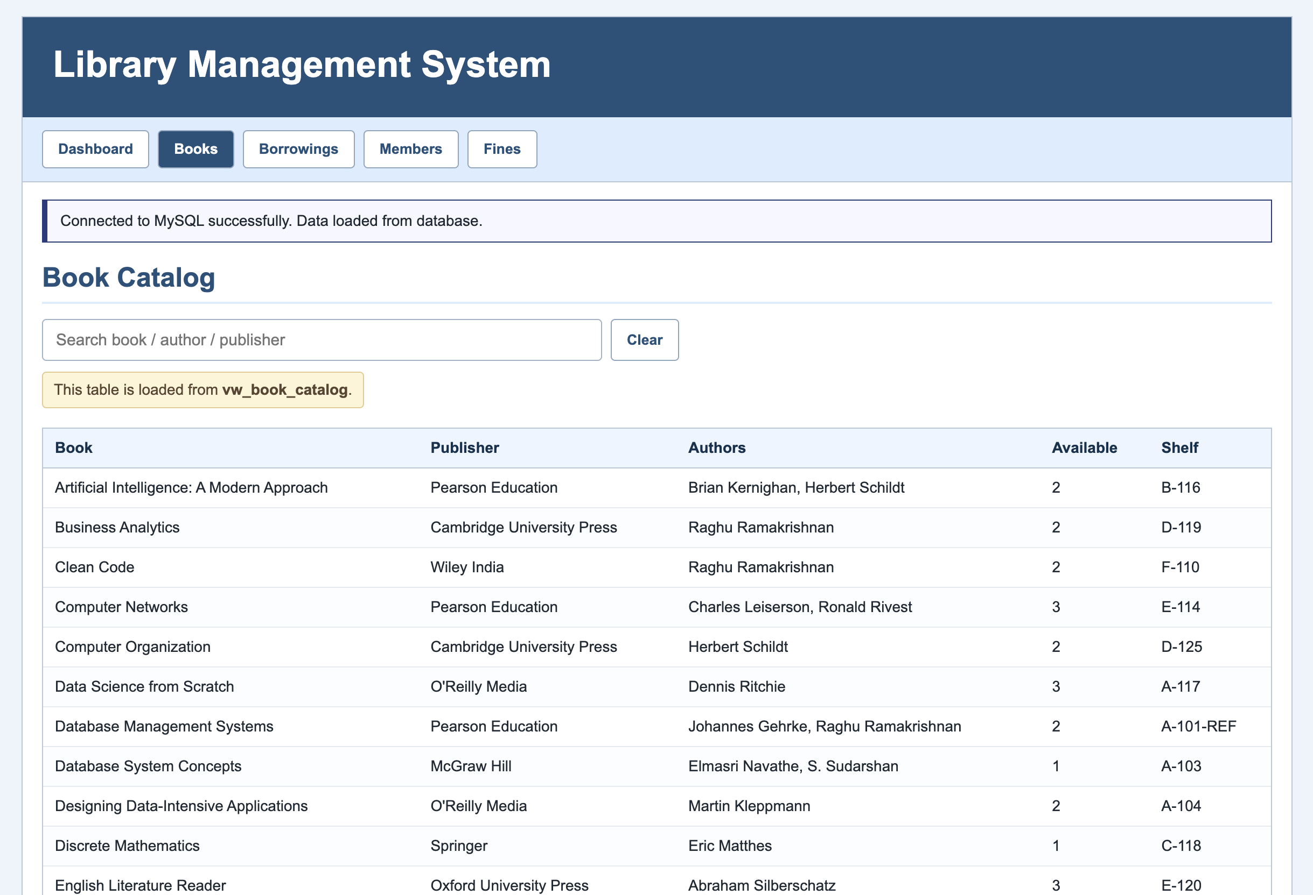
Figure 4.2 — Book Catalog page, populated from the vw_book_catalog view
The Members tab lists every registered member along with their type (Student, Faculty, or Staff), contact email, membership expiry date, and current status. This page draws on the members table directly, since membership administration is an admin-facing concern rather than a reporting concern, and benefits from the same CHECK constraint discussed in Section 2.2 that guarantees every listed expiry date is genuinely after the corresponding membership date.
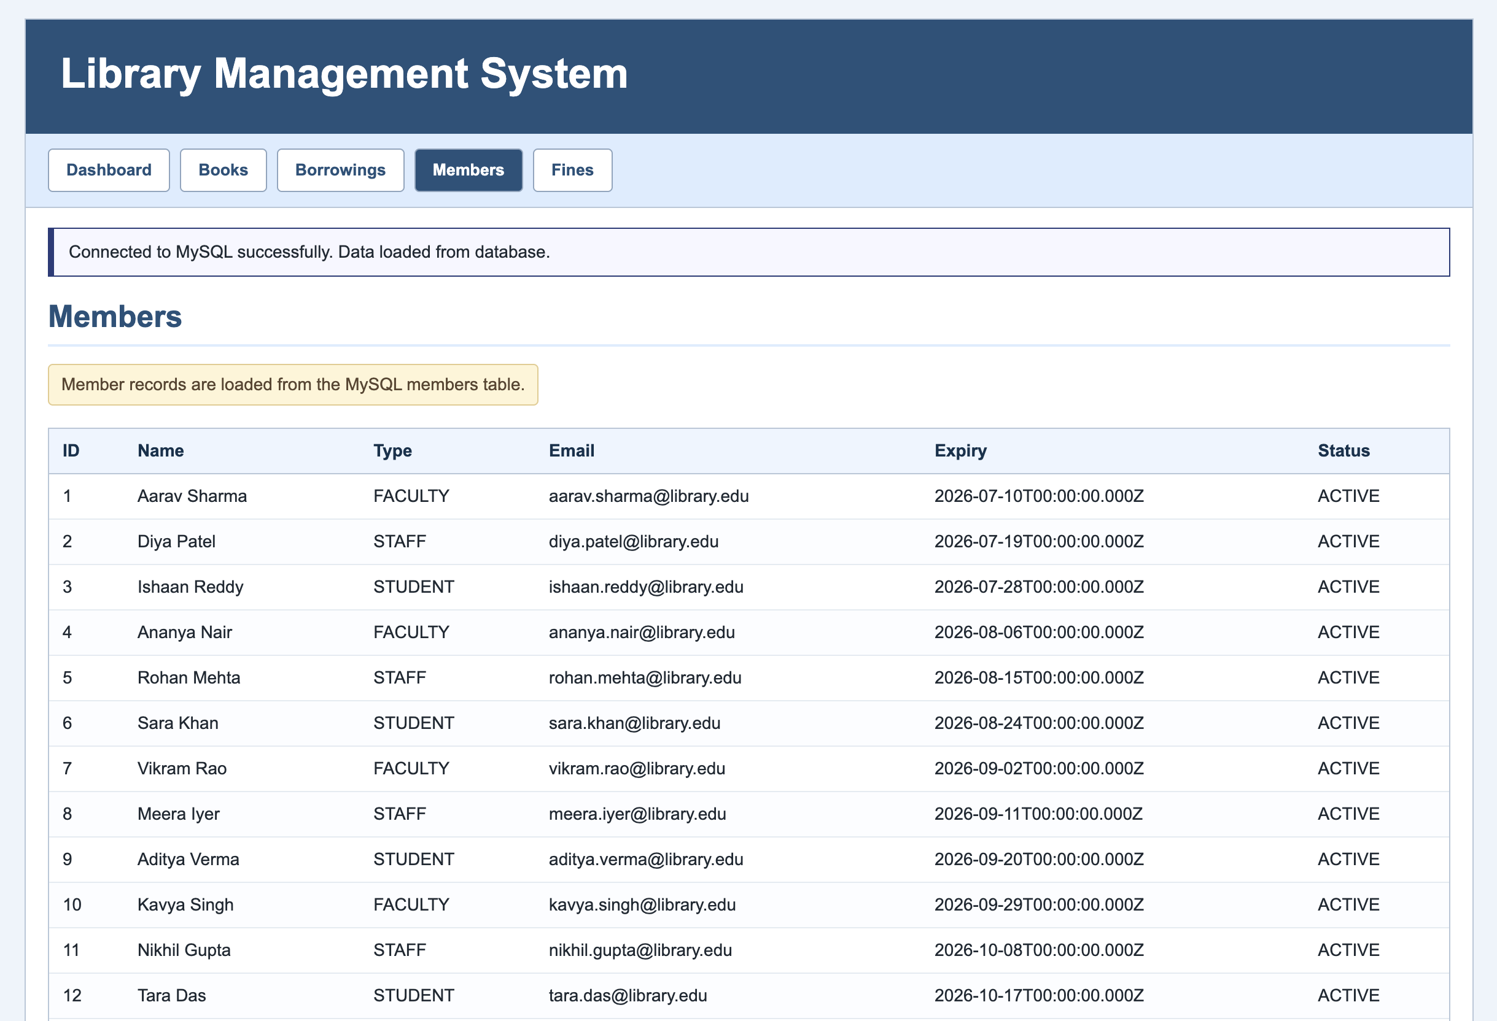
Figure 4.3 — Members page, listing registered Students, Faculty, and Staff
Two further tabs, Borrowings and Fines, follow the same pattern: Borrowings surfaces vw_active_borrowings so staff can see every book currently checked out and how overdue it is, and Fines surfaces vw_member_fine_summary so staff can see, per member, how many late returns they have accumulated and what they currently owe. Together, the five tabs map directly onto the four functional requirements from Section 2.1 — catalog management, transaction visibility, fine calculation, and advanced reporting — which was a deliberate design choice so that every screen in the application could be traced back to a specific project requirement.

5. System Design & Collaboration
The project was developed collaboratively, adhering to professional software engineering workflows rather than having a single member write the entire schema in isolation. The MySQL backend was modularized into distinct components, each owned by a team member, so that schema design, data population, query development, and documentation could proceed in parallel once the relational model in Section 3.1 was agreed upon.
Module | Owner | Responsibility
M1 | Shruti | Core Schema Design, DDL implementation, and Indexing.
M2 | Kunal | Member / Staff tables and Data Manipulation (DML) operations.
M3 | Dhrumil | Transactional Junction Tables and Advanced SQL Business Queries.
M4 | Neeraj | Advanced Logic, Analytical Views, and Stored Procedures for Issue / Return logic.
M5 | Chetan | Master Data Seeding, System Integration, and Documentation.

This division of labor was chosen to mirror how database-backed applications are typically built in industry: one or two engineers own the schema and its constraints, another owns the data access and manipulation layer, another focuses on the business logic that sits above raw CRUD operations, and at least one person is responsible for integration and documentation so the individual modules come together into a single coherent deliverable. Regular sync points between modules — particularly between M1's schema and M3's transactional queries — ensured that foreign key relationships and naming conventions stayed consistent across the whole codebase as the project progressed.

6. Testing & Validation
Because the schema leans on CHECK constraints and foreign keys to enforce correctness, a meaningful part of the validation effort was simply attempting to insert data that should be rejected, and confirming that MySQL rejected it. The team also validated the reporting views against hand-computed expected results before treating them as trustworthy enough to drive the frontend.
- Constraint testing: Attempted inserts with a negative price, an available count below zero, a due date before the issue date, and a membership expiry date before the membership date were each confirmed to fail at the database layer, exactly as the non-functional requirements in Section 2.2 specify.
- Referential integrity testing: Attempted inserts into borrow_records referencing a non-existent book_id or member_id were confirmed to fail, verifying that the foreign key relationships back to books and members are actually enforced rather than merely documented.
- View correctness testing: For a small, hand-picked set of members and borrow records, the fine amounts and overdue-day counts produced by vw_member_fine_summary and vw_active_borrowings were recalculated manually and compared against the view's output, confirming the DATEDIFF and CASE logic produces the expected fine of five currency units per overdue day.
- Frontend integration testing: Each tab of the application — Dashboard, Books, Borrowings, Members, and Fines — was checked against the live MySQL connection to confirm the displayed figures and rows matched the underlying tables and views at the time of viewing, rather than reflecting stale or cached data.
Together, these checks gave the team confidence that the constraints described on paper in Section 2.2 are genuinely active in the deployed schema, and that the views the frontend depends on are computing the correct values rather than merely returning data in the right shape.

7. Conclusion
This project successfully bridges academic Database Management System concepts with real-world engineering practices. By implementing a fully normalized MySQL backend complete with constraints, indexes, multi-table joins, and analytical views, the Library Management System eliminates manual record-keeping errors and provides a highly efficient, scalable architecture for institutional use.
Pairing that backend with a working HTML, CSS, and JavaScript frontend turned the schema from a theoretical exercise into a system that can actually be operated by a librarian or browsed by a member, and gave the team direct, visible confirmation that the views built in Section 3.1 answer the reporting requirements they were designed for.
The modular team structure ensured clean separation of concerns — from schema design and data seeding through to query development, view design, and final documentation — closely mirroring professional database development workflows. The resulting system is, in its current form, ready for incremental extension: additional procedures for automated issue and return logic, a richer fines-payment workflow, or a more capable frontend could each be layered on top of the existing schema without requiring it to be redesigned.

