**INTRODUCTION:**

Food trucks have become a popular choice for quick and delicious meals on the go. Our proposed project aims to develop a comprehensive Food Truck Management System using MySQL Managing a food truck efficiently involves handling orders, maintaining a menu, this system incorporates features such as staff and department management, truck ownership tracking, and maintenance scheduling and ensuring seamless transactions.

The database will consist of multiple interconnected tables to store various types of information:

* Food Table: Stores details about each food item such as Order ID, name, Menu id, price, and Quantity.
* Client Table: Contains information about each customer ID, customer name and their phone number.
* Amount Table: This table will store the client id included along with their total prices.
* Menu Table: Stores the current menu items offered by the food truck, including their details like item ID, name, and price.
* Staff Table: Contains information about employees working for the food truck business, including staff ID, name, contact details, and department ID.
* Department Table: Categorizes staff members into different departments or roles for organizational purposes.
* Truck Table: Stores details about the food truck fleet, including truck ID, owner name, and other relevant information like location.
* Maintenance Table: Records scheduled maintenance tasks for each food truck, including maintenance ID, truck ID, maintenance date, and details of the staff maintenance performed.
* Location table: Contains the name of location where food truck is located.

**OBJECTIVE:**

The objective of the Food Truck Management System with Staff and Maintenance Tracking project is to design and implement a comprehensive database management system using MySQL that addresses the multifaceted needs of food truck businesses.

The key objectives of this project include:

* Dynamic Menu Management: Implement a dynamic menu management system that allows food truck operators to easily update and modify the menu as needed, ensuring accurate representation of available food items.
* Transparent Billing and Payment: Provide customers with transparent billing information, including a breakdown of costs, to streamline the payment process and enhance customer satisfaction.
* Effective Staff and Department Management: Create a staff management system that allows food truck operators to manage employee information effectively, including staff roles and department assignments, to optimize organizational structure and workflow.
* Truck Ownership Tracking: Develop a system to track ownership information for food trucks, providing insights into ownership relationships and facilitating administrative tasks related to truck management.
* Scheduled Maintenance Tracking: Implement a maintenance scheduling system to ensure timely maintenance of food trucks, enhancing fleet reliability and longevity while minimizing downtime.
* User-Friendly Interface: Design an intuitive user interface that is easy to navigate for both food truck operators and customers, enhancing user experience and system usability.

By achieving these objectives, the Food Truck Management System aims to optimize operational efficiency, enhance customer satisfaction, and support the sustainable growth and success of food truck businesses.

**HARDWARE / SOFTWARE REQUIREMENT:**

* Hardware

RAM 4GB or higher.

CPU 2 core 2.4 GHz or higher.

Storage 8GB.

* Software

Windows x86 64-bit

MySQL 8.0.37

**DATABASE DESIGN:**

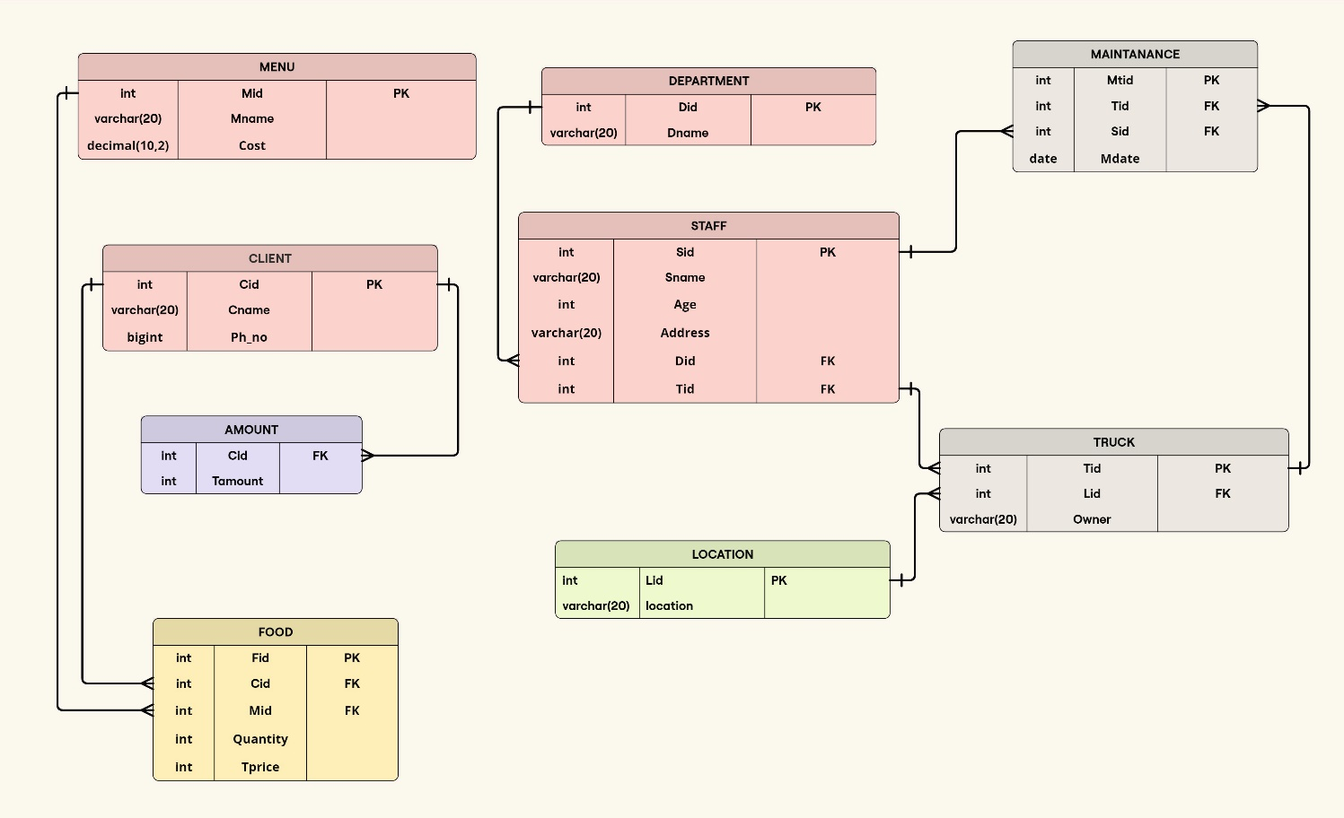

**Figure 1: Schema Diagram**

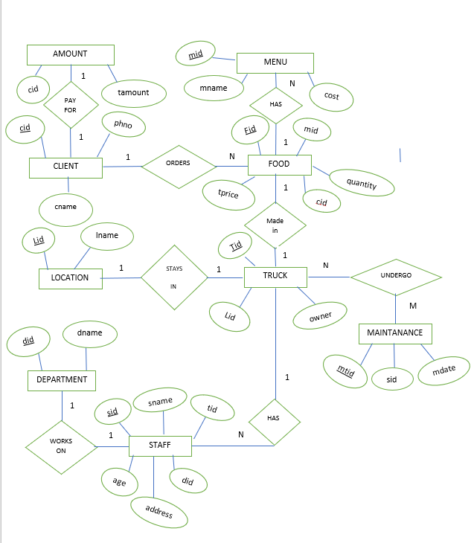

**Figure 2 E-R Diagram**

**QUERIES AND REPORTS:**

**Creating the table**:

* Client table

create table client(cid int,cname varchar(20),phno bigint,primary key(cid));

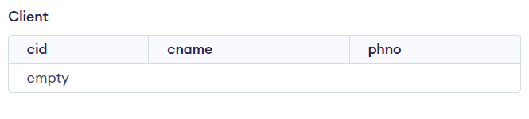

* Menu table:

create table menu(mid int,mname varchar(20),cost decimal(10,2), primary key(mid));

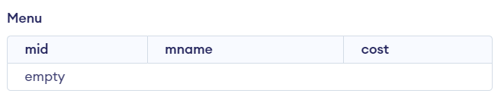

* Food table

create table food(fid int AUTO_INCREMENT,cid int,mid int,quantity int,tprice int ,primary key(fid),foreign key(cid) references client(cid) , foreign key(mid) references menu(mid));

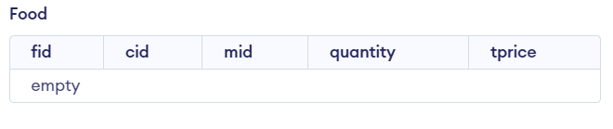

* Amount table

create table amount(aid int ,cid varchar(10),tamount int,primary key(aid) , foreign key(cid) references client(cid));

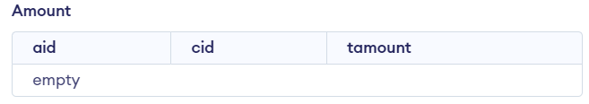

* Location table

create table location(lid int,location varchar(20),primary key(lid));

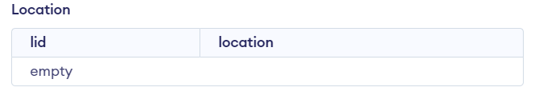

* Truck table

create table truck(tid int,lid int,owner varchar(20),primary key(tid) , foreign key(lid) references location(lid));

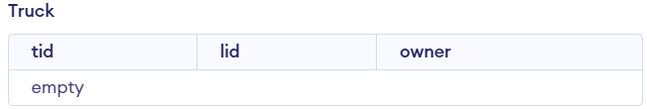

* Department table

create table department(did int,dname varchar(20),primary key(did));

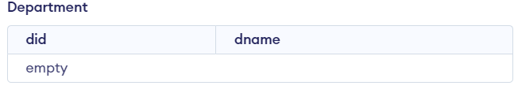

* Staff table

create table staff(sid int,sname varchar(20),age int,address varchar(20), did int,tid int,primary key(sid),foreign key(tid) references truck(tid), foreign key(did) references department(did));

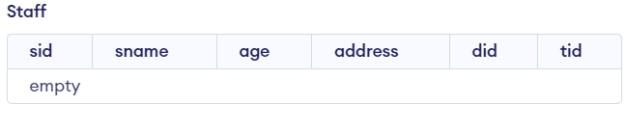

* Maintenance table

create table maintaince(mtid int,tid int,sid int,mdate date,primary key(mtid),foreign key(tid) references truck(tid),foreign key(sid) references staff(sid));

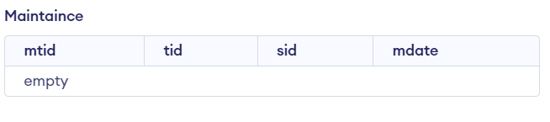

**Inserting into table**

* Menu table insert into menu values(1,'chicken taco', 60) , (2,'veg taco',50),(3,'french fries', 40),(4,'chicken burritos',80),(5,'veg burritos',70),(6,'nacho',55);

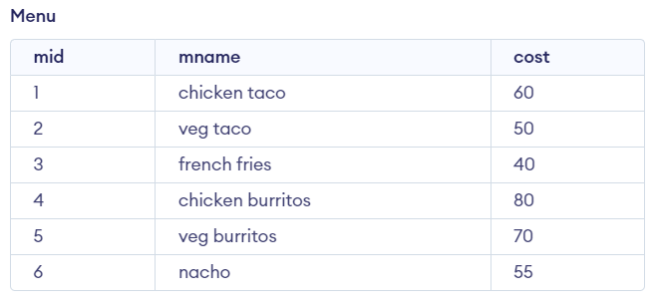

* Client table

insert into client values(1000,'chethan',9844126623),(1001,'shreya', 8754695658), (1002, 'shraddha' , 8996775665),(1003,'deepthi',9787446645) , (1004,'surekha',9846760071),(1005,'savitha',8687584958),(1006,'sunitha',9995654856),(1007,'karthik',9426445648),(1008,'kinmani',9887556456),(1009,'pappuri',9995643459),(1010,'cheya',9654658789);

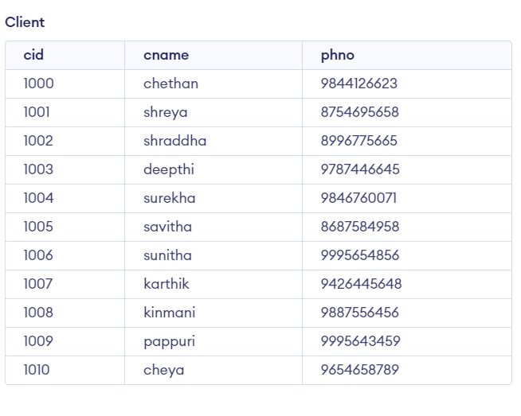

* Location table insert into location values(10,'carstreet'),(11,'morgans gate'),(12,'puttur');

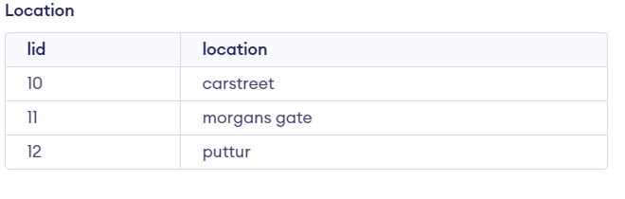

* Department table insert into department values(101,' head_chef'),(102,'receptionist'), (103,'sous_chef'),(104,'helper'), (105,'mechanic');

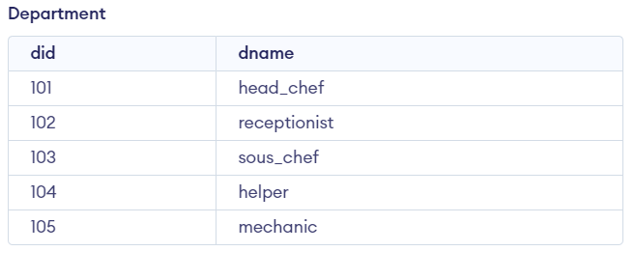

* Truck table insert into truck values(20,10,'krishna'),(21,11,'srinivas'),(22,12,'devadas');

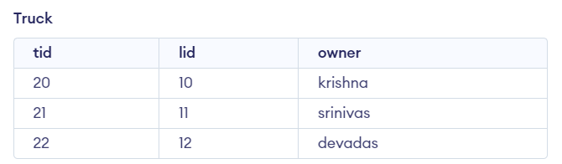

* Staff Table

Insert into staff values(200,'sharat',25,'manglore',101,20),(201,'sharv',26, 'manglore',102,20),(202,'anil',30,'kumble',103,20),(203,'navin',26, 'manglore',104,20), (204,'arvi',22,'manglore',105,20),(205,'nash',25,'tokkotu',101,21),(206,'imli',26,'manglore',102,21),(207,'aryan',30,'manjeshwara',103,21),(208,'jeros',26,'manglore',104,21),(209,'kamal',22,'manglore',105,21),(210,'koyal',25,'kumble',101,22),(211,'kumar',26,'manglore',102,22),(212,'shennu',30,'manjeshwara',103,22),(213,'navin',26,'tokkotu',104,22),(214,'appu',22,'manglore',105,22);

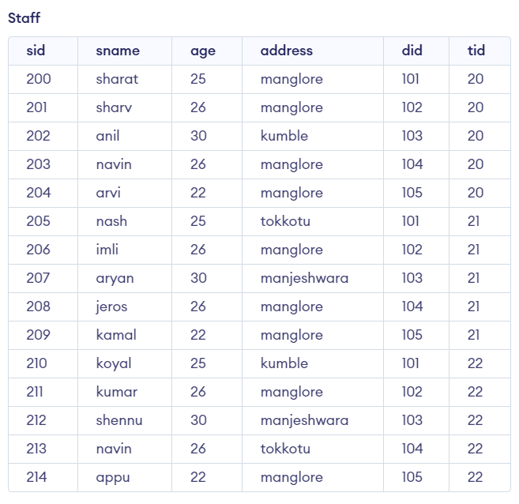

* Maintenance table

insert into maintaince values(30,20,204,'2024-02-24'),(31,21,209,'2024-02-24'),(32,22,214,'2024-02-24');

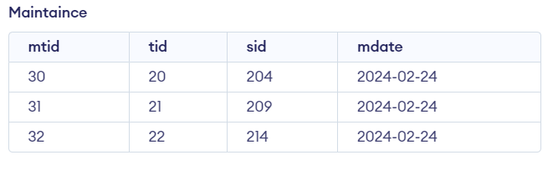

**Q1.Create a Tigger function to update price of food ordered by the client for each row.**

Delimiter //

CREATE TRIGGER calci

-> BEFORE INSERT ON food

-> FOR EACH ROW

-> BEGIN

-> DECLARE menu_cost DECIMAL(10,2);

-> SELECT cost INTO menu_cost FROM menu WHERE mid = NEW.mid;

-> SET NEW.price = NEW.qty * menu_cost;

-> END;

-> //

Delimiter ;

insert into food(cid,mid,qty)values(1000,1,2);

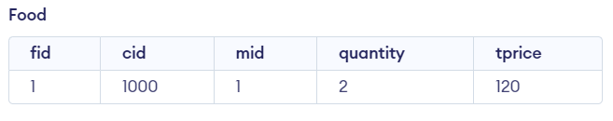

**Q2.Create a procedure to calculate total amount of client to be paid by using there client id**

Delimiter //

 CREATE PROCEDURE totalamount(IN id INT)

    -> BEGIN

    ->     INSERT INTO amount(cid, tamount)

    ->     SELECT cid, SUM(price)

    ->     FROM food

    ->     WHERE cid = id

    ->     GROUP BY cid;

    ->     select * from amount where cid=id;

    -> END;

    -> //

Delimiter ;

call totalamount(1001);

**Output:**

+------+---------+

| cid  | tamount |

+------+---------+

| 1001 |     160 |

**Q3.Display the name of all staff who works as helper**

select s.sname from staff s left join department d on d.did=s.did where d.dname='helper';

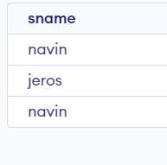

**Q4.Display the name of mechanic who has maintained krishna’s truck**

select sname from staff s,maintaince m ,truck t where m.sid=s.sid and t.tid=m.tid and t.owner='krishna';

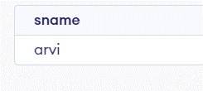

**Q5.Display name of city from where most number are staff are from**

Select address from staff group by address order by count(address) desc limit 1;

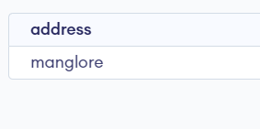

**Q6.Display the name of client who has ordered “nacho”**

select c.* from client c,food f where f.cid=c.cid and f.mid in (select mid from menu where mname='nacho');

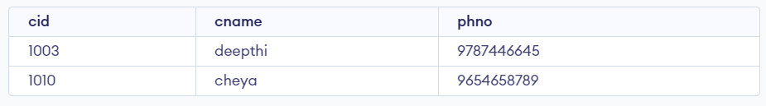

**Q7.Display the number of employee from their native place**

select count(sid),address from staff group by address order by count(address);

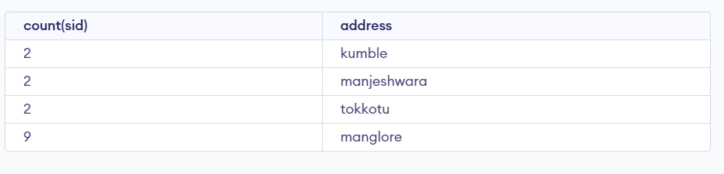

**Conclusion:**

In conclusion, the development of a comprehensive database management system (DBMS) for a food truck enterprise has been successfully conceptualized. Through meticulous design and implementation, various crucial aspects of the business have been addressed, ranging from client management to staff organization and maintenance scheduling.

The integration of multiple tables, including Client, Food, Menu, Amount, Truck, Location, Staff, and Maintenance, ensures a streamlined operation that enhances efficiency and accuracy in data handling. By centralizing information such as client details, food offerings, transaction records, and maintenance schedules, the system facilitates seamless coordination and decision-making processes within the food truck business.

Moreover, the retrieval of essential data, such as total amounts payable by clients and the current location of trucks, is simplified through the relational structure of the database. This enables prompt and informed actions, contributing to enhanced customer service and operational performance.

Overall, the DBMS for the food truck enterprise stands as a testament to the power of database technology in optimizing business processes and fostering growth. Its robust framework not only supports day-to-day operations but also lays a foundation for scalability and innovation in the dynamic landscape of the food industry.

**Future Work:**

Our database management system (DBMS) is poised for exciting future developments that will further improve user experience and operational effectiveness. We intend to add multiple additional tables to the current framework as one of the next improvements.

* First, a "Ingredient" table will be put into place to carefully record the ingredients that are used in food preparation, providing customers with more clarity about the culinary components of their orders. This innovation makes nutritional analysis and allergen tracking easier while also promoting customer knowledge.
* Second, to ensure ideal stock management and save waste, a "Storage" table will be connected to track products kept in the food truck's refrigerator and keep an eye on inventory levels.
* Lastly, a special "Premium User" table will be created to serve our premium users, allowing for customized offers.

**References:**

* An Introduction to Database Systems,C.J Data,A. Kannan,

S Swamynatham,Pearson education,8Th Edition,2013

* Database Management Systems, Majmudar Arun K,Bhattacharyya Pritimoy,McGraw-Hill,1st Edition 2010