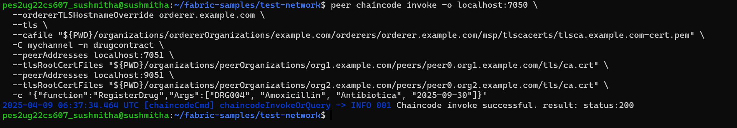
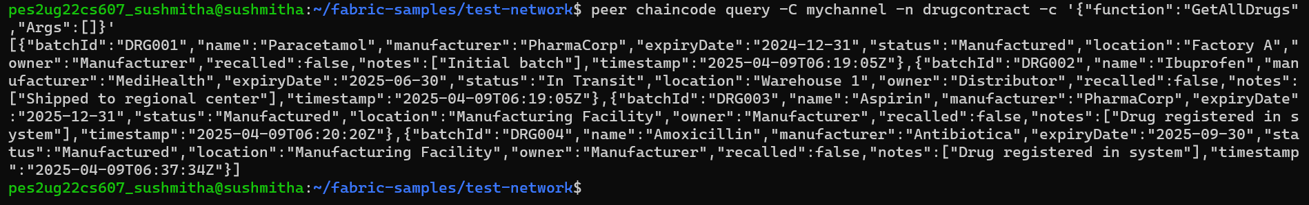
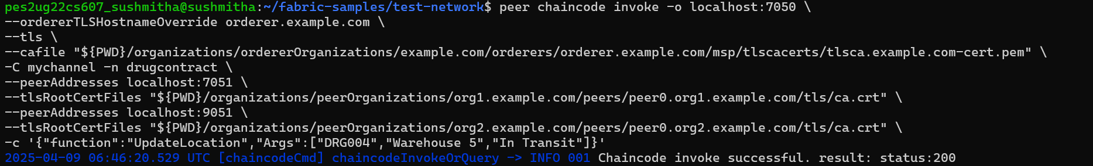
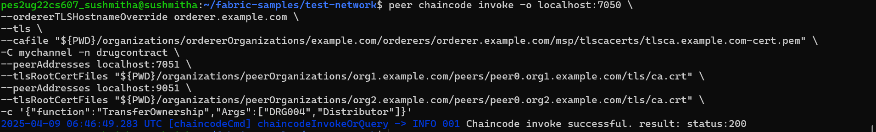
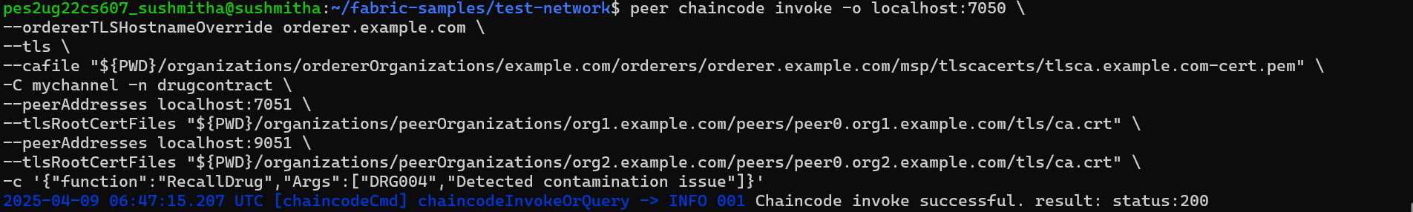
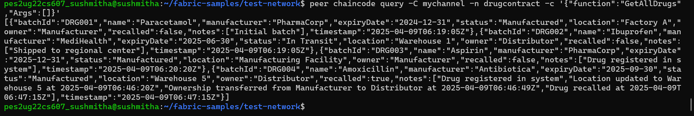
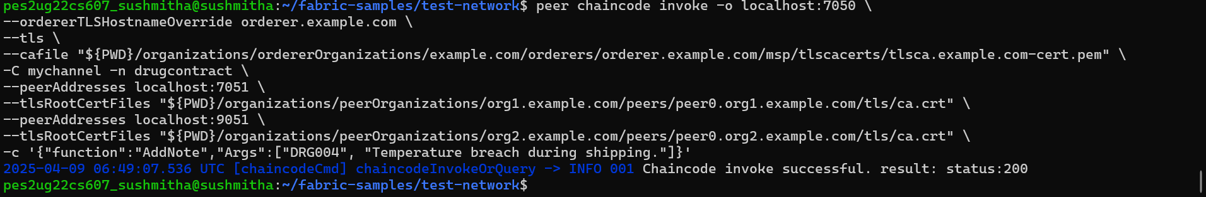
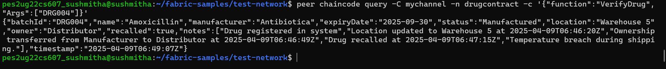

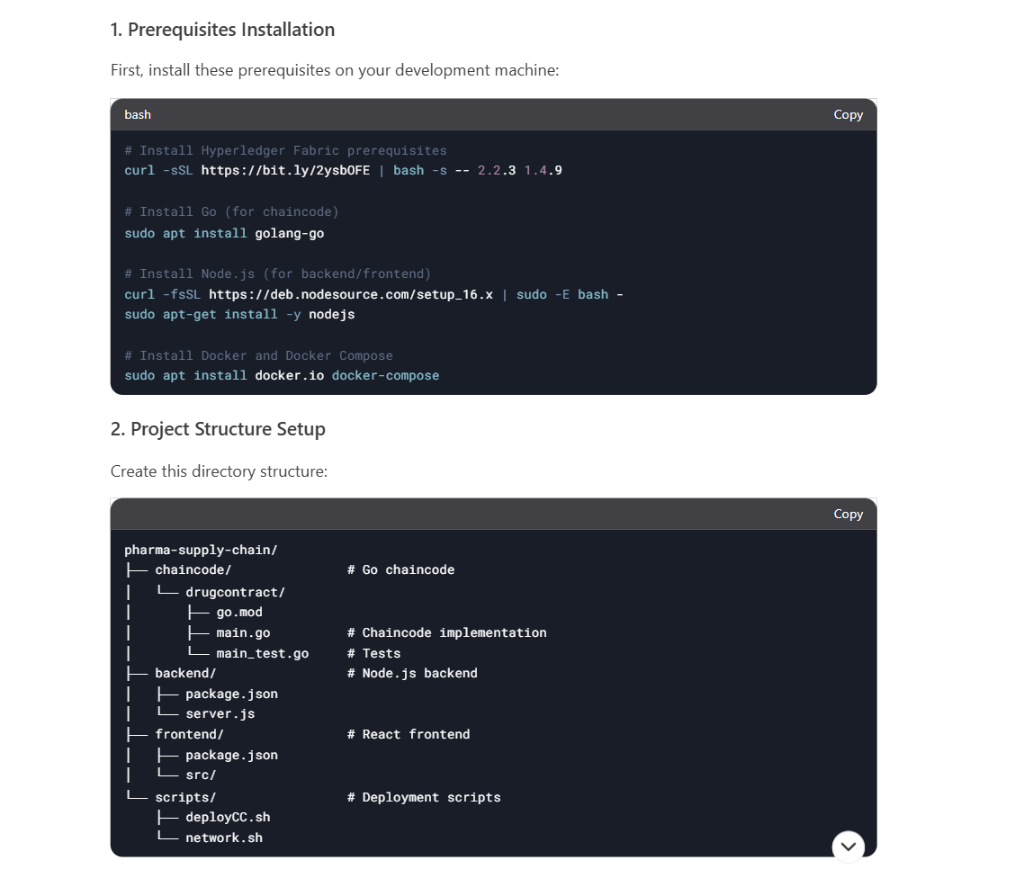

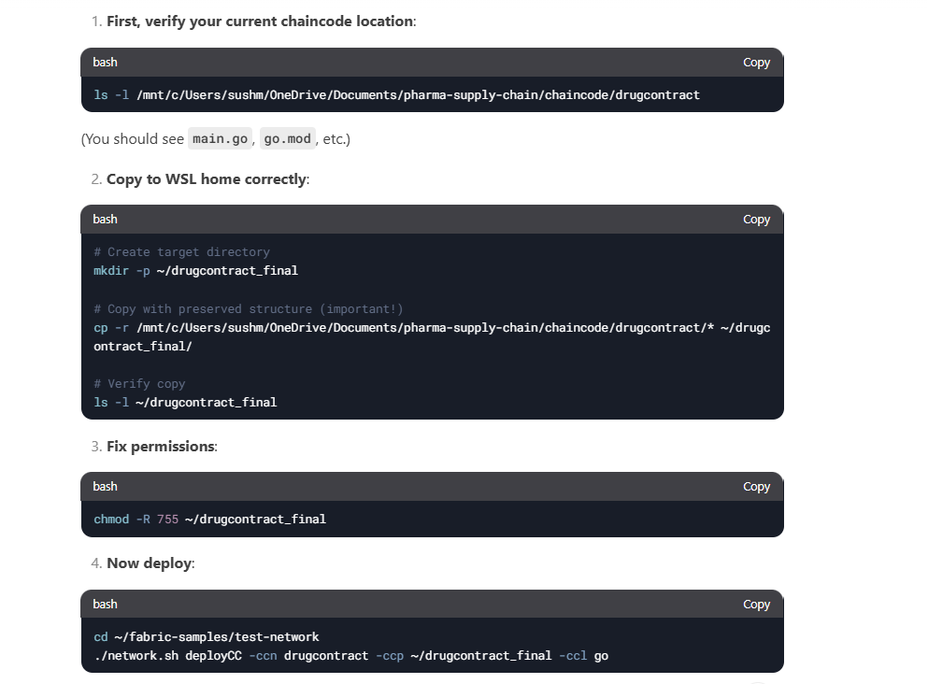

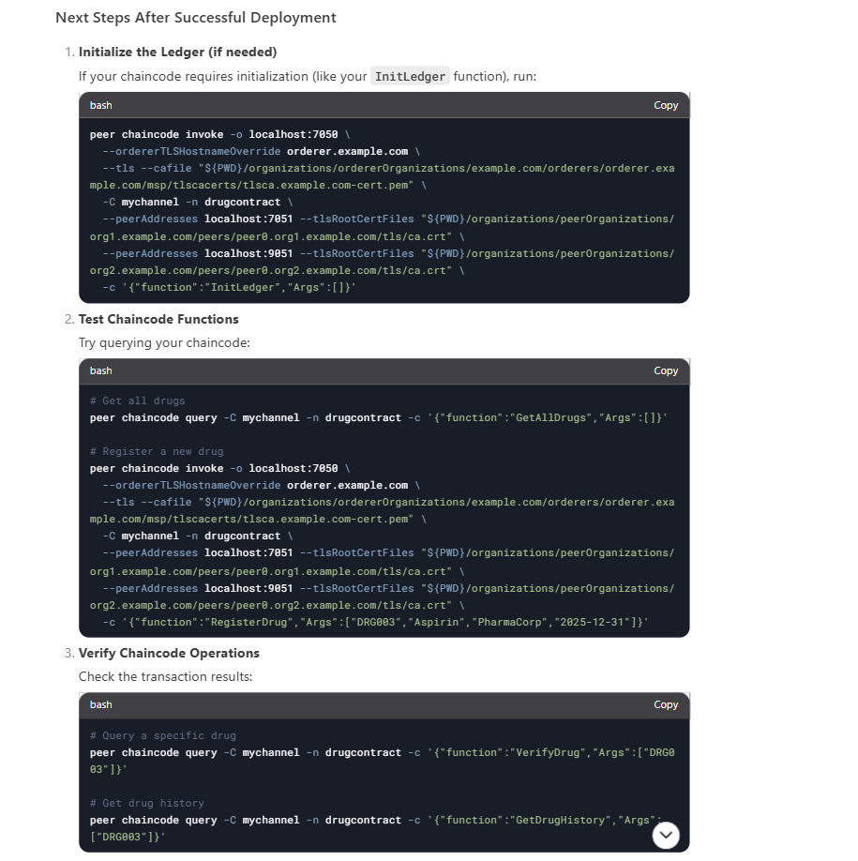

Error fixes
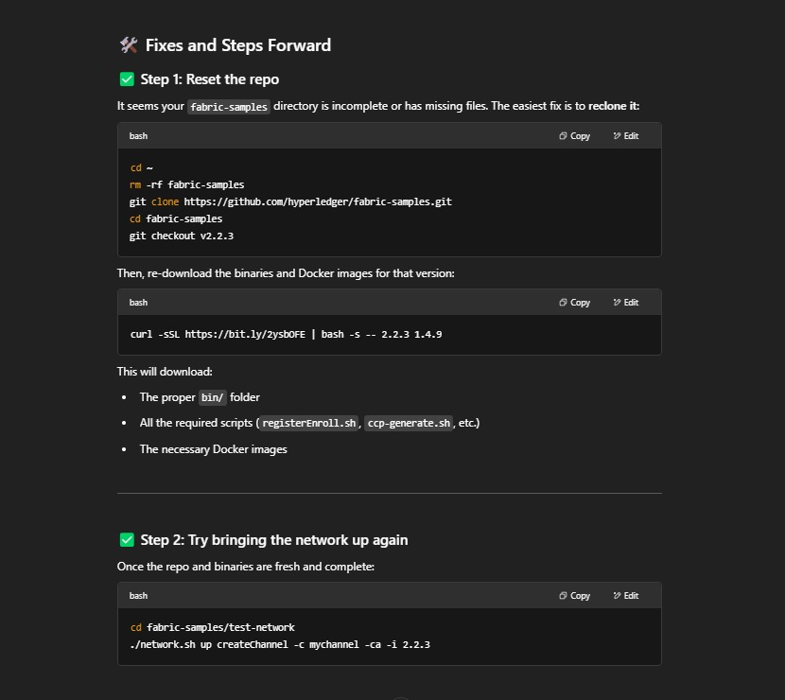

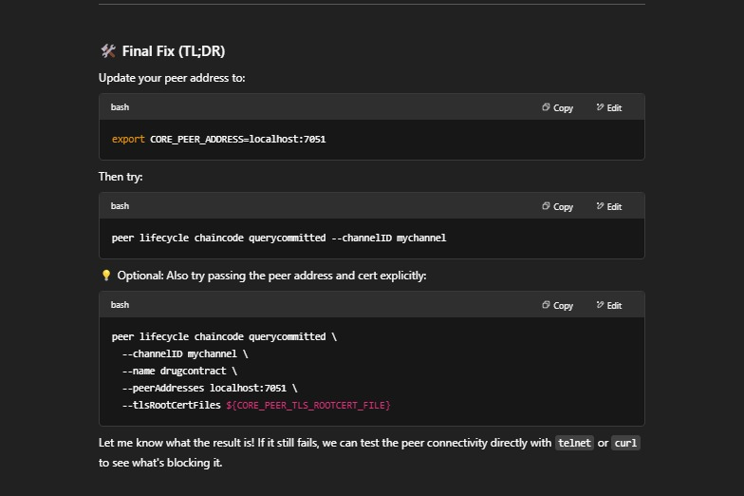

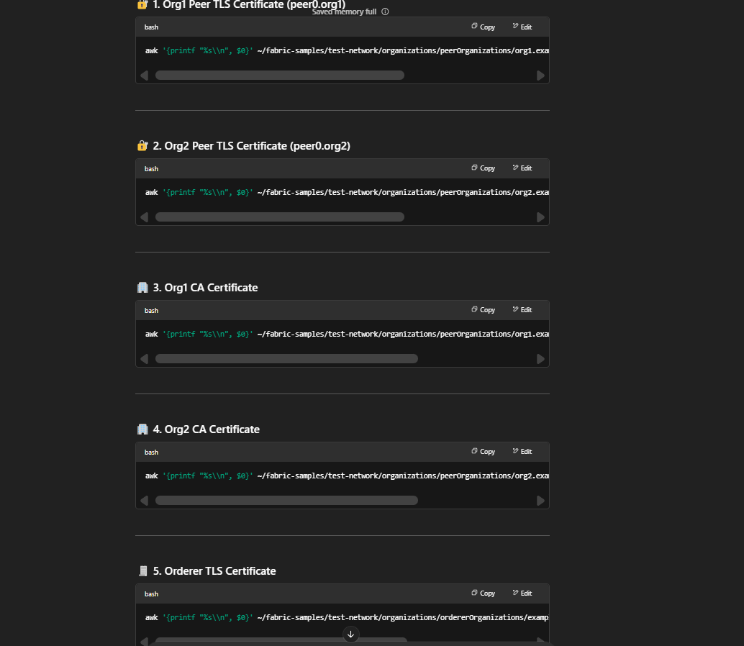

awk '{printf "%s\\n", $0}' ~/fabric-samples/test-network/organizations/peerOrganizations/org1.example.com/peers/peer0.org1.example.com/tls/ca.crt

awk '{printf "%s\\n", $0}' ~/fabric-samples/test-network/organizations/peerOrganizations/org2.example.com/peers/peer0.org2.example.com/tls/ca.crt

awk '{printf "%s\\n", $0}' ~/fabric-samples/test-network/organizations/peerOrganizations/org1.example.com/ca/ca.org1.example.com-cert.pem

awk '{printf "%s\\n", $0}' ~/fabric-samples/test-network/organizations/peerOrganizations/org2.example.com/ca/ca.org2.example.com-cert.pem

awk '{printf "%s\\n", $0}' ~/fabric-samples/test-network/organizations/ordererOrganizations/example.com/orderers/orderer.example.com/tls/ca.crt

